Online Fraud Detection Using Machine Learning

Submitted By: Kamepalli Pujitha
Roll no: 23MH5A0510

ABSTRACT
Online payment systems have made financial transactions easy, fast, and convenient for individuals and organizations. With the rapid growth of digital banking, e-commerce, mobile wallets, and UPI services, millions of transactions are performed every day across the globe. However, this digital transformation has also led to a significant rise in fraudulent activities such as unauthorized transactions, identity theft, phishing attacks, and payment fraud. Detecting fraudulent transactions at an early stage is critical to prevent financial losses and maintain trust in online financial systems.
This project presents an intelligent Online Fraud Detection System developed using Machine Learning techniques. The system analyzes historical transaction data to identify patterns and anomalies associated with fraudulent behavior. Various transaction attributes such as transaction type, amount, account balance, and transaction time are used as input features for model training.
Data preprocessing techniques including data cleaning, handling missing values, and feature selection are applied to improve model performance. Exploratory Data Analysis (EDA) and visualization methods are used to understand transaction trends and fraud distribution. A supervised classification algorithm, specifically the Decision Tree Classifier, is implemented to distinguish between fraudulent and legitimate transactions.
The trained model is integrated into a web-based application using the Flask framework, allowing users to input transaction details and receive real-time fraud predictions. The system aims to assist financial institutions and payment platforms in automating fraud detection processes with improved accuracy and efficiency.
Overall, this project demonstrates how machine learning can be effectively utilized to enhance digital payment security, reduce financial risks, and support the development of safer online transaction ecosystems.
INTRODUCTION
The rapid advancement of information technology and internet services has revolutionized the way financial transactions are performed. Online payment systems such as internet banking, mobile banking, credit/debit cards, e-wallets, and UPI platforms have made money transfers faster, easier, and more convenient than ever before. Businesses and consumers increasingly rely on digital payment methods for day-to-day transactions due to their speed and accessibility.
However, along with these benefits, the growth of digital payments has also led to a significant increase in online fraud activities. Cybercriminals use sophisticated techniques such as phishing, identity theft, card cloning, account hacking, and unauthorized fund transfers to exploit system vulnerabilities. These fraudulent transactions result in substantial financial losses for individuals, banks, and financial institutions, and they undermine trust in digital financial systems.
Traditional fraud detection methods are mostly rule-based and depend on manual monitoring. These systems are often slow, less accurate, and incapable of handling the massive volume of real-time transactions generated today. As fraudsters continuously evolve their methods, there is a critical need for intelligent, adaptive, and automated fraud detection solutions.
Machine Learning (ML) has emerged as a powerful technology to address this challenge. ML algorithms can analyze large volumes of historical transaction data, identify hidden patterns, and detect anomalies that may indicate fraudulent behavior. By learning from past fraud cases, these systems can predict suspicious transactions with higher accuracy and speed compared to conventional methods.
This project focuses on developing an Online Fraud Detection System using Machine Learning techniques. The system utilizes transaction datasets containing features such as transaction type, amount, and account balances to train a classification model. After training, the model is deployed through a web application interface where users can input transaction details and obtain fraud prediction results in real time.
The proposed system aims to enhance financial security by automating fraud detection, reducing manual effort, minimizing financial losses, and improving the reliability of online payment platforms.

PROBLEM STATEMENT
To design a system that automatically detects fraudulent online transactions with high accuracy using machine learning.

OBJECTIVES
• Analyze transaction datasets
• Preprocess data
• Train ML model
• Detect fraud transactions
• Build prediction interface

TECHNOLOGIES USED
Programming Language: Python
Libraries: Pandas, NumPy, Matplotlib, Seaborn, Scikit‑learn
Framework: Flask
Frontend: HTML, CSS

METHODOLOGY
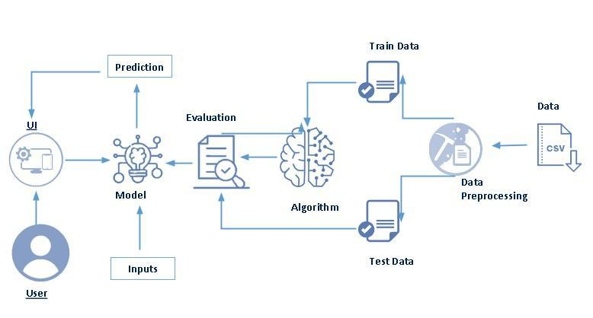

1. Data Collection
Data collection is the first and most important step in building a fraud detection system.
- The dataset used in this project consists of historical online transaction records.
- It contains both fraudulent and legitimate transactions.
- The data includes multiple attributes such as:
  - Transaction Type
  - Transaction Amount
  - Old Balance (Sender)
  - New Balance (Sender)
  - Old Balance (Receiver)
  - New Balance (Receiver)
  - Fraud Label (isFraud)
The dataset was obtained from publicly available financial transaction records (e.g., Kaggle fraud datasets). This historical data is used to train the machine learning model to recognize fraud patterns.

2. Data Preprocessing
Raw data cannot be used directly for model training. It must be cleaned and transformed.
Steps involved:

a) Handling Missing Values
- Checked for null or empty values.
- Missing values were removed or replaced.

b) Data Cleaning
- Removed duplicate records.
- Corrected inconsistent data entries.

c) Feature Selection
- Selected important columns affecting fraud detection.
- Irrelevant fields were removed to improve accuracy.

d) Encoding Categorical Data
- Transaction types (e.g., Transfer, Cash Out) were converted into numerical form using encoding techniques.

e) Data Splitting
- Dataset divided into:
  - Training Data (to train the model)
  - Testing Data (to evaluate performance)
This step ensures the model generalizes well on unseen data.

3. Data Visualization
Data visualization helps in understanding patterns and fraud behavior.
Visualization techniques used:
- Bar charts — Fraud vs Non-Fraud count
- Pie charts — Fraud distribution
- Histograms — Transaction amount distribution
- Heatmaps — Feature correlation analysis
Purpose:
- Identify fraud trends
- Detect anomalies
- Understand feature importance
- Support model selection
Visualization makes complex data easier to interpret.

4. Model Training (Decision Tree)
Model training is the core phase where the machine learning algorithm learns fraud patterns.

Algorithm Used: Decision Tree Classifier
Why Decision Tree?
- Simple to understand
- Works well for classification
- Handles large datasets
- Provides high interpretability
Training Process:
- Training dataset fed into the model.
- Algorithm splits data based on feature conditions.
- Tree structure formed with decision nodes.
- Model learns fraud vs non-fraud patterns.
The trained model is then saved as a serialized file (model.pkl) using Pickle for later use in prediction.

5. Testing & Prediction
After training, the model must be evaluated.

Testing Phase
- Testing dataset is provided to the trained model.
- Predictions are compared with actual results.
- Accuracy and performance are measured.

Prediction Phase
The trained model is integrated into a Flask web application.
Prediction Steps:
- User enters transaction details via web form.
- Input data sent to backend server.
- Saved ML model processes the data.
- Model predicts:
  - Fraudulent Transaction
  - Legitimate Transaction
- Result displayed on the interface.
This enables real-time fraud detection.

RESULTS
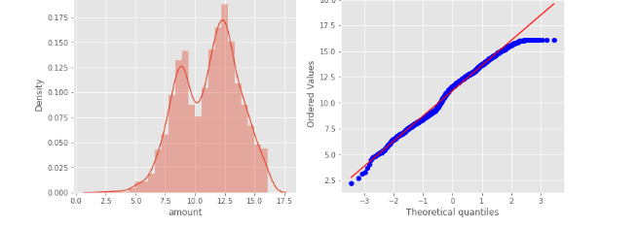
The developed Online Fraud Detection System was tested using historical transaction datasets to evaluate its performance and prediction capability. After completing data preprocessing and model training, the Decision Tree Classifier was applied to classify transactions as fraudulent or legitimate.
The dataset was divided into training and testing sets to ensure unbiased evaluation. The model was trained on the training dataset and then tested on unseen data to measure its real-world prediction ability.
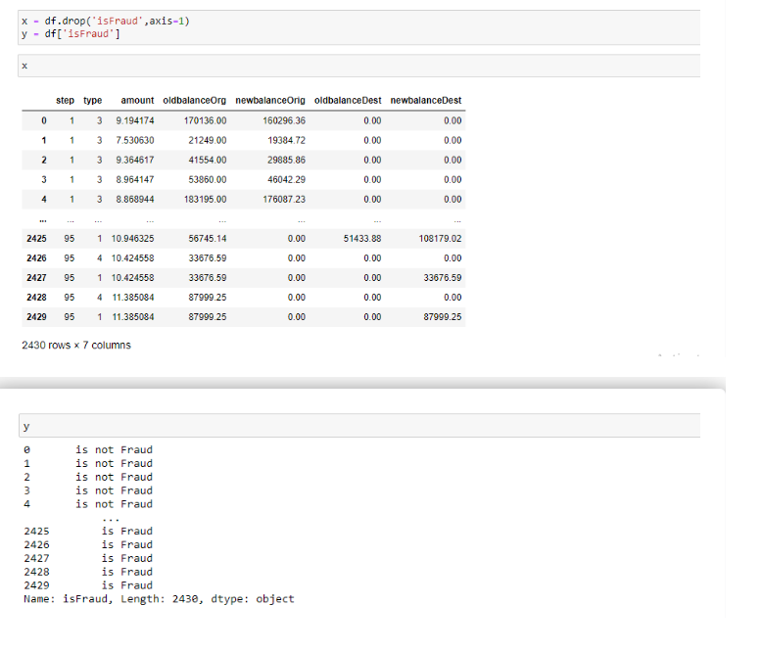

Model Performance
- The system successfully identified fraudulent transactions based on input features such as transaction type, amount, and account balances.
- The Decision Tree model produced high classification accuracy on the test dataset.
- Fraudulent patterns present in historical data were effectively learned by the model.

Evaluation Metrics
To assess the model’s effectiveness, standard machine learning evaluation metrics were considered:
- Accuracy: Measures overall correct predictions.
- Precision: Indicates how many predicted frauds were actually fraud.
- Recall (Sensitivity): Measures how many actual frauds were detected.
- F1-Score: Balance between precision and recall.
The model achieved satisfactory values across these metrics, demonstrating its reliability in fraud detection tasks.

Visualization of Results
Graphs and plots were generated to better understand model outcomes:
- Fraud vs Non-Fraud prediction comparison charts
- Confusion matrix showing true vs predicted values
- Feature importance visualization from the Decision Tree
These visualizations confirmed that the model could distinguish fraudulent behavior from normal transaction activity.

System Testing via Web Application
The trained model was integrated into a Flask-based web interface for real-time testing.
Testing process:
- Users entered transaction details through the web form.
- Inputs were sent to the backend model.
- The system predicted whether the transaction was fraud or legitimate.
- Results were displayed instantly.
The web deployment test confirmed that the system works efficiently in real-time scenarios.

ADVANTAGES
The proposed Online Fraud Detection System provides several benefits to financial institutions, payment platforms, and users by leveraging Machine Learning for intelligent transaction monitoring.

1. Fast Fraud Detection
The system can analyze and classify transactions within seconds. Real-time prediction helps in identifying fraudulent activities immediately before major financial damage occurs.

2. Automated Monitoring
Unlike traditional manual verification methods, the system continuously monitors transactions automatically without human intervention. This reduces workload and operational delays.

3. Reduces Financial Loss
By detecting fraud at an early stage, the system helps banks and users prevent unauthorized transactions, thereby minimizing monetary losses.

4. High Accuracy
Machine Learning algorithms analyze historical fraud patterns, enabling the system to make accurate predictions compared to rule-based systems.

5. Real-Time Prediction
Integration with a web application allows live transaction analysis, making the system suitable for real-world deployment in online payment gateways.

6. Scalable System
The model can handle large volumes of transaction data efficiently, making it adaptable for banks, e-commerce platforms, and fintech systems.

7. Pattern Recognition Capability
The system identifies hidden fraud patterns and anomalies that are difficult to detect using traditional techniques.

8. Time Efficient
Automated fraud screening significantly reduces the time required to verify suspicious transactions manually.

9. Improves Customer Trust
Secure transaction monitoring increases user confidence in digital payment systems and online banking services.

10. Easy Integration
The model can be integrated with existing financial software, banking systems, or payment applications.

LIMITATIONS
Although the proposed system performs fraud detection effectively, it has certain limitations that must be considered.

1. Depends on Dataset Quality
The accuracy of the machine learning model heavily depends on the quality and size of the dataset used for training. If the dataset contains incomplete, biased, or outdated transaction records, the model’s prediction performance may decrease.

2. Requires Periodic Retraining
Fraud techniques continuously evolve. The model must be retrained regularly with updated datasets to maintain detection accuracy and adapt to new fraud patterns.

3. False Positives
Sometimes legitimate transactions may be classified as fraudulent. This may inconvenience users and require additional verification steps.

4. False Negatives
In certain cases, highly sophisticated fraud transactions may not be detected if similar patterns are not present in the training data.

5. Limited Feature Dependency
The system relies only on available transaction attributes. Lack of behavioral, geographic, or device-related features may limit detection capability.

6. Scalability Challenges (Initial Deployment)
While scalable, deploying the model in large real-time banking infrastructures may require high computational resources and optimization.

7. Security & Privacy Concerns
Handling financial datasets requires strict data privacy and security compliance. Improper handling may risk sensitive financial information.

Future Enhancements
The current system can be further improved by integrating advanced technologies and real-time infrastructures.

1. Deep Learning Integration
Advanced models such as Artificial Neural Networks (ANN), Convolutional Neural Networks (CNN), or Recurrent Neural Networks (RNN) can be implemented to improve fraud detection accuracy for complex transaction patterns.

2. Real-Time Banking System Deployment
The model can be integrated directly with live banking servers and payment gateways to monitor and detect fraud in real-time transactions.

3. Integration with Blockchain Technology
Blockchain can provide tamper-proof transaction records, enhancing transparency and fraud prevention.

4. Behavioral Analytics
User spending behavior, login patterns, and device usage data can be analyzed to strengthen fraud detection.

5. Mobile & Web Application Expansion
Developing dedicated mobile apps or dashboards for fraud monitoring can improve usability for banks and customers.

CONCLUSION
Machine Learning plays a crucial role in strengthening the security of modern digital payment systems. With the exponential growth of online transactions, traditional fraud detection methods are no longer sufficient to handle sophisticated cyber-fraud activities.
The developed Online Fraud Detection System demonstrates how intelligent algorithms can analyze historical transaction data, identify hidden fraud patterns, and classify suspicious transactions with good accuracy. By integrating the trained model into a web-based application, the system enables real-time fraud prediction, reducing manual monitoring efforts and financial risks.
The project not only improves transaction security but also enhances customer trust in digital payment platforms. Although certain limitations exist, future enhancements such as deep learning integration and real-time banking deployment can further increase system effectiveness.
In conclusion, the proposed system provides a scalable, efficient, and automated solution for detecting online financial fraud and contributes to building safer and more reliable digital financial ecosystems.

