Deliverable 3
Complex queries
Query 1: Top Selling Items
Business Question: Which items generate the most revenue?

SELECT i.item_name,
SUM(sd.quantity) AS total_sold,
SUM(sd.quantity * sd.selling_price) AS revenue
FROM ITEM i
INNER JOIN SALES_DETAIL sd ON i.item_id = sd.item_id
GROUP BY i.item_name
HAVING SUM(sd.quantity * sd.selling_price) > 1000
ORDER BY revenue DESC;
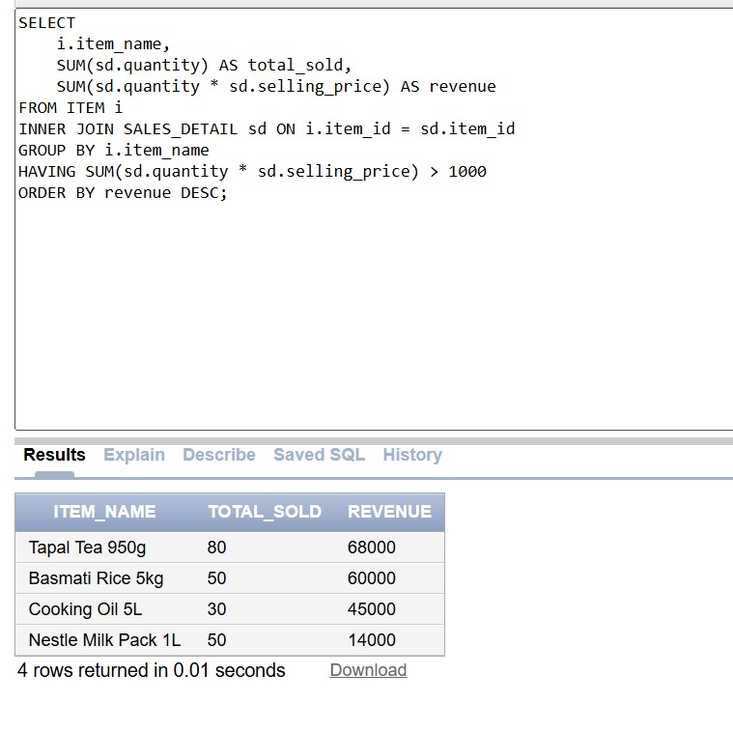

Query 2: Low Stock Alert
Business Question: Which items are below minimum stock?

SELECT w.warehouse_name, i.item_name,
st.quantity AS current_stock,
i.min_stock_level
FROM WAREHOUSE w
INNER JOIN STOCK st ON w.warehouse_id = st.warehouse_id
INNER JOIN ITEM i ON st.item_id = i.item_id
WHERE st.quantity < i.min_stock_level
ORDER BY st.quantity;
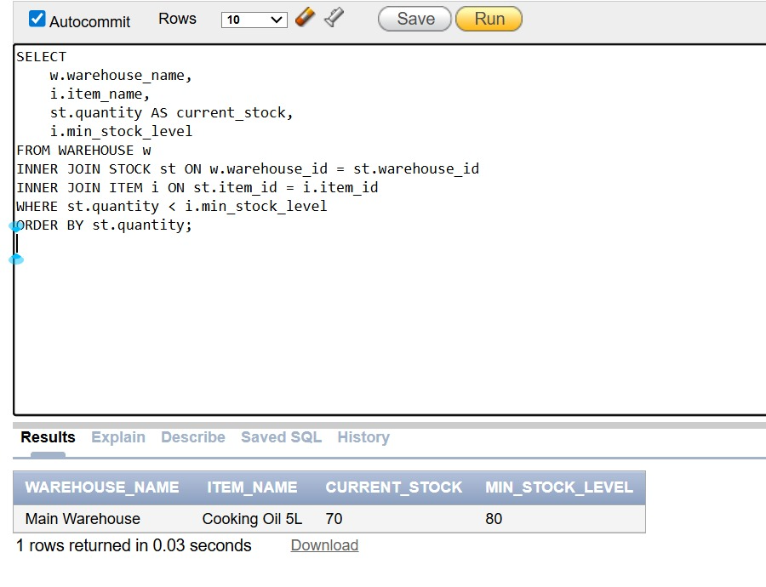

Query 3: Top Customers
Business Question: Who are our best customers?

SELECT cu.customer_name, cu.contact,
COUNT(s.sale_id) AS orders,
SUM(s.total_amount) AS spent
FROM CUSTOMER cu
INNER JOIN SALE s ON cu.customer_id = s.customer_id
GROUP BY cu.customer_name, cu.contact
HAVING SUM(s.total_amount) > 5000
ORDER BY spent DESC;
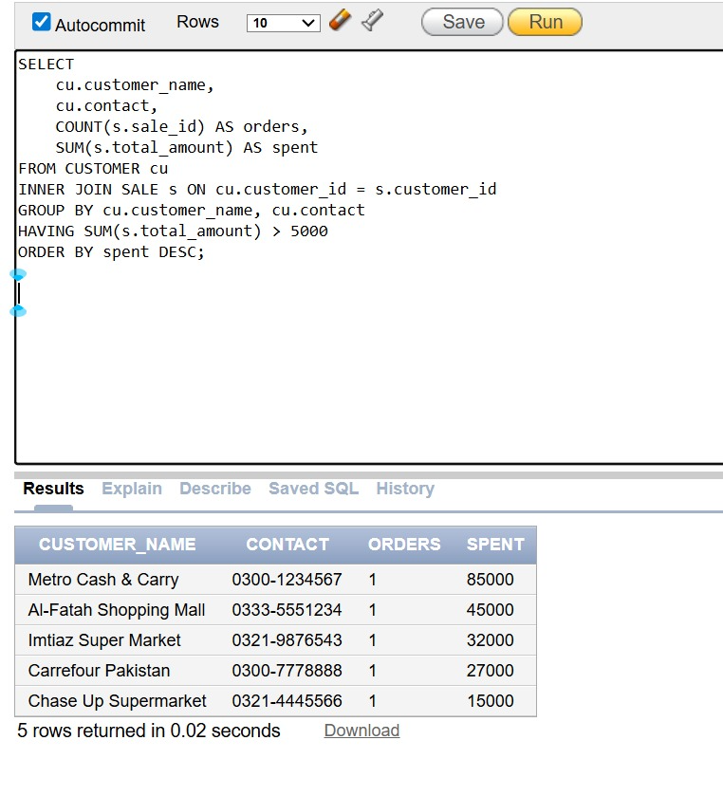

Query 4: Unsold Items
Business Question: Which items never sold?

SELECT i.item_name, i.selling_price, i.description
FROM ITEM i
LEFT JOIN SALES_DETAIL sd ON i.item_id = sd.item_id
WHERE sd.item_id IS NULL
ORDER BY i.selling_price DESC;

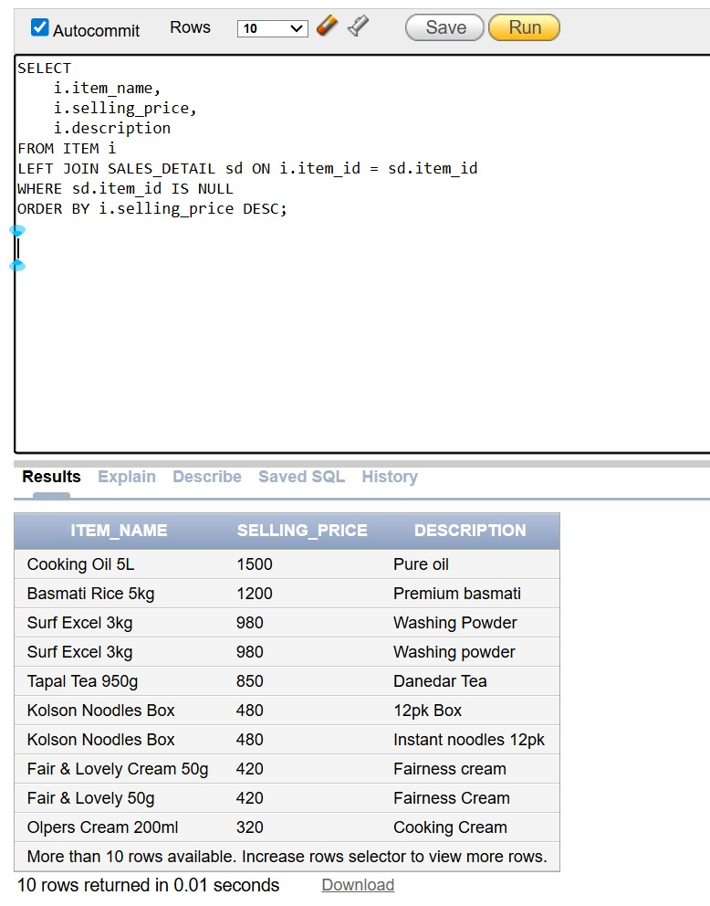

Query 5: Supplier Summary
Business Question: Which supplier supplied the most?

SELECT su.supplier_name, su.contact,
COUNT(p.purchase_id) AS purchases,
SUM(p.total_amount) AS total_value
FROM SUPPLIER su
INNER JOIN PURCHASE p ON su.supplier_id = p.supplier_id
GROUP BY su.supplier_name, su.contact
ORDER BY total_value DESC;

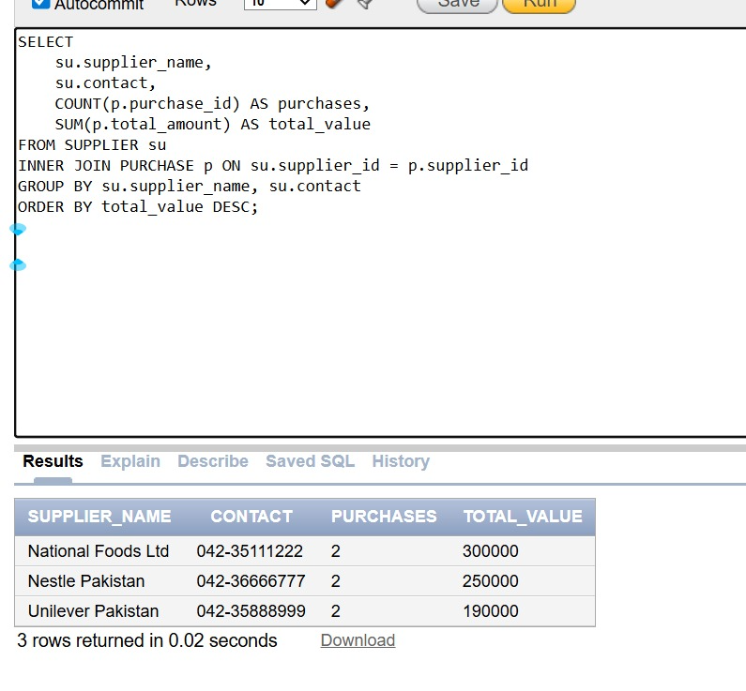

Query 6: Items per Category
Business Question: How many items in each category?

SELECT c.category_name,
COUNT(i.item_id) AS items_count
FROM CATEGORY c
INNER JOIN ITEM i ON c.category_id = i.category_id
GROUP BY c.category_name
HAVING COUNT(i.item_id) > 0
ORDER BY items_count DESC;

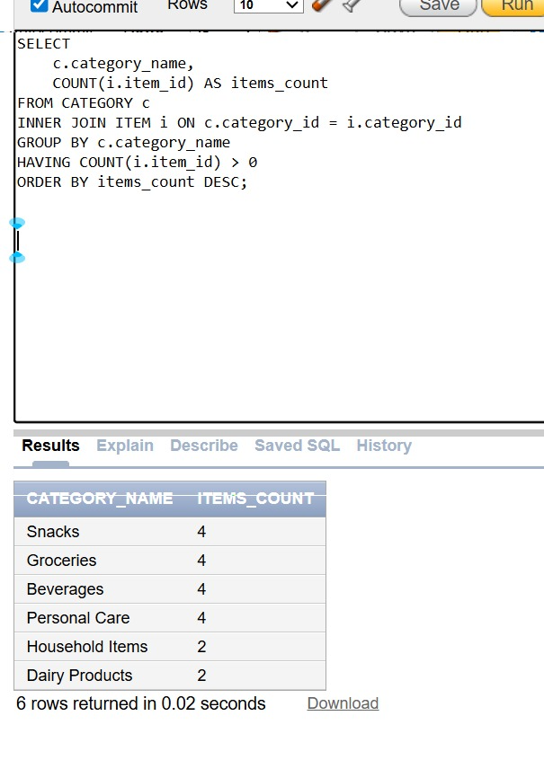

Query 7: Monthly Sales
Business Question: Monthly sales performance?

SELECT TO_CHAR(sale_date, 'Month YYYY') AS month,
COUNT(sale_id) AS sales_count,
SUM(total_amount) AS revenue
FROM SALE
GROUP BY TO_CHAR(sale_date, 'Month YYYY')
ORDER BY MAX(sale_date) DESC;

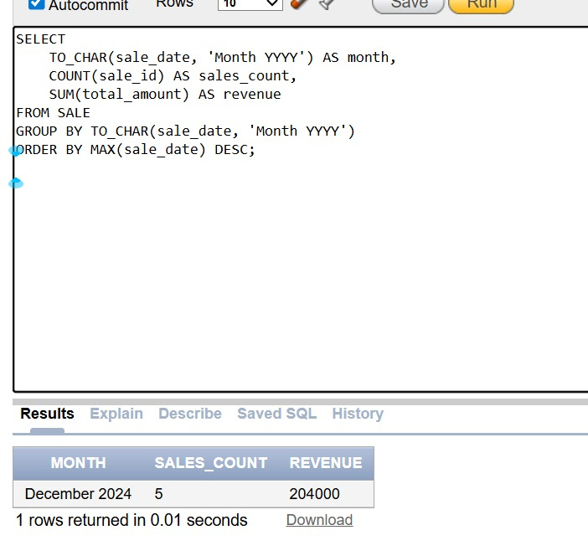

Query 8: Expensive Items
Business Question: Items above category average price?

SELECT i.item_name, i.selling_price,
(SELECT AVG(i2.selling_price)
FROM ITEM i2
WHERE i2.category_id = i.category_id) AS avg_price
FROM ITEM i
WHERE i.selling_price > (
SELECT AVG(i3.selling_price)
FROM ITEM i3
WHERE i3.category_id = i.category_id
)
ORDER BY i.selling_price DESC;

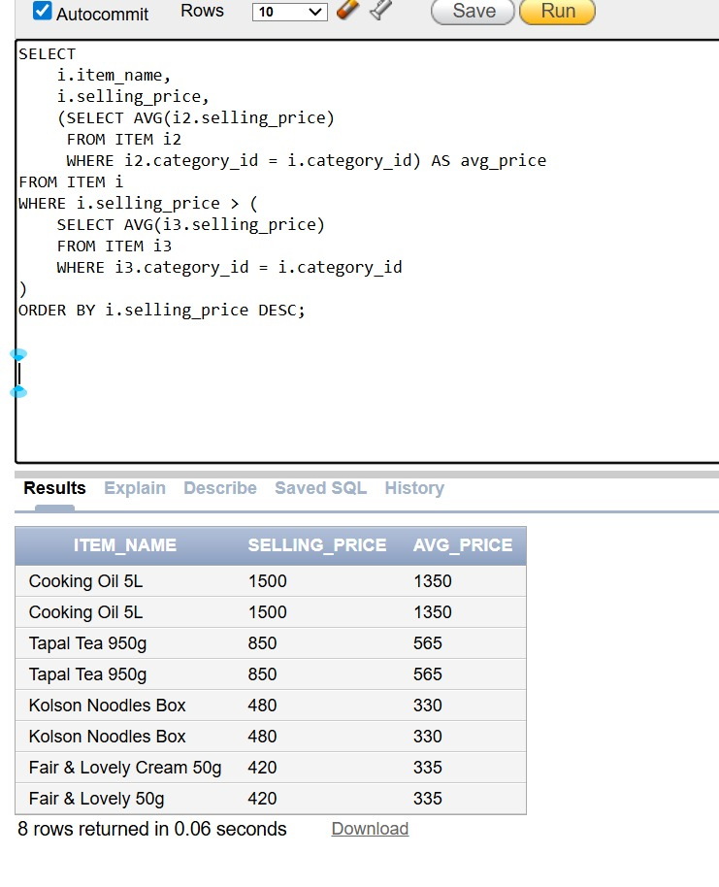

Query 9: Sales vs Purchases
Business Question: Compare sales and purchases?

SELECT 'Sales' AS type, COUNT(*) AS count,
SUM(total_amount) AS value
FROM SALE
UNION ALL
SELECT 'Purchases' AS type,
COUNT(*) AS count,
SUM(total_amount) AS value
FROM PURCHASE
ORDER BY type;
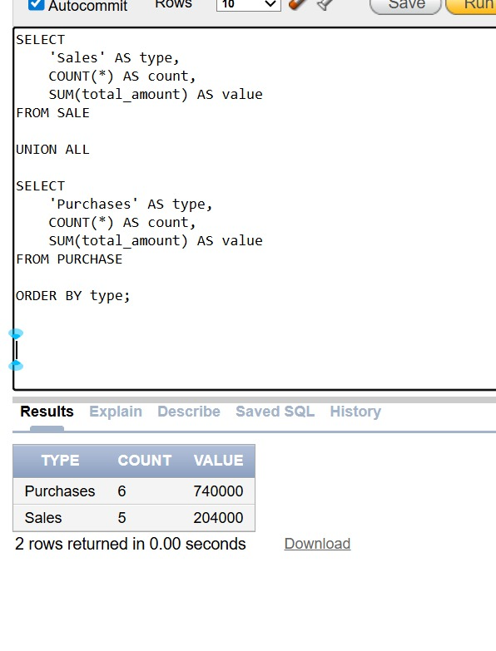

Query 10: Warehouse Stock Value
Business Question: What is warehouse inventory value?

SELECT w.warehouse_name, w.location,
COUNT(st.item_id) AS items,
(SELECT SUM(st2.quantity * i2.selling_price)
FROM STOCK st2
INNER JOIN ITEM i2 ON st2.item_id = i2.item_id
WHERE st2.warehouse_id = w.warehouse_id) AS value
FROM WAREHOUSE w
INNER JOIN STOCK st ON w.warehouse_id = st.warehouse_id
GROUP BY w.warehouse_name, w.location, w.warehouse_id
HAVING COUNT(st.item_id) > 0
ORDER BY value DESC;

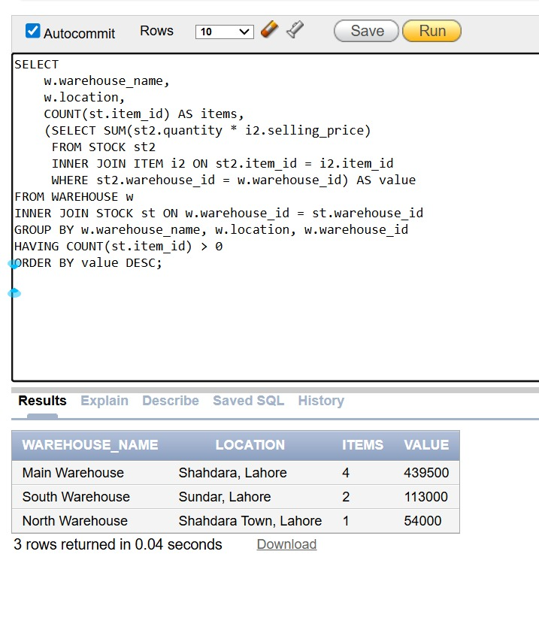

Query 11: Items Need Reorder
Business Question: Which items to reorder?

SELECT i.item_name, i.min_stock_level AS minimum,
NVL(SUM(st.quantity), 0) AS available,
(i.min_stock_level - NVL(SUM(st.quantity), 0)) AS need
FROM ITEM i
LEFT JOIN STOCK st ON i.item_id = st.item_id
GROUP BY i.item_name, i.min_stock_level
HAVING NVL(SUM(st.quantity), 0) < i.min_stock_level
ORDER BY need DESC;

