NATURAL LANGUAGE PROCESSING PORTFOLIO PROJECT

NewsBot Intelligence System
News classification and explainable content intelligence using the BBC News dataset

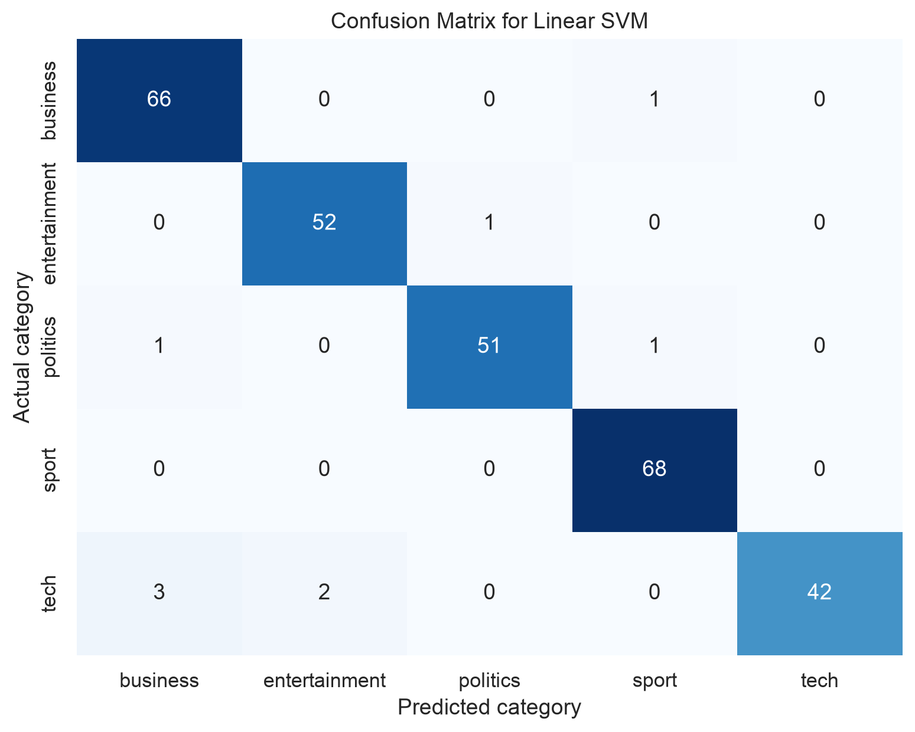
Model evaluation snapshot

Project format | Individual portfolio project
Dataset | BBC News Classification | 1,490 labeled articles
Repository link: add the public GitHub URL after uploading the included ITAI2373-NewsBot-Midterm folder.

Executive Summary
NewsBot is a working natural language processing system that routes full-text news articles to five editorial categories and enriches them with sentiment, named entities, grammatical patterns, syntactic relationships, and interpretable TF-IDF features. On a leakage-controlled held-out test set, the selected Linear SVM achieved 96.9% accuracy and 96.7% macro F1. The result supports fast editorial triage while preserving human-readable evidence about each prediction.

Business Context and Value
Newsrooms, public-relations teams, financial analysts, and media-monitoring operations face a common bottleneck: the volume of incoming reporting grows faster than staff can consistently tag it. Manual categorization is slow and varies between reviewers. NewsBot standardizes the first pass, allowing people to focus on judgment, verification, and response.
User | Decision supported | Practical value
Editorial desk | Where should an article be routed? | Faster triage and consistent taxonomy
Communications analyst | Who and what are being discussed? | Entity tracking and coverage summaries
Business intelligence team | How does tone differ by topic? | Category-level sentiment monitoring
Model reviewer | Why did the model choose this class? | Discriminative terms and error analysis

System Scope
- Preprocess and validate full English news articles.
- Compare three multi-class classifiers using the same stratified holdout.
- Extract TF-IDF, POS, dependency, sentiment, and entity evidence.
- Save a reusable model and integrated inference interface for unseen text.
- Generate reproducible tables and publication-quality charts within free-tier resources.

Data and Preprocessing
The recommended Kaggle BBC News Classification training file contains 1,490 labeled rows with article ID, full article text, and category. It meets the assignment requirements for substantial English-language content, clear labels, at least four categories, and a size below 2,000 records.
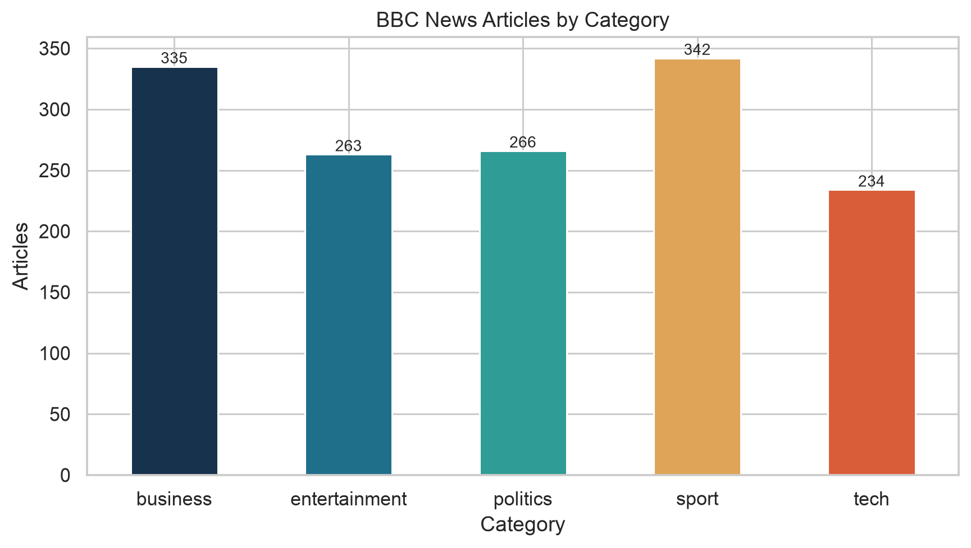
Figure 1. Class distribution after data-quality filtering
Quality check | Result
Source rows | 1,490
Missing text or label | 0
Exact duplicate articles | 50
Analysis rows | 1,440
Mean / median words | 385.5 / 338
Train / test | 1,152 / 288

Preprocessing Design
The pipeline normalizes whitespace, replaces URLs and email addresses with stable tokens, removes unsupported characters, and preserves punctuation plus monetary symbols needed downstream. Exact duplicates are removed before splitting, preventing the same article from appearing in both training and test data. TF-IDF applies English stop-word filtering directly; spaCy supplies tokenization and lemmatization for linguistic analysis. A fixed random seed of 42 and stratification make the evaluation reproducible.

Lexical and Linguistic Analysis

TF-IDF Features
The shared vectorizer uses unigram and bigram features, sublinear term frequency, minimum document frequency of two, a 0.95 maximum document-frequency threshold, and a 20,000-feature limit. This balances interpretability and memory use while retaining phrases that distinguish closely related desks.
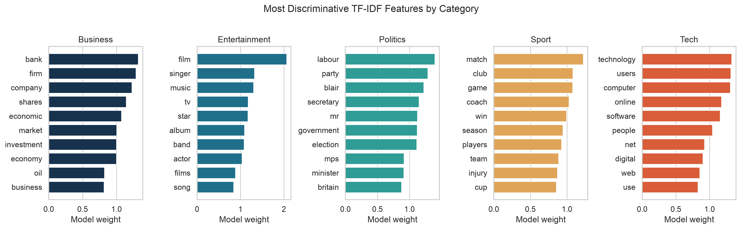
Figure 2. Highest-weight category features in the selected classifier

Part-of-Speech Patterns
A balanced, reproducible sample of 500 articles was processed with spaCy. Proper nouns and common nouns dominate because reporting centers on people, organizations, places, and events. Category-level variation provides a compact writing-style signature without becoming a direct replacement for the classifier.
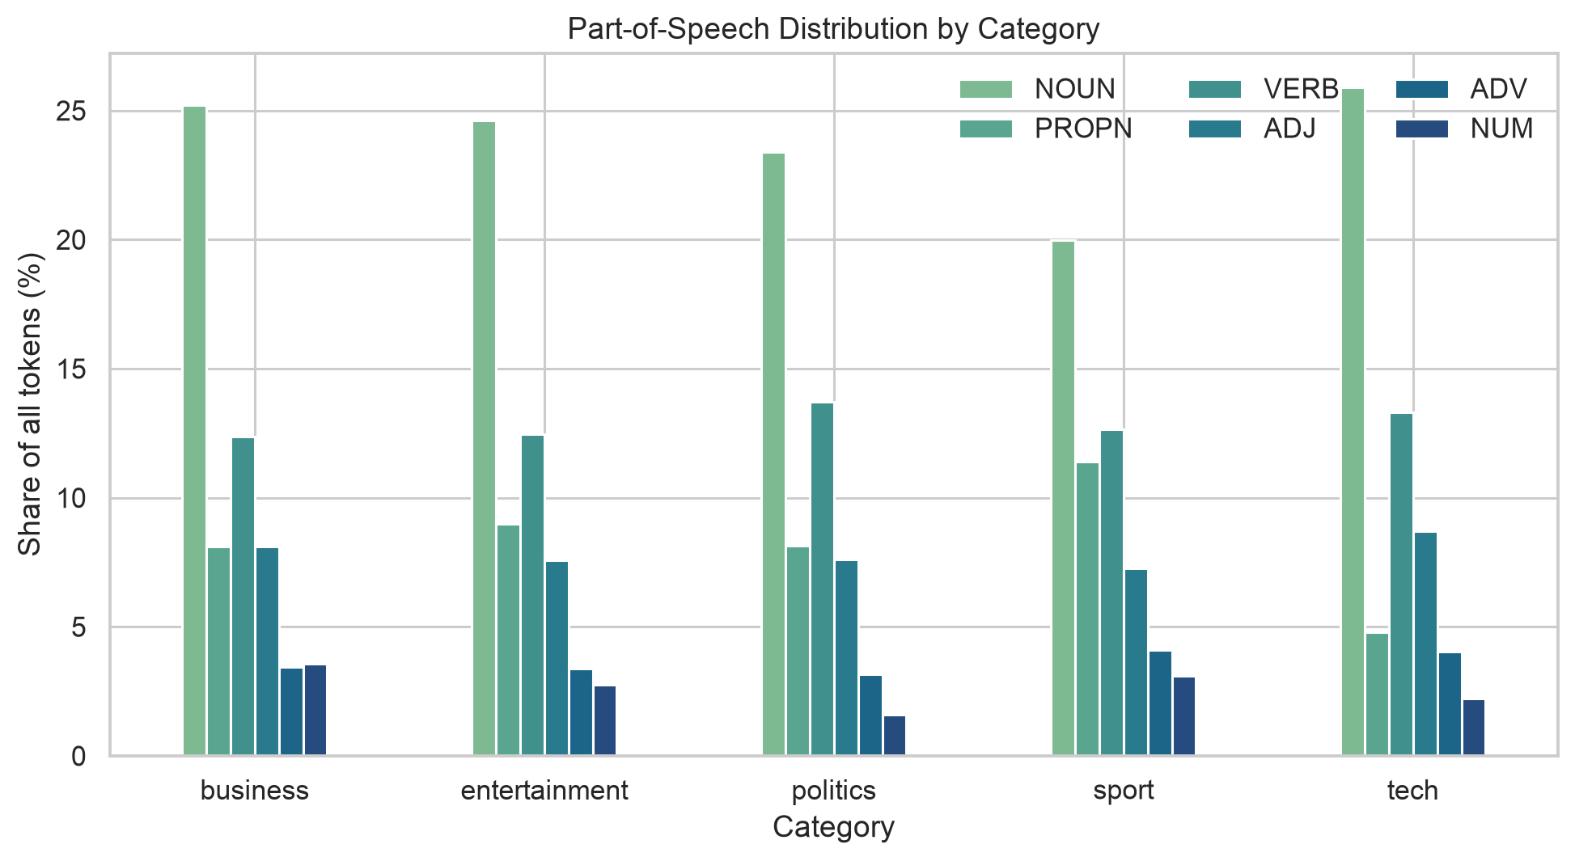
Figure 3. POS share by category in the balanced analysis sample

Syntax and Semantic Structure
Dependency parsing records grammatical subjects, objects, prepositional objects, sentence roots, modifiers, and compounds. These relationships supply a structured view of who acted, what happened, and which concepts modify one another. For a new article, the integrated interface returns each key token, its dependency label, and its governing head.
Feature | Interpretation | Example use
nsubj | Grammatical subject | Identify the actor attached to a reporting verb
ROOT | Main sentence predicate | Summarize the central action or state
dobj / pobj | Direct or prepositional object | Capture targets, instruments, or contextual objects
amod | Adjectival modifier | Describe evaluative or identifying language
compound | Multi-token concept | Preserve phrases such as interest rate or mobile phone

Named Entities
The system extracts PERSON, ORG, GPE, DATE, and MONEY entities. This structured layer enables monitoring beyond topic labels: organizations can track stakeholders, locations, timelines, and financial references. Counts below use the same balanced 500-article sample as the POS analysis.
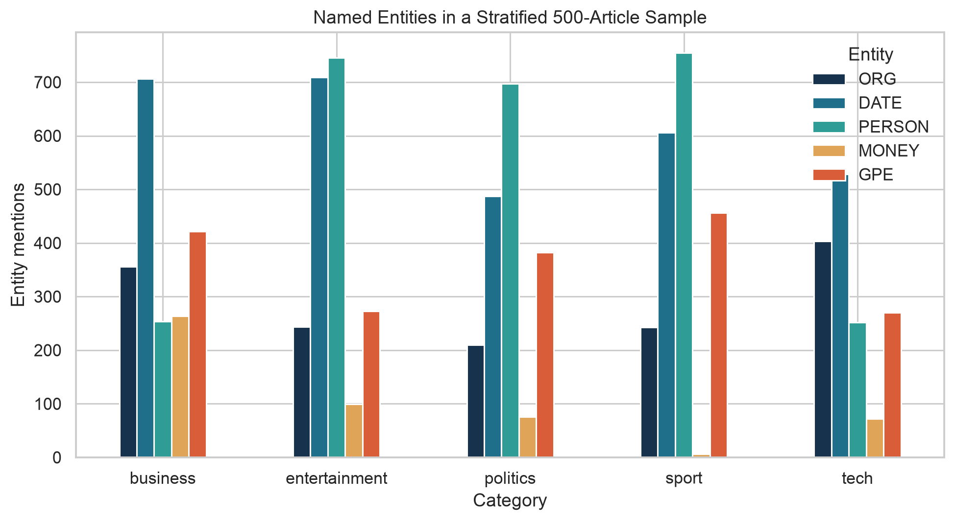
Figure 4. Named-entity mentions by category

Sentiment and Emotional Tone
VADER assigns a compound score from -1 to +1 for each article. Entertainment, sport, and tech show the most positive average lexical tone, while politics is closest to neutral. This does not mean those categories are objectively positive or negative; the score reflects word choice and punctuation, including quoted language.
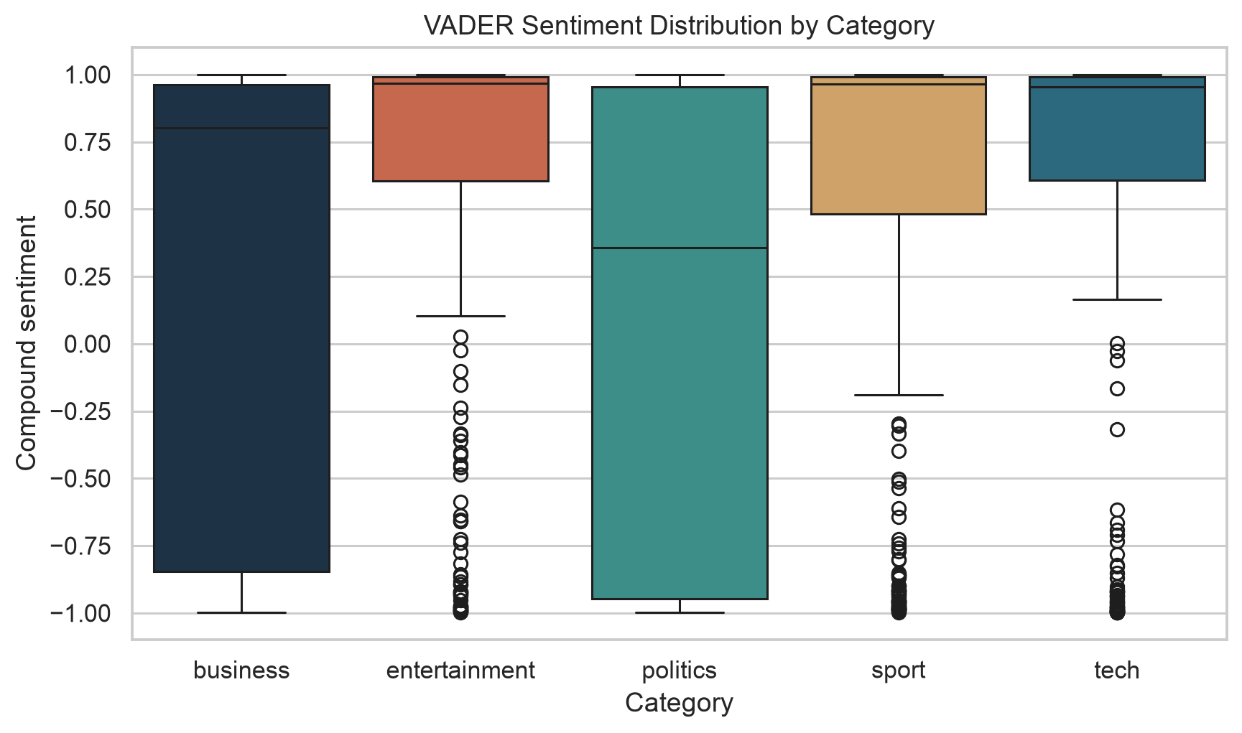
Figure 5. Article-level VADER sentiment distributions
Category | Mean | Median | Std. dev.
Business | 0.238 | 0.802 | 0.837
Entertainment | 0.590 | 0.968 | 0.687
Politics | 0.049 | 0.356 | 0.881
Sport | 0.549 | 0.966 | 0.727
Tech | 0.533 | 0.955 | 0.748

Interpretation Guardrail
Sentiment is a monitoring signal, not a factual judgment. News articles often quote conflicting speakers, use domain-specific terms, or describe negative events in neutral language. Production users should review source text before acting on a score and should validate the lexicon against their own news stream.

Classification Evaluation
Three supervised algorithms were evaluated on the same 20% stratified holdout. Accuracy measures overall correctness; macro F1 averages class-level F1 scores so every category contributes equally. Linear SVM ranked first on macro F1 and was saved as the production candidate.
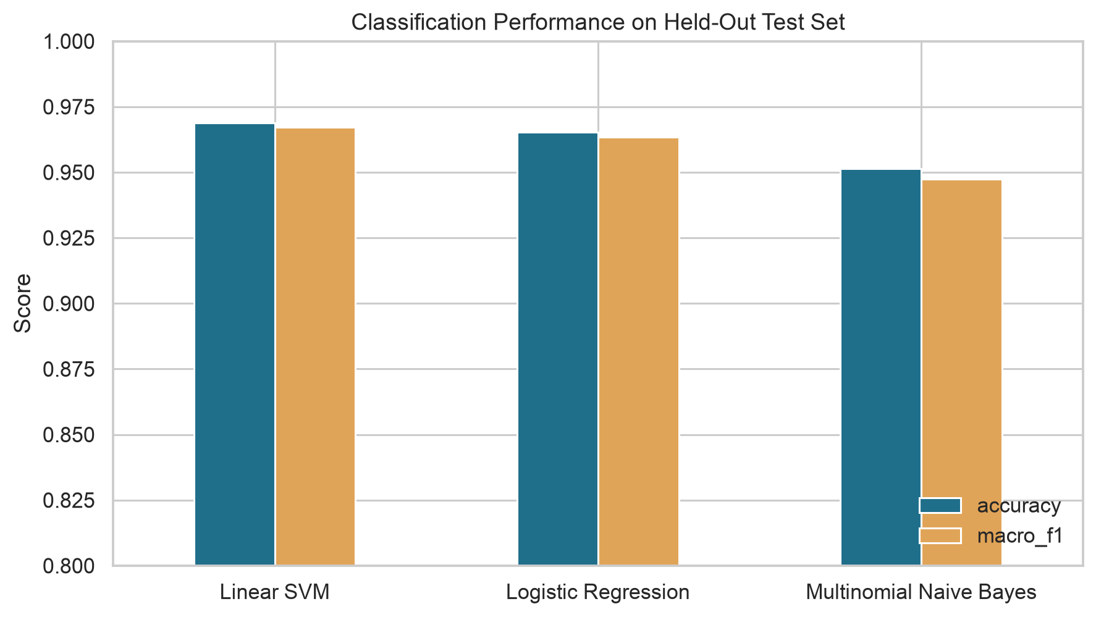
Figure 6. Held-out comparison across three algorithms
Model | Accuracy | Macro F1
Linear SVM | 0.969 | 0.967
Logistic Regression | 0.965 | 0.963
Multinomial Naive Bayes | 0.951 | 0.947

Classification Error Analysis
Figure 7. Linear SVM confusion matrix on 288 unseen test articles
The remaining errors are sparse rather than concentrated in one weak category. The classifier therefore offers useful consistency across all five desks, though errors between business, politics, and tech remain plausible when an article spans policy, markets, and technology.

Integrated System and Portfolio Delivery
The final `NewsBot` interface accepts raw article text and returns a predicted category, compound sentiment and label, named entities, POS counts, and key dependency relationships. The model artifact, notebook, pipeline, charts, result tables, dataset, and report are organized in a clean repository folder. Running `python newsbot_pipeline.py` rebuilds the complete analysis; the notebook provides a guided Colab-compatible walkthrough.
Module | Implementation | Saved evidence
1 Context | Editorial routing and media intelligence use case | README and report
2 Preprocessing | Noise normalization, validation, duplicate control | Prepared article analysis
3 TF-IDF | Optimized unigram and bigram vectors | Term tables and weights
4 POS | spaCy category distributions | POS chart and CSV
5 Syntax | Dependency relations and inference output | Dependency distribution CSV
6 Sentiment | VADER article and category scores | Sentiment chart and CSV
7 Classification | NB, logistic regression, Linear SVM | Metrics, matrix, model
8 NER | PERSON, ORG, GPE, DATE, MONEY | Entity chart and CSV

Business Recommendations
- Use automated category routing as a first-pass queue, with human override.
- Track confidence and error rates by publisher and over time to detect domain drift.
- Combine entity frequency with category and sentiment to surface emerging stakeholders.
- Retrain on newer, multi-source articles before using the model outside BBC-style reporting.

Limitations Future Work and Reflection

Limitations
The dataset represents one publisher and a limited historical period, so strong holdout performance does not prove performance on modern or multi-source news. The labels describe broad topics and do not cover health, science, local reporting, or hybrid stories. Linear SVM scores are not calibrated probabilities. VADER and the small spaCy model can miss domain-specific tone, nested entities, and ambiguous names.

Future Enhancements
- Add calibrated confidence and an abstain-to-human threshold.
- Evaluate on a time-separated, multi-publisher test set and report drift.
- Introduce multilabel classification for cross-desk articles.
- Build an interactive Streamlit dashboard for article entry and trend exploration.
- Fine-tune entity rules for public companies, products, and policy programs.

Individual Project Reflection
Completing every module as one individual project required treating integration as a design problem rather than a collection of disconnected exercises. The most important decision was to keep one validated article representation and one reproducible sampling strategy while allowing each task to use the representation it needed. TF-IDF benefited from normalized text and built-in stop-word filtering; sentiment needed punctuation; POS, dependencies, and NER needed the original grammatical structure. Separating these paths prevented preprocessing choices for one module from weakening another.
The duplicate check also changed the evaluation from a classroom demonstration into a more defensible portfolio result. Removing 50 repeated articles before splitting reduced leakage risk. Comparing all models on the same holdout and selecting by macro F1 made the conclusion easy to audit. I would next focus on external validation and monitoring rather than chasing a slightly higher score on the same source.

Professional Development Impact
This project demonstrates that I can move from a business question to a maintainable NLP pipeline, evaluate alternatives, interpret linguistic outputs, and communicate limits alongside results. The repository is designed so an employer or instructor can reproduce the analysis, inspect evidence, and test new text without reading every implementation detail first.

References and Reproducibility
Kaggle. BBC News Classification competition dataset. https://www.kaggle.com/competitions/learn-ai-bbc/data
Pedregosa, F., et al. (2011). Scikit-learn: Machine Learning in Python. Journal of Machine Learning Research, 12, 2825-2830.
Hutto, C. J., & Gilbert, E. (2014). VADER: A parsimonious rule-based model for sentiment analysis of social media text. Proceedings of ICWSM.
Explosion. spaCy industrial-strength natural language processing documentation. https://spacy.io/
Manning, C. D., Raghavan, P., & Schütze, H. (2008). Introduction to Information Retrieval. Cambridge University Press.

Reproduction Checklist
- Install dependencies from requirements.txt and download en_core_web_sm.
- Run newsbot_pipeline.py from the repository root.
- Confirm summary.json reports 1,440 analysis rows and random seed 42.
- Confirm Linear SVM accuracy is 0.96875 on the 288-article holdout.
- Open the notebook to review narrative, charts, and integrated inference.

Repository Note
A public URL cannot exist until the included folder is uploaded to the author's GitHub account. After upload, replace the repository-link line on the cover with the working URL required by the assignment.

