Literature Survey Report

Problem Statement: Passive Sonar-Based Classification of Aquatic Animals, Enemy Ships, and Surface Objects Using Machine Learning and Deep Learning Techniques

Abstract

Underwater target classification plays a critical role in naval surveillance, marine ecosystem monitoring, underwater robotics, and defense applications. Passive sonar systems are widely employed for underwater target detection because they operate by listening to naturally occurring acoustic signals without transmitting sound waves, making them difficult to detect. The objective of this project is to develop an intelligent classifier capable of distinguishing among aquatic animals, enemy ships, and surface objects such as rocks using passive sonar signals.
This literature survey presents a comprehensive review of passive sonar technology, underwater acoustic signal processing techniques, classical machine learning methods, modern deep learning architectures, transfer learning approaches, and publicly available datasets relevant to underwater acoustic target recognition. The survey also identifies existing research gaps and proposes a suitable architecture for developing a robust multi-class passive sonar classification system.

1. Introduction

1.1 Overview of Passive Sonar

Sonar (Sound Navigation and Ranging) systems are extensively used for underwater detection, navigation, and target recognition. Sonar systems are broadly categorized into Active Sonar and Passive Sonar.
Active Sonar
Active sonar systems transmit acoustic pulses into the water and analyze the reflected echoes received from surrounding objects. The transmitted signal interacts with underwater targets and returns to the receiver, enabling target localization and identification.
Passive Sonar
Passive sonar systems operate solely by receiving and analyzing acoustic signals naturally emitted by underwater sources. These sources include vessel engines, propeller cavitation noise, marine animal vocalizations, and environmental sounds. Since passive sonar systems do not emit detectable signals, they provide significant tactical advantages in military and surveillance applications.
Passive sonar technology is widely employed in submarines, torpedoes, naval surveillance systems, and underwater monitoring platforms due to its covert operational capability.
1.2 Problem Statement

The underwater environment contains a diverse range of acoustic sources whose signatures often overlap in frequency and time domains. Accurate classification of underwater acoustic targets remains a challenging task because of environmental noise, signal attenuation, multipath propagation, and variability in target-generated sounds.
The proposed classification system aims to distinguish among three major categories:
Aquatic Animals
Marine organisms such as whales, dolphins, and fish generate biological acoustic signals characterized by varying frequencies, temporal patterns, and vocalization structures.
Enemy Ships
Military vessels, submarines, and surface ships produce mechanical acoustic signatures generated by engines, propulsion systems, and propeller cavitation.
Surface Objects (Rocks)
Unlike ships and marine animals, rocks do not generate acoustic signals independently. Their identification relies on analyzing reflected acoustic characteristics and environmental interaction patterns captured by sonar systems.
The ability to accurately classify these targets using passive sonar data is essential for both defense and marine monitoring applications.
2. Underwater Acoustic Signal Processing Techniques

Before applying machine learning algorithms, raw sonar signals must be transformed into meaningful feature representations. Signal processing techniques play a crucial role in extracting discriminative characteristics from underwater acoustic data.

2.1 LOFAR (Low Frequency Analysis and Recording)

LOFAR is one of the most widely used signal analysis techniques in passive sonar systems. It generates a two-dimensional representation known as a LOFARGRAM, which illustrates frequency power variations over time.
LOFAR analysis is extensively used for:
- Underwater target detection
- Vessel tracking
- Acoustic target classification
- Feature extraction for machine learning models
LOFARGRAMs effectively capture spectral signatures associated with ship machinery noise and propulsion systems.
Reference: Clausius Press
2.2 DEMON (Detection of Envelope Modulation on Noise)

DEMON analysis is specifically designed to extract propeller-related information from underwater acoustic signals.
Ship propellers generate cavitation bubbles that produce periodic noise patterns. These modulation characteristics are unique to specific vessels and therefore serve as reliable target identifiers.
Key advantages include:
- Propeller blade rate estimation
- Vessel identification
- Enhanced target discrimination
DEMON analysis is frequently combined with LOFAR processing to improve underwater target recognition performance.
Reference: InTechOpen
2.3 Mel-Frequency Cepstral Coefficients (MFCC)

MFCCs are among the most commonly used feature extraction techniques in audio and speech processing. They provide a compact representation of acoustic signals while preserving important spectral information.
In underwater acoustic target recognition, MFCCs are utilized to:
- Reduce feature dimensionality
- Capture frequency characteristics
- Improve classification performance
Several studies have demonstrated the effectiveness of MFCC features when combined with deep neural networks such as ResNet architectures.
Reference: MDPI
2.4 Spectrogram-Based Time-Frequency Analysis

Spectrograms represent signal energy distribution across frequency and time dimensions.
Recent deep learning approaches employ spectrograms as image-like inputs for convolutional neural networks. Time-frequency representations enable neural networks to learn complex spectro-temporal patterns associated with different underwater targets.
Spectrogram-based analysis has become one of the most successful approaches in modern underwater acoustic classification systems.
Reference: MDPI

3. Classical Machine Learning Approaches

Prior to the widespread adoption of deep learning, underwater target classification primarily relied on handcrafted feature extraction methods combined with conventional machine learning algorithms.
3.1 UCI Sonar Benchmark Dataset
One of the earliest and most influential datasets in sonar classification research is the UCI Connectionist Bench (Sonar, Mines vs. Rocks) dataset developed by Gorman and Sejnowski in 1988.
Dataset characteristics:
- 208 samples
- 60 frequency-band energy features
- 111 mine samples
- 97 rock samples
The classification objective is to distinguish between sonar signals reflected from metallic objects and naturally occurring rocks.
This dataset remains a benchmark for evaluating sonar classification algorithms.
Dataset Link:
https://archive.ics.uci.edu/dataset/151/connectionist+bench+sonar+mines+vs+rocks
3.2 Support Vector Machines (SVM)

Support Vector Machines were widely adopted for underwater acoustic target classification because of their ability to handle high-dimensional feature spaces.
Advantages:
- Strong performance on small datasets
- Effective decision boundaries
- Robust generalization capabilities
However, their effectiveness depends heavily on manually engineered features.
3.3 Expert Systems and Traditional Neural Networks
Early research introduced expert systems that incorporated domain knowledge into rule-based classification frameworks.
Although these systems provided initial success, they lacked adaptability and struggled under varying environmental conditions.
Subsequent neural network models improved classification capabilities but remained limited by shallow architectures and handcrafted feature dependencies.
Reference: ArXiv
4. Deep Learning Approaches
The emergence of deep learning has significantly improved underwater acoustic target recognition by enabling automatic feature extraction directly from data.
4.1 Convolutional Neural Networks (CNN)
CNNs have become the dominant architecture for sonar classification tasks.
Typical workflow:
- Convert acoustic signals into spectrograms, LOFARGRAMs, or DEMONGRAMs.
- Use CNN layers for hierarchical feature extraction.
- Apply fully connected layers and Softmax classification.
Research demonstrates classification accuracies exceeding 95% using CNN-based systems.
A notable architecture, Audio Perspective Region-based CNN (APRCNN), achieved 98.4% classification accuracy under low signal-to-noise conditions.
References: IIETA, Academia.edu, ResearchGate
4.2 CNN-LSTM Hybrid Models
CNNs effectively learn spatial representations but are less effective in modeling temporal dependencies.
Hybrid CNN-LSTM architectures address this limitation by:
- Using CNNs for spatial feature extraction
- Using LSTMs for temporal sequence modeling
These architectures have shown strong performance on challenging and imbalanced underwater acoustic datasets.
References: NIH, MDPI
4.3 Residual Networks and Attention Mechanisms
Deep Residual Attention CNN (DRACNN) integrates:
- Residual learning
- Attention mechanisms
- Deep feature extraction
The architecture achieved approximately 97.1% recognition accuracy on the ShipsEar dataset while maintaining low computational complexity.
Reference: MDPI
4.4 Time Delay Neural Networks (TDNN)
TDNN architectures model temporal relationships within acoustic sequences.
Recent studies incorporating histogram layers and statistical context modeling have demonstrated improved passive sonar target recognition performance.
Reference: ArXiv 2307.13788
4.5 Transformer-Based Models
Transformer architectures have recently gained attention for underwater acoustic classification.
Lightweight transformer-based models inspired by MobileViT and GhostNet have achieved classification accuracies exceeding 98% on benchmark datasets while maintaining relatively low parameter counts.
Reference: ResearchGate

5. Transfer Learning Approaches

5.1 Image-Based Transfer Learning
Spectrograms and LOFARGRAMs can be treated as images and processed using pre-trained computer vision models such as:
- AlexNet
- VGGNet
- ResNet
- EfficientNet
These models leverage knowledge learned from ImageNet and can be fine-tuned for sonar classification tasks.
Studies report classification accuracies above 95% using transfer learning approaches.
References: ArXiv, MDPI
5.2 Audio-Based Transfer Learning
Recent research explores transferring knowledge from large-scale speech models to underwater acoustic target recognition.
The UATR-SLM framework demonstrates that representations learned from human speech data can be successfully adapted to underwater acoustic environments.
Reference: ArXiv 2025
5.3 Cross-Domain Transfer Learning
Cross-dataset transfer learning has also shown promising results.
For example, DRACNN models trained on ShipsEar have been successfully adapted to DeepShip data, demonstrating strong generalization capabilities across datasets.
Reference: MDPI

6. Publicly Available Datasets
A major challenge in underwater acoustic target recognition is the limited availability of publicly accessible labeled datasets.
Dataset 1: UCI Sonar Mines vs. Rocks
- 208 samples
- 60 numerical features
- Binary classification (Mine vs. Rock)
Link:
https://archive.ics.uci.edu/dataset/151/connectionist+bench+sonar+mines+vs+rocks
Dataset 2: ShipsEar Dataset
- Real-world vessel recordings
- 11 vessel types
- 5-class classification benchmark
- 2,223 processed samples
Reference:
Applied Acoustics, 2016
Dataset 3: DeepShip Dataset
- 47 hours of underwater recordings
- 265 vessels
- Four vessel categories:
  - Cargo ships
  - Passenger ships
  - Oil tankers
  - Tugboats
One of the most comprehensive underwater acoustic datasets currently available.
Reference:
Expert Systems with Applications, 2021
Dataset 4: Processed DeepShip and ShipsEar Dataset
Available through IEEE DataPort.
Characteristics:
- Sampling rate: 16 kHz
- 11,270 audio segments
- Five target categories
- Total duration: 3.13 hours
Link:
https://ieee-dataport.org/documents/processed-deepships-dataset-and-shipsear-dataset
7. Comprehensive Survey Papers
Survey 1
Deep Learning for Underwater Sonar Classification
Published in Sensors (MDPI), 2022
The survey categorizes deep learning approaches into:
- CNN-based methods
- Biologically inspired preprocessing
- Time-frequency analysis methods
- Raw signal learning
- Transfer learning approaches
Survey 2
Machine Learning Methods for Underwater Acoustic Target Recognition
Published in Journal of Marine Science and Engineering, 2023
The survey discusses:
- Statistical learning methods
- Deep learning architectures
- Transfer learning approaches
- Acoustic feature extraction techniques
Survey 3
Sonar-Based Deep Learning in Underwater Robotics
Published in ArXiv, 2024
The review evaluates major sonar datasets and discusses current challenges in underwater target recognition.

8. Research Gaps

Despite significant progress, several limitations remain:
- Most existing studies focus on ship-type classification or mine-versus-rock classification.
- Very few studies attempt simultaneous classification of biological, mechanical, and natural underwater targets.
- Unified passive sonar classification systems capable of recognizing aquatic animals, enemy ships, and rock-like structures remain largely unexplored.
- The integration of marine biological acoustics with naval acoustic target recognition represents an important research opportunity.

9. Proposed System Architecture
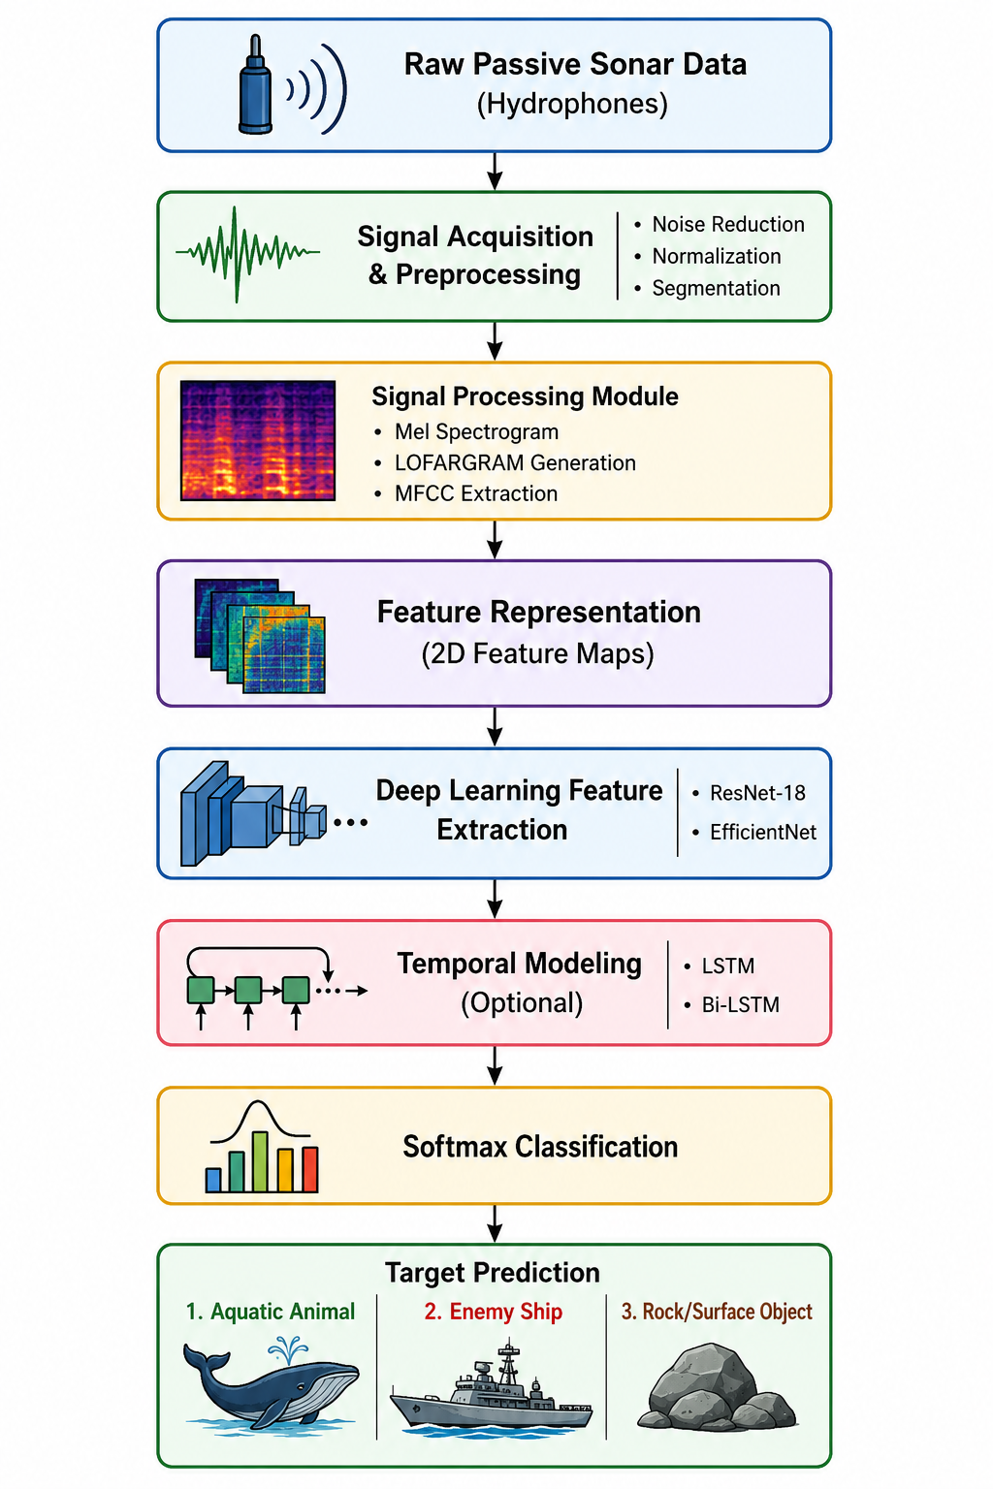
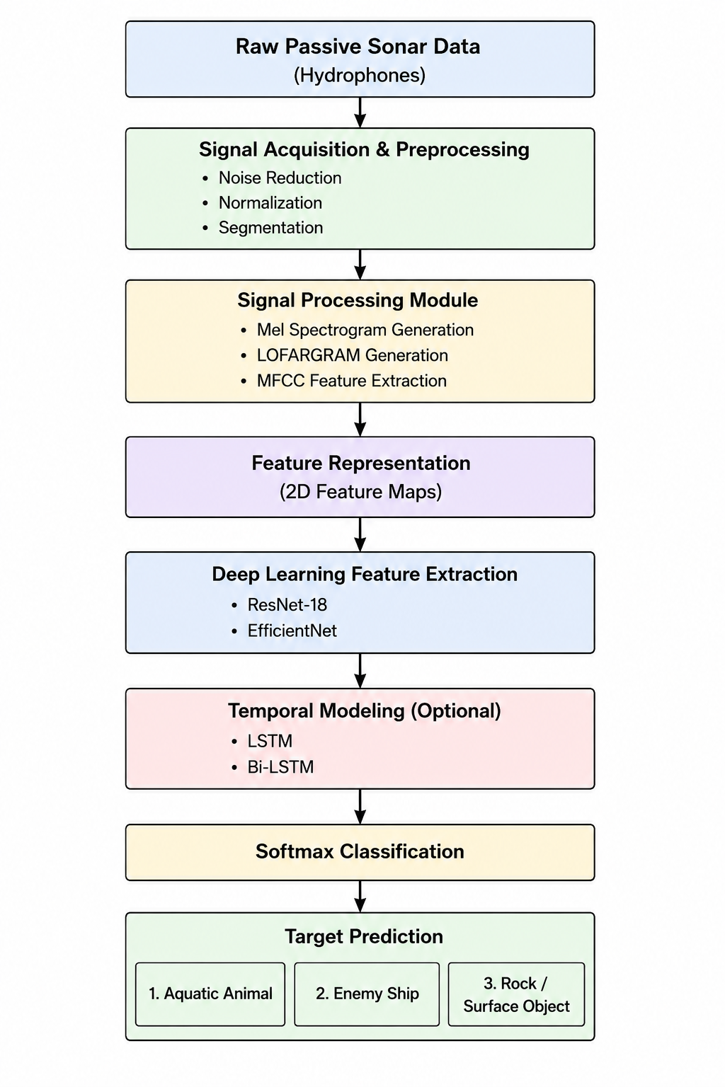
Based on the reviewed literature, the following architecture is proposed for the project:

10. Conclusion

This literature survey demonstrates that passive sonar-based underwater target classification has evolved significantly from traditional feature-engineering approaches to advanced deep learning frameworks. Contemporary methods primarily rely on time-frequency representations such as spectrograms, LOFARGRAMs, and MFCC features combined with CNN-based architectures. Transfer learning from pre-trained image and audio models has further improved classification performance in scenarios with limited labeled data.
The proposed project seeks to address an important research gap by developing a unified passive sonar classification system capable of simultaneously recognizing aquatic animals, enemy ships, and rock or surface objects. By integrating publicly available datasets, advanced signal processing techniques, and state-of-the-art deep learning architectures, the project aims to contribute toward intelligent underwater acoustic target recognition systems for both defense and environmental monitoring applications.

References
- Deep Learning for Underwater Sonar Classification, Sensors (MDPI), 2022.
- DeepShip: An Underwater Acoustic Benchmark Dataset, Expert Systems with Applications, 2021.
- A Survey of Underwater Acoustic Target Recognition Methods Based on Machine Learning, Journal of Marine Science and Engineering, 2023.
- Underwater Acoustic Target Recognition Based on Deep Residual Attention CNN (DRACNN), Journal of Marine Science and Engineering, 2023.
- Connectionist Bench (Sonar, Mines vs. Rocks), Gorman & Sejnowski, 1988.
- APRCNN: Feature Extraction of Underwater Acoustic Signal Target Using Machine Learning, IIETA, 2024.

