CO1_AT1

Q17. Application: Hierarchical Tree Query Engine
A tree-processing engine reduces the problem size by half at each recursive level and
performs logarithmic work for query evaluation. Apply the substitution method to solve the recurrence T(n)=T(n/2)+log⁡n. Expand the relation step-by-step and explain the recursion depth. Derive the final asymptotic complexity and analyze its scalability. Interpret the result using asymptotic notation.

Aim
To analyze the recurrence relation of a hierarchical tree query engine using the substitution method, determine the recursion depth, derive the asymptotic time complexity, and evaluate its scalability.

Problem Statement
A hierarchical tree-processing engine reduces the problem size by half at every recursive level and performs logarithmic work for query evaluation.
The recurrence relation is:
T(n) = T(n/2) + log₂(n)
The objective is to expand this recurrence step-by-step using the substitution method and determine its final asymptotic complexity.

Algorithm
- Start with the input size n
- Perform logarithmic work log2(n).
- Reduce the problem size from n to n/2
- Repeat the process recursively.
- Continue until the problem size becomes 1.
- Count the number of recursive levels.
- Sum the logarithmic work performed at each level.
- Determine the final asymptotic complexity.

Program:
import math
n = 16
print("======================================")
print(" HIERARCHICAL TREE QUERY ENGINE")
print("======================================")

print("\nRecurrence:")
print("T(n) = T(n/2) + log2(n)")

current = n
level = 0
total_work = 0

print("\nStep-by-Step Expansion:")
print("-----------------------")

while current > 1:
log_value = math.log2(current)
next_value = current / 2

total_work += log_value

print(
"Level", level,
": T(", int(current),
") = T(", int(next_value),
") +", round(log_value, 2)
)

current = next_value
level += 1

print("Level", level, ": T(1) = 1")

print("\n======================================")
print(" RESULT")
print("======================================")

print("Input Size :", n)
print("Recursion Depth :", level)
print("Total Work :", round(total_work, 2))

print("\nSubstitution Method:")
print("T(n) = T(n/2) + log2(n)")
print(" = T(n/4) + log2(n/2) + log2(n)")
print(" = T(n/8) + log2(n/4) + log2(n/2) + log2(n)")
print(" = ...")
print(" = T(1) + log2(n) + log2(n/2) + ... + log2(2)")

print("\nComplexity Analysis:")
print("Recursion Depth = O(log n)")
print("Total Time = O((log n)^2)")
print("Final Complexity = Theta((log n)^2)")

Output:

HIERARCHICAL TREE QUERY ENGINE

Recurrence:
T(n) = T(n/2) + log2(n)

Step-by-Step Expansion:
Level 0 : T( 16 ) = T( 8 ) + 4.0
Level 1 : T( 8 ) = T( 4 ) + 3.0
Level 2 : T( 4 ) = T( 2 ) + 2.0
Level 3 : T( 2 ) = T( 1 ) + 1.0
Level 4 : T(1) = 1

RESULT:

Input Size : 16
Recursion Depth : 4
Total Work : 10.0

Substitution Method:
T(n) = T(n/2) + log2(n)
= T(n/4) + log2(n/2) + log2(n)
= T(n/8) + log2(n/4) + log2(n/2) + log2(n)
= ...
= T(1) + log2(n) + log2(n/2) + ... + log2(2)

Complexity Analysis:
Recursion Depth = O(log n)
Total Time = O((log n)^2)
Final Complexity = Theta((log n)^2)

Program Screenshot:
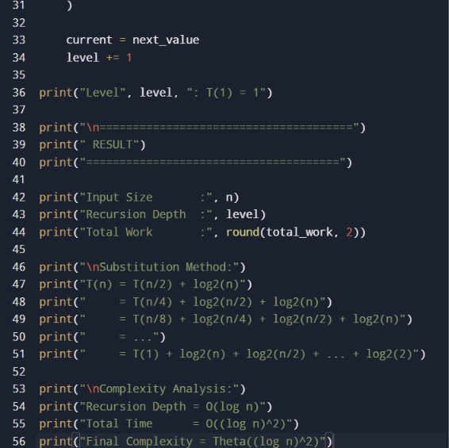

Output Screenshot:
