CO2_AT2

Q18. Debugging Maximum Element (Wrong Comparison Direction)
The following code incorrectly finds the maximum element due to reversed comparison logic. Identify the issue and explain why incorrect results occur. Debug the algorithm step-by-step. Optimize initialization and comparison. Analyze time complexity and rewrite corrected code.
def find_max(arr):
max_val = arr[0]
for i in range(len(arr)):
if arr[i] &lt; max_val: # ERROR
max_val = arr[i]
return max_val

Aim
To identify and correct the logical error in a maximum-element algorithm, debug the program step-by-step, optimize its initialization and comparison, and analyze its time and space complexity.

Problem Statement
The given program is intended to find the maximum element in an array. However, it uses a reversed comparison condition:
if arr[i] < max_val:
This causes the algorithm to update max_val when a smaller element is found. Therefore, the program does not correctly find the maximum element.
The comparison must be corrected to:
if arr[i] > max_val:

Algorithm

Step 1: Start.
Step 2: Store the first array element in max_val.
Step 3: Traverse the array from the second element to the last element.
Step 4: Compare the current element with max_val.
Step 5: If the current element is greater than max_val, update max_val.
Step 6: Continue until all elements are checked.
Step 7: Return max_val as the maximum element.
Step 8: Stop.

Program:

def find_max(arr):
max_val = arr[0]

for i in range(1, len(arr)):
if arr[i] > max_val:
max_val = arr[i]

return max_val
arr = [10, 5, 20, 8, 15]
result = find_max(arr)
print("Array:", arr)
print("Maximum Element:", result)

Output:
Array: [10, 5, 20, 8, 15]
Maximum Element: 20

=== Code Execution Successful ===

Program Screenshot:
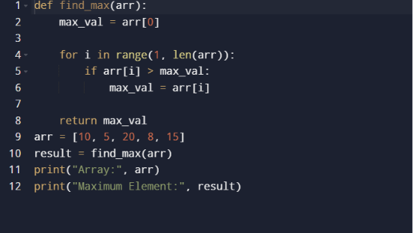

Output Screenshot:
