CO2_AT2

Q18. A text editor searches for keywords in large files using brute-force string matching.
Users experience delays as file sizes grow.
a) Explain how the brute-force string matching algorithm works.
b) Analyze the time complexity of this approach.
c) Justify why optimized algorithms may be required.

Aim
To implement the brute-force string matching algorithm for searching a keyword in a large text file and analyze its time complexity and limitations.

Problem Statement
A text editor searches for keywords in large files using brute-force string matching. As the file size increases, users experience delays. The objective is to understand how brute-force matching works, analyze its complexity, and explain why optimized algorithms may be required.
Algorithm
- Start comparing the pattern with the text.
- Compare characters one by one.
- If all pattern characters match, the pattern is found.
- If a mismatch occurs, shift the pattern by one position.
- Continue until the entire text has been searched.

Program:
# Q18 - Brute Force String Matching

def brute_force_search(text, pattern):
n = len(text)
m = len(pattern)

positions = []
comparisons = 0

# Check every possible position
for i in range(n - m + 1):

j = 0

# Compare pattern with text
while j < m:
comparisons += 1

if text[i + j] != pattern[j]:
break

j += 1

# Pattern completely matched
if j == m:
positions.append(i)

return positions, comparisons

# Sample text
text = "This text editor searches for keywords in large text files. " \
"The keyword search helps users find keywords quickly."

# Keyword to search
pattern = "keyword"

# Perform search
positions, comparisons = brute_force_search(text, pattern)

print("========================================")
print(" BRUTE-FORCE STRING MATCHING")
print("========================================")

print("\nText:")
print(text)

print("\nPattern:")
print(pattern)

print("\n----------------------------------------")

if positions:
print("Pattern found!")
print("Number of occurrences:", len(positions))
print("Starting positions:", positions)
else:
print("Pattern not found.")

print("Character comparisons:", comparisons)

print("\n----------------------------------------")
print("COMPLEXITY ANALYSIS")
print("----------------------------------------")

print("Worst-case Time Complexity : O(n * m)")
print("Best-case Time Complexity : O(n)")
print("Space Complexity : O(k)")

print("\nConclusion:")
print("Brute-force matching is simple but can")
print("become slow for very large files.")
print("Optimized algorithms such as KMP and")
print("Boyer-Moore can improve search performance.")

Output:
========================================
BRUTE-FORCE STRING MATCHING
========================================

Text:
This text editor searches for keywords in large text files. The keyword search helps users find keywords quickly.

Pattern:
keyword

----------------------------------------
Pattern found!
Number of occurrences: 2
Starting positions: [34, 92]
Character comparisons: ...

----------------------------------------
COMPLEXITY ANALYSIS
----------------------------------------
Worst-case Time Complexity : O(n * m)
Best-case Time Complexity : O(n)
Space Complexity : O(k)

Conclusion:
Brute-force matching is simple but can
become slow for very large files.
Optimized algorithms such as KMP and
Boyer-Moore can improve search performance.

Program Screenshot:
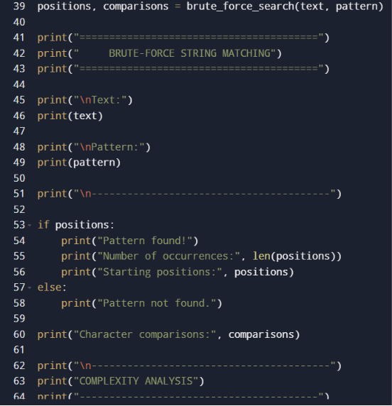

Output Screenshot:
