# DATE:

# EXPERIMENT-6

**IMPLEMENTATION OF TREE TOPOLOGY USING PACKET TRACER**

**Aim:** To Implement a tree topology using packet tracer and hence to transmit data between the devices connected using tree topology.

**Software / Apparatus required:** Packet Tracer / End devices, Hubs, connectors.

**Procedure:**

**Steps for building topology:**

**Step 1: Start Packet Tracer**

**Step 2: Choosing Devices and Connections Step 3: Building the Topology – Adding Hosts**  Single click on the **End Devices**.

Single click on the **Generic** host.

Move the cursor into topology area.

Single click in the topology area and it copies the device.

**Step 4: Building the Star Topology – Connecting the Hosts to Hubs**

Select a Hub, by clicking once on **Hub** and once on a **generic Hub**

Add the Hub by moving the plus sign “**+**”

**Step 5: Connect PCs to Hub by first choosing Connections**

Click once on the **Automatic cable selector**

Click once on **PC2**

Choose **Fast Ethernet**

Drag the cursor to **Hub0**

Click once on **Hub0**

**Proceeding in this way create three star topologies**

**Step 6: Building the Tree Topology – Connecting the Hubs to Active Hub**

Connect the hubs of star topologies to active hub to create tree topology.

**Step 7: Configuring IP Addresses and Subnet Masks on the Hosts**

To start communication between the hosts IP Addresses and Subnet Masks had to be configured on the devices. Click once on PC0. Choose the Config tab and click on Fast

automatically.

**Step 8: Verifying Connectivity in Real time Mode** Be sure you are in **Real time** mode.

Select the **Add Simple PDU** tool used to ping devices.

Click once on PC0, then once on PC3.

The PDU **Last Status** should show as **Successful**.

Step 9: **Verifying Connectivity in Simulation Mode** Be sure you are in **Simulation** mode.

Deselect all filters (All/None) and select only **ICMP**. Select the **Add Simple PDU** tool used to ping devices Click once on PC0, then once on PC3.

Continue clicking **Capture/Forward** button until the ICMP ping is completed. You should see the ICMP messages move between the hosts, hub and switch. The PDU **last status** should show as **Successful**.

**OUTPUT:**

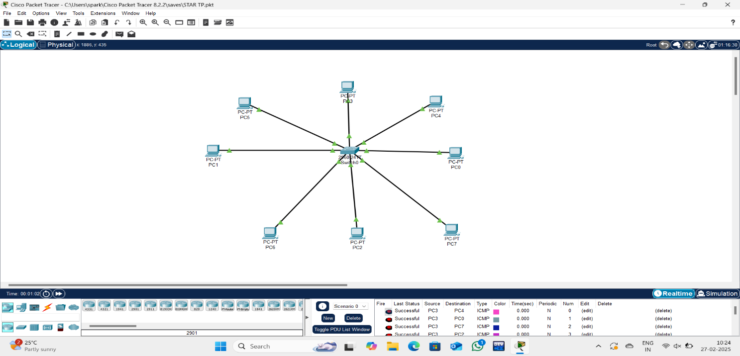

**Result:** Thus the Tree topology is implemented with Packet Tracer simulation Tool