EVENTFORCE MANAGEMENT SYSTEM
SALESFORCE IMPLEMENTATION

Project Documentation
Salesforce Lightning Experience – Developer Edition
Document Detail | Information
Project | EventForce Management System
Platform | Salesforce Lightning Experience (Developer Edition org)
Coverage | Phase 1 to Phase 4: Requirement Analysis, Backend, UI/UX, Data Migration, Testing & Security
Version | 1.0
Prepared by | Project Team
EVENTFORCE MANAGEMENT SYSTEM –
SALESFORCE IMPLEMENTATION

User Story:
The EventForce Management System gives event teams one Salesforce workspace for handling client enquiries, event scheduling, venue reservations, vendor coordination, cancellation approvals, client reminders and post-event feedback. Data is organised into Event, Client, Vendor, Venue, Feedback and Event Vendor objects, which are linked through lookup and master-detail relationships.
A record-triggered Flow sends reminders to clients, an Approval Process controls cancellation requests, and Apex classes and triggers update venue availability and block double bookings. A Lightning App with Reports and Dashboards gives live visibility of schedules, vendor activity and overall performance. As a result, the organisation saves coordination effort, keeps its data accurate, communicates better and offers clients a smoother experience.

Contents
Section | Title
1 | Introduction
2 | Ideation Phase
3 | Requirement Analysis Phase
4 | Project Design Phase
5 | Project Planning & Scheduling
6 | Project Development Phase (Phase 1 to Phase 4, Milestones 1 to 18)
7 | Functional & Performance Testing
8 | Advantages & Disadvantages
9 | Conclusion
10 | Future Scope
11 | Appendix and Screenshot Checklist

How to Use the Screenshot Placeholders
Every step that needs proof of work contains a blue dashed box named SCREENSHOT followed by a number. Each box says exactly which screen to capture from your own Salesforce org.
- Complete the configuration in your org and capture the screen named in the box.
- Click inside the dashed box and delete the placeholder text.
- Choose Insert, then Pictures, and select your screenshot. Resize it to the width of the box.
- Keep the caption below the box, or edit it if your screen differs.
- Use the checklist in Section 11 to confirm that every screenshot has been added.

1. INTRODUCTION

1.1 Project Overview :
The EventForce Management System is a Salesforce-based CRM solution that brings event planning and event management into one place. It handles clients, events, venues, vendors, feedback and cancellations inside a single, structured Salesforce platform.
The solution is built from custom objects, relationships, validation rules, Flows, Approval Processes, Apex triggers and classes, Reports and Dashboards. Together these support venue availability management, double-booking prevention, automatic event reminders, cancellation approvals, feedback management and operational reporting.
The project aims to cut manual effort, improve booking coordination and data accuracy, strengthen communication with clients and internal teams, and give managers a clear view of event activity.

1.2 Purpose :
The purpose of the EventForce Management System is to give event teams a centralised Salesforce platform in which planning work is managed and automated. The system is designed to:
- Keep client, event, venue, vendor and feedback information in one place.
- Simplify event booking and venue reservation.
- Prevent venue double bookings through automated Apex logic.
- Automate event reminders and the cancellation approval process.
- Improve coordination between clients, event coordinators, vendors and venue managers.
- Provide reports and dashboards that support operational visibility and decisions.
- Reduce manual work, improve data accuracy and enhance the client experience.

1.3 Scope of This Document :
- The ideation, requirement, design and planning work carried out before development (Sections 2 to 5).
- Step-by-step configuration of the Salesforce org in four phases and eighteen milestones (Section 6).
- Test scenarios used to confirm functionality, security and performance (Section 7).
- Screenshots from the implemented org, placed in the marked boxes throughout the document.

1.4 Intended Audience :
- Project guide, evaluators and reviewers who assess the implementation.
- Salesforce administrators and developers who maintain or extend the org.
- Business users such as event coordinators, vendor managers and administrators.

2. IDEATION PHASE

2.1 Problem Statement (Customer Problem Statement Template)
The table below lists the main problems faced by the people who run events. Each row describes who the customer is, what they are trying to do, what stops them, why, and how that makes them feel.
PS | I am (Customer) | I’m trying to | But | Because | Which makes me feel
PS-1 | Event Operations Manager | manage client, event, venue and vendor activities efficiently | information is difficult to manage in one place | operations need coordination across several areas | Frustrated and concerned
PS-2 | Event Coordinator | create and manage event bookings smoothly | event, client and venue details need many manual steps | there is no central platform for the whole event lifecycle | Overwhelmed and frustrated
PS-3 | Venue Manager | manage venue availability accurately | one venue may be assigned to several events | bookings need reliable tracking and double-booking prevention | Concerned and uncertain
PS-4 | Vendor Manager | coordinate vendors for different events | vendor details and assignments are handled separately for each event | events can need several vendors and services | Overwhelmed and concerned
PS-5 | Event Coordinator | send event information and reminders on time | reminders have to be sent by hand | clients must be told before an event approaches | Stressed and concerned
PS-6 | Event Administrator | handle cancellation requests in a systematic way | cancellation decisions need approval and status updates | there is no controlled approval process | Frustrated and uncertain
PS-7 | Event Coordinator | collect and manage client feedback | feedback has to be kept together with event and client details | feedback relates to both events and clients | Concerned about client satisfaction
PS-8 | Event Operations Manager | monitor operational performance | event data is not easy to see in one place | information must be organised into reports and dashboards | Concerned and less confident in decisions

2.2 Empathy Map Canvas
User Persona: Event Coordinator
Primary Responsibility: Managing event bookings, client requirements, venue reservations, vendor coordination, reminders and event status updates.
Quadrant | What the Event Coordinator Experiences
Think & Feel | Wants events to run smoothly, wants to avoid booking conflicts and wants clients to receive a dependable service.
Hear | Receives requirements and updates from clients, vendors, venue managers and event administrators.
See | Event details, client information, venue availability, vendor assignments, cancellations and feedback.
Say & Do | Coordinates with stakeholders, updates event records, manages bookings, follows up on requirements and tracks progress.
Pain | Manual coordination, scattered information, the risk of double-booked venues and trouble tracking many events at once.
Gain | Central event information, automatic reminders and processes, accurate venue availability, better coordination and clearer visibility.

2.3 Brainstorming & Idea Prioritization
Ideas Considered
Idea | Approach | Key Limitation
Manual Registers | Keep event, client, venue and vendor details in registers | Time-consuming and hard to maintain
Spreadsheet Tracking | Track bookings and event details in spreadsheets | Little automation and no real-time coordination
Standalone Portal | Build a dedicated event management portal | Higher development and maintenance effort
Salesforce CRM | Run event operations on the Salesforce platform | Needs careful configuration and implementation

Final Selection – Salesforce CRM was chosen because of:
- Automation – Automation of reminders, approvals, status updates and other business processes.
- Scalability – Room to grow in events, users, records and business needs.
- Real-Time Visibility – Central data with reports and dashboards for live monitoring.
Decision: Salesforce CRM is the best fit for a centralised, automated and scalable EventForce Management System.

3. REQUIREMENT ANALYSIS PHASE

3.1 Customer Journey Map
The journey map follows a client from the first enquiry to the final feedback and shows where the system supports each stage.
Stage | Journey Stage | What Happens in Salesforce
1 | Event Enquiry & Client Registration | Client requirements and contact details are captured.
2 | Event Planning & Booking | Event type, date, budget and status are created and managed.
3 | Venue Selection & Reservation | Suitable venues are found, availability is checked and double bookings are prevented.
4 | Vendor Coordination | Vendors and services are assigned to the event and their status is tracked.
5 | Event Confirmation & Communication | Confirmed events trigger automatic communication, including reminders to clients.
6 | Event Execution & Monitoring | Progress is followed through records, reports and dashboards.
7 | Cancellation & Approval | Cancellation requests go through the approval process with status updates and notifications.
8 | Feedback & Closure | Client feedback is captured and completed events are updated for tracking and analysis.

3.2 Solution Requirements

Functional Requirements
FR No. | Requirement
FR-1 | Event management
FR-2 | Client management
FR-3 | Venue management
FR-4 | Vendor management
FR-5 | Event–vendor assignment
FR-6 | Venue availability and double-booking prevention
FR-7 | Automated event reminders
FR-8 | Event cancellation approval
FR-9 | Feedback management
FR-10 | Reports and dashboards
FR-11 | Event status automation
FR-12 | Data migration through the Data Import Wizard

Non-Functional Requirements
NFR | Description
Usability | A Lightning App that makes event management and navigation simple
Security | Access controlled by profiles, roles and permissions
Reliability | Accurate automation, approvals and venue booking validation
Performance | Efficient handling of event and operational data
Availability | Cloud-based Salesforce access for authorised users
Scalability | Support for more events, clients, vendors, venues and users
Maintainability | Flows, Apex, validation rules and security that can be monitored and updated
Data Integrity | Validation and controlled data migration to keep records accurate

3.3 Data Flow Diagram

Main Flow:
- Client or event team enters client and event details.
- Salesforce validates and stores the data as Event, Client, Venue and Vendor records.
- Venue availability is checked, and the venue and vendors are assigned.
- The event is confirmed, and an automatic reminder goes out three days before the event.
- The event is carried out and its status is updated.
- Feedback is collected after the event.
- Reports and dashboards summarise the results.

Supporting Flows:
Process | Flow
Cancellation Request | Event Coordinator → Cancellation request → Approval Process → Approved or Rejected → Event status update → Notifications
Venue Booking Validation | Event → Apex trigger → VenueStatusHelper → Check existing venue and event date → Block double booking or update venue availability
Event Completion | Event date has passed → Scheduled Apex → Batch process → Event status becomes Completed

In summary, clients, event coordinators, vendor managers and venue managers work in the Salesforce CRM. Data is held in the six custom objects, business logic runs through Flows, the Approval Process and Apex, and the outcome appears as operational data, status updates, reports and dashboards that support decisions.
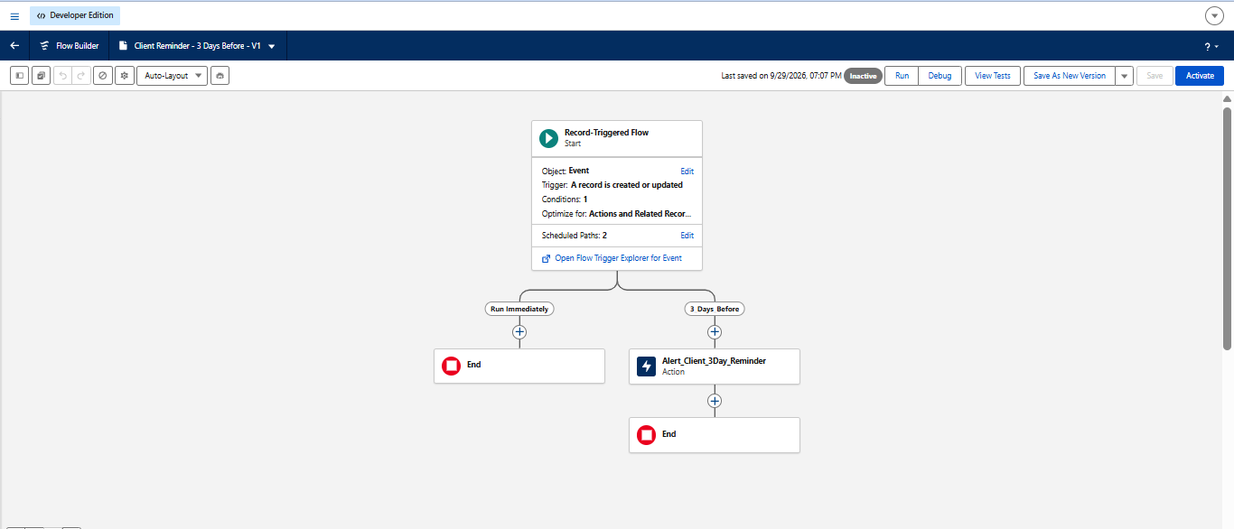

3.4 Technology Stack
Layer | Technology
Platform | Salesforce CRM / Developer Edition
User Interface | Salesforce Lightning App
Database | Salesforce custom objects
Business Logic | Flows, formula fields and validation rules
Approval | Salesforce Approval Process
Automation | Record-triggered Flows and Apex triggers
Processing | Batch Apex and Scheduled Apex
Security | Profiles, roles, permission sets, sharing rules and organisation-wide defaults
Reporting | Reports and Dashboards

4. PROJECT DESIGN PHASE

4.1 Problem–Solution Fit
The identified event-management problems match well with what Salesforce offers. The solution joins custom data structures, automation, Apex business logic, approvals, security controls and reporting to solve the everyday challenges of planning and coordinating events.
Problem | Solution in EventForce | Fit / Benefit
Client, event, venue and vendor data is hard to manage centrally | Custom objects: Event, Client, Venue, Vendor, Feedback and EventVendor | Central, structured event data
Event booking needs many manual activities | Salesforce Flows and automated processes | Less manual effort and a faster process
Risk of venue double booking | Apex trigger and VenueStatusHelper | Checks availability and blocks double bookings
Vendor coordination is complicated | EventVendor junction object for many-to-many assignment | Several vendors per event, several events per vendor
Cancellations need control | Event_Cancellation_Process approval | Structured approval and status updates
Feedback must connect to events | Feedback object with Event and Client relationships | Organised feedback management
Operations are hard to monitor | Reports and the EventForce Operations Dashboard | Better visibility for decisions
Users need different access levels | Profiles, roles, permission sets, OWD and sharing rules | Controlled and secure data access

4.2 Proposed Solution
Parameter | Description
Problem | Event management is manual and scattered across files and people
Solution | Salesforce CRM as one central platform
Innovation | Automatic event reminders, venue validation and cancellation approvals
Impact | Faster event coordination and clearer operational visibility
Business Model | Centralised event planning and management
Scalability | Handles growing numbers of events, clients, vendors, venues and users

4.3 Solution Architecture

Components:
Layer | Components
Data Layer | Event, Client, Vendor, Venue, EventVendor (junction) and Feedback objects; formula fields; validation rules
Automation Layer | Flows, Approval Process, Apex triggers, Apex classes, Batch Apex and Scheduled Apex
Security Layer | Profiles, roles, permission sets, sharing rules and organisation-wide defaults
Migration Layer | Data Import Wizard
Presentation Layer | Lightning App, Reports and Dashboards

5. PROJECT PLANNING & SCHEDULING

5.1 Project Planning
- Agile methodology
- Epics → Stories → Story Points
- Sprint-based execution in four sprints
- Velocity (story points per sprint) used for estimation
The work was split into 16 user stories worth 80 story points in total. Each of the four sprints carried 20 story points over six working days.

Product Backlog, Sprint Schedule and Estimation
Sprint | Epic | No. | User Story / Task | Pts | Priority | Member
Sprint-1 | Event Management | US-01 | As an Event Coordinator, I want to create events with type, date and status so that event data is standardised. | 5 | High | Member1
Sprint-1 | Client & Venue Management | US-02 | As an Event Coordinator, I want to link a client and a venue to an event so that coordination is centralised. | 8 | High | Member2
Sprint-1 | Navigation | US-03 | As an Event Coordinator, I want tabs for every object so that I can reach records quickly. | 5 | Medium | Member3
Sprint-1 | Data Quality | US-04 | As an Event Administrator, I want client emails validated so that reminders reach the client. | 2 | High | Member4
Sprint-2 | Vendor Management | US-05 | As a Vendor Manager, I want to assign several vendors to an event so that services are coordinated. | 8 | High | Member3
Sprint-2 | Notifications | US-06 | As a Client, I want a timely reminder so that I know when my event is near. | 5 | High | Member4
Sprint-2 | Budget | US-07 | As an Event Coordinator, I want the budget calculated from the event type so that estimates are consistent. | 2 | Medium | Member1
Sprint-2 | Feedback Management | US-08 | As an Event Coordinator, I want feedback linked to client and event so that satisfaction can be tracked. | 5 | Medium | Member2
Sprint-3 | Approval | US-09 | As an Event Administrator, I want cancellation requests approved so that cancellations are controlled. | 8 | High | Member1
Sprint-3 | Venue Management | US-10 | As a Venue Manager, I want double bookings blocked so that venue schedules stay accurate. | 8 | High | Member2
Sprint-3 | Automation | US-11 | As an Event Administrator, I want past events marked Completed every night so that statuses stay current. | 3 | Medium | Member3
Sprint-3 | Data Migration | US-12 | As an Event Administrator, I want existing records imported so that the org starts with real data. | 1 | Medium | Member4
Sprint-4 | Security | US-13 | As an Event Administrator, I want role-based access so that users see only what they need. | 5 | High | Member3
Sprint-4 | Lightning App | US-14 | As an Event Coordinator, I want one app for all modules so that I work from a single workspace. | 2 | Medium | Member4
Sprint-4 | Reports & Dashboards | US-15 | As an Event Operations Manager, I want reports and dashboards so that operations are monitored. | 8 | Medium | Member1
Sprint-4 | Testing | US-16 | As the project team, we want functional and security testing so that the solution is reliable. | 5 | High | Member2

Sprint Schedule and Velocity
Sprint | Total Points | Duration | Start Date | End Date | Points Completed | Release Date
Sprint-1 | 20 | 6 Days | 24 Oct 2022 | 29 Oct 2022 | 20 | 29 Oct 2022
Sprint-2 | 20 | 6 Days | 31 Oct 2022 | 05 Nov 2022 | 20 | 05 Nov 2022
Sprint-3 | 20 | 6 Days | 07 Nov 2022 | 12 Nov 2022 | 20 | 12 Nov 2022
Sprint-4 | 20 | 6 Days | 14 Nov 2022 | 19 Nov 2022 | 20 | 19 Nov 2022

Average velocity = total story points ÷ number of sprints = 80 ÷ 4 = 20 points per sprint, or about 3.3 points per working day (20 ÷ 6).

6. PROJECT DEVELOPMENT PHASE
The development work was carried out in four phases. Phase 1 covers analysis and planning, Phase 2 builds the backend, Phase 3 builds the user interface and analytics, and Phase 4 covers data migration, testing and security. The work is described as eighteen milestones, each with its own screenshots.

Phase 1: Requirement Analysis & Planning
The goal was to build an EventForce Management System in Salesforce that helps event planners handle client bookings, vendor coordination, venue reservations and feedback collection on a single CRM platform. Key processes such as event scheduling, cancellation approvals and client reminders are automated, while reports and dashboards give real-time visibility.

Functional Scope :
- Custom objects: Event, Client, Vendor, Venue, Feedback and Event Vendor (junction object).
- Relationship modelling with lookup, master-detail and many-to-many (Event ↔ Vendor) relationships.
- Flows for reminders, feedback notifications and approval updates.
- Validation rules and formula fields for correct data entry and event budget calculation.
- Approval Process for event cancellation requests, with email alerts to coordinators and clients.
- Profiles, roles and permission sets to control user access.
- Reports and dashboards for event summaries, vendor performance and upcoming events.

Stakeholder Mapping :
Stakeholder | Role in the System
Clients | Request event services, give feedback and view event updates
Event Coordinators | Manage scheduling, client communication and approval workflows
Vendors | Deliver assigned services such as catering, decor and logistics
Venue Managers | Manage venue availability and reservations
Event Administrators | Oversee system operation, security and data monitoring

Execution Roadmap :
- Object and field setup – create the Event, Client, Vendor, Venue, Feedback and Event Vendor objects.
- Automation – build the record-triggered Flow for event reminders and the approval updates.
- Validation rules and formula fields – enforce data accuracy and calculate the event budget.
- Profiles, roles and permission sets – set up user access and record visibility.
- Approval process – automate the cancellation request workflow with notifications.
- Apex classes and triggers – update venue availability and prevent double bookings.
- Reports and dashboards – build analytics for upcoming events and performance.
Together with the sharing rules defined in Phase 4, this work moved EventForce from a static data structure to a dynamic, automated and secure CRM able to support real event-management workflows.

Phase 2: Backend Development & Configurations
Phase 2 builds the foundation of the application: the Salesforce developer account, the data architecture, the custom objects, tabs, fields and relationships, and the automation that runs behind the screens, namely validation rules, the approval process, Flows, Apex classes and triggers, and batch and scheduled Apex.

Milestone 1 : Salesforce Account

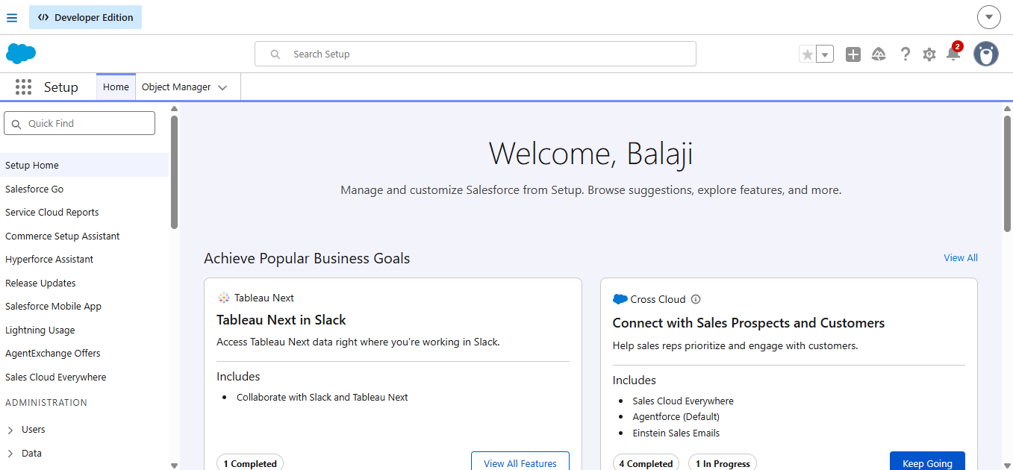

What Is Salesforce ?
Salesforce is a cloud customer success platform that helps organisations sell, service, market, analyse and connect with customers. It lets teams manage relationships with prospects and customers, collaborate with employees and partners, and store data securely in the cloud.

Activity 1: Creating a Developer Account
A Developer Edition org is a free Salesforce environment for building and testing applications.
- Open https://developer.salesforce.com/signup in your browser.
- Fill in the sign-up form with the following details:
- First name and last name
- Email address
- Role: Developer
- Company: your college or organisation name
- Country: India, and your postal code
- Username: a unique name in email format, for example yourname@organisation.com (it need not be a real email address)
Click Sign me up after the form is complete.

Activity 2: Account Activation
- Open the inbox of the email address used at sign-up. The message may take 5 to 10 minutes to arrive.
- Click Verify Account in the email.
- Set a password, answer the security question and click Change Password.
- You are then taken to the Salesforce Setup page.

Data Architecture

Custom Objects Created:
Object | Key Fields
Event__c | Event Name, Event Date, Event Type, Event Status, Event Budget
Client__c | Client Name, Email, Phone, Address, Country, City
Vendor__c | Vendor Name, Email, Phone, Service Type, Status
Venue__c | Venue Name, Address, Location (URL), Capacity, Availability Status
Feedback__c | Feedback ID (Auto Number), Rating, Comments
EventVendor__c | Junction object that links Event and Vendor (many-to-many)

Relationships:
Relationship | Type
Event → Client | Lookup
Event → Venue | Lookup
Feedback → Event | Lookup
Feedback → Client | Lookup
EventVendor → Event | Master-Detail
EventVendor → Vendor | Master-Detail

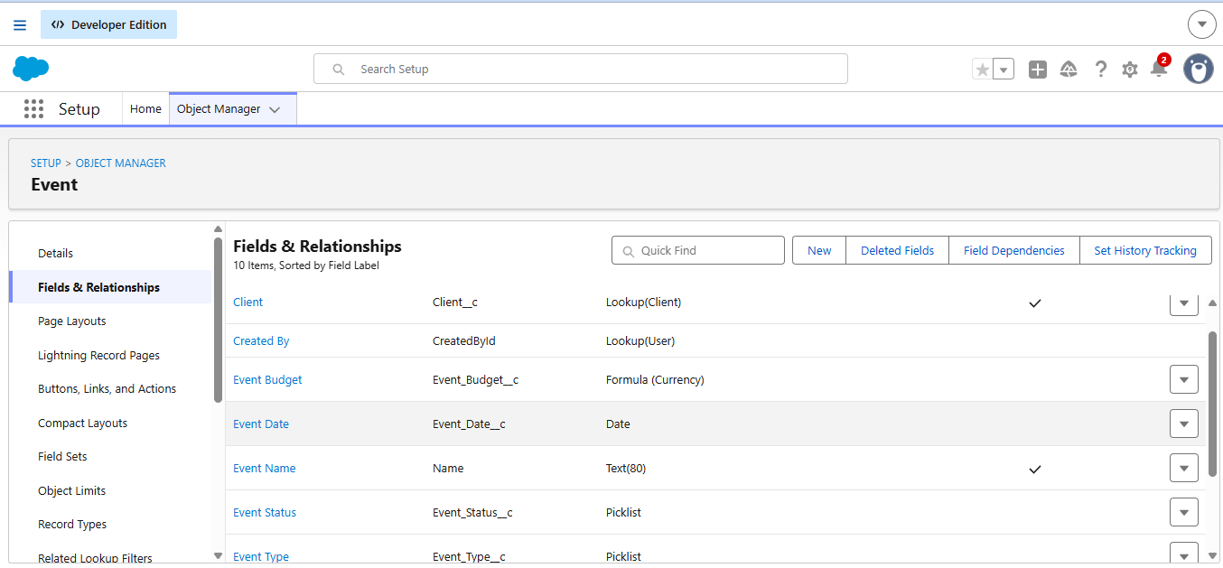

Steps to Implement
The backend was built in the following order. Each step is explained in the milestone that follows.
Milestone | Task
2 | Create the custom objects
3 | Create tabs for the objects
4 | Create fields and relationships
5 | Add validation rules
6 | Create the approval process for event cancellation
7 | Build the Flow for client reminders
8 | Write Apex classes and the venue status trigger
9 | Write the Apex trigger that prevents double bookings
10 | Create batch and scheduled Apex for event completion

Milestone 2 : Object

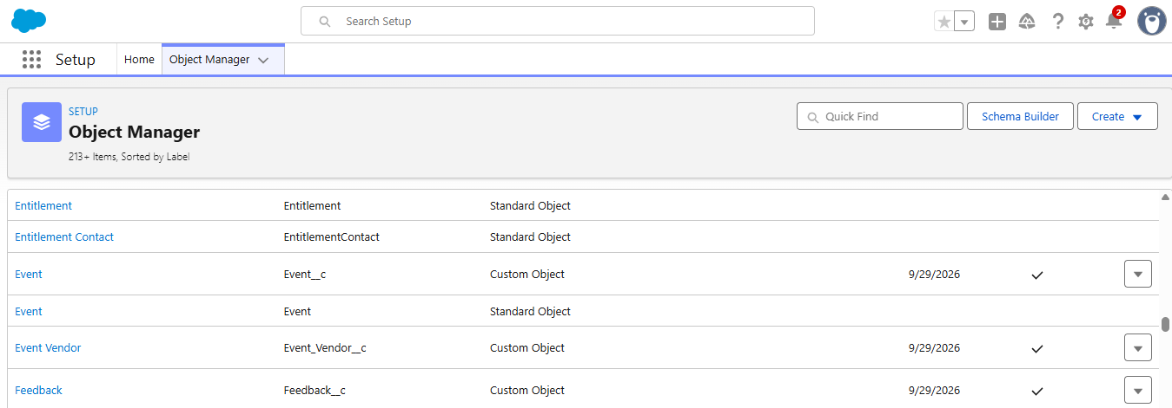

What Is an Object ?
Salesforce objects are database tables that store data specific to an organisation. An object is made of fields (columns) and records (rows). This application uses five custom objects, Event, Client, Vendor, Venue and Feedback, and one junction object, Event Vendor, which is created in Milestone 4.

Activity 1: Create the Event Object
- From Setup, open Object Manager.
- Click Create, then select Custom Object.
- Enter Label as Event and Plural Label as Events. Set Record Name to Event Name with the data type Text.
- Under Optional Features, tick Allow Reports, Allow Activities and Track Field History.
- Make sure Deployment Status is Deployed and Search Status is Allow Search.
- Tick Add Notes and Attachments related list to default page layout, leave the rest unchanged and click Save.

Activity 2: Create the Client Object
- Click the gear icon, then Setup, then the Object Manager tab.
- Open the Create drop-down at the right and select Custom Object.
- Enter Label as Client, Plural Label as Clients and Record Name as Client Name (data type Text).
- Tick Allow Reports and Allow Search, and tick Add Notes and Attachments related list to default page layout.
- Click Save.

Activity 3: Create the Vendor Object
- Repeat the same navigation: Setup, Object Manager, Create, Custom Object.
- Enter Label as Vendor, Plural Label as Vendors and Record Name as Vendor Name (data type Text).
- Tick Allow Reports and Allow Search, and add the Notes and Attachments related list.
- Click Save.

Activity 4: Create the Venue Object
- Open Setup, Object Manager, Create, Custom Object.
- Enter Label as Venue, Plural Label as Venues and Record Name as Venue Name (data type Text).
- Tick Allow Reports and Allow Search, and add the Notes and Attachments related list.
- Click Save.

Activity 5: Create the Feedback Object
- Open Setup, Object Manager, Create, Custom Object.
- Enter Label as Feedback, Plural Label as Feedbacks and Record Name as Feedback.
- Choose the data type Auto Number, set the display format to F-{0000} and the starting number to 0.
- Tick Allow Reports and Allow Search, and add the Notes and Attachments related list.
- Click Save.

Milestone 3 : Tabs

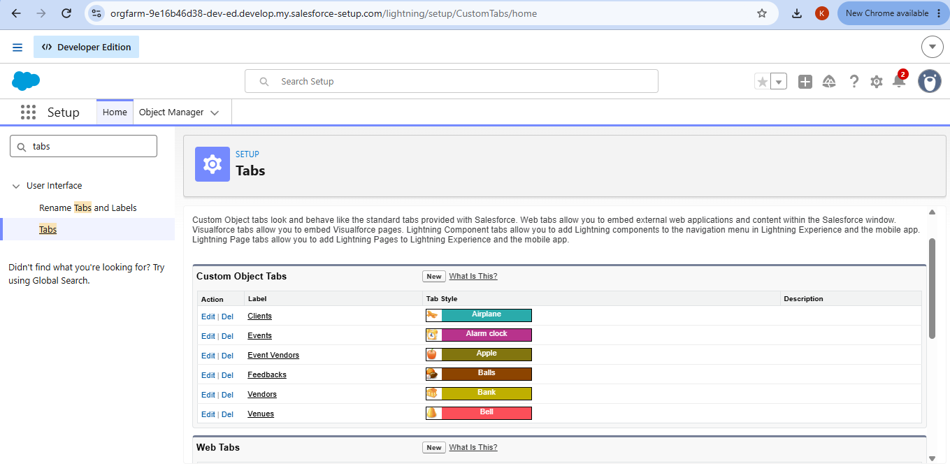

Tab:
Tabs help users see information at a glance. A tab shows the data of an object or other web content inside the application.
Standard object tabs display data from standard objects. Custom object tabs display data from custom objects and look and work just like standard tabs.

Activity 1: Create the Custom Tabs
- Click the Home tab, type Tabs in Quick Find and select Tabs.
- Under Custom Object Tabs, click New.
- For Object, select Event. For Tab Style, choose any icon.
- Leave the defaults unchanged and click Next, Next and Save.
- Repeat steps 2 to 4 for the Client, Vendor, Venue and Feedback objects.
Object | Tab Created | Tab Style
Event | Events | Any icon
Client | Clients | Any icon
Vendor | Vendors | Any icon
Venue | Venues | Any icon
Feedback | Feedbacks | Any icon

Milestone 4 : Fields and Relationships

What Are Fields ?
Fields in Salesforce are the columns of a relational table. Each field stores one kind of data value for a record of an object.

There are two types of fields in Salesforce:
- Standard fields: Every custom object has built-in fields such as Created By, Last Modified By, Owner and the name field. They are always present and cannot be deleted or edited. Standard objects also have default fields that cannot be removed.
- Custom fields: Fields added by the administrator or developer to meet business needs. They may or may not be required.

Activity 1: Create Fields for the Event Object
- Click the gear icon and select Setup. Open the Object Manager tab next to Home.
- Select Event, then choose Fields & Relationships in the left menu and click New.
- Choose the data type Picklist and click Next. Enter the Field Label Event Type.
- Choose Enter values, with each value separated by a new line, and add the values listed in the table below.
- Click Next, Next and Save.
- Create the remaining fields in the same way, choosing each data type with care.
Field Label | Data Type | Values / Notes
Event Type | Picklist | Wedding, Corporate, Birthday, Anniversary, Festival, Concert, Other
Event Date | Date | Date on which the event takes place
Event Status | Picklist | Planned, Confirmed, Completed, Pending Cancellation, Canceled, Rejected
Event Budget | Formula (Currency) | Calculated from the Event Type (see below)

Create the Formula Field for Event Budget
- Choose the data type Formula and click Next.
- Enter the Field Label Event Budget and select the return type Currency. Click Next.
- Paste the formula below into the formula editor and click Check Syntax.
- Click Next, Next and Save.
CASE( TEXT(Event_Type__c),
"Wedding", 50000,
"Corporate", 30000,
"Birthday", 10000,
"Anniversary", 20000,
"Festival", 60000,
"Concert", 40000,
"Other", 15000,
0 )

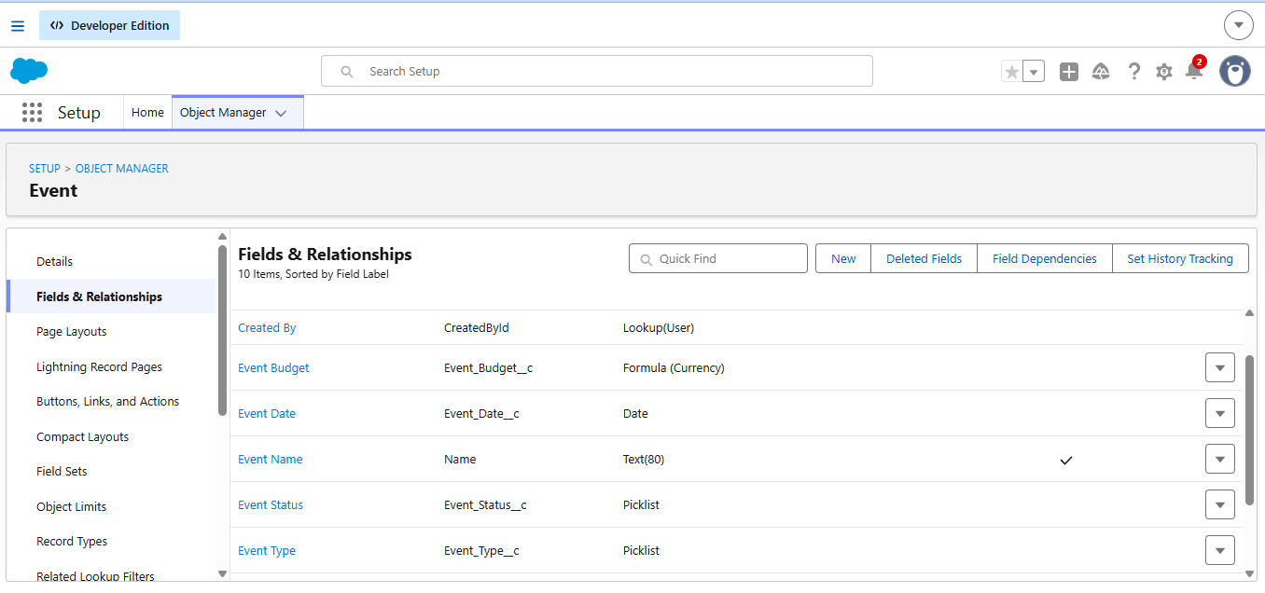

Activity 2: Create Fields for the Client Object
Field Label | Data Type | Values / Notes
Email | Email | Client email address (used for reminders)
Phone | Phone | Client contact number
Address | Text Area | Postal address of the client
Country | Picklist | India, Philippines, Saudi Arabia, USA, Switzerland, Thailand, Maldives, Dubai, Sri Lanka, Bangkok, Singapore, Myanmar, France, Nepal
City | Picklist | Cities of the countries above, for example Hyderabad, Mumbai, Delhi, Bangalore, Chennai, Riyadh, Jeddah, New York, Los Angeles, Geneva and Bern

- Open Object Manager > Client > Fields & Relationships and click New.
- Create the Email, Phone and Address fields by choosing their data types, entering the labels and clicking Next, Next, Save.
- Create the Country picklist and enter its values one per line, then save.
- Create the City picklist in the same way and save.
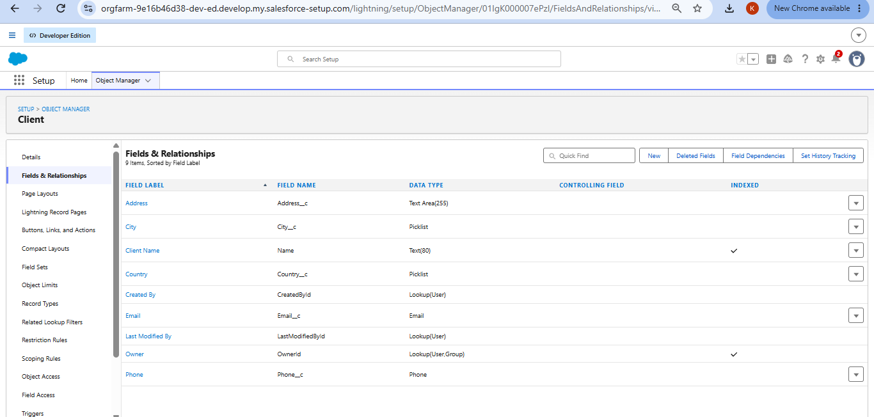

Activity 3: Create Fields for the Vendor Object
Field Label | Data Type | Values / Notes
Service Type | Multi-Select Picklist | Catering, Decor, Photography, Videography, Lighting, Stage Setup, Makeup Artist, DJ/Music, Transportation, Hosting/Anchor
Email | Email | Vendor email address
Phone | Phone | Vendor contact number
Status | Picklist | Available, Booked, Cancelled

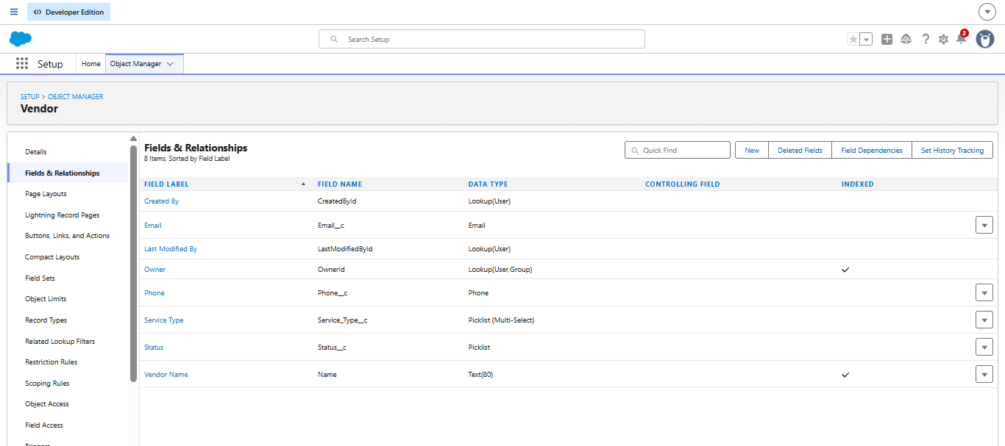

Activity 4: Create Fields for the Venue Object
Field Label | Data Type | Values / Notes
Address | Text Area | Postal address of the venue
Location | URL | Map link of the venue
Capacity | Number | Maximum number of guests
Availability Status | Picklist | Available, Reserved, Not Available

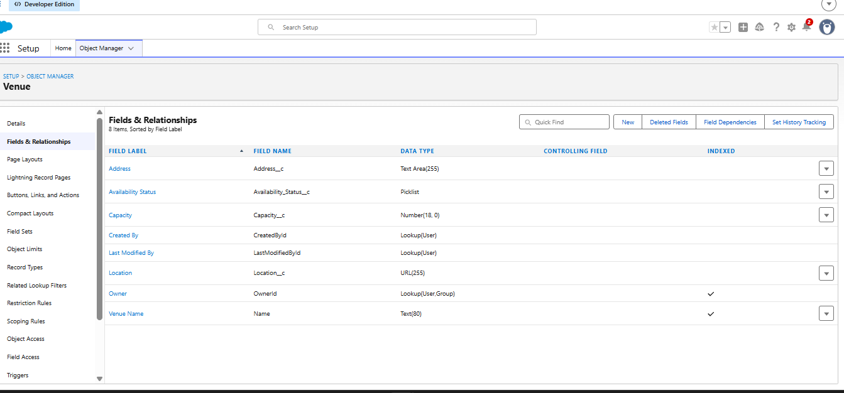

Activity 5: Create Fields for the Feedback Object
Field Label | Data Type | Values / Notes
Rating | Picklist | 1, 2, 3, 4, 5
Comments | Long Text Area | Free-text comments from the client

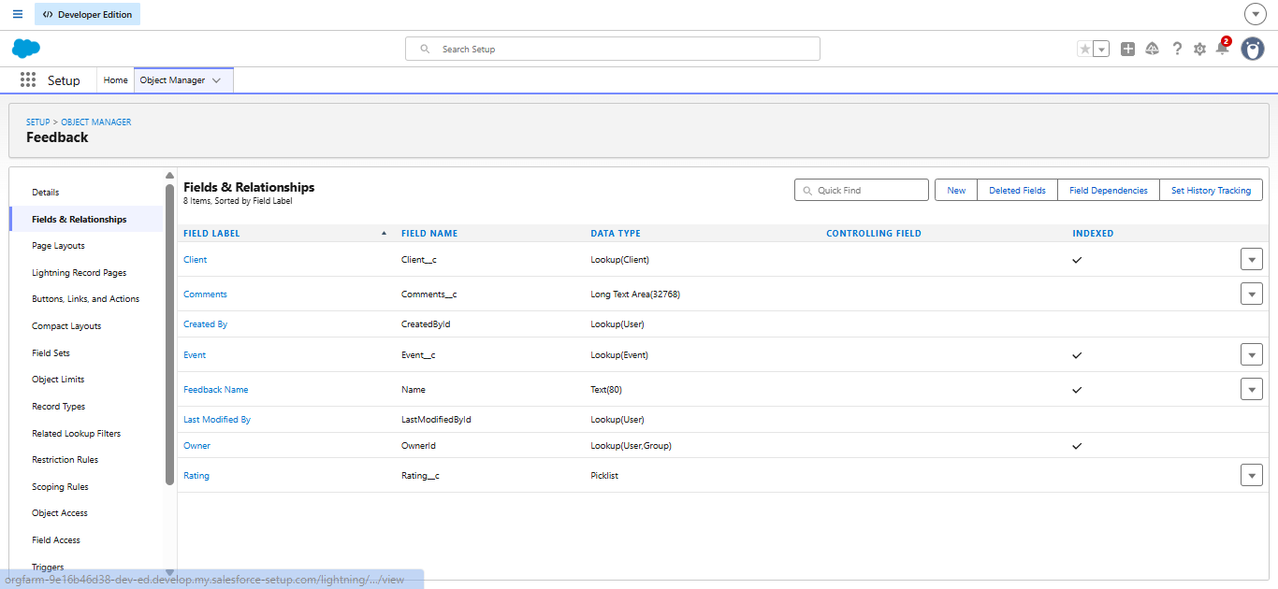

Relationships:

Activity 1: Lookup Relationships on the Event Object
- From Setup, open Object Manager and select Event, then Fields & Relationships.
- Click New, select Lookup Relationship and click Next.
- Choose the related object Venue, click Next, enter the Field Label Venue and click Next, Next, Next, Save.
- Repeat to add a second lookup, choosing Client as the related object and Client as the label.

Many-to-Many Relationship (Event ↔ Vendor)
Salesforce does not allow a direct many-to-many relationship, so a junction object called EventVendor__c is used.
- Go to Object Manager and create a new custom object with the Label Event Vendor and the Object Name EventVendor__c.
- Open Event Vendor > Fields & Relationships > New and select Master-Detail Relationship. Choose Event as the related object, label it Event and click Save & New.
- Select Master-Detail Relationship again, choose Vendor as the related object, label it Vendor and click Save.

Activity 2: Lookup Relationships on the Feedback Object
- Open Object Manager, select Feedback and choose Fields & Relationships.
- Click New, select Lookup Relationship, choose Event as the related object and label it Event.
- Click New again, select Lookup Relationship, choose Client as the related object and label it Client.

Activity 3: Lookup Filter
Scenario: Each Event belongs to a Client. When feedback is entered, the Event lookup should list only the events of the selected client. For example, if a client named Ramesh is chosen, only Ramesh’s events should be shown.
- Click the gear icon and open Setup, then Object Manager, then Feedback.
- Choose Fields & Relationships, open the Event lookup field (Event__c) and click Edit.
- Scroll to the Lookup Filter section and click Show Filter Settings.
- Build the filter: Field = Event: Client__c, Operator = equals, Value = Field, then select Feedback: Client__c.
- Tick Enable this Filter and click Save.

Milestone 5 : Validation Rules
Validation rules run when a user tries to save a record. They check that the data meets given criteria. If it does not, an error message is shown and the record is not saved until the problem is fixed.

Activity 1: Create a Validation Rule on Client__c
- Go to Setup, open Object Manager, type Client in the quick find box and open the Client object.
- Click Validation Rules, then New.
- Enter the Rule Name Email_Valid_Address and tick Active.
- Enter the error condition formula shown below.
- Enter the Error Message Please Enter Valid Email Address, set the Error Location to Field, choose the Email field and click Save.
NOT(REGEX(Email__c, "^[a-zA-Z0-9._]+@[a-zA-Z0-9.]+\\.[a-zA-Z]{2,}$"))

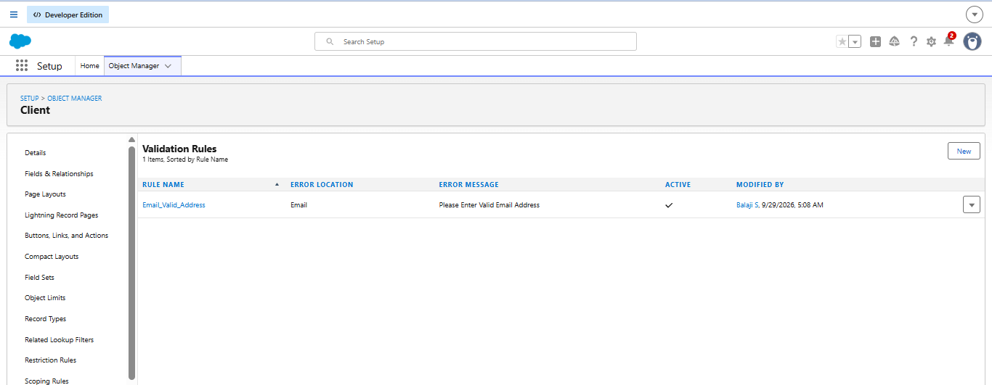

Milestone 6 : Approval Process
Activity 1: Create an approval process for event cancellation.
Note: Complete the Profiles, Roles and Users milestones (14, 15 and 16) before setting up this approval process, because approvers must exist as users.

Step A: Create the Classic Email Templates
- Go to Setup (gear icon at the top right) and type Email Templates in Quick Find.
- Click Classic Email Templates, then New Template, and choose the type Text.
- Create the four templates described in the table below.
Template Name | Subject | Message Summary
Event Cancellation Request Notification | Approval Request: Cancel Event {!Event__c.Name} | Tells the approver that a request to cancel the event has been submitted, with the event name and date.
Email to Client After Cancellation | Event Cancellation Notice – {!Event__c.Name} | Informs the client that the event has been cancelled and gives the event name and date.
Approval Notification to Event Owner | Event Cancellation Approved: {!Event__c.Name} | Tells the owner the request was approved and the status is now Canceled.
Rejection Notification to Event Owner | Event Cancellation Rejected: {!Event__c.Name} | Tells the owner the request was rejected and the status is back to Confirmed.

For the first template, use the folder Unfiled Public Email Templates, keep the encoding UTF-8 and use a body similar to: “Hello! An approval request has been submitted to cancel the event. Event Name: {!Event__c.Name}, Event Date: {!Event__c.Event_Date__c}. Thank you, EventForce Management System.”

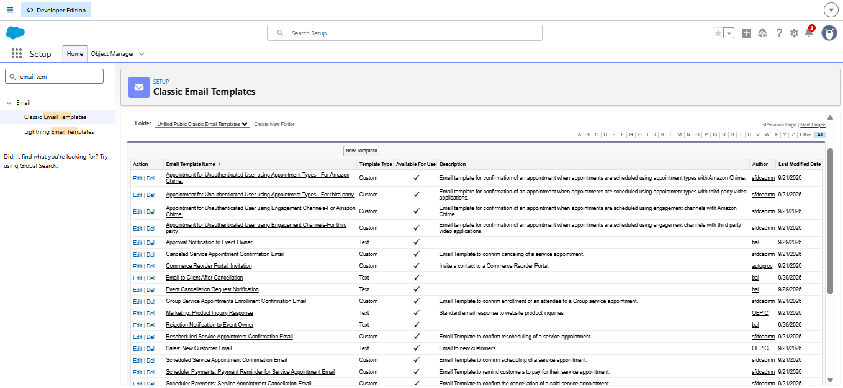

Step B: Create the Approval Process
- In Quick Find type Approval Processes, open it, and select the object Event.
- Click Create New Approval Process and choose Use Standard Setup Wizard.
- Step 1 – Basic Settings: enter the name Event_Cancellation_Process and keep the auto-filled unique name.
- Specify Entry Criteria: choose Criteria are met, then Event Status equals Pending Cancellation. Click Next.
- Step 2 – Select Approver: choose Automatically assign using user or queue and pick a specific user (the manager), or choose the manager of the submitting user. Make sure users have managers set in their user record.
- Step 3 – Email Template: select Event Cancellation Request Notification.
- Step 4 – Fields to Display: move Event Name, Owner, Client, Last Modified By, Created By, Event Budget, Event Date, Event Status, Event Type and Venue to the selected list and reorder them.
- Step 5 – Initial Submitters: select Event Owner and click Save.

Step C: Add the Approval Actions
Action Stage | Action | Details
Initial Submission | Email Alert | Description: Alert - Event Cancellation Request; object Event__c; template Event Cancellation Request Notification; recipient role Event Coordinator; from the current user’s email address
Final Approval | Field Update | Name: Event Status Update; field Event Status; new value Canceled
Final Approval | Email Alert | Description: Alert - Cancellation Approved; template Approval Notification to Event Owner; recipient Event Owner
Final Rejection | Email Alert | Description: Alert - Cancellation Rejected; template Rejection Notification to Event Owner; recipient Event Owner
Final Rejection | Field Update | Name: Event Status To Rejected; field Event Status; new value Rejected

Step D: Add the Approval Step and Activate
- Click Add New Step. Enter the step name Manager Review and click Next.
- Under Specify Step Criteria choose All records should enter this step. Click Next.
- Select Assigned Approver: choose Automatically assign to approver(s) and select a specific user or related user. Click Save.
- Click View Approval Process Detail Page and then click the Activate button.
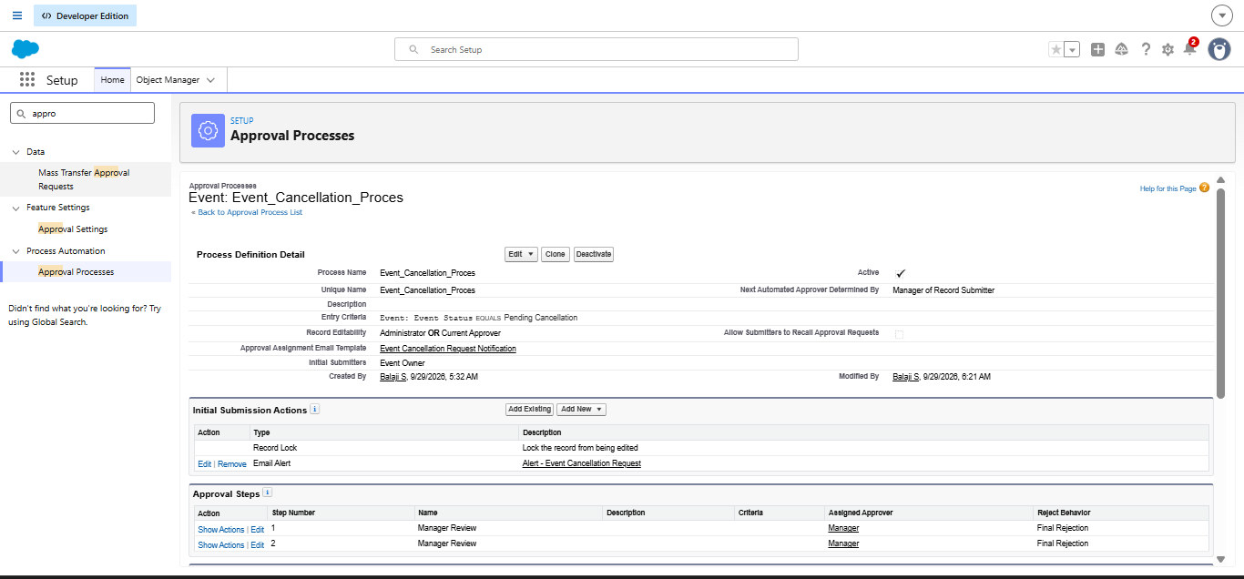

Milestone 7 : Flows
A flow is a Salesforce automation tool that can run business processes, collect and update data and guide users through screens. Flows are built in a visual builder and need no code.

Activity 1: Send a 3-Day Reminder Email to the Client
Scenario: When an Event is created or updated with the status Confirmed and has a client with an email address, an email reminder is sent to the client three days before the event date.
- Go to Setup, type Flow in Quick Find, open Flows and click New Flow.
- Select Record-Triggered Flow and click Create.
- Under Object select Event and choose A record is created or updated.
- Set the condition: Event Status equals Confirmed. Optimise the flow for Actions and Related Records, then click Done.
- Click the Start element, then Add Schedule Path. Name the path 3_Days_Before.
- Set Time Source to Event: Event Date, Offset Number to 3 and Offset Options to Days Before. Close the dialog.
- Open the Toolbox (top left) and click New Resource. Choose Text Template, set the API name Subject and enter: Reminder: Your Event {!$Record.Name} is in 3 days. View as Plain Text and click Done.
- Create a second Text Template with the API name Body. Enter the message below and view it as Plain Text.
Hello {!$Record.Client__r.Name},
This is a reminder that your event "{!$Record.Name}" will take place on {!$Record.Event_Date__c}.
Venue: {!$Record.Venue__r.Name}
Type: {!$Record.Event_Type__c}
We look forward to seeing you! - EventForce Team

- Under the 3_Days_Before path click the + symbol, choose Action and search for Send Email.
- Enter the label Alert_Client_3Day_Reminder. Set the recipient address list to the client’s email and the CC list to the event owner.
- Under Configure Email Content choose Compose Email Content, set Subject to the Subject resource and Body to the Body resource.
- Click Save, enter the Flow Label Client Reminder - 3 Days Before, then click Save and Activate.

Milestone 8 : Apex Classes

Activity 1: Update the Venue Status
Scenario: When an Event is created with a Venue, the venue’s Availability Status becomes Reserved. When the event is cancelled, the status becomes Available again.

Create the Apex Class:
- Click the gear icon and select Developer Console.
- Click File, then New, then Apex Class.
- Name the class VenueStatusHelper and click OK.
- Write the code below and save with Ctrl+S.
public with sharing class VenueStatusHelper {
public static void updateVenueStatus(List<Event__c> events) {
List<Venue__c> venues = new List<Venue__c>();
for (Event__c ev : events) {
if (ev.Venue__c != null) {
if (ev.Event_Status__c == 'Confirmed') {
venues.add(new Venue__c(Id = ev.Venue__c, Availability_Status__c = 'Reserved'));
} else if (ev.Event_Status__c == 'Canceled') {
venues.add(new Venue__c(Id = ev.Venue__c, Availability_Status__c = 'Available'));
}
}
}
if (!venues.isEmpty()) update venues;
}
}

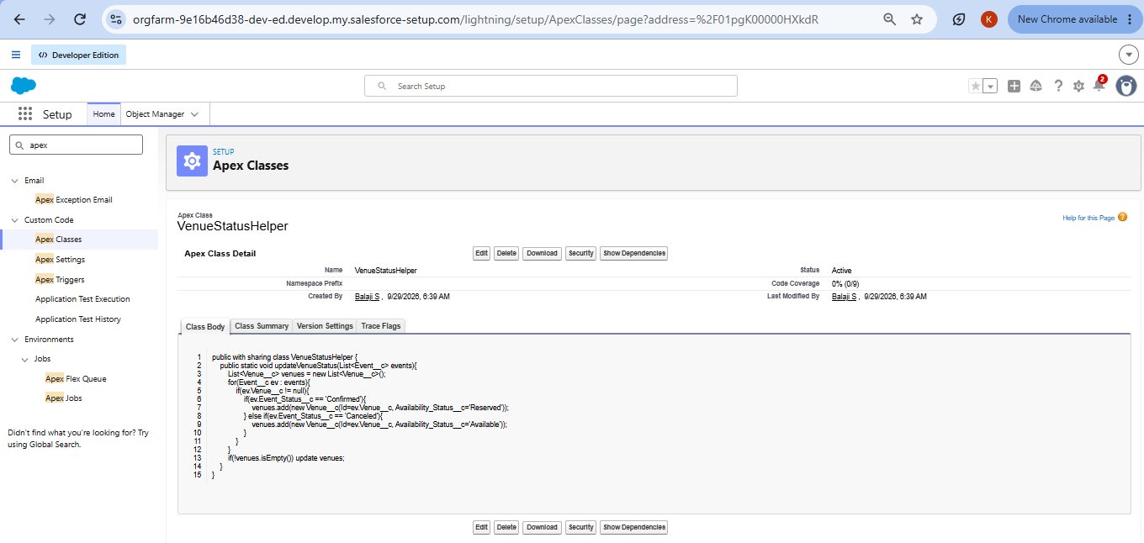

Create the Trigger for This Class:
- In the Developer Console click File, then New, then Apex Trigger.
- Name it EventTrigger13 and select the object Event__c. Click Submit.
- Write the trigger code below and save.
trigger EventTrigger13 on Event__c (after insert, after update) {
VenueStatusHelper.updateVenueStatus(Trigger.new);
}

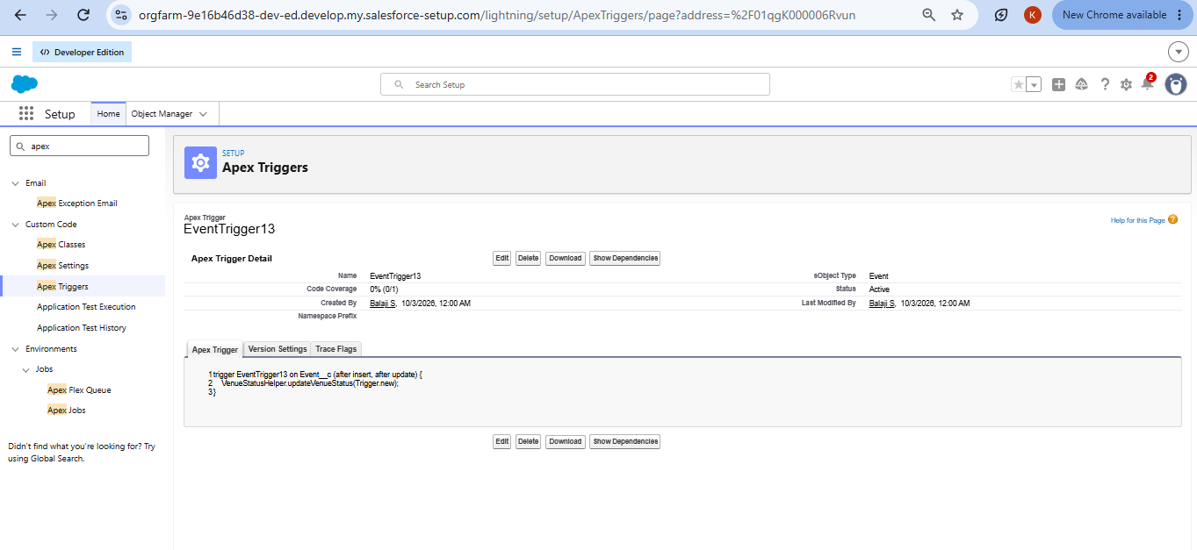

Milestone 9 : Apex Trigger

Activity 1: Prevent Double Booking
Scenario: Two events must not be booked at the same venue on the same date.
- In the Developer Console click File, then New, then Apex Trigger.
- Name the trigger PreventDoubleBooking, select the object Event__c and click Submit.
- Write the code below and save with Ctrl+S.
trigger PreventDoubleBooking on Event__c (before insert, before update) {
Set<Id> venueIds = new Set<Id>();
for (Event__c ev : Trigger.new) {
if (ev.Venue__c != null) venueIds.add(ev.Venue__c);
}
Map<Id, List<Event__c>> venueEventMap = new Map<Id, List<Event__c>>();
for (Event__c e : [SELECT Id, Venue__c, Event_Date__c FROM Event__c WHERE Venue__c IN :venueIds]) {
if (!venueEventMap.containsKey(e.Venue__c)) {
venueEventMap.put(e.Venue__c, new List<Event__c>());
}
venueEventMap.get(e.Venue__c).add(e);
}
for (Event__c ev : Trigger.new) {
if (ev.Venue__c != null && venueEventMap.containsKey(ev.Venue__c)) {
for (Event__c existing : venueEventMap.get(ev.Venue__c)) {
if (existing.Event_Date__c == ev.Event_Date__c && existing.Id != ev.Id) {
ev.addError('This Venue is already booked on this date.');
}
}
}
}
}

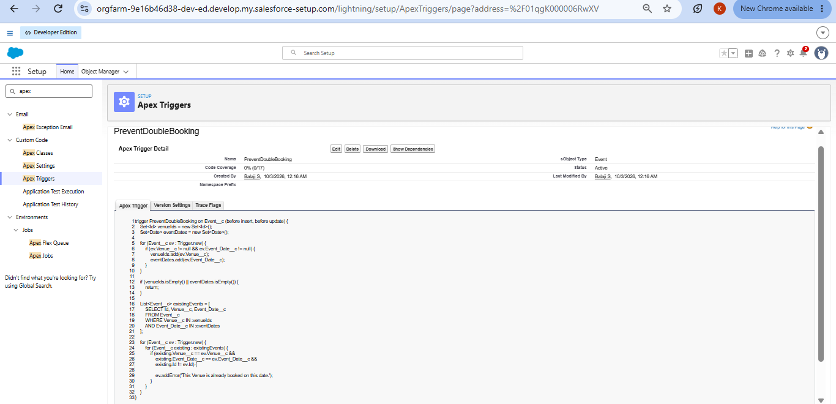

Milestone 10 : Batchable and Schedulable Asynchronous Apex
Scenario: All events whose date has passed are marked as Completed every night.

Step 1: Create the Batch Apex Class
- Click the gear icon and select Developer Console.
- Click File, then New, then Apex Class, and name it BatchCompleteEvents.
- Write the code below and save with Ctrl+S.
global class BatchCompleteEvents implements Database.Batchable<sObject> {
global Database.QueryLocator start(Database.BatchableContext bc) {
return Database.getQueryLocator(
'SELECT Id, Event_Date__c, Event_Status__c FROM Event__c ' +
'WHERE Event_Date__c < TODAY AND Event_Status__c != \'Completed\'');
}
global void execute(Database.BatchableContext bc, List<Event__c> scope) {
for (Event__c ev : scope) { ev.Event_Status__c = 'Completed'; }
update scope;
}
global void finish(Database.BatchableContext bc) {
System.debug('Past events marked as Completed');
}
}

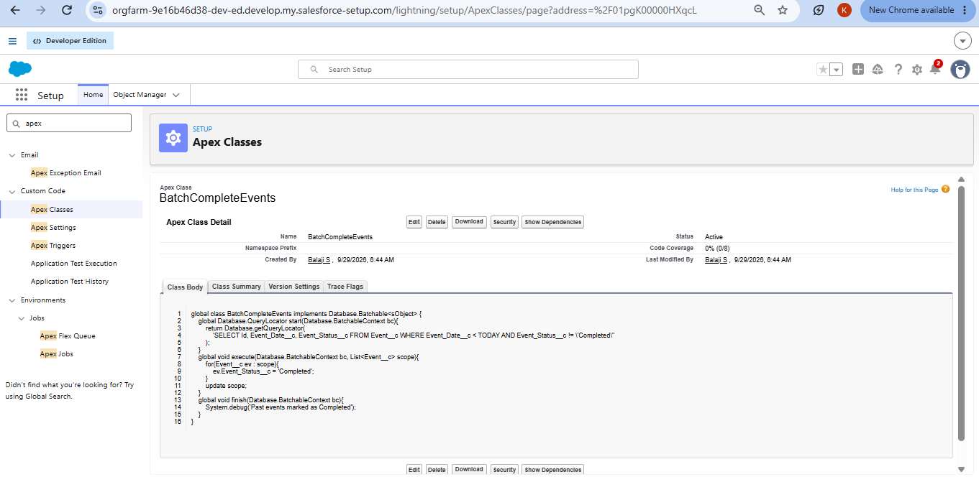

Step 2: Create the Schedulable Class
- In the Developer Console click File, then New, then Apex Class, and name it ScheduleCompleteEvents.
- Write the code below and save with Ctrl+S.
global class ScheduleCompleteEvents implements Schedulable {
global void execute(SchedulableContext sc) {
Database.executeBatch(new BatchCompleteEvents(), 200);
}
}

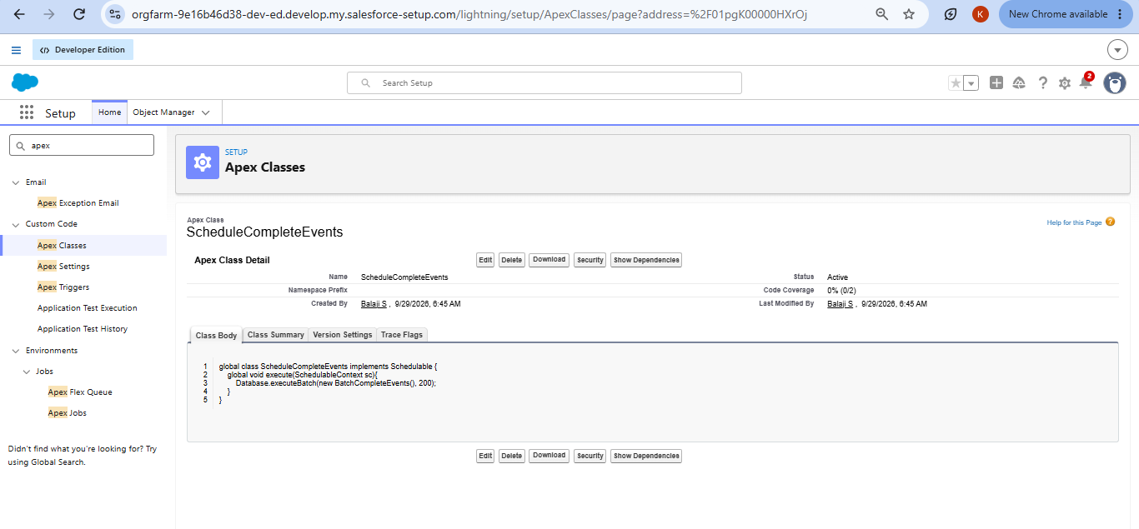

Step 3: Schedule the Job from Setup
- Click the gear icon and open Setup.
- Type Apex Classes in Quick Find and open Apex Classes.
- Click the Schedule Apex button at the top.
- Enter the Job Name Daily Event Completion and select the Apex class ScheduleCompleteEvents.
- Set Frequency to Weekly, select all days and set the Preferred Start Time to 08:00 PM.
- Click Save. Salesforce now runs BatchCompleteEvents every day at 8 PM and marks past events as Completed.

Phase 3: UI/UX Development & Customization
Phase 3 gives EventForce a simple, user-friendly interface. A custom Lightning App brings all modules, Events, Clients, Vendors, Venues and Feedback, into one workspace. Reports and a Dashboard then turn the stored records into visual summaries of event schedules, vendor activity and client feedback.
The report Upcoming Events by Month supports analysis of the event calendar, and the EventForce Operations Dashboard shows the main business figures at a glance. Together they give users a responsive, data-driven experience in the Lightning interface.

Milestone 11 : The Lightning App

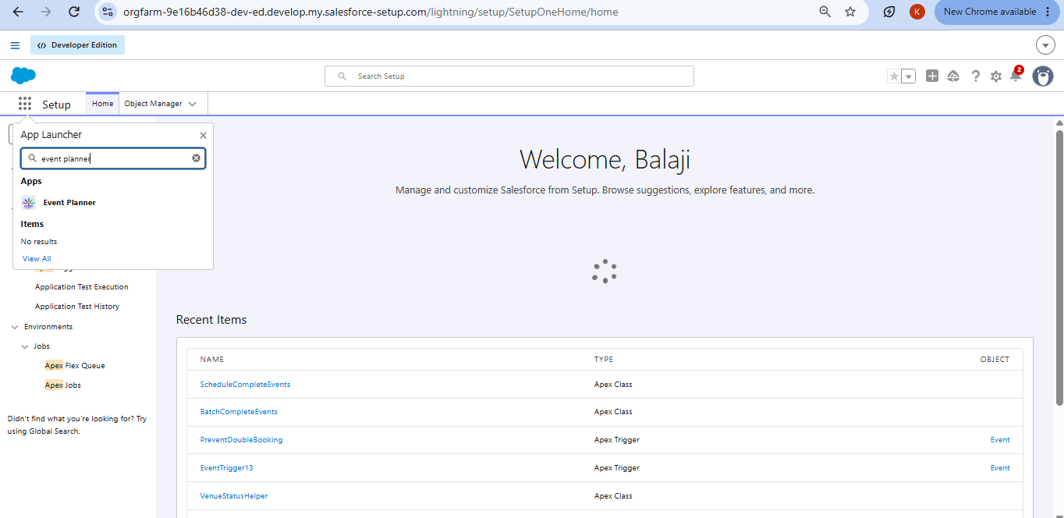

What Is an App ?
An app in Salesforce is a group of tabs that work together as a unit. It has a name, a logo and a particular set of tabs. The simplest app has just two tabs.

Activity 1: Create a Lightning App
- From Setup, type App Manager in Quick Find and select App Manager.
- Click New Lightning App. Enter Event Planner as the App Name, upload an image as the logo and click Next.
- Under App Options leave the defaults and click Next. Under Utility Items leave the defaults and click Next.
- From Available Items select Event, Client, Vendor, Venue, Feedback, Reports and Dashboards and move them to Selected Items. Click Next.
- From Available Profiles select System Administrator and move it to Selected Profiles.
- Click Save & Finish.
- To check the result, open the App Launcher, type Event Planner and select the app.

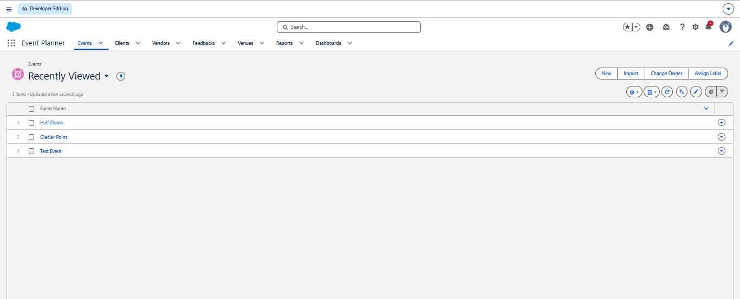

Note:
- The App Launcher shows the apps you can open.
- The App Name shows the app you are currently using.
- The Navigation Menu shows the tabs available inside the app.

Milestone 12 : Reports

Activity 1: Create a Report Folder
- Click the App Launcher and search for Reports. Open the Reports tab.
- Click New Folder and enter the Folder Label EventForce Report. The unique name fills in automatically.
- Click Save.

Activity 2: Share the Report Folder
- In the Reports tab click All Folders and open the drop-down arrow beside the EventForce Report folder, then choose Share.
- Select Share with Roles, search for Event Coordinator and Vendor Manager and give each the View access level.
- Click Share, then Done.

Activity 3: Create a Report
Note: Before creating the report, add at least 10 records to every object and fill in every field so that the report has meaningful data.
Report 1 : Upcoming Events – Summary by Month. Use: to see upcoming events and the number of events in each month.
- Open the App Launcher, go to the Reports tab and click New Report.
- Set the category to All, search for Events or Events with Client & Venue, select it and click Start Report.
- In the outline pane, add these columns: Event Name, Event Date, Event Type, Client Name, Venue Name and Event Budget. Remove any other columns. Turn on Update Preview Automatically.
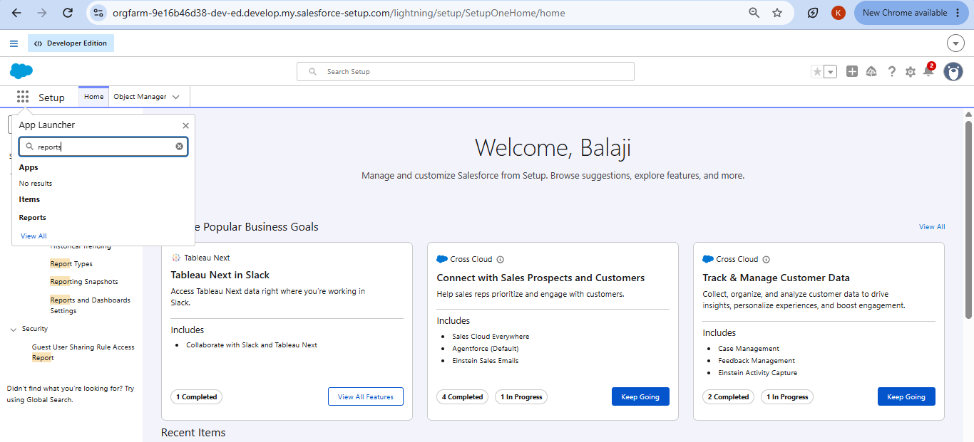
- Open Filters and apply: Show Me = All Events, Event Date greater than or equal to TODAY (or Next 30 Days), and Event Status not equal to Canceled.
- Under Group Rows choose Event Date and group it by Calendar Month.
- Click Add Summary and summarise Row Count and the SUM of Event Budget.
- Click Add Chart. Choose Column or Line, with Event Date (Calendar Month) on the X-axis and Row Count or SUM of Event Budget on the Y-axis.
- Click Save, name the report Upcoming Events by Month, choose the folder EventForce Report and click Save, then Run.

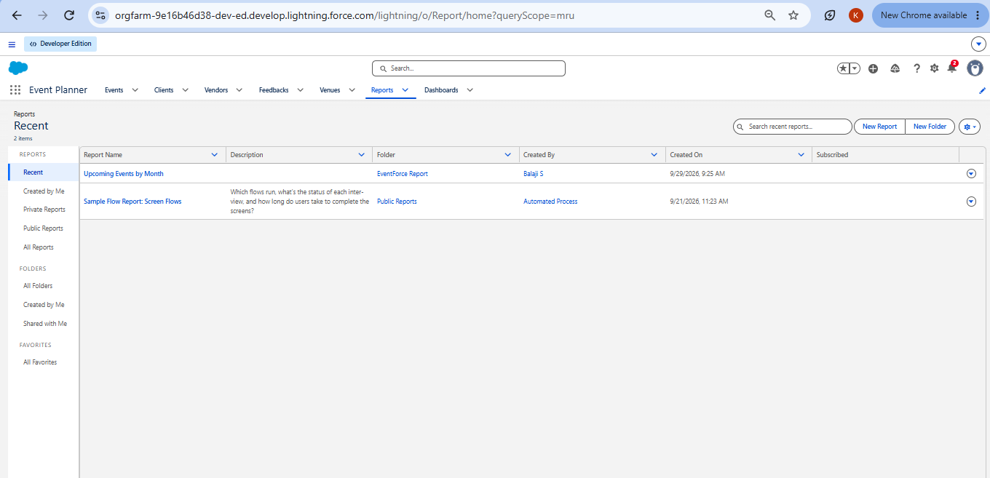

Milestone 13 : Dashboards

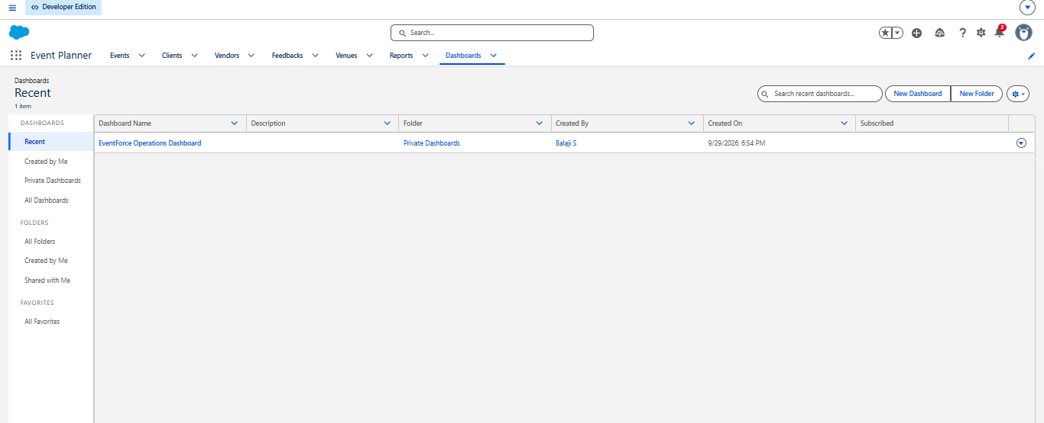

Activity 1: Create the Dashboard
- In the EventForce Management System app, open the Dashboards tab and click New Dashboard.
- Name it EventForce Operations Dashboard and click Create.
- Click + Widget and select the report Upcoming Events by Month.
- Set the chart type to Donut Chart, Max Values Displayed to 6, the Subtitle to Upcoming Events Overview and the Widget Theme to Light.
- Click Save, then Save the dashboard.
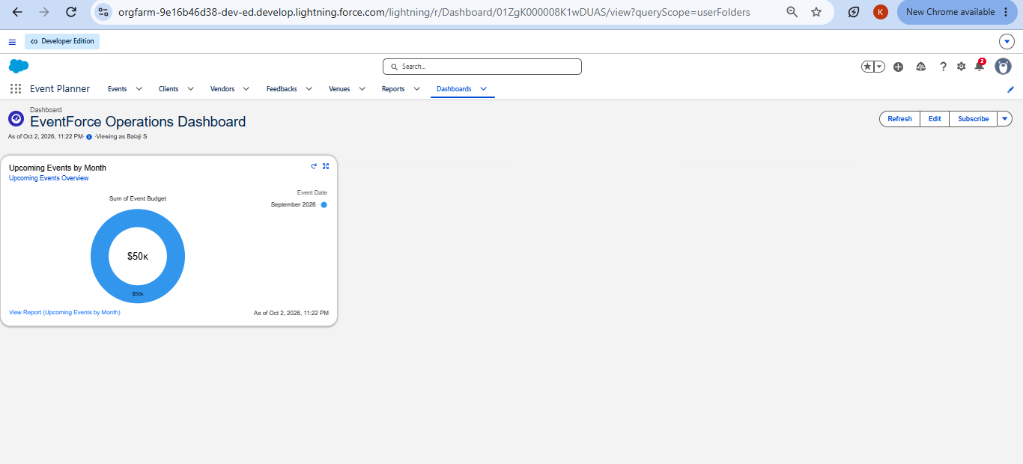

Phase 4: Data Migration, Testing & Security
Phase 4 prepares the system for use. Validated data is loaded into Salesforce, user accounts are created, and role-based access control protects the data.
Records for Events, Clients, Vendors, Venues and Feedback were imported with the Data Import Wizard after checks for duplicates and consistency. User accounts were created for the Event Admin, Event Coordinator, Vendor Manager and Client, each with its own profile and role. Security was set up with profiles, a role hierarchy, permission sets and sharing rules, and the organisation-wide defaults were set to Private so that visibility is opened only where it is needed.

Data Migration using the Data Import Wizard

Pre-Validation Checklist
- Remove duplicate clients, vendors and venues from the source files.
- Make sure every record has its required fields, such as names, dates and email addresses.
- Use the exact picklist values defined in Milestone 4, for example Event Type and Event Status.
- Save each file in CSV format with one object per file.

Import Steps
- From Setup, type Data Import Wizard in Quick Find and open it. Click Launch Wizard.
- Choose Custom Objects, select the object to load (Client first, then Venue, Vendor, Event and Feedback) and choose Add new records.
- Upload the CSV file and click Next.
- Check the field mapping, matching each column to the correct Salesforce field, and click Next.
- Click Start Import and monitor progress under Bulk Data Load Jobs.
- Open the object tab and confirm the records and their relationships.

Milestone 14 : Profile

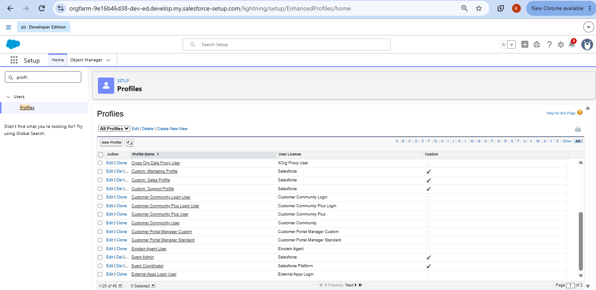

What Is a Profile ?
A profile is a collection of settings and permissions that define what a user can do in Salesforce. It controls object permissions, field permissions, user permissions, tab settings, app settings, Apex class access, page layouts, record types, login hours and login IP ranges. A profile can be given to many users, but each user has only one profile.
Profile | Cloned From | Object Access
Event Admin | System Administrator | Full access to all objects (it already has Modify All Data, Customize Application and full CRUD)
Event Coordinator | Standard Platform User | Event: Create, Read, Edit, Delete; Client: Read, Edit; Vendor: Read; Venue: Read; Feedback: Create, Read
Vendor Manager | Standard Platform User | Vendor: Create, Read, Edit, Delete; Event, Venue, Client and Feedback: Read only
Client Profile | Standard Platform User | Event: Read only (own events); Feedback: Create, Read; Vendor and Venue: no access

Activity 1: Create the Event Admin Profile
- From Setup, type Profiles in Quick Find and click New Profile.
- Select the existing profile System Administrator, enter the profile name Event Admin and click Save.
Cloning System Administrator gives Event Admin full access from the start. Permissions can be reduced later if required.
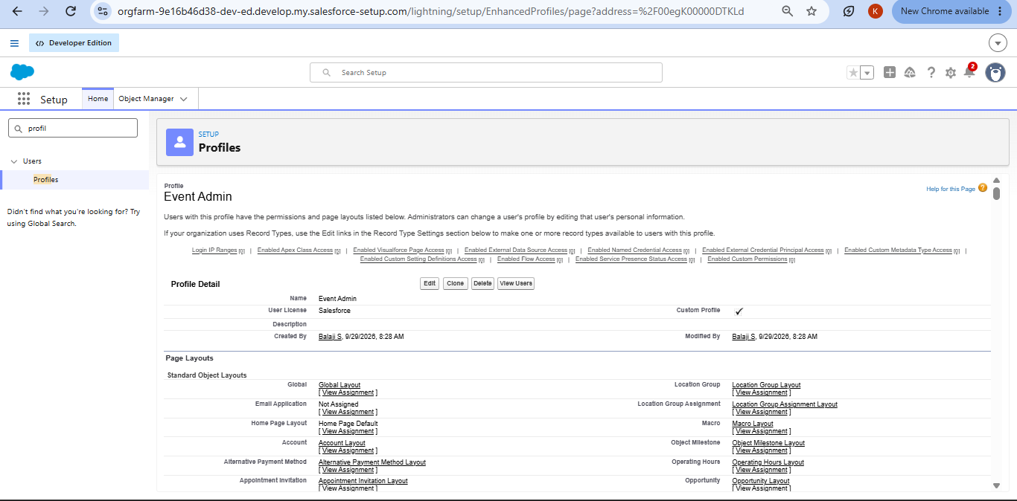

Activity 2: Create the Event Coordinator Profile
- From Setup, open Profiles and click New Profile.
- Select the existing profile Standard Platform User and enter the name Event Coordinator. Click Save.
- Click Edit. Set the Custom App setting to Event Planner as default.
- Scroll to Custom Object Permissions and grant: Event – Create, Read, Edit, Delete; Client – Read, Edit; Vendor – Read; Venue – Read; Feedback – Create, Read.
- Under Session Settings set the timeout to 2 hours of inactivity.
- Under Password Policies set passwords to never expire and the minimum length to 8, then click Save.

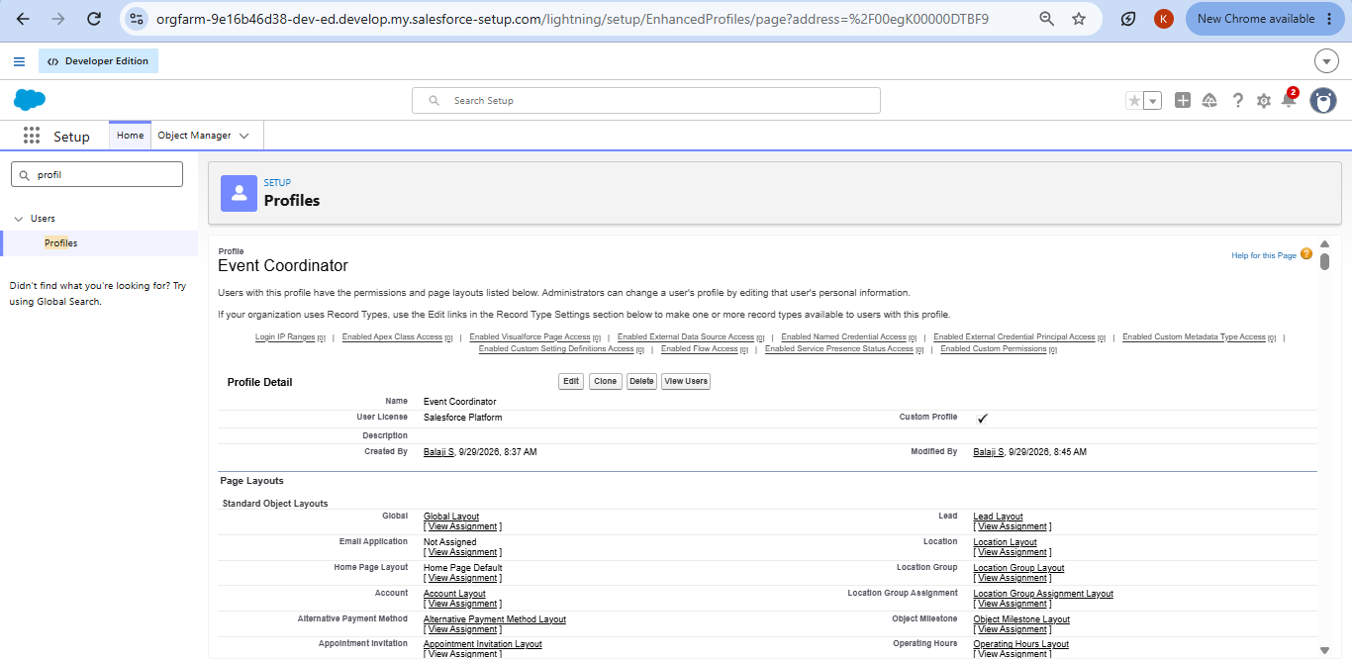

Activity 3: Create the Vendor Manager Profile
- Click New Profile, select Standard Platform User and enter the name Vendor Manager. Click Save, then Edit.
- Set Event Planner as the default custom app.
- Grant Vendor – Create, Read, Edit, Delete, and Read only on Event, Venue, Client and Feedback.
- Set the session timeout to 2 hours, passwords to never expire and the minimum length to 8, then Save.

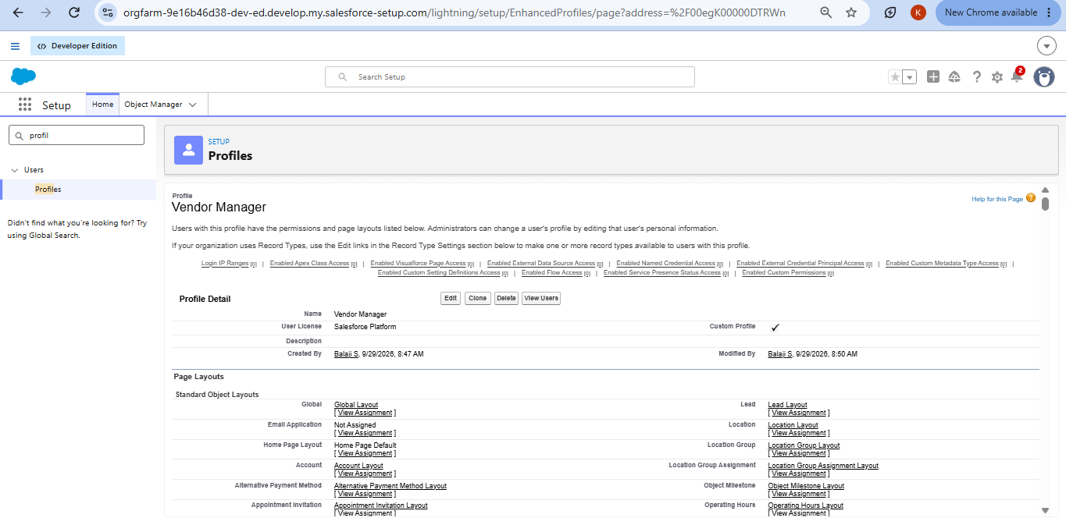

Activity 4: Create the Client Profile
- Click New Profile, select Standard Platform User and enter the name Client Profile. Click Save, then Edit.
- Set Event Planner as the default custom app.
- Grant Event – Read only (for their own events), Feedback – Create, Read, and no access to Vendor and Venue.
- Set the session timeout to 2 hours, passwords to never expire and the minimum length to 8, then Save.
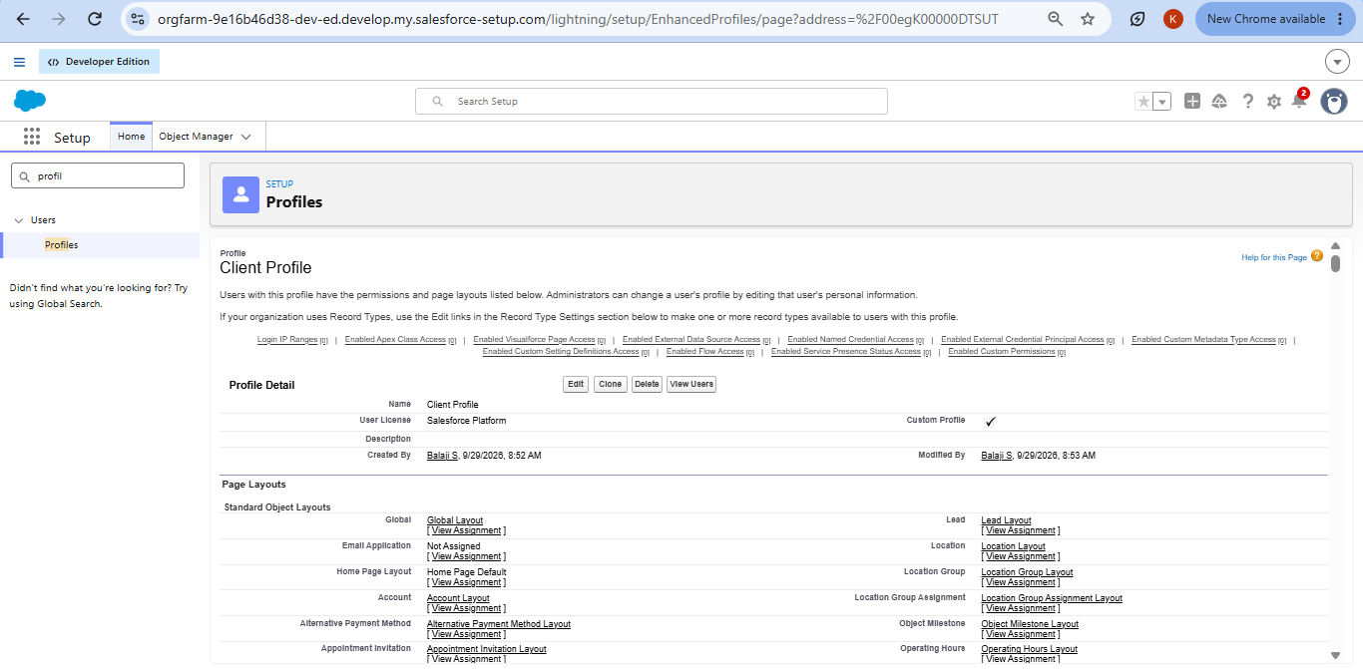

Milestone 15 : Role
Roles control which users can see certain data and also define the reporting hierarchy of the organisation. Users in higher roles get wider access to data.
Role | Position in the Hierarchy
Event Admin | Directly under CEO
Event Coordinator | Under Event Admin
Vendor Manager | Under Event Admin
Client | Under Event Admin

Activity 1: Create the Event Admin Role
- In Quick Find search for Roles and open the Roles option, then select Set Up Roles.
- Click Expand All and click Add Role under CEO.
- Enter the label Event Admin. The role name fills in automatically. Click Save.

Activity 2: Create the Other Roles
- Under Event Admin click Add Role, enter the label Event Coordinator and click Save.
- Repeat to create the roles Vendor Manager and Client, each under Event Admin.
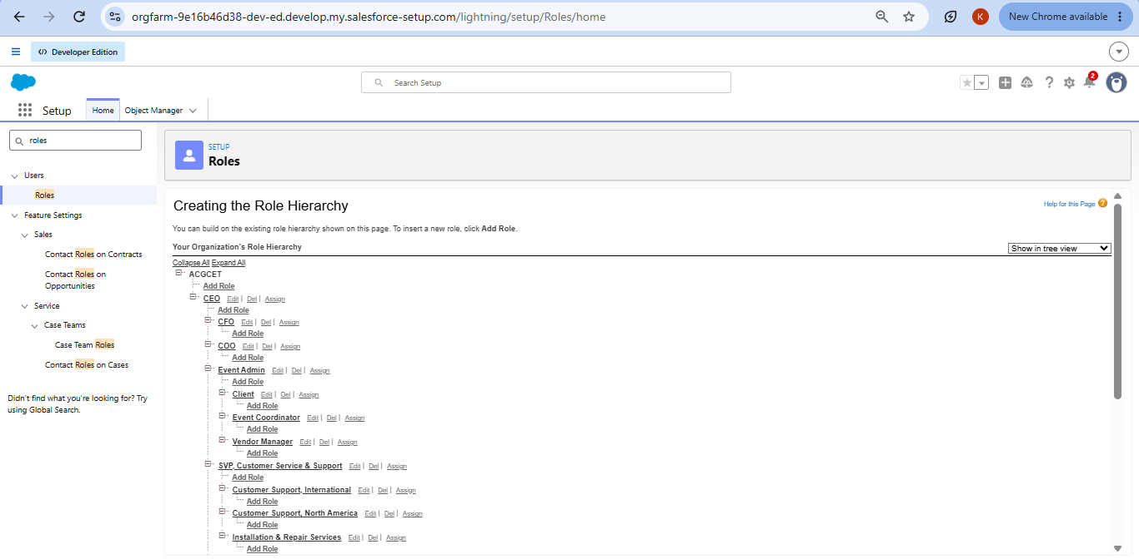

Milestone 16 : User
A user is anyone who logs in to Salesforce. Each user has an account that identifies them, and the account settings decide which features and records they can use.
Note: A Developer Edition org allows only two users to hold a Salesforce licence. If no licence is free, deactivate a user who has one or change the licence type from Salesforce to another type.

Activity 1: Create a User
- From Setup, type Users in Quick Find and select Users. Click New User.
- Fill in the First Name, Last Name, Alias, Email, a unique Username in email format and a Nickname.
- Set Role to Event Admin, User License to Salesforce and Profile to Event Admin.
- Click Save.

Activity 2: Create the Other Users
- Repeat the steps to create users for the roles Event Coordinator, Vendor Manager and Client.
- For these users choose the User License Salesforce Platform and the matching profile.
User Role | Licence | Profile
Event Admin | Salesforce | Event Admin
Event Coordinator | Salesforce Platform | Event Coordinator
Vendor Manager | Salesforce Platform | Vendor Manager
Client | Salesforce Platform | Client Profile

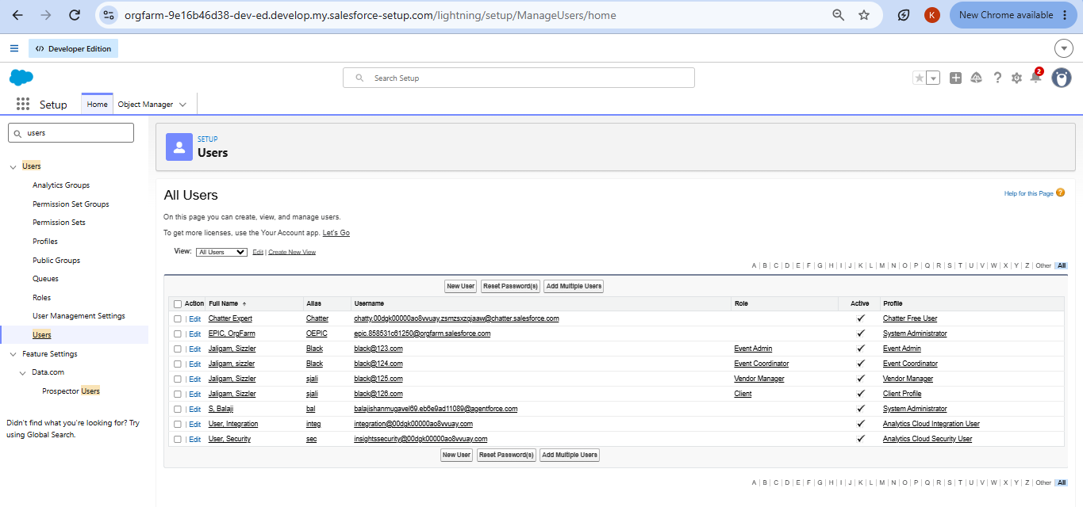

Milestone 17 : Permission Set
A permission set is a collection of settings and permissions that gives users extra access to tools, features and objects without changing their profile.

Activity 1: Create a Permission Set
- Go to Setup, type Permission Set in Quick Find, select Permission Sets and click New.
- Enter the Label Feedback Manager and click Save.
- Open Object Settings, search for the Feedback object and click Edit.
- Under Object Permissions enable Read, Edit, Create and Delete, then Save.
- Click Manage Assignments, then Add Assignment.
- Select the user with the Event Coordinator role, click Next and then Assign.

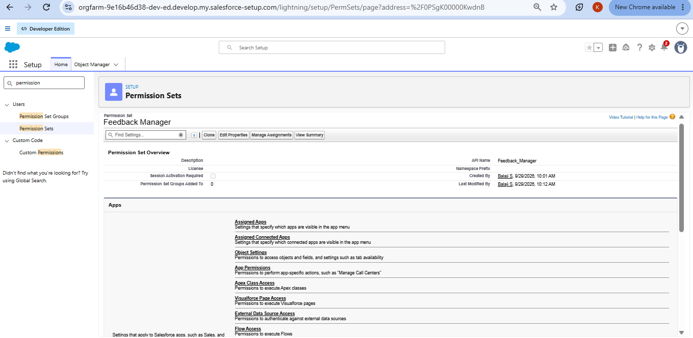

Milestone 18 : Sharing Settings
Sharing settings control how records are accessed and shared in the organisation. They protect data security and privacy.

Organization-Wide Default (OWD) Settings:
OWD is the baseline level of access to records. Role hierarchy, sharing rules, manual sharing and Apex sharing can then open access further, but cannot restrict below the OWD.
OWD Option | Meaning
Private | Only the record owner and users above the owner in the role hierarchy can see or edit the record.
Public Read Only | All users can view records, but only the owner and users above can edit them.
Public Read/Write | All users can view and edit records, whatever the ownership.
Controlled by Parent | A child record follows the access of its parent record (for example, a detail record in a master-detail relationship).

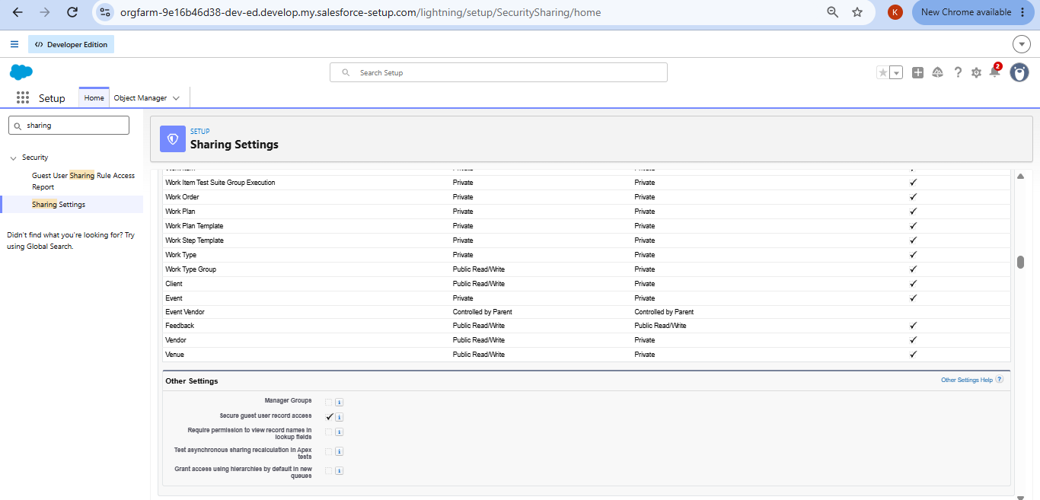

Activity 1: Configure the OWD for Event
- Go to Setup, then Sharing Settings, and click Edit in the Organization-Wide Defaults section.
- Find the Event object and set Default Internal Access to Private. Set Default External Access to Private as well.
- Click Save.

Sharing Rules:
Sharing rules open records to more users based on conditions. They are used for objects whose OWD is Private or Public Read Only, because sharing rules can only extend access and never restrict it. There are two types: owner-based sharing rules and criteria-based sharing rules.

Activity 2: Create a Sharing Rule
- In Sharing Settings, scroll to the Event object’s sharing rules and click New.
- Enter the Label Event_Sharing_For_Vendors. The rule name fills in automatically.
- In step 3, select the records to be shared: members of Roles, then Event Coordinator.
- In step 4, share with Roles, then Vendor Manager.
- In step 5, set the access level to Read Only and click Save.
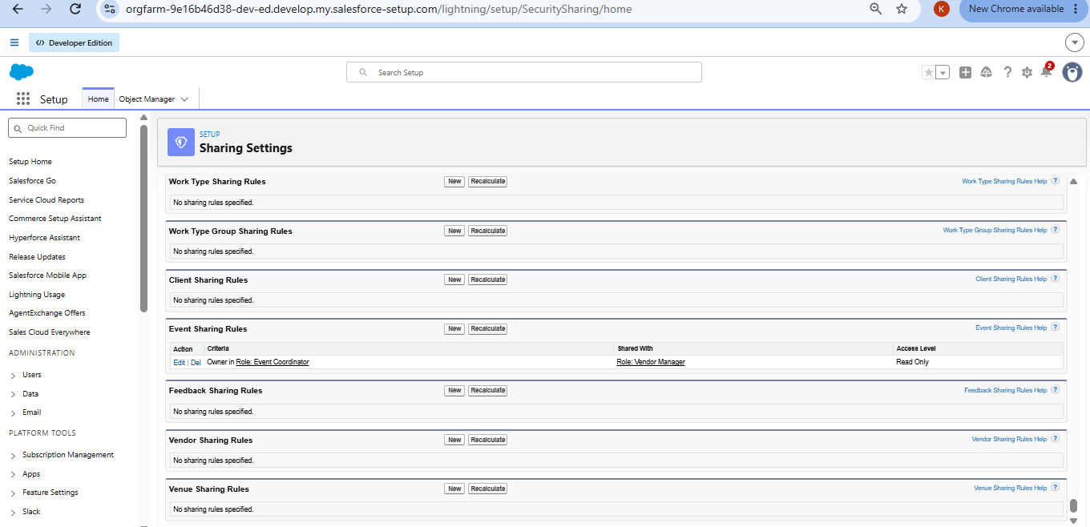

7. FUNCTIONAL & PERFORMANCE TESTING
After configuration, the application was tested in the Developer Edition org. Screenshots were captured to confirm that events, venues, vendors, approvals, reminders, batch processing, dashboards and security all behave as designed. The tests also covered the speed and correctness of the automation when many records are processed.
ID | Feature | Test Step | Expected Result
T-01 | Validation rule | Save a Client with an invalid email address | Error message appears and the record is not saved
T-02 | Formula field | Create events of different types | Event Budget matches the amount defined for each type
T-03 | Lookup filter | Create Feedback for a client | Only that client’s events can be chosen
T-04 | Junction object | Assign two vendors to one event | Both Event Vendor records are saved
T-05 | Venue status trigger | Confirm an event with a venue | Venue Availability Status becomes Reserved
T-06 | Double booking | Create two events at one venue on one date | The second event is blocked with an error
T-07 | Approval process | Change an event to Pending Cancellation and submit it | Approver is notified; on approval the status becomes Canceled
T-08 | Rejection path | Reject a cancellation request | Status becomes Rejected and the owner is notified
T-09 | Flow reminder | Confirm an event three days ahead | Client receives the reminder email
T-10 | Batch Apex | Run the batch with past-dated events | Events with past dates become Completed
T-11 | Scheduled Apex | Check Scheduled Jobs | Daily Event Completion is listed with the next run time
T-12 | Reports and dashboard | Open the report and dashboard | Figures match the event records
T-13 | Security | Log in as each user | Each user sees only the tabs, objects and records allowed

Test Evidence

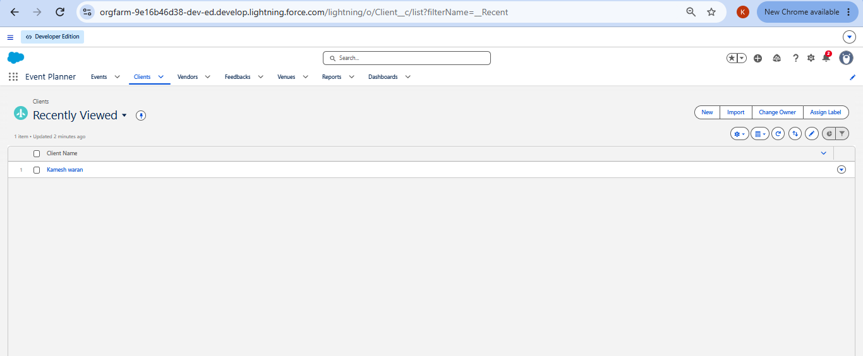

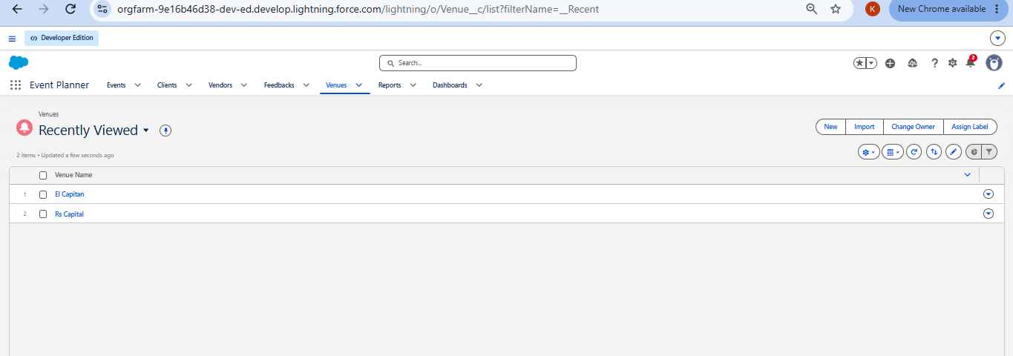

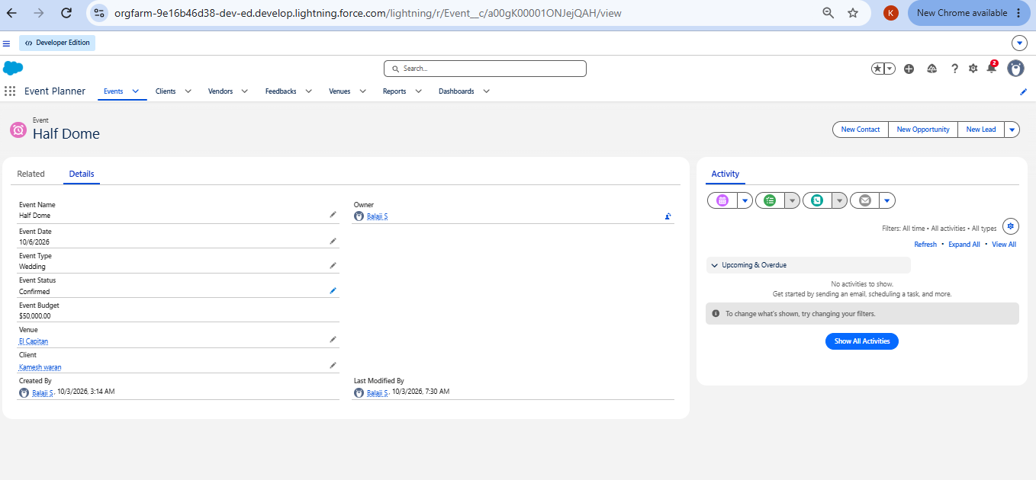

Performance Observations
- Triggers handle records in bulk, so loading many events at once does not hit Salesforce limits.
- The batch job processes events in groups of 200, and the schedule runs outside working hours.
- Reports and the dashboard refresh quickly on the data volumes used in the test org.

8. ADVANTAGES & DISADVANTAGES

Advantages
- Centralised Data Management – Event, Client, Vendor, Venue, Feedback and EventVendor data is managed in one Salesforce org.
- Process Automation – Flows automate reminders and other routine processes and reduce manual effort.
- Double-Booking Prevention – The Apex trigger and VenueStatusHelper check venue availability and avoid booking conflicts.
- Controlled Cancellation – The Approval Process gives event cancellation requests a structured path.
- Operational Visibility – Reports and dashboards show event schedules, vendor activity and feedback.
- Secure Access – Profiles, roles, permission sets, OWD and sharing rules control who sees which records.
- Scalability – Salesforce can support more users, records and requirements as the business grows.
- Better Data Quality – Validation rules and pre-checks during migration keep records accurate and consistent.

Disadvantages
- Developer Edition Limits – The project was built in a Developer Edition org for academic purposes and is not connected to a production environment.
- No Production Deployment – Moving the solution to production was outside the scope of this work.
- Extra Tools for Deployment – Real deployments may need sandboxes, change sets, Salesforce DX or CI/CD tools.
- Configuration Complexity – Managing Flows, Apex, approvals and security needs solid Salesforce knowledge.
- Ongoing Maintenance – Flows, Apex jobs, approvals, validation rules and sharing settings need regular monitoring.

9. CONCLUSION
The EventForce Management System shows how Salesforce can simplify and automate event planning and management. Events, Clients, Vendors, Venues, Feedback and EventVendor data now live on one platform.
The implementation brings together Salesforce Lightning, Flows, validation rules, formula fields, the Approval Process, Apex triggers and classes, Batch and Scheduled Apex, security controls, Reports and Dashboards. This automation covers event reminders, cancellation approvals, venue availability, double-booking prevention and event completion.
The project also shows why data migration, testing, security, documentation and maintenance matter in a Salesforce implementation. Although it was built and tested in a Developer Edition org without a production deployment, it follows real-world practice and is a solid base for future growth.

10. FUTURE SCOPE
The system can be extended to support larger event operations and to improve automation, integration and the user experience.
- Production Deployment – Deploy the solution from development to a production org with suitable deployment tools.
- Advanced Event Automation – Extend automation to more event planning and operational activities.
- Enhanced Vendor Management – Add richer vendor tracking and performance management.
- Advanced Analytics – Create more reports and dashboards for events, venues, vendors and client feedback.
- External Integrations – Connect Salesforce with outside systems and services used in event operations.
- Mobile Accessibility – Make event management convenient on mobile devices.
- Scalability Enhancements – Support more events, clients, vendors, venues and users.
- Continuous Maintenance – Keep improving Flows, Apex, validation rules and sharing settings as needs change.
These enhancements can grow the current EventForce implementation into a fuller, enterprise-ready event management CRM.

11. APPENDIX

Appendix Summary
Part | Content
A. Custom Objects | Event, Client, Vendor, Venue, EventVendor, Feedback
B. Automation | Flows, validation rules, Approval Process, Apex triggers and classes
C. Processing | Batch Apex and Scheduled Apex
D. Security | Profiles, roles, permission sets, OWD, sharing rules
E. Data Migration | Salesforce Data Import Wizard
F. UI & Analytics | Lightning App, Reports and Dashboards
G. Testing & Documentation | Configuration testing, security testing, automation testing and project documentation

Thank You

