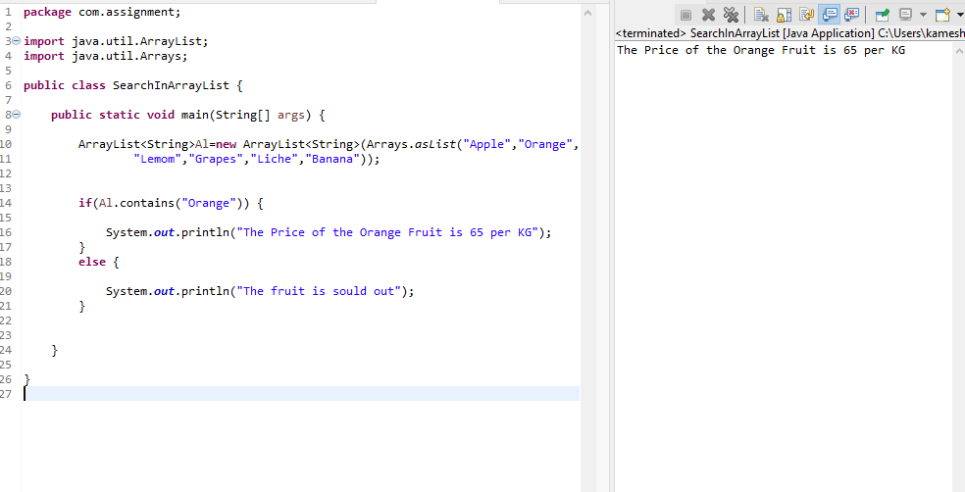1.  Java program to search an element in a array list

2. Write a Java program to sort a given array list

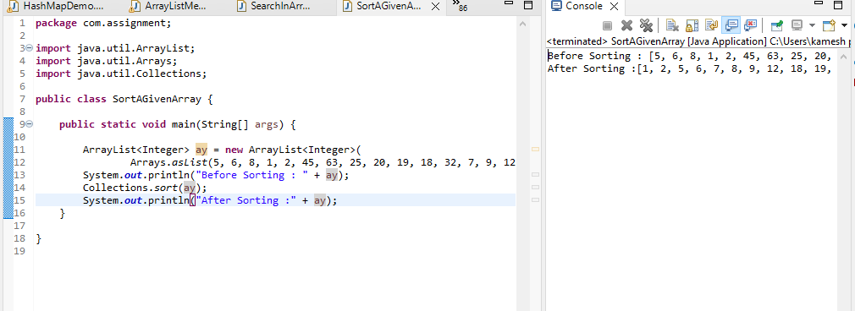

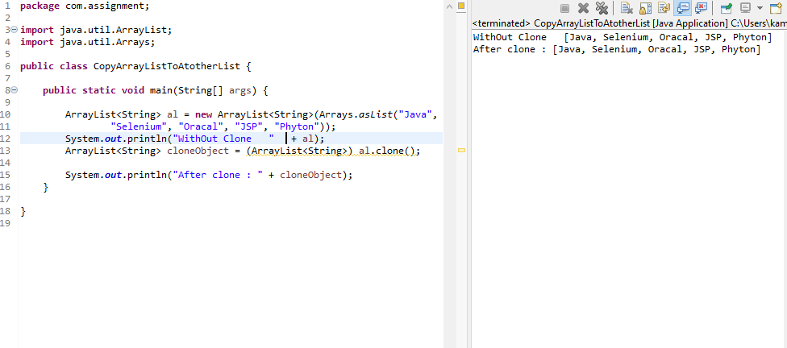3. Write a Java program to copy one array list into another

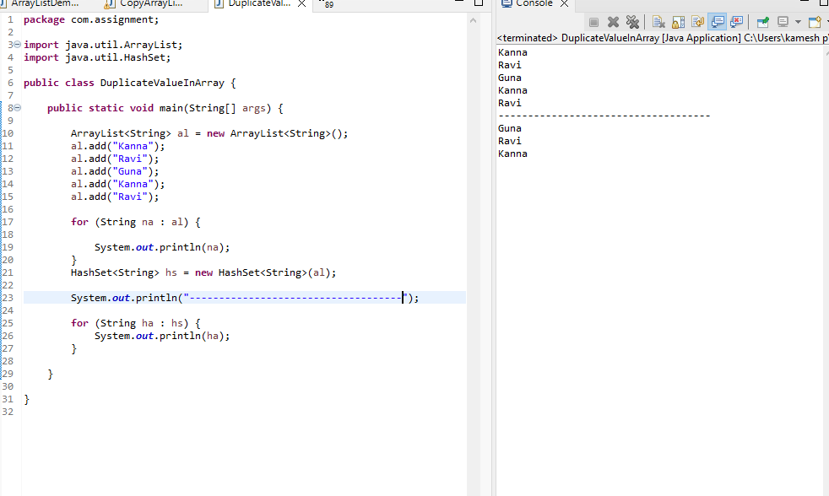4. Remove Duplicate value from Array List

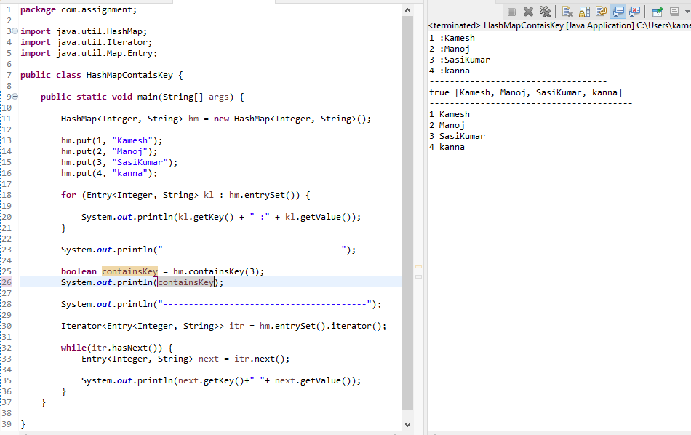5. Write a Java program to test if a map contains a mapping for the specified key

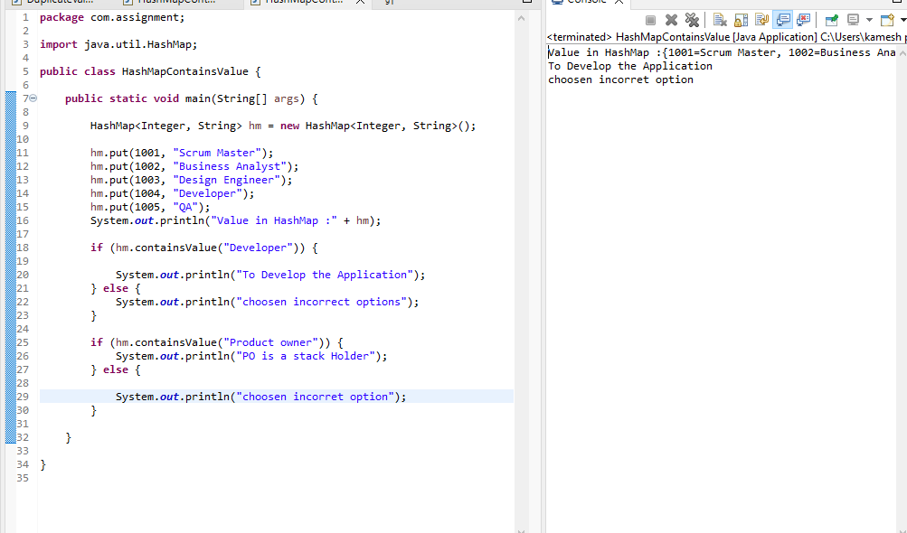6. Java program to test if a map contains a mapping for the specified value

7. Java program to create a set view of the mappings contained in a map

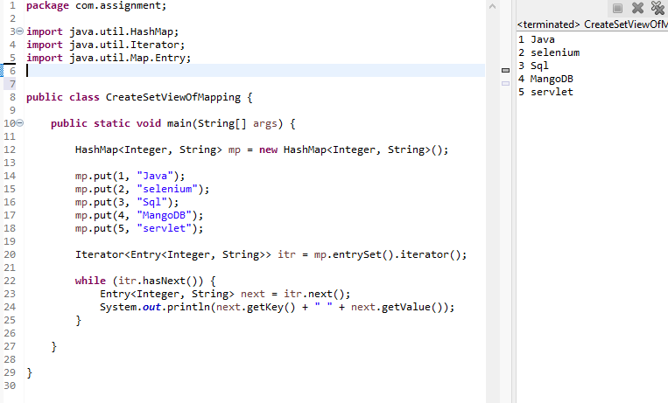

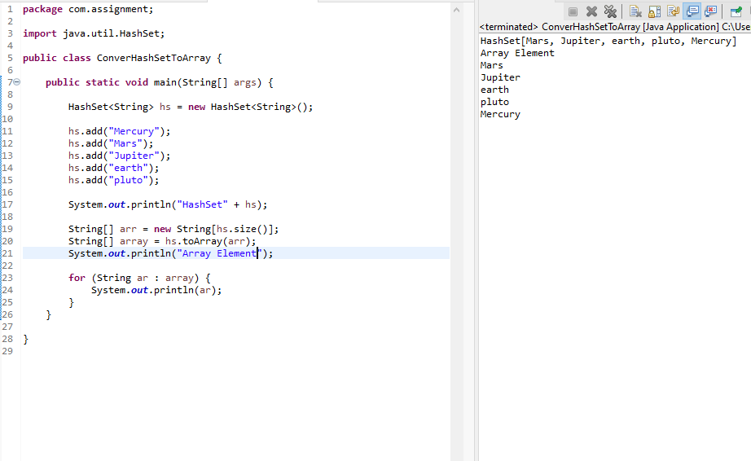8.  Java program to convert a hash set to an array

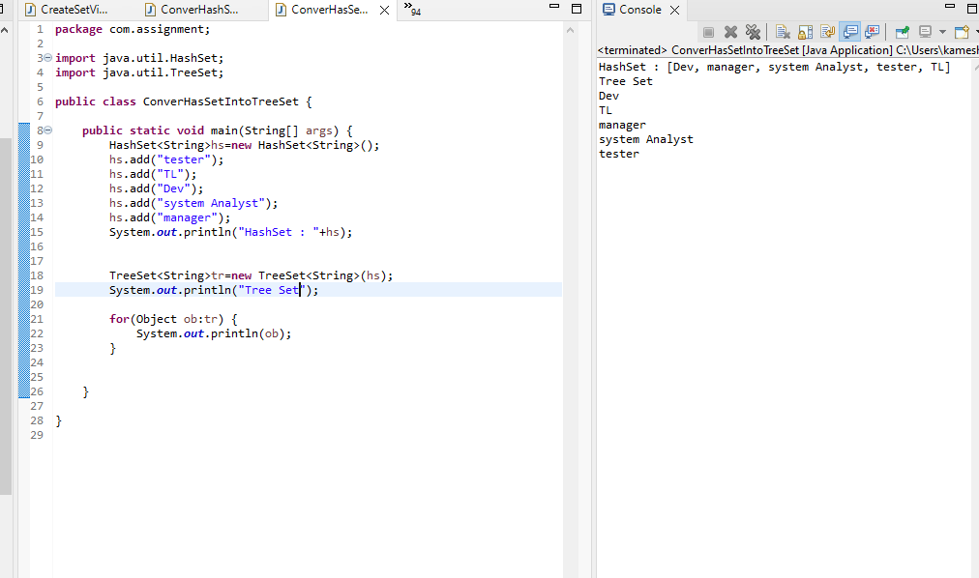9.  Java program to convert a hash set to a tree set