EQUILOAN: FAIRNESS AWARE, CALIBRATED AND EXPLAINABLE
LOAN APPROVAL DECISION SUPPORT SYSTEM

A PROJECT REPORT

Submitted by
[KAMESHWAR M] [210425243106]
[MITHRA VEERA A] [210425243148]
[VIJAYARAGAVAN K] [210425243316]

in partial fulfillment for the award of the degree of
BACHELOR OF TECHNOLOGY
in
ARTIFICIAL INTELLIGENCE AND DATA SCIENCE

DEPARTMENT OF ARTIFICIAL INTELLIGENCE AND DATA SCIENCE
CHENNAI INSTITUTE OF TECHNOLOGY (AUTONOMOUS)
Chennai 600 069
2026

BONAFIDE CERTIFICATE
Certified that the project report entitled “EquiLoan: Fairness Aware, Calibrated and Explainable Loan Approval Decision Support System” is the bonafide work of [STUDENT NAME 1] and [STUDENT NAME 2], carried out under the supervision of [SUPERVISOR NAME], Department of Artificial Intelligence and Data Science, Chennai Institute of Technology.

HEAD OF THE DEPARTMENT PROJECT SUPERVISOR

INTERNAL EXAMINER EXTERNAL EXAMINER

ACKNOWLEDGEMENT
We express our sincere thanks to the management and faculty members of Chennai Institute of Technology for providing the facilities required to carry out this undergraduate project. We thank the Head of the Department of Artificial Intelligence and Data Science for the support given throughout the work.
We are grateful to our project supervisor, [DR. G. SANMUGASUNDARAM]Sir, for the regular guidance, technical suggestions and feedback given during the development of this project. The discussions on data preparation, model evaluation and responsible use of machine learning helped us shape the work in a clear direction.
We also thank the faculty members, laboratory staff and our classmates for their suggestions during the different stages of the project. Finally, we thank our families for their support and encouragement during the completion of this work.

ABSTRACT
Loan approval is a common classification problem in data science, but a model that only reports high accuracy does not give enough information for a real decision setting. This project studies loan approval prediction as a complete data science problem that includes data quality, class imbalance, model comparison, probability reliability, fairness, explainability and uncertainty. The work uses a loan dataset with 148,670 records and 37 columns. The target variable is status, where 0 represents an approved application and 1 represents a rejected application. The original data is imbalanced, with 111,273 approved records and 37,397 rejected records.
The project compares standard classification models such as Logistic Regression, Decision Tree, Random Forest, Gradient Boosting, XGBoost, Naive Bayes and Support Vector Machine. Preprocessing is kept inside the machine learning pipeline so that missing value handling, encoding, scaling and feature selection are learned only from training data. A leakage audit is included because some interest related fields may contain information that is available only after an underwriting decision. The project also compares the original class distribution with balanced training strategies instead of assuming that a 50:50 dataset is always better.
The main value addition is the joint study of prediction quality, calibration, fairness, confidence based abstention and explanation. Platt scaling and isotonic calibration are considered for reliable probabilities. Group level fairness is studied across available demographic or proxy variables. A three state output is proposed so that uncertain cases can be sent for human review instead of being forced into approve or reject. SHAP based interpretation and constrained counterfactual examples are used to explain model behaviour. Cross validation is used to check whether results and important features remain stable across different folds. The novelty of the student project lies in this combined experimental design and in the comparison of trade offs, not in claiming that any single machine learning algorithm is new.
Keywords: Loan Approval, Data Science, Machine Learning, Fairness, Probability Calibration, Explainable AI, Human Review, Cross Validation

TABLE OF CONTENTS
1 INTRODUCTION
1.1 Background
1.2 Problem Statement
1.3 Objectives
1.4 Significance of the Project
1.5 Scope
1.6 Limitations of Existing Systems
1.7 Overview of Proposed System
2 LITERATURE REVIEW
2.1 Existing Research
2.2 Key Observations
2.3 Research Gaps
2.4 Novelty and Value Addition
3 METHODOLOGY
3.1 System Overview
3.2 Problem Solving Approach
3.3 Technologies Used
3.4 System Architecture
3.5 Data Collection and Description
3.6 Data Preprocessing Strategy
3.7 Feature Engineering
3.8 Models and Experimental Setup
3.9 Training and Evaluation
3.10 Fairness, Calibration and Explainability
3.11 Existing System and Proposed Work
4 IMPLEMENTATION AND DEVELOPMENT PROCESS
4.1 Implementation Overview
4.2 System Modules
4.3 Dashboard Design
4.4 Challenges and Mitigation
5 TESTING AND VALIDATION
5.1 Testing Objectives
5.2 Testing Strategy
5.3 Data Pipeline Validation
5.4 Machine Learning Validation
5.5 Fairness and Calibration Validation
5.6 Test Cases
6 RESULTS AND DISCUSSION
6.1 Dataset Observations
6.2 Experimental Result Plan
6.3 Expected Comparison Tables
6.4 Discussion Framework
7 CONCLUSION
7.1 Summary
7.2 Key Contributions
7.3 Limitations
7.4 Future Enhancements
REFERENCES
APPENDIX

LIST OF FIGURES
Figure 1.1 Target Distribution in the Original Dataset
Figure 3.1 EquiLoan Data Science Workflow
Figure 3.2 Proposed Three State Decision Layer

LIST OF TABLES
Table 1.1 Dataset Summary
Table 2.1 Literature Comparison
Table 2.2 Novelty Matrix
Table 3.1 Main Feature Groups
Table 3.2 Planned Models
Table 3.3 Evaluation Metrics
Table 3.4 Existing System and Proposed Work
Table 5.1 Core Test Cases
Table 6.1 Dataset Level Observations
Table 6.2 Model Comparison Template

SYMBOLS AND ABBREVIATIONS
Acronym | Expansion
AI | Artificial Intelligence
ML | Machine Learning
DS | Data Science
LR | Logistic Regression
DT | Decision Tree
RF | Random Forest
SVM | Support Vector Machine
XGB | Extreme Gradient Boosting
SHAP | SHapley Additive exPlanations
SPD | Statistical Parity Difference
DIR | Disparate Impact Ratio
ROC AUC | Area Under the Receiver Operating Characteristic Curve
PR AUC | Area Under the Precision Recall Curve
ECE | Expected Calibration Error
CV | Cross Validation

CHAPTER 1
INTRODUCTION

1.1 Background
Banks and lending institutions process a large number of loan applications. Each application contains information about the applicant, the requested loan, credit history, income, property details and other financial factors. A loan decision must consider several of these variables together. Manual checking can take time and can also differ from one evaluator to another. For this reason, loan approval prediction has become a common application of machine learning.
From a data science point of view, the problem is more than selecting a classifier. The data can contain missing values, categorical variables, class imbalance and fields that may accidentally reveal the target. A model may also produce a high accuracy while making poor decisions for the smaller class. In addition, a predicted probability may not represent a reliable level of confidence. These issues make the project suitable for a complete data science workflow that covers data understanding, preprocessing, modeling, evaluation and interpretation.
The EquiLoan project studies these issues using a large tabular loan dataset. The aim is to develop a decision support framework in which model performance is checked together with probability calibration, fairness, explanation and uncertainty. The system is intended as an academic prototype and not as a real banking approval engine.

1.2 Problem Statement
Most student level loan prediction projects stop after comparing a few algorithms and reporting the model with the highest accuracy. This approach does not answer several important questions. It does not show whether the probability values are reliable, whether the model treats different groups consistently, whether the important features are stable, or what should happen when the model is uncertain. The project therefore addresses the problem of building a loan approval prediction system that is useful as a data science study rather than only as a classification demo.
The specific problem considered is to predict the loan status while reducing avoidable modeling errors caused by leakage, imbalance and overfitting. The project also studies whether a three state decision process can improve reliability by sending uncertain cases for manual review.

1.3 Dataset Summary
Item | Description
Dataset size | 148,670 records
Number of columns | 37
Target | status
Class 0 | 111,273 records, approved
Class 1 | 37,397 records, rejected
Original class ratio | approximately 74.84 percent to 25.16 percent
Data type | mixed numerical and categorical tabular data

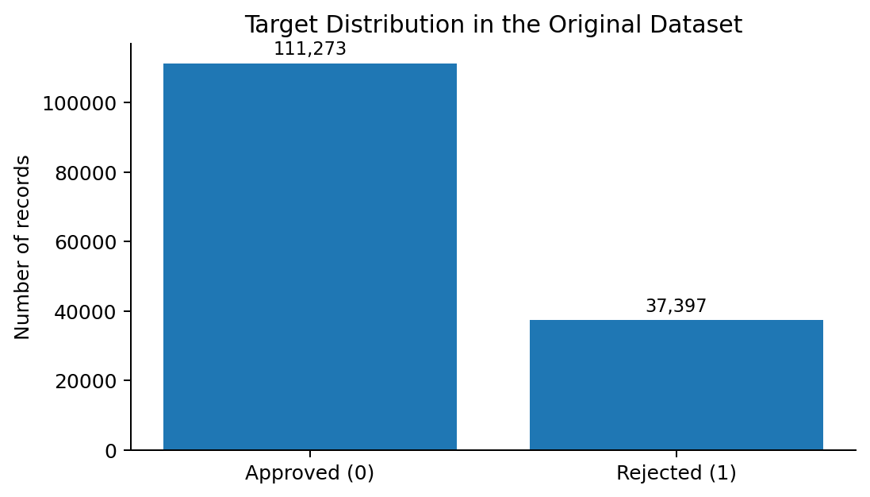
Figure 1.1 Target Distribution in the Original Dataset

1.4 Objectives

1.4.1 General Objective
To design and evaluate a reliable loan approval prediction framework using data science methods, with attention to model performance, calibration, fairness, interpretability and uncertainty.

1.4.2 Specific Objectives
- To study the structure, missing values, class distribution and possible leakage in the loan dataset.
- To compare several standard machine learning classifiers using the same evaluation procedure.
- To keep preprocessing inside the training pipeline so that information from validation or test data is not used during fitting.
- To compare the natural class distribution with suitable balancing methods such as class weights, undersampling or SMOTE applied only on training data.
- To evaluate probability calibration using Brier score, log loss and reliability curves.
- To audit group level prediction differences using available demographic or proxy attributes.
- To introduce a human review zone for uncertain predictions instead of forcing every record into a binary output.
- To explain model predictions using global and local feature contribution methods.
- To test the stability of model scores and feature importance across cross validation folds.

1.5 Significance of the Project
This project is important mainly as a data science study. It connects several topics that are usually taught separately, including exploratory data analysis, supervised learning, class imbalance, cross validation, model calibration, fairness metrics and explainable machine learning. The project also gives a practical way to discuss the limits of accuracy as a single evaluation measure.
The work is also connected to SDG 8 and SDG 10 at a project level. Faster and more consistent credit assessment can support efficient financial services, while fairness analysis can help identify whether model outputs differ across available groups. These links are treated as motivation and not as a claim that the project solves wider economic or social inequality.

1.6 Scope
- The work is limited to supervised classification on the supplied tabular loan dataset.
- The project compares classical and tree based machine learning models.
- Preprocessing, balancing, model fitting and evaluation are implemented as reproducible pipelines.
- Fairness analysis is limited to demographic or proxy fields available in the dataset.
- Explainability is used to understand model behaviour and not to claim causal relationships.
- The dashboard is intended to display model outputs, comparisons and review cases for a student prototype.

1.7 Limitations of Existing Systems
Many existing loan prediction implementations focus on accuracy and use a single train test split. Some apply oversampling before the split, which can cause leakage. Others use explanation plots without checking probability calibration or subgroup behaviour. Recent research has started to combine explainability and fairness, which means that using SHAP or fairness metrics alone is no longer enough to support a novelty claim. The proposed project therefore treats novelty as an experimental combination and comparison of several responsible data science checks.

1.8 Overview of the Proposed System
The proposed system begins with raw data and performs validation before any model is fitted. The model pipeline handles missing values, encoding and scaling where needed. A group of baseline classifiers is then trained and evaluated. The strongest candidates are checked for calibration, fairness and stability. The final prediction layer includes an uncertain zone that sends borderline applications to human review. Explanations are generated only after the predictive pipeline has been validated.

CHAPTER 2
LITERATURE REVIEW

2.1 Existing Research

2.1.1 Explainable Ensemble Loan Approval Models
Recent loan approval studies have shown that ensemble methods such as Random Forest and XGBoost can provide strong predictive performance. A 2026 study by Gawande and co authors combined Random Forest and XGBoost with SHAP, LIME and group fairness checks. This is important for our project because it shows that explainability and fairness are already active research areas in loan approval prediction. Therefore, EquiLoan does not treat SHAP or fairness auditing by itself as a new idea.

2.1.2 Fairness and Explainability in Credit Scoring
A 2026 systematic review of research published between 2020 and 2025 found that performance, fairness and explainability are becoming central concerns in AI based credit scoring. The review supports the need to evaluate more than predictive accuracy when machine learning is used in financial decision support.

2.1.3 Class Imbalance in Loan Approval
Recent loan approval work has also used SMOTE and class balancing to improve minority class learning. These techniques can be useful, but they must be applied only to training data. Applying synthetic oversampling before the train test split can make test results look better than they really are. Our project therefore treats imbalance handling as an experiment inside the training pipeline.

2.1.4 Probability Calibration in Credit Models
Credit scoring research has studied the calibration of predicted probabilities because a classification score is not automatically a trustworthy probability. Earlier work has shown that post processing methods such as Platt calibration can improve probability estimates. This motivates the use of Brier score, log loss and calibration curves in EquiLoan.

2.1.5 Fairness Beyond One Overall Metric
Recent work on credit lending has shown that a model can appear fair at an overall group level while differences can still appear inside subgroups. This is a useful reminder that a single fairness number is not enough. EquiLoan therefore plans to report subgroup results carefully and will avoid presenting fairness metrics as proof of the absence of discrimination.

2.2 Key Observations from Existing Research
Observation | Meaning for EquiLoan
Tree ensembles are strong baselines | Random Forest and XGBoost should be compared, but not assumed to be best.
Explainability is already common | SHAP alone is not a novelty claim.
Fairness auditing is increasingly used | Fairness must be part of a broader experiment.
Calibration is relevant in credit scoring | Probability quality should be measured separately from accuracy.
Class balancing can help minority recall | Balancing should be tested inside training folds.
High accuracy can hide leakage | Leakage checks are required before trusting results.

2.3 Research Gaps
The literature review suggests that no single component of EquiLoan should be presented as completely new. The gap for this student project is the way the components are studied together on the same large dataset. In particular, the project compares predictive quality, probability calibration, fairness, confidence based abstention and stability using one consistent pipeline. It also studies the effect of class balancing instead of assuming that a balanced dataset is always better.
A second gap is the treatment of uncertain applications. Standard loan classifiers usually force every record into one of two classes. EquiLoan introduces a review zone where low confidence cases are separated from high confidence decisions. The purpose is not to automate final lending decisions, but to study whether selective prediction can reduce errors on difficult cases.

2.4 Novelty and Value Addition
The novelty of this undergraduate project is an experimental and methodological novelty. It does not claim a new mathematical algorithm. The project combines several data science checks that are often studied separately and measures the trade offs between them. The main question is whether a model can remain useful when accuracy, calibration, fairness, confidence and stability are considered together.
Area | Common approach | EquiLoan value addition
Prediction | Choose model with highest accuracy | Compare accuracy with F1, ROC AUC, PR AUC and class errors
Class imbalance | Balance data once | Compare natural distribution and training only balancing methods
Probability | Use raw model probability | Measure and calibrate probability reliability
Fairness | Optional single metric | Compare group metrics with predictive performance
Decision | Approve or reject | Add human review for uncertain cases
Explainability | Single feature importance plot | Use global, local and counterfactual analysis
Robustness | One split | Use cross validation and stability checks

This contribution should be described as a candidate research contribution until the full experiment and literature review are completed. The report deliberately avoids phrases such as “the first system” because such a statement would require a much wider literature search.

CHAPTER 3
METHODOLOGY

3.1 System Overview
The project follows a standard data science life cycle. It starts with data understanding and validation, moves to preprocessing and model building, and then adds reliability checks after the baseline models are established. The dashboard is treated as the presentation layer, while the main contribution remains the data analysis and model evaluation.
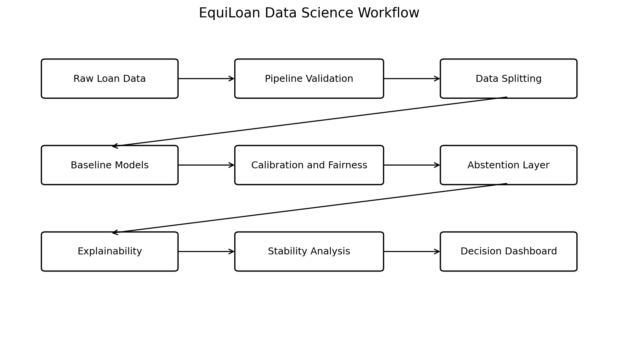
Figure 3.1 EquiLoan Data Science Workflow

3.2 Problem Solving Approach
The work is divided into controlled experiments. The first experiment uses the natural class distribution. The second studies class weighted learning. Additional experiments can use undersampling or SMOTE on training data. Each model is trained under the same split and evaluation rules so that comparisons are fair. After the baseline stage, the strongest models are checked for calibration, fairness and confidence based abstention.

3.3 Technologies Used

3.3.1 Python
Python is used because it provides a complete ecosystem for tabular data analysis, machine learning and visualization.

3.3.2 Data Processing Libraries
Pandas and NumPy are used for data inspection and numerical operations. Matplotlib is used for plots and evaluation charts.

3.3.3 Machine Learning Libraries
Scikit learn is used for pipelines, preprocessing, model training, cross validation, calibration and evaluation. XGBoost can be used as an additional gradient boosting baseline if the environment supports it.

3.3.4 Explainability and Fairness Tools
SHAP is planned for global and local feature contribution analysis. Fairness metrics can be calculated directly from confusion matrix values and group prediction rates, or with a suitable fairness library if required.

3.3.5 Development Environment
Jupyter Notebook or Google Colab can be used for experiments. A lightweight dashboard can be developed using Streamlit or a similar Python based framework after the model study is complete.

3.4 Data Collection and Description
The supplied dataset contains 148,670 records and 37 columns. The target column is status. The dataset contains numerical and categorical attributes related to loan terms, income, property, credit information and applicant characteristics. The original data is retained as the reference dataset. No manual cleaning is performed before the modeling workflow. Cleaning decisions are made inside the pipeline so that the experiment remains reproducible.
Feature group | Example fields
Identifiers | id, Unnamed: 0, year
Applicant information | gender, age, region, senior_age
Loan details | loan_type, loan_purpose, loan_amount, term
Financial information | income, property_value, ltv, dtir1
Credit information | credit_score, credit_type, credit_worthiness
Interest and charges | rate_of_interest, interest_rate_spread, upfront_charges
Target | status

3.5 Data Preprocessing Strategy
Preprocessing is not carried out by manually editing the source file. Instead, preprocessing steps are fitted only on training data. Numerical columns can use median imputation where justified. Categorical columns can use mode imputation and one hot encoding. Scaling is used only for models that need it. Identifier columns are not automatically removed before validation; they are first checked to confirm whether they are non predictive or could cause memorization.
A separate leakage audit is performed for rate_of_interest, interest_rate_spread, upfront_charges and high_interest_rate. These fields may have a relationship with the final underwriting result because some values may be set only after approval. Models are therefore compared with and without these fields. If performance drops sharply when they are removed, the result is investigated before any model is accepted.

3.6 Class Imbalance Strategy
The original target distribution is about three approved applications for every rejected application. The project does not assume that a 50:50 dataset is automatically better. Instead, imbalance handling is treated as part of the experiment. Natural distribution, class weights, undersampling and SMOTE can be compared. Synthetic sampling methods are applied only inside the training folds. Validation and test data keep their original distribution so that the final scores remain realistic.

3.7 Feature Engineering
Feature engineering is limited to variables that have a clear financial meaning and can be calculated from information available before the decision. Examples include loan to income ratio, property value to loan ratio and simple interaction terms. Existing variables such as ltv and dtir1 are checked before creating duplicates. Any engineered feature is retained only if it improves validation results without creating leakage.

3.8 Models and Experimental Setup
Model | Reason for inclusion
Logistic Regression | Simple and interpretable baseline
Decision Tree | Easy to inspect and compare
Random Forest | Strong non linear tabular baseline
Gradient Boosting | Boosted tree comparison
XGBoost | High performance tabular baseline
Naive Bayes | Simple probabilistic baseline
Support Vector Machine | Margin based comparison where computationally practical

3.9 Model Training and Evaluation
A stratified train validation test strategy is used so that each split contains a similar target proportion. Cross validation is used on the training portion for model comparison and tuning. The final test set is not used for choosing hyperparameters. This reduces the chance of overfitting the project to a single split.
Metric | Purpose
Accuracy | Overall correct classification rate
Precision | How many predicted positives are correct
Recall | How many actual positives are detected
F1 score | Balance between precision and recall
ROC AUC | Ranking ability across thresholds
PR AUC | Useful when class distribution is uneven
Brier Score | Probability calibration quality
Log Loss | Penalty for incorrect confident probabilities
Confusion Matrix | Counts of false approvals and false rejections

3.10 Fairness Analysis
Fairness is evaluated only on attributes that are available and meaningful for group comparison. Possible fields include gender, age group and region. Statistical parity difference, disparate impact ratio, true positive rate and false positive rate can be reported. These metrics are treated as diagnostic indicators. They do not prove that a decision is legally fair or unfair and they do not identify the cause of a disparity by themselves.

3.11 Probability Calibration
Two models can have similar classification accuracy but very different probability quality. Platt scaling and isotonic regression are therefore considered after the predictive model has been selected. Calibration is evaluated with Brier score, log loss and reliability curves. The best calibration method is selected on validation data, not on the test set.

3.12 Confidence Based Human Review
The proposed decision layer has three possible outputs: reject, human review and approve. Two probability thresholds define the review zone. These thresholds are not fixed in advance. They are selected from validation experiments by studying the relationship between coverage and error rate. The aim is to test whether the model can avoid a portion of its most uncertain mistakes by referring them for human review.
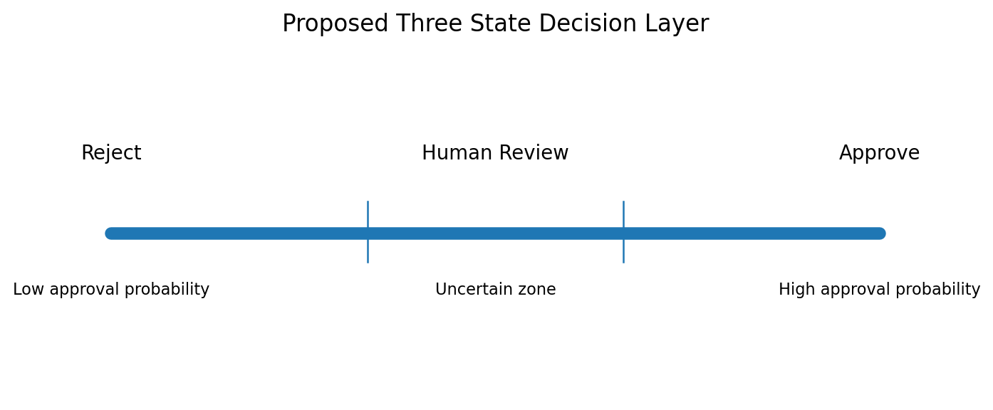
Figure 3.2 Proposed Three State Decision Layer

3.13 Explainability and Counterfactual Analysis
Global explanation is used to identify which features the selected model relies on most. Local explanation is used to inspect individual predictions. SHAP values are suitable for this purpose. Counterfactual examples can be generated only for changeable features and within realistic ranges. Protected or fixed personal attributes must not be suggested as variables that an applicant should change.

3.14 Existing System and Proposed Work
Aspect | Typical loan prediction project | EquiLoan
Goal | Highest accuracy | Reliable and auditable data science evaluation
Data split | Single split | Stratified split and cross validation
Imbalance | Ignored or balanced once | Compared as a controlled experiment
Calibration | Not tested | Brier score, log loss and calibration curves
Fairness | Usually absent | Group level diagnostics
Decision | Binary only | Approve, reject or human review
Explainability | Optional importance plot | Global, local and constrained counterfactual analysis
Stability | Rarely checked | Feature and metric stability across folds

CHAPTER 4
IMPLEMENTATION AND DEVELOPMENT PROCESS

4.1 Overview of System Implementation
The implementation is planned as a set of small modules rather than one long notebook. This makes it easier to reproduce experiments and avoids accidental changes between models. Each stage saves its configuration and results so that the final comparison can be traced back to the same dataset version and random seed.

4.2 System Modules and Implementation Details

4.2.1 Data Validation Module
This module checks dataset shape, target labels, missing values, duplicates, data types, suspicious identifiers and possible leakage fields. It does not silently remove data. Every removal or transformation is recorded.

4.2.2 Preprocessing Module
The preprocessing module creates separate numerical and categorical pipelines. Imputation, encoding and scaling are fitted only using training folds. This module is shared by all models wherever possible.

4.2.3 Baseline Modeling Module
The baseline module trains the selected classifiers using a common evaluation function. Results are written into a comparison table containing validation and test metrics.

4.2.4 Class Balance Experiment Module
This module compares the original distribution against class weights and training only sampling methods. It records changes in minority class recall, precision, PR AUC and overall generalization.

4.2.5 Calibration Module
The calibration module fits Platt scaling or isotonic regression on training and validation data. It generates a reliability curve and compares Brier score before and after calibration.

4.2.6 Fairness Audit Module
The fairness module calculates prediction rates and error rates for selected groups. It produces tables that can be compared across models and thresholds.

4.2.7 Explainability Module
The explanation module produces global feature rankings and local explanations for selected test records. Counterfactual examples are generated only when the changes are reasonable and do not involve protected attributes.

4.2.8 Dashboard Module
The dashboard presents dataset information, model comparison, calibration, fairness results and individual prediction explanations. The dashboard is a support component. It does not replace the data science analysis and it does not make a real financial decision.

4.3 Dashboard Design
The dashboard should be simple and academic in style. The first page can show the dataset summary and selected model. A comparison page can show model metrics. A reliability page can show calibration and fairness results. A review page can display uncertain cases and local explanations. The interface should avoid decorative charts that do not help the analysis.

4.4 Challenges and Mitigation Strategies
Challenge | Mitigation
Target leakage | Compare models with and without suspicious post decision fields
Class imbalance | Use stratified evaluation and training only balance methods
Overfitting | Cross validation, controlled tuning and final holdout test
Fairness metric misuse | Report several metrics and explain their limits
Unrealistic counterfactuals | Apply feature constraints and realistic ranges
High computational cost | Use smaller tuning grids and staged experiments

CHAPTER 5
TESTING AND VALIDATION

5.1 Introduction to System Testing
Testing is required at both the software and machine learning levels. A model can run without errors and still give misleading results if the data split, preprocessing or evaluation is wrong. For this reason, the project includes tests for data flow, leakage prevention, reproducibility and metric calculation.

5.2 Testing Objectives
- Confirm that the raw dataset is loaded without silent modification.
- Confirm that preprocessing is fitted on training data only.
- Confirm that class balancing does not affect validation or test records.
- Confirm that the same random seed reproduces the same split and results.
- Confirm that probability values are between zero and one.
- Confirm that fairness metrics are computed from the correct groups.
- Confirm that the human review zone contains only cases between the selected confidence thresholds.

5.3 Testing Strategy
Unit tests are used for preprocessing functions and metric calculations. Integration tests are used for the full pipeline from input data to prediction output. Machine learning validation uses stratified cross validation and a final untouched test set. The final report records both average scores and variation across folds.

5.4 Machine Learning Model Validation
Model validation focuses on generalization rather than only training score. A large gap between training and validation performance is treated as an overfitting warning. Very low performance on both training and validation data may indicate underfitting or weak features. Hyperparameter tuning is therefore kept moderate and is guided by validation results.

5.5 Fairness and Calibration Validation
Fairness results are checked across more than one metric because different fairness definitions can give different conclusions. Calibration results are checked both numerically and visually. If calibration improves Brier score but reduces useful ranking performance, this trade off is reported instead of hidden.

5.6 Core Test Cases
Test ID | Test case | Expected result
T01 | Load raw dataset | 148,670 records and 37 columns are detected
T02 | Check target labels | Only expected binary labels are used for modeling
T03 | Pipeline fit | Imputer and encoder are fitted on training data only
T04 | Balance experiment | Validation and test sets keep natural distribution
T05 | Leakage audit | Suspicious rate fields are tested separately
T06 | Calibration | Calibrated probabilities remain between 0 and 1
T07 | Abstention | Cases between thresholds are marked for review
T08 | Reproducibility | Fixed seed returns the same split and model configuration

CHAPTER 6
RESULTS AND DISCUSSION

6.1 Current Dataset Observations
At the current stage, the confirmed results are dataset level observations rather than final model scores. The dataset contains 148,670 records and 37 columns. The target is imbalanced, with 111,273 approved records and 37,397 rejected records. Several financial fields contain missing values and some interest related fields require a leakage audit before model results can be trusted.
Observation | Value or interpretation
Total records | 148,670
Total columns | 37
Approved class | 111,273 records, 74.84 percent
Rejected class | 37,397 records, 25.16 percent
Main modeling risk | Possible leakage from interest and charge related fields
Main evaluation risk | Accuracy may hide poor rejected class performance

6.2 Experimental Result Plan
Final model performance has not been inserted into this report because the complete experiment has not yet been run under the agreed leakage safe pipeline. Reporting invented scores would weaken the project. The following tables are designed to be filled directly from the notebook outputs after the experiments are completed.

6.3 Model Comparison Template
Model | Accuracy | Precision | Recall | F1 | ROC AUC | PR AUC | Brier Score
Logistic Regression | To be measured | To be measured | To be measured | To be measured | To be measured | To be measured | To be measured
Decision Tree | To be measured | To be measured | To be measured | To be measured | To be measured | To be measured | To be measured
Random Forest | To be measured | To be measured | To be measured | To be measured | To be measured | To be measured | To be measured
XGBoost | To be measured | To be measured | To be measured | To be measured | To be measured | To be measured | To be measured

6.4 Class Balance Comparison
The main comparison should check whether balancing improves the rejected class without causing a large reduction in overall performance. The important measures are rejected class recall, PR AUC, false approval rate and validation stability. A 50:50 training set will not be treated as automatically better than the original distribution.

6.5 Calibration and Human Review Analysis
After selecting a strong classifier, the raw and calibrated probability curves should be compared. If calibration improves the Brier score, the calibrated probability can be used for the human review thresholds. The abstention experiment should then report coverage, error rate on automatically decided cases and the percentage of records sent for review.

6.6 Fairness Discussion
Fairness results should be discussed together with sample size for each group. A difference in prediction rate is a signal for further analysis and should not be presented as proof of discrimination. The report should show whether the same model threshold changes error rates differently across groups and whether calibration or abstention changes those gaps.

6.7 Expected Interpretation of the Final Results
The final model should not be selected from accuracy alone. A slightly lower accuracy may be acceptable if probability calibration, minority class performance and stability are clearly better. Similarly, a model with excellent predictive performance should not be selected without checking leakage and subgroup behaviour. The discussion should explain these trade offs in simple terms.

CHAPTER 7
CONCLUSION

7.1 Summary of the Work
EquiLoan is designed as a data science project for studying loan approval prediction in a more complete way. The project begins with a large real distribution dataset and builds a leakage aware machine learning pipeline. Standard models are compared before adding calibration, fairness, explainability and confidence based review. This keeps the core of the work focused on data science rather than on web development.

7.2 Key Contributions
- A reproducible comparison of several loan approval classifiers on a large tabular dataset.
- A controlled study of natural class distribution and training only balancing methods.
- A leakage audit for features that may contain post decision information.
- Probability calibration in addition to normal classification metrics.
- Group level fairness diagnostics reported together with predictive performance.
- A three state prediction layer that separates uncertain cases for human review.
- Cross validation based stability analysis for scores and important features.

7.3 Achievement of Objectives
The system design and experimental framework satisfy the project objective of creating a responsible loan approval data science study. The next stage is to complete the full set of experiments and insert the measured results into Chapter 6. The framework is deliberately structured so that unsuccessful experiments can also be reported and discussed.

7.4 Limitations
- The dataset represents one source and may not match the distribution of another lender or region.
- Available demographic fields are limited and cannot cover every fairness concern.
- Fairness metrics are statistical indicators and do not establish legal compliance.
- Counterfactual explanations depend on model behaviour and should not be treated as financial advice.
- The proposed dashboard is an academic prototype and is not intended for real lending decisions.

7.5 Future Enhancements
Future work can include time based validation if a reliable time variable is available, drift detection, additional calibration methods and a stronger counterfactual generation method. A later extension can also study model version history and compare how different notebook versions changed preprocessing, features and architecture. Such an extension should be treated as a separate research module after the base EquiLoan pipeline is stable.

REFERENCES
[1] K. Gawande, Pallavi, D. Thakur, et al., “An explainable ensemble learning framework for transparent and accurate loan approval prediction,” Discover Artificial Intelligence, vol. 6, 2026. doi: 10.1007/s44163-026-01569-6.
[2] “Performance, Fairness, and Explainability in AI-Based Credit Scoring: A Systematic Literature Review,” Journal of Risk and Financial Management, vol. 19, no. 2, 2026, article 104. doi: 10.3390/jrfm19020104.
[3] “Machine Learning-Based Loan Approval Automation: Enhancing Efficiency, Accuracy and Fairness in Credit Decision-Making,” Expert Systems, 2026. doi: 10.1111/exsy.70307.
[4] G. Babaei, P. Giudici, and P. Neelakantan, “Explainability, fairness and the Simpson’s paradox in credit lending,” Physica A: Statistical Mechanics and its Applications, 2025.
[5] “Assessing Fairness and Transparency in Credit Scoring Using Explainable AI,” 2025 Control Instrumentation System Conference, IEEE, 2025. doi: 10.1109/CISCON66933.2025.11337606.
[6] M. Garcin and S. Stephan, “Credit scoring using neural networks and SURE posterior probability calibration,” arXiv:2107.07206, 2021.
[7] K. C., “A leakage-aware explainable machine learning pipeline for credit risk prediction with SHAP and fairness auditing,” Zenodo, 2026.
[8] S. Nayak, “Calibrated Credit Intelligence: Shift-Robust and Fair Risk Scoring with Bayesian Uncertainty and Gradient Boosting,” arXiv:2603.06733, 2026.

APPENDIX

A. Proposed Project Folder Structure
A simple folder structure is recommended so that the project remains easy to understand and submit as a student project.
project/
data/
notebooks/
src/
validation.py
preprocessing.py
models.py
calibration.py
fairness.py
explainability.py
results/
dashboard/
report/

B. Suggested Final Result Tables
- Dataset characteristics and missing values
- Baseline model comparison
- Cross validation mean and standard deviation
- Natural distribution versus balance strategy comparison
- Calibration comparison
- Fairness metric comparison
- Human review coverage and error comparison
- Feature importance stability table
- Final model selection summary

C. Research Questions
- Can a loan approval model maintain useful predictive performance while reducing large group level disparities?
- Does probability calibration improve the reliability of model confidence values?
- Can a human review zone reduce the error rate on uncertain applications?
- How stable are model performance and feature importance across cross validation folds?
- How does class balancing affect minority class performance compared with the natural class distribution?

