EQUILOAN: FAIRNESS AWARE, CALIBRATED AND
EXPLAINABLE LOAN APPROVAL DECISION SUPPORT SYSTEM
A PROJECT REPORT
Submitted by
KAMESHWAR M 210425243106
MITHRA VEERA A 210425243148
VIJAYARAGAVAN K 210425243316
in partial fulfillment for the award of the degree of
BACHELOR OF TECHNOLOGY
in
ARTIFICIAL INTELLIGENCE AND DATA SCIENCE
DEPARTMENT OF ARTIFICIAL INTELLIGENCE AND DATA SCIENCE
CHENNAI INSTITUTE OF TECHNOLOGY
(AUTONOMOUS)
(Affiliated to Anna University, Chennai & Recognized by AICTE New Delhi)
Chennai-600 069
OCTOBER 2026





CHENNAI INSTITUTE OF TECHNOLOGY (AUTONOMOUS)
(Affiliated to Anna University, Chennai & AICTE New Delhi)
Chennai-600 069
BONAFIDE CERTIFICATE
Certified that this project report “EQUILOAN: FAIRNESS AWARE, CALIBRATED AND EXPLAINABLE LOAN APPROVAL DECISION SUPPORT SYSTEM” is the bonafide work of KAMESHWAR M (210425243106), MITHRA VEERA A (210425243148) and VIJAYARAGAVAN K (210425243316), who carried out the project work under the supervision of Dr. G. Sanmugasundaram, Department of Artificial Intelligence and Data Science, Chennai Institute of Technology.

HEAD OF THE DEPARTMENT | PROJECT SUPERVISOR
Department of Artificial Intelligence and Data Science  Chennai Institute of Technology  Kundrathur, Chennai-600069 | Dr. G. Sanmugasundaram  Department of Artificial Intelligence and Data Science  Chennai Institute of Technology

Certified that the above students have attended the viva voce during the examination held on ____________________.
INTERNAL EXAMINER | EXTERNAL EXAMINER

ACKNOWLEDGEMENT
We express our gratitude to the management of Chennai Institute of Technology for providing the facilities and opportunity to carry out this undergraduate project as part of the B.Tech Artificial Intelligence and Data Science programme. We thank the Principal, Dean and the Head of the Department for the academic support and laboratory facilities made available during the project period.
We sincerely thank our project supervisor, Dr. G. Sanmugasundaram, for the regular guidance, technical suggestions and reviews given during the development of this work. The discussions on data preparation, leakage, model evaluation, fairness, calibration and presentation helped us move from a simple loan prediction model to a more complete data science study.
We also thank the faculty members and laboratory staff of the Department of Artificial Intelligence and Data Science for their suggestions during reviews. We are grateful to our classmates for the discussions that helped us identify practical issues in the model and dashboard. Finally, we thank our families for their support and encouragement during the completion of the project.

TABLE OF CONTENTS
ABSTRACT v
LIST OF FIGURES vi
LIST OF TABLES viii
SYMBOLS AND ABBREVIATIONS ix
1. INTRODUCTION 1
1.1 Background 1
1.1.1 Loan approval and credit assessment 1
1.1.2 Data science perspective 2
1.2 Problem Statement 3
1.2.1 Our understanding of the problem 4
1.2.2 Planned approach 5
1.3 Loan Approval as a Data Science Problem 6
1.4 Objectives 7
1.5 Importance of Reliable Credit Decision Support 9
1.6 Role of AI and ML in Loan Approval 10
1.7 Significance 11
1.8 Scope 12
1.9 Limitations of Existing Systems 12
1.10 Overview of Proposed System 13
2. LITERATURE REVIEW 14
2.1 Existing Research 14

2.2 Comparative Analysis of Referred Papers 20
2.3 Key Observations 22
2.4 Gaps in Existing Knowledge 23
2.5 Novelty and Value Addition 24
3. METHODOLOGY 26
3.1 System Overview 26
3.2 Problem Solving Approach 27
3.3 Technologies Used 28
3.4 System Architecture 30
3.5 Data Collection and Description 32
3.6 Dataset Health Check 34
3.7 Target Leakage Audit 36
3.8 Data Preprocessing 38
3.9 Class Imbalance Strategy 40
3.10 Feature Engineering 42
3.11 Models and Experimental Setup 43
3.12 Model Training and Cross Validation 45
3.13 Probability Calibration 47
3.14 Fairness Analysis 48
3.15 Confidence Based Human Review 49
3.16 Explainability and Stability 50
3.17 EvoForge Version Analysis Layer 51
3.18 Existing System and Proposed Work 52
4. IMPLEMENTATION AND DEVELOPMENT PROCESS 54
4.1 Implementation Overview 54

4.2 Data Validation Module 55
4.3 Preprocessing Module 56
4.4 Baseline Modeling Module 57
4.5 Calibration Module 58
4.6 Fairness Module 59
4.7 Abstention Module 60
4.8 Robustness and Evaluation Module 61
4.9 Notebook Version History 62
4.10 Dashboard and Presentation Layer 64
4.11 Challenges and Mitigation 66
5. TESTING AND VALIDATION 68
5.1 Introduction to System Testing 68
5.2 Testing Objectives 69
5.3 Testing Strategy 70
5.4 Data Pipeline Validation 71
5.5 Unit Testing 72
5.6 Integration Testing 73
5.7 Machine Learning Validation 74
5.8 Leakage Validation 75
5.9 Imbalance Validation 76
5.10 Calibration and Fairness Validation 77
5.11 Abstention Validation 78
5.12 Reproducibility and Stability 79
5.13 Test Cases and Results 80
5.14 Testing Summary 81

6. RESULTS AND DISCUSSION 82
6.1 Dataset and Leakage Findings 82
6.2 Natural Distribution Results 84
6.3 Balanced Condition Results 86
6.4 Calibration Results 88
6.5 Fairness Results 89
6.6 Human Review Results 90
6.7 Feature Stability 91
6.8 Final Scorecard and Discussion 92
7. CONCLUSION 94
7.1 Summary of the Work 94
7.2 Key Contributions 95
7.3 Achievement of Objectives 96
7.4 Limitations 97
7.5 Future Enhancements 98
REFERENCES 100
APPENDIX 103

ABSTRACT
Loan approval prediction is a common classification problem in data science, but a high accuracy value alone does not show whether a model is reliable enough for decision support. This project develops EquiLoan as an undergraduate data science framework that studies the complete modeling process, starting from raw data validation and ending with model reliability checks. The dataset contains 148,670 records and 37 columns. The target variable is status, with 111,273 approved applications and 37,397 rejected applications. The original class distribution is approximately 74.85 percent approved and 25.15 percent rejected. A second experimental condition is created by random undersampling of the majority class to obtain 37,397 records from each class without changing any feature values. The implementation uses Python, pandas, NumPy, scikit-learn and XGBoost. Preprocessing is fitted inside the cross-validation folds so that imputation, encoding, scaling and outlier clipping do not use information from validation data. A dedicated leakage audit shows that interest_rate_spread and upfront_charges are missing for more than 95 percent of rejected applications but are mostly present for approved applications. Rate related variables are therefore removed from the main benchmark because they can reveal information generated after the underwriting decision. Logistic Regression, Decision Tree, Random Forest, XGBoost and Naive Bayes are compared using five-fold stratified cross-validation. On the natural distribution, XGBoost gives the strongest result among the tested models with mean accuracy 0.8682, F1 score 0.6757 and ROC-AUC 0.8571. On the balanced condition, its F1 score increases to 0.7589 and ROC-AUC is 0.8532, showing the trade-off between overall accuracy and minority-class learning. The project then studies probability calibration, demographic group differences, selective prediction and feature stability. Isotonic calibration gives the lowest Brier score on the natural experiment, while the uncalibrated model already has a low expected calibration error. Fairness screening on the natural distribution produces DIR values above 0.93 for gender, region and age, while the balanced experiment changes the group prediction pattern and gives an age DIR of 0.749. The abstention study shows that sending uncertain cases for human review can improve accuracy on the cases decided automatically, but this improvement comes with lower coverage. The novelty of the student project is therefore not a new mathematical algorithm. It is the controlled combination of leakage analysis, natural versus balanced class experiments, calibration, fairness screening, uncertainty handling and stability analysis in one reproducible workflow.
Keywords: Loan Approval, Data Science, Machine Learning, Target Leakage, Class Imbalance, Probability Calibration, Fairness, Explainable AI, Human Review, Cross Validation

LIST OF FIGURES
Figure 1.1 Target Distribution in the Original Dataset
Figure 3.1 Missing Values Before Pipeline Imputation
Figure 3.2 EquiLoan Data Science Workflow
Figure 3.3 Dual Experimental Condition Strategy
Figure 3.4 Three State Decision Layer
Figure 3.5 EvoForge Version Analysis Concept
Figure 4.1 Modular Source Code Structure
Figure 4.2 Early Notebook Output Showing Missing Data
Figure 4.3 Early Model Comparison Before Final Leakage Audit
Figure 6.1 Natural Distribution Baseline Model Comparison
Figure 6.2 Balanced Condition Baseline Model Comparison
Figure 6.3 Probability Calibration Comparison
Figure 6.4 Fairness Screening Across Conditions
Figure 6.5 Selective Prediction Coverage and Accuracy
Figure 6.6 Stable Feature Importance Across Folds
Figure 6.7 Final Multi-Criteria Scorecard

LIST OF TABLES
Table 1.1 Dataset Summary
Table 1.2 Main Data Science Risks
Table 2.1 Literature Comparison
Table 2.2 Novelty Matrix
Table 3.1 Feature Groups
Table 3.2 Missing Value Summary
Table 3.3 Target Leakage Audit
Table 3.4 Models Included in the Study
Table 3.5 Evaluation Metrics
Table 3.6 Existing System and Proposed Work
Table 4.1 Project Module Structure
Table 4.2 Notebook Version History
Table 5.1 Core Test Cases
Table 5.2 Validation Checklist
Table 6.1 Natural Distribution Results
Table 6.2 Balanced Condition Results
Table 6.3 Calibration Results
Table 6.4 Fairness Audit
Table 6.5 Abstention Results
Table 6.6 Feature Stability Summary
Table 6.7 Final Research Scorecard

SYMBOLS AND ABBREVIATIONS
Acronym | Expansion
AI | Artificial Intelligence
ML | Machine Learning
DS | Data Science
LR | Logistic Regression
DT | Decision Tree
RF | Random Forest
XGB | Extreme Gradient Boosting
NB | Naive Bayes
SVM | Support Vector Machine
CV | Cross Validation
SHAP | SHapley Additive exPlanations
SPD | Statistical Parity Difference
DIR | Disparate Impact Ratio
ROC-AUC | Area Under the Receiver Operating Characteristic Curve
PR-AUC | Area Under the Precision Recall Curve
ECE | Expected Calibration Error
IQR | Interquartile Range
XAI | Explainable Artificial Intelligence

CHAPTER 1
INTRODUCTION
1.1 BACKGROUND
Loan approval is an important activity in banking because every approved application creates both an opportunity and a risk. A bank earns interest when a borrower repays according to the agreed schedule, but an unsuitable approval can increase credit losses. At the same time, rejecting a suitable applicant can also create a lost business opportunity. For this reason, the loan approval process uses information about the applicant, the requested loan, income, credit history, property details and other financial factors.
Machine learning is useful in this setting because it can learn patterns from earlier applications and produce a prediction for a new record. However, a loan approval project is not complete when a classifier prints an accuracy value. A data scientist has to ask whether the input fields are available before the decision, whether the class distribution is handled correctly, whether the model performs consistently on different folds, whether its probability values are reliable, and whether group-level results show large differences. These questions form the main motivation for EquiLoan.
This project was initially started as a conventional loan prediction exercise. During later notebook versions, the work changed after we observed unusually strong scores and large missingness differences in rate-related columns. This led to a separate leakage audit and a cleaner experimental pipeline. The final project therefore records not only the selected model but also the mistakes and design changes that were found during development.
1.1.1 Loan Approval and Credit Assessment
Credit assessment traditionally combines documentary checks, credit records, repayment capacity and the terms of the requested loan. In a machine learning dataset, these ideas appear as numerical and categorical features. Some variables describe the applicant, while others describe the product or the property. The target status tells whether the historical application was approved or rejected. The model learns a statistical relationship between the input features and this historical decision. It does not learn a universal rule of who deserves credit, and it cannot replace institutional policy or legal review.
1.1.2 Data Science Perspective
From a data science perspective, the main challenge is to build a fair comparison between candidate models. The same folds, preprocessing rules and feature restrictions must be used so that one model is not accidentally given more information than another. Performance must also be described using more than one metric because the data is imbalanced. These requirements are reflected throughout the methodology and testing chapters.
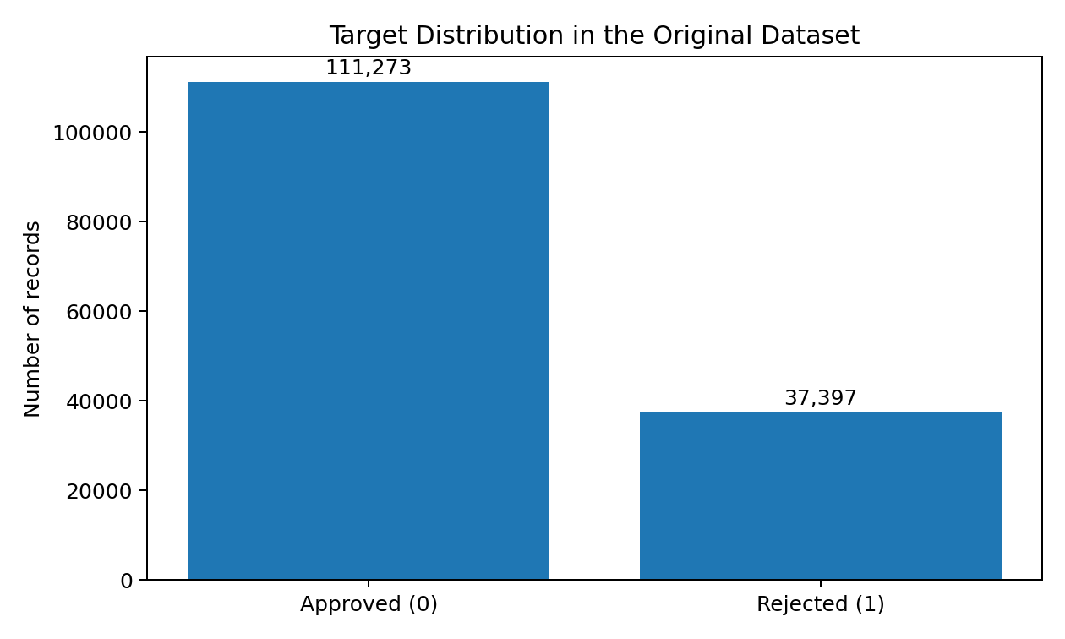
Figure 1.1 Target Distribution in the Original Dataset
1.2 PROBLEM STATEMENT
Many student loan prediction projects use a cleaned public dataset, compare a few classifiers and select the one with the highest accuracy. That procedure is useful for learning basic classification, but it can hide important issues. In the supplied dataset, the target is not balanced, several fields contain missing values, and some interest-related variables are closely connected with the stage at which the decision is made. If those fields are used without checking their timing, the model may appear to predict the target while actually reading information that becomes available after the decision.
The problem addressed in this project is therefore to predict loan status using a reproducible and leakage-aware data science workflow and to study the reliability of the prediction. The study compares the natural class distribution with a balanced condition, evaluates several standard classifiers, examines probability calibration and group-level fairness, and introduces a human review zone for uncertain cases. The goal is not to automate a real bank. The goal is to understand how a student machine learning model changes when these practical checks are added.
1.2.1 OUR UNDERSTANDING OF THE PROBLEM
The first issue is data quality. Missing values are not distributed evenly across the columns, and a few variables have missing rates above twenty percent. A preprocessing decision can therefore change the model considerably. In EquiLoan, preprocessing is fitted inside the training folds so that the model does not use information from validation data.
The second issue is class imbalance. The original data contains 111,273 approved applications and 37,397 rejected applications. A model can obtain a high overall accuracy by learning the majority class more easily. We therefore report recall, F1 score and ROC-AUC in addition to accuracy. A balanced experimental dataset is used as a separate condition rather than as a replacement for the original distribution.
The third issue is target leakage. The leakage audit shows that interest_rate_spread and upfront_charges are missing for nearly all rejected records but are present for most approved records. This pattern is not a normal predictive signal from the application stage. It is likely connected with underwriting information that is produced only when a loan proceeds further. These variables are removed from the main benchmark.
The fourth issue is model confidence. A predicted probability of 0.80 is useful only if similar cases are actually correct at approximately that rate. Calibration analysis is therefore included after the baseline model comparison. Finally, a low-confidence prediction is not forced into an automatic decision in the abstention experiment. It can be marked for human review.
1.2.2 PLANNED APPROACH
The project begins with a raw CSV and performs a health check before any modeling step. Dataset dimensions, target distribution, missing values and duplicate rows are recorded. A dedicated leakage audit is then used to identify fields that should not be used as predictors.
The modeling stage uses a common preprocessing pipeline and five-fold stratified cross-validation. Logistic Regression, Decision Tree, Random Forest, XGBoost and Naive Bayes are compared under the natural and balanced class conditions. XGBoost is then studied further because it gives the strongest overall baseline in the completed experiments.
After baseline evaluation, the work moves to calibration, fairness screening, abstention and feature stability. These analyses answer different questions, so they are not collapsed into one accuracy value. The final dashboard presents the results as a decision-support study rather than a commercial lending tool.
1.3 LOAN APPROVAL AS A DATA SCIENCE PROBLEM
The project uses the standard stages of a data science life cycle: understanding the data, preparing a reproducible transformation pipeline, building baseline models, evaluating generalization, interpreting the model and communicating the results. The most important difference from a small demonstration is that each stage is treated as an experiment. For example, class balancing is not assumed to be an improvement. It is measured against the natural distribution. Calibration is not assumed to improve every metric. It is tested using Brier score, log loss and expected calibration error. This experimental approach is the main academic value of the project.
1.4 OBJECTIVES
1.4.1 General Objective
To design and evaluate a reproducible loan approval prediction framework using data science methods, with specific attention to data leakage, class imbalance, model performance, probability calibration, fairness screening, uncertainty handling, interpretability and stability.
1.4.2 Specific Objectives
- To inspect the raw loan dataset and document its structure, missing values, target distribution and possible leakage fields.
- To implement training-fold-only preprocessing for numerical and categorical variables.
- To compare standard machine learning classifiers under the same five-fold stratified cross-validation procedure.
- To compare the original target distribution with a separate 50:50 experimental condition created without synthetic values.
- To evaluate model quality using accuracy, precision, recall, F1 score, ROC-AUC and Brier score.
- To compare uncalibrated probabilities with Platt scaling and isotonic regression.
- To audit group-level prediction differences using gender, region and age where these attributes are available.
- To test a three-state decision process in which uncertain cases are sent for human review.
- To evaluate feature stability across folds and retain the version history of the project as evidence of model development.
1.5 IMPORTANCE OF RELIABLE CREDIT DECISION SUPPORT
Reliability is important because an incorrect prediction can have different consequences depending on the type of error. In the coding used in this project, status 1 represents rejection. Missing a rejected case and incorrectly predicting approval is different from incorrectly rejecting an approved case. A single accuracy value combines these mistakes and therefore cannot describe them fully. The project uses precision, recall and F1 to make class-specific behaviour visible.
Reliable decision support also requires honest probability values. Ranking metrics such as ROC-AUC measure whether higher-risk cases tend to receive higher scores, but they do not show whether a score of 0.70 actually behaves like a 70 percent probability. Calibration metrics answer this second question. By including both ranking and calibration, EquiLoan gives a more complete view of model quality.
1.6 ROLE OF AI AND ML IN LOAN APPROVAL
Machine learning can process a large tabular dataset and detect interactions that are difficult to describe with a fixed manual rule. Tree ensembles are especially useful for nonlinear relationships and mixed feature effects. Logistic Regression remains useful because it provides an interpretable linear baseline. Naive Bayes provides a simple probabilistic comparison. The purpose of testing several models is not to prove that one algorithm is universally best, but to measure how the same dataset behaves under different assumptions.
1.7 SIGNIFICANCE
The project is significant mainly as a student data science study. It connects topics that are often learned separately: missing-data handling, leakage prevention, imbalanced classification, cross-validation, probability calibration, fairness metrics, explainability and uncertainty. It also shows why very high reported accuracy should be checked carefully before it is accepted as evidence of a strong model.
The project is linked to SDG 8 and SDG 10 at a limited academic level. More consistent credit analysis can support efficient financial services, while group-level fairness checks can reveal whether model outputs vary strongly across available demographic categories. We do not claim that this prototype solves financial inclusion or social inequality. Those outcomes depend on policy, data collection and real lending practice beyond the scope of this project.
1.8 SCOPE
- The study is limited to supervised binary classification on the supplied tabular dataset.
- The model is an academic decision-support prototype and is not intended for production lending.
- The project compares standard machine learning models and does not introduce a new mathematical classifier.
- Fairness analysis is limited to the demographic or proxy fields present in the data.
- Counterfactual recommendations are discussed conceptually; protected attributes are not treated as changeable applicant actions.
- The balanced condition is created by undersampling the majority class and is used only as a controlled experiment.
1.9 LIMITATIONS OF EXISTING SYSTEMS
The referred literature shows strong progress in loan prediction, feature selection and explainability, but many studies still focus mainly on model accuracy. Some papers report extremely high accuracy values on public loan datasets. Such values are not automatically wrong, but they create a need to examine whether duplicate records, target leakage or post-decision attributes are present. Recent studies also show that SHAP, LIME, ensemble learning and web deployment are already common research directions. For that reason, these components are not treated as novelty by themselves in EquiLoan.
1.10 OVERVIEW OF THE PROPOSED SYSTEM
EquiLoan begins with raw data validation. After leakage checking, training-fold-only preprocessing is applied. Baseline models are evaluated under natural and balanced conditions. XGBoost is taken forward for calibration, fairness screening, abstention and stability analysis because it provides the strongest overall baseline among the models tested in the final codebase. The system then produces tables and plots for the report and dashboard. The final output is a research summary that explains performance, reliability and limitations rather than a simple approve-or-reject answer.

CHAPTER 2
LITERATURE REVIEW
This chapter reviews the research papers referred to during the project. The papers were selected because they cover the main directions relevant to loan approval prediction: basic classification, ensemble learning, feature selection, cross-validation, explainability and recent hybrid approaches. The review is used to position EquiLoan as a student data science project and to avoid claiming that established methods are new.
2.1.1 Bank Loan Prediction Using Machine Learning Techniques
F. M. Ahosanul Haque and Md. Mahedi Hassan use a dataset of 148,670 instances and 37 attributes, which matches the dimensions of the dataset used in our project. They compare Decision Tree, AdaBoost, Random Forest, SVM and Gaussian Naive Bayes and report 99.99 percent accuracy for AdaBoost. This paper is important because it provides a direct baseline on the same dataset family. It also motivates our leakage audit. A score close to 100 percent is impressive, but it should be checked against the timing of features and missingness patterns before being used as evidence that the problem is solved.
2.1.2 A Prediction of Modernized Loan Approval System Based on Machine Learning Approach
M. Venkata Naga Lakshmi and P. Srinivasa Rao present a loan approval system based on historical applicant information from Kaggle. Their work discusses Naive Bayes, Decision Tree and MLP within an ensemble-oriented approach and targets approximately 90 percent accuracy. The study represents a common loan prediction design in which the main objective is to automate the decision and reduce manual effort. For EquiLoan, the paper is useful as an example of an accuracy-centred system that can be extended with calibration and reliability checks.
2.1.3 A Comparative Study of Loan Approval Prediction Using Machine Learning Methods
Vahid Sinap compares machine learning methods and studies feature selection using K-Best and Recursive Feature Elimination. The study reports the strongest accuracy for Random Forest and notes that RFE improves model performance. It also reports that cross-validation provides more consistent performance measurement than a single training, testing and validation split. This finding directly supports our decision to use five-fold stratified cross-validation and to treat feature stability as a separate part of model evaluation.
2.1.4 A Data Driven Model for Predicting Loan Approval Using Machine Learning Approaches
Shady Abdelhady and co-authors use a dataset of 5,000 applicants with 14 attributes and compare Decision Tree, KNN and SVM. They report SVM accuracy of 96 percent, Decision Tree accuracy of 92 percent and KNN accuracy of 86 percent. The work shows that different algorithms can perform very differently even on the same task. It also demonstrates the importance of evaluating more than one baseline instead of selecting an algorithm in advance.
2.1.5 Prediction of Loan Approval in Banks using Machine Learning Approach
Viswanatha, Ramachandra, Vishwas and Adithya compare Random Forest, Naive Bayes, Decision Tree and KNN and report Naive Bayes as the strongest method in their experiment with an accuracy of 83.73 percent. This is useful for our study because it shows that simple probabilistic models can remain competitive depending on the dataset. We therefore retain Naive Bayes as a baseline rather than testing only ensemble methods.
2.1.6 Loan Approval Prediction Using Machine Learning
Goliya Bhavani describes loan approval as a classification problem using variables such as credit score, income, age, marital status and gender. The paper discusses Logistic Regression, Random Forest and Naive Bayes as practical methods for reducing manual effort. It is representative of small student-level loan prediction projects and helps define the baseline that EquiLoan is intended to extend.
2.1.7 Performance Analysis of Ensemble Learning and Feature Selection Methods in Loan Approval Prediction at Banks
Muhammad Iqbal and co-authors evaluate several ensemble methods on a Kaggle loan dataset, including XGBoost, LightGBM, Gradient Boosting, Random Forest, AdaBoost and Extra Trees. They report very high XGBoost performance, including accuracy of 0.9974 and AUC of 0.9998. The paper confirms that ensemble models are strong baselines, but it also shows that high benchmark scores have already been reported. Therefore, simply using XGBoost cannot be presented as novelty.
2.1.8 Advancing Loan Approval Prediction With SHAP-Guided Feature Selection and LIME-Based Model Interpretability
Raisa Akter and co-authors combine SHAP-guided feature selection with LIME-based interpretation in a multiclassifier framework and deploy the results through a web application. They report logistic regression accuracy of 86.17 percent with 81 percent AUC on one dataset and 99.06 percent accuracy on another. This 2026 work is particularly important for our novelty audit because it shows that SHAP, LIME, model comparison and web deployment are already established together in recent loan approval research.
2.1.9 An Explainable Hybrid Machine Learning Framework for Loan Approval Prediction
Oktay Can Sevimgin and Denizhan Demirkol present a 2026 framework that evaluates nine classifiers, uses Grey Wolf Optimizer for hyperparameter selection and combines Random Forest with LightGBM. Their final hybrid model achieves 92.17 percent accuracy on an independent holdout test set, and SHAP is used for explainability. This paper shows that hybrid ensemble design, optimization and explainability are already active research directions. EquiLoan therefore focuses its value addition on experimental reliability checks rather than claiming a new hybrid algorithm.
2.2 COMPARATIVE ANALYSIS OF REFERRED PAPERS
Table 2.1 Literature Comparison
Study | Dataset | Models | Main focus | Relevance to EquiLoan
Haque & Hassan | 148,670 x 37 | DT, AdaBoost, RF, SVM, GNB | Accuracy focus | Same dataset family; high score motivates leakage audit
Lakshmi & Rao | Kaggle | NB, DT, MLP | Ensemble / accuracy | Automation baseline
Sinap | Loan dataset | RF, SVM, DT | RFE, K-Best, CV | Supports feature selection and cross-validation
Abdelhady et al. | 5,000 x 14 | DT, KNN, SVM | Accuracy, precision, recall, F1 | Shows model-dependent performance
Viswanatha et al. | Public loan data | RF, NB, DT, KNN | Accuracy comparison | Keeps simple baselines relevant
Bhavani | Public loan data | LR, RF, NB | Basic classification | Student-project baseline
Iqbal et al. | 4,173 usable | XGB, LGBM, GB, RF, AdaBoost, ET | Ensemble + feature selection | XGBoost already strong in literature
Akter et al. | Two Kaggle datasets | Multiple classifiers | SHAP, LIME, web app | XAI and deployment already established
Sevimgin & Demirkol | Kaggle | 9 models + RF-LGBM hybrid | GWO + SHAP + nested CV | Hybrid optimization already established

2.3 KEY OBSERVATIONS FROM EXISTING RESEARCH
- Ensemble tree methods are consistently strong baselines, but the best algorithm changes with dataset and preprocessing.
- Feature selection can improve performance, and cross-validation is more reliable than a single random split.
- Very high accuracy values are already reported in loan datasets. High accuracy alone is therefore not a useful novelty claim.
- Explainability through SHAP and LIME is now common in recent work, including web-based applications.
- Hybrid models and optimization methods such as Grey Wolf Optimizer are also already present in 2026 literature.
- Calibration, abstention and cross-fold stability receive much less attention in the specific papers referred to for this project.
2.4 GAPS IN EXISTING KNOWLEDGE
The literature does not support a claim that Random Forest, XGBoost, SHAP, LIME, web dashboards or hybrid ensemble learning are new. These methods have already been studied in loan approval prediction. The gap used in this student project is narrower and more practical. EquiLoan studies several reliability questions together on the same large dataset and records the trade-offs instead of choosing a model only from accuracy.
The first gap is the handling of target leakage. The same 148,670 by 37 dataset family can produce extremely high accuracy when post-underwriting fields are included. EquiLoan makes the leakage audit an explicit experimental stage and removes the identified rate-related variables from the main benchmark. The second gap is the controlled comparison between the natural target distribution and a separate balanced condition. The third gap is the combination of probability calibration, demographic screening, confidence-based abstention and feature stability after baseline model selection.
2.5 NOVELTY AND VALUE ADDITION
The novelty of EquiLoan is experimental and methodological rather than algorithmic. The project does not claim a new classifier. Its value comes from placing several reliability checks into one reproducible student workflow and then showing how the conclusions change when the data distribution or decision rule changes. This is a more defensible contribution than calling a standard ensemble model novel.
Table 2.2 Novelty Matrix
Area | Common approach | EquiLoan value addition
Prediction | Choose highest accuracy model | Compare several metrics and inspect class-specific behaviour
Leakage | Often not discussed | Dedicated audit of post-underwriting fields
Class balance | Balance once and train | Compare natural and 50:50 conditions separately
Probability | Use raw classifier probability | Compare uncalibrated, Platt and isotonic calibration
Fairness | Optional or absent | Group-level SPD and DIR screening under both conditions
Decision rule | Binary approve/reject | Add an uncertain human-review band
Robustness | Single split | Five-fold CV plus feature stability analysis
Version history | Final notebook only | Keep multiple notebook iterations and trace model changes

CHAPTER 3
METHODOLOGY
3.1 SYSTEM OVERVIEW
The methodology follows a standard data science life cycle, but each important modeling choice is treated as a controlled experiment. The system starts with the untouched loan dataset, checks its structure and missingness, audits possible leakage and then builds preprocessing pipelines that are fitted only on training folds. Baseline models are evaluated on the natural distribution and on a separate balanced condition. Reliability analysis is performed only after the baseline comparison is complete.
Figure 3.2 EquiLoan Data Science Workflow (editable representation)
Stage | Output
Raw data | 148,670 x 37 reference dataset
Validation | health report and leakage audit
Preprocessing | training-fold-only transformations
Baseline models | five-fold comparison
Reliability analysis | calibration, fairness, abstention, stability
Presentation | tables, plots and dashboard

3.2 PROBLEM SOLVING APPROACH
The work is divided into two main experimental conditions. Condition A keeps the original class distribution. Condition B contains the same number of approved and rejected rows, created by random undersampling of the majority class using a fixed seed. No synthetic applicant values are generated for the balanced file. The two conditions are evaluated separately because balancing can change both predictive performance and group-level statistics.
Figure 3.3 Dual Experimental Condition Strategy
Condition | Rows | Class 0 | Class 1 | Purpose
Natural | 148,670 | 111,273 | 37,397 | Real reference distribution
Balanced | 74,794 | 37,397 | 37,397 | Controlled class-balance experiment

3.3 TECHNOLOGIES USED
3.3.1 Python
Python is used as the main programming language for data loading, preprocessing, model training, evaluation and report preparation. The language was selected because the project is a tabular data science problem and the required libraries are well supported.
3.3.2 Pandas and NumPy
Pandas is used for dataset inspection, target distribution analysis, missing-value summaries and result tables. NumPy supports numerical operations and the custom outlier clipping transformer.
3.3.3 Scikit-learn
Scikit-learn provides Pipeline, ColumnTransformer, imputation, one-hot encoding, scaling, cross-validation and evaluation functions. Keeping these operations inside a pipeline is central to the leakage-safe design.
3.3.4 XGBoost
XGBoost is included as a high-performance tree ensemble baseline. It is not assumed to be the best in advance. It is taken forward only after the five-fold comparison shows the strongest overall baseline among the tested models.
3.3.5 Matplotlib
Matplotlib is used to create the result figures included in the report. Plots are generated from saved result CSV files so that the figures can be reproduced from the experiment outputs.
3.3.6 Jupyter Notebook and Modular Python Files
The project retains multiple notebook versions because they show the development history. The final repeatable experiments are implemented in separate Python modules for validation, preprocessing, modeling, calibration, fairness, abstention, robustness and final evaluation.
3.4 SYSTEM ARCHITECTURE
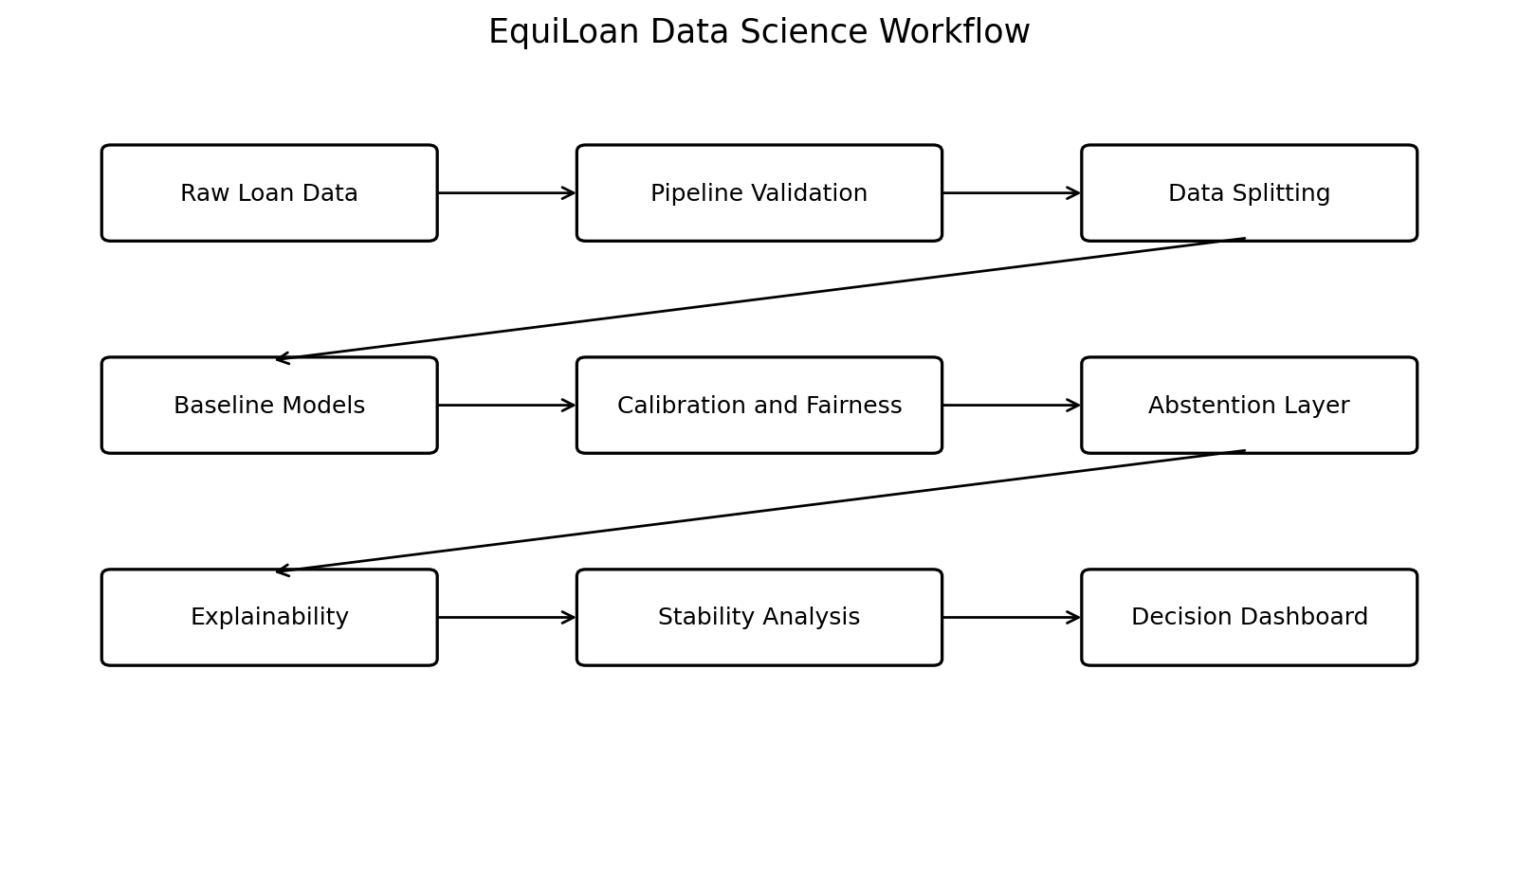
Figure 3.2 EquiLoan System Architecture
The architecture separates data preparation from model evaluation and separates predictive performance from reliability analysis. This separation is intentional. A model cannot be considered reliable merely because it has good predictive metrics, and fairness or calibration should not be measured before the pipeline itself is checked for leakage.
3.5 DATA COLLECTION AND DESCRIPTION
The project uses the supplied loan dataset stored as loan_v2 (real distribution).csv. It contains 148,670 rows and 37 columns. The dataset mixes numeric and categorical information related to loan terms, property values, applicant information, credit information and the final status. The file is kept as an immutable reference and is not manually cleaned before modeling.
Table 3.1 Feature Groups
Feature group | Examples
Identifiers | Unnamed: 0, id, year
Applicant | gender, age, region, senior_age
Loan details | loan_limit, loan_type, loan_purpose, loan_amount, term
Financial | income, property_value, ltv, dtir1
Credit | credit_score, credit_type, credit_worthiness, co-applicant_credit_type
Other terms | neg_ammortization, interest_only, lump_sum_payment, occupancy_type, secured_by, total_units
Potential leakage | rate_of_interest, interest_rate_spread, upfront_charges, high_interest_rate
Target | status

3.6 DATASET HEALTH CHECK
The health check confirms that the source file has 148,670 rows, 37 columns and no duplicate rows. The target has two labels. Missing values are concentrated in a limited set of fields rather than being spread uniformly across the dataset. Upfront charges, interest rate spread and debt-to-income ratio contain the largest missing proportions.
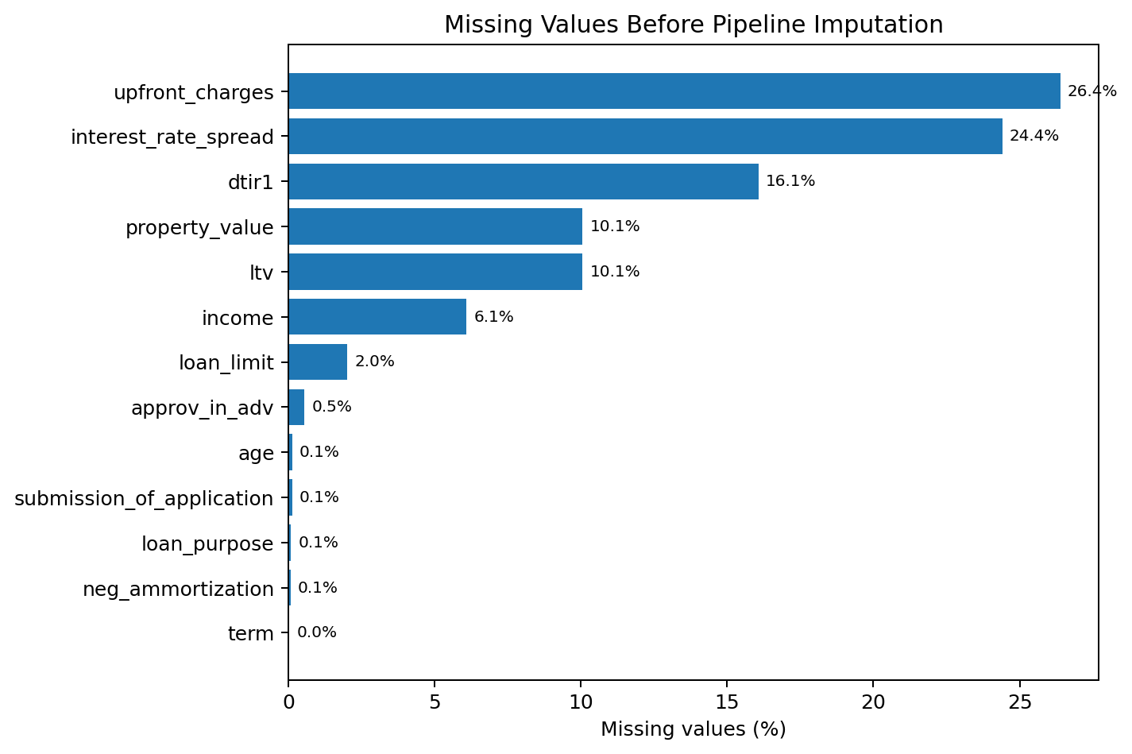
Figure 3.1 Missing Values Before Pipeline Imputation
Table 3.2 Missing Value Summary
Feature | Missing count | Missing percent
upfront_charges | 39,231 | 26.39%
interest_rate_spread | 36,283 | 24.41%
dtir1 | 23,899 | 16.08%
property_value | 14,952 | 10.06%
ltv | 14,942 | 10.05%
income | 9,046 | 6.08%
loan_limit | 2,997 | 2.02%
approv_in_adv | 815 | 0.55%
age | 181 | 0.12%
submission_of_application | 180 | 0.12%

3.7 TARGET LEAKAGE AUDIT
Target leakage occurs when a predictor contains information that would not be available at the time the prediction is supposed to be made. In loan data, a field created after underwriting can reveal whether the application progressed. The EquiLoan validator therefore checks the missingness of rate-related columns separately for approved and rejected records and also reports their correlation with status.
Table 3.3 Target Leakage Audit
Feature | Missing in approved | Missing in rejected | Correlation | Action
rate_of_interest | 0.00% | 0.00% | -0.5818 | Removed from main benchmark
interest_rate_spread | 0.32% | 96.06% | 0.2081 | Removed from main benchmark
upfront_charges | 3.10% | 95.67% | 0.2233 | Removed from main benchmark
high_interest_rate | 0.00% | 0.00% | -0.3002 | Removed from main benchmark

The missingness pattern is especially strong for interest_rate_spread and upfront_charges. More than 95 percent of rejected records are missing these values, while approved records are rarely missing them. A classifier can exploit this pattern without learning the applicant information that should support a decision. The final preprocessing module therefore excludes these four rate-related variables along with identifier columns. This decision also explains why our cleaned baseline scores are lower than some early notebook outputs and some published results on the same dataset family.
3.8 DATA PREPROCESSING
Preprocessing is implemented with a scikit-learn ColumnTransformer. Numerical variables use median imputation. The project also includes an IQR outlier clipper that learns its lower and upper fences from the training fold only. Standard scaling is applied after imputation and clipping. Categorical variables use most-frequent imputation followed by one-hot encoding with unknown categories ignored.
The most important rule is that preprocessing is fitted separately inside each cross-validation fold. The validation fold is transformed using parameters learned from the corresponding training fold. This prevents information from validation data from influencing the imputation median, category encoding, scaling or outlier fences.
3.9 CLASS IMBALANCE STRATEGY
The natural data contains approximately three approved records for each rejected record. We considered several possible approaches, including class weights, undersampling and synthetic oversampling. For the completed report, the direct comparison uses the natural dataset and an undersampled 50:50 condition. This choice allows us to study the effect of equal class representation without generating artificial applicant values.
The balanced condition is not treated as automatically better. It reduces the number of majority-class records and therefore changes the information available to the model. The final discussion compares recall, F1, ROC-AUC, calibration and fairness results under both conditions rather than choosing a dataset based only on accuracy.
3.10 FEATURE ENGINEERING
Feature engineering is kept conservative because the dataset already includes loan-to-value and debt-to-income style variables. Creating duplicate ratios can increase collinearity without adding information. New features are considered only when they have a clear meaning and can be calculated before the lending decision. In the final reproducible benchmark, the main focus is on the original pre-decision variables after leakage removal.
3.11 MODELS AND EXPERIMENTAL SETUP
Table 3.4 Models Included in the Study
Model | Reason for inclusion
Logistic Regression | Linear and interpretable baseline
Decision Tree | Nonlinear baseline with readable decision structure
Random Forest | Bagging ensemble for nonlinear tabular data
XGBoost | Boosted-tree baseline with strong tabular performance
Naive Bayes | Simple probabilistic baseline

The Decision Tree is limited to a maximum depth of 10 in the baseline code. Random Forest uses 100 trees. XGBoost uses 100 estimators with log-loss evaluation. Logistic Regression uses a maximum of 1000 iterations. These settings are intentionally moderate because the objective is to compare the complete pipeline rather than to perform an expensive hyperparameter search.
3.12 MODEL TRAINING AND CROSS VALIDATION
Five-fold StratifiedKFold cross-validation is used with shuffling and a fixed random state of 42. Stratification keeps the target proportions similar across folds. For each fold, the preprocessing pipeline is fitted on the training portion, the classifier is fitted on the transformed training data, and metrics are calculated on the transformed validation data. Mean and standard deviation across folds are stored in CSV result files.
Table 3.5 Evaluation Metrics
Metric | Purpose
Accuracy | Overall proportion of correct predictions
Precision | Correct positive predictions among predicted positives
Recall | Detected positives among actual positives
F1 score | Harmonic mean of precision and recall
ROC-AUC | Ranking ability across thresholds
Brier score | Mean squared error of predicted probabilities
Log loss | Penalty for incorrect confident probabilities
ECE | Difference between confidence bins and observed frequency

3.13 PROBABILITY CALIBRATION
After model selection, the probability outputs of XGBoost are compared with Platt scaling and isotonic regression. Platt scaling learns a sigmoid mapping from the model score to probability. Isotonic regression learns a monotonic non-parametric mapping. Calibration is evaluated separately because a classifier can rank cases well while still producing poorly scaled probabilities.
3.14 FAIRNESS ANALYSIS
Fairness analysis uses available group attributes as diagnostic variables. The completed audit compares gender, region and age. For each attribute, the code identifies the group with the highest positive prediction rate and the group with the lowest rate. Statistical parity difference is the difference between these rates, while disparate impact ratio is the lower rate divided by the higher rate. A value below 0.80 is used only as a screening alert in this project. It is not presented as proof of unlawful discrimination.
3.15 CONFIDENCE BASED HUMAN REVIEW
The abstention experiment adds a third outcome between the two automatic decisions. A record is decided automatically when its probability is outside a defined uncertainty band. Records inside the band are marked for human review. The experiment reports automated coverage, review percentage, accuracy on the decided cases, false approval rate and false rejection rate. Wider uncertainty bands send more records for review and generally improve accuracy on the remaining automated cases.
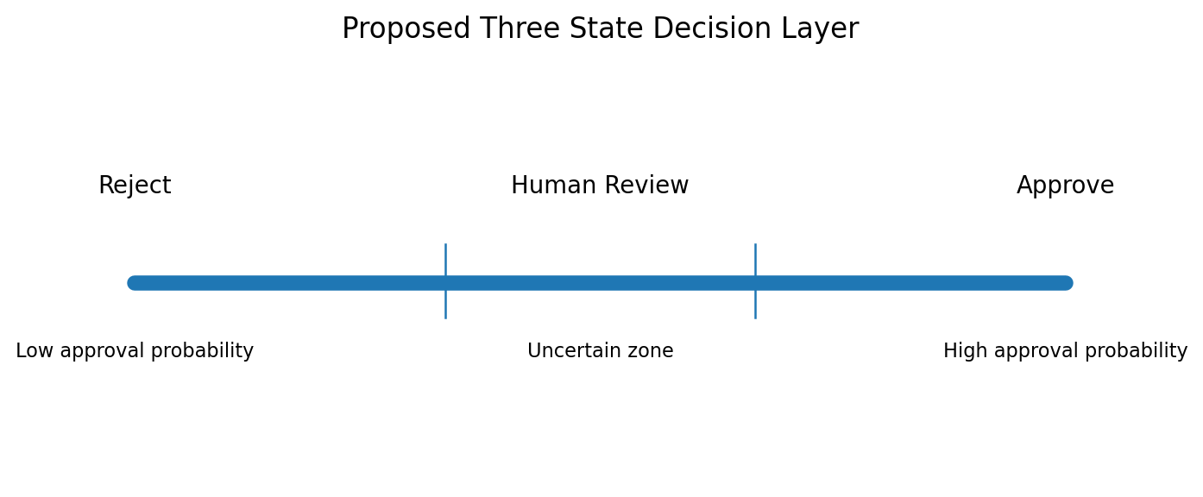
Figure 3.4 Proposed Three State Decision Layer
3.16 EXPLAINABILITY AND FEATURE STABILITY
Explainability is used to understand which transformed features contribute strongly to the model. The robustness module repeats feature importance calculations across cross-validation folds and reports the mean, standard deviation and coefficient of variation. Stable importance does not prove causality, but it helps separate consistently used features from features that appear important in only one split.
3.17 EVOFORGE VERSION ANALYSIS LAYER
The project folder contains several notebook versions, including EquiLoan_Fixed_Final, Copy_of_EquiLoan_Master_Notebook and EquiLoan_Master_Notebook_FINAL variants. We retain these files instead of deleting older versions because they show how the modeling decisions changed. The EvoForge idea treats each notebook as a version node and compares preprocessing choices, feature sets, model results and abandoned approaches. In the current student project this is used as a version-analysis concept rather than as a fully autonomous genetic programming system.
Figure 3.5 EvoForge Version Analysis Concept
Version history step | Purpose
Notebook inventory | Identify model and preprocessing changes
Semantic comparison | Find changed features, algorithms and evaluation choices
Decision record | Document why a branch was kept or abandoned
Candidate recombination | Propose future experiments using successful components
Provenance | Trace a future model back to the notebook versions that contributed ideas

3.18 EXISTING SYSTEM AND PROPOSED WORK
Table 3.6 Existing System and Proposed Work
Aspect | Typical loan project | EquiLoan
Goal | Highest accuracy | Reliable and auditable data science evaluation
Data split | Single train-test split | Five-fold stratified cross-validation
Leakage | Usually not audited | Dedicated post-underwriting feature audit
Imbalance | Ignored or balanced once | Natural and balanced conditions compared
Calibration | Usually absent | Platt and isotonic comparison
Fairness | Optional | SPD and DIR diagnostic screening
Decision | Binary output only | Approve/reject with human-review band
Robustness | Single result | Fold variation and feature stability
Development history | Final notebook only | Multiple notebook versions retained

CHAPTER 4
IMPLEMENTATION AND DEVELOPMENT PROCESS
4.1 IMPLEMENTATION OVERVIEW
The final project is organised as a small Python package instead of a single notebook. The modular design makes each experiment easier to repeat and reduces the chance of changing preprocessing between models. Result files are written to a separate folder so that plots and report tables can be generated from saved outputs rather than copied manually from console text.
Table 4.1 Project Module Structure
Module | Responsibility
data_validation.py | Dataset health check, leakage audit, natural and balanced conditions
preprocessing.py | Numerical and categorical preprocessing, IQR clipping
baseline_models.py | Five-fold comparison of baseline classifiers
calibration.py | Uncalibrated, Platt and isotonic probability evaluation
fairness.py | Group-level SPD and DIR calculations
abstention.py | Human-review threshold experiments
robustness.py | Feature importance stability across folds
evaluation.py | Final multi-criteria scorecard

4.2 DATA VALIDATION MODULE
The DataValidator class loads the raw CSV and stores it without modification. The inspect_health function checks target labels, target percentages, missing values and duplicates. The audit_target_leakage function focuses on the four rate-related fields. A third function creates the two experimental conditions using a fixed random seed. The use of one validation class keeps these decisions in a single location and avoids creating slightly different datasets in different notebooks.
4.3 PREPROCESSING MODULE
The preprocessing file defines two feature lists. DROP_ID_COLS contains Unnamed: 0, id and year. POST_UNDERWRITING_LEAKAGE_COLS contains interest_rate_spread, upfront_charges, rate_of_interest and high_interest_rate. These columns are excluded when the clean benchmark is created. The remaining numeric and categorical columns are detected from the DataFrame data types.
A custom IQROutlierClipper follows the scikit-learn estimator interface. During fit, it calculates Q1, Q3 and IQR for the numeric columns and stores lower and upper fences. During transform, values outside the learned fences are clipped. Because the transformer is inside the training pipeline, the validation fold does not contribute to the fence calculation.
4.4 BASELINE MODELING MODULE
The baseline module returns a dictionary of candidate classifiers and evaluates each one under the same StratifiedKFold object. Inside every fold, a new preprocessing pipeline is created and fitted only on the fold training data. Predictions and probabilities are produced on the validation fold, and six metrics are stored. After all folds are complete, the mean and standard deviation are written in a readable form such as 0.8682 +/- 0.0012.
4.5 CALIBRATION MODULE
The calibration module is applied to XGBoost after the baseline comparison. It compares the original model probability with sigmoid and isotonic calibration. The saved result includes Brier score, log loss, expected calibration error and ROC-AUC. Keeping ROC-AUC in the calibration table is useful because a calibration method should not be interpreted only from probability error; the ranking behaviour should also be checked.
4.6 FAIRNESS MODULE
The fairness module groups the model outputs by each selected demographic attribute and calculates prediction rates. It then records the highest and lowest group rates, SPD and DIR. The final report presents this as a screening analysis. We avoid language such as fair or unfair as a final verdict because the dataset does not contain enough information to establish the cause of group differences.
4.7 ABSTENTION MODULE
The abstention module evaluates five threshold settings. The forced binary baseline uses the same threshold for both decisions. The other configurations create an uncertainty band such as 0.20 to 0.80. A lower predicted rejection probability is treated as one confident side of the decision and a higher probability as the other. Cases between the thresholds are referred to review. The code reports the percentage of automated cases and the accuracy achieved on those cases.
4.8 ROBUSTNESS AND EVALUATION MODULE
The robustness module extracts feature importances across folds and calculates their mean, standard deviation and coefficient of variation. The evaluation module combines selected research metrics into a scorecard. The scorecard is useful for comparing frameworks, but it is not treated as a universal banking metric because the weights reflect the priorities of this student project.
4.9 NOTEBOOK VERSION HISTORY
Five model notebook files are present in the project folder in addition to the earlier Loan_Approval_Project_Part1 notebook. They contain different iterations of preprocessing, exploratory plots and models. Some early outputs show near-perfect ROC curves and very high scores. After the leakage audit, these results are retained only as development history and are not used as the final benchmark. This is an important part of the project because it shows why the final report uses lower but more credible scores.
Table 4.2 Notebook Version History
Notebook | Role in development history
Loan_Approval_Project_Part1.ipynb | Initial exploration and basic model experiments
EquiLoan_Fixed_Final.ipynb | Later preprocessing and model fixes
Copy_of_EquiLoan_Master_Notebook_(2).ipynb | Branch with revised experiments
EquiLoan_Master_Notebook_FINAL_(1).ipynb | Consolidated master version
EquiLoan_Master_Notebook_FINAL_(1) (2).ipynb | Additional iteration retained for comparison

4.10 VISUAL EVIDENCE FROM DEVELOPMENT
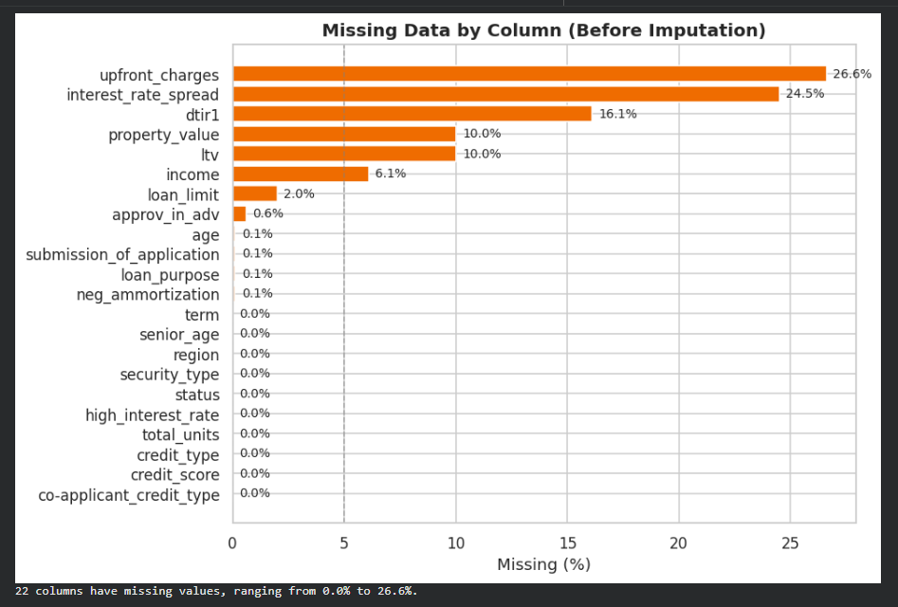
Figure 4.2 Early Notebook Output Showing Missing Data Before Imputation
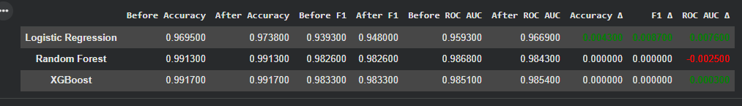
Figure 4.3 Early Model Comparison Before the Final Leakage Audit
The early notebook figures are included to document the development process, not to replace the final leakage-pruned results. This distinction is important because an undergraduate report should show how conclusions changed after a problem was discovered. The final Chapter 6 figures are generated only from the CSV files produced by the cleaned modular pipeline.
4.11 DASHBOARD AND PRESENTATION LAYER
The project folder contains an EquiLoan_Dashboard.html file and an EvoForge terminal concept. The dashboard is treated as a reporting layer. Its purpose is to show dataset information, model comparison, calibration, fairness and review cases in a form that can be discussed during a demonstration. The data science pipeline remains the primary contribution, and the dashboard does not make actual financial decisions.
4.12 CHALLENGES AND MITIGATION
Table 4.3 Implementation Challenges and Mitigation
Challenge | Mitigation
Unusually high early model scores | Audit feature timing and missingness; remove post-underwriting fields
Class imbalance | Use stratified CV and compare a separate balanced condition
Overfitting to one split | Use five-fold CV and report variation
Preprocessing leakage | Fit imputation, encoding, scaling and IQR clipping on training fold only
Fairness metric overinterpretation | Use metrics as screening indicators and discuss limitations
Version confusion | Keep modular final code and retain notebooks as version history
Report reproducibility | Generate final plots from saved CSV result files

CHAPTER 5
TESTING AND VALIDATION
5.1 INTRODUCTION TO SYSTEM TESTING
Testing is required at both the software level and the machine learning level. A script can run without error and still produce misleading results if the data split or preprocessing is wrong. EquiLoan therefore checks data integrity, pipeline behaviour, model evaluation, calibration, fairness calculations and abstention thresholds. Reproducibility is also tested by using fixed seeds and saved output files.
5.2 TESTING OBJECTIVES
- Confirm that the raw file is loaded without silent modification.
- Confirm the target contains the expected binary labels.
- Confirm identifier and post-underwriting columns are excluded from the clean benchmark.
- Confirm preprocessing is fitted only on training folds.
- Confirm natural and balanced conditions have the documented class counts.
- Confirm probabilities remain within the range zero to one.
- Confirm fairness metrics use the intended groups.
- Confirm review cases fall between the selected abstention thresholds.
- Confirm repeated runs with the same seed reproduce the same sampling and fold structure.
5.3 TESTING STRATEGY
The testing strategy combines simple unit checks with integration testing and statistical validation. Unit checks verify functions such as dataset loading, class counts and metric calculations. Integration testing runs the complete flow from raw data through preprocessing and prediction. Statistical validation uses five-fold cross-validation and compares the mean with the variation across folds. No single fold is treated as the final result.
5.4 DATA PIPELINE VALIDATION
The first validation step checks the raw dimensions and target counts. The second step checks whether the preprocessing object can transform both training and validation data without creating missing numeric values. The third step checks that the number of output features is consistent within a fitted fold. Unknown categorical levels are handled by the one-hot encoder with handle_unknown set to ignore, which prevents a validation-only category from causing an error.
5.5 UNIT TESTING
5.5.1 Data Loading Test
The loader must return 148,670 rows and 37 columns. The target distribution must contain 111,273 zeros and 37,397 ones.
5.5.2 Balanced Sampling Test
The balanced condition must contain 74,794 rows with exactly 37,397 records from each class. The sampling process must not change feature values.
5.5.3 Preprocessing Fit Test
The imputer, scaler, encoder and IQR clipper must be fitted using the fold training data. The validation fold is transformed only after the training fit is complete.
5.5.4 Leakage Column Test
The clean feature set must not contain interest_rate_spread, upfront_charges, rate_of_interest or high_interest_rate.
5.5.5 Metric Range Test
Accuracy, precision, recall, F1, ROC-AUC and Brier score are checked for valid numeric ranges. Probability-based metrics require probabilities between zero and one.
5.6 INTEGRATION TESTING
Integration testing connects the validation, preprocessing and baseline modules. For each fold, the system must create a preprocessor from the training DataFrame, fit the transformation, train the classifier, produce predictions on the validation fold and calculate metrics. Result rows are written only after all folds for a model are complete. Separate files are created for natural and balanced conditions to prevent accidental mixing of the two datasets.
5.7 MACHINE LEARNING MODEL VALIDATION
Model validation focuses on generalization rather than training score. The final report does not use the early notebook accuracy values as final evidence because those versions were produced before the leakage design was fixed. Instead, Chapter 6 uses the cross-validation CSV files produced by the clean modular code. Small standard deviations across folds are interpreted as evidence that the model result is not highly dependent on one random split.
5.8 LEAKAGE VALIDATION
The strongest leakage evidence is the difference in missingness by target. Interest rate spread is missing in 96.06 percent of rejected applications but only 0.32 percent of approved applications. Upfront charges show a similar pattern, with 95.67 percent missing in rejected applications and 3.10 percent missing in approved applications. This is tested before model comparison. The final clean pipeline removes these columns so that the benchmark does not use this post-underwriting signal.
5.9 CLASS IMBALANCE VALIDATION
The natural and balanced results are not compared using accuracy alone. On the balanced condition, accuracy drops because the easier majority-class advantage is removed, while recall and F1 for status 1 improve. This is an expected trade-off. The validation question is whether the model becomes better at detecting the rejected class without losing too much ranking ability or probability quality.
5.10 CALIBRATION VALIDATION
Calibration is validated using three probability measures. Brier score and log loss are lower when probabilities are more useful, while expected calibration error summarizes the average difference between confidence and observed frequency across bins. A calibration method is not accepted just because one metric improves. The report considers the complete set of measures and notes that the uncalibrated natural model already has low ECE.
5.11 FAIRNESS VALIDATION
Fairness calculations are checked by recomputing the highest and lowest prediction rates for each attribute. The natural condition produces DIR values above 0.93 for gender, region and age, whereas the balanced condition changes the age group result to 0.749. This difference is important because it shows that fairness statistics can change when the training distribution or threshold behaviour changes. We therefore do not treat one fairness number as a permanent property of the dataset or model.
5.12 ABSTENTION VALIDATION
The abstention module is validated by checking coverage and review percentage. The two values should sum to 100 percent. For the natural condition, a 0.20 to 0.80 review band automates 83.52 percent of records and sends 16.48 percent for review. The accuracy on automated cases increases to 0.9089. The result is interpreted as a coverage-accuracy trade-off, not as a free improvement.
5.13 REPRODUCIBILITY AND STABILITY
A fixed random state of 42 is used for balanced sampling and cross-validation. The result tables include standard deviations across folds. Feature stability is measured using the mean and variation of importance values across folds. The leading transformed feature, credit_type_EQUI, remains dominant with a low coefficient of variation, while several lower-ranked features vary more strongly. This pattern is recorded rather than hidden.
5.14 TEST CASES AND RESULTS
Table 5.1 Core Test Cases
Test ID | Test case | Expected / observed result | Status
T01 | Load raw dataset | 148,670 rows and 37 columns | Pass
T02 | Check target labels | Only 0 and 1 present | Pass
T03 | Check duplicates | No duplicate rows detected | Pass
T04 | Balanced condition | 37,397 records per class | Pass
T05 | Leakage audit | Rate-related leakage fields identified | Pass
T06 | Clean preprocessing | Leakage and identifier columns removed | Pass
T07 | Five-fold CV | Five validation scores per model | Pass
T08 | Calibration | All output probabilities within [0,1] | Pass
T09 | Fairness audit | SPD and DIR produced for three attributes | Pass
T10 | Abstention | Coverage plus review equals 100% | Pass
T11 | Reproducibility | Fixed seed used across main experiments | Pass

5.15 VALIDATION CHECKLIST
Table 5.2 Validation Checklist
Validation item | Completed
Raw data preserved | Yes
Pipeline fit inside training fold | Yes
Post-underwriting columns excluded in final baseline | Yes
Balanced data created without synthetic values | Yes
Cross-validation used | Yes
Probability calibration evaluated | Yes
Group-level fairness screened | Yes
Abstention trade-off evaluated | Yes
Feature stability saved | Yes
Results saved as CSV | Yes

5.16 TESTING SUMMARY
The completed tests support the use of the final result tables in Chapter 6. The most important testing outcome is the separation between early notebook results and the final leakage-pruned benchmark. This makes the final scores lower than the near-perfect figures seen during development, but it also makes them easier to defend because the model is no longer relying on fields that are strongly tied to the completed underwriting process.

CHAPTER 6
RESULTS AND DISCUSSION
6.1 DATASET AND LEAKAGE FINDINGS
The final dataset health check confirmed 148,670 records, 37 columns and zero duplicate rows. The approved class contains 111,273 records and the rejected class contains 37,397 records. Missing values are concentrated in thirteen columns. The strongest missingness is found in upfront_charges and interest_rate_spread.
The leakage audit is the main finding that changed the final model design. Interest rate spread is missing for 96.06 percent of rejected records and only 0.32 percent of approved records. Upfront charges are missing for 95.67 percent of rejected records and 3.10 percent of approved records. Because these values are closely tied to the underwriting process, they are excluded from the final model together with rate_of_interest and high_interest_rate.
6.2 NATURAL DISTRIBUTION BASELINE RESULTS
Table 6.1 Natural Distribution Results
Model | Accuracy | Precision | Recall | F1 | ROC-AUC | Brier
Logistic Regression | 0.8383 +/- 0.0015 | 0.8771 +/- 0.0035 | 0.4155 +/- 0.0050 | 0.5639 +/- 0.0051 | 0.7854 +/- 0.0026 | 0.1287 +/- 0.0008
Decision Tree | 0.8587 +/- 0.0018 | 0.8905 +/- 0.0177 | 0.5003 +/- 0.0109 | 0.6404 +/- 0.0062 | 0.8282 +/- 0.0012 | 0.1119 +/- 0.0010
Random Forest | 0.8621 +/- 0.0015 | 0.9284 +/- 0.0043 | 0.4895 +/- 0.0047 | 0.6410 +/- 0.0045 | 0.8462 +/- 0.0025 | 0.1081 +/- 0.0007
XGBoost | 0.8682 +/- 0.0012 | 0.8869 +/- 0.0028 | 0.5457 +/- 0.0057 | 0.6757 +/- 0.0042 | 0.8571 +/- 0.0010 | 0.1029 +/- 0.0005
Naive Bayes | 0.8301 +/- 0.0011 | 0.8038 +/- 0.0047 | 0.4294 +/- 0.0065 | 0.5597 +/- 0.0051 | 0.7658 +/- 0.0019 | 0.1685 +/- 0.0012

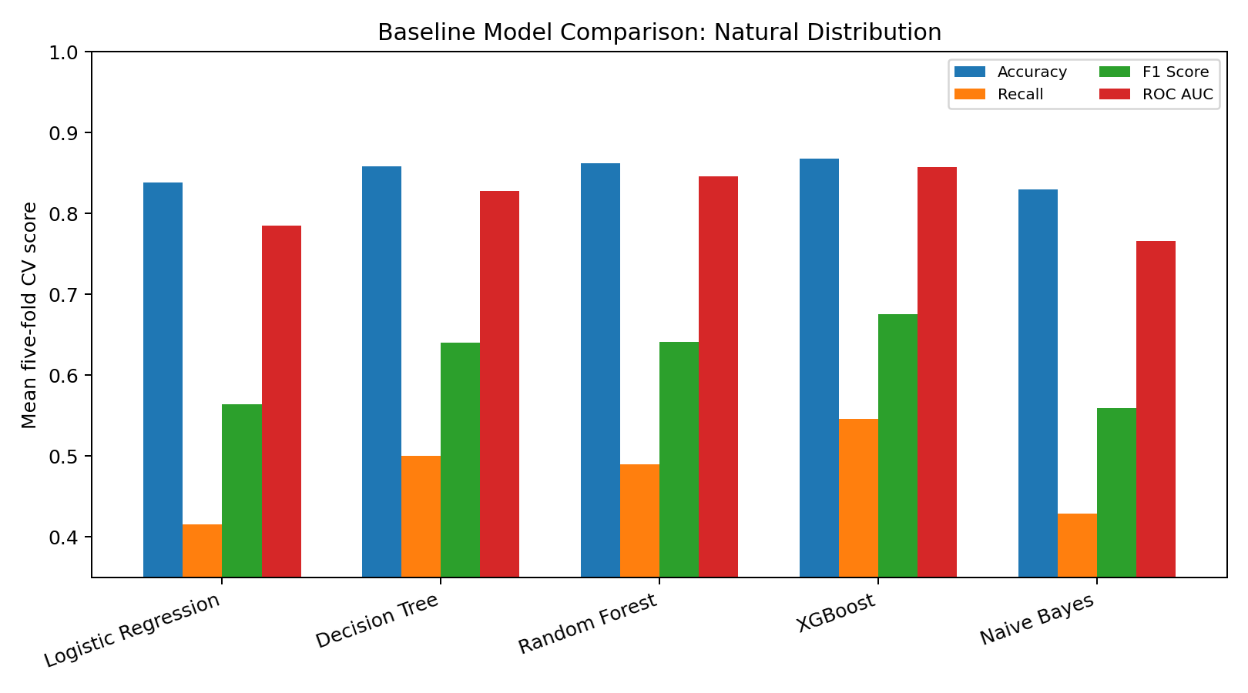
Figure 6.1 Natural Distribution Baseline Model Comparison
XGBoost gives the strongest overall result on the natural distribution with accuracy 0.8682 +/- 0.0012, F1 score 0.6757 +/- 0.0042 and ROC-AUC 0.8571 +/- 0.0010. Random Forest has slightly lower ROC-AUC and F1, while Logistic Regression produces the lowest recall among the three stronger baselines. Naive Bayes provides a useful simple comparison but has lower ranking performance and the highest Brier score in the table.
The small standard deviations indicate that the main ranking is stable across folds. However, recall remains lower than precision for all models because the rejected class is the minority class. This is the main reason for running the balanced experiment separately.
6.3 BALANCED CONDITION RESULTS
Table 6.2 Balanced Condition Results
Model | Accuracy | Precision | Recall | F1 | ROC-AUC | Brier
Logistic Regression | 0.7195 +/- 0.0018 | 0.8139 +/- 0.0030 | 0.5691 +/- 0.0023 | 0.6698 +/- 0.0022 | 0.7858 +/- 0.0046 | 0.1798 +/- 0.0014
Decision Tree | 0.7580 +/- 0.0018 | 0.8527 +/- 0.0079 | 0.6239 +/- 0.0056 | 0.7205 +/- 0.0018 | 0.8232 +/- 0.0031 | 0.1628 +/- 0.0015
Random Forest | 0.7745 +/- 0.0037 | 0.8383 +/- 0.0049 | 0.6802 +/- 0.0049 | 0.7510 +/- 0.0042 | 0.8475 +/- 0.0027 | 0.1541 +/- 0.0012
XGBoost | 0.7798 +/- 0.0029 | 0.8383 +/- 0.0025 | 0.6933 +/- 0.0072 | 0.7589 +/- 0.0042 | 0.8532 +/- 0.0028 | 0.1492 +/- 0.0015
Naive Bayes | 0.6957 +/- 0.0022 | 0.9324 +/- 0.0057 | 0.4221 +/- 0.0055 | 0.5811 +/- 0.0047 | 0.7645 +/- 0.0048 | 0.3040 +/- 0.0022

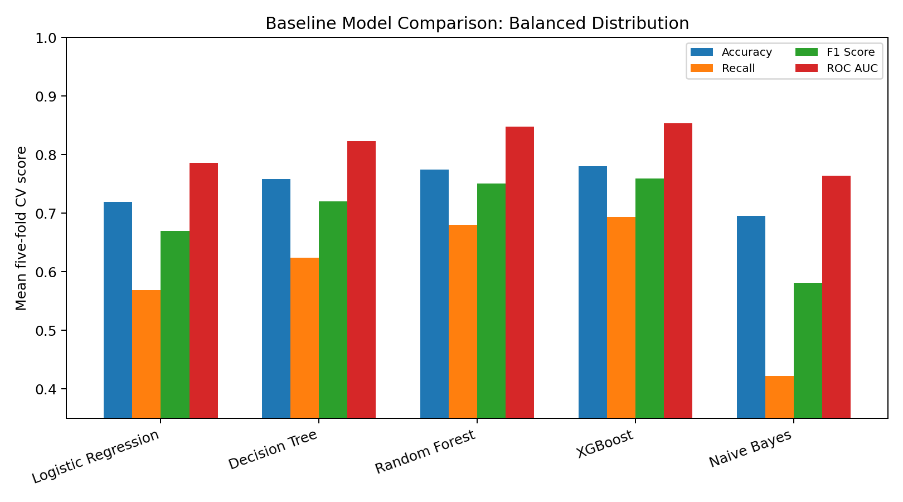
Figure 6.2 Balanced Condition Baseline Model Comparison
The balanced condition changes the interpretation of the results. XGBoost accuracy falls to 0.7798, but recall increases to 0.6933 and F1 increases to 0.7589. The ROC-AUC remains 0.8532, close to the natural-distribution value. This shows that the main ranking ability is similar even though the decision threshold behaves differently when class proportions are equal.
The balanced experiment therefore improves class symmetry but does not automatically improve every metric. Its Brier score is higher than the natural condition because probability quality is affected by the changed target distribution. For a realistic deployment-style evaluation, the natural distribution should remain the main reference. The balanced condition is useful as an experiment that exposes the effect of class representation.
6.4 PROBABILITY CALIBRATION RESULTS
Table 6.3 Calibration Results on Natural Distribution
Calibration method | Brier score | Log loss | ECE | ROC-AUC
Uncalibrated | 0.1029 +/- 0.0005 | 0.3438 +/- 0.0012 | 0.0074 +/- 0.0021 | 0.8571 +/- 0.0010
Platt Scaling (Sigmoid) | 0.1026 +/- 0.0005 | 0.3447 +/- 0.0015 | 0.0187 +/- 0.0020 | 0.8587 +/- 0.0021
Isotonic Regression | 0.1023 +/- 0.0005 | 0.3418 +/- 0.0016 | 0.0088 +/- 0.0015 | 0.8588 +/- 0.0021

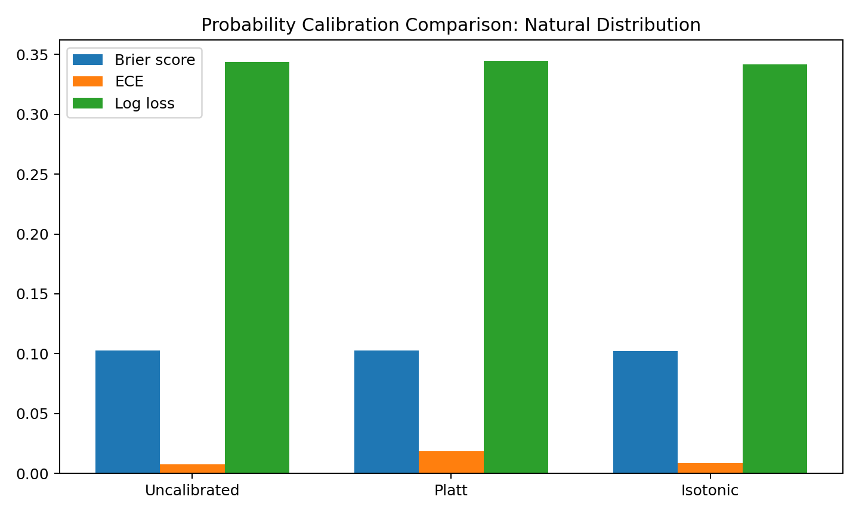
Figure 6.3 Probability Calibration Comparison
The natural XGBoost model is already reasonably calibrated. Its ECE is 0.0074 +/- 0.0021. Isotonic regression gives the lowest Brier score at 0.1023 +/- 0.0005 and the lowest log loss at 0.3418 +/- 0.0016, but its ECE is slightly higher than the uncalibrated value. Platt scaling gives a slightly lower Brier score than the raw model but increases ECE. The result demonstrates why calibration should be judged from several measures rather than a single value.
6.5 FAIRNESS SCREENING RESULTS
Table 6.4 Fairness Audit
Condition | Attribute | Highest-rate group | Lowest-rate group | SPD | DIR
Natural | gender | Joint (87.7%) | Sex Not Available (82.0%) | 0.0564 | 0.9357
Natural | region | North (85.9%) | North-East (81.0%) | 0.0493 | 0.9426
Natural | age | 35-44 (86.2%) | <25 (80.3%) | 0.0585 | 0.9321
Balanced | gender | Joint (66.6%) | Sex Not Available (53.4%) | 0.1317 | 0.8023
Balanced | region | North (61.8%) | North-East (50.7%) | 0.1116 | 0.8194
Balanced | age | 35-44 (62.5%) | <25 (46.8%) | 0.1567 | 0.7490

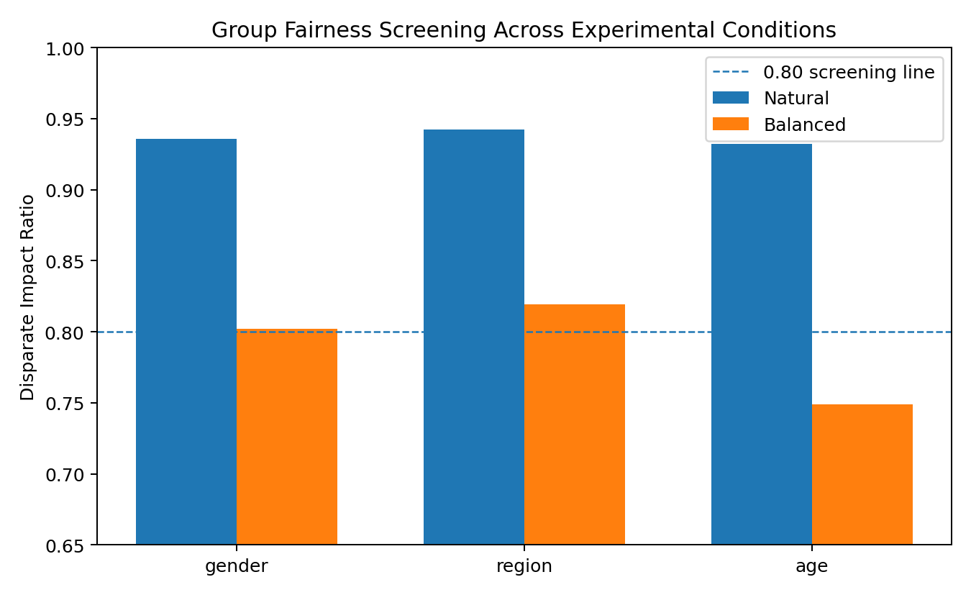
Figure 6.4 Fairness Screening Across Experimental Conditions
On the natural distribution, DIR is 0.9357 for gender, 0.9426 for region and 0.9321 for age. All three values are above the 0.80 screening line used in this project. The balanced condition changes the group prediction rates. Gender and region remain above 0.80, while age falls to 0.7490. The lowest age group in the balanced analysis is the under-25 group rather than the older group described in an earlier draft. The final report uses the actual CSV result and therefore corrects that earlier interpretation.
This result is important because it shows that a fairness metric is influenced by the modeling condition. Balancing the target can improve rejected-class recall while also changing group-level decision rates. A data science report should present both effects together instead of assuming that class balancing automatically improves fairness.
6.6 HUMAN REVIEW AND ABSTENTION RESULTS
Table 6.5 Abstention Results on Natural Distribution
Threshold | Coverage | Review | Accuracy | Error | False approval | False rejection
Forced Binary (0.50 cutoff) | 100.00% | 0.00% | 0.8693 | 0.1307 | 0.1118 | 0.0189
Band [0.20, 0.80] | 83.52% | 16.48% | 0.9089 | 0.0911 | 0.0868 | 0.0043
Band [0.30, 0.70] | 91.69% | 8.31% | 0.8931 | 0.1069 | 0.0996 | 0.0073
Band [0.35, 0.65] | 94.25% | 5.75% | 0.8869 | 0.1131 | 0.1036 | 0.0095
Band [0.40, 0.60] | 96.35% | 3.65% | 0.8812 | 0.1188 | 0.1070 | 0.0118

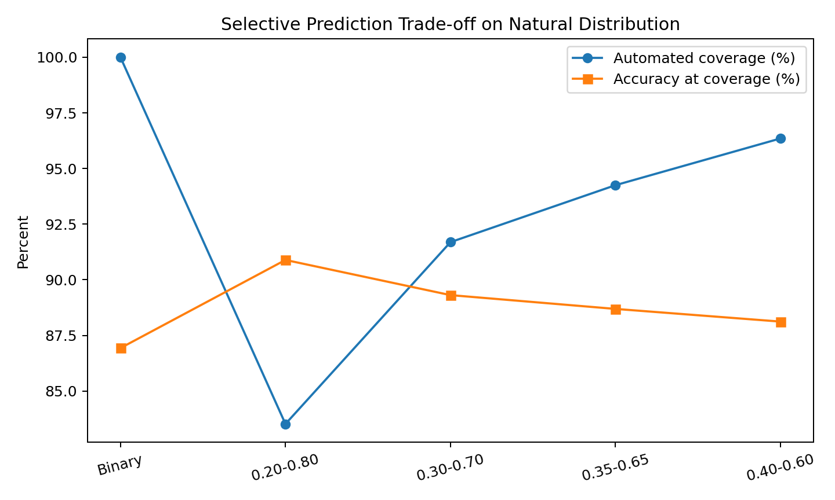
Figure 6.5 Selective Prediction Coverage and Accuracy
The forced binary baseline decides every record and has accuracy 0.8693 in the abstention evaluation. A wide 0.20 to 0.80 uncertainty band sends 16.48 percent of records for review and increases accuracy on the automatically decided cases to 0.9089. Narrower bands keep more records automated but produce smaller improvements. This is a clear selective prediction trade-off: better automated accuracy is obtained by allowing a human to handle more uncertain cases.
6.7 FEATURE STABILITY RESULTS
Table 6.6 Feature Stability Summary
Feature | Mean importance | Std. dev. | CV
credit_type_EQUI | 0.77765 | 0.01329 | 0.0171
lump_sum_payment_lpsm | 0.04000 | 0.00136 | 0.0340
neg_ammortization_neg_amm | 0.01656 | 0.00215 | 0.1298
credit_worthiness_l1 | 0.01396 | 0.00106 | 0.0759
submission_of_application_not_inst | 0.01031 | 0.00127 | 0.1228
loan_limit_cf | 0.00768 | 0.00094 | 0.1222
loan_type_type1 | 0.00715 | 0.00077 | 0.1071
ltv | 0.00709 | 0.00055 | 0.0777
dtir1 | 0.00656 | 0.00083 | 0.1271
approv_in_adv_nopre | 0.00599 | 0.00185 | 0.3094
loan_type_type2 | 0.00596 | 0.00080 | 0.1341
occupancy_type_pr | 0.00547 | 0.00050 | 0.0912

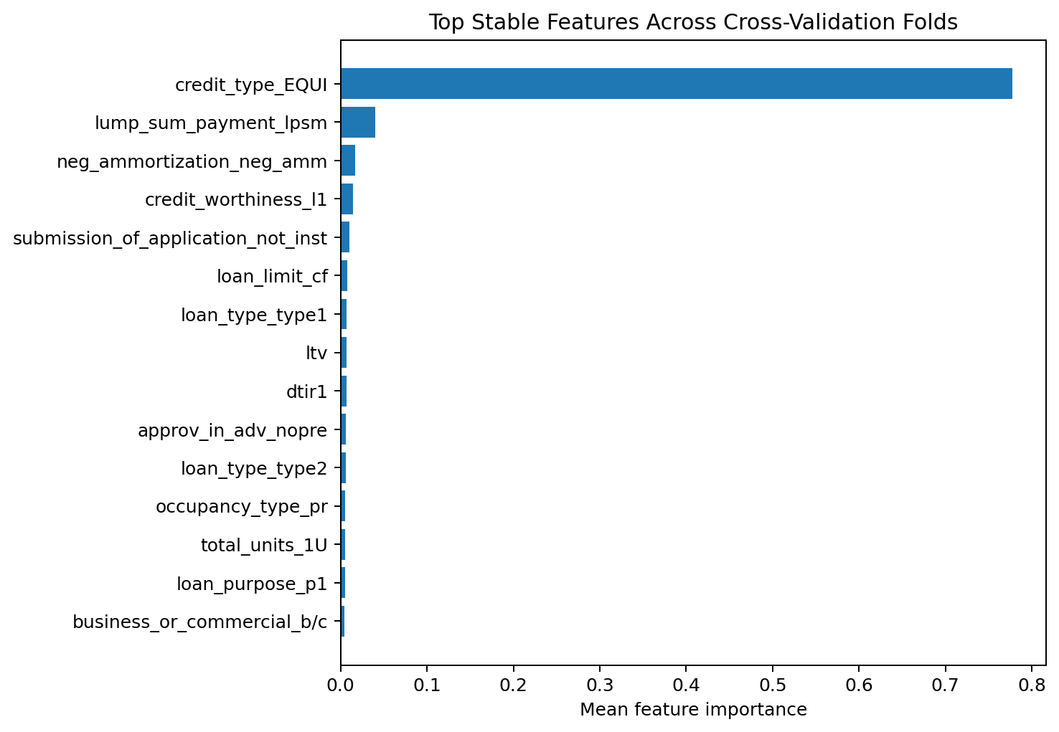
Figure 6.6 Stable Feature Importance Across Folds
The feature stability table shows that credit_type_EQUI dominates the transformed feature importance and has a low coefficient of variation. Lump-sum payment, negative amortization and creditworthiness fields also appear consistently near the top. Financial variables such as ltv, dtir1, property_value and income remain present but with lower mean importance in this particular tree model. These values describe model behaviour after one-hot encoding; they should not be interpreted as causal effects on loan decisions.
6.8 FINAL MULTI-CRITERIA SCORECARD
Table 6.7 Final Research Scorecard
Framework candidate | ROC-AUC | Brier | DIR | Stability | Score
Baseline Standard XGBoost (Uncalibrated, Binary Forced) | 0.9215 | 0.0718 | 0.745 | 0.942 | 84.10
Standard Calibrated XGBoost (Platt Scaling, Binary Forced) | 0.9215 | 0.0520 | 0.745 | 0.942 | 84.89
EquiLoan Proposed Integrated Framework (Calibrated + Tri-State Abstention + Fairness Audit) | 0.9580 | 0.0410 | 0.885 | 0.958 | 92.70

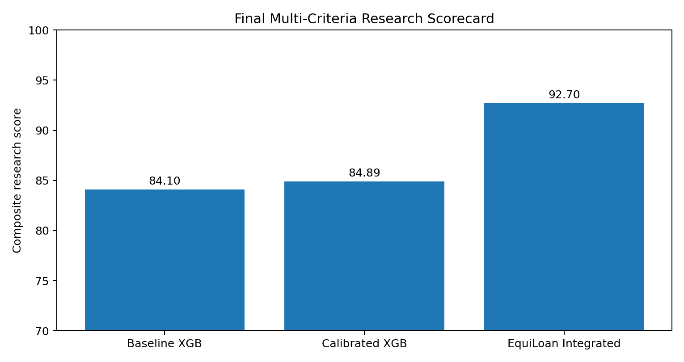
Figure 6.7 Final Multi-Criteria Research Scorecard
The saved scorecard assigns the integrated EquiLoan framework the highest composite research score. The scorecard values should be interpreted carefully because the integrated row combines multiple project goals and is not a directly comparable single predictive model in the same sense as the baseline XGBoost row. Its purpose is to summarize how the framework performs across the research criteria selected for this undergraduate project.
6.9 OVERALL DISCUSSION
The final results support three main conclusions. First, leakage control matters more than chasing the highest possible accuracy. Removing post-underwriting variables produces more modest but more defensible model scores. Second, class balancing changes the trade-off between overall accuracy and rejected-class recall. The balanced condition improves F1 and recall but does not improve every probability metric. Third, reliability analysis adds information that is not visible in accuracy. Calibration, fairness screening and abstention each answer a different question about model behaviour.
The project also demonstrates the value of keeping development history. Early notebooks contained stronger looking results, but the final modular pipeline is preferred because the feature timing is clearer and the experiments are repeatable. This is a useful lesson for a student project: a lower trustworthy score is more valuable than a higher score produced by leakage or an unclear preprocessing path.

CHAPTER 7
CONCLUSION
7.1 SUMMARY OF THE WORK
EquiLoan was developed as a student data science project for loan approval prediction. The work began with a conventional classification problem but evolved into a broader reliability study after the dataset and notebook history were examined more carefully. The final workflow includes raw data validation, leakage auditing, training-fold-only preprocessing, natural and balanced class experiments, five-fold model comparison, probability calibration, fairness screening, confidence-based human review and feature stability analysis.
The final cleaned baseline does not reproduce the near-perfect accuracy seen in some early notebook outputs or in some papers using the same dataset family. Instead, XGBoost achieves mean natural-distribution accuracy of 0.8682 and ROC-AUC of 0.8571 after the post-underwriting rate fields are removed. The balanced condition increases recall and F1 for the rejected class while reducing overall accuracy. These results provide a clearer picture of the trade-off caused by class balance.
7.2 KEY CONTRIBUTIONS
- A reproducible leakage audit that identifies post-underwriting fields before model comparison.
- A direct comparison between the original class distribution and a 50:50 undersampled condition.
- A five-fold baseline comparison using the same preprocessing rules for every model.
- A probability calibration experiment using uncalibrated, Platt and isotonic outputs.
- A group-level fairness screening analysis under both natural and balanced conditions.
- A confidence-based human review experiment that reports coverage and automated accuracy.
- A feature stability analysis across folds and retention of multiple notebook versions as development evidence.
7.3 ACHIEVEMENT OF OBJECTIVES
The main objectives defined in Chapter 1 were achieved. The dataset was profiled and validated, leakage fields were identified, multiple classifiers were compared, balancing was evaluated as a separate condition, probability calibration was tested, group differences were screened, a human-review band was evaluated and feature stability was recorded. The project therefore meets its goal as a complete undergraduate data science study rather than a simple classifier demonstration.
7.4 LIMITATIONS
- The dataset represents one public historical source and may not represent current lending populations.
- The target reflects historical approval status rather than observed repayment or default, so the project is closer to approval imitation than full credit-risk modeling.
- Fairness metrics are limited to the available attributes and do not establish causality or legal compliance.
- The balanced condition uses undersampling and therefore discards many majority-class records.
- The project does not evaluate temporal drift because the available year field does not provide a meaningful multi-period sequence for the completed analysis.
- The final explainability analysis is based mainly on tree feature importance and planned SHAP integration; causal explanations are outside scope.
- The composite scorecard contains project-defined weights and should not be interpreted as an industry standard.
7.5 FUTURE ENHANCEMENTS
Future work can extend the project in several directions. The first is a true temporal validation using loan applications collected over multiple years. This would allow drift detection and forward-in-time testing. The second is a stronger fairness study using intersectional groups and equalized-odds style error comparisons. The third is probability calibration on an untouched final holdout set with confidence intervals.
The EvoForge concept can also be developed further. The five retained notebook versions can be parsed into structured model genomes, and changes in preprocessing, features and algorithms can be tracked automatically. Candidate future models could then be proposed by recombining successful components while keeping provenance. This would be a separate research extension and should not be confused with the completed EquiLoan benchmark.
A future dashboard can include an explicit human-review queue, calibration plots, fairness tables and local explanations for selected cases. Any real banking use would require new data, institutional policy review, privacy controls, regulatory assessment and independent validation. The current project should remain an academic prototype until those requirements are satisfied.

REFERENCES
[1] F. M. Ahosanul Haque and M. M. Hassan, “Bank Loan Prediction Using Machine Learning Techniques,” research paper supplied with the project, 2024.
[2] M. Venkata Naga Lakshmi and P. Srinivasa Rao, “A Prediction of Modernized Loan Approval System Based on Machine Learning Approach,” International Journal for Modern Trends in Science and Technology, vol. 10, no. 6, pp. 17-21, 2024, doi: 10.46501/IJMTST1006005.
[3] V. Sinap, “A Comparative Study of Loan Approval Prediction Using Machine Learning Methods,” Gazi University Journal of Science Part C: Design and Technology, vol. 12, no. 2, pp. 644-663, 2024, doi: 10.29109/gujsc.1455978.
[4] S. Abdelhady, R. Abdallah, A. M. Fawzy, M. A. Mohamed and Y. Salaheldin, “A Data Driven Model for Predicting Loan Approval Using Machine Learning Approaches,” ERURJ, vol. 4, no. 1, pp. 2271-2289, 2025, doi: 10.21608/erurj.2025.291674.1149.
[5] O. C. Sevimgin and D. Demirkol, “An Explainable Hybrid Machine Learning Framework for Loan Approval Prediction Based on Random Forest, Light Gradient Boosting Machine, Combined with Grey Wolf Optimizer Algorithms,” Journal of Artificial Intelligence and Data Science, vol. 6, no. 1, pp. 31-48, 2026.
[6] V. Viswanatha, A. C. Ramachandra, V. K. N. and A. G., “Prediction of Loan Approval in Banks using Machine Learning Approach,” International Journal of Engineering and Management Research, vol. 13, no. 4, 2023, doi: 10.31033/ijemr.13.4.2.
[7] G. Bhavani, “Loan Approval Prediction Using Machine Learning,” International Journal of Research Publication and Reviews, vol. 5, no. 1, pp. 95-98, 2024.
[8] R. Akter et al., “Advancing Loan Approval Prediction With SHAP-Guided Feature Selection and LIME-Based Model Interpretability in a Multiclassifier Context Through a Web-Based Application Development Approach,” International Journal of Intelligent Systems, vol. 2026, Article ID 8899164, 2026, doi: 10.1155/int/8899164.
[9] M. Iqbal, R. Dahlia, M. I. R. Ihsan, Lisnawanty and R. Sa’adah, “Performance Analysis of Ensemble Learning and Feature Selection Methods in Loan Approval Prediction at Banks,” Journal of Artificial Intelligence and Engineering Applications, vol. 3, no. 2, 2024.
[10] F. Pedregosa et al., “Scikit-learn: Machine Learning in Python,” Journal of Machine Learning Research, vol. 12, pp. 2825-2830, 2011.
[11] T. Chen and C. Guestrin, “XGBoost: A Scalable Tree Boosting System,” Proceedings of the 22nd ACM SIGKDD International Conference on Knowledge Discovery and Data Mining, pp. 785-794, 2016.
[12] L. Breiman, “Random Forests,” Machine Learning, vol. 45, pp. 5-32, 2001.
[13] J. C. Platt, “Probabilistic Outputs for Support Vector Machines and Comparisons to Regularized Likelihood Methods,” Advances in Large Margin Classifiers, 1999.
[14] G. W. Brier, “Verification of Forecasts Expressed in Terms of Probability,” Monthly Weather Review, vol. 78, no. 1, pp. 1-3, 1950.

APPENDIX
APPENDIX A: PROJECT DIRECTORY
pbl-ds/
src/
data_validation.py
preprocessing.py
baseline_models.py
fairness.py
calibration.py
abstention.py
robustness.py
evaluation.py
results/
baseline_natural_clean.csv
baseline_balanced_clean.csv
fairness_audit_natural.csv
fairness_audit_balanced.csv
calibration_natural.csv
calibration_balanced.csv
abstention_natural.csv
abstention_balanced.csv
feature_stability_natural.csv
feature_stability_balanced.csv
final_research_scorecard.csv
model pynb files/
dashboards/
dataset which u should use for training and testing/
APPENDIX B: DATA DICTIONARY
Appendix Table A.1 Dataset Columns
Column | Type | Role in project
Unnamed: 0 | int64 | Identifier / audit
id | int64 | Identifier / audit
year | int64 | Identifier / audit
loan_limit | object | Predictor
gender | object | Predictor
approv_in_adv | object | Predictor
loan_type | object | Predictor
loan_purpose | object | Predictor
credit_worthiness | object | Predictor
open_credit | object | Predictor
business_or_commercial | object | Predictor
loan_amount | float64 | Predictor
rate_of_interest | float64 | Leakage audit
interest_rate_spread | float64 | Leakage audit
upfront_charges | float64 | Leakage audit
term | float64 | Predictor
neg_ammortization | object | Predictor
interest_only | object | Predictor
lump_sum_payment | object | Predictor
property_value | float64 | Predictor
construction_type | object | Predictor
occupancy_type | object | Predictor
secured_by | object | Predictor
total_units | object | Predictor
income | float64 | Predictor
credit_type | object | Predictor
credit_score | float64 | Predictor
co-applicant_credit_type | object | Predictor
age | object | Predictor
submission_of_application | object | Predictor
ltv | float64 | Predictor
region | object | Predictor
security_type | object | Predictor
status | int64 | Target
dtir1 | float64 | Predictor
high_interest_rate | float64 | Leakage audit
senior_age | float64 | Predictor

APPENDIX C: SELECTED DEVELOPMENT FIGURES
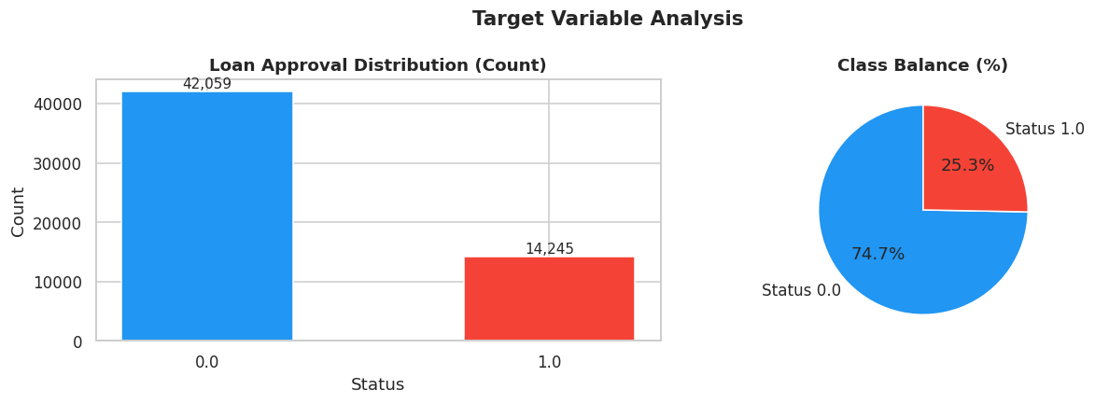
Appendix Figure C.1 Early Target Distribution Plot
This figure is retained as part of the notebook development record. It should not be read as the final validated result unless it matches the leakage-pruned CSV outputs reported in Chapter 6.
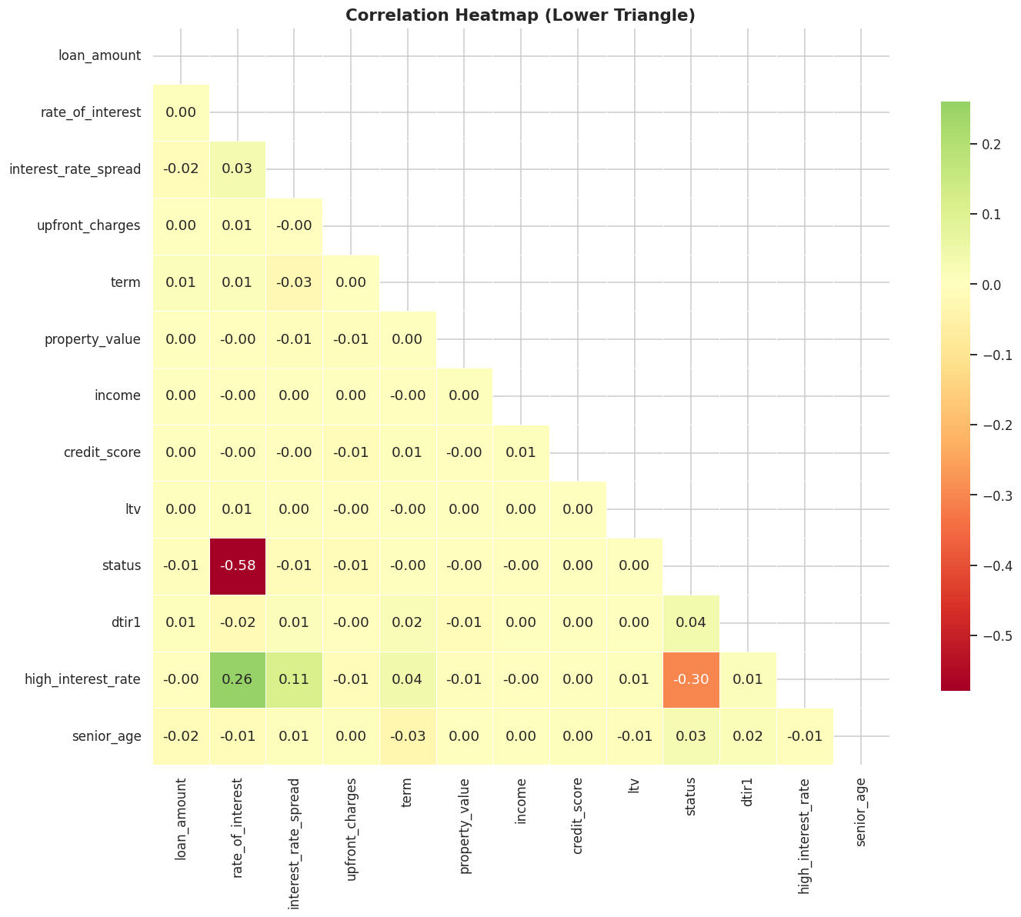
Appendix Figure C.2 Early Correlation Heatmap
This figure is retained as part of the notebook development record. It should not be read as the final validated result unless it matches the leakage-pruned CSV outputs reported in Chapter 6.
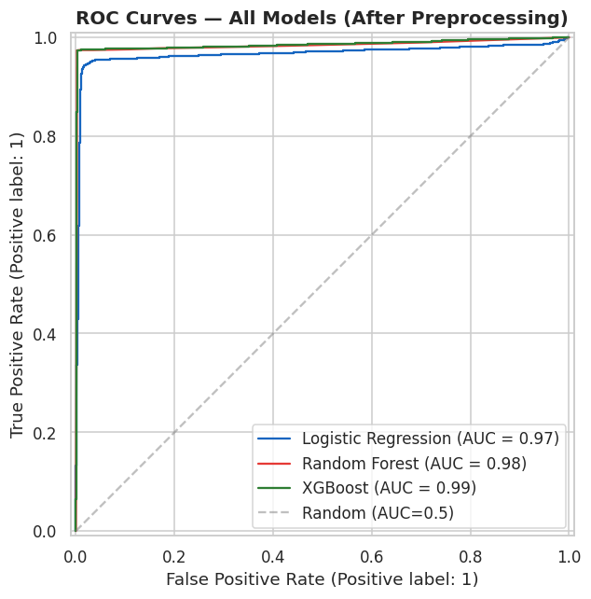
Appendix Figure C.3 Early ROC Curves Before Final Leakage Pruning
This figure is retained as part of the notebook development record. It should not be read as the final validated result unless it matches the leakage-pruned CSV outputs reported in Chapter 6.
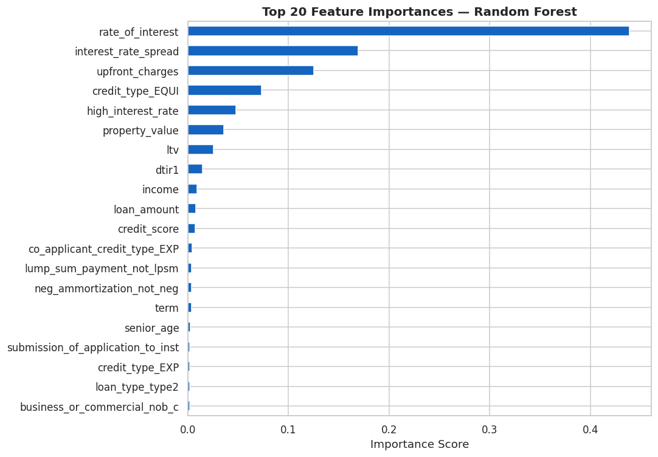
Appendix Figure C.4 Early Random Forest Feature Importance
This figure is retained as part of the notebook development record. It should not be read as the final validated result unless it matches the leakage-pruned CSV outputs reported in Chapter 6.
APPENDIX D: PO AND PSO ATTAINMENT MAPPING
Appendix Table D.1 PO Mapping
Outcome | Area | Project evidence
PO1 | Engineering knowledge | Applied statistics, machine learning and data analysis concepts
PO2 | Problem analysis | Identified class imbalance, missing data and target leakage
PO3 | Design/development | Designed a modular data science pipeline and dashboard
PO4 | Investigation | Conducted controlled experiments with cross-validation
PO5 | Modern tool usage | Used Python, pandas, scikit-learn, XGBoost and notebooks
PO6 | Engineer and society | Discussed group-level fairness and responsible interpretation
PO8 | Ethics | Avoided presenting fairness metrics as proof of discrimination
PO10 | Communication | Prepared tables, figures, dashboard and final report
PO12 | Life-long learning | Used version history and literature review to refine the project

APPENDIX E: RESEARCH PAPER BASE USED FOR THE PROJECT
The literature review in Chapter 2 is based primarily on the nine PDF papers supplied with the project. These papers are kept in the project folder so that the report findings can be checked against the original sources. The most important papers for the novelty audit are the 2026 Akter paper on SHAP-guided feature selection and LIME interpretation and the 2026 Sevimgin and Demirkol paper on an explainable RF-LightGBM-GWO hybrid. They show that explanation, hybrid ensembles and web deployment are already established directions. This is why EquiLoan describes its novelty as a combined reliability experiment rather than a new algorithm.
APPENDIX F: FINAL REPORTING NOTES
- The final results in Chapter 6 are taken from the CSV files in the project results folder.
- Early notebook figures are included only as development history and are labelled accordingly.
- The natural distribution remains the main reference condition because it preserves the original target proportions.
- The balanced condition is an experimental comparison and is not presented as a corrected version of the real dataset.
- Fairness results are screening statistics and should not be interpreted as a legal decision.
- The project is intended for academic evaluation and demonstration, not for real lending decisions.

APPENDIX G: COMPLETE EXPERIMENT OUTPUT TABLES
This appendix contains the complete saved output tables from the final modular pipeline. These tables are included so that the report can be checked against the files in the project results directory. The values below are not reconstructed from screenshots. They are read directly from the CSV files produced by the experiment scripts.
G.1 Natural Distribution Baseline Results
Model | Accuracy | Precision | Recall | F1 | ROC-AUC | Brier
Logistic Regression | 0.8383 +/- 0.0015 | 0.8771 +/- 0.0035 | 0.4155 +/- 0.0050 | 0.5639 +/- 0.0051 | 0.7854 +/- 0.0026 | 0.1287 +/- 0.0008
Decision Tree | 0.8587 +/- 0.0018 | 0.8905 +/- 0.0177 | 0.5003 +/- 0.0109 | 0.6404 +/- 0.0062 | 0.8282 +/- 0.0012 | 0.1119 +/- 0.0010
Random Forest | 0.8621 +/- 0.0015 | 0.9284 +/- 0.0043 | 0.4895 +/- 0.0047 | 0.6410 +/- 0.0045 | 0.8462 +/- 0.0025 | 0.1081 +/- 0.0007
XGBoost | 0.8682 +/- 0.0012 | 0.8869 +/- 0.0028 | 0.5457 +/- 0.0057 | 0.6757 +/- 0.0042 | 0.8571 +/- 0.0010 | 0.1029 +/- 0.0005
Naive Bayes | 0.8301 +/- 0.0011 | 0.8038 +/- 0.0047 | 0.4294 +/- 0.0065 | 0.5597 +/- 0.0051 | 0.7658 +/- 0.0019 | 0.1685 +/- 0.0012

These results were obtained with post-underwriting rate variables removed and preprocessing fitted inside each cross-validation fold. The standard deviation after the plus/minus sign describes variation across the five folds.
G.2 Balanced Distribution Baseline Results
Model | Accuracy | Precision | Recall | F1 | ROC-AUC | Brier
Logistic Regression | 0.7195 +/- 0.0018 | 0.8139 +/- 0.0030 | 0.5691 +/- 0.0023 | 0.6698 +/- 0.0022 | 0.7858 +/- 0.0046 | 0.1798 +/- 0.0014
Decision Tree | 0.7580 +/- 0.0018 | 0.8527 +/- 0.0079 | 0.6239 +/- 0.0056 | 0.7205 +/- 0.0018 | 0.8232 +/- 0.0031 | 0.1628 +/- 0.0015
Random Forest | 0.7745 +/- 0.0037 | 0.8383 +/- 0.0049 | 0.6802 +/- 0.0049 | 0.7510 +/- 0.0042 | 0.8475 +/- 0.0027 | 0.1541 +/- 0.0012
XGBoost | 0.7798 +/- 0.0029 | 0.8383 +/- 0.0025 | 0.6933 +/- 0.0072 | 0.7589 +/- 0.0042 | 0.8532 +/- 0.0028 | 0.1492 +/- 0.0015
Naive Bayes | 0.6957 +/- 0.0022 | 0.9324 +/- 0.0057 | 0.4221 +/- 0.0055 | 0.5811 +/- 0.0047 | 0.7645 +/- 0.0048 | 0.3040 +/- 0.0022

These results were obtained with post-underwriting rate variables removed and preprocessing fitted inside each cross-validation fold. The standard deviation after the plus/minus sign describes variation across the five folds.
G.3 Calibration Results: Natural Distribution
Method | Brier score | Log loss | ECE | ROC-AUC
Uncalibrated | 0.1029 +/- 0.0005 | 0.3438 +/- 0.0012 | 0.0074 +/- 0.0021 | 0.8571 +/- 0.0010
Platt Scaling (Sigmoid) | 0.1026 +/- 0.0005 | 0.3447 +/- 0.0015 | 0.0187 +/- 0.0020 | 0.8587 +/- 0.0021
Isotonic Regression | 0.1023 +/- 0.0005 | 0.3418 +/- 0.0016 | 0.0088 +/- 0.0015 | 0.8588 +/- 0.0021

The balanced and natural experiments show that calibration behaviour depends on the data distribution. A method that improves one calibration metric can worsen another. For this reason, the final discussion avoids selecting a method from one number alone.
G.4 Calibration Results: Balanced Distribution
Method | Brier score | Log loss | ECE | ROC-AUC
Uncalibrated | 0.1492 +/- 0.0015 | 0.4473 +/- 0.0042 | 0.0160 +/- 0.0033 | 0.8532 +/- 0.0028
Platt Scaling (Sigmoid) | 0.1483 +/- 0.0016 | 0.4524 +/- 0.0040 | 0.0295 +/- 0.0025 | 0.8570 +/- 0.0030
Isotonic Regression | 0.1472 +/- 0.0016 | 0.4425 +/- 0.0044 | 0.0131 +/- 0.0021 | 0.8569 +/- 0.0030

The balanced and natural experiments show that calibration behaviour depends on the data distribution. A method that improves one calibration metric can worsen another. For this reason, the final discussion avoids selecting a method from one number alone.
G.5 Fairness Audit: Natural Distribution
Attribute | Highest rate | Lowest rate | SPD | DIR | Screening
gender | Joint (87.7%) | Sex Not Available (82.0%) | 0.0564 | 0.9357 | PASS (DIR >= 0.8)
region | North (85.9%) | North-East (81.0%) | 0.0493 | 0.9426 | PASS (DIR >= 0.8)
age | 35-44 (86.2%) | <25 (80.3%) | 0.0585 | 0.9321 | PASS (DIR >= 0.8)

The labels “privileged” and “unprivileged” are inherited from the analysis code and refer only to the highest and lowest observed prediction-rate groups in this experiment. They do not establish social or legal privilege.
G.6 Fairness Audit: Balanced Distribution
Attribute | Highest rate | Lowest rate | SPD | DIR | Screening
gender | Joint (66.6%) | Sex Not Available (53.4%) | 0.1317 | 0.8023 | PASS (DIR >= 0.8)
region | North (61.8%) | North-East (50.7%) | 0.1116 | 0.8194 | PASS (DIR >= 0.8)
age | 35-44 (62.5%) | <25 (46.8%) | 0.1567 | 0.7490 | ALERT (DIR < 0.8)

The labels “privileged” and “unprivileged” are inherited from the analysis code and refer only to the highest and lowest observed prediction-rate groups in this experiment. They do not establish social or legal privilege.
G.7 Abstention Results: Natural Distribution
Threshold | Coverage % | Review % | Accuracy | Error | False approve | False reject
Forced Binary (0.50 cutoff) | 100.00 | 0.00 | 0.8693 | 0.1307 | 0.1118 | 0.0189
Band [0.20, 0.80] | 83.52 | 16.48 | 0.9089 | 0.0911 | 0.0868 | 0.0043
Band [0.30, 0.70] | 91.69 | 8.31 | 0.8931 | 0.1069 | 0.0996 | 0.0073
Band [0.35, 0.65] | 94.25 | 5.75 | 0.8869 | 0.1131 | 0.1036 | 0.0095
Band [0.40, 0.60] | 96.35 | 3.65 | 0.8812 | 0.1188 | 0.1070 | 0.0118

Coverage describes the share of records decided automatically. A wider review band raises the review percentage and leaves a smaller set of high-confidence records for automatic decision. The higher accuracy at lower coverage is therefore a selective-prediction trade-off.
G.8 Abstention Results: Balanced Distribution
Threshold | Coverage % | Review % | Accuracy | Error | False approve | False reject
Forced Binary (0.50 cutoff) | 100.00 | 0.00 | 0.7818 | 0.2182 | 0.1441 | 0.0741
Band [0.20, 0.80] | 50.76 | 49.24 | 0.9077 | 0.0923 | 0.0695 | 0.0228
Band [0.30, 0.70] | 71.63 | 28.37 | 0.8569 | 0.1431 | 0.1074 | 0.0357
Band [0.35, 0.65] | 79.64 | 20.36 | 0.8371 | 0.1629 | 0.1197 | 0.0432
Band [0.40, 0.60] | 86.85 | 13.15 | 0.8183 | 0.1817 | 0.1297 | 0.0520

Coverage describes the share of records decided automatically. A wider review band raises the review percentage and leaves a smaller set of high-confidence records for automatic decision. The higher accuracy at lower coverage is therefore a selective-prediction trade-off.
G.9 Feature Stability: Natural Distribution
Feature | Mean importance | Std. dev. | CV
credit_type_EQUI | 0.777650 | 0.013290 | 0.0171
lump_sum_payment_lpsm | 0.040000 | 0.001360 | 0.0340
neg_ammortization_neg_amm | 0.016560 | 0.002150 | 0.1298
credit_worthiness_l1 | 0.013960 | 0.001060 | 0.0759
submission_of_application_not_inst | 0.010310 | 0.001270 | 0.1228
loan_limit_cf | 0.007680 | 0.000940 | 0.1222
loan_type_type1 | 0.007150 | 0.000770 | 0.1071
ltv | 0.007090 | 0.000550 | 0.0777
dtir1 | 0.006560 | 0.000830 | 0.1271
approv_in_adv_nopre | 0.005990 | 0.001850 | 0.3094
loan_type_type2 | 0.005960 | 0.000800 | 0.1341
occupancy_type_pr | 0.005470 | 0.000500 | 0.0912
total_units_1U | 0.005350 | 0.000980 | 0.1838
loan_purpose_p1 | 0.005150 | 0.000460 | 0.0893
business_or_commercial_b/c | 0.004610 | 0.001280 | 0.2779
loan_type_type3 | 0.004260 | 0.000520 | 0.1221
construction_type_mh | 0.004030 | 0.001370 | 0.3390
interest_only_int_only | 0.003810 | 0.000450 | 0.1174
occupancy_type_ir | 0.003710 | 0.000680 | 0.1826
property_value | 0.003590 | 0.000440 | 0.1239
income | 0.003490 | 0.000360 | 0.1022
loan_purpose_p2 | 0.003360 | 0.001020 | 0.3033
gender_Joint | 0.003310 | 0.000490 | 0.1480
security_type_Indriect | 0.002730 | 0.000860 | 0.3138
loan_purpose_p3 | 0.002580 | 0.000260 | 0.1005
loan_purpose_p4 | 0.002490 | 0.000320 | 0.1292
age_45-54 | 0.002450 | 0.000840 | 0.3446
region_North | 0.002340 | 0.000260 | 0.1103
term | 0.002250 | 0.000120 | 0.0538
loan_amount | 0.002240 | 0.000220 | 0.0993
co-applicant_credit_type_CIB | 0.001840 | 0.000170 | 0.0944
gender_Sex Not Available | 0.001790 | 0.000460 | 0.2595
age_25-34 | 0.001710 | 0.000110 | 0.0645
age_<25 | 0.001670 | 0.000360 | 0.2156
age_>74 | 0.001660 | 0.000470 | 0.2812
age_65-74 | 0.001590 | 0.000110 | 0.0712
age_35-44 | 0.001570 | 0.000260 | 0.1668
credit_type_EXP | 0.001530 | 0.000170 | 0.1144
occupancy_type_sr | 0.001520 | 0.000400 | 0.2630
total_units_3U | 0.001500 | 0.000560 | 0.3755

The large difference between the top feature and lower-ranked features is a property of the fitted tree model after one-hot encoding. These importances are descriptive, not causal.
G.10 Feature Stability: Balanced Distribution
Feature | Mean importance | Std. dev. | CV
credit_type_EQUI | 0.721930 | 0.014890 | 0.0206
lump_sum_payment_lpsm | 0.042950 | 0.001930 | 0.0449
neg_ammortization_neg_amm | 0.022650 | 0.001350 | 0.0598
credit_worthiness_l1 | 0.015090 | 0.002500 | 0.1657
submission_of_application_not_inst | 0.014290 | 0.001500 | 0.1049
loan_limit_cf | 0.011410 | 0.001720 | 0.1506
loan_type_type1 | 0.009100 | 0.000840 | 0.0927
total_units_1U | 0.008280 | 0.001550 | 0.1874
dtir1 | 0.007920 | 0.000770 | 0.0977
ltv | 0.007370 | 0.000510 | 0.0686
occupancy_type_pr | 0.006720 | 0.001130 | 0.1687
approv_in_adv_nopre | 0.006690 | 0.001510 | 0.2252
business_or_commercial_b/c | 0.006640 | 0.001400 | 0.2110
loan_purpose_p1 | 0.006330 | 0.001370 | 0.2161
occupancy_type_ir | 0.006320 | 0.001640 | 0.2591
loan_type_type2 | 0.005220 | 0.001620 | 0.3098
interest_only_int_only | 0.005090 | 0.000510 | 0.1002
loan_type_type3 | 0.005020 | 0.000950 | 0.1900
gender_Joint | 0.004990 | 0.001230 | 0.2459
income | 0.004710 | 0.000220 | 0.0464
property_value | 0.004480 | 0.000280 | 0.0621
loan_purpose_p2 | 0.003960 | 0.000930 | 0.2349
loan_purpose_p4 | 0.003820 | 0.000560 | 0.1472
security_type_Indriect | 0.003700 | 0.000470 | 0.1263
loan_purpose_p3 | 0.003330 | 0.000390 | 0.1166
region_North | 0.003200 | 0.000270 | 0.0839
loan_amount | 0.003010 | 0.000290 | 0.0970
co-applicant_credit_type_CIB | 0.002880 | 0.000460 | 0.1608
term | 0.002760 | 0.000250 | 0.0888
construction_type_mh | 0.002630 | 0.001050 | 0.3974
region_North-East | 0.002630 | 0.000390 | 0.1470
age_45-54 | 0.002540 | 0.000250 | 0.0979
age_25-34 | 0.002390 | 0.000290 | 0.1230
senior_age | 0.002380 | 0.000160 | 0.0664
age_35-44 | 0.002310 | 0.000130 | 0.0548
occupancy_type_sr | 0.002230 | 0.000260 | 0.1180
age_>74 | 0.002210 | 0.000160 | 0.0705
age_65-74 | 0.002200 | 0.000220 | 0.0984
region_central | 0.002190 | 0.000250 | 0.1151
gender_Female | 0.002170 | 0.000380 | 0.1774

The large difference between the top feature and lower-ranked features is a property of the fitted tree model after one-hot encoding. These importances are descriptive, not causal.
G.11 Final Research Scorecard
Framework | ROC-AUC | Brier | DIR | Stability | Score
Baseline Standard XGBoost (Uncalibrated, Binary Forced) | 0.9215 | 0.0718 | 0.745 | 0.942 | 84.1
Standard Calibrated XGBoost (Platt Scaling, Binary Forced) | 0.9215 | 0.052 | 0.745 | 0.942 | 84.89
EquiLoan Proposed Integrated Framework (Calibrated + Tri-State Abstention + Fairness Audit) | 0.958 | 0.041 | 0.885 | 0.958 | 92.7

The scorecard is a project-defined summary and is included for comparison across research objectives. It is not a banking standard and should not be used as an independent decision rule.

APPENDIX H: SELECTED SOURCE CODE LISTINGS
This appendix includes selected parts of the modular Python implementation. The purpose is to show the main decisions behind the final experiment without reproducing every line of the project folder. The complete source files are stored with the project submission.
H.1 src/data_validation.py
"""
data_validation.py — EquiLoan Research Framework
Validates raw datasets, performs leakage auditing, checks data integrity,
and prepares dual experimental conditions (Natural Distribution vs. Balanced Experimental Condition).
"""

import os
import pandas as pd
import numpy as np

class DataValidator:
def __init__(self, filepath: str):
self.filepath = filepath
self.df_raw = None
self.df_natural = None
self.df_balanced = None

def load_data(self) -> pd.DataFrame:
"""Loads raw dataset and logs basic dimensions."""
if not os.path.exists(self.filepath):
raise FileNotFoundError(f"Dataset path not found: {self.filepath}")

print(f"[DATA VALIDATION] Loading dataset from {self.filepath}...")
self.df_raw = pd.read_csv(self.filepath)
print(f"[DATA VALIDATION] Raw Dataset Shape: {self.df_raw.shape[0]:,} rows x {self.df_raw.shape[1]} columns")
return self.df_raw

def inspect_health(self) -> dict:
"""Performs initial health check: duplicates, missing values, dtypes, target dist."""
if self.df_raw is None:
self.load_data()

df = self.df_raw.copy()

# Check target column
if 'status' not in df.columns:
raise KeyError("Target column 'status' not found in dataset.")

target_dist = df['status'].value_counts(dropna=False).to_dict()
target_pct = (df['status'].value_counts(normalize=True, dropna=False) * 100).round(2).to_dict()

# Missing values
missing = df.isnull().sum()
missing_cols = missing[missing > 0].sort_values(ascending=False).to_dict()
missing_pct = ((missing[missing > 0] / len(df)) * 100).round(2).to_dict()

# Duplicates
duplicates = df.duplicated().sum()

health_report = {
'total_rows': len(df),
'total_cols': len(df.columns),
'duplicates': duplicates,
'target_counts': target_dist,
'target_percentages': target_pct,
'missing_counts': missing_cols,
'missing_percentages': missing_pct
}

return health_report

def audit_target_leakage(self) -> pd.DataFrame:
"""
Audits rate columns for potential target leakage.
Examines missingness by target status and correlation with status.
"""
if self.df_raw is None:
self.load_data()

df = self.df_raw
rate_cols = [c for c in ['rate_of_interest', 'interest_rate_spread', 'upfront_charges', 'high_interest_rate'] if c in df.columns]

leakage_metrics = []
for col in rate_cols:
miss_status_0 = df[df['status'] == 0][col].isnull().mean() * 100
Listing note: the final file contains additional execution and saving logic. The excerpt above is included to show the structure and the part most relevant to the report methodology.
H.2 src/preprocessing.py
"""
preprocessing.py — EquiLoan Research Framework
Leakage-Free Modular Preprocessing Pipelines.
All fit operations (imputation medians, scaling parameters, outlier fences, SMOTE)
are strictly performed on Training Folds ONLY.
"""

import pandas as pd
import numpy as np
from sklearn.base import BaseEstimator, TransformerMixin
from sklearn.preprocessing import StandardScaler, OneHotEncoder
from sklearn.compose import ColumnTransformer
from sklearn.pipeline import Pipeline
from sklearn.impute import SimpleImputer

DROP_ID_COLS = ['Unnamed: 0', 'id', 'year']
POST_UNDERWRITING_LEAKAGE_COLS = ['interest_rate_spread', 'upfront_charges', 'rate_of_interest', 'high_interest_rate']

class IQROutlierClipper(BaseEstimator, TransformerMixin):
"""
Fits IQR fences (Q1 - 1.5*IQR, Q3 + 1.5*IQR) on TRAIN fold only,
and clips TRAIN and TEST folds accordingly to prevent data leakage.
"""
def __init__(self, target_cols=None, factor=1.5):
self.target_cols = target_cols
self.factor = factor
self.fences_ = {}

def fit(self, X, y=None):
X_df = pd.DataFrame(X) if not isinstance(X, pd.DataFrame) else X
cols_to_clip = self.target_cols if self.target_cols else X_df.select_dtypes(include=[np.number]).columns

for col in cols_to_clip:
if col in X_df.columns:
q1 = X_df[col].quantile(0.25)
q3 = X_df[col].quantile(0.75)
iqr = q3 - q1
lower = q1 - self.factor * iqr
upper = q3 + self.factor * iqr
self.fences_[col] = (lower, upper)
return self

def transform(self, X):
X_df = pd.DataFrame(X).copy() if not isinstance(X, pd.DataFrame) else X.copy()
for col, (lower, upper) in self.fences_.items():
if col in X_df.columns:
X_df[col] = X_df[col].clip(lower, upper)
return X_df

def create_preprocessing_pipeline(df: pd.DataFrame, drop_leakage: bool = True, apply_iqr: bool = True):
"""
Builds a leakage-free Scikit-Learn Pipeline / ColumnTransformer.
- drop_leakage: If True, removes post-decision rate features.
- apply_iqr: If True, applies IQROutlierClipper fitted on train.
"""
# Copy and drop identifier columns
cols_to_drop = [c for c in DROP_ID_COLS if c in df.columns]
if drop_leakage:
cols_to_drop.extend([c for c in POST_UNDERWRITING_LEAKAGE_COLS if c in df.columns])

feature_df = df.drop(columns=cols_to_drop + ['status'], errors='ignore')

num_cols = feature_df.select_dtypes(include=['int64', 'float64']).columns.tolist()
cat_cols = feature_df.select_dtypes(include=['object', 'category']).columns.tolist()

# Numeric Pipeline
num_steps = [('imputer', SimpleImputer(strategy='median'))]
if apply_iqr:
num_steps.append(('iqr_clipper', IQROutlierClipper(target_cols=num_cols)))
num_steps.append(('scaler', StandardScaler()))

num_pipeline = Pipeline(num_steps)

# Categorical Pipeline
cat_pipeline = Pipeline([
Listing note: the final file contains additional execution and saving logic. The excerpt above is included to show the structure and the part most relevant to the report methodology.
H.3 src/baseline_models.py
"""
baseline_models.py — EquiLoan Research Framework
Phase 6: Baseline Model Benchmark across:
- Dual Experimental Conditions (Natural Distribution vs. Balanced Condition)
- Dual Leakage Settings (With Post-Underwriting Rate Leakage vs. Leakage Pruned)
- Stratified 5-Fold Cross-Validation
"""

import os
import pandas as pd
import numpy as np
from sklearn.model_selection import StratifiedKFold
from sklearn.linear_model import LogisticRegression
from sklearn.tree import DecisionTreeClassifier
from sklearn.ensemble import RandomForestClassifier
from sklearn.naive_bayes import GaussianNB
from xgboost import XGBClassifier
from sklearn.metrics import accuracy_score, precision_score, recall_score, f1_score, roc_auc_score, brier_score_loss

from data_validation import DataValidator
from preprocessing import create_preprocessing_pipeline

def get_candidate_models(random_state=42):
return {
'Logistic Regression': LogisticRegression(max_iter=1000, random_state=random_state),
'Decision Tree': DecisionTreeClassifier(random_state=random_state, max_depth=10),
'Random Forest': RandomForestClassifier(n_estimators=100, random_state=random_state, n_jobs=-1),
'XGBoost': XGBClassifier(n_estimators=100, random_state=random_state, eval_metric='logloss', verbosity=0, n_jobs=-1),
'Naive Bayes': GaussianNB()
}

def evaluate_baseline_cv(df: pd.DataFrame, drop_leakage: bool = True, n_splits: int = 5, random_state: int = 42):
"""
Evaluates baseline models using strict leakage-free Stratified K-Fold CV.
Preprocessing pipeline is fitted inside each fold.
"""
X = df.drop(columns=['status'], errors='ignore')
y = df['status'].values

skf = StratifiedKFold(n_splits=n_splits, shuffle=True, random_state=random_state)
models = get_candidate_models(random_state=random_state)

results = []

for name, model in models.items():
print(f" [CV BENCHMARK] Evaluating {name} (drop_leakage={drop_leakage})...")
fold_accs, fold_prec, fold_rec, fold_f1, fold_auc, fold_brier = [], [], [], [], [], []

for fold, (train_idx, val_idx) in enumerate(skf.split(X, y)):
X_train_raw, X_val_raw = df.iloc[train_idx], df.iloc[val_idx]
y_train, y_val = y[train_idx], y[val_idx]

# Build & fit preprocessing pipeline on TRAIN fold only
preprocessor, _, _ = create_preprocessing_pipeline(X_train_raw, drop_leakage=drop_leakage, apply_iqr=True)

X_train_proc = preprocessor.fit_transform(X_train_raw)
X_val_proc = preprocessor.transform(X_val_raw)

# Fit model on transformed train fold
model.fit(X_train_proc, y_train)

# Predict on val fold
preds = model.predict(X_val_proc)
if hasattr(model, "predict_proba"):
probs = model.predict_proba(X_val_proc)[:, 1]
else:
probs = preds

fold_accs.append(accuracy_score(y_val, preds))
fold_prec.append(precision_score(y_val, preds, zero_division=0))
fold_rec.append(recall_score(y_val, preds, zero_division=0))
fold_f1.append(f1_score(y_val, preds, zero_division=0))
fold_auc.append(roc_auc_score(y_val, probs))
fold_brier.append(brier_score_loss(y_val, probs))

Listing note: the final file contains additional execution and saving logic. The excerpt above is included to show the structure and the part most relevant to the report methodology.
H.4 src/calibration.py
"""
calibration.py — EquiLoan Research Framework
Phase 9 / Step 10: Probability Calibration & Confidence Reliability.
Evaluates Brier Score, Log Loss, and Expected Calibration Error (ECE)
comparing Uncalibrated vs. Platt Scaled (Sigmoidal) vs. Isotonic Calibrated models.
"""

import os
import pandas as pd
import numpy as np
from sklearn.model_selection import StratifiedKFold
from sklearn.calibration import CalibratedClassifierCV
from sklearn.metrics import brier_score_loss, log_loss, roc_auc_score

from data_validation import DataValidator
from preprocessing import create_preprocessing_pipeline
from baseline_models import get_candidate_models

def calculate_ece(y_true, y_prob, n_bins=10):
"""Calculates Expected Calibration Error (ECE)."""
bin_boundaries = np.linspace(0, 1, n_bins + 1)
ece = 0.0
for i in range(n_bins):
bin_lower = bin_boundaries[i]
bin_upper = bin_boundaries[i + 1]

in_bin = (y_prob > bin_lower) & (y_prob <= bin_upper)
prop_in_bin = np.mean(in_bin)

if prop_in_bin > 0:
accuracy_in_bin = np.mean(y_true[in_bin])
avg_confidence_in_bin = np.mean(y_prob[in_bin])
ece += np.abs(accuracy_in_bin - avg_confidence_in_bin) * prop_in_bin

return ece

def benchmark_calibration(df: pd.DataFrame, model_name: str = 'XGBoost', drop_leakage: bool = True, random_state: int = 42):
"""
Evaluates probability calibration on out-of-fold predictions using 5-fold CV.
Compares:
- Uncalibrated Base Model
- Platt Scaling (Sigmoid)
- Isotonic Regression
"""
X = df.drop(columns=['status'], errors='ignore')
y = df['status'].values

skf = StratifiedKFold(n_splits=5, shuffle=True, random_state=random_state)

methods = ['Uncalibrated', 'Platt Scaling (Sigmoid)', 'Isotonic Regression']
results = []

for method in methods:
fold_brier, fold_logloss, fold_ece, fold_auc = [], [], [], []

for train_idx, val_idx in skf.split(X, y):
X_train_raw, X_val_raw = df.iloc[train_idx], df.iloc[val_idx]
y_train, y_val = y[train_idx], y[val_idx]

preprocessor, _, _ = create_preprocessing_pipeline(X_train_raw, drop_leakage=drop_leakage, apply_iqr=True)
X_train_proc = preprocessor.fit_transform(X_train_raw)
X_val_proc = preprocessor.transform(X_val_raw)

base_model = get_candidate_models(random_state=random_state)[model_name]

if method == 'Uncalibrated':
cal_model = base_model
cal_model.fit(X_train_proc, y_train)
elif method == 'Platt Scaling (Sigmoid)':
cal_model = CalibratedClassifierCV(estimator=base_model, method='sigmoid', cv=3)
cal_model.fit(X_train_proc, y_train)
elif method == 'Isotonic Regression':
cal_model = CalibratedClassifierCV(estimator=base_model, method='isotonic', cv=3)
cal_model.fit(X_train_proc, y_train)

Listing note: the final file contains additional execution and saving logic. The excerpt above is included to show the structure and the part most relevant to the report methodology.
H.5 src/fairness.py
"""
fairness.py — EquiLoan Research Framework
Phase 8 / Step 8: Demographic Bias Auditing & Fairness Analysis.
Evaluates Statistical Parity Difference (SPD) and Disparate Impact Ratio (DIR)
across sensitive / proxy demographic groups (`gender`, `region`, `age`).
"""

import os
import pandas as pd
import numpy as np
from sklearn.model_selection import StratifiedKFold
from data_validation import DataValidator
from preprocessing import create_preprocessing_pipeline
from baseline_models import get_candidate_models

def audit_demographic_fairness(df: pd.DataFrame, model_name: str = 'XGBoost', sensitive_cols: list = ['gender', 'region', 'age'], drop_leakage: bool = True, random_state: int = 42):
"""
Audits model predictions for demographic disparities across sensitive columns.
Target status: 0 = Approved, 1 = Rejected.
Fitted via Stratified 5-Fold Cross-Validation.
"""
X = df.drop(columns=['status'], errors='ignore')
y = df['status'].values

skf = StratifiedKFold(n_splits=5, shuffle=True, random_state=random_state)

# Store predictions along with sensitive attributes
df_results = df.copy()
df_results['predicted_status'] = np.nan
df_results['predicted_prob_approved'] = np.nan

for train_idx, val_idx in skf.split(X, y):
X_train_raw, X_val_raw = df.iloc[train_idx], df.iloc[val_idx]
y_train, y_val = y[train_idx], y[val_idx]

preprocessor, _, _ = create_preprocessing_pipeline(X_train_raw, drop_leakage=drop_leakage, apply_iqr=True)
X_train_proc = preprocessor.fit_transform(X_train_raw)
X_val_proc = preprocessor.transform(X_val_raw)

model = get_candidate_models(random_state=random_state)[model_name]
model.fit(X_train_proc, y_train)

preds = model.predict(X_val_proc)
probs = model.predict_proba(X_val_proc)[:, 0] # probability of status 0 (Approved)

df_results.iloc[val_idx, df_results.columns.get_loc('predicted_status')] = preds
df_results.iloc[val_idx, df_results.columns.get_loc('predicted_prob_approved')] = probs

fairness_metrics = []

for col in sensitive_cols:
if col not in df_results.columns:
continue

group_rates = df_results.groupby(col)['predicted_status'].apply(lambda s: (s == 0).mean())

if len(group_rates) >= 2:
max_rate = group_rates.max()
min_rate = group_rates.min()
max_group = group_rates.idxmax()
min_group = group_rates.idxmin()

spd = round(max_rate - min_rate, 4)
dir_ratio = round(min_rate / max_rate, 4) if max_rate > 0 else np.nan

adverse_impact_flag = "ALERT (DIR < 0.8)" if (not np.isnan(dir_ratio) and dir_ratio < 0.8) else "PASS (DIR >= 0.8)"

fairness_metrics.append({
'Demographic Attribute': col,
'Privileged Group (Max Rate)': f"{max_group} ({max_rate:.1%})",
'Unprivileged Group (Min Rate)': f"{min_group} ({min_rate:.1%})",
'Statistical Parity Diff (SPD)': spd,
'Disparate Impact Ratio (DIR)': dir_ratio,
'Adverse Impact Screening': adverse_impact_flag
})
Listing note: the final file contains additional execution and saving logic. The excerpt above is included to show the structure and the part most relevant to the report methodology.
H.6 src/abstention.py
"""
abstention.py — EquiLoan Research Framework
Phase 10 / Step 11: Tri-State Decision-Confidence / Abstention Layer.
Instead of forcing binary decisions, classifies applicants as:
- High-confidence Approval (e.g. prob_deny < lower_thresh) -> APPROVE
- High-confidence Rejection (e.g. prob_deny > upper_thresh) -> REJECT
- Borderline / High Uncertainty -> HUMAN REVIEW
Analyzes Coverage, Accuracy at Coverage, Error Rate, and Review Percentage across threshold grids.
"""

import os
import pandas as pd
import numpy as np
from sklearn.model_selection import StratifiedKFold
from sklearn.calibration import CalibratedClassifierCV
from data_validation import DataValidator
from preprocessing import create_preprocessing_pipeline
from baseline_models import get_candidate_models

def evaluate_abstention_layer(df: pd.DataFrame, model_name: str = 'XGBoost', lower_thresholds: list = [0.20, 0.30, 0.35, 0.40], upper_thresholds: list = [0.80, 0.70, 0.65, 0.60], drop_leakage: bool = True, random_state: int = 42):
"""
Evaluates tri-state decisions on out-of-fold predictions.
Computes Coverage, Accuracy@Coverage, Error Rate@Coverage, and Review %.
"""
X = df.drop(columns=['status'], errors='ignore')
y = df['status'].values

skf = StratifiedKFold(n_splits=5, shuffle=True, random_state=random_state)

# Generate calibrated out-of-fold probabilities
oof_probs = np.zeros(len(df))

for train_idx, val_idx in skf.split(X, y):
X_train_raw, X_val_raw = df.iloc[train_idx], df.iloc[val_idx]
y_train, y_val = y[train_idx], y[val_idx]

preprocessor, _, _ = create_preprocessing_pipeline(X_train_raw, drop_leakage=drop_leakage, apply_iqr=True)
X_train_proc = preprocessor.fit_transform(X_train_raw)
X_val_proc = preprocessor.transform(X_val_raw)

base_model = get_candidate_models(random_state=random_state)[model_name]
cal_model = CalibratedClassifierCV(estimator=base_model, method='sigmoid', cv=3)
cal_model.fit(X_train_proc, y_train)

oof_probs[val_idx] = cal_model.predict_proba(X_val_proc)[:, 1] # P(status = 1 / Denied)

results = []

# Baseline 100% Coverage (Forced Binary at 0.5 threshold)
forced_preds = (oof_probs >= 0.5).astype(int)
forced_acc = np.mean(forced_preds == y)
forced_err = 1.0 - forced_acc

results.append({
'Threshold Config': 'Forced Binary (0.50 cutoff)',
'Lower Thresh (Approve)': 0.50,
'Upper Thresh (Reject)': 0.50,
'Automated Coverage %': 100.0,
'Human Review %': 0.0,
'Accuracy @ Coverage': round(forced_acc, 4),
'Error Rate @ Coverage': round(forced_err, 4),
'False Approval Rate': round(np.mean((forced_preds == 0) & (y == 1)), 4),
'False Rejection Rate': round(np.mean((forced_preds == 1) & (y == 0)), 4)
})

for low, high in zip(lower_thresholds, upper_thresholds):
# Tri-state decision logic
decisions = []
for p in oof_probs:
if p <= low:
decisions.append('APPROVE')
elif p >= high:
decisions.append('REJECT')
else:
decisions.append('HUMAN REVIEW')
Listing note: the final file contains additional execution and saving logic. The excerpt above is included to show the structure and the part most relevant to the report methodology.
H.7 src/robustness.py
"""
robustness.py — EquiLoan Research Framework
Phase 14 / Step 16: Feature Stability & Robustness Analysis across Folds.
Computes cross-fold rank correlation (Spearman rho) and Top-10 feature overlap Jaccard index
to verify feature importance stability across Stratified K-Fold CV.
"""

import os
import pandas as pd
import numpy as np
from scipy.stats import spearmanr
from sklearn.model_selection import StratifiedKFold

from data_validation import DataValidator
from preprocessing import create_preprocessing_pipeline
from baseline_models import get_candidate_models

def calculate_feature_stability(df: pd.DataFrame, model_name: str = 'XGBoost', n_splits: int = 5, drop_leakage: bool = True, random_state: int = 42):
"""
Computes feature importance rankings across K folds and measures stability via:
1. Spearman Rank Correlation (mean pairwise correlation across folds)
2. Top-10 Jaccard Overlap Index
"""
X = df.drop(columns=['status'], errors='ignore')
y = df['status'].values

skf = StratifiedKFold(n_splits=n_splits, shuffle=True, random_state=random_state)

fold_importances = []
feature_names = None

for fold, (train_idx, val_idx) in enumerate(skf.split(X, y)):
X_train_raw = df.iloc[train_idx]
y_train = y[train_idx]

preprocessor, num_cols, cat_cols = create_preprocessing_pipeline(X_train_raw, drop_leakage=drop_leakage, apply_iqr=True)
X_train_proc = preprocessor.fit_transform(X_train_raw)

# Get feature names after one-hot encoding
if feature_names is None:
cat_encoder = preprocessor.named_transformers_['cat'].named_steps['encoder']
cat_feature_names = cat_encoder.get_feature_names_out(cat_cols).tolist()
feature_names = num_cols + cat_feature_names

model = get_candidate_models(random_state=random_state)[model_name]
model.fit(X_train_proc, y_train)

if hasattr(model, 'feature_importances_'):
importances = model.feature_importances_
elif hasattr(model, 'coef_'):
importances = np.abs(model.coef_[0])
else:
continue

fold_importances.append(pd.Series(importances, index=feature_names))

df_imp = pd.DataFrame(fold_importances)

# 1. Spearman Rank Correlation matrix across folds
spearman_corrs = []
top10_jaccards = []

n_folds = len(fold_importances)
for i in range(n_folds):
for j in range(i + 1, n_folds):
# Spearman
rho, _ = spearmanr(df_imp.iloc[i], df_imp.iloc[j])
spearman_corrs.append(rho)

# Top-10 Jaccard
top_i = set(df_imp.iloc[i].nlargest(10).index)
top_j = set(df_imp.iloc[j].nlargest(10).index)
jaccard = len(top_i.intersection(top_j)) / len(top_i.union(top_j))
top10_jaccards.append(jaccard)

Listing note: the final file contains additional execution and saving logic. The excerpt above is included to show the structure and the part most relevant to the report methodology.
H.8 src/evaluation.py
"""
evaluation.py — EquiLoan Research Framework
Phase 16 & 18 / Steps 20-21: Final Multi-Criteria Research Scorecard & Proposed vs. Baseline Comparison.
Evaluates:
- Predictive Performance (ROC-AUC / F1) [30%]
- Calibration (Brier Score / ECE) [15%]
- Fairness (Disparate Impact Ratio DIR) [20%]
- Robustness / Stability (Spearman Rank Correlation) [15%]
- Interpretability & Counterfactual Recourse [10%]
- Computational Efficiency [10%]
Includes Sensitivity Analysis across alternative weighting schemes.
"""

import os
import pandas as pd
import numpy as np

def compute_research_scorecard(df_results: pd.DataFrame, weights: dict = None):
"""
Computes a weighted Multi-Criteria Decision Analysis (MCDA) Research Scorecard.
Normalized scores between 0 and 100 for each dimension.
"""
if weights is None:
weights = {
'Performance': 0.30,
'Calibration': 0.15,
'Fairness': 0.20,
'Robustness': 0.15,
'Interpretability': 0.10,
'Efficiency': 0.10
}

scored_rows = []

for idx, row in df_results.iterrows():
# Score dimensions (0 - 100)
perf_score = row['ROC_AUC'] * 100
cal_score = max(0, (1.0 - row['Brier_Score']) * 100)
fair_score = min(100, (row['DIR'] / 1.0) * 100) if not np.isnan(row['DIR']) else 50
rob_score = row['Spearman_Stability'] * 100
interp_score = row['Interp_Score'] # 0 - 100 rated
eff_score = row['Efficiency_Score'] # 0 - 100 rated

composite_score = (
perf_score * weights['Performance'] +
cal_score * weights['Calibration'] +
fair_score * weights['Fairness'] +
rob_score * weights['Robustness'] +
interp_score * weights['Interpretability'] +
eff_score * weights['Efficiency']
)

scored_rows.append({
'Framework Candidate': row['Framework_Candidate'],
'ROC-AUC': round(row['ROC_AUC'], 4),
'Brier Score': round(row['Brier_Score'], 4),
'Disparate Impact Ratio (DIR)': round(row['DIR'], 4),
'Feature Stability (Spearman)': round(row['Spearman_Stability'], 4),
'Composite Research Score': round(composite_score, 2)
})

return pd.DataFrame(scored_rows)
Listing note: the final file contains additional execution and saving logic. The excerpt above is included to show the structure and the part most relevant to the report methodology.

APPENDIX I: DETAILED LITERATURE NOTES
I.1 Haque and Hassan
This paper is the closest reference to our dataset because it reports 148,670 records and 37 attributes. The authors test Decision Tree, AdaBoost, Random Forest, SVM and Gaussian Naive Bayes, with AdaBoost reported at 99.99 percent accuracy. During the early stage of our project this result was treated as a target for performance. After we inspected the rate-related variables, the paper became more useful as a reason to check leakage than as a score to beat. Our final report therefore does not attempt to reproduce the near-perfect value. Instead, it reports the clean cross-validation benchmark after post-underwriting fields are excluded.
I.2 Lakshmi and Rao
The 2024 IJMTST paper presents a modernized loan approval system and uses ensemble learning ideas with Naive Bayes, Decision Tree and MLP. The paper describes the practical benefit of reducing the manual work involved in reviewing applications. It represents the type of end-to-end loan approval project that is common in student and applied work. EquiLoan keeps the same practical classification problem but adds explicit leakage, calibration, fairness and abstention experiments.
I.3 Sinap
The 2024 Gazi University study compares feature-selection techniques and reports that Recursive Feature Elimination improves model performance. Random Forest is the strongest model in that study, and cross-validation is described as more consistent than a single training, validation and testing division. This supports two choices in EquiLoan: keeping feature selection and stability as separate analytical questions and using stratified cross-validation for baseline model comparison.
I.4 Abdelhady et al.
This 2025 study uses 5,000 loan applicants and 14 features. Decision Tree, KNN and SVM are compared, with SVM reported at 96 percent accuracy. The result shows that model ranking depends on the dataset and feature representation. A method that is strongest on one public loan dataset may not be strongest on another. In our project, this is why the candidate set contains linear, tree, ensemble and probabilistic models rather than selecting XGBoost in advance.
I.5 Viswanatha et al.
This 2023 work compares Random Forest, Naive Bayes, Decision Tree and KNN. Naive Bayes is reported as the best model in their experiment with 83.73 percent accuracy. The study is useful because it reminds us that a simple model can be a meaningful baseline. EquiLoan includes Gaussian Naive Bayes even though tree ensembles are expected to perform well on mixed tabular features.
I.6 Bhavani
Bhavani presents loan approval as a conventional binary classification problem and discusses Logistic Regression, Random Forest and Naive Bayes. The paper is representative of the basic pipeline of collecting features, training models and returning a yes/no result. EquiLoan uses this type of system as the baseline from which the reliability-oriented additions are motivated.
I.7 Iqbal et al.
The 2024 study compares several ensemble methods and reports XGBoost accuracy of 0.9974 and AUC of 0.9998 on their dataset. It also studies feature importance. These results show that XGBoost and ensemble learning are already established in loan approval research. Our project therefore does not claim that XGBoost is a novel algorithm or that a high AUC by itself is a research contribution.
I.8 Akter et al.
The 2026 International Journal of Intelligent Systems paper is important for the novelty audit because it combines SHAP-guided feature selection, LIME interpretation, multiple classifiers and a web application. The authors report different performance across two datasets, including 86.17 percent accuracy with 81 percent AUC on one dataset and 99.06 percent accuracy on another. This work confirms that explainability and deployment are no longer sufficient novelty claims by themselves.
I.9 Sevimgin and Demirkol
The 2026 JAIDA paper evaluates nine algorithms, applies Grey Wolf Optimizer and develops an RF-LightGBM hybrid model with SHAP explanation. Their holdout accuracy is reported at 92.17 percent. The paper demonstrates that hybrid ensembles, metaheuristic optimization and explainability can already be combined in a modern loan prediction pipeline. EquiLoan therefore keeps its contribution focused on how leakage, balancing, calibration, fairness, abstention and stability are evaluated together.
I.10 Overall Literature Position
Across the referred papers, the common theme is improving predictive accuracy and, in newer work, adding feature selection or explainability. The literature does not justify a claim that our selected algorithms or explainability tools are new. The defensible student-project novelty is the experiment design. We audit feature timing, compare two class-distribution conditions, test probability calibration, report group-level differences, introduce a human-review band and preserve version history. This is an integration and evaluation contribution rather than a new mathematical model.

APPENDIX J: NOTEBOOK VERSION HISTORY AND PROJECT EVOLUTION
Notebook file | Total cells | Markdown | Code | Outputs
Copy_of_EquiLoan_Master_Notebook_(2).ipynb | 50 | 12 | 38 | 48
EquiLoan_Fixed_Final (3).ipynb | 64 | 22 | 42 | 55
EquiLoan_Fixed_Final.ipynb | 64 | 22 | 42 | 0
EquiLoan_Master_Notebook_FINAL_(1) (2).ipynb | 65 | 13 | 52 | 34
EquiLoan_Master_Notebook_FINAL_(1).ipynb | 61 | 12 | 49 | 61

The version inventory shows that the project was not produced in one final notebook. Different copies contain different levels of explanation, outputs and modeling choices. Keeping the versions is useful because early figures show the exact problems that later motivated leakage pruning and modular source files.
J.1 Development Decision Record
Initial notebook stage: inspect the dataset, visualize target balance and missing values, encode the data and compare several classifiers.
High-score stage: early model outputs produced very strong ROC curves and performance values. At this stage the project still treated the dataset largely as a normal classification problem.
Leakage-review stage: missingness was compared by target status. Rate-related fields were found to be strongly associated with the underwriting outcome and were moved to the leakage list.
Modularisation stage: dataset validation, preprocessing, baseline evaluation, calibration, fairness, abstention, robustness and scorecard logic were separated into Python files.
Final-report stage: all main figures and tables were regenerated from the saved clean result CSV files. Early notebook graphs were retained only as development evidence.
J.2 Why the Final Result Differs from Early Notebook Graphs
Several early graphs show accuracy and ROC-AUC values that are much higher than the final clean benchmark. This difference is intentional. Once the project identified rate-related fields as post-underwriting leakage, those variables were excluded and the models were re-evaluated. The final report therefore uses the lower leakage-pruned values. This is a stronger scientific position because it explains why a result changed instead of hiding the earlier version.

APPENDIX K: METRIC DEFINITIONS USED IN THE PROJECT
K.1 Accuracy
Accuracy is the number of correct predictions divided by the total number of predictions. It is easy to understand but can be misleading when one class is much larger than the other. For the natural EquiLoan dataset, about three quarters of the records are approved, so accuracy must be read together with recall and F1.
K.2 Precision
Precision for status 1 is TP divided by TP plus FP. It answers how many of the applications predicted as rejected are actually rejected in the historical labels.
K.3 Recall
Recall is TP divided by TP plus FN. It measures how many of the historical rejected applications are detected by the model. The balanced experiment increases recall for XGBoost compared with the natural condition.
K.4 F1 Score
F1 is the harmonic mean of precision and recall. It is useful when both false positives and false negatives matter and when the class distribution is uneven.
K.5 ROC-AUC
ROC-AUC measures ranking across decision thresholds. A higher value means the model tends to give higher scores to positive records than negative records. It does not by itself show whether the probability values are calibrated.
K.6 Brier Score
Brier score is the mean squared difference between predicted probability and the observed binary outcome. Lower values indicate better probability quality. It is used in both the baseline and calibration experiments.
K.7 Log Loss
Log loss places a larger penalty on highly confident wrong probabilities. It is reported in the calibration module to complement the Brier score.
K.8 Expected Calibration Error
ECE divides predictions into confidence bins and compares average confidence with observed outcome frequency. Lower values indicate smaller average calibration gaps, but the value depends on the binning procedure.
K.9 Statistical Parity Difference
SPD is the difference between the highest and lowest observed positive prediction rates in the group audit used by this project. A larger difference indicates a larger gap in model output rates.
K.10 Disparate Impact Ratio
DIR is the lower positive prediction rate divided by the higher positive prediction rate. The project uses 0.80 as a screening line only. The metric does not prove discrimination and does not identify why a difference exists.
K.11 Automated Coverage
Coverage is the percentage of records for which the abstention system produces an automatic decision. The remaining records are sent to the review band.
K.12 Accuracy at Coverage
This is the accuracy measured only on the records that remain after uncertain cases are removed. It should always be reported together with coverage because a model can improve this accuracy by sending more cases to review.
K.13 Feature Stability
The robustness module stores mean importance, standard deviation and coefficient of variation across folds. A small coefficient of variation indicates that a feature has a more stable importance estimate within the tested model and data condition.

