Customer Segmentation Project: The Data Science Approach
______________________________

Phase 1-Documentation Submission

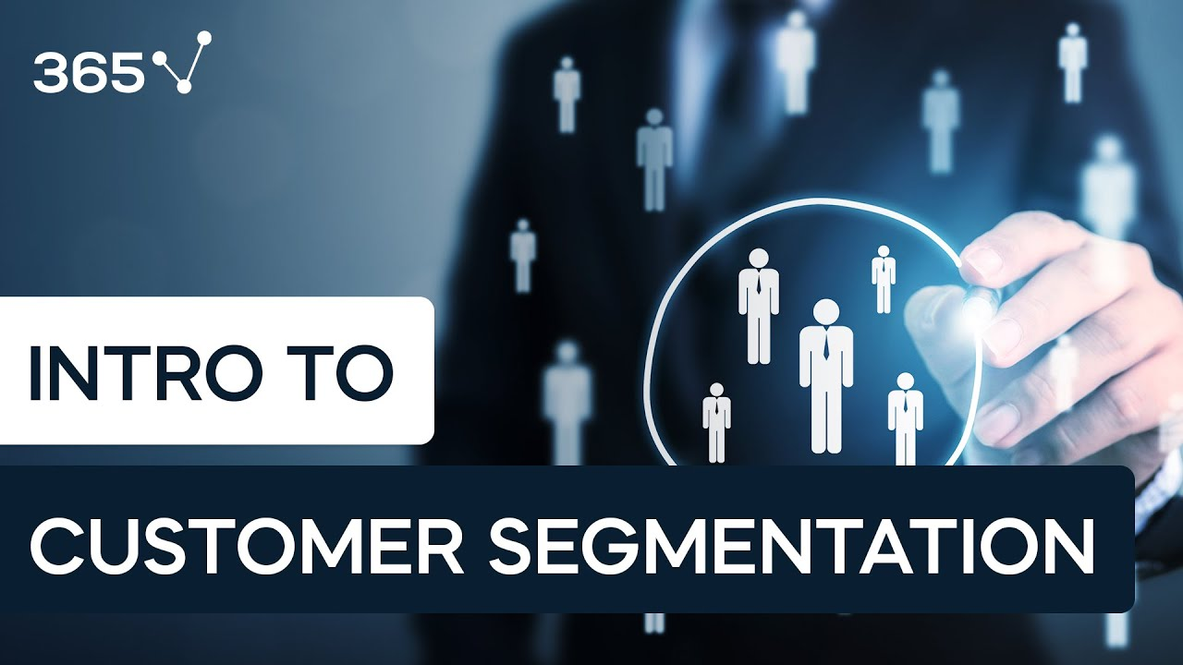
Introduction:
In the rapidly evolving landscape of business and technology, the importance of understanding and catering to customer needs cannot be overstated. As we are college students passionate about the intersection of data science and marketing, We embark on a project aimed at leveraging data-driven insights to enhance marketing strategies. The focus is on customer segmentation, a pivotal aspect that enables businesses to tailor their approaches, fostering a more personalised and satisfying customer experience.

____________________

Problem Definition:
In the rapidly evolving landscape of business and marketing, effective marketing hinges on a deep understanding of customers. Our project aims to employ data science techniques for customer segmentation, focusing on behaviour, preferences, and demographic attributes. Traditional one-size-fits-all approaches often fail to resonate with individual customers' unique characteristics, prompting the need for a data-driven strategy. The objective of our project is to overcome the limitations of generic marketing strategies by dissecting the diverse customer base into distinct groups. Our goal is to identify patterns within customer data and formulate personalised marketing strategies to enhance overall customer satisfaction.

____________________

Data Collection:

->We have Collected relevant data on customer behaviour, preferences, and demographic attributes from various sources, such as customer databases, online interactions, surveys, and third-party data providers.
->This may include:
Behavioural Data: Purchase history, website interactions, responses to marketing campaigns.
->Preference Data: Surveys, feedback, reviews.
->Demographic Data: Age, gender, location, income.

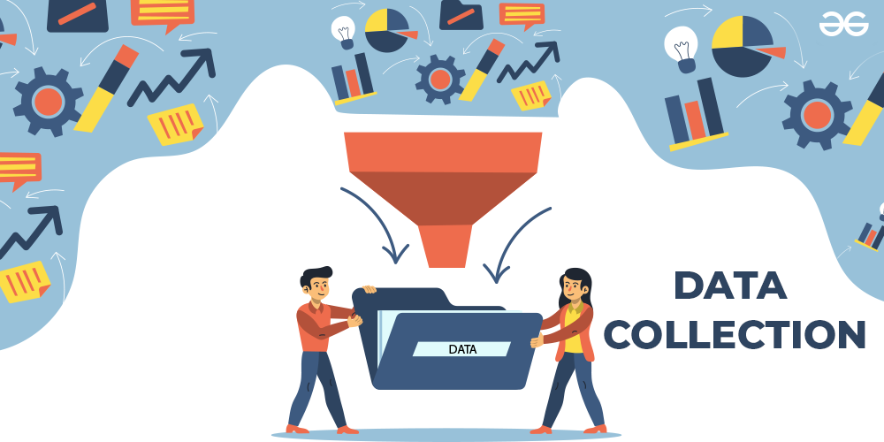

->We have Ensured data privacy and compliance with regulations like GDPR. We anonymize and aggregate data to protect customer privacy.
____________________

Data Preprocessing:

->We Clean and preprocess the data collected to ensure its quality and usability.
->Steps may include:
->Handling missing data: Impute or remove missing values.
->Removing duplicates: Ensure each customer is represented once.
->Data transformation: Normalise numerical features, encode categorical variables.

____________________
Feature Engineering:

->We can create new features or transform existing ones to extract more meaningful information.
->For example, you might create features like:
RFM (Recency, Frequency, Monetary) features: Calculate these metrics based on customer transaction history.
->Demographic features: Create categories or bins for age, income, or other demographic attributes.
->Preference features: Incorporate sentiment analysis scores from customer reviews or feedback.
____________________
Clustering Algorithms:

->We must conduct EDA(Exploratory Data Analysis) to understand the data distribution, identify outliers, and visualise relationships between variables.
->Use summary statistics, histograms, scatter plots, and correlation matrices.
->Apply clustering algorithms to group or segment customers based on their attributes.
->Common clustering methods include:
->K-Means Clustering: Divide customers into K clusters based on similarities.
->Hierarchical Clustering: Build a hierarchical tree of clusters.
->DBSCAN: Identify dense regions of data points as clusters.
->Model Evaluation:
Evaluate the performance of the clustering models using appropriate metrics. Adjust the number of clusters (K) if needed.
____________________
Visualisation:

->Visualise the clusters to provide a clear representation of customer segments.
->Example are:
Scatter Plots: Visualise clusters using scatter plots to understand the distribution of customers.
Heatmaps: Use heatmaps to showcase the relationships between different features.
Dimensionality Reduction: Apply techniques like PCA or t-SNE for a concise representation of clusters.

____________________
Interpretation of Results:

->Analyse the characteristics of each cluster to understand what distinguishes one segment from another.
->Identify common behaviours, preferences, and demographic profiles within each cluster.
->Identify actionable insights for personalised marketing strategies.

____________________
Conclusion:
This design thinking process outlines a structured approach to solving the problem of customer segmentation for personalised marketing. Each step is iterative, allowing for continuous learning and improvement. By understanding the needs of stakeholders, defining data requirements, ideating creative solutions, and prototyping and testing various components, this process aims to deliver a robust and effective customer segmentation solution.
____________________

TEAM MEMBERS:
__________________________
JEEVANBABU R
MANOJH PA
KISHORE A
KASIM SHERIFF H
KAMESHWARAN BL

