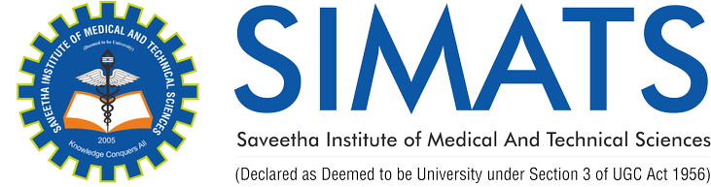

Name: Kameshwaran K (192421120)

Course Name: Mobile Computing for Modern App Development
Course Code: ITA0306

Q: BUS BOOKING APPLICATION

