
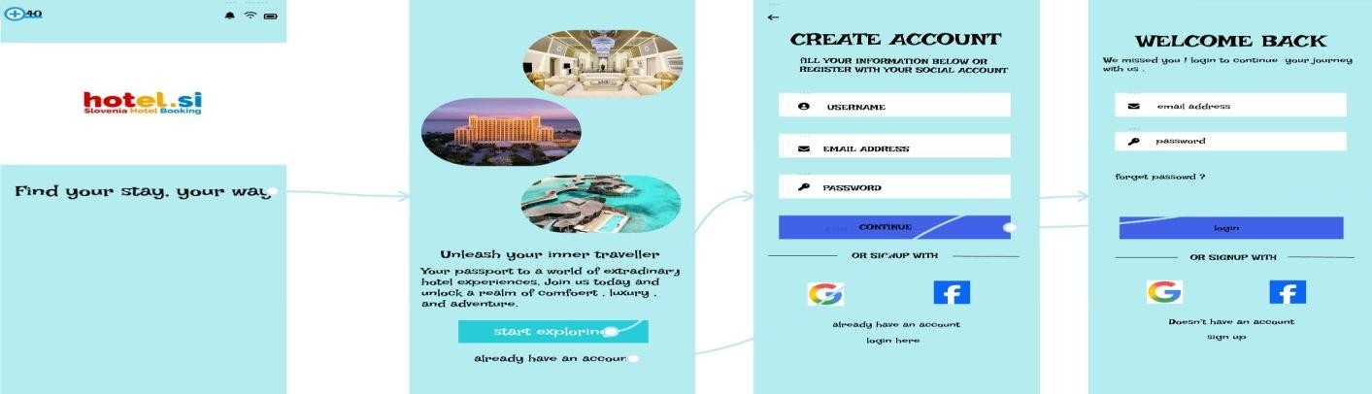
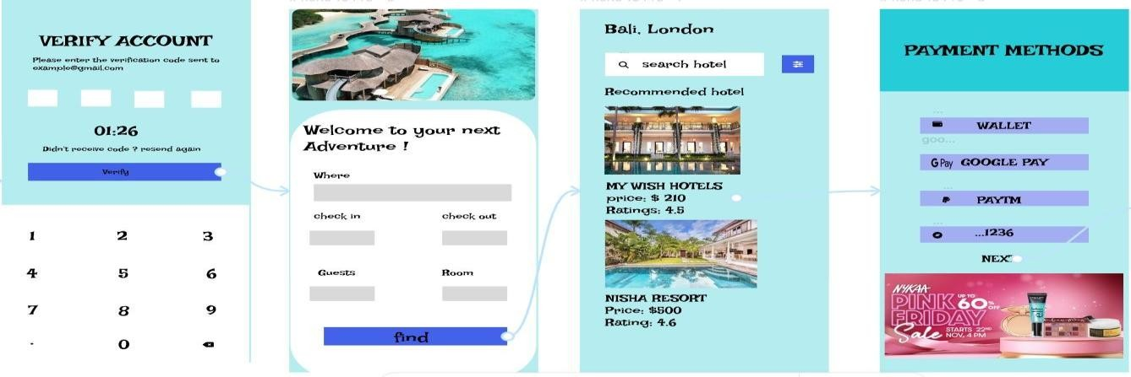


Name: Kameshwaran K (192421120)

HOTEL BOOKING
S
YSTEM

