

Name: Mobile Computing for Modern App Development Name: Kameshwaran K (192421120)

Course Code: ITA0306

25) Create a wireframe for an Android app that utilizes background services. Use Figma to illustrate the service interactions and data flow.

Aim:
Create a wireframe for an Android app that utilizes background services using Figma

Procedure:
- Open Figma
- Create a new file
- Select the Frames
- Design Visual Elements
- Make it Interactive
- Add icons on the Frame

- Incorporate Multimedia
- Storyboard Animation
- Review and edit the Prototype
- Save and Share

Design

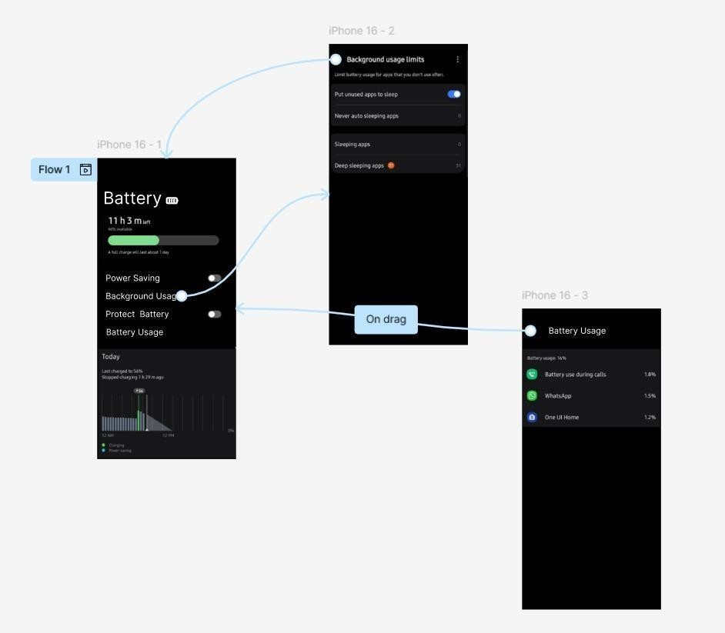

Result:
Hencea wireframe for an Android app that utilizes background services. Using Figma have been created successfully.

