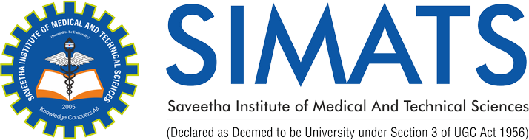

Course Name: Mobile Computing for Modern App Development Name: Kameshwaran K (192421120)
Course Code: ITA0306

