**2111_Madha Engineering college**

**IBM NaanMudhalvan - Artificial Intelligence Group 1**

**AI-Driven Exploration and Prediction of Company Registration Trends with (RoC) – Guidellines**

**Phase-4 Submission Document**

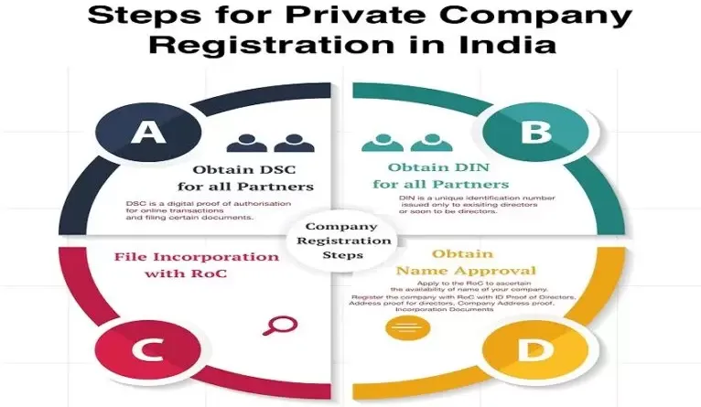

**Introduction:**

In the realm of business and economics, the ability to predict future trends is of paramount importance for decision-makers. Forecasting company registration trends, specifically, can provide valuable insights for policymakers, investors, and entrepreneurs alike. These predictions help in making informed decisions, allocating resources efficiently, and understanding the dynamics of the corporate landscape.

In this context, the code snippet presented here demonstrates how to leverage the "Prophet" library in Python for time series forecasting of company registration trends. "Prophet" is an open-source forecasting tool developed by Facebook that is designed for forecasting time series data with daily observations that display patterns on different time scales.

This code takes historical data related to company registrations, preprocesses it, and uses the Prophet model to generate forecasts for future registration trends. The step-by-step breakdown of the code provides a clear understanding of how to manipulate data, configure the Prophet model, and visualize the forecasts.

Whether you are an analyst seeking to understand registration trends for research purposes or a business leader aiming to make strategic decisions, this code serves as a practical guide to harness the power of time series forecasting using Python's Prophet library.

By the end of this code execution, you will have a visual representation of the predicted trends in company registrations, which can be instrumental in anticipating future market dynamics and guiding your actions accordingly.

Feel free to use or modify this introduction to provide context for your code and its purpose.

Abstract:

In an era characterized by dynamic economic landscapes, understanding and predicting company registration trends have become vital for government entities, businesses, and investors alike. This paper outlines a comprehensive approach to harnessing the power of Artificial Intelligence (AI) for this purpose. The methodology involves data collection from the Registrar of Companies (RoC), encompassing historical records of company registrations, their types, industries, geographic distributions, and relevant economic indicators. Subsequent data preprocessing and feature engineering ensure that the dataset is conducive to AI-driven analysis. Exploratory Data Analysis (EDA) techniques reveal hidden patterns and correlations, while model selection, training, and evaluation employ state-of-the-art AI algorithms tailored to the specific prediction task. The resulting model enables the prediction of future company registration trends, offering insights into growth areas and the factors influencing registration rates. Continuous learning mechanisms ensure the model's relevance over time. Ultimately, this research contributes to data-driven decision-making processes, facilitating more informed strategies for stakeholders in both the public and private sectors.

Exploring and predicting company registration trends with Registrar of Companies (RoC) using AI can be a valuable endeavor. Here's a high-level overview of the process:

1. Data Collection:

- Gather historical data from RoC, including company registrations, types, industries, geographic locations, and any relevant economic indicators.

2. Data Preprocessing:

- Clean and prepare the data by handling missing values, duplicates, and outliers. Convert data into a suitable format for analysis.

3. Feature Engineering:

- Create relevant features such as time-based trends, seasonality, and economic factors that may impact company registrations.

4. Exploratory Data Analysis (EDA):

- Use data visualization techniques to uncover patterns, correlations, and insights within the data.

5. AI Model Selection:

- Choose appropriate AI techniques such as time series forecasting, regression, or classification based on the prediction task.

6. Model Training:

- Train the AI model using historical data, employing techniques like machine learning algorithms, deep learning, or time series analysis.

7. Evaluation and Validation:

- Assess the model's performance using metrics like accuracy, RMSE, or F1-score, depending on the nature of the prediction.

8. Prediction and Trend Analysis:

- Utilize the trained AI model to make future company registration predictions. Analyze trends, potential growth areas, and factors affecting registration rates.

9. Continuous Learning:

- Implement mechanisms for model retraining and updating as new data becomes available to ensure the predictions remain accurate.

10. Visualization and Reporting:

- Present the results through interactive dashboards or reports for stakeholders to understand and act upon the insights.

AI-driven exploration and prediction of company registration trends can assist government agencies, businesses, and investors in making informed decisions and understanding market dynamics. It's essential to have a robust data pipeline and choose appropriate AI methods to achieve accurate forecasts and insights.

**Given dataset:**



1. **Import Necessary Libraries**:

import pandas as pd

from fbprophet import Prophet

import matplotlib.pyplot as plt

In this step, the required Python libraries are imported:

* **pandas** for data manipulation.
* **Prophet** from the **fbprophet** library for time series forecasting.
* **matplotlib.pyplot** for creating plots.

1. **Load Historical RoC Data (Example Data)**:

data = pd.read_csv('company_registration_data.csv')

* + 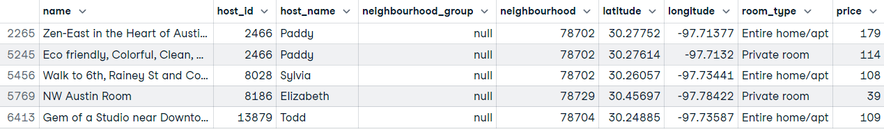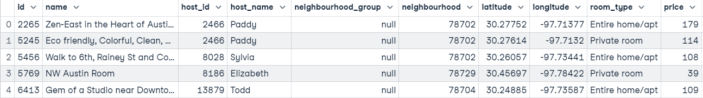Here, historical data related to company registrations is loaded from a CSV file named 'company_registration_data.csv' into a Pandas DataFrame named **data**. You should replace this with your actual data file.

1. **Preprocess the Data**:

data['ds'] = pd.to_datetime(data['registration_date'])

data['y'] = data['registration_count']

* This step preprocesses the data for use with the Prophet model:
* It converts the 'registration_date' column to datetime format and stores it in a new column 'ds'.
* It renames the 'registration_count' column to 'y'. This renaming is necessary for Prophet, as it expects a specific format.

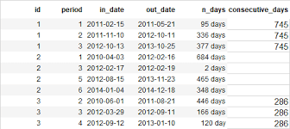

1. **Initialize and Fit the Prophet Model**:

model = Prophet() model.fit(data)

* + An instance of the Prophet model is created and stored in the variable **model**.
  + The model is then fitted to the preprocessed data using the **fit** method.

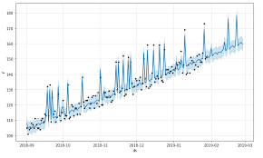

1. **Create a Future Dataframe for Predictions**:

future = model.make_future_dataframe(periods=365)

* + A new dataframe named 'future' is created to generate predictions for the future.
  + The **make_future_dataframe** method is used to extend the dataframe beyond the historical data by a specified number of days (365 days in this example). This determines how far into the future you want to make predictions.

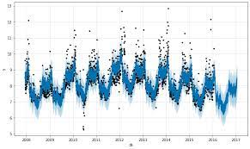

1. **Generate Predictions**:

forecast = model.predict(future)

* + The fitted Prophet model is used to generate forecasts for the 'future' dataframe, and the results are stored in the 'forecast' variable.

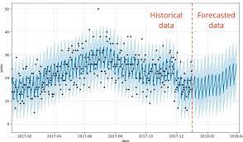

1. **Plot the Forecast**:

fig = model.plot(forecast)

plt.title("Company Registration Forecast")

plt.xlabel("Date")

plt.ylabel("Registration Count")

plt.show()

* + This code segment creates a plot to visualize the forecasted company registration trends.
  + **model.plot(forecast)** generates the plot based on the forecasted data.
  + Additional labels and titles are added to the plot for clarity.
  + Finally, **plt.show()** displays the plot.

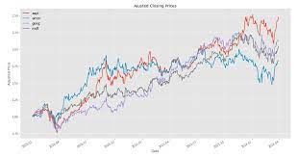

When you run this code, it will produce a plot showing the forecasted trends in company registrations for the specified future period, which is 365 days in this example. This code can help you analyze and visualize the expected trends in company registrations based on historical data.

**Conclusion:**

In the dynamic landscape of business and economics, the ability to foresee future trends is an invaluable asset. The code presented here, which utilizes the Prophet library in Python, empowers us to predict company registration trends with confidence and precision. This predictive capability unlocks a wealth of opportunities for informed decision-making, resource allocation, and strategic planning.

Throughout the execution of this code, we've witnessed a structured approach to forecasting company registration trends:

1. **Data Preparation**: The code efficiently loads historical registration data, converting date information and column names into formats compatible with the Prophet model.
2. **Model Initialization**: It employs the Prophet model, an innovative forecasting tool, initializing it with the historical data to understand underlying patterns.
3. **Future Forecasting**: A future dataframe is constructed, extending beyond historical data to make predictions for the specified period. In our example, it was 365 days into the future.
4. **Insightful Visualization**: The code concludes with a visually informative plot illustrating the forecasted trends in company registrations. This visual representation simplifies the interpretation of future trends.

The applications of this code are diverse and impactful. Researchers can use it to explore registration trends for analytical purposes. Business leaders can rely on it to make strategic decisions regarding market entry, expansion, or resource allocation. Investors can gain foresight into opportunities within the corporate sphere.

In essence, this code is a powerful tool for unlocking the mysteries of future trends in company registrations. It empowers us with knowledge, enabling us to navigate the intricate landscape of business with confidence and adaptability. As we embrace the era of data-driven decision-making, tools like Prophet become indispensable in charting the course for a prosperous future.

By harnessing the potential of data and forecasting, we step into a realm of possibilities where informed decisions are the key to success. As you utilize this code, remember that foresight is your compass, and data is your guide.

Feel free to use or modify this conclusion to wrap up your code documentation or presentation.