Toucan: ECO nature guide, CC BY-SA 3.0 <https://creativecommons.org/licenses/by-sa/3.0>, via Wikimedia Commons

Saffron Finch: https://animalia.bio/de/saffron-finch, CC BY-SA 2.0

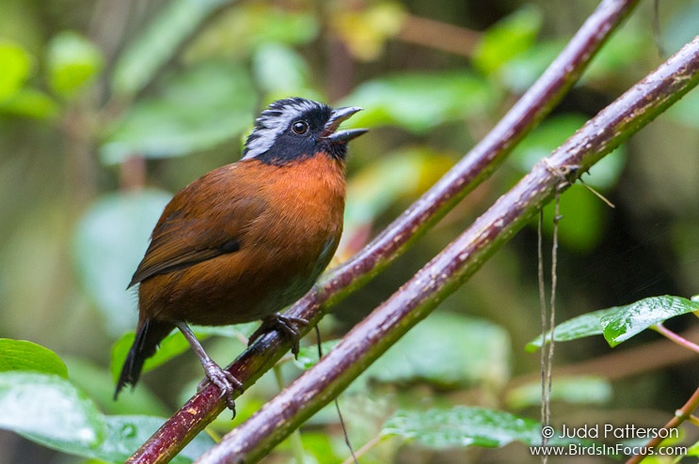
https://www.birdsinfocus.com/show.php?absID=5966

