**Assignment 7.2**

**Question No.1:**

Write a programme to create barplots for all the categorical variables in the data set mtcars

> par(mfrow = c(2,3))

> for(col in 1 :ncol(catcars)) {barplot(table(factor(catcars[,col])), xlab = names(catcars[col]), main = c("Distribution by", names(catcars[col])))}

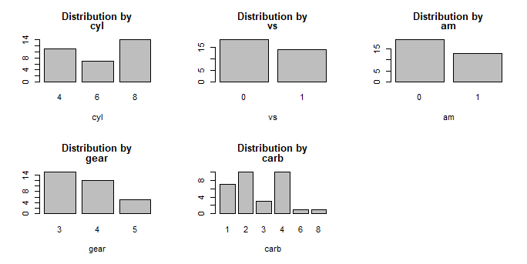

**Question No.2:**

Create a Scatter Plot Matrix by gear types for the dataset of mtcars

scatterplotMatrix(~mpg+cyl+disp+hp+drat+wt+qsec+vs+am+gear+carb | gear, data=mtcars)

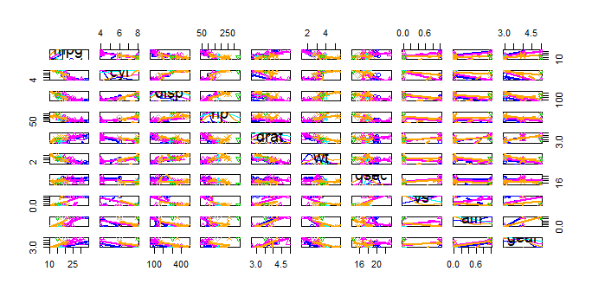

**Question No.3:**

Write a programme to create a plot density by class variable

We can use the dplyr library for the same along with library(purr), library(ggplot2), library(tidyr)

> mtcars %>%

+ keep(is.numeric) %>% # Keep only numeric columns

+ gather() %>% # Convert to key-value pairs

+ ggplot(aes(value)) + # Plot the values

+ facet_wrap(~ key, scales = "free") + # In separate panels

+ geom_density() # as density

