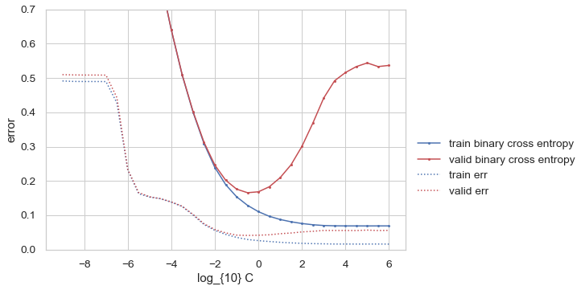
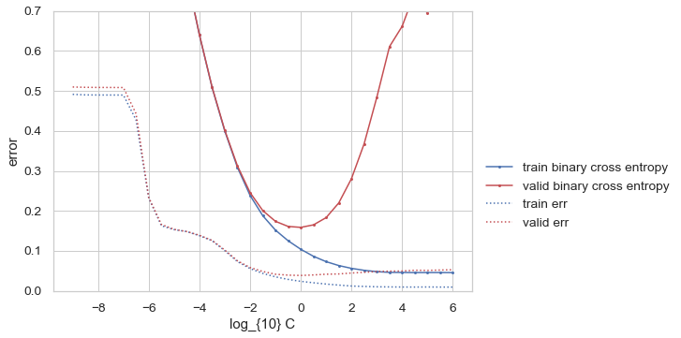
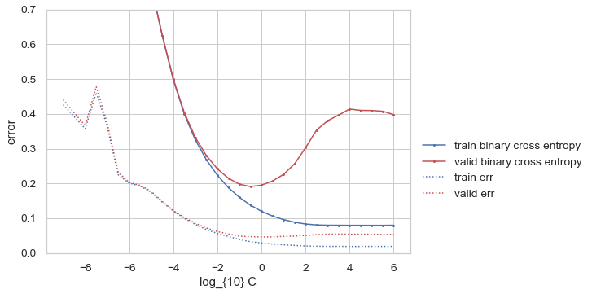
Model 1: Hyperparameter Selection Plot
Model 2: Hyperparameter Selection Plot
Model 0: Hyperparameter Selection Plot

