LAB Logbook

Lab 1

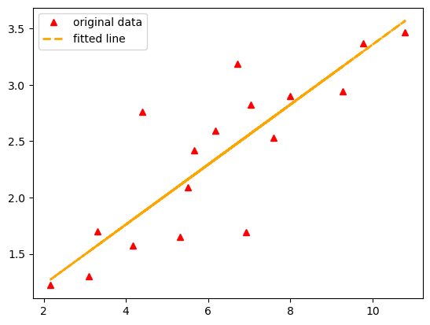

Lab 2

**Test accuracy: 0.887**

**The output of the neural network is O1=O2=0.81**

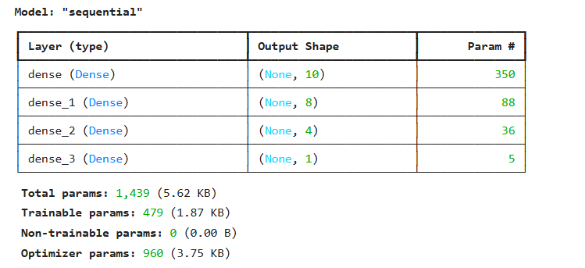

Lab 3

**Test accuracy: 0.8823999762535095**

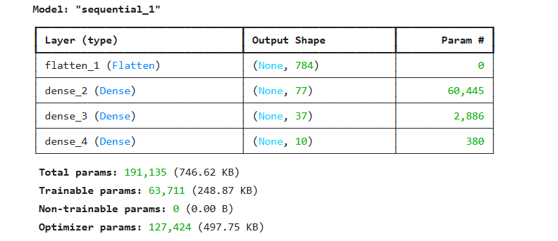

Lab 4

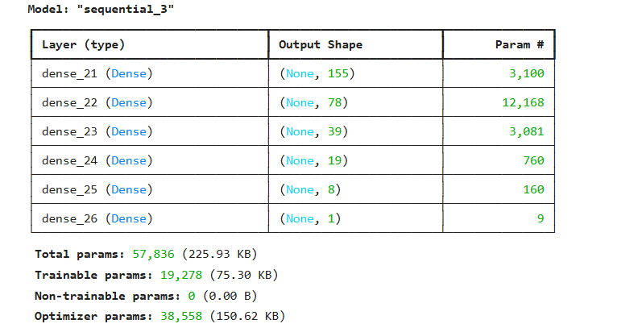

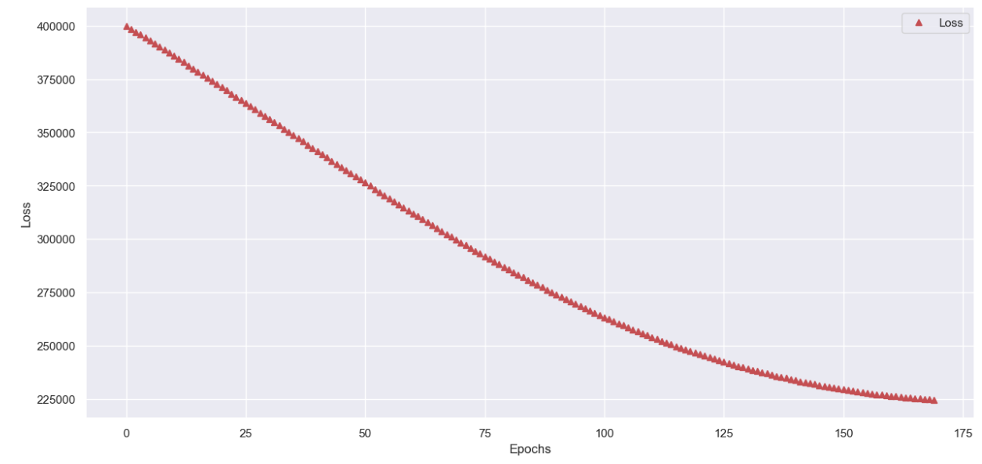

Lab 5

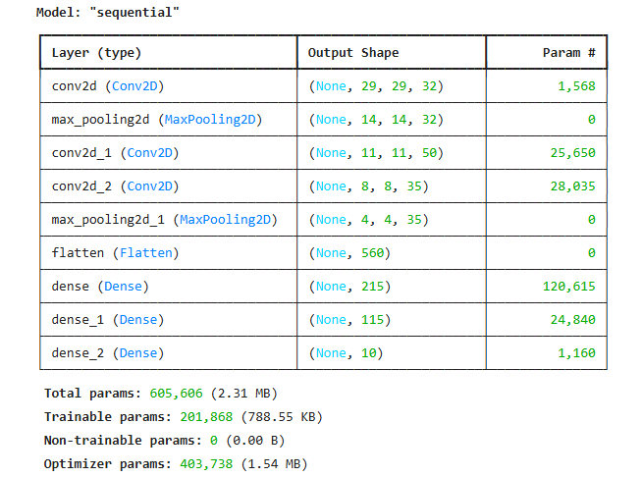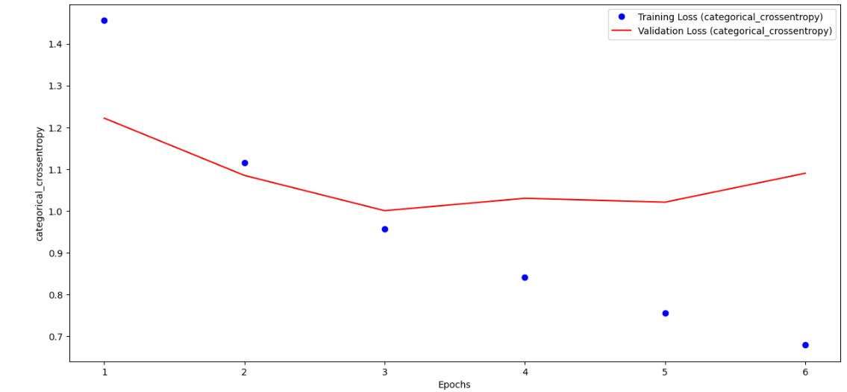

**Based on this analysis, the optimal number of epochs for training the model is 3-4**

Lab 6

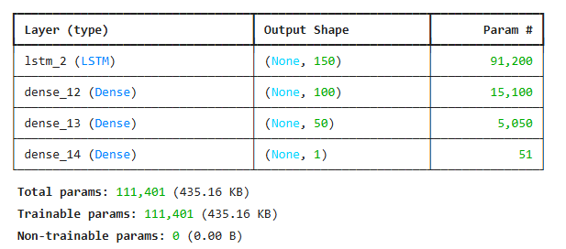

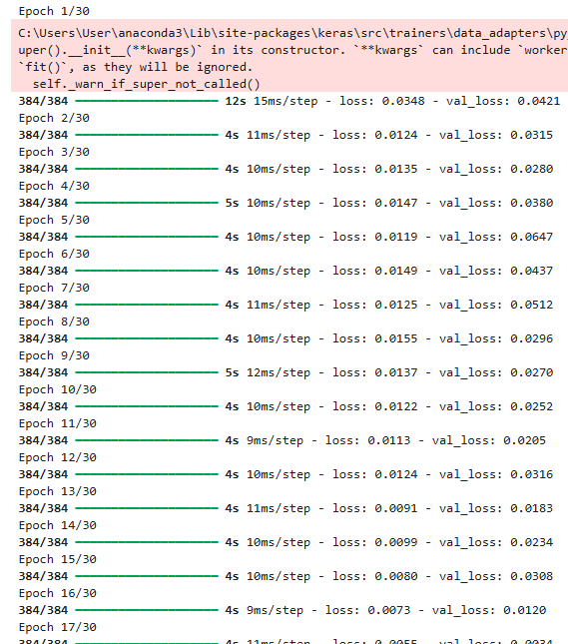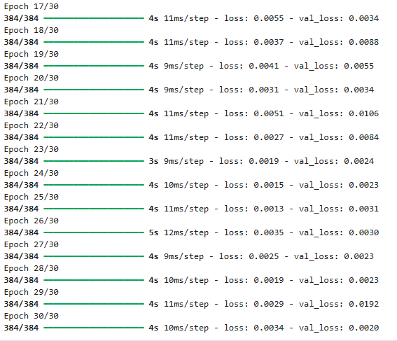

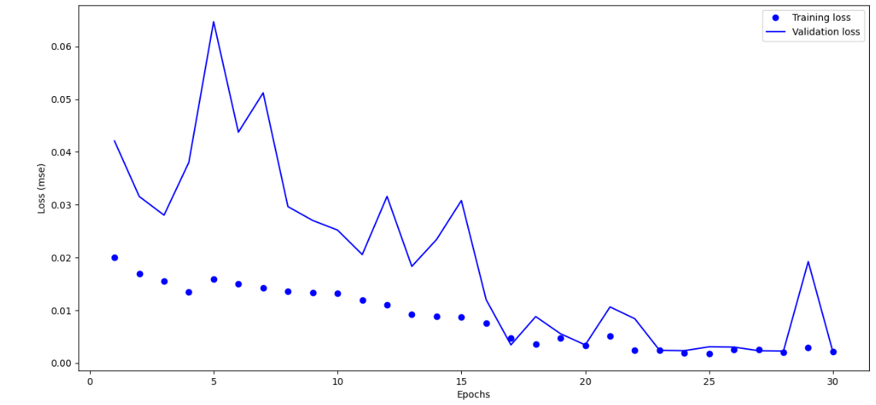

**Based on this analysis, the optimal number of epochs for training the model is 17**

Lab 7

Lab 8

Lab 9

Lab 10

Lab 11

Lab 12