LAB Logbook

Lab 1

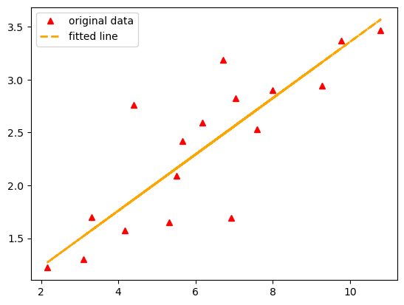

Lab 2

Lab 3

Test accuracy: 0.8823999762535095

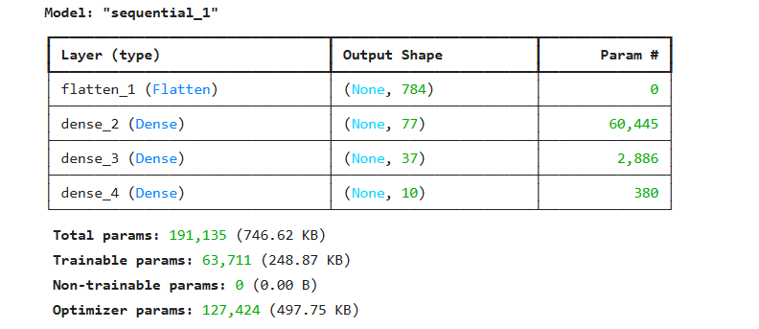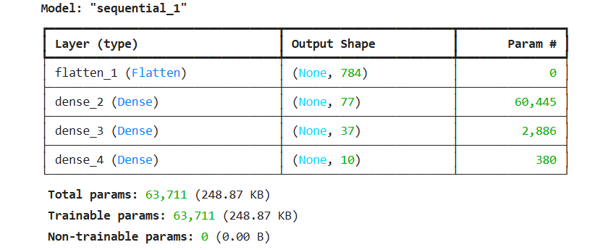

Lab 4

Lab 5

Lab 6

Lab 7

Lab 8

Lab 9

Lab 10

Lab 11

Lab 12