Boston house prices (PyTorch)
1) Implement pytorch based housing regression using Boston dataset(not california) and model:

Where:

MSE and NRMSE loss function results (x1000 epochs):
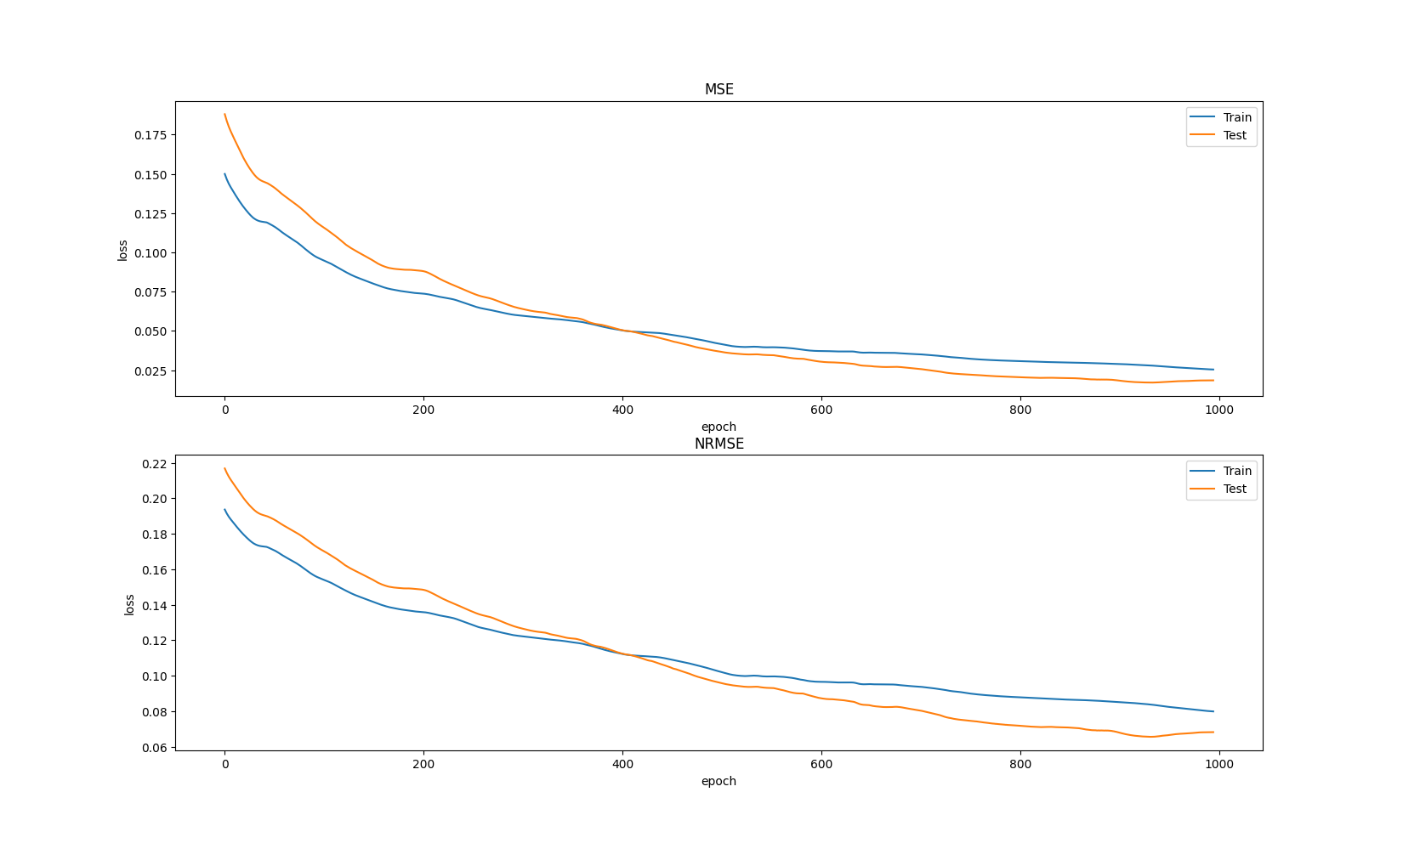
I had to store all the data as tensors in GPU memory and decrease .item() which does data sync (VRAM → RAM) and decreases performance. I guess something similar happens when calling .item() while running on CPU. So I’m calculating loss values once per 1000 epochs. Speedup is significant.

Wine classification (NumPy, PyTorch)

Loss/accuracy for the Iris tutorial:
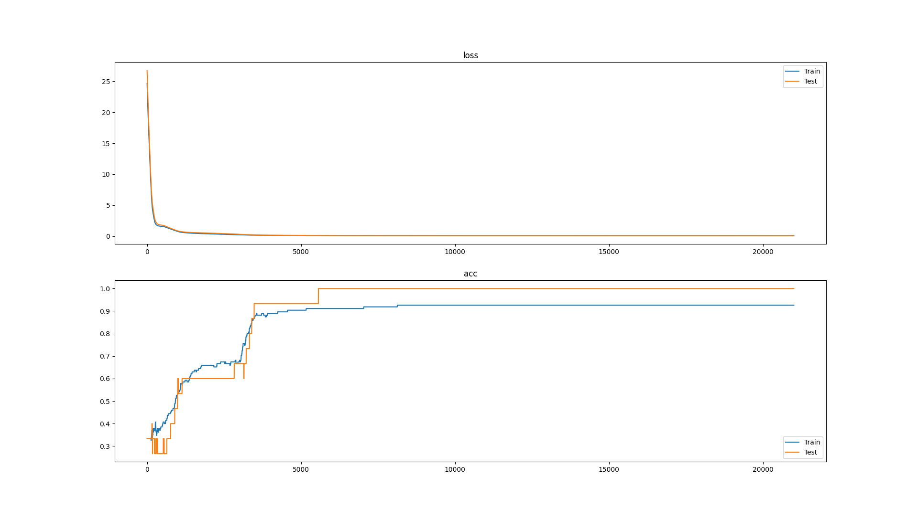
Accuracy is being calculated as correct guess count divided by total guess count:
guess_cnt = reduce(
lambda cnt, values: cnt + (np.argmax(values[0]) == np.argmax(values[1])),
zip(y, y_prim.value),
0
)
accuracy = guess_cnt / len(y_prim.value)

2) Implement numpy based classification using dataset – sklearn.datasets.load_wine
Successfully walked through Iris video tutorial, for some reason same code with different dataset and adjusted input count fails to calculate loss (results in nan).
def forward(self, x: Variable):
self.x = x
np_x = np.copy(x.value)
# numerical stability for large values
np_x -= np.max(np_x, axis=1, keepdims=True)
self.output = Variable(
(np.exp(np_x + 1e-8)) / np.sum(np.exp(np_x), axis=1, keepdims=True)
)
return self.output
This is strange. But once I normalized data it started working. PyTorch works in both cases.
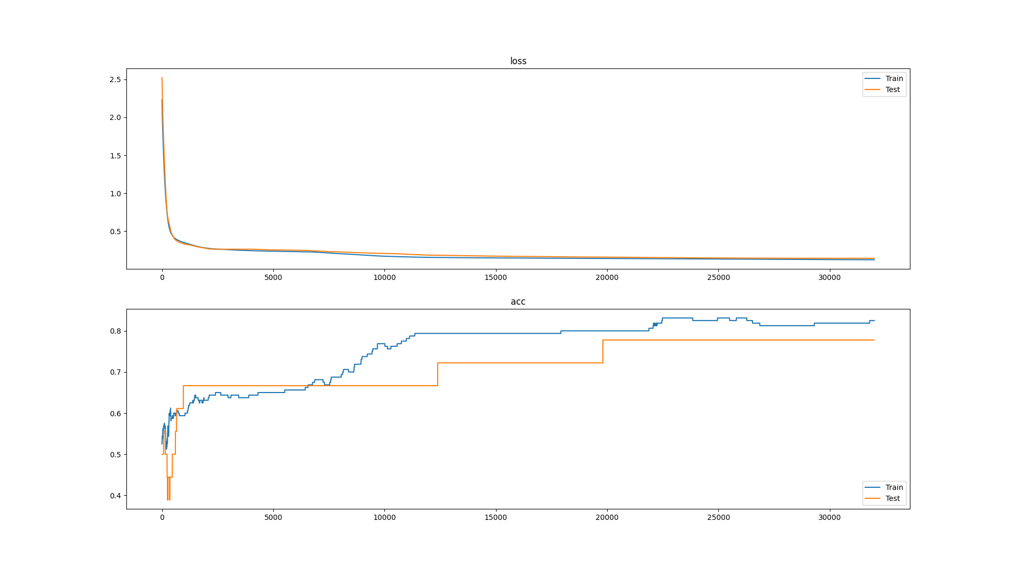

3) Implement pytorch based classification using dataset – sklearn.datasets.load_wine
