RĪGAS TEHNISKĀ UNIVERSITĀTE
Datorzinātnes un informācijas tehnoloģijas fakultāte
Lietišķo datorsistēmu institūts
Mākslīgā intelekta un sistēmu inženierijas katedra

Oļegs Korsaks
Bakalaura studiju programmas „Datorsistēmas”
students, stud. apl. nr. 051RDB146

Salidzinošā analīze datu kopu formātiem PyTorch attēlu klasifikācijas uzdevumiem

Atskaite par bakalaura darbu

Zinātniskais vadītājs
Mg.sc.ing, Pētnieks
Ēvalds Urtāns

Rīga 2021

Table of Contents
1. Ievads 3
1.1. Dziļā māšinmācīšanās 3
Pamata arhitektūras 3
Linārie slāņi 3
Aktivizācijas funkcijas 3
Kļūdas funkcijas 3
MAE 3
MSE 3
CCE 3
BCE 3
Atpakaļizplatīšanās algoritms 3
Apmācām Parametru Optizācijas algoritmi 3
Metrikas 4
1.2. Attēlu klasifikācija 4
1.3. PyTorch vide 4
2. Metodoloģija 4
2.1. Datu ielādes metodes 4
2.1.1. Failu sistēma 4
2.1.2. Linux mmap 4
2.1.3. nVidia mmap 4
2.1.4. HDF5 4
2.1.5. PostgreSQL 4
2.2. Datu kopas 4
2.2.1. CIFAR10 4
2.2.2. Tiny ImageNet 4
2.4. Apmācības protokols 4
3. Rezultāti 5
4. Tālākie pētījumi 5
5. Secinājumi 5
Python introduction 6
Asteroids game 7
Robot arm 9
House prices 11
Backpropagation 15
LeakyReLu task 17
NumPy + OOP version 20

1. Ievads

1.1. Dziļā māšinmācīšanās

Pamata arhitektūras

Linārie slāņi

Aktivizācijas funkcijas
Softmax (priekš klasifikācijas)

Kļūdas funkcijas
Kļūdas funkcija palīdz noteikt cik tālu tekoša prognozēta vērtība ir no patiesas. Un ja to pielietot visiem datu eksemplāriem – ar to var noteikt, cik labi tekošais modelis var prognozēt rezultātus kopumā. Ideālā gadījumā kļūdai jābūt vienādai nullei, gan apmācības datu eksemplāriem, gan pārbaudes. Tātad apmācība cenšas kļūdu samazināt.

MAE
Mean absolute error vai vidēja absolūta kļūda:

Tā ir vidēja absolūta starpība starp pareizas un prognozētas vertībām. Kļūda pieaug lineāri un tiek pielietota regresijas uzdevumiem, kuru rezultāts ir viena vērtība.

MSE
Mean squared error vai vidēja kvadrātiskā kļūda:

Tā ir vidēja starpība starp pareizas un prognozētas vertībām, kas tiek pacelta kvadrātā. Kvadrāts palīdz izvairīties no negatīvām vērtībām. Kā arī kļūdas vērtība pieaug straujāk, salīdzinot ar MAE. Tiek pielietota regresijas uzdevumiem.

CCE

BCE

Atpakaļizplatīšanās algoritms
(grafiski un ar vienādojiem)

Apmācām Parametru Optizācijas algoritmi
SGD

Metrikas
novērtēt cik labs rezultāts Accuracy, F1

1.2. Attēlu klasifikācija
ConvNets
ResNet / DenseNet

1.3. PyTorch vide
Modeļu implementāciju <> viendājumi
Datu ielādes process (DataSet)

2. Metodoloģija

2.1. Datu ielādes metodes

2.1.1. Failu sistēma

2.1.2. Linux mmap

2.1.3. nVidia mmap

2.1.4. HDF5

2.1.5. PostgreSQL

2.2. Datu kopas

2.2.1. CIFAR10

2.2.2. Tiny ImageNet
.. vel kādas
^ Atrast HiRes datu kopas priekš klasifikācijas
^ Atrast dažādu izmēru attēlu datu kopas
^ 3 dažādu izmēru / kofigurāciju datu kopas

2.4. Apmācības protokols
* Jāizdomā metrikas kā noteikt ietekmi datu ielādes metodēm
* Vidējais epocha ātrums sekundēs

3. Rezultāti
Datu ielādes metodes PRET datu kopām

4. Tālākie pētījumi

5. Secinājumi

Python introduction
My power function
from decimal import Decimal
from functools import reduce
from itertools import repeat
from operator import mul
from typing import Union
def my_pow(number: Union[int, float, Decimal], power: int):
if power > 0:
return reduce(mul, repeat(number, power))
elif power == 0:
return 1
return 1 / reduce(mul, repeat(number, abs(power)))

Matrix dot product:
import numpy as np
def dot(a, b):
try:
a_height, a_width = np.shape(a)
except ValueError:
a_height, a_width = np.shape(a)[0], 1
try:
b_height, b_width = np.shape(b)
except ValueError:
b_height, b_width = np.shape(b)[0], 1
if a_width != b_height:
raise ValueError(f'Wrong shape of matrix: {np.shape(a)=} {np.shape(b)=}')
c = np.array(
tuple(
sum(x * y for x, y in zip(a[row_idx], b[:, col_idx]))
for row_idx in range(a_height)
for col_idx in range(b_width)
)
)
return c.reshape((a_height, b_width))

Asteroids game
Implemented helper functions:
def rotation_mat(degrees: float):
"""
Rotating around Z axis
:param degrees:
:return:
"""
theta = np.radians(degrees)
c = np.cos(theta)
s = np.sin(theta)
return np.array([
[c, -s, 0.0],
[s, c, 0.0],
[0.0, 0.0, 1.0],
])
def translation_mat(dx: float, dy: float):
return np.array([
[1.0, 0.0, dx],
[0.0, 1.0, dy],
[0.0, 0.0, 1.0],
])
def scale_mat(sx: float, sy: float):
return np.array([
[sx, 0.0, 0.0],
[0.0, sy, 0.0],
[0.0, 0.0, 1.0],
])
def dot(a, b):
try:
a_height, a_width = np.shape(a)
except ValueError:
a_height, a_width = np.shape(a)[0], 1
try:
b_height, b_width = np.shape(b)
except ValueError:
b_height, b_width = np.shape(b)[0], 1
if a_width != b_height:
raise ValueError(f'Wrong shape of matrix: {np.shape(a)=} {np.shape(b)=}')
c = np.array(
tuple(
sum(x * y for x, y in zip(a[row_idx], b[:, col_idx]))
for row_idx in range(a_height)
for col_idx in range(b_width)
)
)
return c.reshape((a_height, b_width))
def vec2d_to_vec3d(vec2d):
i = np.array((
(1.0, 0.0),
(0.0, 1.0),
(0.0, 0.0),
))
return dot(i, vec2d[:, None]).transpose()[0] + np.array([0.0, 0.0, 1.0])
def vec3d_to_vec2d(vec3d):
i = np.array((
(1.0, 0.0, 0.0),
(0.0, 1.0, 0.0),
))
return dot(i, vec3d[:, None])

Robot arm
1) Implement 3-segment robot arm.
I’ve implemented a dynamic N-segment robot arm by slightly prettifying initial code.

def rotation(theta: float):
"""
:param theta: in radians
:return:
"""
c = np.cos(theta)
s = np.sin(theta)
return np.array((
(c, -s),
(s, c),
))
def d_rotation(theta: float):
"""
:param theta: in radians
:return:
"""
c = np.cos(theta)
s = np.sin(theta)
return np.array((
(-s, -c),
(c, -s),
))

2) Implemented multi-segment robot arm:
prev_r = None
for segment_idx in range(SEGMENT_COUNT):
# getting rotation value
theta = thetas[segment_idx]
# getting rotation matrix
r = rotation(theta)
dr_theta_1 = d_rotation(theta)
# calculating current segment vector by adding rotated segment template to the tip of the previous segment
np_joints[segment_idx+1] = np.dot(r, segment) + np_joints[segment_idx]
# STILL BLACK MAGIC FOR ME
x = dr_theta_1 @ segment
if segment_idx:
x = prev_r @ x
# is this somehow related to derivative of the loss function?
d_theta_1 = np.sum(x * -2 * (TARGET_POINT - np_joints[-1]))
# END OF BLACK MAGIC
# updating and storing new rotation value for the current segment
thetas[segment_idx] -= d_theta_1 * LEARNING_RATE
prev_r = r
loss = np.sum((TARGET_POINT - np_joints[-1]) ** 2)
plt.title(f'loss: {loss:.4f} thetas: {tuple(round(np.rad2deg(theta)) for theta in thetas)}')

3) Loss of MSE from tip of robot arm (last vector) to target point:
loss = np.sum((TARGET_POINT - np_joints[-1]) ** 2)

House prices
1) Implement by hand equations of derivative using LaTeX (I will use similar format in LibreOffice/ODF, sorry)

2) Writing equations for housings:

3) Cost function
We will use mean squared error cost function:

where (is our model)
We need to minimize cost function’s result.

4) Gradient descent
The goal of this is to update and to minimize cost function result.

but to simultaneously update both variables we need to assign them to temporary variables first, so b doesn’t affect calculation of the W.
- is a learning rate, which defines how fast we are going to change b and W.
By intuition what is going to happen – partial derivative of the cost function will be a positive slope (will return a positive number) if the mse will on the right side of the local minima, as a result we will subtract a slope value multiplied by learning rate from W (or b). Otherwise we will add it. In ideal situation once MSE is 0 – we don’t move anymore.

So let’s try to figure out partial derivatives:
For or :

equals to:

and for or :

equals to:

For linear model:
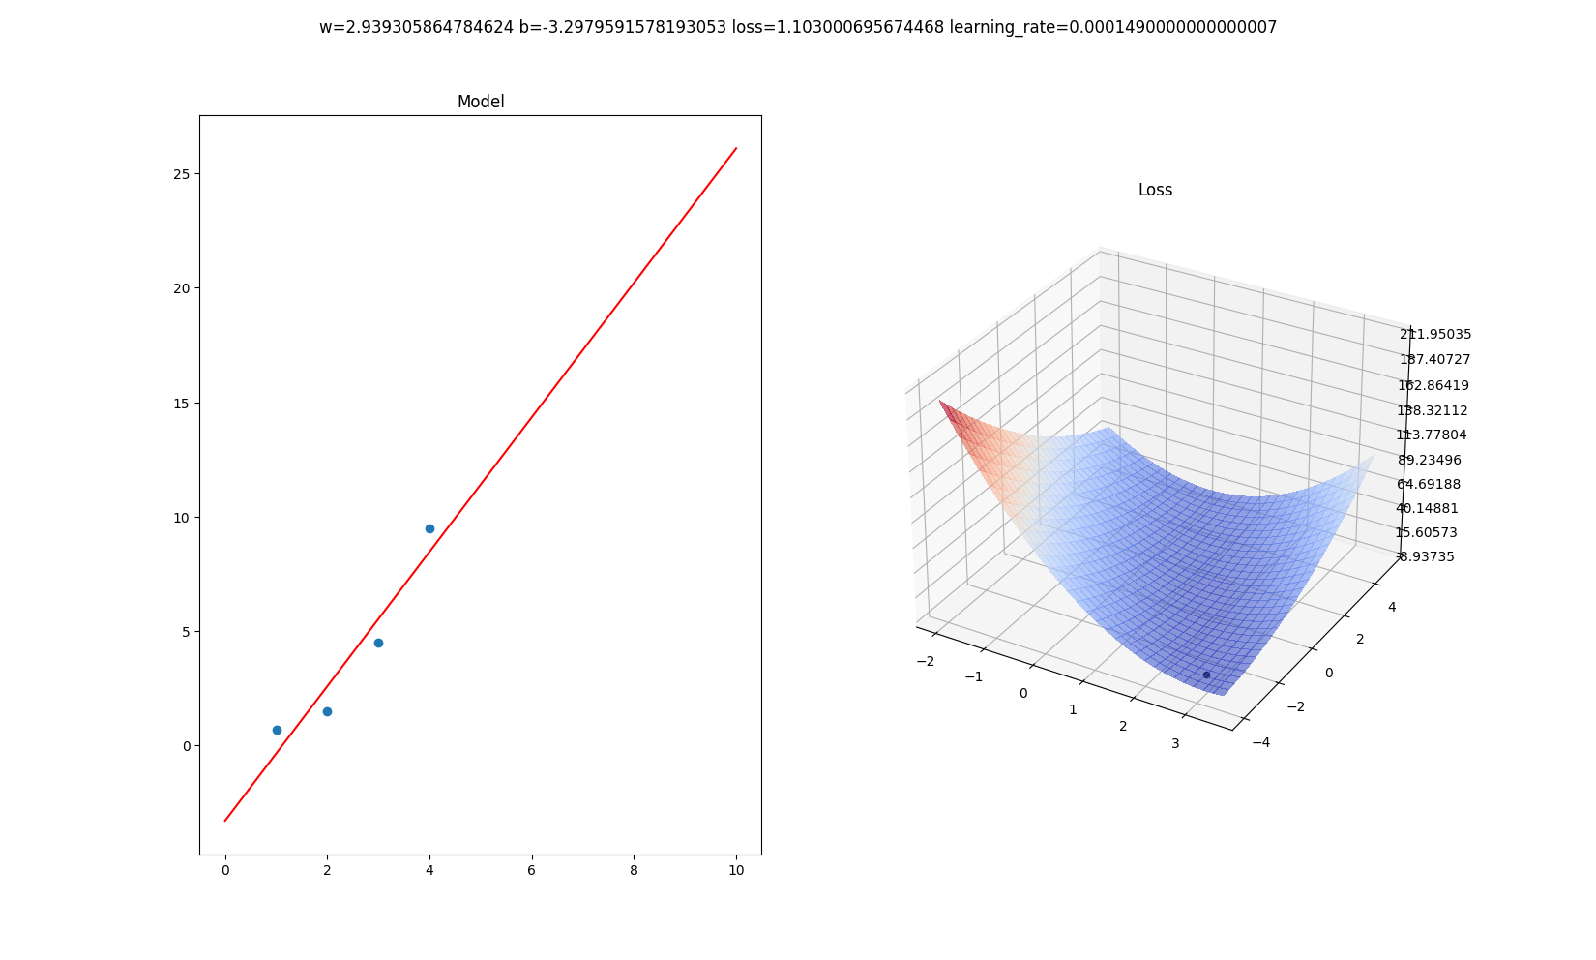
For sigmoid model:

We need to find a gradient descent:

where
let’s substitute so

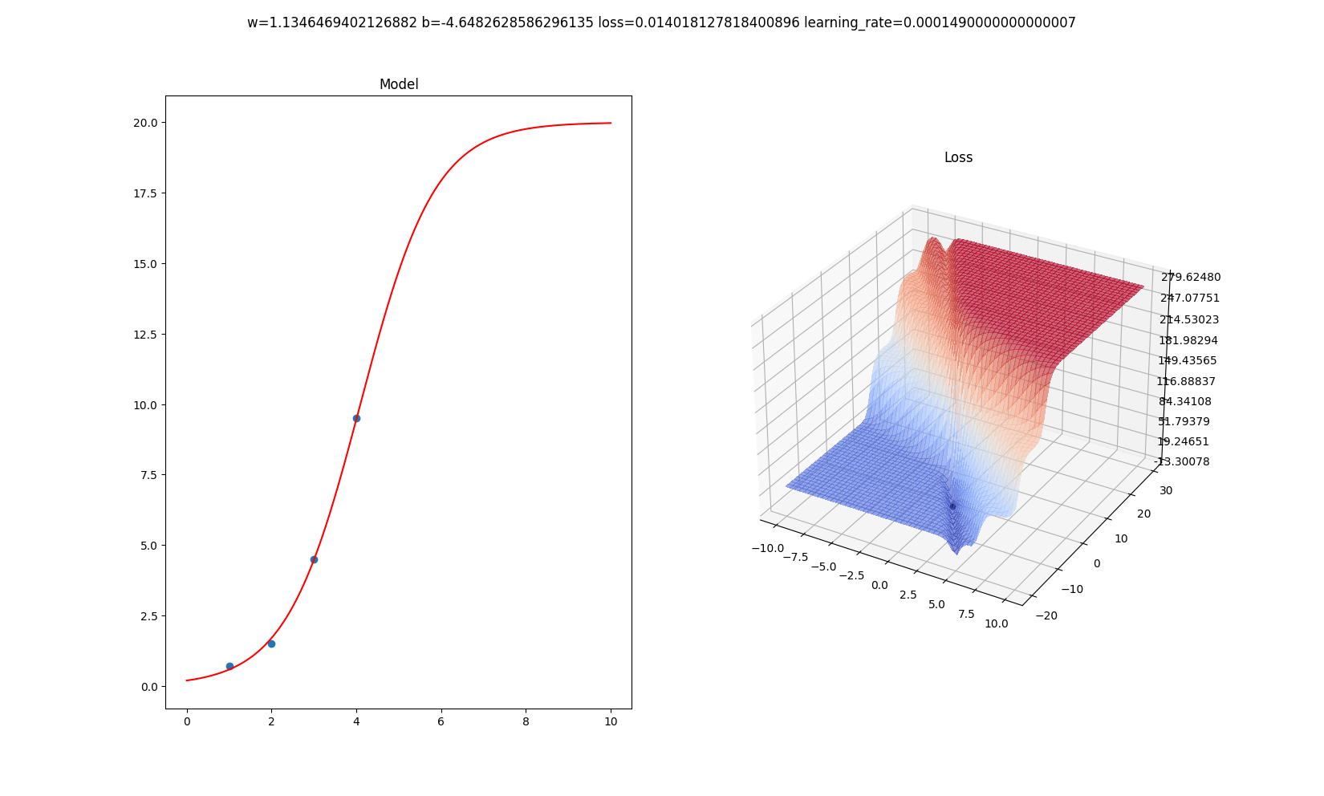
Animated version: https://www.youtube.com/watch?v=4hFCo9tbU34
It looks cool but I don’t find sigmoid logical here because there is no chance that 10 floor building may cost same as 100 floor. What about cubic ? Where would shift the line vertically and would regulate its width. That was my intuition on how to fit the line. The nice part here is that loss function derivative is the same as for linear. And is:

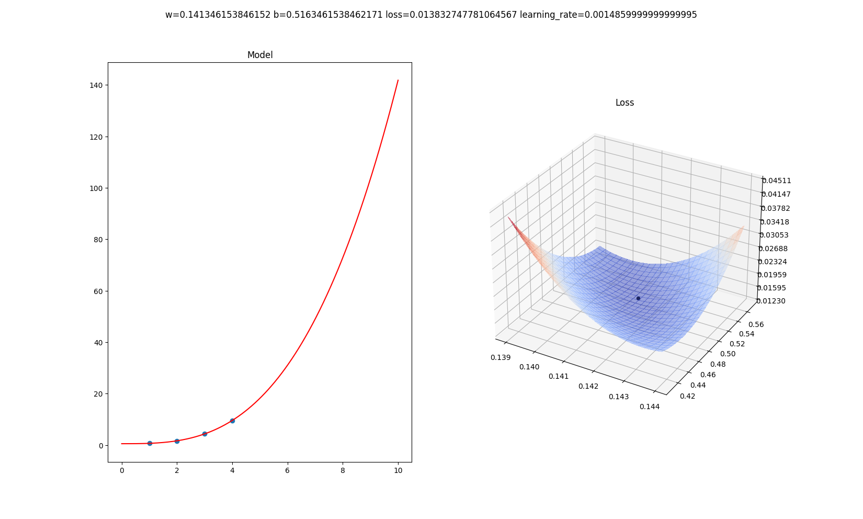
And it worked. That’s much better.

Backpropagation

SGD:

Let’s assume:
Then:

LeakyReLu task

Model:

Where:

hereis a slope, not the learning rate

MAE loss function:

SGD:

Running this model produces following result:
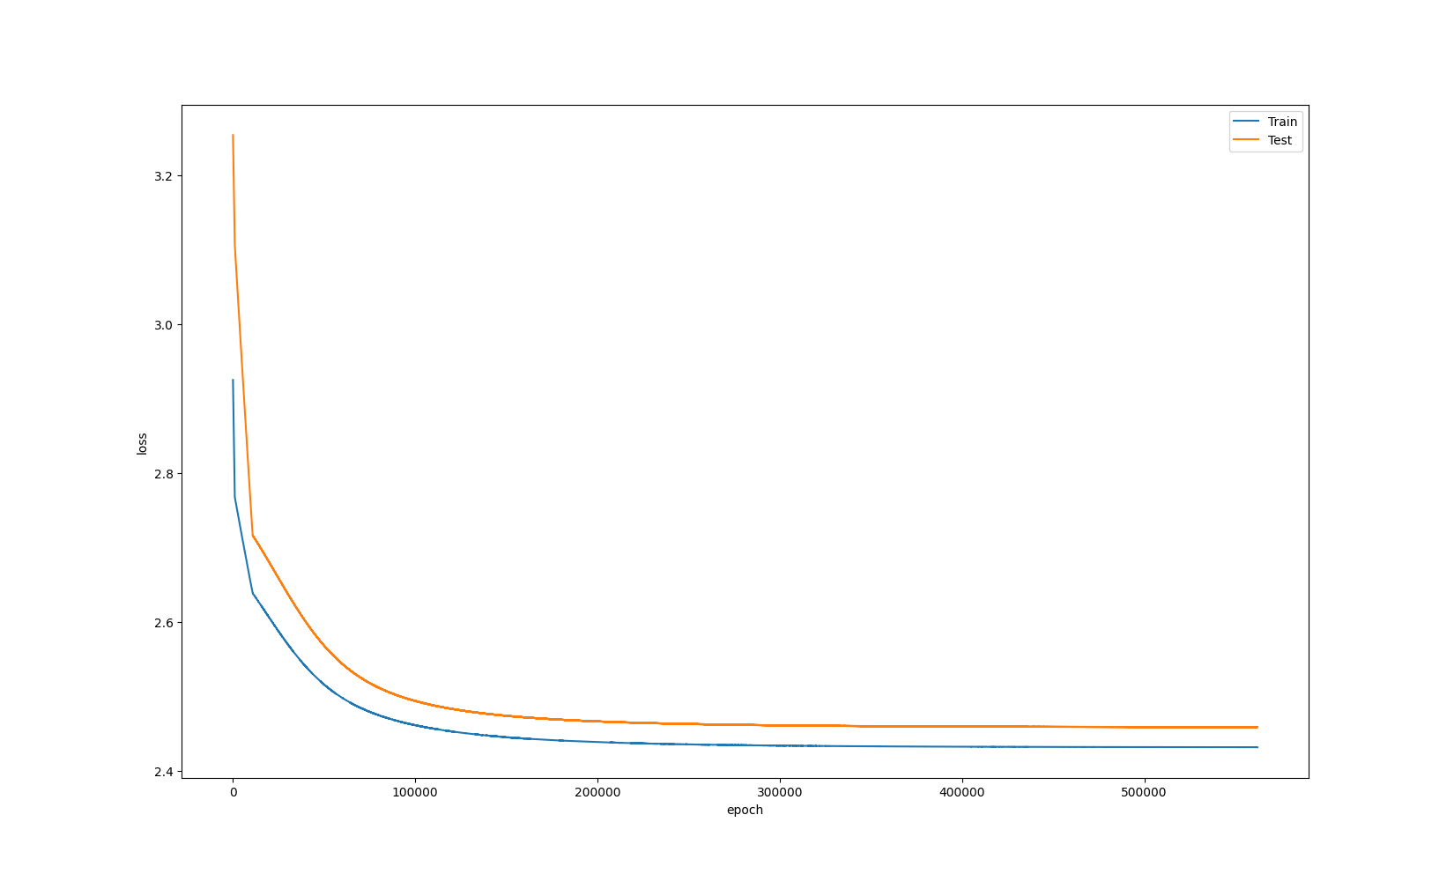

NumPy + OOP version
1) Implement dataset normalization to get X and Y features in range from -1..1.

Need also function to convert Y back to real values.
Solution: To convert values back – we need to remember min and max values of initial dataset, otherwise we don’t know according to what values we have -1 and 1 boundaries.
def normalize(values: np.ndarray) -> Tuple[np.ndarray, np.ndarray, np.ndarray]:
max_values = np.max(values, axis=0)
min_values = np.min(values, axis=0)
return 2.0 * ((values - min_values) / (max_values - min_values) - 0.5), min_values, max_values
def denormalize(values: np.ndarray, min_values: np.ndarray, max_values: np.ndarray) -> np.ndarray:
return (values / 2.0 + 0.5) * (max_values - min_values) + min_values

2) Implement model with new functions
- Use code from 4. (?) task
- Add classes LossMSE (Mean square error loss function), LayerSigmoid
class SigmoidLayer:
def __init__(self):
self.x = None
self.output = None
def forward(self, x: Variable) -> Variable:
self.x = x
self.output = Variable(
1.0 / (1.0 + np.exp(-x.value))
)
return self.output
def backward(self):
self.x.grad = -1.0 / (1.0 + np.exp(-self.x.value)) ** 2 * self.output.grad

class MSELoss:
def __init__(self):
self.y: Optional[Variable] = None
self.y_prim: Optional[Variable] = None
def forward(self, y: Variable, y_prim: Variable) -> float:
self.y = y
self.y_prim = y_prim
return np.mean((y.value - y_prim.value) ** 2)
def backward(self):
self.y_prim.grad = 2.0 * (self.y_prim.value - self.y.value)

- Replace ReLU with Sigmoid in Model
We will use same Sigmoid formulas:

- Train with LossMSE
And same MSE cost function:

- Fine tune Hyper parameters so you can get lowest error in 300 epochs

Resulting model layers are:
self.layers = [
LinearLayer(in_features=8, out_features=4),
SigmoidLayer(),
LinearLayer(in_features=4, out_features=4),
SigmoidLayer(),
LinearLayer(in_features=4, out_features=1)
]

