Wine classification
1) Implement F1-score and confusion matrix
def get_f1_score(matrix: np.ndarray) -> dict:
score = {}
for item_idx in range(matrix.shape[0]):
tp = matrix[item_idx, item_idx]
tn = matrix[item_idx].sum() - tp
fn = matrix[:, item_idx].sum() - tp
fp = matrix.sum() - tp - tn - fn
score[item_idx] = (2 * tp) / (2 * tp + fp + fn)
return score

def get_confusion_matrix(expected, predicted) -> np.ndarray:
matrix = np.zeros(shape=(3, 3), dtype=np.int)
for expected_item, predicted_item in zip(expected, predicted):
matrix[expected_item][predicted_item] += 1
return matrix

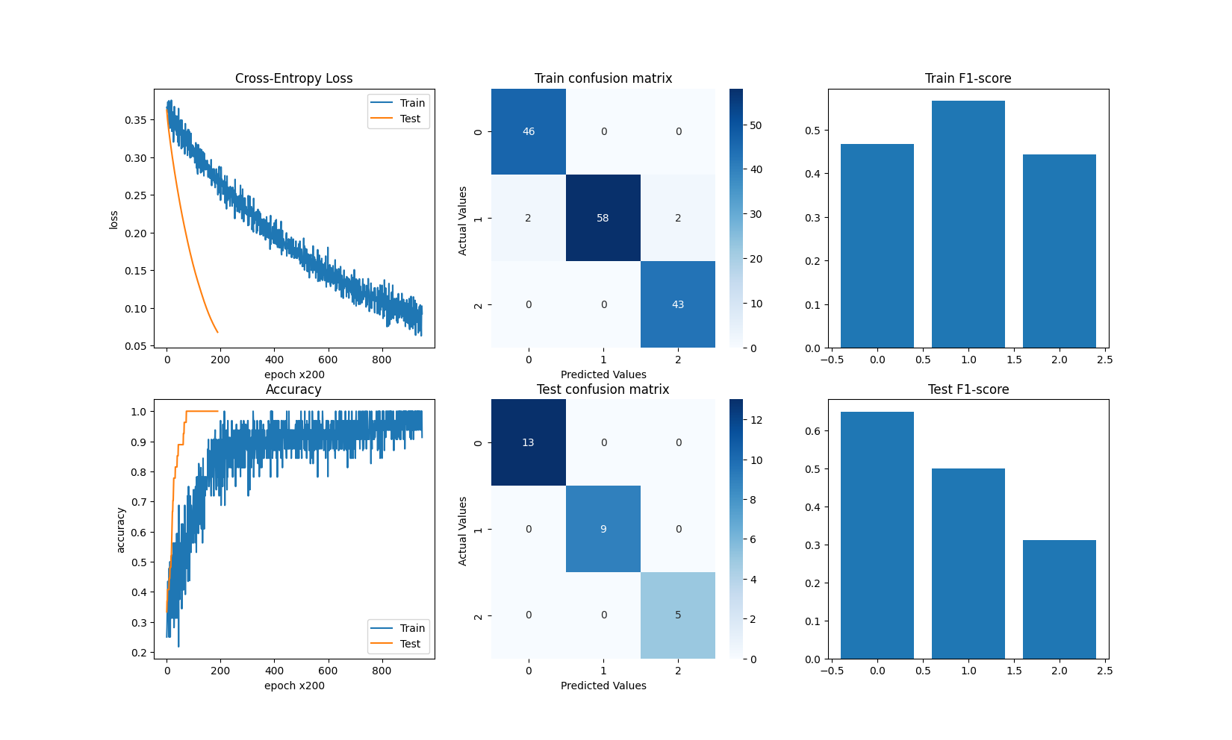

Conv2d (PyTorch)
1) Implement Conv2D task, but instead of using MNIST please change dataset and
model to use LFW dataset: https://scikit-learn.org/stable/modules/generated/
sklearn.datasets.fetch_lfw_people.html#sklearn.datasets.fetch_lfw_people

Tried to adjust the model, but never got good results for accuracy
self.encoder = torch.nn.Sequential(
Conv2d(in_channels=1, out_channels=3, kernel_size=9, stride=2, padding=1),
ReLU(),
Conv2d(in_channels=3, out_channels=6, kernel_size=7, stride=2, padding=1),
ReLU(),
Conv2d(in_channels=6, out_channels=12, kernel_size=5, stride=2, padding=1),
ReLU(),
Conv2d(in_channels=12, out_channels=24, kernel_size=3, stride=2, padding=1),
ReLU(),
Conv2d(in_channels=24, out_channels=48, kernel_size=3, stride=2, padding=1)
)
o_1 = get_out_size(INPUT_SIZE, kernel_size=9, stride=2, padding=1)
o_2 = get_out_size(o_1, kernel_size=7, stride=2, padding=1)
o_3 = get_out_size(o_2, kernel_size=5, stride=2, padding=1)
o_4 = get_out_size(o_3, kernel_size=3, stride=2, padding=1)
o_5 = get_out_size(o_4, kernel_size=3, stride=2, padding=1)
self.fc = Linear(
in_features=48*o_5*o_5,
out_features=feature_count
)

