ResNet, DenseNet, InceptionNet
1) Implement ResNet according to scheme:
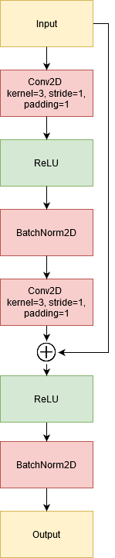
Performance:
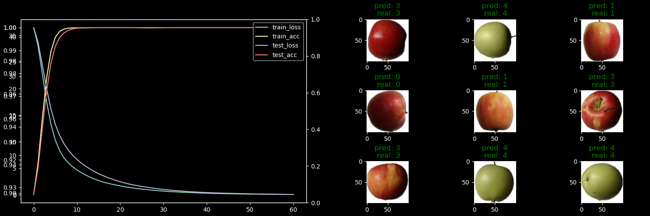

2) Implement DenseNet according to scheme:
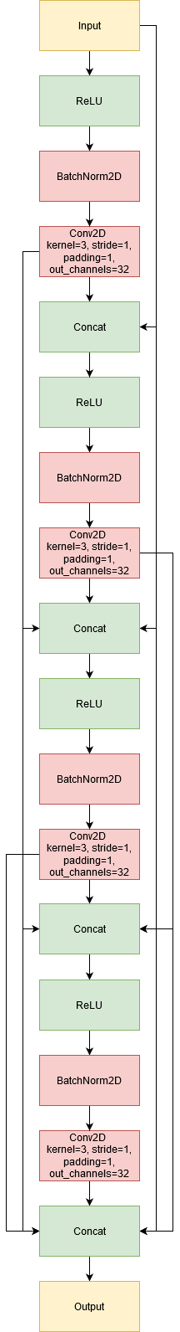Figure 1: DenseNet block
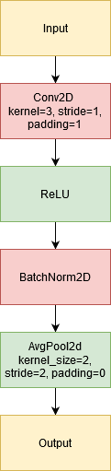Figure 2: Transition layer

Performance:
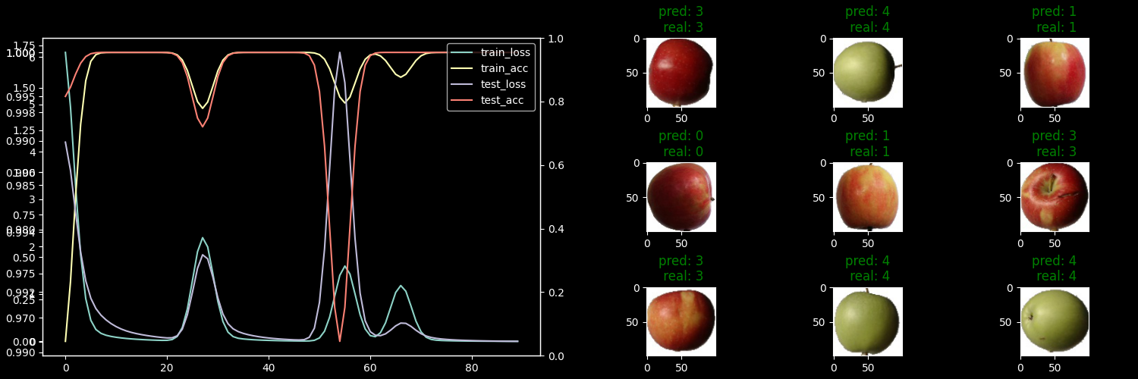

3) Implement InceptionNet according to scheme:
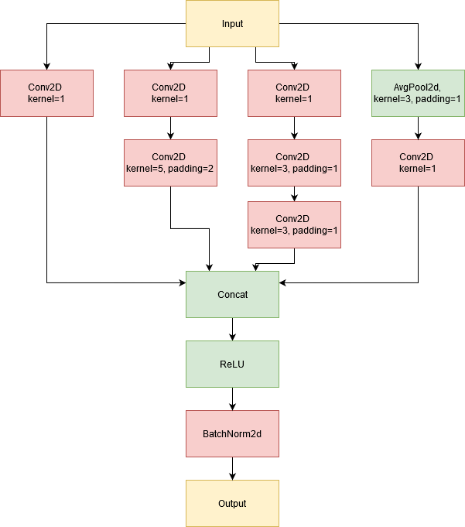Figure 3: InceptionNet block
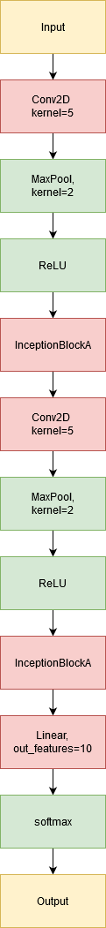Figure 4: InceptionNet

Performance:
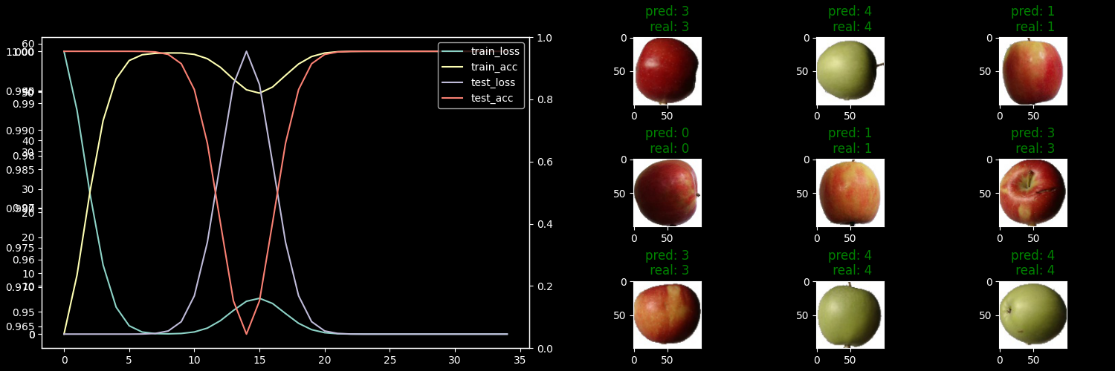
4) Implement own dataset based on NumPy memmap:
class DatasetFlickrImageNumpyMmap(torch.utils.data.Dataset):
def __init__(self, root: str = 'data', force: bool = False):
super().__init__()
kaggle.api.authenticate()
image_dir_name = 'flickr30k_images'
result_file_name = 'results.csv'
dataset_file_name = 'data.npy'
dataset_path = Path(Path(__file__).parent, root, image_dir_name)
dataset_file_path = Path(dataset_path, dataset_file_name)
image_dir_path = Path(dataset_path, image_dir_name)
result_file_path = Path(dataset_path, result_file_name)
metadata_file_path = Path(dataset_path, 'metadata_mmap.json')
self.y = []
self.image_height = 256
self.image_width = self.image_height
self.bytes_per_value = 64 / 8
if force or not dataset_path.exists():
kaggle.api.dataset_download_files('hsankesara/flickr-image-dataset', path=root, quiet=False, unzip=True,
force=force)
# Removing duplicated data
rmtree(Path(image_dir_path, image_dir_name), ignore_errors=True)
Path(image_dir_path, result_file_name).unlink(missing_ok=True)
if force or not dataset_file_path.exists() or not metadata_file_path.exists():
with open(result_file_path, mode='r', encoding='utf-8') as f:
reader = csv.reader(f, delimiter='|')
# Skipping header
next(reader)
results = tuple(reader)
get_filename = itemgetter(0)
filenames = set(map(get_filename, results))
self.data_length = len(filenames)
self.dataset_shape = (self.data_length, 3, self.image_height, self.image_width)
self.x = open_memmap(
str(dataset_file_path), mode='w+', dtype='float64', shape=self.dataset_shape
)
for idx, filename in enumerate(filenames):
image_file_path = Path(image_dir_path, filename)
image = Image.open(image_file_path)
width, height = image.size # Get dimensions
new_size = min(width, height)
left = int((width - new_size) / 2)
top = int((height - new_size) / 2)
right = int((width + new_size) / 2)
bottom = int((height + new_size) / 2)
# Crop the center of the image
image = image.crop((left, top, right, bottom))
image = image.resize((self.image_height, self.image_width), resample=Resampling.LANCZOS)
image = np.asarray(image) / 255.0
# Converting HxWxC to CxHxW
image = np.transpose(image, (2, 0, 1))
self.x[idx, :, :] = image[:, :]
# TODO: what to use???
self.y.append(0)
self.x.flush()
with open(metadata_file_path, 'w') as f:
metadata = {
'shape': self.dataset_shape,
'labels': self.y
}
json.dump(metadata, f)
else:
with open(metadata_file_path) as f:
metadata = json.load(f)
self.dataset_shape = metadata['shape']
self.data_length = self.dataset_shape[0]
self.y = metadata['labels']
self.x = open_memmap(
str(dataset_file_path), mode='r', dtype='float64', shape=self.dataset_shape
)
self.y = F.one_hot(torch.LongTensor(self.y))
def __len__(self):
if MAX_LEN:
return MAX_LEN
return self.data_length
def __getitem__(self, idx):
x = torch.from_numpy(np.copy(self.x[idx]))
return x, self.y[idx]

Jautājums: Varbūt būtu labāk jau no paša sākuma pārveidot datus tensorā un saglabāt?

Performance:
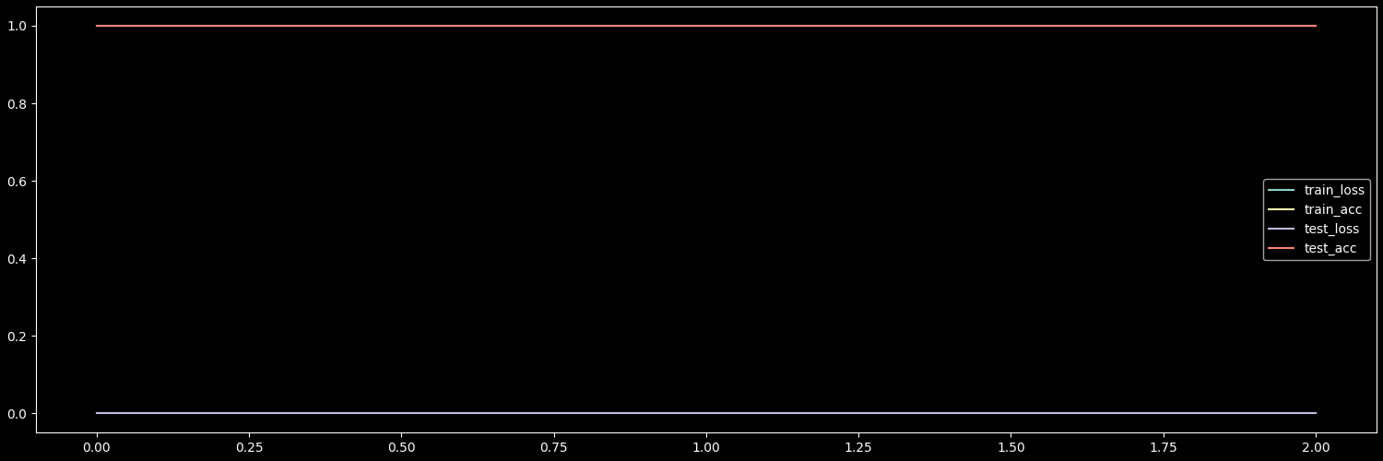
Accuracy is 1 and loss is 0 because I had no labels, so they always match “0”.
Takeaway: my Network had so too many channels for batch size of 64 (for 16GB RAM), I thought it was memmap which loaded complete dataset everytime, but debugging showed that it was model.forward(x). So I decreased batch size to 32 and it stopped swapping.
5) Implement own dataset using filesystem
class DatasetFlickrImage(torch.utils.data.Dataset):
def __init__(self, root: str = 'data', force: bool = False, transform=None, target_transform=None):
super().__init__()
kaggle.api.authenticate()
image_dir_name = 'flickr30k_images'
result_file_name = 'results.csv'
dataset_path = Path(Path(__file__).parent, root, image_dir_name)
self.image_dir_path = Path(dataset_path, image_dir_name)
result_file_path = Path(dataset_path, result_file_name)
metadata_file_path = Path(dataset_path, 'metadata_file.json')
self.transform = transform
self.y = []
self.image_height = 256
self.image_width = self.image_height
self.bytes_per_value = 64 / 8
if force or not dataset_path.exists():
kaggle.api.dataset_download_files('hsankesara/flickr-image-dataset', path=root, quiet=False, unzip=True,
force=force)
# Removing duplicated data
rmtree(Path(self.image_dir_path, image_dir_name), ignore_errors=True)
Path(self.image_dir_path, result_file_name).unlink(missing_ok=True)
if force or not metadata_file_path.exists():
with open(result_file_path, mode='r', encoding='utf-8') as f:
reader = csv.reader(f, delimiter='|')
# Skipping header
next(reader)
results = tuple(reader)
get_filename = itemgetter(0)
filenames = set(map(get_filename, results))
self.data_length = len(filenames)
with open(metadata_file_path, 'w') as fm:
# TODO: what to use???
metadata = {filename: 0 for filename in filenames}
json.dump(metadata, fm)
with open(metadata_file_path) as f:
metadata = json.load(f)
self.x = tuple(metadata.keys())
self.y = tuple(metadata.values())
self.data_length = len(self.y)
# How do I know class count when passing transformation? idk...
if target_transform:
self.y = target_transform(self.y)
# So I transform it manually inside
self.y = F.one_hot(torch.LongTensor(self.y))
def __len__(self):
if MAX_LEN:
return MAX_LEN
return self.data_length
def __getitem__(self, idx):
image_path = Path(self.image_dir_path, self.x[idx])
x = read_image(str(image_path))
y = self.y[idx]
if self.transform:
x = self.transform(x)
x = x / 255.0
return x, y

6) Implement own dataset using Zarr:
class DatasetFlickrImageZarr(torch.utils.data.Dataset):
def __init__(self, root: str = 'data', force: bool = False, chunks=None):
super().__init__()
kaggle.api.authenticate()
image_dir_name = 'flickr30k_images'
result_file_name = 'results.csv'
dataset_file_name = 'data.zarr'
dataset_path = Path(Path(__file__).parent, root, image_dir_name)
dataset_file_path = Path(dataset_path, dataset_file_name)
image_dir_path = Path(dataset_path, image_dir_name)
result_file_path = Path(dataset_path, result_file_name)
self.y = []
self.image_height = 256
self.image_width = self.image_height
self.bytes_per_value = 64 / 8
if force or not dataset_path.exists():
kaggle.api.dataset_download_files('hsankesara/flickr-image-dataset', path=root, quiet=False, unzip=True,
force=force)
# Removing duplicated data
rmtree(Path(image_dir_path, image_dir_name), ignore_errors=True)
Path(image_dir_path, result_file_name).unlink(missing_ok=True)
if force or not dataset_file_path.exists():
with open(result_file_path, mode='r', encoding='utf-8') as f:
reader = csv.reader(f, delimiter='|')
# Skipping header
next(reader)
results = tuple(reader)
get_filename = itemgetter(0)
filenames = set(map(get_filename, results))
self.data_length = len(filenames)
self.dataset_shape = (self.data_length, 3, self.image_height, self.image_width)
self.dataset = zarr.open(str(dataset_file_path), mode='w')
self.x = self.dataset.zeros('samples', shape=self.dataset_shape, chunks=chunks, dtype='float64')
self.y = self.dataset.zeros('labels', dtype='int64', shape=self.data_length if USE_CUDA else MAX_LEN)
y = []
for idx, filename in enumerate(filenames):
image_file_path = Path(image_dir_path, filename)
image = Image.open(image_file_path)
width, height = image.size # Get dimensions
new_size = min(width, height)
left = int((width - new_size) / 2)
top = int((height - new_size) / 2)
right = int((width + new_size) / 2)
bottom = int((height + new_size) / 2)
# Crop the center of the image
image = image.crop((left, top, right, bottom))
image = image.resize((self.image_height, self.image_width), resample=Resampling.LANCZOS)
image = np.asarray(image) / 255.0
# Converting HxWxC to CxHxW
image = np.transpose(image, (2, 0, 1))
self.x[idx, :, :] = image
# TODO: what to use???
y.append(0)
# WORKAROUND: save time
if idx >= MAX_LEN - 1:
break
self.y[:] = torch.tensor(y, dtype=torch.long)
self.root = zarr.open(str(dataset_file_path), mode='r')
self.x = self.root['samples']
self.y = F.one_hot(self.root['labels'])
self.data_length = len(self.y)
def __len__(self):
if MAX_LEN:
return MAX_LEN
return self.data_length
def __getitem__(self, idx):
x = torch.from_numpy(np.copy(self.x[idx]))
return x, self.y[idx]

7) Implement own dataset using HDF5

TODO
8) Implement own Dataset using CuPy
TODO

