Data Analysis
AG35441
survey_data <- read.csv("data/Analysis.csv")
dat <- survey_data |>
clean_names() |>
rename(
awareness = total_awareness_score,
behaviour = average_behaviour,
perceived_control = s3q1,
value_recognition = s3q2,
platform_transparency = s3q3,
trust = trust_score,
regulation = average_regulation_score,
age = age_recoded,
gender = gender_recoded,
education = education_recoded,
screen_time = screen_time_recoded
) |>
mutate(
age_band = factor(age, levels = 1:5,
labels = c("18-24", "25-34", "35-44", "45-54", "55+"),
ordered = TRUE),
edu_band = factor(education, levels = 1:3,
labels = c("Secondary", "Undergraduate", "Postgraduate"),
ordered = TRUE),
screen_band = factor(screen_time, levels = 1:4,
labels = c("<1h", "1-3h", "4-5h", ">5h"),
ordered = TRUE),
gender_f = factor(gender, levels = c(0, 1),
labels = c("Male", "Female"))
)
glimpse(dat)
## Rows: 120
## Columns: 35
## $ s1q1 <chr> "TRUE", "TRUE", "FALSE", "TRUE", "TRUE", "TRUE",…
## $ s1q2 <chr> "FALSE", "FALSE", "FALSE", "Not Sure", "FALSE", …
## $ s1q3 <chr> "Not Sure", "TRUE", "TRUE", "TRUE", "TRUE", "TRU…
## $ s1q4 <chr> "FALSE", "FALSE", "TRUE", "FALSE", "FALSE", "FAL…
## $ s1q5 <chr> "Not Sure", "TRUE", "FALSE", "FALSE", "TRUE", "T…
## $ s1q6 <chr> "Not Sure", "FALSE", "FALSE", "TRUE", "FALSE", "…
## $ s1q1_recoded <int> 1, 1, 0, 1, 1, 1, 1, 1, 1, 1, 1, 1, 1, 1, 0, 1, …
## $ s1q2_recoded <int> 1, 1, 1, 0, 1, 1, 1, 1, 0, 0, 1, 1, 1, 1, 1, 0, …
## $ s1q3_recoded <int> 0, 1, 1, 1, 1, 1, 0, 1, 0, 1, 1, 1, 1, 1, 1, 1, …
## $ s1q4_recoded <int> 1, 1, 0, 1, 1, 1, 1, 1, 1, 1, 1, 1, 1, 1, 1, 1, …
## $ s1q5_recoded <int> 0, 1, 0, 0, 1, 1, 1, 1, 0, 1, 1, 1, 1, 0, 0, 0, …
## $ s1q6_recoded <int> 0, 1, 1, 0, 1, 0, 1, 1, 0, 0, 1, 0, 0, 1, 1, 1, …
## $ awareness <int> 3, 6, 3, 3, 6, 5, 5, 6, 2, 4, 6, 5, 5, 5, 4, 4, …
## $ s2q1 <int> 2, 5, 4, 3, 4, 2, 4, 4, 2, 5, 1, 2, 2, 4, 5, 4, …
## $ s2q2 <int> 1, 4, 3, 4, 4, 3, 4, 5, 3, 3, 5, 1, 2, 4, 4, 2, …
## $ s2q3 <int> 1, 1, 2, 1, 4, 2, 4, 1, 3, 1, 1, 1, 1, 2, 2, 1, …
## $ s2q4 <int> 2, 2, 3, 1, 4, 2, 2, 2, 3, 1, 1, 2, 1, 4, 3, 2, …
## $ s2q5 <int> 4, 5, 4, 3, 4, 4, 4, 4, 3, 5, 3, 5, 2, 4, 4, 3, …
## $ behaviour <dbl> 2.0, 3.4, 3.2, 2.4, 4.0, 2.6, 3.6, 3.2, 2.8, 3.0…
## $ perceived_control <int> 1, 4, 2, 2, 2, 1, 3, 2, 3, 1, 1, 2, 1, 1, 1, 1, …
## $ value_recognition <int> 4, 4, 3, 4, 3, 5, 3, 4, 3, 5, 4, 5, 5, 4, 5, 4, …
## $ platform_transparency <int> 2, 2, 3, 2, 3, 2, 3, 3, 2, 2, 2, 2, 2, 2, 2, 1, …
## $ trust <dbl> 1.5, 3.0, 2.5, 2.0, 2.5, 1.5, 3.0, 2.5, 2.5, 1.5…
## $ s4q1 <int> 5, 4, 5, 3, 3, 5, 4, 5, 4, 5, 4, 5, 4, 5, 5, 4, …
## $ s4q2 <int> 5, 5, 5, 4, 3, 5, 5, 4, 4, 5, 4, 5, 5, 5, 5, 4, …
## $ s4q3 <int> 5, 5, 5, 2, 4, 5, 4, 4, 4, 5, 3, 4, 3, 5, 4, 5, …
## $ regulation <dbl> 5.00, 4.67, 5.00, 3.00, 3.33, 5.00, 4.33, 4.33, …
## $ age <int> 5, 1, 1, 2, 1, 1, 1, 1, 4, 1, 1, 4, 1, 2, 1, 1, …
## $ gender <int> 0, 0, 0, 1, 0, 1, 1, 0, 1, 1, 0, 1, 0, 0, 0, 0, …
## $ education <int> 3, 3, 2, 3, 2, 3, 2, 3, 3, 3, 1, 3, 3, 3, 3, 2, …
## $ screen_time <int> 2, 2, 2, 4, 1, 3, 2, 2, 2, 2, 1, 2, 2, 1, 2, 2, …
## $ age_band <ord> 55+, 18-24, 18-24, 25-34, 18-24, 18-24, 18-24, 1…
## $ edu_band <ord> Postgraduate, Postgraduate, Undergraduate, Postg…
## $ screen_band <ord> 1-3h, 1-3h, 1-3h, >5h, <1h, 4-5h, 1-3h, 1-3h, 1-…
## $ gender_f <fct> Male, Male, Male, Female, Male, Female, Female, …
cat("\nN =", nrow(dat), "\n")
##
## N = 120
dat |> tabyl(age_band)
## age_band n percent
## 18-24 49 0.40833333
## 25-34 27 0.22500000
## 35-44 24 0.20000000
## 45-54 13 0.10833333
## 55+ 7 0.05833333
dat |> tabyl(edu_band)
## edu_band n percent
## Secondary 13 0.1083333
## Undergraduate 39 0.3250000
## Postgraduate 68 0.5666667
dat |> tabyl(screen_band)
## screen_band n percent
## <1h 13 0.1083333
## 1-3h 62 0.5166667
## 4-5h 26 0.2166667
## >5h 19 0.1583333
dat |> tabyl(gender_f)
## gender_f n percent
## Male 57 0.475
## Female 63 0.525
#Survey This is a test analysis of a dataset on Everyday Users’ Perceptions of Data Use and Value Creation in the Hidden Value Chains of the Data Economy.
#Hypotheses
##Hypothesis 1 H1 Greater awareness of data extraction is not associated with greater privacy-protective behaviour.
##Hypothesis 2 H2 Greater awareness of data extraction is associated with lower platform trust.
##Hypothesis 3 H3 Greater awareness of data extraction is associated with stronger support for regulation.
##Hypothesis 4 H4 Users recognise their everyday online activity as a source of economic value for platforms.
##Hypothesis 5 H5 Stronger value recognition is associated with lower perceived control, lower platform trust, and stronger support for regulation.
#Descriptive statistics
dat |>
select(awareness, behaviour, perceived_control, value_recognition,
platform_transparency, trust, regulation) |>
psych::describe() |>
round (2)
## vars n mean sd median trimmed mad min max range
## awareness 1 120 4.42 1.39 5.0 4.55 1.48 0 6.0 6.0
## behaviour 2 120 2.28 0.72 2.2 2.28 0.89 1 4.0 3.0
## perceived_control 3 120 1.82 0.77 2.0 1.74 1.48 1 4.0 3.0
## value_recognition 4 120 4.05 0.88 4.0 4.12 1.48 1 5.0 4.0
## platform_transparency 5 120 2.03 0.71 2.0 2.03 0.00 1 4.0 3.0
## trust 6 120 1.93 0.59 2.0 1.92 0.74 1 3.5 2.5
## regulation 7 120 4.00 0.84 4.0 4.09 0.99 1 5.0 4.0
## skew kurtosis se
## awareness -0.61 -0.25 0.13
## behaviour 0.14 -0.81 0.07
## perceived_control 0.65 -0.07 0.07
## value_recognition -0.69 0.11 0.08
## platform_transparency 0.09 -0.66 0.06
## trust 0.20 -0.72 0.05
## regulation -0.81 0.57 0.08
#Normality check
dat |>
select(awareness, behaviour, perceived_control, value_recognition,
platform_transparency, trust, regulation) |>
lapply(shapiro.test)
## $awareness
##
## Shapiro-Wilk normality test
##
## data: X[[i]]
## W = 0.89442, p-value = 0.0000001028
##
##
## $behaviour
##
## Shapiro-Wilk normality test
##
## data: X[[i]]
## W = 0.96963, p-value = 0.008145
##
##
## $perceived_control
##
## Shapiro-Wilk normality test
##
## data: X[[i]]
## W = 0.81123, p-value = 0.00000000004124
##
##
## $value_recognition
##
## Shapiro-Wilk normality test
##
## data: X[[i]]
## W = 0.83873, p-value = 0.000000000404
##
##
## $platform_transparency
##
## Shapiro-Wilk normality test
##
## data: X[[i]]
## W = 0.82306, p-value = 0.0000000001069
##
##
## $trust
##
## Shapiro-Wilk normality test
##
## data: X[[i]]
## W = 0.91927, p-value = 0.000002184
##
##
## $regulation
##
## Shapiro-Wilk normality test
##
## data: X[[i]]
## W = 0.91549, p-value = 0.00000133
#Knowledge-tems check
dat |>
select(s1q1_recoded:s1q6_recoded) |>
colMeans() |>
round(2)
## s1q1_recoded s1q2_recoded s1q3_recoded s1q4_recoded s1q5_recoded s1q6_recoded
## 0.84 0.77 0.69 0.88 0.61 0.62
#Reliability
kr20 <- psych::alpha(dat |>
select(s1q1_recoded:s1q6_recoded),
check.keys = FALSE)
beh_alpha <- psych::alpha(dat |>
select(s2q1:s2q5),
check.keys = FALSE)
reg_alpha <- psych::alpha(dat |>
select(s4q1:s4q3),
check.keys = FALSE)
r_trust <- cor(dat$perceived_control, dat$platform_transparency, use = "complete.obs")
sb_trust <- (2 * r_trust) / (1 + r_trust)
tibble::tibble(
Scale = c("Awareness (6)", "Behaviour (5)", "Regulation (3)", "Trust (2)"),
Coefficient = c("KR-20", "Cronbach alpha", "Cronbach alpha", "Spearman-Brown"),
Value = round(c(kr20$total$raw_alpha, beh_alpha$total$raw_alpha,
reg_alpha$total$raw_alpha, sb_trust), 2)
)
## # A tibble: 4 × 3
## Scale Coefficient Value
## <chr> <chr> <dbl>
## 1 Awareness (6) KR-20 0.51
## 2 Behaviour (5) Cronbach alpha 0.7
## 3 Regulation (3) Cronbach alpha 0.84
## 4 Trust (2) Spearman-Brown 0.41
#Correlations
corr_vars <- dat |>
select(awareness, behaviour, perceived_control, value_recognition,
platform_transparency, trust, regulation)
sp <- psych::corr.test(corr_vars, method = "spearman")
round(sp$r, 2)
## awareness behaviour perceived_control value_recognition
## awareness 1.00 -0.23 -0.12 0.14
## behaviour -0.23 1.00 0.09 0.06
## perceived_control -0.12 0.09 1.00 -0.33
## value_recognition 0.14 0.06 -0.33 1.00
## platform_transparency 0.01 -0.01 0.28 -0.06
## trust -0.09 0.06 0.82 -0.25
## regulation -0.16 0.55 -0.12 0.30
## platform_transparency trust regulation
## awareness 0.01 -0.09 -0.16
## behaviour -0.01 0.06 0.55
## perceived_control 0.28 0.82 -0.12
## value_recognition -0.06 -0.25 0.30
## platform_transparency 1.00 0.77 -0.19
## trust 0.77 1.00 -0.19
## regulation -0.19 -0.19 1.00
round(sp$p, 3)
## awareness behaviour perceived_control value_recognition
## awareness 0.000 0.161 1.000 1.000
## behaviour 0.011 0.000 1.000 1.000
## perceived_control 0.199 0.341 0.000 0.004
## value_recognition 0.138 0.549 0.000 0.000
## platform_transparency 0.879 0.952 0.002 0.536
## trust 0.347 0.496 0.000 0.005
## regulation 0.078 0.000 0.181 0.001
## platform_transparency trust regulation
## awareness 1.000 1.000 0.861
## behaviour 1.000 1.000 0.000
## perceived_control 0.029 0.000 1.000
## value_recognition 1.000 0.081 0.012
## platform_transparency 0.000 0.000 0.518
## trust 0.000 0.000 0.518
## regulation 0.041 0.040 0.000
#Group Comparisons
outcomes <- c("awareness", "behaviour", "trust", "regulation", "value_recognition")
sapply(outcomes, function(v) wilcox.test(dat[[v]] ~ dat$gender_f)$p.value) |> round(3)
## awareness behaviour trust regulation
## 0.742 0.625 0.830 0.353
## value_recognition
## 0.195
sapply(outcomes, function(v) kruskal.test(dat[[v]] ~ dat$age_band)$p.value) |> round(3)
## awareness behaviour trust regulation
## 0.000 0.002 0.891 0.000
## value_recognition
## 0.457
sapply(outcomes, function(v) kruskal.test(dat[[v]] ~ dat$edu_band)$p.value) |> round(3)
## awareness behaviour trust regulation
## 0.579 0.010 0.538 0.000
## value_recognition
## 0.116
sapply(outcomes, function(v) kruskal.test(dat[[v]] ~ dat$screen_band)$p.value) |> round(3)
## awareness behaviour trust regulation
## 0.375 0.994 0.877 0.344
## value_recognition
## 0.207
dat |> rstatix::dunn_test(awareness ~ age_band) |> filter(p.adj < 0.05)
## # A tibble: 3 × 9
## .y. group1 group2 n1 n2 statistic p p.adj p.adj.signif
## <chr> <chr> <chr> <int> <int> <dbl> <dbl> <dbl> <chr>
## 1 awareness 18-24 45-54 49 13 -3.30 0.000962 0.00770 **
## 2 awareness 25-34 45-54 27 13 -3.83 0.000126 0.00114 **
## 3 awareness 35-44 45-54 24 13 -4.07 0.0000479 0.000479 ***
dat |> rstatix::dunn_test(behaviour ~ age_band) |> filter(p.adj < 0.05)
## # A tibble: 3 × 9
## .y. group1 group2 n1 n2 statistic p p.adj p.adj.signif
## <chr> <chr> <chr> <int> <int> <dbl> <dbl> <dbl> <chr>
## 1 behaviour 18-24 35-44 49 24 -3.58 0.000340 0.00340 **
## 2 behaviour 35-44 45-54 24 13 3.16 0.00157 0.0141 *
## 3 behaviour 35-44 55+ 24 7 2.87 0.00411 0.0329 *
dat |> rstatix::dunn_test(regulation ~ age_band) |> filter(p.adj < 0.05)
## # A tibble: 4 × 9
## .y. group1 group2 n1 n2 statistic p p.adj p.adj.signif
## <chr> <chr> <chr> <int> <int> <dbl> <dbl> <dbl> <chr>
## 1 regulation 18-24 35-44 49 24 -3.91 0.0000935 0.000842 ***
## 2 regulation 25-34 35-44 27 24 -2.74 0.00619 0.0433 *
## 3 regulation 35-44 45-54 24 13 3.39 0.000687 0.00550 **
## 4 regulation 35-44 55+ 24 7 4.00 0.0000631 0.000631 ***
print(dat |> rstatix::dunn_test(awareness ~ age_band) |> filter(p.adj < 0.05))
## # A tibble: 3 × 9
## .y. group1 group2 n1 n2 statistic p p.adj p.adj.signif
## <chr> <chr> <chr> <int> <int> <dbl> <dbl> <dbl> <chr>
## 1 awareness 18-24 45-54 49 13 -3.30 0.000962 0.00770 **
## 2 awareness 25-34 45-54 27 13 -3.83 0.000126 0.00114 **
## 3 awareness 35-44 45-54 24 13 -4.07 0.0000479 0.000479 ***
print(dat |> rstatix::dunn_test(behaviour ~ age_band) |> filter(p.adj < 0.05))
## # A tibble: 3 × 9
## .y. group1 group2 n1 n2 statistic p p.adj p.adj.signif
## <chr> <chr> <chr> <int> <int> <dbl> <dbl> <dbl> <chr>
## 1 behaviour 18-24 35-44 49 24 -3.58 0.000340 0.00340 **
## 2 behaviour 35-44 45-54 24 13 3.16 0.00157 0.0141 *
## 3 behaviour 35-44 55+ 24 7 2.87 0.00411 0.0329 *
print(dat |> rstatix::dunn_test(regulation ~ age_band) |> filter(p.adj < 0.05))
## # A tibble: 4 × 9
## .y. group1 group2 n1 n2 statistic p p.adj p.adj.signif
## <chr> <chr> <chr> <int> <int> <dbl> <dbl> <dbl> <chr>
## 1 regulation 18-24 35-44 49 24 -3.91 0.0000935 0.000842 ***
## 2 regulation 25-34 35-44 27 24 -2.74 0.00619 0.0433 *
## 3 regulation 35-44 45-54 24 13 3.39 0.000687 0.00550 **
## 4 regulation 35-44 55+ 24 7 4.00 0.0000631 0.000631 ***
#Regressions
f <- ~ awareness + age + gender + education + screen_time
m_behaviour <- lm(update(f, behaviour ~ .), data = dat)
m_trust <- lm(update(f, trust ~ .), data = dat)
m_regulation <- lm(update(f, regulation ~ .), data = dat)
m_value <- lm(update(f, value_recognition ~ .), data = dat)
lapply(list(behaviour = m_behaviour, trust = m_trust,
regulation = m_regulation, value = m_value),
function(m) list(
betas = effectsize::standardize_parameters(m),
fit = broom::glance(m)[c("r.squared","adj.r.squared","statistic","p.value")],
vif = car::vif(m)
))
## $behaviour
## $behaviour$betas
## # Standardization method: refit
##
## Parameter | Std. Coef. | 95% CI
## -----------------------------------------
## (Intercept) | -2.53e-16 | [-0.17, 0.17]
## awareness | -0.21 | [-0.39, -0.03]
## age | -0.13 | [-0.31, 0.05]
## gender | -0.16 | [-0.34, 0.02]
## education | 0.31 | [ 0.12, 0.49]
## screen time | 0.02 | [-0.15, 0.20]
##
## $behaviour$fit
## # A tibble: 1 × 4
## r.squared adj.r.squared statistic p.value
## <dbl> <dbl> <dbl> <dbl>
## 1 0.137 0.0992 3.62 0.00446
##
## $behaviour$vif
## awareness age gender education screen_time
## 1.075148 1.076632 1.096052 1.114879 1.032531
##
##
## $trust
## $trust$betas
## # Standardization method: refit
##
## Parameter | Std. Coef. | 95% CI
## ----------------------------------------
## (Intercept) | -2.32e-16 | [-0.18, 0.18]
## awareness | -0.06 | [-0.25, 0.13]
## age | 0.10 | [-0.09, 0.29]
## gender | 2.85e-04 | [-0.19, 0.19]
## education | -0.09 | [-0.29, 0.10]
## screen time | 0.05 | [-0.13, 0.24]
##
## $trust$fit
## # A tibble: 1 × 4
## r.squared adj.r.squared statistic p.value
## <dbl> <dbl> <dbl> <dbl>
## 1 0.0275 -0.0152 0.644 0.667
##
## $trust$vif
## awareness age gender education screen_time
## 1.075148 1.076632 1.096052 1.114879 1.032531
##
##
## $regulation
## $regulation$betas
## # Standardization method: refit
##
## Parameter | Std. Coef. | 95% CI
## ----------------------------------------
## (Intercept) | 6.99e-16 | [-0.17, 0.17]
## awareness | -0.07 | [-0.24, 0.11]
## age | -0.04 | [-0.22, 0.13]
## gender | 4.21e-03 | [-0.17, 0.18]
## education | 0.39 | [ 0.21, 0.57]
## screen time | -0.04 | [-0.21, 0.14]
##
## $regulation$fit
## # A tibble: 1 × 4
## r.squared adj.r.squared statistic p.value
## <dbl> <dbl> <dbl> <dbl>
## 1 0.159 0.122 4.30 0.00129
##
## $regulation$vif
## awareness age gender education screen_time
## 1.075148 1.076632 1.096052 1.114879 1.032531
##
##
## $value
## $value$betas
## # Standardization method: refit
##
## Parameter | Std. Coef. | 95% CI
## ----------------------------------------
## (Intercept) | 3.59e-16 | [-0.17, 0.17]
## awareness | 0.22 | [ 0.04, 0.40]
## age | 0.16 | [-0.02, 0.34]
## gender | 0.08 | [-0.10, 0.25]
## education | 0.20 | [ 0.02, 0.38]
## screen time | -0.16 | [-0.33, 0.02]
##
## $value$fit
## # A tibble: 1 × 4
## r.squared adj.r.squared statistic p.value
## <dbl> <dbl> <dbl> <dbl>
## 1 0.150 0.113 4.02 0.00214
##
## $value$vif
## awareness age gender education screen_time
## 1.075148 1.076632 1.096052 1.114879 1.032531
models <- list(behaviour = m_behaviour, trust = m_trust,
regulation = m_regulation, value = m_value)
purrr::map_dfr(models, broom::glance, .id = "model") |>
select(model, r.squared, adj.r.squared, statistic, p.value) |>
mutate(across(where(is.numeric), ~ round(.x, 3)))
## # A tibble: 4 × 5
## model r.squared adj.r.squared statistic p.value
## <chr> <dbl> <dbl> <dbl> <dbl>
## 1 behaviour 0.137 0.099 3.62 0.004
## 2 trust 0.027 -0.015 0.644 0.667
## 3 regulation 0.159 0.122 4.30 0.001
## 4 value 0.15 0.113 4.02 0.002
m_control <- lm(perceived_control ~ value_recognition + awareness +
age + gender + education + screen_time, data = dat)
effectsize::standardize_parameters(m_control)
## # Standardization method: refit
##
## Parameter | Std. Coef. | 95% CI
## -----------------------------------------------
## (Intercept) | 3.18e-17 | [-0.17, 0.17]
## value recognition | -0.29 | [-0.48, -0.10]
## awareness | -0.04 | [-0.23, 0.14]
## age | 0.11 | [-0.07, 0.29]
## gender | 0.11 | [-0.07, 0.29]
## education | 0.02 | [-0.17, 0.20]
## screen time | 0.17 | [-0.01, 0.35]
broom::glance(m_control)[c("r.squared","adj.r.squared","statistic","p.value")]
## # A tibble: 1 × 4
## r.squared adj.r.squared statistic p.value
## <dbl> <dbl> <dbl> <dbl>
## 1 0.155 0.110 3.45 0.00360
#Diagnostic
lapply(list(m_behaviour, m_trust, m_regulation, m_value),
function(m) shapiro.test(residuals(m))$p.value)
## [[1]]
## [1] 0.6564425
##
## [[2]]
## [1] 0.01060855
##
## [[3]]
## [1] 0.00107682
##
## [[4]]
## [1] 0.1181768
lapply(list(m_behaviour, m_trust, m_regulation, m_value), lmtest::bptest)
## [[1]]
##
## studentized Breusch-Pagan test
##
## data: X[[i]]
## BP = 6.3948, df = 5, p-value = 0.2697
##
##
## [[2]]
##
## studentized Breusch-Pagan test
##
## data: X[[i]]
## BP = 7.9663, df = 5, p-value = 0.1581
##
##
## [[3]]
##
## studentized Breusch-Pagan test
##
## data: X[[i]]
## BP = 7.1432, df = 5, p-value = 0.2102
##
##
## [[4]]
##
## studentized Breusch-Pagan test
##
## data: X[[i]]
## BP = 13.035, df = 5, p-value = 0.02305
which(cooks.distance(m_behaviour) > 4 / nrow(dat))
## 5 40 52 53 65 79 81 120
## 5 40 52 53 65 79 81 120
infl <- c(5, 40, 52, 53, 65, 79, 81, 120)
m_beh_no_infl <- lm(update(f, behaviour ~ .), data = dat[-infl, ])
effectsize::standardize_parameters(m_beh_no_infl)
## # Standardization method: refit
##
## Parameter | Std. Coef. | 95% CI
## -----------------------------------------
## (Intercept) | -4.39e-17 | [-0.16, 0.16]
## awareness | -0.30 | [-0.48, -0.13]
## age | -0.25 | [-0.42, -0.07]
## gender | -0.14 | [-0.31, 0.03]
## education | 0.41 | [ 0.24, 0.58]
## screen time | -0.09 | [-0.26, 0.08]
#Robustness
lmtest::coeftest(m_value, vcov = sandwich::vcovHC(m_value, type = "HC3"))
##
## t test of coefficients:
##
## Estimate Std. Error t value Pr(>|t|)
## (Intercept) 2.851976 0.566126 5.0377 0.000001784 ***
## awareness 0.140615 0.067493 2.0834 0.03945 *
## age 0.113005 0.070671 1.5990 0.11258
## gender 0.132826 0.170292 0.7800 0.43701
## education 0.259022 0.144984 1.7866 0.07667 .
## screen_time -0.155155 0.091346 -1.6985 0.09214 .
## ---
## Signif. codes: 0 '***' 0.001 '**' 0.01 '*' 0.05 '.' 0.1 ' ' 1
reg_ord <- MASS::polr(factor(s4q1) ~ awareness + age + gender + education + screen_time,
data = dat, Hess = TRUE)
summary(reg_ord)
## Call:
## MASS::polr(formula = factor(s4q1) ~ awareness + age + gender +
## education + screen_time, data = dat, Hess = TRUE)
##
## Coefficients:
## Value Std. Error t value
## awareness -0.24722 0.1296 -1.9070
## age -0.07575 0.1454 -0.5210
## gender -0.17873 0.3538 -0.5052
## education 0.96675 0.2799 3.4534
## screen_time -0.12089 0.2067 -0.5849
##
## Intercepts:
## Value Std. Error t value
## 1|2 -3.2174 1.2697 -2.5340
## 2|3 -1.6911 1.1676 -1.4485
## 3|4 0.3421 1.1488 0.2978
## 4|5 1.6651 1.1574 1.4387
##
## Residual Deviance: 310.5702
## AIC: 328.5702

Visualizations
library(scales)
theme_set(
theme_minimal(base_size = 12) +
theme(
plot.title = element_text(hjust = 0.5, face = "bold", size = 14),
plot.subtitle = element_text(hjust = 0.5),
plot.margin = margin(10, 15, 10, 10),
strip.text = element_text(face = "bold")
)
)
fill_main <- "#2C6E8F"
accent <- "#B4460E"

Age
dat |>
select(age_band, awareness, behaviour, regulation) |>
pivot_longer(-age_band, names_to = "measure", values_to = "score") |>
ggplot(aes(age_band, score, fill = age_band)) +
geom_violin(alpha = 0.6, colour = NA) +
geom_boxplot(width = 0.15, fill = "white", outlier.size = 0.6) +
facet_wrap(~ measure, scales = "free_y") +
scale_fill_brewer(palette = "Blues") +
labs(x = "Age",
y = "Score",
title = "Distribution of outcomes by Age") +
theme(axis.text.x = element_text(angle = 45, hjust = 1), legend.position = "none")
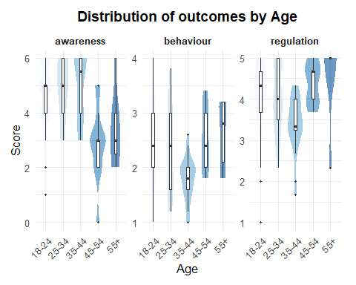

Knowledge item difficulty
tibble::tibble(
item = factor(
c("Q1 Cookie consent", "Q2 App deletion", "Q3 CAPTCHA/AI",
"Q4 Reject breaks site", "Q5 Third-party sharing", "Q6 Incognito"),
levels = rev(c("Q1 Cookie consent", "Q2 App deletion", "Q3 CAPTCHA/AI",
"Q4 Reject breaks site", "Q5 Third-party sharing", "Q6 Incognito"))
),
correct = colMeans(dat |> select(s1q1_recoded:s1q6_recoded))
) |>
ggplot(aes(item, correct)) +
geom_col(fill = fill_main) +
geom_text(aes(label = scales::percent(correct, accuracy = 1)), hjust = -0.15, size = 3.5) +
coord_flip(ylim = c(0, 1)) +
labs(x = NULL,
y = "Proportion correct",
title = "Awareness by Knowledge Item")
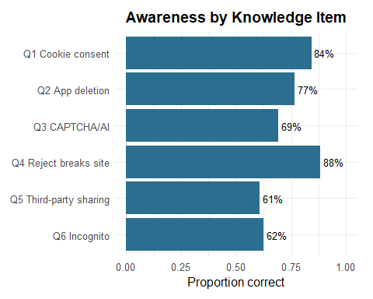
key <- c(s1q1 = "TRUE", s1q2 = "FALSE", s1q3 = "TRUE",
s1q4 = "FALSE", s1q5 = "TRUE", s1q6 = "FALSE")
labels <- c(s1q1 = "Q1 Cookie consent", s1q2 = "Q2 App deletion",
s1q3 = "Q3 CAPTCHA/AI", s1q4 = "Q4 Reject breaks site",
s1q5 = "Q5 Third-party sharing", s1q6 = "Q6 Incognito")
dat |>
select(s1q1:s1q6) |>
pivot_longer(everything(), names_to = "item", values_to = "answer") |>
mutate(
answer = toupper(trimws(as.character(answer))),
outcome = case_when(
answer %in% c("TRUE", "FALSE") & answer == toupper(key[item]) ~ "Correct",
answer %in% c("TRUE", "FALSE") & answer != toupper(key[item]) ~ "Incorrect",
TRUE ~ "Not sure"
),
item = factor(labels[item], levels = rev(labels)),
outcome = factor(outcome, levels = c("Correct", "Not sure", "Incorrect"))
) |>
count(item, outcome) |>
group_by(item) |>
mutate(prop = n / sum(n)) |>
ggplot(aes(prop, item, fill = outcome)) +
geom_col() +
scale_x_continuous(labels = scales::percent) +
scale_fill_manual(values = c(Correct = "#2C6E8F",
`Not sure` = "#C9C9C9",
Incorrect = "#B4460E")) +
labs(x = "Proportion of respondents",
y = NULL, fill = NULL,
title = "Knowledge Item Responses")
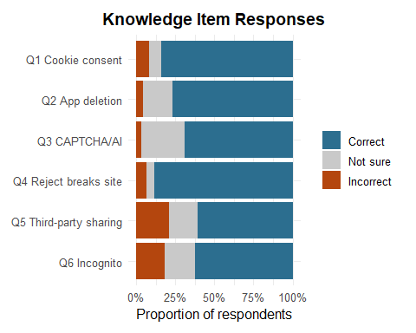

Composite distributions
dat |>
select(awareness, behaviour, perceived_control, value_recognition,
platform_transparency, trust, regulation) |>
pivot_longer(everything(), names_to = "measure", values_to = "score") |>
ggplot(aes(score)) +
geom_histogram(bins = 12, fill = fill_main) +
facet_wrap(~ measure, scales = "free") +
labs(x = "Score",
y = "Count",
title = "Distribution of composite measures")
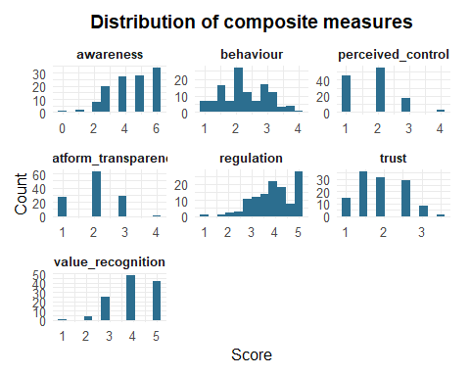

Value recognition
dat |>
count(value_recognition) |>
ggplot(aes(factor(value_recognition), n, fill = factor(value_recognition))) +
geom_col() +
scale_fill_brewer(palette = "Blues") +
labs(x = "Value recognition",
y = "Respondents",
title = "Recognition of Value Generation") +
theme(legend.position = "none")
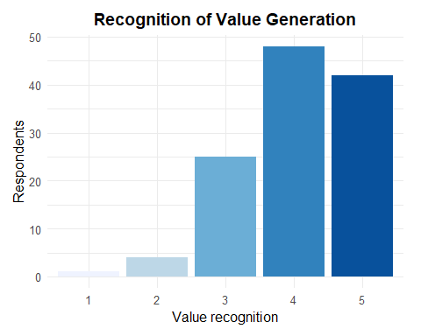
dat |>
count(edu_band, value_recognition) |>
group_by(edu_band) |>
mutate(prop = n / sum(n)) |>
ggplot(aes(edu_band, prop, fill = factor(value_recognition))) +
geom_col() +
scale_y_continuous(labels = scales::percent) +
scale_fill_brewer(palette = "Blues", name = "Value recognition") +
labs(x = "Education", y = "Proportion of respondents",
title = "Value Recognition by Education")
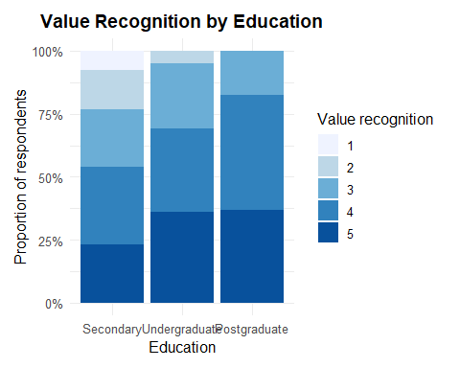

Scatterplot: Awareness and behaviour
ggplot(dat, aes(awareness, behaviour)) +
geom_jitter(width = 0.15, height = 0.05, alpha = 0.5, colour = "#4C4C4C") +
geom_smooth(method = "lm",
se = TRUE,
colour = fill_main,
fill = fill_main,
alpha = 0.15) +
scale_x_continuous(limits = c(0, 6), breaks = 0:6) +
scale_y_continuous(limits = c(1, 5), breaks = 1:5) +
labs(x = "Awareness score",
y = "Protective behaviour",
title = "Awareness and Protective Behaviour")
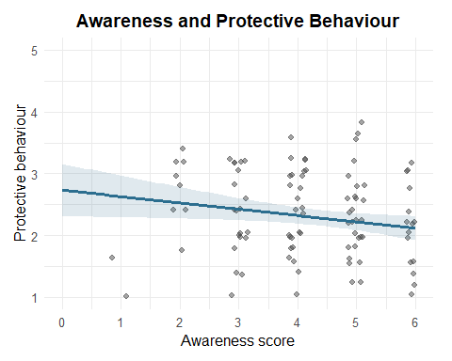

Scatterplot: Value recognition and perceived control
ggplot(dat, aes(value_recognition, perceived_control)) +
geom_jitter(width = 0.1,
height = 0.1,
alpha = 0.5,
colour = "#4C4C4C") +
geom_smooth(method = "lm",
se = TRUE,
colour = fill_main,
fill = fill_main,
alpha = 0.15) +
labs(x = "Value Recognition",
y = "Perceived Control",
title = "Value Recognition and Perceived Control")
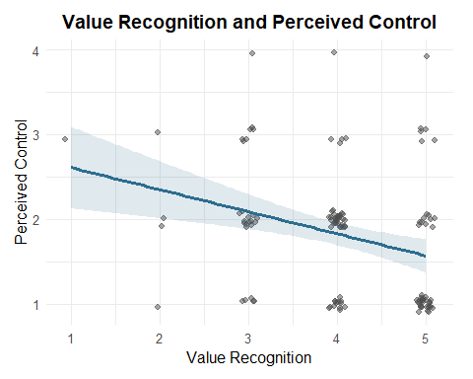

Scatterplot: Value recognition and regulation
ggplot(dat, aes(value_recognition, regulation)) +
geom_jitter(width = 0.1,
height = 0.05,
alpha = 0.5,
colour = "#4C4C4C") +
geom_smooth(method = "lm",
se = TRUE,
colour = fill_main,
fill = fill_main,
alpha = 0.15) +
labs(x = "Value recognition",
y = "Support for regulation",
title = "Value Recognition and Support for Regulation")
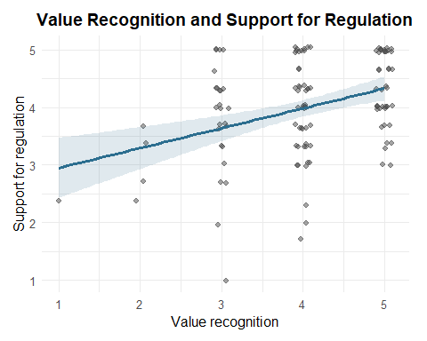

Scatterplot: Behaviour and regulation
ggplot(dat, aes(behaviour, regulation)) +
geom_jitter(width = 0.05,
height = 0.05,
alpha = 0.5,
colour = "#4C4C4C") +
geom_smooth(method = "lm",
se = TRUE,
colour = accent,
fill = accent,
alpha = 0.15) +
labs(x = "Protective behaviour (1-5)",
y = "Support for regulation (1-5)",
title = "Protective behaviour and support for regulation")
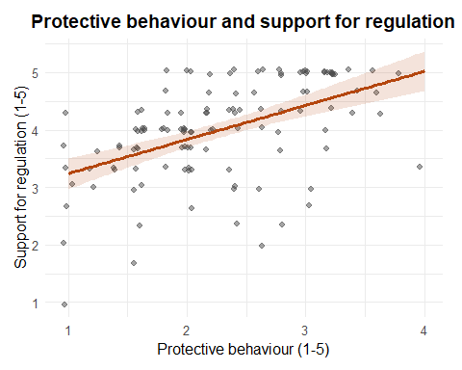

Boxplot: Age effects
dat |>
select(age_band, awareness, behaviour, regulation) |>
pivot_longer(-age_band, names_to = "measure", values_to = "score") |>
ggplot(aes(age_band, score, fill = age_band)) +
geom_boxplot(alpha = 0.85) +
facet_wrap(~ measure, scales = "free_y") +
scale_fill_brewer(palette = "Blues") +
labs(x = "Age",
y = "Score",
title = "Outcomes by Age") +
theme(axis.text.x = element_text(angle = 45, hjust = 1), legend.position = "none")
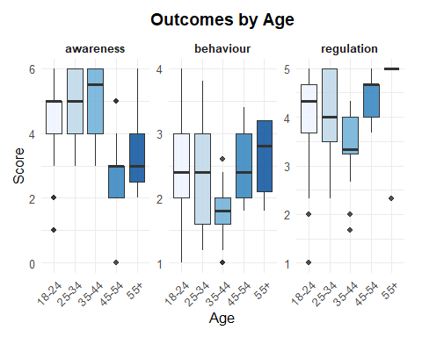

Boxplot: Regulation by education
ggplot(dat, aes(edu_band, regulation, fill = edu_band)) +
geom_boxplot(alpha = 0.85) +
scale_fill_brewer(palette = "Blues") +
labs(x = "Education",
y = "Support for regulation",
title = "Support for Regulation by Education") +
theme(legend.position = "none")
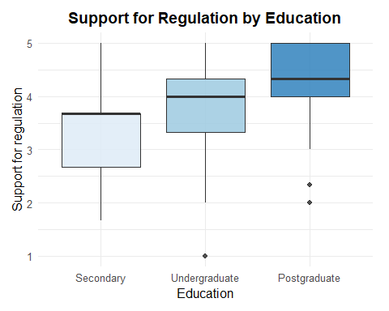

Correlation heatmap
m <- dat |>
select(awareness, behaviour, perceived_control, value_recognition,
platform_transparency, trust, regulation) |>
cor(method = "spearman")
as.data.frame(as.table(m)) |>
ggplot(aes(Var1, Var2, fill = Freq)) +
geom_tile(colour = "white") +
geom_text(aes(label = round(Freq, 2)), size = 3) +
scale_fill_gradient2(low = "#B2182B", mid = "white", high = "#2166AC",
limits = c(-1, 1), name = "rho") +
labs(x = NULL,
y = NULL,
title = "Spearman correlations") +
theme(axis.text.x = element_text(angle = 45, hjust = 1))
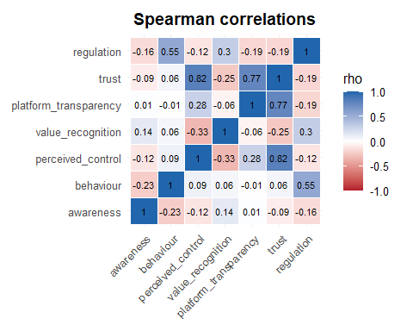

Coefficient forest plot
models <- list(Behaviour = m_behaviour, Trust = m_trust,
Regulation = m_regulation, Value = m_value)
purrr::map_dfr(models, function(m) {
sp <- effectsize::standardize_parameters(m)
tibble::tibble(term = sp$Parameter, beta = sp$Std_Coefficient,
low = sp$CI_low, high = sp$CI_high)
}, .id = "model") |>
filter(term != "(Intercept)") |>
ggplot(aes(beta, term, colour = model)) +
geom_vline(xintercept = 0, linetype = "dashed", colour = "grey50") +
geom_pointrange(aes(xmin = low, xmax = high)) +
facet_wrap(~ model) +
scale_colour_brewer(palette = "Set2") +
labs(x = "Standardised coefficient (95% CI)",
y = NULL,
title = "Predictors across the four models") +
theme(legend.position = "none")
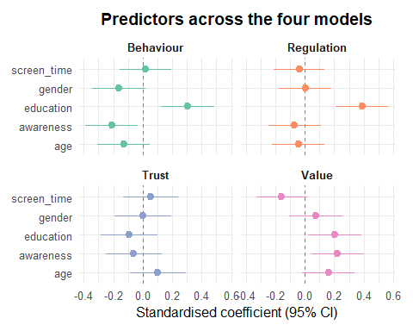

Awareness effect across outcomes
models <- list(Behaviour = m_behaviour, Trust = m_trust,
Regulation = m_regulation, Value = m_value)
purrr::map_dfr(models, function(m) {
sp <- effectsize::standardize_parameters(m)
tibble::tibble(term = sp$Parameter, beta = sp$Std_Coefficient,
low = sp$CI_low, high = sp$CI_high)
}, .id = "model") |>
filter(term == "awareness") |>
ggplot(aes(beta, model, colour = model)) +
geom_vline(xintercept = 0, linetype = "dashed", colour = "grey50") +
geom_pointrange(aes(xmin = low, xmax = high)) +
scale_colour_brewer(palette = "Set2") +
labs(x = "Standardised awareness coefficient (95% CI)",
y = NULL,
title = "Effect of awareness on each outcome") +
theme(legend.position = "none")
