**Nama: Muhammad Kholish Kamil**

**Npm: 223040141**

**https://github.com/kamil026/PBO_223040141**

**Latihan 1**

**Kelas Orang**

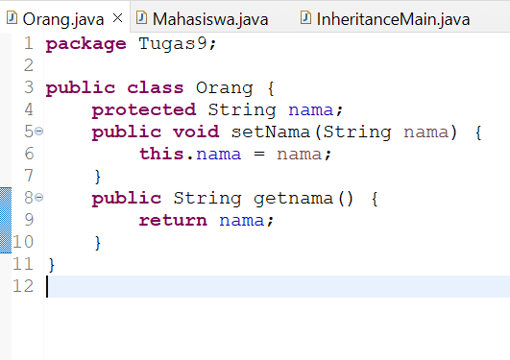

**Kelas Mahasiswa**

**Kelas Mahasiswa**

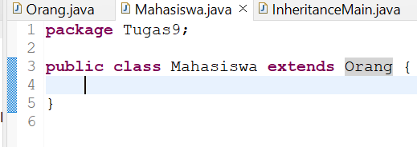

**InheritanceMain**

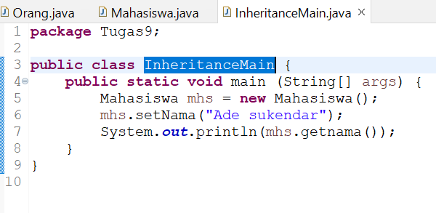

**Output**

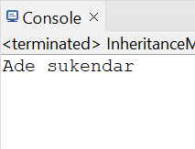

**Latihan 2**

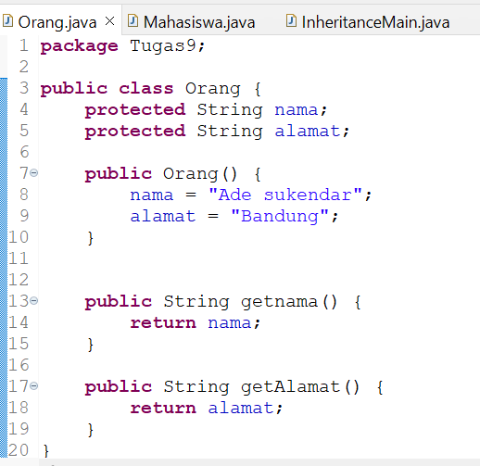**Kelas Orang**

**Kelas Mahasiswa**



**InheritanceMain**

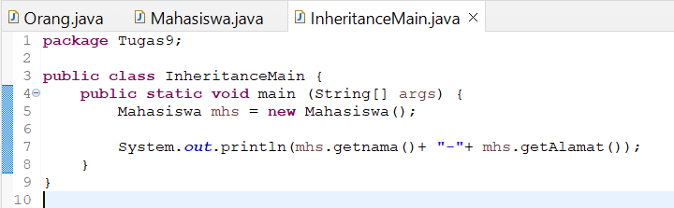

**Output**

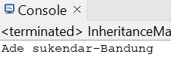**A**

**Latihan 3**

**Kelas Orang**

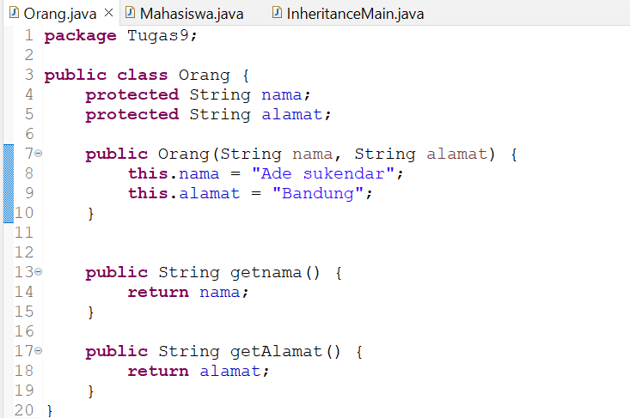

**Kelas Mahasiswa**

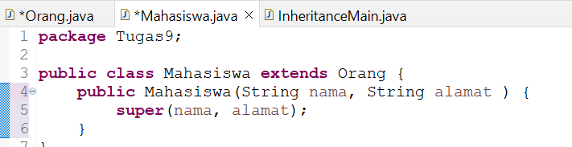

**InheritanceMain**

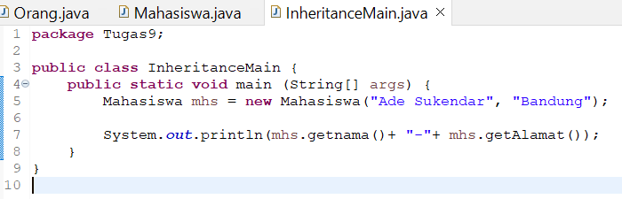

**OutPut**

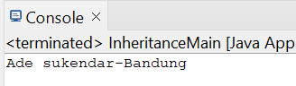

**Latihan 4**

**Kelas Orang**

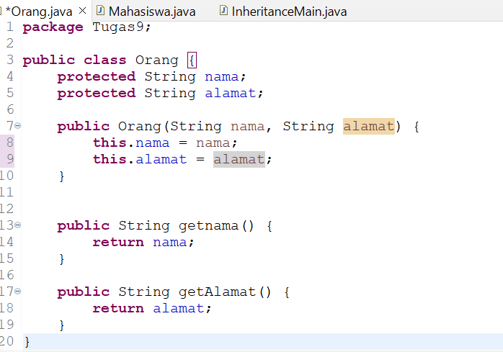

**Kelas Mahasiswa**

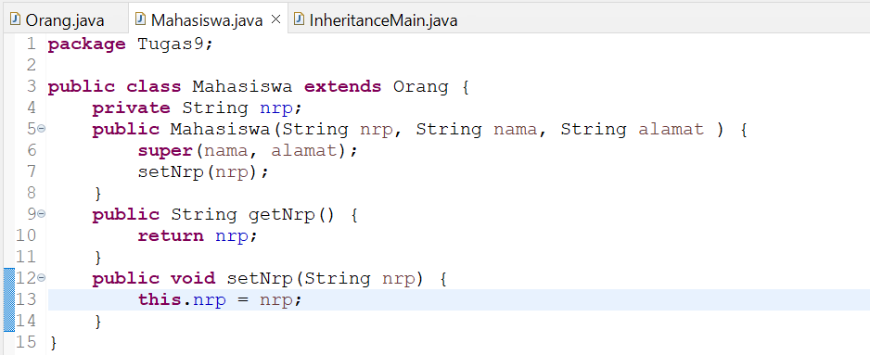

**InheritanceMain**

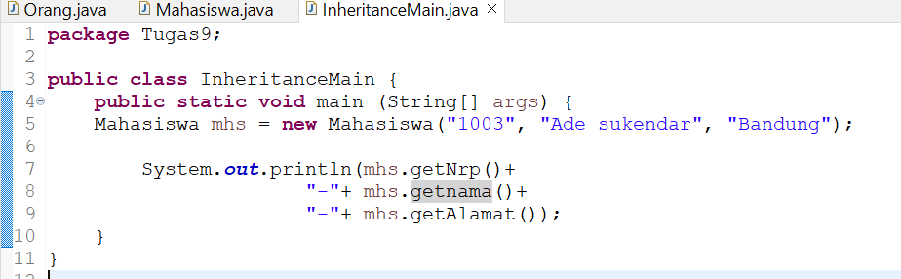

**OutPut**

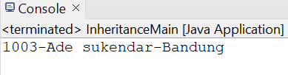

**Tugas**

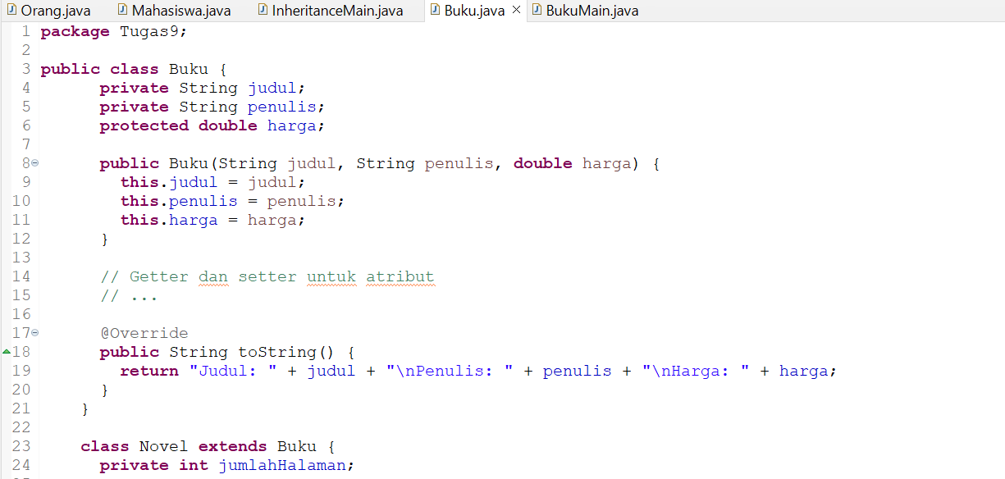**Buku.java**

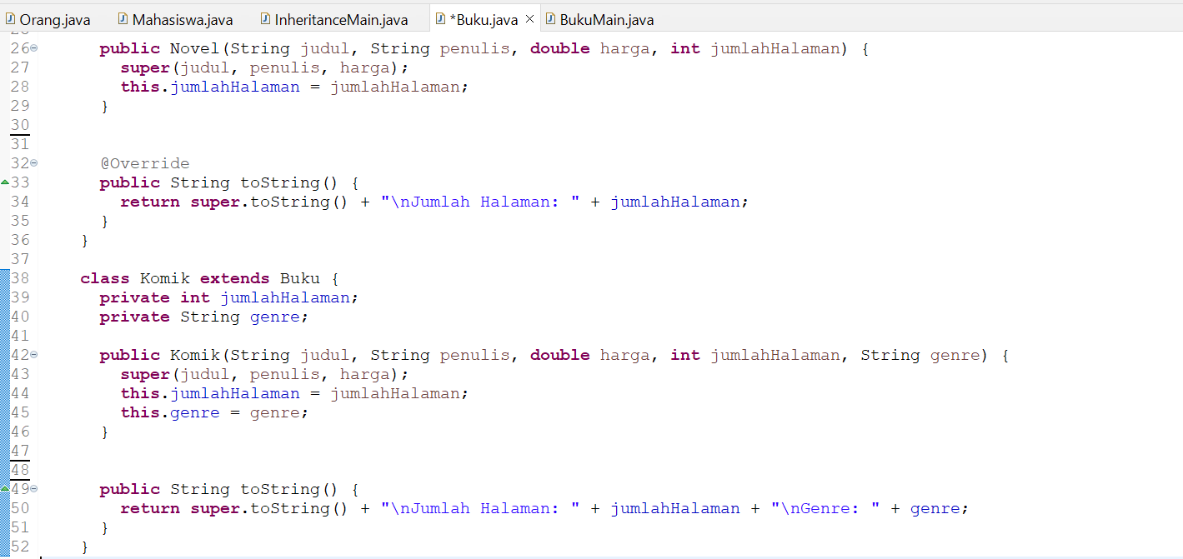

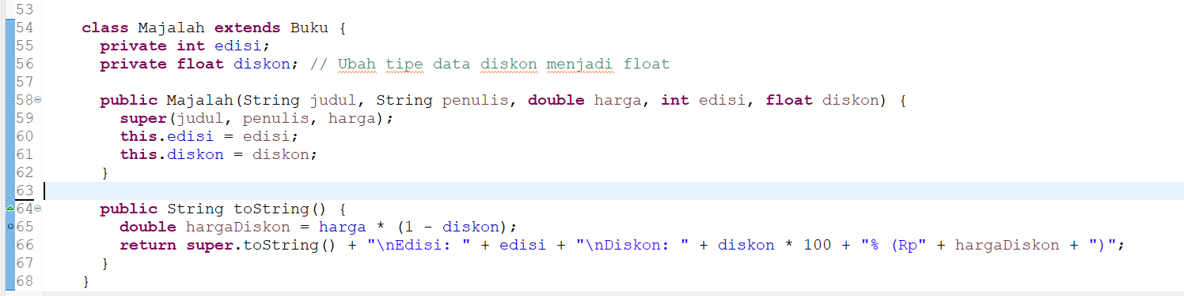

**BukuMain.java**

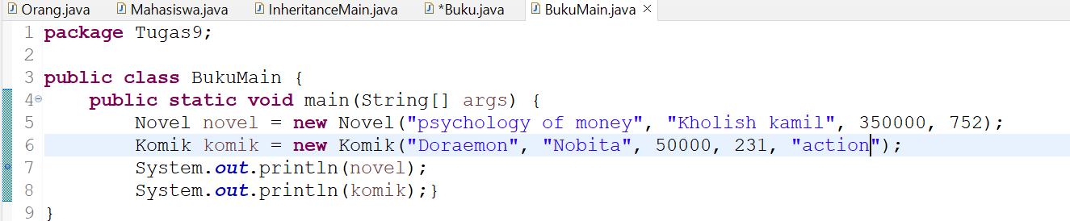

**OutPut**

