binning numerical variables

Kamila

6/11/2020

## R Markdown

## re-encoding from UTF-8

## Including Plots

I want to look how to bin the numerical variable hnc_exitage: for this firstly I want to look at the unormalized and normalized histograms for hnc_exitage for hnc_exitstat:

## Warning: package 'tidyverse' was built under R version 3.6.3

## -- Attaching packages ------------------------------------------------------------------------------------------- tidyverse 1.3.0 --

## v ggplot2 3.3.0 v purrr 0.3.4  
## v tibble 3.0.1 v dplyr 1.0.0  
## v tidyr 1.0.2 v stringr 1.4.0  
## v readr 1.3.1 v forcats 0.5.0

## Warning: package 'ggplot2' was built under R version 3.6.3

## Warning: package 'tibble' was built under R version 3.6.3

## Warning: package 'tidyr' was built under R version 3.6.3

## Warning: package 'readr' was built under R version 3.6.3

## Warning: package 'purrr' was built under R version 3.6.3

## Warning: package 'dplyr' was built under R version 3.6.3

## Warning: package 'stringr' was built under R version 3.6.3

## Warning: package 'forcats' was built under R version 3.6.3

## -- Conflicts ---------------------------------------------------------------------------------------------- tidyverse_conflicts() --  
## x dplyr::filter() masks stats::filter()  
## x dplyr::lag() masks stats::lag()

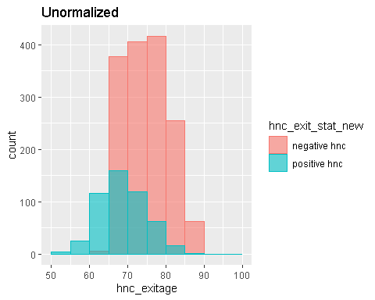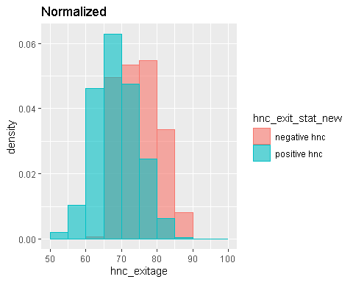

And with the density plot on the histogram: 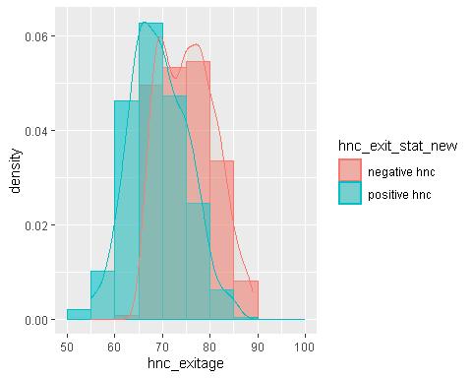

## $title  
## [1] "Normalized"  
##   
## attr(,"class")  
## [1] "labels"

But firstly, lets look at the bar chart for hnc_exitstat:

## Warning: package 'scales' was built under R version 3.6.3

##   
## Attaching package: 'scales'

## The following object is masked from 'package:purrr':  
##   
## discard

## The following object is masked from 'package:readr':  
##   
## col_factor

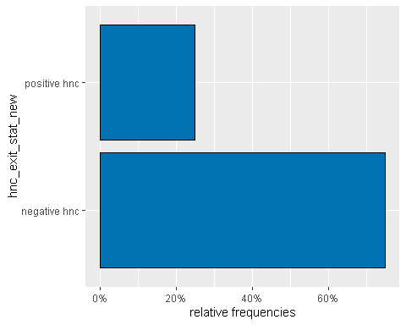 I want to look at the frequebcy and percentage of the hnc exitstatus in the tabular form:

## tb1   
## negative hnc 1522 0.7504931  
## positive hnc 506 0.2495069

and I want to add to the normalized histogram the curves:

