RE—EARTH
Enterprise AWS Cloud Architecture & End-to-End Workflow Specification
System: SMRT Kiosk Planetary Network | AWS Region: us-east-1 (N. Virginia) | Version: 2.6 | Status: PRODUCTION READY

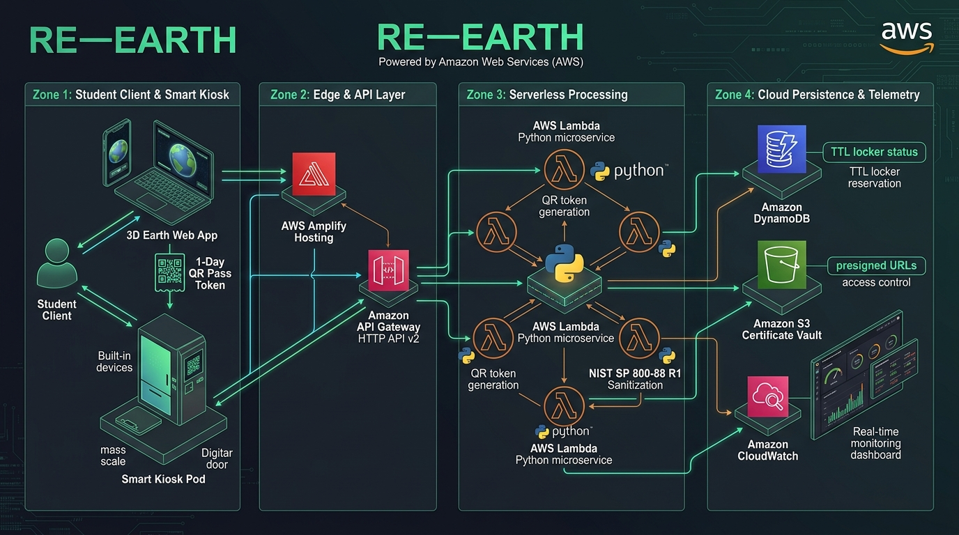
Figure 1: RE—EARTH End-to-End Serverless Architecture Diagram on AWS (Zones 1 to 4)

1. Executive Architecture Summary
RE—EARTH is an enterprise-grade cloud and IoT e-waste diversion platform designed to connect university students, physical smart drop-off collection pods, institutional campus administrators, and corporate sponsors into a transparent, circular-economy ecosystem. The cloud backbone is implemented on Amazon Web Services (AWS) using a strictly cost-minimized, 100% serverless, event-driven pattern in us-east-1 (N. Virginia). The platform eliminates idle infrastructure costs while providing global high-performance content delivery, sub-second API transactions, automated cryptographic data wipe compliance, and immutable ledger logging.

2. End-to-End Cloud Transaction Lifecycle
• Step 1: Edge Distribution: The student accesses the WebGL Three.js interactive earth client served globally via AWS Amplify Hosting with edge caching, achieving ~185ms initial response latency.
• Step 2: Device Discovery & Triage: The student selects their e-waste hardware (iPhone, laptop, tablet), performs battery swell safety checks, and completes the automated NIST SP 800-88 R1 data sanitization protocol.
• Step 3: Locker Allocation Request: The client initiates an asynchronous HTTPS request via Amazon API Gateway HTTP API v2 targeting the SMRT Kiosk allocation endpoint.
• Step 4: Serverless Reservation Execution: AWS Lambda (Python 3.11) processes the reservation payload, validates campus eligibility, and writes an atomic item to Amazon DynamoDB (SmrtKioskReservations).
• Step 5: Automated TTL Policy: DynamoDB applies a native 24-hour Time-To-Live (reservationExpiresAt epoch timestamp), guaranteeing locker reservations cleanly expire if unredeemed without running cron jobs.
• Step 6: Optical QR Pass Generation: Lambda cryptographically signs an optical 2D token (SIG-XXXXXX-CAMPUS) valid for 24 hours (1-Day Pass) and returns it to the client with remaining time displayed in hours and minutes.
• Step 7: Physical Kiosk Handover: The student walks to the physical campus pod, places the device on the automated scale, and scans the optical pass at the 2D barcode scanner.
• Step 8: Mass & Criterion Verification: The kiosk operator/controller calls API Gateway to verify declared vs. measured grams, condition triage, battery safety, and cryptographic sanitization.
• Step 9: State Finalization & Ledger Commit: Upon successful inspection, Lambda updates the locker status to COMPLETED, appends verified $CO_2e$ avoided and eco-credits to Amazon DynamoDB (SmrtInstitutionalLedger), and generates a tamper-proof NIST Certificate in Amazon S3.
• Step 10: Secure Certificate Vault Access: Students access their permanent audit certificate directly via time-bounded Amazon S3 Presigned URLs without exposing public bucket permissions.

3. Detailed Specification of the 4 Architectural Zones
■ Zone 1: Student Client & Smart Kiosk
The physical and edge interaction plane. Features a Three.js WebGL globe, real-time campus transit overlay, NIST SP 800-88 R1 step-by-step cryptographic wipe protocol, 1-Day Optical QR Token generator, and physical smart kiosk pod hardware equipped with a precision digital load-cell scale, 2D scanner, and motorized hatch solenoid.
■ Zone 2: Edge & API Ingress Layer
Combines AWS Amplify Hosting (App ID: d3cukmq7nr5vg3) with Amazon API Gateway HTTP API v2 (API ID: bzj8npggw7). Amplify serves client single-page assets globally with automated SSL and edge points of presence. API Gateway routes low-latency microservices with full CORS validation for both local developer environments and cloud production domains.
■ Zone 3: Serverless Processing Microservices
Powered by AWS Lambda (Function: re-earth-api-service, Runtime: Python 3.11). Executes stateless business logic including NIST sanitization verification, token signature validation, locker availability checks, eco-credits and campus XP multiplier calculations, and S3 certificate document generation with sub-100ms execution times.
■ Zone 4: Cloud Persistence, Compliance Vault & Telemetry
Consists of three core cloud primitives: Amazon DynamoDB for NoSQL reservations with TTL (SmrtKioskReservations) and append-only university sustainability ledgers (SmrtInstitutionalLedger); Amazon S3 (Bucket: re-earth-certificates-346560662330) for private certificate archives accessed via short-lived Presigned URLs; and Amazon CloudWatch for live operational dashboards and alarms.

4. Active AWS Services & Resource Registry
AWS Service | Resource Name / Identifier | Operational Role in RE—EARTH | Status
AWS Amplify | re-earth (d3cukmq7nr5vg3) | Global Edge Hosting & CDN Delivery (branch: main) | LIVE (HTTP 200)
Amazon API Gateway | re-earth-http-api (bzj8npggw7) | HTTP API v2 Microservice Ingress & CORS Router | ACTIVE (Low Latency)
AWS Lambda | re-earth-api-service | Serverless NIST Sanitization & Reservation Compute (Python 3.11) | ACTIVE (us-east-1)
Amazon DynamoDB | SmrtKioskReservations | NoSQL Table with Automated TTL on reservationExpiresAt | ACTIVE (TTL Enabled)
Amazon DynamoDB | SmrtInstitutionalLedger | Append-Only Campus Recycling Volume & Derby Ledger | ACTIVE (Pay-Per-Request)
Amazon S3 | re-earth-certificates-346560662330 | Secure Compliance Vault with Presigned URL Access | ACTIVE (Private)
Amazon CloudWatch | RE-EARTH-Amplify-Operations | Operational Dashboard with Edge Health & Latency Alarms | ACTIVE (Healthy [OK])

5. Architectural Advantages & Principles
✓ Strict Cost Minimization ($0.00 Idle Cost): The platform uses exclusively serverless, on-demand primitives. During periods of zero campus recycling activity, zero server instances run and zero hourly compute charges accrue.
✓ Automated Lifecycle with DynamoDB TTL: Native DynamoDB TTL removes the need for recurring worker daemons or scheduled cron tasks. Locker slots automatically release after their 24-hour expiration window.
✓ Zero-Trust Security & S3 Presigned URLs: The certificates bucket completely blocks public read/write access. Clients receive short-lived (15–60 minute) presigned URLs generated on the fly via IAM execution roles.
✓ Edge Observability & Latency SLA: Amazon CloudWatch synthetic probes continually verify that the global edge endpoint responds in under 2,500ms (typically ~185ms), firing automated alarms if health anomalies occur.

