Climate change is projected to expand suitable habitat for the White-eared Bulbul (Pycnonotus leucotis) in Iraq: a MaxEnt modelling study
Article type: Original research article
Authors: [Author 1]¹*, [Author 2]², [Author 3]¹
¹ [Department, University, City, Iraq] ² [Department, Institution, City, Country]
* Corresponding author: [Name], [email address], [ORCID]
Running title: Climate-driven habitat change of the White-eared Bulbul in Iraq
Keywords: Pycnonotus leucotis; species distribution model; MaxEnt; climate change; CMIP6; Iraq; Mesopotamia; land cover; habitat suitability

Abstract
Background. The White-eared Bulbul (Pycnonotus leucotis), locally called the Iraqi bulbul, is a common garden bird of the Mesopotamian lowlands. Its likely response to climate change in Iraq has not been quantified.
Methods. We modelled the species' habitat suitability with MaxEnt. We used 687 occurrence records from Iraq plus GBIF records from the western part of the species' range (34–64°E, 20–40°N). After cleaning, exclusion of records from five northern governorates and 10 km spatial thinning, 963 presences remained, against 20,000 background points. Predictors were six bioclimatic variables (WorldClim 2.1) selected for low collinearity, three land-cover fractions (ESA WorldCover 2021) and distance to major rivers. Feature classes and regularization were tuned with spatial block cross-validation. The model was projected to 2041–2060 and 2061–2080 under SSP2-4.5 and SSP5-8.5 with two CMIP6 models (MPI-ESM1-2-HR and UKESM1-0-LL) and their ensemble mean.
Results. The selected model (linear, quadratic and product features; regularization multiplier 3) reached a spatially cross-validated AUC of 0.826 ± 0.023 and a continuous Boyce index of 0.985. Mean diurnal temperature range (24.6%), built-up land (16.5%), precipitation seasonality (13.1%) and annual mean temperature (12.5%) contributed most. About 96,900 km² of Iraq (22%) is currently suitable, concentrated along the Tigris–Euphrates alluvial plain. The ensemble projects suitable area to grow by 45% (SSP2-4.5) to 59% (SSP5-8.5) by 2041–2060, and by 60% to 87% by 2061–2080. No currently suitable cell was projected to be lost. Gains are mostly in the northern governorates and the foothills.
Conclusions. Under the climate and land-cover conditions modelled, warming is not expected to reduce the White-eared Bulbul's habitat in Iraq; it is more likely to favour a northward expansion. The projections assume present-day land cover and water availability. Southern Iraq reaches climates outside the training range by 2061–2080 under SSP5-8.5, so projections there are least certain.

1. Introduction
Climate change is shifting the geographic ranges of many species, and the direction and size of these shifts differ among taxa and regions [10, 45]. Species distribution models (SDMs) relate occurrence records to environmental conditions and are widely used to map current habitat suitability and project it under future climates [1, 2, 43, 44]. Among presence-background methods, maximum entropy modelling (MaxEnt) is the most frequently used, because it performs well with presence-only data and modest sample sizes [3, 4, 5].
The Middle East is warming faster than the global average, with large increases projected in heat extremes and changes in rainfall seasonality [48, 49]. Iraq combines a hot, arid alluvial plain fed by the Tigris and Euphrates, the Mesopotamian marshes in the south-east, and cooler, wetter foothills and mountains in the north and north-east [38, 47]. Its biota is therefore exposed to steep climatic gradients and to strong human modification through irrigation, urbanisation and changes in river flow [38, 47]. Despite this, quantitative projections of climate impacts on Iraqi birds remain scarce.
The White-eared Bulbul (Pycnonotus leucotis; Passeriformes: Pycnonotidae), known in Iraq as the Iraqi bulbul, is a medium-sized passerine of dry, open woodland, palm groves, gardens and cultivated land. It ranges from the Levant and Arabia through Mesopotamia and southern Iran to Pakistan and north-western India, and the Mesopotamian population is placed in the subspecies P. l. mesopotamia [6, 7, 8]. It is common around settlements and irrigated land [7, 8], and is listed as Least Concern [9]. Its close association with human-modified and well-watered habitats in a hot, arid region makes it a useful case for testing whether climate alone, or climate together with land cover, explains its distribution.
A known difficulty in projecting the future of species at the edge of their climatic range is niche truncation. A model trained only within one country cannot learn how a species responds to conditions hotter than those found there today, and may therefore overstate future losses [22, 35]. We addressed this by training on the western part of the species' range, which includes climates hotter than present-day Iraq, while reporting all results for Iraq.
The aims of this study were to: (1) identify the climatic and land-cover variables associated with the occurrence of P. leucotis; (2) map its currently suitable habitat in Iraq at governorate level; and (3) project changes in suitable habitat to 2041–2060 and 2061–2080 under two emission scenarios and two global climate models.

2. Materials and methods

2.1 Study area and modelling extent
Results are reported for Iraq (about 438,000 km²; 29–37.4°N, 38.8–48.6°E), clipped to the national border, and summarised for its 18 governorates using Natural Earth 1:10m boundaries [39]. The model was trained on a larger extent, 34–64°E and 20–40°N. This covers south-eastern Turkey and the Levant, Iraq, Iran, the Arabian Peninsula and Gulf states, Afghanistan and western Pakistan. The extent includes climates hotter and drier than present-day Iraq, which reduces niche truncation when projecting to warmer futures [22, 35]. The Indian subcontinent was left out: in a preliminary run its many records and monsoon climate dominated the model and fitted Iraqi records poorly (Section 4.3).

2.2 Occurrence data
The core dataset was 687 georeferenced records of P. leucotis from Iraq, from a GBIF occurrence download that consists mainly of eBird observations [17, 18]. It was supplemented with records from the GBIF occurrence search API for the training extent [18]. To keep requests shallow and to limit the influence of intensively surveyed sites, the extent was queried in 1° × 1° tiles with at most 600 records per tile. Records already in the Iraqi dataset were removed by GBIF identifier, leaving 17,509 additional records.
Records were cleaned in sequence (Table 2): invalid or zero coordinates, records outside the training extent, records before 1970, coordinate uncertainty above 10 km, fossil and living specimens, and duplicate coordinates were removed. All records within five northern governorates (Duhok, Erbil, Sulaymaniyah, Nineveh and Kirkuk) were then withheld from model training (53 records). [Authors: state the reason for this exclusion.] To reduce spatial sampling bias, we kept one record per raster cell and then thinned records so that no two were closer than 10 km [19, 20, 21]. This left 963 presence points for modelling (Fig. 1).

2.3 Environmental predictors
The 19 bioclimatic variables of WorldClim 2.1 for 1970–2000 were used at 2.5 arc-minute resolution (about 4.6 km) [11]. Collinearity was reduced in two steps on values at the background points [24]: variables were removed one at a time until all variance inflation factors (VIF) were below 10, and one of each remaining pair with |r| > 0.7 was then dropped. Annual mean temperature (bio_1) and annual precipitation (bio_12) were kept regardless, as ecologically central variables. Six bioclimatic variables were retained (Table 1); the correlation matrix is shown in Fig. S1.
Four non-climatic predictors were added because the species is closely tied to irrigated and settled land [7, 8]. The fraction of each cell covered by tree cover, cropland and built-up land was computed from ESA WorldCover 2021 v200 (10 m) [16], read at about 160 m resolution and averaged to the model grid. Distance to the nearest major river was computed from Natural Earth 1:10m river centre-lines [39] and capped at 50 km. Uncapped distances were rejected because they mostly encoded region: the river-less Gulf states and Arabian interior hold many records, which made suitability rise with distance from rivers.
Table 1. Predictors used in the final model.
Code | Variable | Unit | Source
bio_1 | Annual mean temperature | °C | WorldClim 2.1
bio_2 | Mean diurnal temperature range | °C | WorldClim 2.1
bio_4 | Temperature seasonality | SD × 100 | WorldClim 2.1
bio_12 | Annual precipitation | mm | WorldClim 2.1
bio_15 | Precipitation seasonality | CV, % | WorldClim 2.1
bio_18 | Precipitation of the warmest quarter | mm | WorldClim 2.1
lc_tree | Tree cover fraction | 0–1 | ESA WorldCover 2021
lc_cropland | Cropland fraction | 0–1 | ESA WorldCover 2021
lc_built | Built-up fraction | 0–1 | ESA WorldCover 2021
dist_river_km | Distance to nearest major river, capped at 50 km | km | Natural Earth 1:10m

Removed for collinearity: bio_3, bio_5, bio_6, bio_7, bio_10, bio_11, bio_13, bio_16, bio_17 and bio_19 (VIF), and bio_8, bio_9 and bio_14 (pairwise |r| > 0.7).

2.4 Background points and model fitting
Twenty thousand background points were drawn at random from valid cells within 300 km of any presence, as an estimate of the area accessible to the species [22, 23]. Models were fitted with the Python implementation of MaxEnt in elapid [31], with cloglog output [5].
We tuned feature classes and regularization [25, 26]. Five feature-class sets (linear; linear + quadratic; + hinge; + product; all four) were combined with six regularization multipliers (0.5, 1, 1.5, 2, 3 and 4), giving 30 candidate models. Each was evaluated by spatial block cross-validation: presences were split into four blocks of equal size at the median longitude and latitudes, and background points were assigned to the same blocks [25]. Among candidates within 0.005 of the highest mean test AUC, we selected the one with the lowest 10th-percentile omission rate (OR10) and, on ties, the strongest regularization [26]. The selected settings were refitted on all data.

2.5 Model evaluation and interpretation
We report mean and standard deviation of test AUC over the four folds, the difference between training and test AUC as a measure of overfitting, and OR10 [26, 32]. For the final model we also report training AUC, the maximum true skill statistic (TSS) [28] and the continuous Boyce index [27]. Continuous suitability was converted to suitable and unsuitable classes at the threshold that maximises the sum of sensitivity and specificity (cloglog 0.246) [29]. Variable importance was measured as the mean drop in training AUC over ten random permutations of each variable, normalised to percentages. Response curves show predicted suitability across each variable with the others held at their background medians [36].

2.6 Future projections
Future bioclimatic variables were taken from WorldClim 2.1 downscaled CMIP6 projections [11, 12] for 2041–2060 and 2061–2080. We used SSP2-4.5 and SSP5-8.5 [13] from two global climate models: MPI-ESM1-2-HR [14] and UKESM1-0-LL [15]. For each scenario and period we computed the mean suitability of the two models (ensemble mean) [46] and the number of models predicting suitable habitat in each cell. Land cover and river distance were held at present-day values. Extrapolation was assessed with the multivariate environmental similarity surface (MESS) [30]; cells with MESS < 0 lie outside the range of training conditions. Suitable areas were computed for Iraq only, weighting cells by their area at each latitude.

2.7 Software and reproducibility
The workflow was written in Python 3.11 using elapid 1.0.4 [31], scikit-learn [40], rasterio, geopandas and matplotlib, and runs end to end from a single configuration file. Before each analysis it passes a self-test with a simulated species of known niche (Spearman ρ = 0.997 between true and predicted suitability). All analyses were run on GitHub Actions; code, configuration and outputs are available in the project repository (Section 7).

3. Results

3.1 Occurrence data
Of 18,196 records, 963 presences remained for modelling after cleaning, exclusion of the northern governorates and spatial filtering (Table 2). Thinned presences were spread across Iran (400), Saudi Arabia (164), the United Arab Emirates (121), Oman (110), Iraq (35), Qatar (25), Kuwait (24) and other countries (34) (Fig. 1). Most of the reduction came from duplicate coordinates and from records clustered in the same cells, as is typical of eBird data.
Table 2. Records remaining after each cleaning step.
Step | Records remaining
Input (Iraqi dataset 687 + GBIF 17,509) | 18,196
Valid coordinates | 18,193
Inside training extent | 18,193
Year ≥ 1970 | 18,181
Coordinate uncertainty ≤ 10 km | 18,101
Fossil and living specimens removed | 18,101
Unique coordinates | 5,770
Outside the five excluded northern governorates | 5,717
On valid environmental cells | 5,693
One record per 2.5′ cell | 2,107
Thinned to ≥ 10 km apart (used in model) | 963

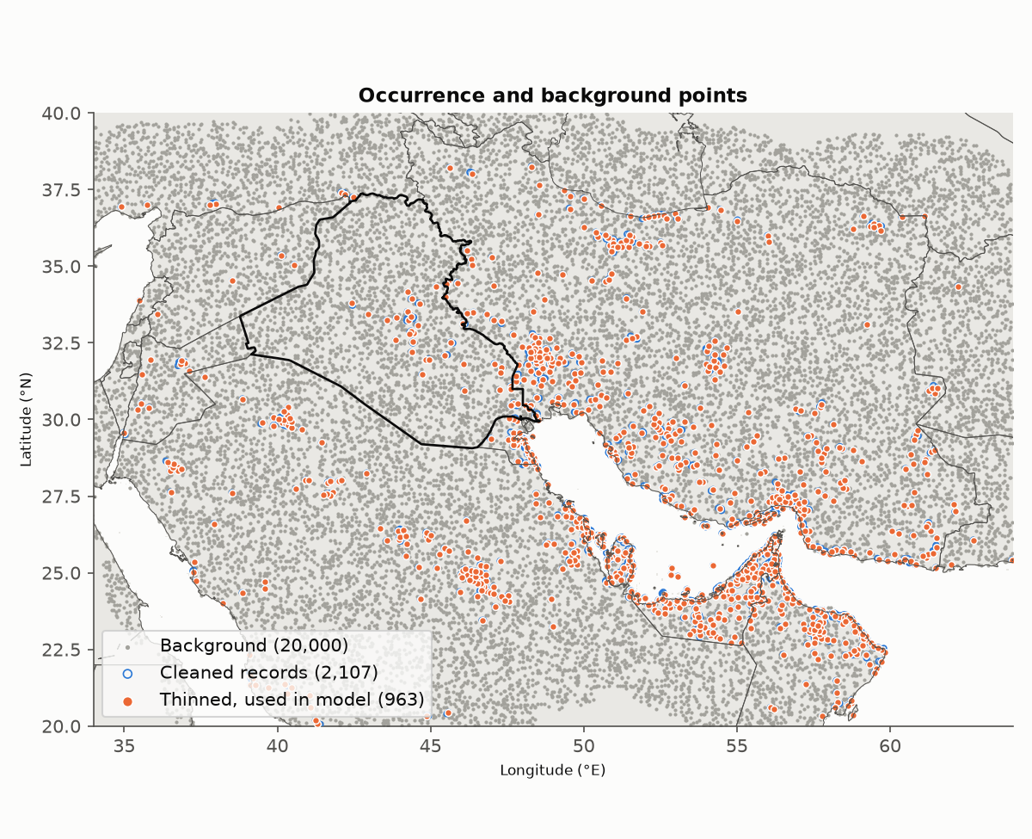
Fig. 1. Occurrence records after cleaning (open circles), thinned records used for modelling (filled), and the 20,000 background points (grey) across the training extent, with Iraq outlined.

3.2 Model selection and performance
The selected model used linear, quadratic and product features with a regularization multiplier of 3 (Fig. S2). It had a mean spatial cross-validation test AUC of 0.826 ± 0.023, a training–test AUC difference of 0.055 and an OR10 of 0.170. Models with hinge features reached similar test AUC (≤ 0.821) but overfitted more (AUC difference 0.080, OR10 0.221). The final model had a training AUC of 0.875 (Fig. S3), a maximum TSS of 0.591 and a continuous Boyce index of 0.985, indicating that predicted suitability increases steadily with the observed frequency of presences.

3.3 Variable contributions and responses
Mean diurnal temperature range (bio_2) contributed most to the model (24.6%), followed by built-up land (16.5%), precipitation seasonality (bio_15, 13.1%) and annual mean temperature (bio_1, 12.5%) (Fig. 2). Cropland (9.0%), precipitation of the warmest quarter (bio_18, 7.6%), annual precipitation (bio_12, 7.0%) and tree cover (5.6%) contributed moderately. Temperature seasonality (3.1%) and distance to rivers (1.0%) contributed little. Climate variables together accounted for 67.0% of importance and land cover for 31.1%.
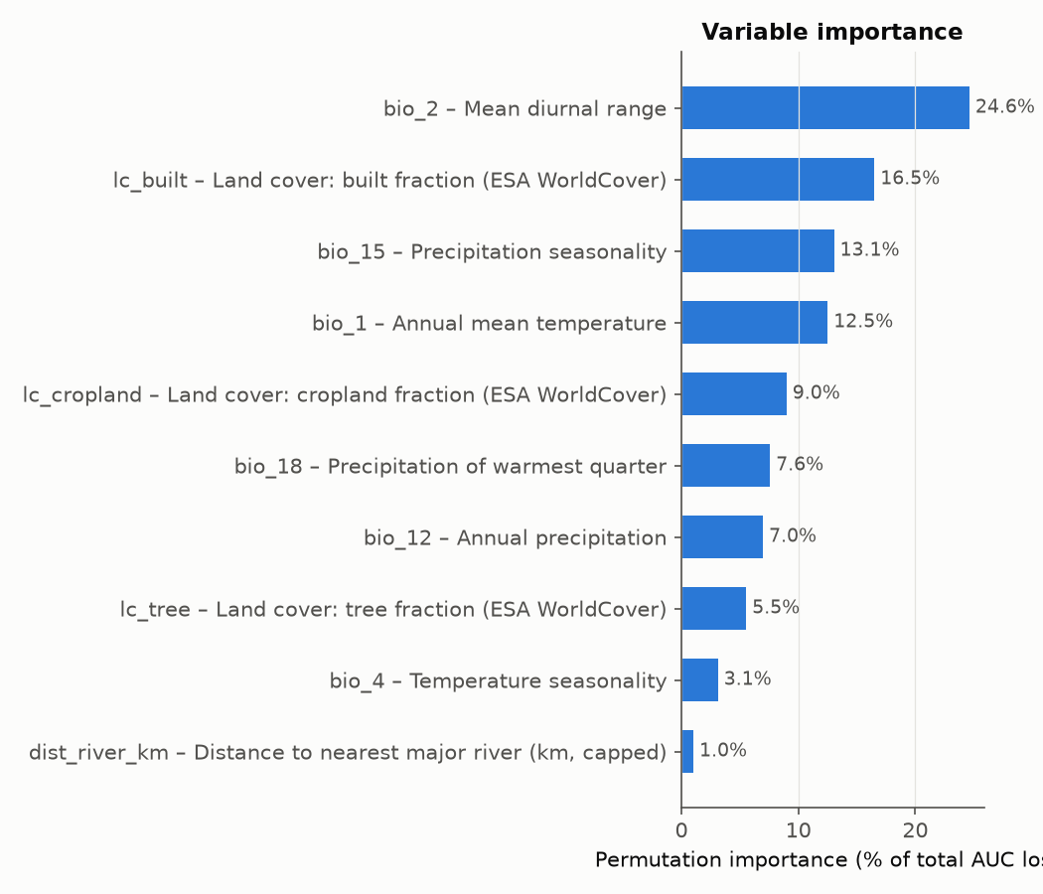
Fig. 2. Permutation importance of each predictor, as a percentage of the total drop in training AUC.
Suitability declined steeply as diurnal temperature range increased, from 0.97 at 5.4 °C to 0.04 at 17 °C (Fig. 3). It rose with precipitation seasonality and with precipitation in the warmest quarter. Its response to annual mean temperature was U-shaped, with the lowest value near 16 °C and the highest at the warm end of the sampled range (29 °C). Suitability peaked at intermediate tree cover (about 40% of a cell) and cropland (about 50%), and rose with built-up cover across the sampled range (0–31%).
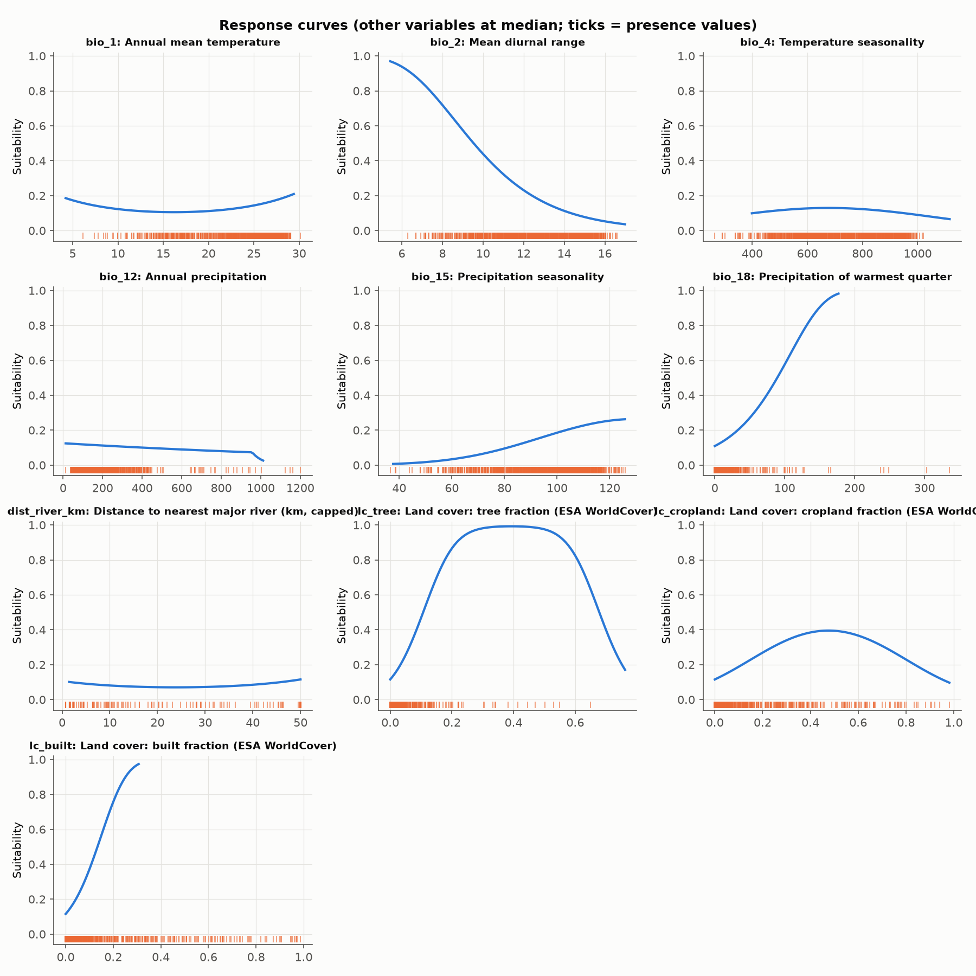
Fig. 3. Response curves: predicted suitability (cloglog) across each predictor with the others held at their background medians. Ticks show values at presence points.

3.4 Current habitat suitability in Iraq
About 96,900 km² of Iraq (22.1% of its area) was classified as currently suitable (Figs. 4–6). Suitable habitat follows the Tigris and Euphrates and the irrigated alluvial plain from Baghdad to Basra, and extends into the foothills of Diyala and Kirkuk. The western desert of Al-Anbar, An-Najaf and Al-Muthanna was largely unsuitable (2–6% suitable). The highest shares of suitable land were in Baghdad, Al-Qadisiyyah, Maysan, Dhi Qar, Diyala, Wasit and Babil (66–100%; Table 3).
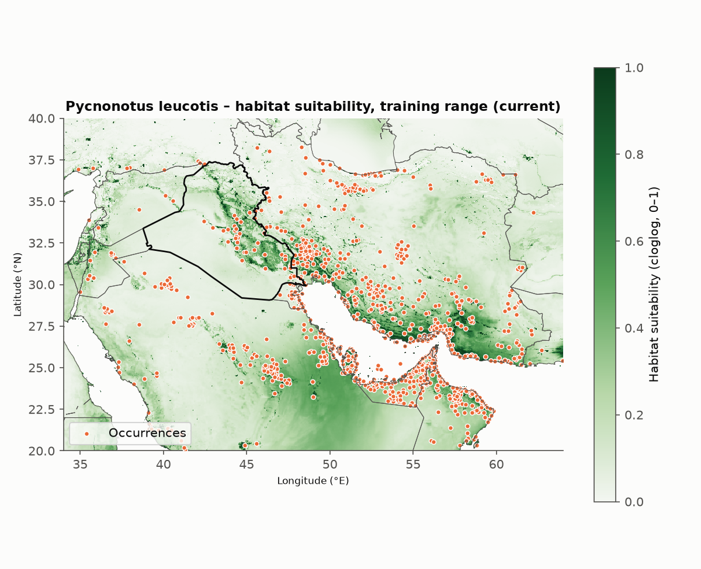
Fig. 4. Current habitat suitability predicted across the training extent, with Iraq outlined.
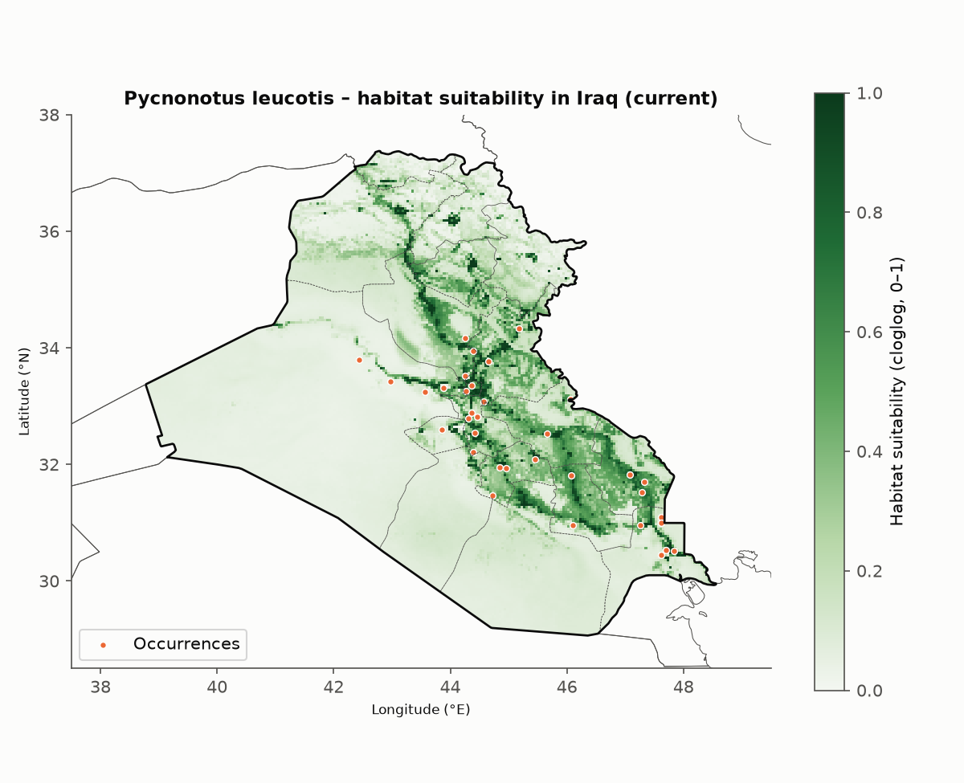
Fig. 5. Current habitat suitability in Iraq (cloglog), with governorate boundaries and the occurrence records inside Iraq used for training.
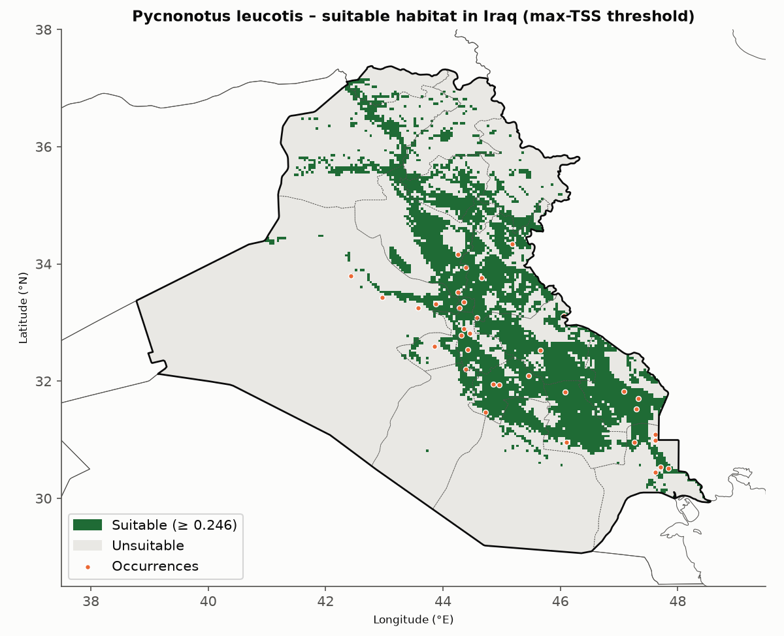
Fig. 6. Suitable (green) and unsuitable (grey) habitat in Iraq at the maximum-TSS threshold (cloglog 0.246).

3.5 Projected changes
Suitable area in Iraq increased under every scenario, period and climate model (Fig. 7). The ensemble mean projected gains of 45% (SSP2-4.5) and 59% (SSP5-8.5) by 2041–2060, and of 60% and 87% by 2061–2080. UKESM1-0-LL projected larger gains (59–113%) than MPI-ESM1-2-HR (26–49%). No currently suitable cell was lost in the ensemble projections: under SSP2-4.5 in 2041–2060, 96,900 km² remained suitable and 43,900 km² were gained; under SSP5-8.5 in 2061–2080, 84,100 km² were gained.
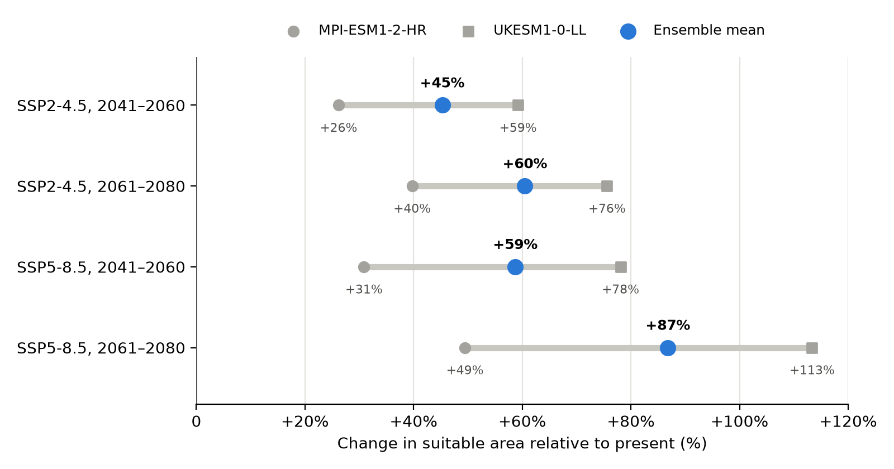
Fig. 7. Projected change in suitable habitat in Iraq relative to the present, for two emission scenarios and two periods. Grey markers show the individual climate models (MPI-ESM1-2-HR, circle; UKESM1-0-LL, square); blue markers show their ensemble mean.
Gains were concentrated in the northern governorates and the foothills (Table 3). Under SSP2-4.5 in 2041–2060 the suitable share rose from 12–17% to 51–63% in Duhok, Erbil and Sulaymaniyah, from 15% to 42% in Nineveh, and from 51% to 86% in Kirkuk. Both climate models agreed on 122,300 km² of suitable habitat under SSP2-4.5 in 2041–2060 and on 144,900 km² under SSP5-8.5 in 2061–2080; a further 32,000 km² and 62,000 km² were suitable under one model only (Figs. 8, 9).
Table 3. Suitable habitat by governorate: current area, and the share of each governorate suitable now and under two ensemble projections. Governorates are ordered by current suitable area. † Northern governorate whose records were excluded from training.
Governorate | Area (km²) | Suitable now (km²) | Suitable now (%) | SSP2-4.5, 2041–2060 (%) | SSP5-8.5, 2061–2080 (%)
Diyala | 19,908 | 13,252 | 66.6 | 78.5 | 94.3
Wasit | 17,712 | 11,748 | 66.3 | 78.8 | 91.4
Salah ad-Din | 25,523 | 11,692 | 45.8 | 54.4 | 62.9
Maysan | 16,257 | 10,929 | 67.2 | 78.7 | 96.9
Dhi Qar | 13,726 | 9,167 | 66.8 | 71.5 | 80.4
Al-Qadisiyyah | 8,551 | 6,960 | 81.4 | 92.5 | 95.7
Nineveh † | 37,828 | 5,579 | 14.7 | 41.7 | 58.5
Kirkuk † | 10,528 | 5,339 | 50.7 | 85.5 | 96.5
Babil | 6,685 | 4,422 | 66.1 | 88.9 | 94.6
Al-Muthanna | 52,684 | 3,290 | 6.2 | 8.2 | 17.4
Al-Anbar | 138,461 | 3,284 | 2.4 | 2.8 | 3.6
Basra | 17,090 | 3,033 | 17.7 | 22.5 | 44.5
Sulaymaniyah † | 17,156 | 2,479 | 14.4 | 50.9 | 76.7
Erbil † | 14,488 | 1,704 | 11.8 | 52.0 | 74.5
Karbala | 4,990 | 1,251 | 25.1 | 32.7 | 42.5
Duhok † | 6,610 | 1,101 | 16.7 | 62.6 | 82.1
Najaf | 29,416 | 1,058 | 3.6 | 4.8 | 8.7
Baghdad‡ | 647 | 647 | 100.0 | 100.0 | 100.0
Iraq | 438,260 | 96,936 | 22.1 | 32.1 | 41.3

‡ The Natural Earth 1:10m polygon for Baghdad covers only the urban core; the rest of Baghdad governorate falls within neighbouring polygons in this dataset.
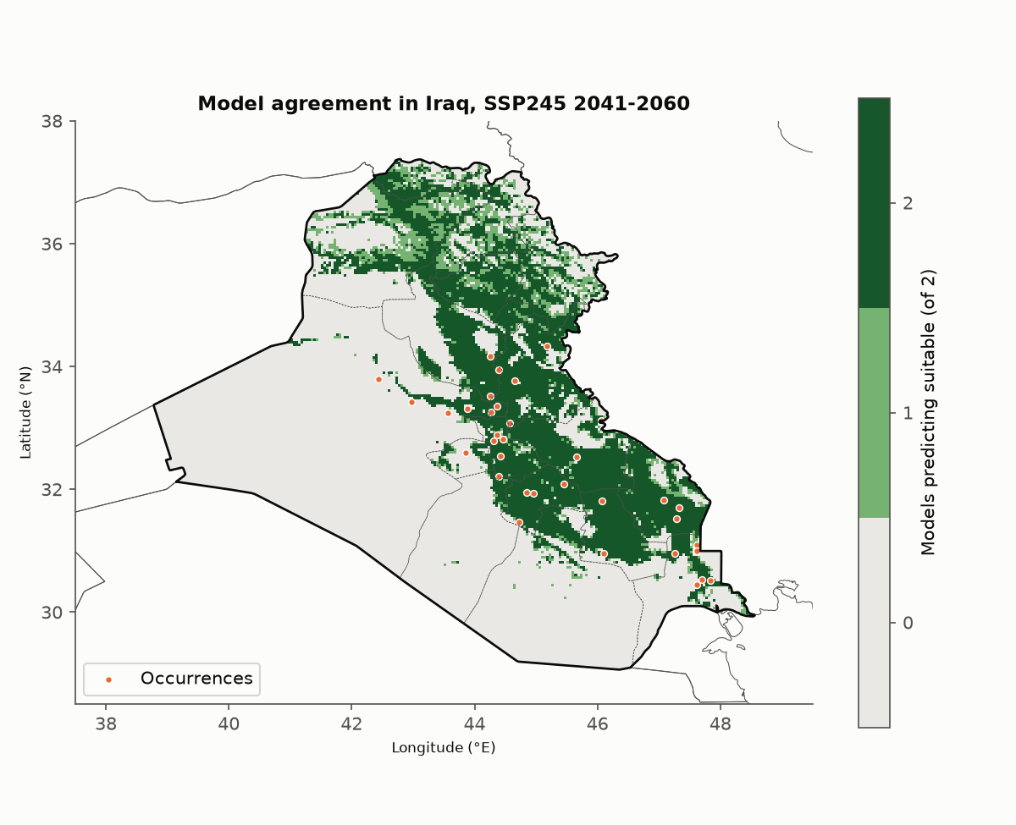
Fig. 8. Number of climate models (of two) projecting suitable habitat in Iraq under SSP2-4.5 in 2041–2060.
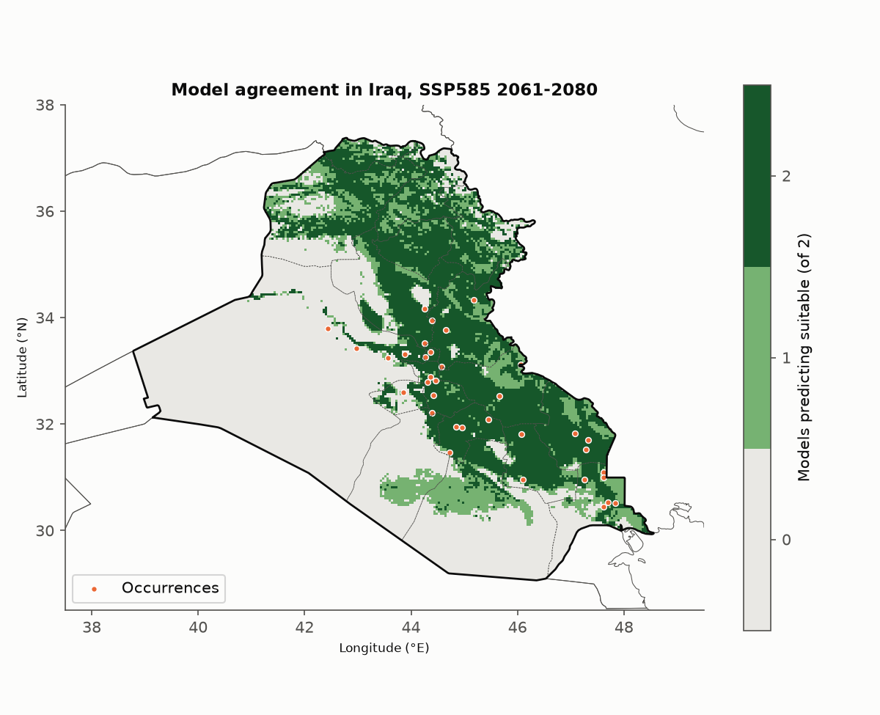
Fig. 9. Number of climate models (of two) projecting suitable habitat in Iraq under SSP5-8.5 in 2061–2080.
Extrapolation was absent from all projections except the 2061–2080 SSP5-8.5 scenarios, where 14.9% of Iraq had MESS < 0 (Fig. 10). These novel climates lay in the south: 71% of Al-Muthanna, 68% of Basra, 43% of Dhi Qar, 39% of Al-Qadisiyyah and 20% of Wasit.
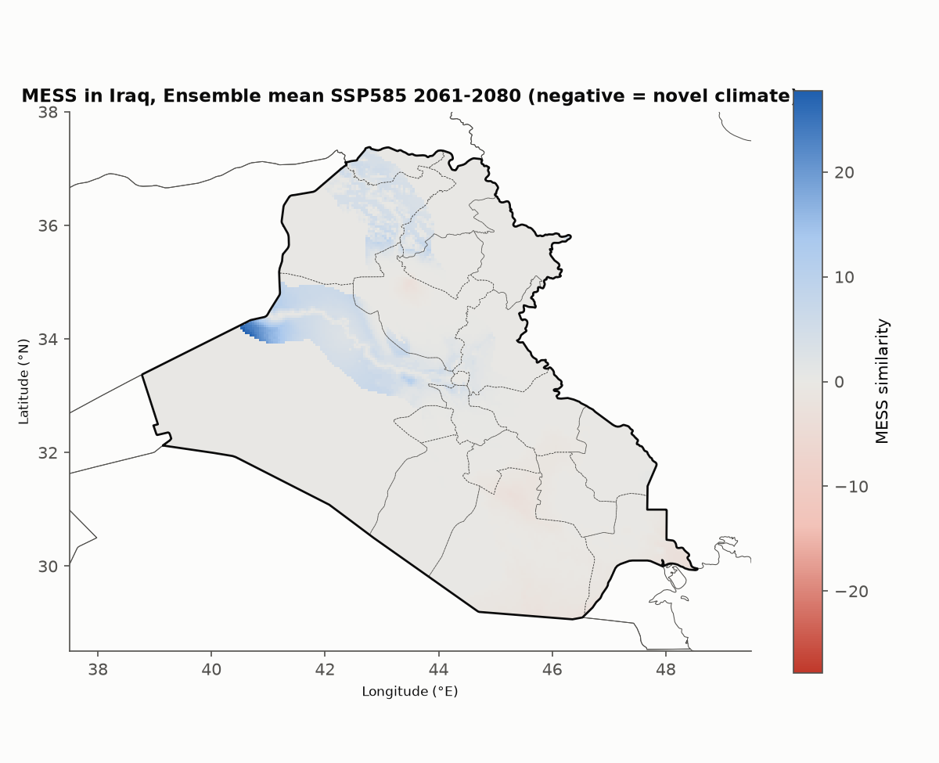
Fig. 10. Multivariate environmental similarity surface (MESS) for the ensemble SSP5-8.5 projection in 2061–2080. Negative values (red) mark climates outside the training range.

4. Discussion

4.1 Climate change is projected to expand, not shrink, suitable habitat
Our main result is that suitable habitat for P. leucotis in Iraq increases under all twelve projections, by 26–113% depending on scenario, period and climate model. No currently suitable cell was lost. This contrasts with the common expectation that warming reduces habitat for species in already hot regions [10]. It is consistent with the species' present range, which already includes places hotter than Iraq, such as Kuwait, Khuzestan and the Gulf coast [6, 7]. Once those conditions are in the training data, the model has no basis for treating a warmer Iraq as unsuitable.
The geography of change is a northward and upslope expansion. Gains are largest in Duhok, Erbil, Sulaymaniyah, Nineveh and Kirkuk, where suitable share rises roughly three- to four-fold by mid-century under SSP2-4.5. This matches the direction of climate-driven range shifts reported for many taxa [45]. The core of the present range, the Tigris–Euphrates plain, remains suitable throughout.

4.2 What limits the species: low diurnal range, warmth and human-made habitat
Mean diurnal temperature range was the strongest single predictor, with suitability highest where days and nights differ least. Small diurnal ranges occur near coasts, in the marshes and over irrigated land, where humidity and evaporation damp temperature swings. The species' preference for such settings fits its use of oases, palm groves, gardens and irrigated fields [6, 7, 8]. The U-shaped response to annual mean temperature, with suitability highest at the warm end, suggests that cold winters rather than summer heat limit the species in the north.
Land cover explained about a third of the model (31%), with suitability highest at intermediate tree and cropland cover and in built-up areas. Adding land cover raised spatially cross-validated AUC from 0.720 to 0.828 and the share of Iraqi records rated suitable from 44% to 71% (Table 4). Climate alone therefore explains the regional range, while land cover explains where within it the bird actually lives. Part of the built-up effect probably reflects observer bias, since eBird observers record more often in and near towns [17, 21, 37].

4.3 Sensitivity of projections to modelling choices
The projected direction depended strongly on the training extent (Table 4). A model trained on Iraq alone projected losses of 53–78%, because it had never seen conditions hotter than present-day Iraq [22, 35]. A model trained on the whole range, including the Indian subcontinent, projected gains of 173–402% but rated only 31% of Iraqi records as suitable today. Its large number of Indian records tied the species to a monsoon niche. Training on the western range gave intermediate results and fitted Iraqi records much better. Capping river distance at 50 km removed an artefact in which distance from rivers stood in for the Gulf region, and reduced the projected gain.
Table 4. Model versions run during the study. Areas for versions 1–5 were computed for the rectangle 37.5–49.5°E, 28.5–38°N; versions 6–7 for Iraq only. Projected change is for the ensemble mean.
Version | Training extent and predictors | Test AUC | Iraqi records suitable now | Suitable area now (km²) | SSP2-4.5, 2041–2060 | SSP5-8.5, 2061–2080
1 | Iraq only, climate | 0.794 | — | 197,000 | −53% | −78%
2 | Whole range (34–78°E), climate | 0.726 | 31% | 55,000 | +173% | +402%
3 | Western range (34–64°E), climate | 0.720 | 44% | 153,000 | +54% | +155%
4 | Western range, climate + land cover + river distance | 0.828 | 71% | 197,000 | +56% | +138%
5 | As 4, river distance capped at 50 km | 0.816 | 70% | 175,000 | +48% | +91%
6 | As 5, results clipped to Iraq | 0.816 | 70% | 110,000 | +43% | +79%
7 (final) | As 6, northern records excluded | 0.826 | — | 96,900 | +45% | +87%

These differences are larger than those between emission scenarios. Projections for species near the edge of their range are only as good as the coverage of the training data [22, 35, 42], and we recommend that comparable studies report such sensitivity runs.

4.4 Climate model uncertainty
The two climate models agreed on direction but differed in magnitude: UKESM1-0-LL projected about twice the gain of MPI-ESM1-2-HR. UKESM1-0-LL has a high equilibrium climate sensitivity and warms more than the CMIP6 average [15, 33]. Such "hot" models can overstate impacts when used alone [34]. The ensemble mean partly offsets this, but two models do not span CMIP6 spread [46]. Areas suitable under both models (122,300 km² under SSP2-4.5 in 2041–2060) are the most robust result.

4.5 Limitations
- Static land cover and water. Land cover and river distance were held at present-day values. Declining Tigris–Euphrates flows and water scarcity in Iraq [47] could shrink irrigated land and gardens, opposing the climate-driven gain.
- Extrapolation in the south. Under SSP5-8.5 in 2061–2080, 15% of Iraq, mostly Al-Muthanna, Basra and Dhi Qar, reaches climates outside the training range (Fig. 10). Projections there are least reliable [30, 35].
- Excluded northern records. Suitability in the five northern governorates was predicted without Iraqi records from those areas. It rests on records from neighbouring regions and should be checked against field data.
- Sampling bias. Records come largely from eBird and are concentrated near towns and roads. Spatial thinning and per-tile caps reduce but do not remove this bias [21, 37].
- Data resolution. Natural Earth river lines omit smaller rivers such as the Great and Little Zab, Diyala and Karun, and the 2.5′ grid (about 4.6 km) cannot resolve narrow riparian strips.
- Model scope. Presence-background models estimate relative suitability, not probability of occurrence [36, 41]. Dispersal, biotic interactions and local adaptation of P. l. mesopotamia were not modelled.

4.6 Implications
P. leucotis is not threatened [9], and our results suggest it is likely to persist and spread in Iraq under climate change, provided irrigated and settled habitats remain. The projected expansion into the Kurdistan Region and Nineveh is a testable prediction. Repeat surveys or structured citizen-science counts along a south–north gradient would show whether the species is already advancing [17]. Because its distribution tracks irrigation and settlement as much as climate, the species could also serve as an accessible indicator of how water management shapes bird habitat in Mesopotamia.

5. Conclusions
1. About 96,900 km² (22%) of Iraq is currently suitable for P. leucotis, centred on the Tigris–Euphrates alluvial plain and its irrigated and settled land.
2. Its distribution is shaped by low diurnal temperature range, warm mean temperatures and rainfall seasonality, and, within that climate, by built-up land, cropland and moderate tree cover.
3. Suitable habitat is projected to grow by 45–59% by 2041–2060 and by 60–87% by 2061–2080 (ensemble means), mainly through northward expansion, with no projected loss of currently suitable areas.
4. The direction of projections depends on whether training data include climates hotter than the focal region. Training on the western part of the range gave the best fit to Iraqi records.
5. Projections assume present-day land cover and water; future water scarcity, and novel climates in southern Iraq under high emissions, are the main sources of uncertainty.

6. Declarations
Acknowledgements. We thank the eBird and GBIF contributors whose observations made this study possible. [Add other acknowledgements.]
Funding. [State funding sources, or "This research received no specific grant from any funding agency."]
Data availability. Occurrence data are available from GBIF. [Before submission: create a GBIF occurrence download with the same filters (species Pycnonotus leucotis, 34–64°E, 20–40°N) and cite its DOI as reference 18.] Climate, land-cover and boundary data are openly available from WorldClim, ESA WorldCover and Natural Earth [11, 16, 39]. Model outputs (GeoTIFF rasters, tables and figures) are in the project repository.
Code availability. The full workflow, configuration and self-test are available at [repository URL, e.g. GitHub kamilalfayadhi/desktop-tutorial, folder maxent_iraqi_bulbul]. [Archive a release on Zenodo and cite its DOI.]
Author contributions (CRediT). [Author 1]: conceptualisation, data curation, writing – original draft. [Author 2]: methodology, formal analysis. [Author 3]: supervision, writing – review and editing. [Adjust as appropriate.]
Competing interests. The authors declare no competing interests. [Confirm.]
Ethics. No animals were handled; the study used existing occurrence records only.
Use of AI tools. The analysis workflow and a first draft of this manuscript were prepared with the assistance of an AI model (Claude, Anthropic). The authors reviewed and verified the methods, results and references and take full responsibility for the content. [Adjust to the target journal's policy.]

References
References were compiled from memory, not from a database search; check each one against the original (authors, pages, DOI) before submission. Items marked [verify] are the least certain.
1. Guisan, A. & Thuiller, W. (2005) Predicting species distribution: offering more than simple habitat models. Ecology Letters 8, 993–1009. https://doi.org/10.1111/j.1461-0248.2005.00792.x
2. Elith, J. & Leathwick, J.R. (2009) Species distribution models: ecological explanation and prediction across space and time. Annual Review of Ecology, Evolution, and Systematics 40, 677–697. https://doi.org/10.1146/annurev.ecolsys.110308.120159
3. Phillips, S.J., Anderson, R.P. & Schapire, R.E. (2006) Maximum entropy modeling of species geographic distributions. Ecological Modelling 190, 231–259. https://doi.org/10.1016/j.ecolmodel.2005.03.026
4. Elith, J., Phillips, S.J., Hastie, T., Dudík, M., Chee, Y.E. & Yates, C.J. (2011) A statistical explanation of MaxEnt for ecologists. Diversity and Distributions 17, 43–57. https://doi.org/10.1111/j.1472-4642.2010.00725.x
5. Phillips, S.J., Anderson, R.P., Dudík, M., Schapire, R.E. & Blair, M.E. (2017) Opening the black box: an open-source release of Maxent. Ecography 40, 887–893. https://doi.org/10.1111/ecog.03049
6. Fishpool, L.D.C. & Tobias, J.A. (2005) Family Pycnonotidae (bulbuls). In: del Hoyo, J., Elliott, A. & Christie, D.A. (eds) Handbook of the Birds of the World, Vol. 10: Cuckoo-shrikes to Thrushes, pp. 124–250. Lynx Edicions, Barcelona.
7. Porter, R. & Aspinall, S. (2010) Birds of the Middle East, 2nd edn. Christopher Helm, London.
8. Salim, M.A., Porter, R.F., Christensen, S., Schiermacker-Hansen, P. & Al-Jbour, S. (2006) Field Guide to the Birds of Iraq. Nature Iraq & BirdLife International. [verify]
9. BirdLife International (2024) Species factsheet: Pycnonotus leucotis. https://datazone.birdlife.org [add access date]
10. Thomas, C.D. et al. (2004) Extinction risk from climate change. Nature 427, 145–148. https://doi.org/10.1038/nature02121
11. Fick, S.E. & Hijmans, R.J. (2017) WorldClim 2: new 1-km spatial resolution climate surfaces for global land areas. International Journal of Climatology 37, 4302–4315. https://doi.org/10.1002/joc.5086
12. Eyring, V., Bony, S., Meehl, G.A., Senior, C.A., Stevens, B., Stouffer, R.J. & Taylor, K.E. (2016) Overview of the Coupled Model Intercomparison Project Phase 6 (CMIP6) experimental design and organization. Geoscientific Model Development 9, 1937–1958. https://doi.org/10.5194/gmd-9-1937-2016
13. O'Neill, B.C. et al. (2016) The Scenario Model Intercomparison Project (ScenarioMIP) for CMIP6. Geoscientific Model Development 9, 3461–3482. https://doi.org/10.5194/gmd-9-3461-2016
14. Müller, W.A. et al. (2018) A higher-resolution version of the Max Planck Institute Earth System Model (MPI-ESM1.2-HR). Journal of Advances in Modeling Earth Systems 10, 1383–1413. https://doi.org/10.1029/2017MS001217
15. Sellar, A.A. et al. (2019) UKESM1: description and evaluation of the U.K. Earth System Model. Journal of Advances in Modeling Earth Systems 11, 4513–4558. https://doi.org/10.1029/2019MS001739
16. Zanaga, D. et al. (2022) ESA WorldCover 10 m 2021 v200. Zenodo. https://doi.org/10.5281/zenodo.7254221
17. Sullivan, B.L., Wood, C.L., Iliff, M.J., Bonney, R.E., Fink, D. & Kelling, S. (2009) eBird: a citizen-based bird observation network in the biological sciences. Biological Conservation 142, 2282–2292. https://doi.org/10.1016/j.biocon.2009.05.006
18. GBIF.org (2026) GBIF Occurrence Download. [Add the DOI of the download used; accessed 2 October 2026.]
19. Boria, R.A., Olson, L.E., Goodman, S.M. & Anderson, R.P. (2014) Spatial filtering to reduce sampling bias can improve the performance of ecological niche models. Ecological Modelling 275, 73–77. https://doi.org/10.1016/j.ecolmodel.2013.12.012
20. Aiello-Lammens, M.E., Boria, R.A., Radosavljevic, A., Vilela, B. & Anderson, R.P. (2015) spThin: an R package for spatial thinning of species occurrence records for use in ecological niche models. Ecography 38, 541–545. https://doi.org/10.1111/ecog.01132
21. Kramer-Schadt, S. et al. (2013) The importance of correcting for sampling bias in MaxEnt species distribution models. Diversity and Distributions 19, 1366–1379. https://doi.org/10.1111/ddi.12096
22. Barve, N. et al. (2011) The crucial role of the accessible area in ecological niche modeling and species distribution modeling. Ecological Modelling 222, 1810–1819. https://doi.org/10.1016/j.ecolmodel.2011.02.011
23. Barbet-Massin, M., Jiguet, F., Albert, C.H. & Thuiller, W. (2012) Selecting pseudo-absences for species distribution models: how, where and how many? Methods in Ecology and Evolution 3, 327–338. https://doi.org/10.1111/j.2041-210X.2011.00172.x
24. Dormann, C.F. et al. (2013) Collinearity: a review of methods to deal with it and a simulation study evaluating their performance. Ecography 36, 27–46. https://doi.org/10.1111/j.1600-0587.2012.07348.x
25. Muscarella, R. et al. (2014) ENMeval: an R package for conducting spatially independent evaluations and estimating optimal model complexity for Maxent ecological niche models. Methods in Ecology and Evolution 5, 1198–1205. https://doi.org/10.1111/2041-210X.12261
26. Radosavljevic, A. & Anderson, R.P. (2014) Making better Maxent models of species distributions: complexity, overfitting and evaluation. Journal of Biogeography 41, 629–643. https://doi.org/10.1111/jbi.12227
27. Hirzel, A.H., Le Lay, G., Helfer, V., Randin, C. & Guisan, A. (2006) Evaluating the ability of habitat suitability models to predict species presences. Ecological Modelling 199, 142–152. https://doi.org/10.1016/j.ecolmodel.2006.05.017
28. Allouche, O., Tsoar, A. & Kadmon, R. (2006) Assessing the accuracy of species distribution models: prevalence, kappa and the true skill statistic (TSS). Journal of Applied Ecology 43, 1223–1232. https://doi.org/10.1111/j.1365-2664.2006.01214.x
29. Liu, C., White, M. & Newell, G. (2013) Selecting thresholds for the prediction of species occurrence with presence-only data. Journal of Biogeography 40, 778–789. https://doi.org/10.1111/jbi.12058
30. Elith, J., Kearney, M. & Phillips, S. (2010) The art of modelling range-shifting species. Methods in Ecology and Evolution 1, 330–342. https://doi.org/10.1111/j.2041-210X.2010.00036.x
31. Anderson, C.B. (2023) elapid: species distribution modeling tools for Python. Journal of Open Source Software 8(84), 4930. https://doi.org/10.21105/joss.04930
32. Lobo, J.M., Jiménez-Valverde, A. & Real, R. (2008) AUC: a misleading measure of the performance of predictive distribution models. Global Ecology and Biogeography 17, 145–151. https://doi.org/10.1111/j.1466-8238.2007.00358.x
33. Zelinka, M.D. et al. (2020) Causes of higher climate sensitivity in CMIP6 models. Geophysical Research Letters 47, e2019GL085782. https://doi.org/10.1029/2019GL085782
34. Hausfather, Z., Marvel, K., Schmidt, G.A., Nielsen-Gammon, J.W. & Zelinka, M. (2022) Climate simulations: recognize the 'hot model' problem. Nature 605, 26–29. https://doi.org/10.1038/d41586-022-01192-2
35. Owens, H.L. et al. (2013) Constraints on interpretation of ecological niche models by limited environmental ranges on calibration areas. Ecological Modelling 263, 10–18. https://doi.org/10.1016/j.ecolmodel.2013.04.011
36. Merow, C., Smith, M.J. & Silander, J.A. (2013) A practical guide to MaxEnt for modeling species' distributions: what it does, and why inputs and settings matter. Ecography 36, 1058–1069. https://doi.org/10.1111/j.1600-0587.2013.07872.x
37. Phillips, S.J. et al. (2009) Sample selection bias and presence-only distribution models: implications for background and pseudo-absence data. Ecological Applications 19, 181–197. https://doi.org/10.1890/07-2153.1
38. Richardson, C.J. & Hussain, N.A. (2006) Restoring the Garden of Eden: an ecological assessment of the marshes of Iraq. BioScience 56, 477–489.
39. Natural Earth (2024) Free vector and raster map data at 1:10m, 1:50m and 1:110m scales. https://www.naturalearthdata.com
40. Pedregosa, F. et al. (2011) Scikit-learn: machine learning in Python. Journal of Machine Learning Research 12, 2825–2830.
41. Araújo, M.B. & Peterson, A.T. (2012) Uses and misuses of bioclimatic envelope modeling. Ecology 93, 1527–1539. https://doi.org/10.1890/11-1930.1
42. Warren, D.L. & Seifert, S.N. (2011) Ecological niche modeling in Maxent: the importance of model complexity and the performance of model selection criteria. Ecological Applications 21, 335–342. https://doi.org/10.1890/10-1171.1
43. Peterson, A.T. et al. (2011) Ecological Niches and Geographic Distributions. Monographs in Population Biology 49. Princeton University Press, Princeton.
44. Pearson, R.G. & Dawson, T.P. (2003) Predicting the impacts of climate change on the distribution of species: are bioclimate envelope models useful? Global Ecology and Biogeography 12, 361–371. https://doi.org/10.1046/j.1466-822X.2003.00042.x
45. Lenoir, J. & Svenning, J.-C. (2015) Climate-related range shifts – a global multidimensional synthesis and new research directions. Ecography 38, 15–28. https://doi.org/10.1111/ecog.00967
46. Araújo, M.B. & New, M. (2007) Ensemble forecasting of species distributions. Trends in Ecology & Evolution 22, 42–47. https://doi.org/10.1016/j.tree.2006.09.010
47. Al-Ansari, N. (2013) Management of water resources in Iraq: perspectives and prognoses. Engineering 5, 667–684. https://doi.org/10.4236/eng.2013.58080 [verify]
48. Zittis, G. et al. (2022) Climate change and weather extremes in the Eastern Mediterranean and Middle East. Reviews of Geophysics 60, e2021RG000762. https://doi.org/10.1029/2021RG000762
49. Lelieveld, J. et al. (2016) Strongly increasing heat extremes in the Middle East and North Africa (MENA) in the 21st century. Climatic Change 137, 245–260. https://doi.org/10.1007/s10584-016-1665-6

Supplementary material
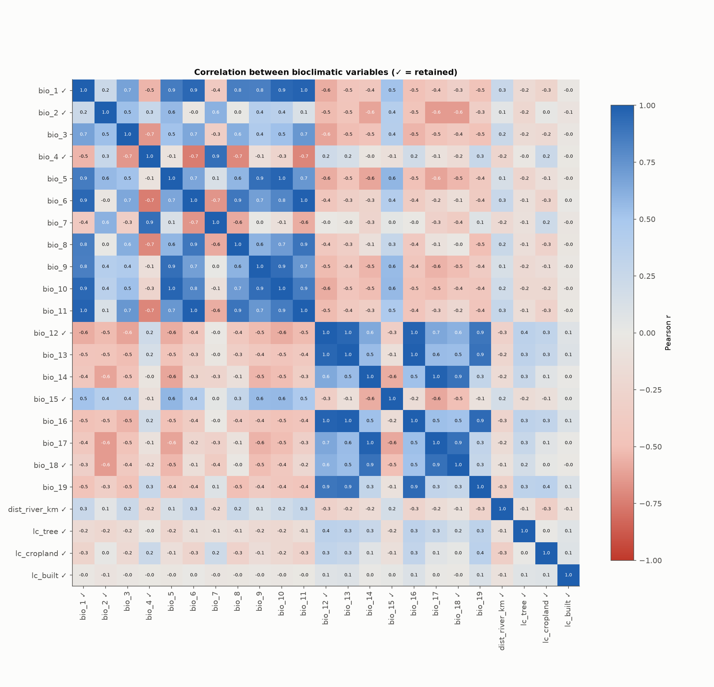
Fig. S1. Pearson correlation between the 19 bioclimatic variables at the background points; ✓ marks retained variables.
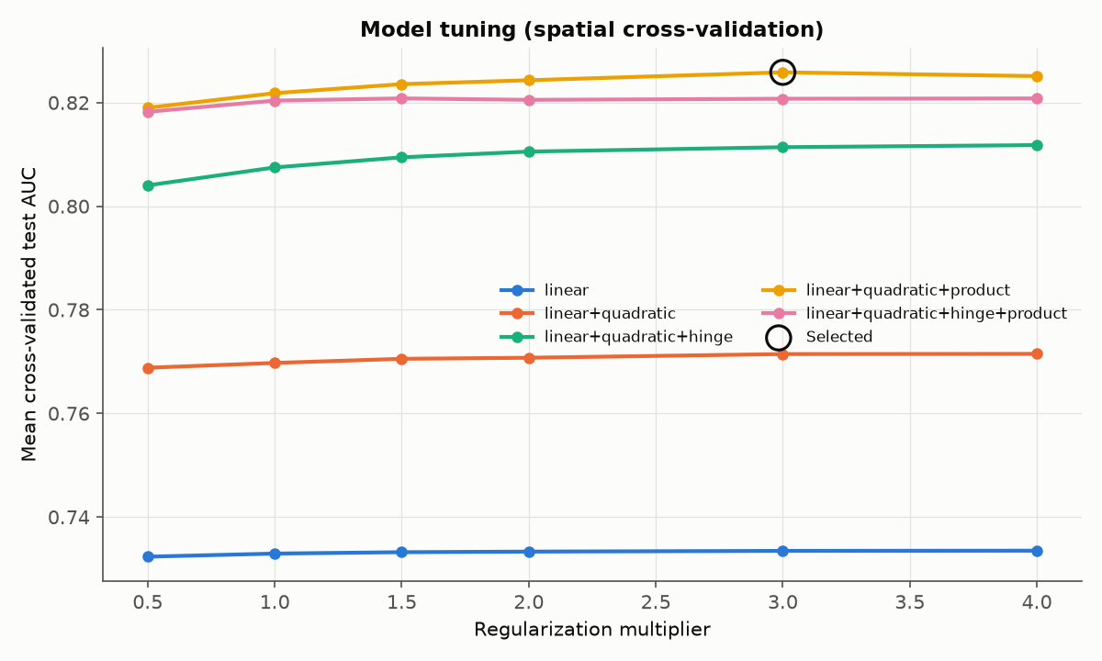
Fig. S2. Mean spatial cross-validation test AUC of the 30 candidate models by feature-class set and regularization multiplier; the circled point is the selected model.
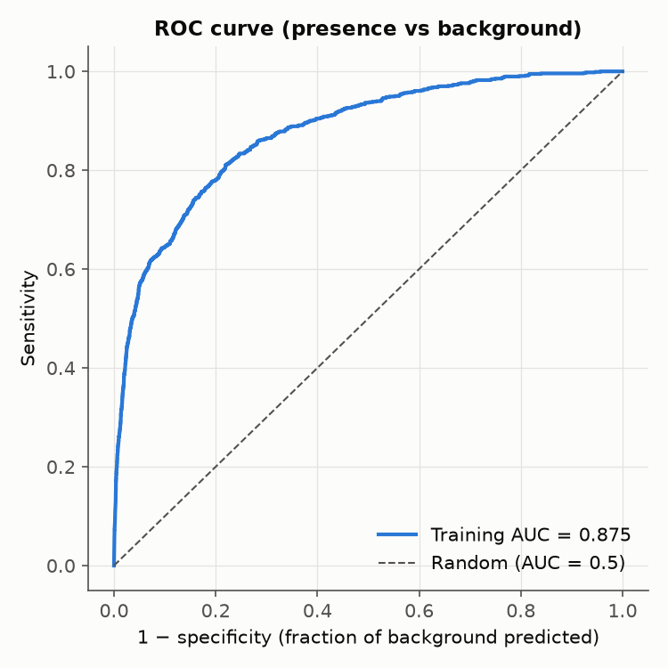
Fig. S3. Receiver operating characteristic curve of the final model (presences against background, training AUC 0.875).
Supplementary files available in the repository (outputs folder):
- Table S1: cleaned and thinned occurrence records (occurrences_cleaned.csv, occurrences_model.csv)
- Table S2: results of all 30 tuning runs (tuning_results.csv)
- Table S3: projected suitable area for all 12 projections (future_scenarios.csv)
- Data S1: GeoTIFF rasters of current and future suitability, suitable/unsuitable classes, MESS and model agreement
- Data S2: fitted model (maxent_model.pkl) and full run log (pipeline.log)

