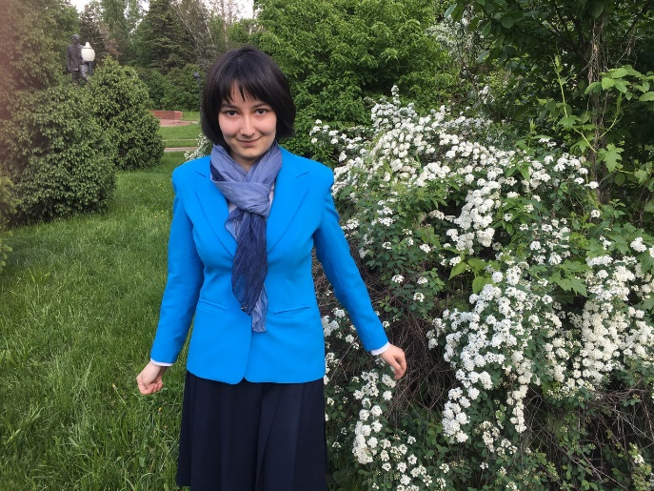Saydazova Kamila

**+7 (967)-032-45-71**

***kamila_saydazova@mail.ru***

Moscow, Russia.

|  |
| --- |
| *Education*   * *2017-2021* * *National research university ‘Higher school of economics’, bachelor of philology* |

***Skills***

|  |  |
| --- | --- |
| ***Programming*** | |
| * ***Java*** | * ***Python*** |

*Languages*

|  |  |  |
| --- | --- | --- |
| * **English** | * **French** | * **Italian** |

***Hobbies***

* ***SWIMMING***
* ***WRITING FANFICTION***
* ***DRAWNING ARTS***

***Personal qualities***

* ***Punctuality***
* ***Neatness***
* ***Responsibility***
* ***Good grammar***
* ***Promptness***