Университет ИТМО
Факультет ПииКТ
Кафедра ВТ(бывш.)

Программирование
Лабораторная работа # 1
Вариант 311527

Выполнил:
Чулаков Камиль Фаридович

Принял:
Цопа Евгений Алексеевич

2020/2021 учебный год, 1 семестр

Задание к работе.

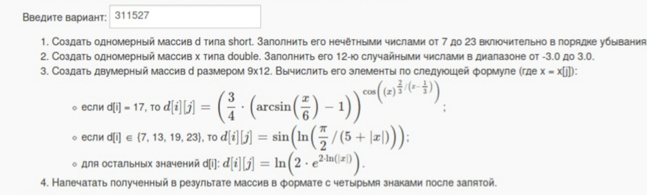

Исходный код программы

/*
* Main.java
*
* Copyright 2020 Kamil Chulakov
*
* This program is free software; you can redistribute it and/or modify
* it under the terms of the GNU General Public License as published by
* the Free Software Foundation; either version 2 of the License, or
* (at your option) any later version.
*
* This program is distributed in the hope that it will be useful,
* but WITHOUT ANY WARRANTY; without even the implied warranty of
* MERCHANTABILITY or FITNESS FOR A PARTICULAR PURPOSE. See the
* GNU General Public License for more details.
*
* You should have received a copy of the GNU General Public License
* along with this program; if not, write to the Free Software
* Foundation, Inc., 51 Franklin Street, Fifth Floor, Boston,
* MA 02110-1301, USA.
*
*
*/

class Main{
public static void main(String[] args){

short[] i = new short[9];
short i_n = 23;

// Getting massive i of {23, 21, ... ,7}
for(int j = 0; j < 9; j++)
{
i[j] = i_n;
//System.out.println(i[j]);
i_n -= 2.0;
}
//System.out.println();
double[] x = new double[12];

// Getting massive x of 12 random nums in range [-3; 3]
for(int j = 0; j < 12; j++){
x[j] = (Math.random() * 6.0) - 3.0;
//System.out.println(x[j]);
}
//System.out.println();

double[][] d = new double [9][12];

// Getting massive d
for(int j = 0; j < 9; j++){
for(int k = 0; k < 12; k++){
if(i[j] == 17){
d[j][k] = Math.pow((3.0 / 4.0) * ((Math.asin(x[k]/6) - 1.0)), Math.cos(Math.pow(x[k], 2.0 / (3.0 * (x[k] - 1.0/3.0)))));
}
else if (i[j] == 13 || i[j] == 7 || i[j] == 19 || i[j] == 23) {
d[j][k] = Math.sin(Math.log((Math.PI/ 2.0) / (5.0 + Math.abs(x[k]))));
}
else{
d[j][k] = Math.log(2.0 * Math.pow(Math.E, 2.0 * Math.log(Math.abs(x[k]))));
}
}
}

//Printing d
for(int j = 0; j < 9; j++){
for(int k = 0; k < 12; k++){
double data = Math.round(d[j][k]*10000.0)/ 10000.0 ;
if (data < 0) System.out.print(" ");
else System.out.print(" ");
if (data == 0.0) System.out.printf("%-7f",Double.NaN);
else System.out.printf("%.4f ", data);
}
System.out.println();
}
}
}

Результат выполнения программы

-0.9985 -0.9989 -0.9669 -0.9640 -0.9364 -0.9909 -1.0000 -0.9916 -0.9969 -0.9297 -0.9756 -0.9695
2.8743 2.8351 0.3393 0.1810 -1.8531 1.6372 2.5313 1.6779 2.0641 -2.7105 0.8018 0.4802
-0.9985 -0.9989 -0.9669 -0.9640 -0.9364 -0.9909 -1.0000 -0.9916 -0.9969 -0.9297 -0.9756 -0.9695
NaN NaN NaN NaN NaN NaN NaN NaN NaN NaN NaN NaN
2.8743 2.8351 0.3393 0.1810 -1.8531 1.6372 2.5313 1.6779 2.0641 -2.7105 0.8018 0.4802
-0.9985 -0.9989 -0.9669 -0.9640 -0.9364 -0.9909 -1.0000 -0.9916 -0.9969 -0.9297 -0.9756 -0.9695
2.8743 2.8351 0.3393 0.1810 -1.8531 1.6372 2.5313 1.6779 2.0641 -2.7105 0.8018 0.4802
2.8743 2.8351 0.3393 0.1810 -1.8531 1.6372 2.5313 1.6779 2.0641 -2.7105 0.8018 0.4802
-0.9985 -0.9989 -0.9669 -0.9640 -0.9364 -0.9909 -1.0000 -0.9916 -0.9969 -0.9297 -0.9756 -0.9695

Выводы по работе:

Узнал, как важно правильно писать команды на Java, познаковился с функциями библиотеки Math и форматированным выводом. Ах, ну и комплЕксные числа.

