Arcade Ticketing System
Student name: Kamile Kacinskaite
Student number: C00312390
Date submitted: 21/04/2026

Table of Contents
Arcade Ticketing System 1
Description 3
Summary 5
Requirements 7
Table Data & Structure 9
User Interface 13
Er Diagram 16
Code Snippets 18
Test Cases 20
TC-01: Verify Successful Staff Login With Valid Credentials 20
TC-02: Verify Customer Registration Creates a New Account 21
TC-03: Verify Staff Can Add Tickets via Top-Up 22
TC-05: Verify Staff Can Delete a Customer Record 24
References 25

Description
The Arcade Ticketing System is a digital platform designed to modernise the management of tickets and game sessions within an arcade environment. It replaces traditional, paper-based ticketing with an integrated digital solution that improves user experience, reduces human error, and supports data-driven operations. The system enables players to earn, store, and redeem digital tickets seamlessly, while providing staff and administrators with powerful tools to oversee and manage the entire arcade ecosystem.

System Actors and Roles
The system serves three primary user roles, each with distinct responsibilities and access levels:
- Customer (Player): The end-user of the arcade. Customers create accounts or log in, play arcade games to earn digital tickets, view their ticket balance and transaction history, and redeem tickets for prizes via a kiosk or counter. They may use a QR code or smart card to interact with machines.
- Arcade Staff: Front-line employees who log in with role-based permissions to validate tickets during redemption, manage prize stock, monitor real-time system performance, handle player accounts, and generate usage and redemption reports.
- Admin / System Operator: Responsible for backend operations including receiving score data from arcade machines to issue correct ticket quantities, verifying ticket authenticity, managing security and audit logs, configuring system settings, and ensuring encrypted, scalable transaction processing.

Core Use Cases
The system centres around five core use cases that define the key interactions between users and the platform:
- UC-001 – Log In and Check Ticket Balance: A customer logs in via the app using their credentials. The authentication system verifies access and displays the current ticket balance from the database. Precondition: account exists or registration is available.
- UC-002 – Play Game and Receive Digital Tickets: A customer plays a game; once complete the machine records the score. The Ticket Calculation Engine determines the ticket reward and automatically credits the customer’s Digital Wallet or QR/smart card. The updated balance is displayed immediately.
- UC-003 – Redeem Tickets for Prizes: A customer with sufficient tickets browses the Prize Catalogue and selects a prize. The system validates ticket authenticity, deducts the required amount from the customer’s wallet, updates prize stock, and confirms the redemption.
- UC-004 – Generate Usage Reports: Staff log into the admin portal, view real-time analytics on machine activity and ticket flow, and generate exportable reports covering usage trends, peak hours, and redemption data.
- UC-005 – Manage Security and System Settings: Admin accesses the secure backend to review audit logs, flag suspicious activity, adjust system configuration, and confirm that all changes are logged for accountability.

Summary
Overall concept of the Arcade Ticketing System
The Arcade Ticketing System is designed to streamline the management of tickets and game sessions in an arcade environment. The system aims to replace the manual, outdated ticketing processes with a more suitable, digital solution that enhances user experience, operational efficiency, and data accuracy. By providing this platform for issuing, redeeming, and managing tickets, the system enables arcades to handle customer interactions and queries more effectively, reduces human error and collects valuable data for operational analysis.

The High-Level System Operation
At a high level, the system operates through three main components: ticket issuance, ticket redemption, and system administration. When a player uses an arcade game machine, the system generates digital tickets instead of the classic physical ones, based on performance and game results after each round. These tickets are automatically linked to the players account or issued via a QR code or smart card. Players can redeem tickets for rewards at a kiosk or the counter, where then the system validates ticket authenticity and updates the players balance. Administrators have access to a secure backend dashboard for monitoring system activity, managing game-machine settings and security, inventory for prizes, and performing maintenance or any sort of updates. The entire system functions in real time, supporting both online and offline modes for resilience and scalability.

Main features, functionalities and system purposes
- Digital Ticket Management: Automates ticket generation, tracking, and redemption to replace paper-based methods.
- User Authentication: Allows players to register and or log in to view their ticket balance, transaction history, and redeem rewards.
- Prize Inventory Control: Enables administrators to manage prize stock levels and associate ticket costs with each prize item.
- Game Integration: Connects directly with arcade game machines to collect data and issue tickets automatically based on winnings.
- Reporting and Analytics: Generates real-time reports on ticket usage, machine activity, peak usage times, and redemption trends.
- System Administration Panel: Provides tools for staff to use and manage user accounts and their history, adjust ticket allocation rules, and configure prize settings.
- Scalability and Security: Designed to support large numbers of users and machines while ensuring secure transactions and data integrity.
System main purpose: The primary purpose of the Arcade Ticketing System is to modernize the arcade experience and make it more efficient by introducing a digital, user-friendly ticket management system platform that benefits all customers and arcade operators.

Requirements
The following requirements have been derived from the project’s user stories, use cases, and typical scenarios. They are grouped by functional area and linked to the actors they serve.
Functional Requirements
- REQ-AUTH-01 – User Authentication: The system must allow customers to register an account and log in securely. Upon providing valid credentials, a session token must be issued and the user dashboard displayed. Invalid credentials must result in an appropriate error message without granting access.
- REQ-AUTH-02 – Role-Based Access Control: The system must enforce role-based permissions. Staff must only access features relevant to their role (e.g., prize management, reporting). Admins must have access to all system settings, audit logs, and security configurations. Customers must not be able to access staff or admin functions.
- REQ-GAME-01 – Game Session Recording: The system must receive and record score data from arcade machines at the end of each game session. Each session must be stored with a unique session ID, score, timestamp, and associated customer identifier.
- REQ-GAME-02 – Automatic Ticket Award: The Ticket Calculation Engine must automatically compute the number of digital tickets awarded based on the player’s score. Tickets must be immediately credited to the customer’s Digital Wallet or associated QR/smart card, and the updated balance displayed to the player.
- REQ-REDEEM-03 – Prize Redemption: The system must allow customers to redeem tickets for prizes. When a redemption is requested, the system must verify the customer’s ticket balance is sufficient, check prize stock availability, deduct the correct number of tickets, reduce stock by one, and issue a confirmation to the customer and staff.
- REQ-VALID-04 – Ticket Validation: Before any redemption is processed, the system must validate that the tickets being used are authentic and have not expired. Expired or invalid tickets must be rejected with a clear error message; no balance deduction must occur for rejected tickets.
- REQ-REPORT-05 – Report Generation: Staff with reporting permissions must be able to generate downloadable reports on system activity, ticket usage, machine performance, peak hours, and redemption trends. Reports must be exportable and based on accurate, up-to-date data from all relevant databases.
- REQ-ADMIN-06 – Security and Audit Logging: The system must maintain a complete audit log of all administrative actions including settings changes, account modifications, and security events. Admins must be able to view and filter these logs and flag suspicious activity for review.

Non-Functional Requirements
- REQ-SEC-01 – Data Encryption: All ticket transactions and user data must be encrypted in transit and at rest to ensure data security and prevent unauthorised access or tampering.
- REQ-PERF-02 – Scalability: The system must support a large number of concurrent users and game machines without performance degradation, ensuring the arcade can expand its infrastructure without requiring system replacement.
- REQ-AVAIL-03 – Offline Mode: The system must be capable of operating in offline mode, continuing core arcade operations without internet connectivity, and automatically syncing all data with the central server once connectivity is restored.
- REQ-UX-04 – Usability: All customer-facing interfaces (kiosk, app) must be intuitive and accessible. Key actions such as checking balance, viewing game history, and initiating redemption must be reachable within three interactions from the home screen.

Table Data & Structure

Customer
The customer SQL table serves as the persistent memory for the Synth-City Slots application, bridging the gap between the Java GUI and the stored user data. While the code defines the "logic" for player registration, logins, and ticket top-ups, the table provides the structured schema needed to store these attributes—specifically customer (unique identifier), name, email, and tickets (current balance). When a user interacts with the GUI, the application uses a DAO (Data Access Object) pattern to perform CRUD operations (Create, Read, Update, Delete), ensuring that every ticket earned or profile change is saved permanently in the database.
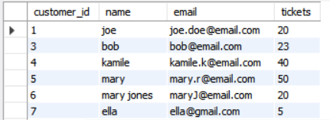
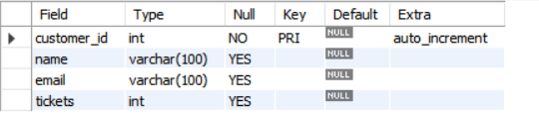
Fig.01

Game
The game SQL table functions as the "Rulebook" for the arcade, defining the configuration and rewards for every playable machine in the system. While the customer table tracks player data, this table uses game_id (unique identifier), game_name, and two critical mechanics: cost_per_play, which determines how many tickets are deducted from a player's balance, and tickets_rewarded, which sets the payout for winning. By storing these values in a database rather than hard-coding them, your application can dynamically load different arcade games and adjust their difficulty or pricing without needing to rewrite the underlying Java code.
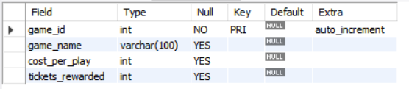
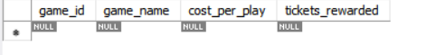
Fig.02

Prize
The prize SQL table acts as the "Virtual Shop" for my application, defining the physical rewards players can claim in exchange for their hard-earned tickets. It utilizes a unique prize_id to catalog each item, alongside a prize_name for display in the GUI. The table governs two essential inventory mechanics: the ticket_cost, which dictates the "price" subtracted from a player's balance during a redemption, and stock, which tracks availability to prevent the system from promising rewards that are no longer on the shelf.
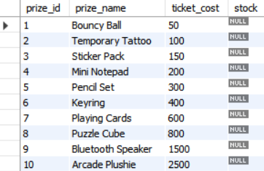
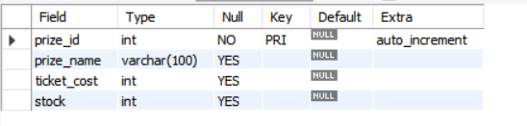
Fig.03

Purchase
The purchase SQL table acts as the transaction ledger, linking players to the rewards they have claimed. While other tables store static information like player names or prize costs, this table records the live history of activity within your system. It uses purchase_id as a unique record for every transaction and employs two foreign keys—customer_id and prize_id—to create a relational link between who bought what. Finally, the purchase_date timestamp ensures you have a chronological audit trail of when each exchange occurred, allowing your application to track player activity and inventory movement over time.
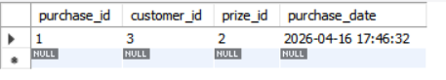
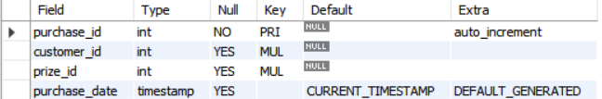
Fig.04

Staff
The staff table serves as the internal registry for the arcade’s employees, storing the essential credentials—username and password—required to access the system's administrative backend. In your code, this table is the primary target for the UserDAO.loginUser() method, which validates staff members before granting them the "Access Granted" status needed to enter the Staff Hub.
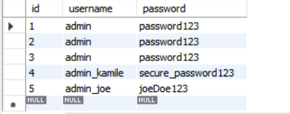
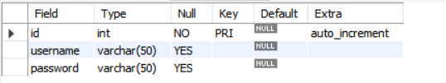
Fig.05

Users
The users table provides a broader identity framework that includes an email field alongside standard login credentials. While similar to the staff table, its inclusion of a contact method allows the system to differentiate between basic login access and a more complete user profile that could be used for account recovery or system-wide administrative communications.
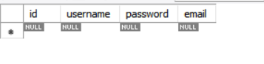
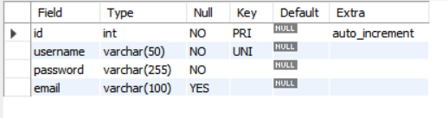
Fig.06

User Interface

The Synth-City Slots interface features a high-contrast Cyberpunk aesthetic, utilizing a "neon-on-dark" palette to establish a futuristic arcade theme.
Core Highlights
- Logical Segmentation: The layout uses color-coded containers (Cyan for Players, Magenta for Staff) to instantly distinguish between user roles and streamline navigation.
- Minimalist UX: A clean, symmetrical design with monospaced fonts ensures the system feels like a modern terminal while maintaining high readability.
- Thematic Branding: The centered logo and geometric accents reinforce a cohesive "Synthwave" brand identity, while the isolated "Shutdown" button provides a clear, high-level administrative exit.
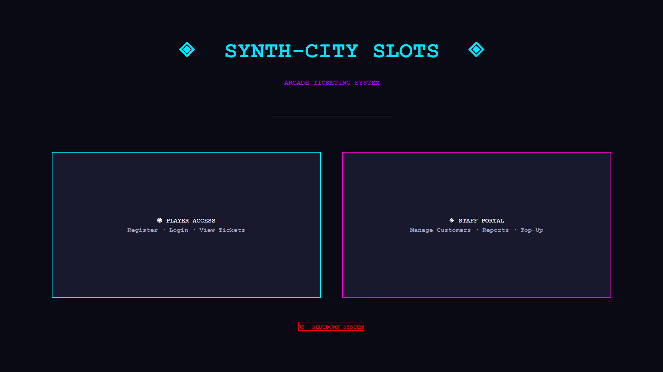

The Player Hub is a dashboard that maintains the project's Cyberpunk aesthetic while transitioning into a personalized user environment. It uses a four-quadrant grid system to organize account actions.
Core Highlights
- Role-Based Personalization: The interface confirms a successful login with a personalized greeting ("Welcome Back, Bob"), maintaining the magenta thematic colour for user-specific data.
- Color-Coded Functionality: Each card uses a unique neon border to categorize actions:
  - Cyan/Yellow: Primary gameplay and reward functions (Tickets & Prizes).
  - Purple/Red: Account management and destructive actions (Edit & Delete).
- Intuitive Navigation: Large, clickable hitboxes with concise descriptions ("Update Your Name or Email") provide a frictionless user experience for account maintenance.
- Consistent Branding: The use of monospaced typography and a centered "Log Out" footer maintains the terminal-style UI seen in the main landing page.

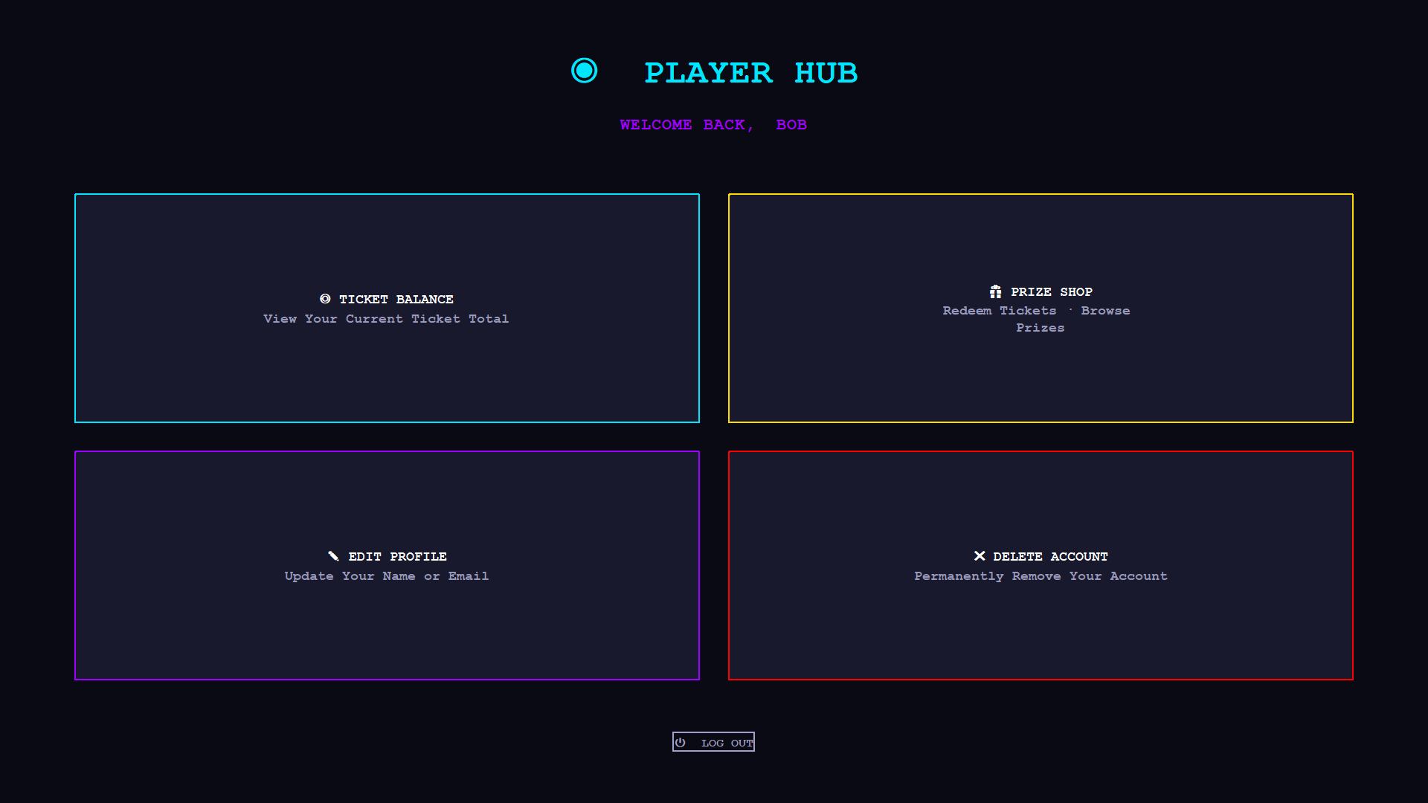

The Staff Control Unit is the primary administrative dashboard, continuing the project’s Cyberpunk aesthetic with a focus on high-level system management and database interaction.
Core Highlights
- Operational Hierarchy: The title transitions to a vibrant magenta header, signalling a shift from "Access" to "Control." This confirms a successful administrative login.
- CRUD-Based Organization: The four-quadrant grid is logically mapped to standard CRUD (Create, Read, Update, Delete) operations for customer management:
  - Cyan (Read): Viewing and filtering records.
  - Green (Create): Adding new accounts.
  - Purple (Update): Editing existing details.
  - Red (Delete): Removing data from the system.
- Functional Clarity: Each card uses specific icons (e.g., plus sign for adding, 'X' for deleting) and concise sub-text to minimize user error during high-stakes data management.
- Security Context: The footer button is labelled "Terminate Session," reinforcing the high-security, technical theme of a staff-only environment compared to a standard "Log Out."

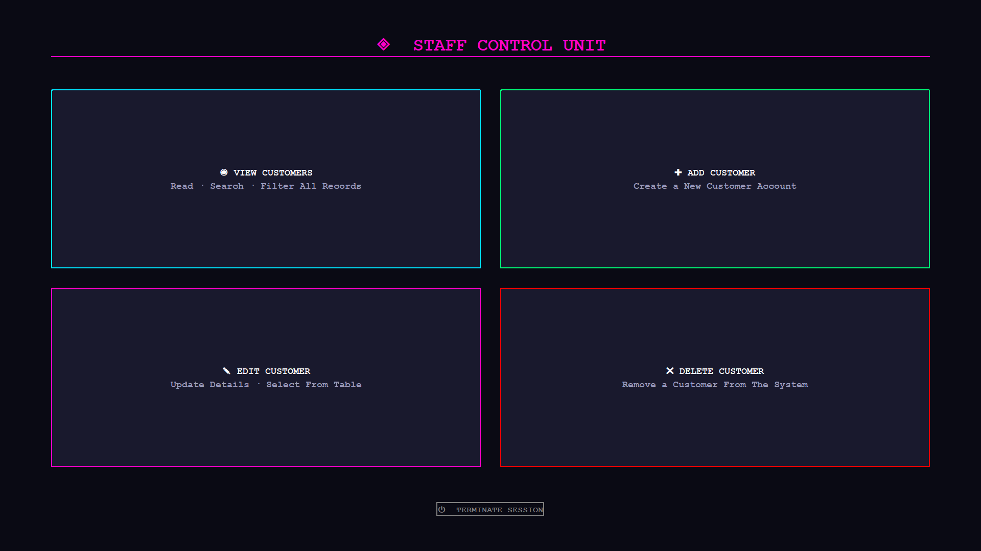

Er Diagram
The 1st Level ER Diagram serves as the structural blueprint for the Synth-City Slots database, defining the relationships between customers, staff, and arcade transactions. In relation to the project's Java code, the entities identified—Customer, Prize, Staff, and Purchase—directly correspond to the Model and Data Access Object (DAO) classes found in the gui and dao packages.
High-Level Integration
- Customer & Staff Entities: The diagram establishes a 1:N relationship between Staff and Customers, which is functionalized in the code through the UserDAO for staff authentication and CustomerDAO for managing player records.
- Transactional Logic: The Purchase entity acts as a central link between Customers and Prizes. This is reflected in the CustomerGUI.java file, where the PurchaseDAO records successful redemptions after verifying a player has sufficient tickets.
- Data Integrity: Attributes such as customer-id, prize-id, and ticket-cost from the diagram provide the logic for the CRUD operations (Create, Read, Update, Delete) seen in the Staff Control Unit, ensuring that player balances and prize stocks are accurately updated in real-time.

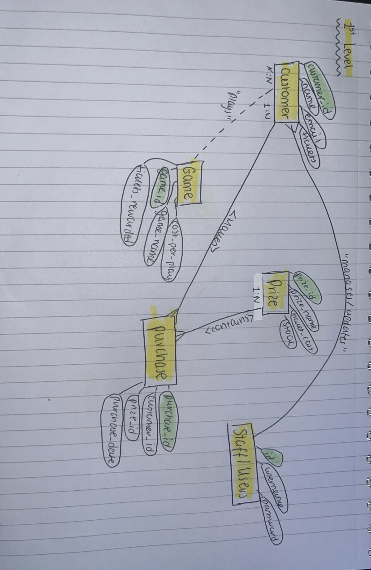
The 2nd Level ER Diagram expands the system's complexity by introducing specialized relationships and many-to-many (N:N) mappings that define the operational flow of the arcade. In the Java implementation, this level of detail governs how data is retrieved and updated across multiple database tables during a single user action.
High-Level Integration
- Many-to-Many Mappings: The diagram highlights $N:N$ relationships between Customers and Games, and Customers and Prizes. In the code, these are handled by associative logic: the PurchaseDAO manages the link between a specific loggedInId and a prizeId, ensuring a single player can claim multiple prizes over time.
- Operational Dependencies: The "Play" relationship between Customer and Game is represented in the diagram as a dashed line, suggesting a functional dependency. This is reflected in the CustomerGUI logic where a customer’s tickets balance is modified based on external game outcomes.
- Staff Oversight: The diagram shows Staff/Users "managing/updating" both Customers and Prizes. This directly maps to the Staff Control Unit in CustomerGUI.java, where administrative methods call CustomerDAO.updateCustomer() to modify ticket counts or profile details.
- Data Normalization: By separating Purchase as a distinct entity with its own purchase_id and purchase_date, the diagram provides the structure for the transaction history visible in the code's "Redemption Code" generation logic.
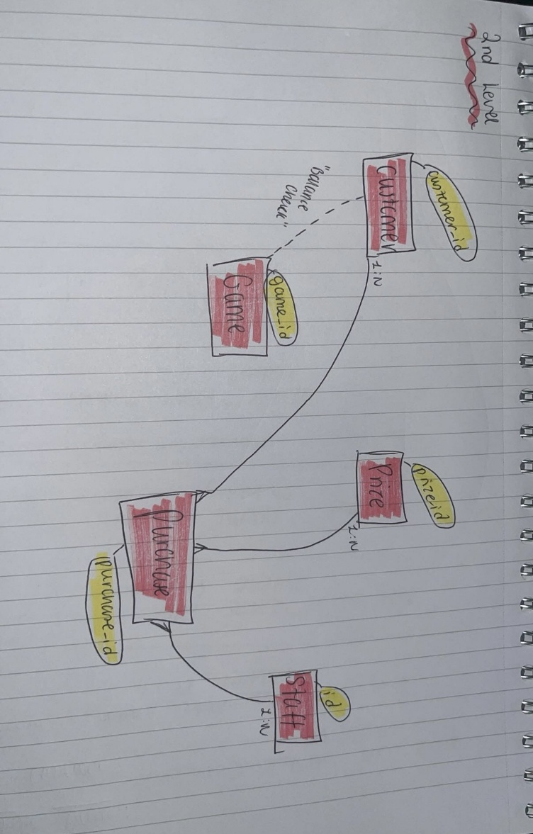

Code Snippets

- The Neon Hover-Invert Button (neonBtn, lines 945–956)
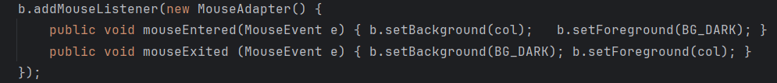
Every button in the app is wired through this factory method. On hover, the button inverts — the neon colour floods the background, and the dark theme becomes the text colour, then snaps back on mouse exit. It's a simple MouseAdapter trick but it gives the whole UI a consistent, punchy arcade feel without a single line of CSS or custom painting.

- The Procedural Redemption Code Generator (lines 833–839)
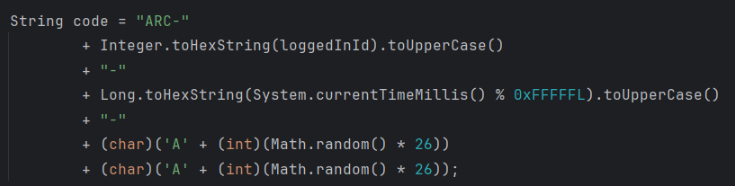
When a player redeems a prize, a unique-looking arcade code is generated on the fly — no database lookup required. It encodes the customer's ID in hex, mixes in a timestamp modulo a large hex constant (0xFFFFFL) for time-based uniqueness, then appends two random uppercase letters. The result looks like ARC-3F-A92B1-KP, which feels legitimate and arcade-authentic.

- ComponentListener as a Lazy Data Refresh Trigger (lines 307–309, 632–634)
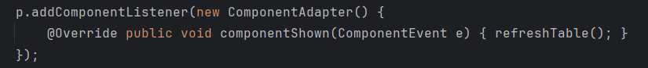
Rather than manually refreshing data every time navigation happens, panels hook into componentShown — a lifecycle event that fires the moment a panel becomes visible via CardLayout. This means the table and balance displays are always fresh without any extra wiring in the navigation buttons. It's a clean separation: navigation just switches the card, and the panel itself decides what to do when it appears.

- UIManager Theming of JOptionPane Dialogs (lines 1012–1026)
Standard Swing dialogs are notoriously ugly and always break dark themes. Here, UIManager global keys are overwritten right before each dialog call to inject the dark background and the correct neon colour — pink for errors, cyan for success, yellow for info. It's a subtle but impactful hack that keeps the arcade aesthetic consistent even in system-level popups that you'd normally have no control over.

- Anonymous DefaultTableModel Overriding Cell Editability (lines 237–239)
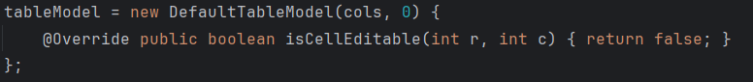
Instead of subclassing DefaultTableModel in a separate file, an anonymous class is created inline that overrides just one method — isCellEditable — to always return false. This makes the entire customer table read-only with a single override, preventing accidental in-place editing without any listener or external guard logic. It's a compact and elegant use of Java's anonymous class feature for a very specific behavioural tweak.

Test Cases
The following test cases validate the core functional requirements of the Arcade Ticketing System. Each test case is linked to a specific requirement and follows a defined set of preconditions, steps, and expected outcomes.

TC-01: Verify Successful Staff Login With Valid Credentials
Test Case ID | Requirement | Preconditions | Steps | Expected Results | Working?
TC-01 | REQ-AUTH-01 (Staff Authentication — valid credentials must grant access) | • System is running and the Staff Login screen is displayed.  • A staff account exists with username admin and a known password. | • 1. Enter a valid username in the Username field.  • 2. Enter the correct password in the Password field.  • 3. Click the ACCESS GRANTED button. | • UserDAO.loginUser() returns true.  • Fields are cleared and the Staff Hub screen is displayed.  • Staff is authenticated and can access all management functions. | Working

TC-02: Verify Customer Registration Creates a New Account
Test Case ID | Requirement | Preconditions | Steps | Expected Results | Working?
TC-02 | REQ-AUTH-01 (User Authentication — new player account creation) | • System is running and the New Player Uplink screen is displayed.  • The email address being registered does not already exist in the database. | • 1. Enter a valid full name (letters only) in the Full Name field.  • 2. Enter a valid email address in the Email field.  • 3. Enter a non-negative integer in the Starting Tickets field.  • 4. Click the REGISTER PLAYER button. | • Name passes the regex ^[a-zA-Z\s]+$ validation.  • Email passes the regex ^[A-Za-z0-9+_.-]+@(.+)$ validation.  • Ticket value is parsed as a non-negative integer.  • CustomerDAO.addCustomer() is called successfully.  • Screen transitions to the CUSTOMER_WELCOME screen. | Working

TC-03: Verify Staff Can Add Tickets via Top-Up
Test Case ID | Requirement | Preconditions | Steps | Expected Results | Working?
TC-03 | REQ-GAME-02 (Ticket balance must be updated and reflect correct totals) | • Staff is logged in and the Staff View screen is showing the customer table.  • At least one customer record exists in the database.  • A customer row is selected in the table. | • 1. Select a customer row in the customer table.  • 2. Click the TOP-UP button.  • 3. Verify the Top-Up screen pre-fills the customer name and current balance.  • 4. Enter a positive integer in the Add Tickets field.  • 5. Click APPLY TOP-UP. | • CustomerDAO.getCustomerById() returns the customer.  • New ticket total equals old balance plus the entered amount.  • CustomerDAO.updateCustomer() is called with the updated balance.  • A success dialog confirms the top-up and the screen returns to Staff View. | Working

TC-04: Verify Customer Login Rejects an Unregistered Email
Test Case ID | Requirement | Preconditions | Steps | Expected Results | Working?
TC-04 | REQ-AUTH-01 (System must reject access for non-existent accounts) | • System is running and the Player Authentication screen is displayed.  • The email address entered does not exist in the customer database. | • 1. Enter an email address not registered in the system.  • 2. Click the ACCESS SYSTEM button. | • CustomerDAO.getCustomerByEmail() returns null.  • An error dialog displays: "ACCESS DENIED: No account found for that email."  • The screen remains on the Player Authentication screen.  • No session is created and loggedInId remains -1. | Working

TC-05: Verify Staff Can Delete a Customer Record
Test Case ID | Requirement | Preconditions | Steps | Expected Results | Working?
TC-05 | REQ-ADMIN-06 (Staff must be able to permanently remove a customer account) | • Staff is logged in and the Staff View screen displays the customer table.  • At least one customer record exists in the database.  • A customer row is selected in the table. | • 1. Select a customer row in the customer table.  • 2. Click the DELETE button.  • 3. Verify the Delete Confirmation screen shows the correct customer name.  • 4. Click CONFIRM DELETE. | • The Delete screen displays the selected customer name in uppercase.  • CustomerDAO.deleteCustomer() is called with the correct customer ID.  • A success dialog confirms: "CUSTOMER PURGED FROM SYSTEM."  • Screen returns to Staff View and the deleted record no longer appears in the table. | Working

References

- Anthropic (2025) Claude (claude-sonnet-4-6) [Large language model]. Used to assist with UI design, code structure, and selected methods in the Arcade Ticketing System. Available at: https://claude.ai (Accessed: 1st April 2026 – 20th April 2026).

- GeeksforGeeks (no date) Java Swing – JComponent class. Available at: https://www.geeksforgeeks.org/advance-java/java-jcomponent (Accessed: 8th March 2026).

- Oracle (2023) Java™ Platform, Standard Edition & Java Development Kit Version 21 API Specification. Available at: https://docs.oracle.com/en/java/javase/21/docs/api/index.html (Accessed: 5th February 2026 – 20th April 2026).

- Stack Overflow (no date) Various community Q&A threads on Java Swing GUI components, MySQL database connectivity via JDBC, and public/private method structure in Java. Available at: https://stackoverflow.com (Accessed: 20th February 2026 - 10th April 2026).

