**Function:**

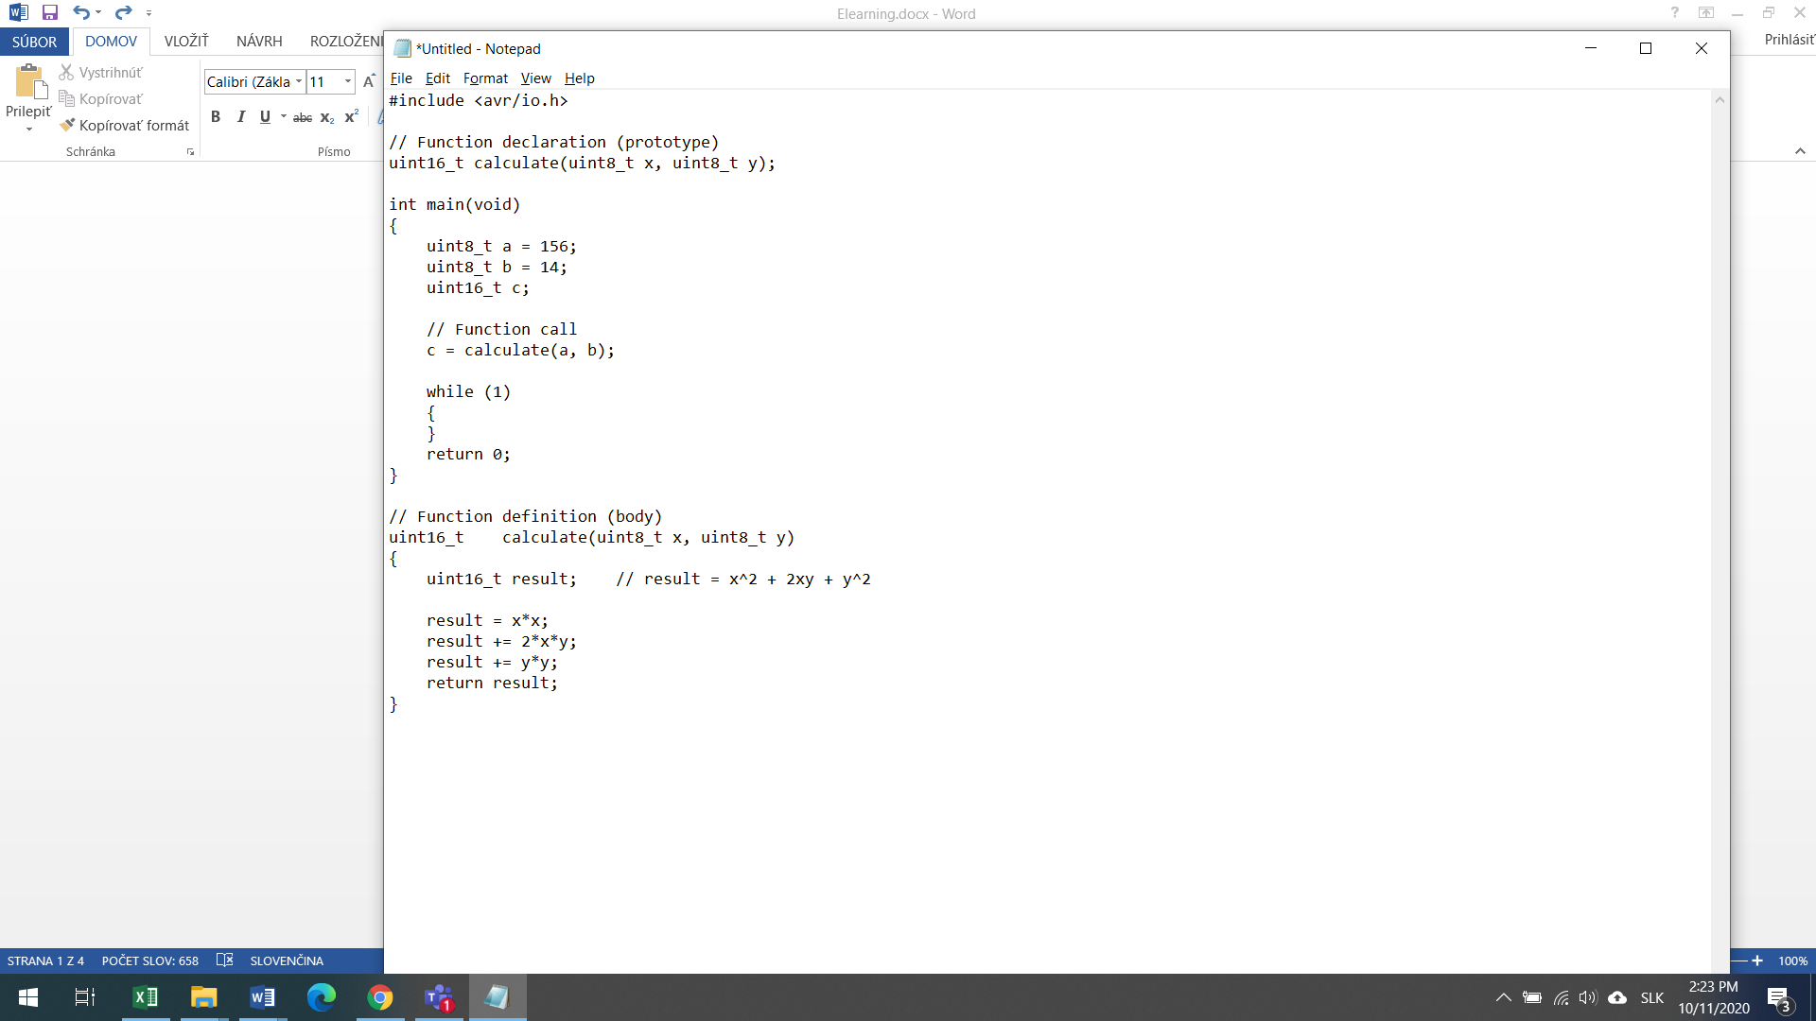

**Chart**



**Scheme**

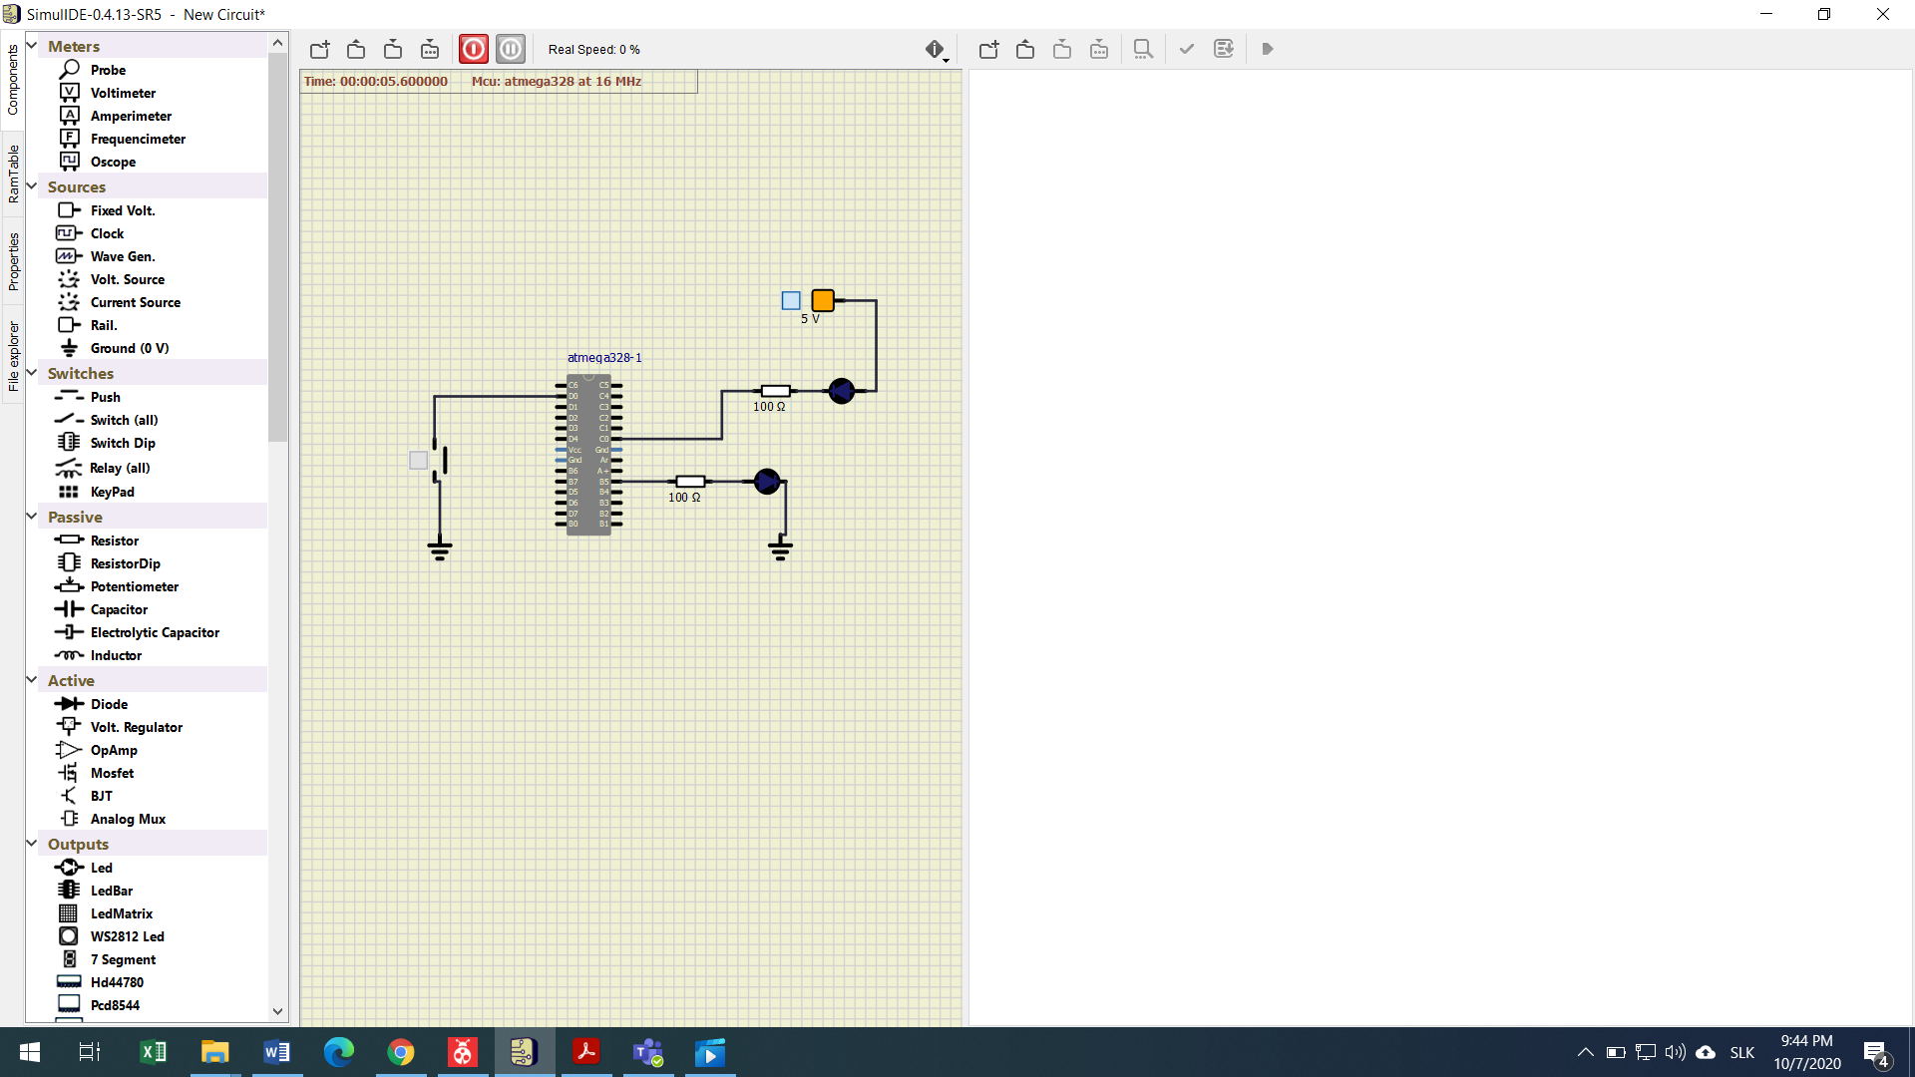

/***********************************************************************

*

* GPIO library for AVR-GCC.

* ATmega328P (Arduino Uno), 16 MHz, AVR 8-bit Toolchain 3.6.2

*

* Copyright (c) 2019-2020 Tomas Fryza

* Dept. of Radio Electronics, Brno University of Technology, Czechia

* This work is licensed under the terms of the MIT license.

*

**********************************************************************/

/* Includes ----------------------------------------------------------*/

#include "gpio.h"

/* Function definitions ----------------------------------------------*/

void GPIO_config_output(volatile *uint8_t* *reg_name, *uint8_t* pin_num)

{

*reg_name = *reg_name | (1<<pin_num);

}

/*--------------------------------------------------------------------*/

void GPIO_config_input_nopullup(volatile *uint8_t* *reg_name, *uint8_t* pin_num)

{

*reg_name = *reg_name & ~(1<<pin_num); // Data Direction Register

*reg_name++; // Change pointer to Data Register

*reg_name = *reg_name & ~ (1<<pin_num); // Data Register

}

void GPIO_config_input_pullup(volatile *uint8_t* *reg_name, *uint8_t* pin_num)

{

*reg_name = *reg_name & ~(1<<pin_num); // Data Direction Register

*reg_name++; // Change pointer to Data Register

*reg_name = *reg_name | (1<<pin_num); // Data Register

}

/*--------------------------------------------------------------------*/

void GPIO_write_low(volatile *uint8_t* *reg_name, *uint8_t* pin_num)

{

*reg_name = *reg_name & ~(1<<pin_num);

}

/*--------------------------------------------------------------------*/

void GPIO_write_high(volatile *uint8_t* *reg_name, *uint8_t* pin_num)

{

*reg_name = *reg_name | (1<<pin_num);

}

/*--------------------------------------------------------------------*/

/* GPIO_toggle */

void GPIO_toggle(volatile *uint8_t* *reg_name, *uint8_t* pin_num)

{

*reg_name = *reg_name ^(1<<pin_num);

}

/*--------------------------------------------------------------------*/

/* GPIO_read */

*uint8_t* GPIO_read(volatile *uint8_t* *reg_name, *uint8_t* pin_num)

{

if (bit_is_clear(*reg_name, pin_num))

{

return 0;

}

else

{

return 1;

}

}

Main.c

/***********************************************************************

*

* Alternately toggle two LEDs when a push button is pressed. Use

* functions from GPIO library.

* ATmega328P (Arduino Uno), 16 MHz, AVR 8-bit Toolchain 3.6.2

*

* Copyright (c) 2019-2020 Tomas Fryza

* Dept. of Radio Electronics, Brno University of Technology, Czechia

* This work is licensed under the terms of the MIT license.

*

**********************************************************************/

/* Defines -----------------------------------------------------------*/

#define LED_GREEN PB5 // AVR pin where green LED is connected

#define LED_RED PC0

#define BTN PD0

#define BLINK_DELAY 500

#ifndef *F_CPU*

#define *F_CPU* 16000000 // CPU frequency in Hz required for delay

#endif

/* Includes ----------------------------------------------------------*/

#include <util/delay.h> // Functions for busy-wait delay loops

#include <avr/io.h> // AVR device-specific IO definitions

#include "gpio.h" // GPIO library for AVR-GCC

/* Function definitions ----------------------------------------------*/

/**

* Main function where the program execution begins. Toggle two LEDs

* when a push button is pressed. Functions from user-defined GPIO

* library is used instead of low-level logic operations.

*/

int main(void)

{

/* GREEN LED */

GPIO_config_output(&DDRB, LED_GREEN);

GPIO_write_low(&PORTB, LED_GREEN);

/* second LED */

GPIO_config_output(&DDRC, LED_RED);

GPIO_write_high(&PORTC, LED_RED);

/* push button */

GPIO_config_input_pullup(&DDRD, BTN);

//GPIO_write_high(&PORTD, BTN);

// WRITE YOUR CODE HERE

// Infinite loop

while (1)

{

// Pause several milliseconds

*_delay_ms*(BLINK_DELAY);

if(GPIO_read(&PIND, BTN) == 0)

{

GPIO_toggle(&PORTB, LED_GREEN);

GPIO_toggle(&PORTC, LED_RED);

}

}

// Will never reach this

return 0;

}

Gpio.h

#ifndef GPIO_H

#define GPIO_H

/***********************************************************************

*

* GPIO library for AVR-GCC.

* ATmega328P (Arduino Uno), 16 MHz, AVR 8-bit Toolchain 3.6.2

*

* Copyright (c) 2019-2020 Tomas Fryza

* Dept. of Radio Electronics, Brno University of Technology, Czechia

* This work is licensed under the terms of the MIT license.

*

**********************************************************************/

/**

* @file gpio.h

* @brief GPIO library for AVR-GCC.

*

* @details

* The library contains functions for controlling AVRs' gpio pin(s).

*

* @note

* Based on AVR Libc Reference Manual. Tested on ATmega328P (Arduino Uno),

* 16 MHz, AVR 8-bit Toolchain 3.6.2.

*

* @copyright (c) 2019-2020 Tomas Fryza

* Dept. of Radio Electronics, Brno University of Technology, Czechia

* This work is licensed under the terms of the MIT license.

*/

/* Includes ----------------------------------------------------------*/

#include <avr/io.h>

/* Function prototypes -----------------------------------------------*/

/**

* @brief Configure one output pin in Data Direction Register.

* @param reg_name - Address of Data Direction Register, such as &DDRA,

* &DDRB, ...

* @param pin_num - Pin designation in the interval 0 to 7

*/

void GPIO_config_output(volatile *uint8_t* *reg_name, *uint8_t* pin_num);

void GPIO_config_input_nopull(volatile *uint8_t* *reg_name, *uint8_t* pin_num);

void GPIO_config_input_pullup(volatile *uint8_t* *reg_name, *uint8_t* pin_num);

void GPIO_write_low(volatile *uint8_t* *reg_name, *uint8_t* pin_num);

void GPIO_write_high(volatile *uint8_t* *reg_name, *uint8_t* pin_num);

void GPIO_toggle(volatile *uint8_t* *reg_name, *uint8_t* pin_num);

*uint8_t* GPIO_read(volatile *uint8_t* *reg_name, *uint8_t* pin_num);

#endif

Deklarácia:

* Hovorí compileru ako sa funkcia volá aký ma typ a aké ma parametre.

Int8_t calculate(int x, int y );

Definicia

* Poskytuje informácie a tele funkcie ako sa funkcia správa.

Int8_t calculate(int x, int y);{

Return(x +y);

}