**Kamil Káčer 211777 Repository: https://github.com/kamilio14/Digital-electronics-2.git**

**Work Done in a lab**

/***********************************************************************

*

* Alternately toggle two LEDs when a push button is pressed.

* ATmega328P (Arduino Uno), 16 MHz, AVR 8-bit Toolchain 3.6.2

*

* Copyright (c) 2018-2020 Tomas Fryza

* Dept. of Radio Electronics, Brno University of Technology, Czechia

* This work is licensed under the terms of the MIT license.

*

**********************************************************************/

/* Defines -----------------------------------------------------------*/

#define LED_GREEN PB5 // AVR pin where green LED is connected

#define LED_RED PC0

#define BTN PD0

#define BLINK_DELAY 250

#ifndef *F_CPU*

#define *F_CPU* 16000000 // CPU frequency in Hz required for delay

#endif

/* Includes ----------------------------------------------------------*/

#include <util/delay.h> // Functions for busy-wait delay loops

#include <avr/io.h> // AVR device-specific IO definitions

/* Functions ---------------------------------------------------------*/

/**

* Main function where the program execution begins. Toggle two LEDs

* when a push button is pressed.

*/

int main(void)

{

/* GREEN LED */

// Set pin as output in Data Direction Register...

DDRB = DDRB | (1<<LED_GREEN);

// ...and turn LED off in Data Register

PORTB = PORTB & ~(1<<LED_GREEN);

/* second LED */

// Set pin as output in Data Direction Register...

DDRC = DDRC | (1<<LED_RED);

// ...and turn LED off in Data Register

PORTC = PORTC & ~(1<<LED_RED);

// Set pin as input

DDRD = DDRD & ~(1<<BTN);

// BTN Set to 1 because is BTN active low

PORTD = PORTD | (1<<BTN);

// Infinite loop

while (1)

{

// Pause several milliseconds

*_delay_ms*(BLINK_DELAY);

loop_until_bit_is_clear(PIND, BTN);

{

PORTB = PORTB ^ (1<<LED_GREEN);

PORTC = PORTC ^ (1<<LED_RED);

}

}

// Will never reach this

return 0;

}

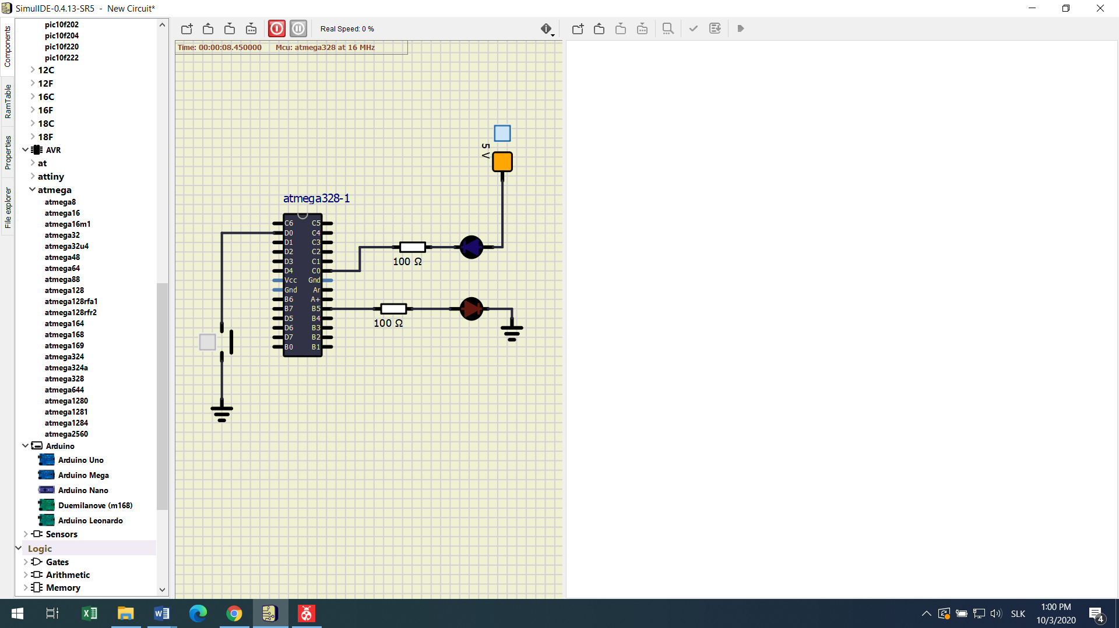

**Home assignment**

/***********************************************************************

*

* Alternately toggle two LEDs when a push button is pressed.

* ATmega328P (Arduino Uno), 16 MHz, AVR 8-bit Toolchain 3.6.2

*

* Copyright (c) 2018-2020 Tomas Fryza

* Dept. of Radio Electronics, Brno University of Technology, Czechia

* This work is licensed under the terms of the MIT license.

*

**********************************************************************/

/* Defines -----------------------------------------------------------*/

#define LED_GREEN0 PB0 // AVR pin where green LED is connected

#define LED_GREEN1 PB1

#define LED_GREEN2 PB2

#define LED_GREEN3 PB3

#define LED_GREEN4 PB4

#define BUTTON_LED PC1

#define BTN PD0

#define BLINK_DELAY 500

#ifndef *F_CPU*

#define *F_CPU* 16000000 // CPU frequency in Hz required for delay

#endif

/* Includes ----------------------------------------------------------*/

#include <util/delay.h> // Functions for busy-wait delay loops

#include <avr/io.h> // AVR device-specific IO definitions

/* Functions ---------------------------------------------------------*/

/**

* Main function where the program execution begins. Toggle two LEDs

* when a push button is pressed.

*/

int main(void)

{

int btn_memory = 0; // turnig off and on leds

// LED 0

DDRB = DDRB | (1<<LED_GREEN0);

PORTB = PORTB & ~(1<<LED_GREEN0);

// LED 1

DDRB = DDRB | (1<<LED_GREEN1);

PORTB = PORTB & ~(1<<LED_GREEN1);

// LED 2

DDRB = DDRB | (1<<LED_GREEN2);

PORTB = PORTB & ~(1<<LED_GREEN2);

// LED 3

DDRB = DDRB | (1<<LED_GREEN3);

PORTB = PORTB & ~(1<<LED_GREEN3);

// LED 4

DDRB = DDRB | (1<<LED_GREEN4);

PORTB = PORTB & ~(1<<LED_GREEN4);

//BUTTON

DDRD = DDRD & ~(1<<BTN);

PORTD = PORTD | (1<<BTN);

//button led

DDRC = DDRC | (1<<BUTTON_LED);

PORTC = PORTC & ~(1<<BUTTON_LED);

// Infinite loop

while (1)

{

if (bit_is_clear(PIND, BTN))

{

if (btn_memory == 0)

{

btn_memory = 1; // turning on

PORTC = PORTC ^ (1<<BUTTON_LED); // Turning on button led to see if it works

}else{

btn_memory = 0;

PORTC = PORTC ^ (1<<BUTTON_LED); // Turning off button led

*_delay_ms*(5000); // Time for turning off button

}

}

if (btn_memory == 1)

{

PORTB = PORTB ^ (1<<LED_GREEN0); // Turning on Led0

*_delay_ms*(BLINK_DELAY);

PORTB = PORTB ^ (1<<LED_GREEN0); // Turning off Led0

PORTB = PORTB ^ (1<<LED_GREEN1); // Turning on Led1

*_delay_ms*(BLINK_DELAY);

PORTB = PORTB ^ (1<<LED_GREEN1); // Turning off Led1

PORTB = PORTB ^ (1<<LED_GREEN2); // Turning on Led2

*_delay_ms*(BLINK_DELAY);

PORTB = PORTB ^ (1<<LED_GREEN2); // Turning off Led2

PORTB = PORTB ^ (1<<LED_GREEN3); // Turning on Led3

*_delay_ms*(BLINK_DELAY);

PORTB = PORTB ^ (1<<LED_GREEN3); // Turning off Led3

PORTB = PORTB ^ (1<<LED_GREEN4); // Turning on Led4

*_delay_ms*(BLINK_DELAY);

PORTB = PORTB ^ (1<<LED_GREEN4); // Turning off Led4

PORTB = PORTB ^ (1<<LED_GREEN3); // Turning on Led3

*_delay_ms*(BLINK_DELAY);

PORTB = PORTB ^ (1<<LED_GREEN3); // Turning off Led3

PORTB = PORTB ^ (1<<LED_GREEN2); // Turning on Led2

*_delay_ms*(BLINK_DELAY);

PORTB = PORTB ^ (1<<LED_GREEN2); // Turning off Led2

PORTB = PORTB ^ (1<<LED_GREEN1); // Turning on Led1

*_delay_ms*(BLINK_DELAY);

PORTB = PORTB ^ (1<<LED_GREEN1); // Turning off Led1

PORTB = PORTB ^ (1<<LED_GREEN0); // Turning on Led0

*_delay_ms*(BLINK_DELAY);

PORTB = PORTB ^ (1<<LED_GREEN0); // Turning on Led0

*_delay_ms*(BLINK_DELAY);

}else

{

}

}

return 0;

}

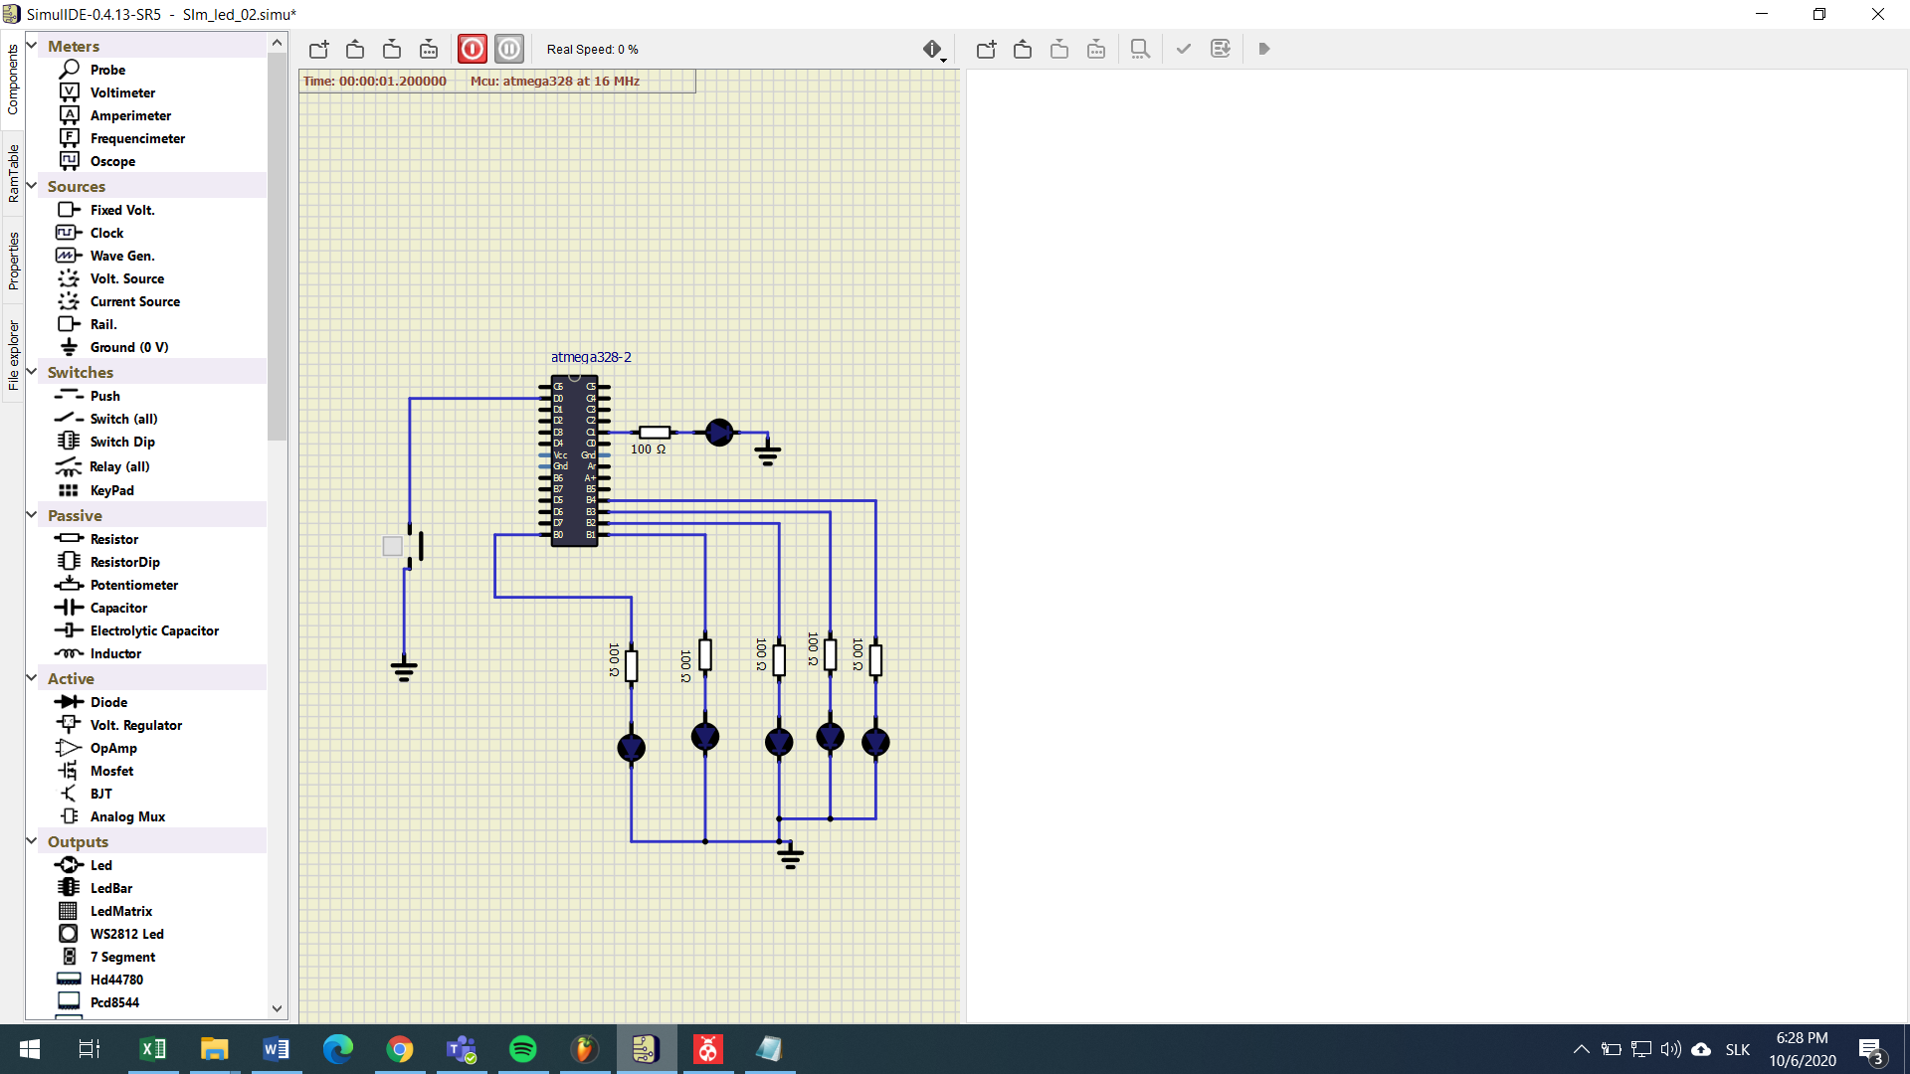

**Charts**







