Band-Pass filter with Unipolar supply

Analog Electronic Circuits Final Project

By Patrycja Nazim, Konrad Iwański ,Kamil Chaj

# Goal

The goal of this project is to design, simulate, measure and analyze active Band-pass filter with attenuation -40dB per decade, using unipolar power supply.

# Circuit Topology

Texas instruments design tool for filters generated bellow circuit. Instead of using operational amplifier proposed by TI we used LM324

In the tool we specfied following parameters:

* Filter type: bandpass
* Filter response: Butterworth
* Center Frequency: 60 kHz
* Pass-band Bandwidth: 40 kHz
* Stop-band Bandwidth: 400 kHz
* Gain: 1
* Resistor series: E12

Topology chosen by TI tool I called Multiple FeedBack (MFB) filter which is very versatile topology that requires relatively small amount of component in comparison to other topologies with similar specifications.

In order for the circuit to be working correctly with unipolar power supply we need to bias the circuit in similar to common-emitter amplifier. For our topology it is enough to connect desired reference voltage to non-inverting inputs of both op-amp and this voltage will be voltage level that small signal will “ride” on.

Our reference voltage is half of supply voltage which is 15V therefore reference is 7.5V, this voltage can be achieved by using simple resistor divider and then leftover op-amp can be used as a buffer so reference will not change when loaded, but we did not use a buffer, we forgor 😊.

# Simulation

For simulation we used LTSPICE as our SPICE of choice. And did following simulations

* Small signal analysis
* Transient sinus and square response

Netlist and LM324 subcircuit can be found in the Appendix

## Small signal analysis

For ac analysis we got following results

Lower cut-off frequency: 37.3 kHz

Upper cut-off frequency: 71.2 kHz

Center frequency: 54.3kHz

## Transient response

Response of the filter for 0V to 1V step

Response of the filter for 1V amplitude 50kHz sinus

# Prototype

We assembeled our circuit first on breadboard and then decided to solder it on universal prototyping board.

Picture bellow is our prototype

## Bill of materials

Cost of tools are not included in the BOM.

|  |  |  |  |  |  |  |
| --- | --- | --- | --- | --- | --- | --- |
| **Element** | **Quantity** | **Min. Quantity** | **Price** | **Link** | **Datasheet** | **Total cost** |
| **LM324N** | 1 | 1 | 1.8 | [AVT](https://sklep.avt.pl/pl/products/uklad-scalony-lm324-dip14-168346.html?query_id=3) | [LM324N](https://www.ti.com/lit/ds/symlink/lm324-n.pdf?ts=1706262201825&ref_url=https%253A%252F%252Fwww.ti.com%252Fproduct%252Fde-de%252FLM324-N) | **1.8** |
| **1nF capacitor** | 4 | 10 | 1.2 | [AVT](https://sklep.avt.pl/pl/products/kondensator-ceramiczny-1nf-100v-179617.html?query_id=2) |  | **1.2** |
| **0.25W 1% resistor set** | 1 | 1 | 21.6 | [AVT](https://sklep.avt.pl/pl/products/zestaw-rezystorow-0207-0-25w-1-700-sztuk-173415.html) |  | **21.6** |
| **Jumper wire set** | 1 | 1 | 10.5 | [AVT](https://sklep.avt.pl/pl/products/zestaw-laczowek-do-plytek-stykowych-sdxx-140szt-176483.html?query_id=7) |  | **10.5** |
| **Prototype board** | 1 | 1 | 8 | [AVT](https://sklep.avt.pl/pl/products/plytka-uniwersalna-90x150x1-5mm-jednostronna-173584.html?query_id=10) |  | **8** |
| **DIP14 base** | 1 | 1 | 0.5 | [AVT](https://sklep.avt.pl/pl/products/podstawka-dip-dil14-pin-170063.html) |  | **0.5** |
| **Total** |  |  |  |  |  | **43.6** |

# Measurement

## First attempt

On first measurement meeting we did not manage to record useful measurements, because unfortunately we made few mistakes on our board. First error we found was that during assembly we switched 10kΩ resistor with 560Ω one, after fixing this issue we still could not record any signal being filtered.

### Troubleshooting

During troubleshooting process we stumbled upon software that transforms any soundcard into function generator and oscilloscope([Soundcard Oscilloscope](https://zeitnitz.eu/scope_en)), which was very help fun in finding the error and verifying that there are no other issue with the circuit.

In the end the problem was shorted inverting input with output in the first stage of our filter, after fixing that, circuit was working correctly.

## Second attempt

On second meeting we recorded all necessary measurement without too many issue.

* Trace 1: Function generator signal
* Trace 2: First stage output
* Trace 3: Second stage output

One of the problem that we encountered during measurement was slew rate of LM324, at first we were testing using sinus with = 1V which caused distortion at the output, after changing = 100mV distortions disappeared.

Waveforms at approximately center frequency, we can see small gain, as predicted with simulation.

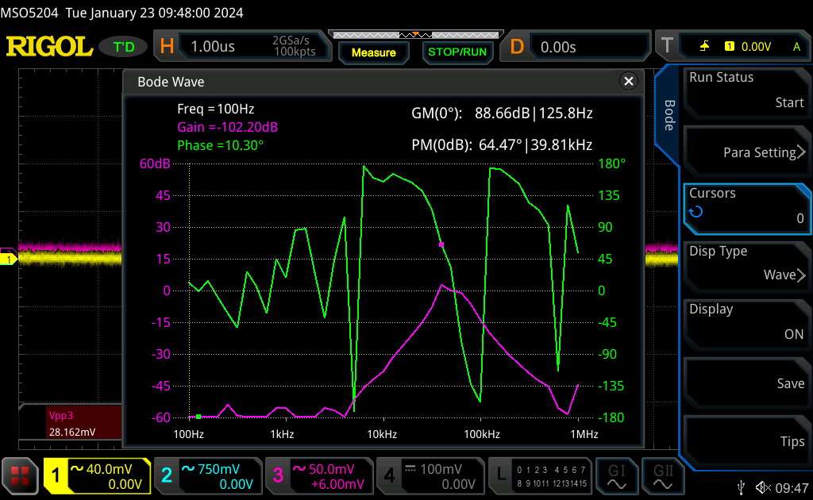We used Bode plot function of laboratory oscilloscope. Measured Bode plot differ from simulated one, but general shape of the plot is kept. The greatest discrepancy can be seen in ranges of frequency that the op-amp is not designed to interact, low frequencies(hundreds of Hertz) and high frequencies(Mega Hertz). Difference can be caused by multiple factors like, use of macro model of the op-amp or suboptimal assembly of the circuit or even some error that we under our radar.

# Conclusions

In the design process of electronic circuit even smallest details matter, there were many details that we did not take into account during design process, like slew rate and frequency limitation of op-amp we replaced recommended op-amp with. For simulation we also used simple macro model instead of more complex one that take into consideration more constrains or even one built with transistors. First failed attempt at taking measurements highlighted importance of troubleshooting skills and continuous testing(if possible) during design process.

# Appendix

LM324 Macro model: <https://github.com/pepaslabs/LTSpice-parts/blob/master/parts/op%20amp/LM324.ti.lib>



**V1 Vcc 0 15**

**XU1 ref 1- Vcc 0 out1 LM324**

**C1 1- A {C}**

**C2 out1 A {C}**

**R1 out1 1- 15k**

**R2 A in 4.7k**

**R3 0 A 1k**

**V2 in 0 SINE(0 1 50k) AC 1**

**XU2 ref 2- Vcc 0 N001 LM324**

**C3 2- B {C}**

**C4 N001 B {C}**

**R4 N001 2- 10k**

**R5 B out1 3.3k**

**R6 0 B 560**

**R7 ref Vcc 1k**

**R8 0 ref 1k**

**C5 out2 N001 10µ**

**;ac dec 100 1k 10meg**

**.tran 0 1m 0 100n**

**.param C = 1n**

**.backanno**

**.end**