OTHERS

**Tags: Adventure Tourism Swimming Fun Relax Explore Game Rest**

**Desc:** Being you is what makes you perfect, being true to what you love makes you worth it. Let’s find out more about yourself and go beyond and break the limit.

* Travel

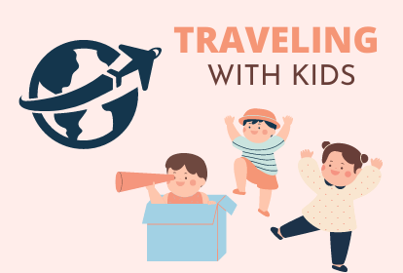

The baby boomer’s guide to travel. Learn travel destinations, hacks and tips and do’s and don’ts for a safer and better experience. Learn and plan how to spend your time exciting, amusing, entertaining and leisurely without worries. https://youtu.be/f7aCwu_SjMo

* Sports

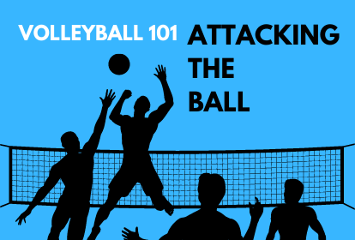

All games, all season. Learn the basics and tips and tricks in improving your game to the next level. Learn from experienced people from their gameplays to their tactics to boost your game skills while enjoying your road to becoming a pro. https://youtu.be/gNWenHIzaT8

* Gardening

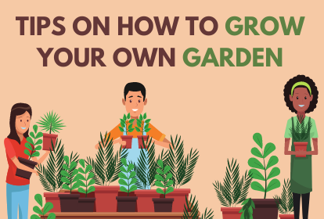

Be environment-friendly. Learn different tools, technique or ways to improve your gardening skills while making your environment livelier and full of colors. Learn to make your surroundings more attractive than before. https://youtu.be/EcxTMEIrHRE

* Swimming

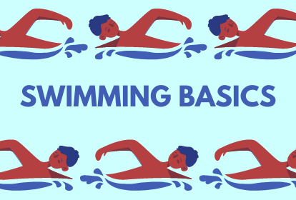

Learn the basics about swimming, the techniques and proper ways to improve your skills while having a good time enjoying the water. Learn to step up your game for you to enjoy the vast entertainment offered by the water. https://youtu.be/AfnwseOgxE0

* Survival

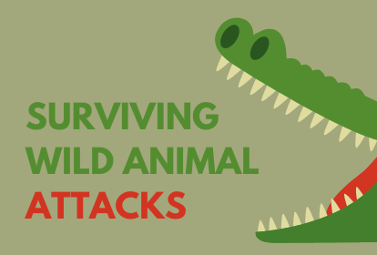

Provide a hand for a paw. Learn the different animals along with their hobbies, tips on how to handle them and how to take better care for them. Find not only a pet but also a partner. https://youtu.be/kkFFq11j6dQ