**Booking Flask Application Demo – Requirements, design and user cases document**

Authors: Kamil Wezka, Gavin James Jones

Date: 06.02.2018

Version 0.1

Contents

Introduction 3

Simple workflow 3

User Scenarios – simple use 3

User Scenarios – security 3

# Introduction

The documents summarise the initial specifications of what the booking application should contain i.e. list of features, user scenarios, infrastructure requirements etc.

# Simple workflow – booking

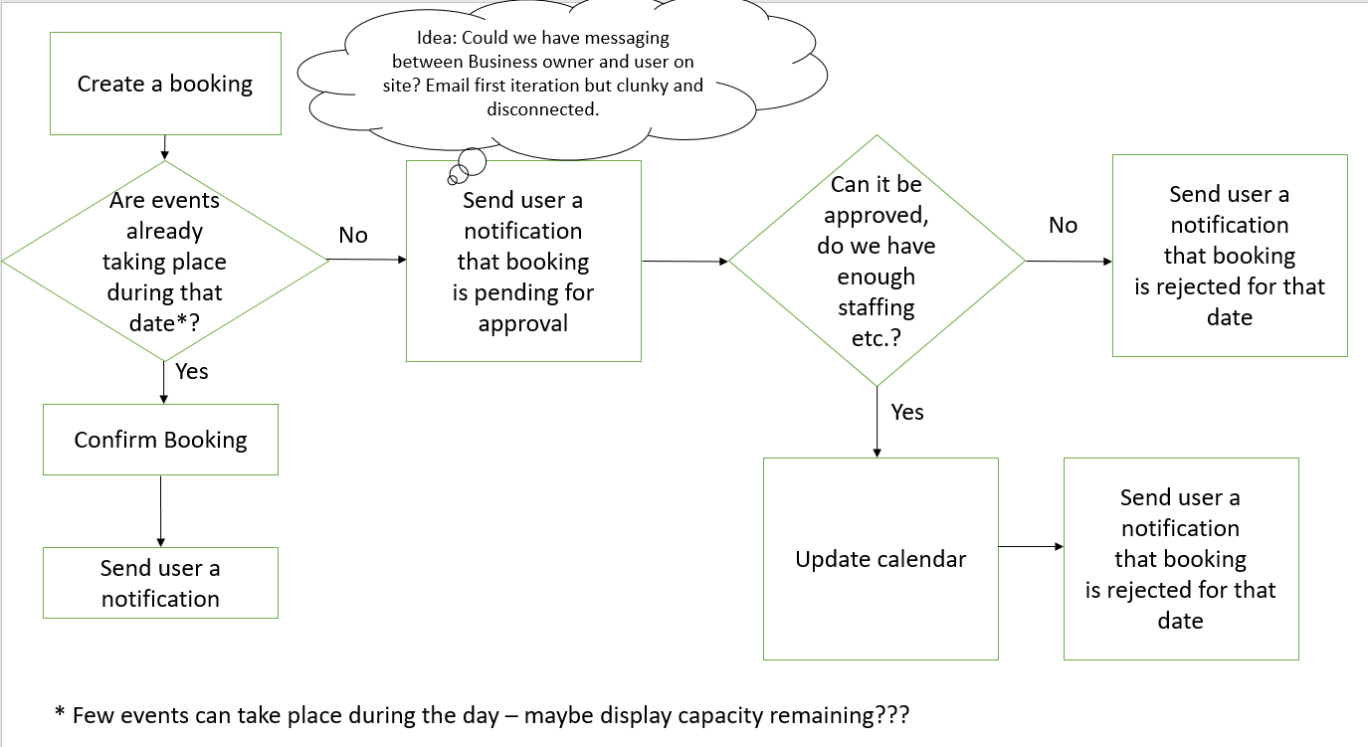

# Simple workflow -cancellation

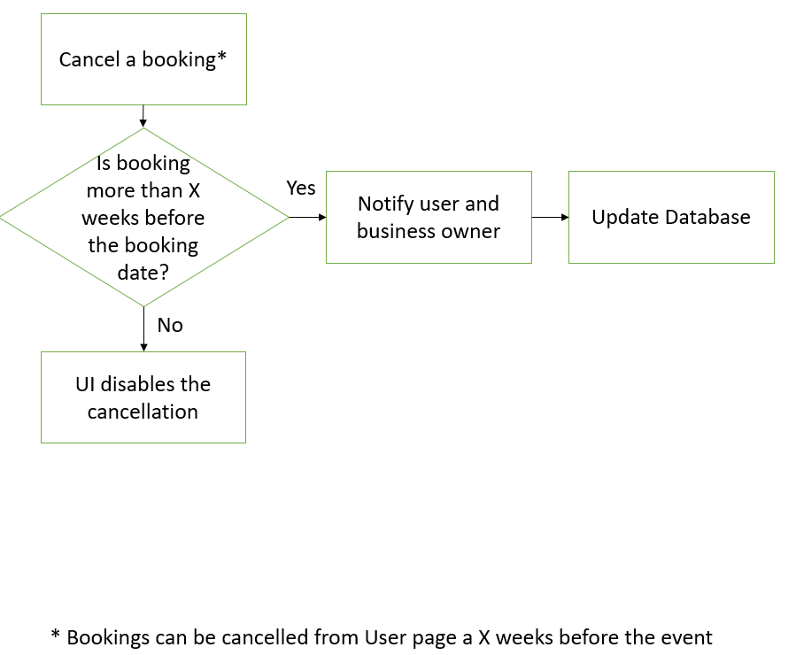

# User Scenarios – account creation

1. User reaches the site by typing <https://app.app-domain.com> and can see the landing page.
2. User clicks on hyperlink and is redirected to /register page. User fills the details which are validated* on the page. Upon completion the user is redirected to /registration_confirmation **.

*Password validation is required to cohere to NIST standard <https://pages.nist.gov/800-63-3/sp800-63b.html> - in summary no repeated letters, password needs to have combinations of alphanumeric characters, can’t be repeated character string, or can’t have name / surname.

** at this stage no tokens are sent to the users.

1. User logs in with their credential.

# User Scenarios – simple use

1. User reaches the site by typing <https://app.app-domain.com> and can see the landing page.
2. User types in correct password / email gets redirected to homepage
3. User requests a booking by clicking ‘request a booking’. They are redirected to /request_booking page. On the page - available, booked with availability and unavailable dates are rendered– each having an adequate colour scheme.
4. User requests a booking with full availability and gets auto approval message and they see their booking on their homepage.
5. User can cancel their booking from their homepage by pressing cancel and is prompted with confirmation. Upon confirmation the event is released and calendar is updated.
6. User presses log out and they get redirected to <https://app.app-domain.com>

# User Scenarios – security

1. User forgets their password. User clicks forgot password hyperlink. User gets redirected to /forgot_password page. User can request password reset after typing their email and pressing submit button. User receives an email notification with a link to /reset_password page.

# Admin user Scenarios

1. Todo