Author: Kamil Łuc

Multiscale Modelling

Report 2

Repository: <https://github.com/kamilluc/multiscale-modelling>

1. Technology (same as in previous part)

**Java 11 LTS** - is a general-purpose computer-programming language that is concurrent, class-based, object-oriented, and specifically designed to have as few implementation dependencies as possible. It is intended to let application developers "write once, run anywhere, meaning that compiled Java code can run on all platforms that support Java without the need for recompilation. Author choose Java because it is sufficient for this task and wanted to expand his knowledge about new version (11 vs 8 from 4 years ago).

|  |  |
| --- | --- |
| Strengths | Weaknesses |
| Strongly-typed language, compiled, good performance, old and tested, very popular on market, variety of libraries, big company (Oracle) behind it, multiplatform, one of the best if not the best environment for programming desktop applications. | Slower than C/C++, quite hard to learn (above basic level) compared to Python/JavaScript etc., confusing licence. |

**JavaFX** - is a Java library used to build Rich Internet Applications. The applications written using this library can run consistently across multiple platforms. The applications developed using JavaFX can run on various devices such as Desktop Computers, Mobile Phones, TVs, Tablets, etc. It’s basically a standard for Javas GUI application (that’s why author choose this technology), it replaced SWING many years ago. Also it allows to use XML like syntax for structure View elements like buttons ale CSS like syntax for styling them.

|  |  |
| --- | --- |
| Strengths | Weaknesses |
| Follows MVC pattern, good looking apps could be created quite easily thanks to HTML and CSS like syntax. Easier and better than predecessor SWING. | Since JDK 9 quite complex initial configuration (JavaFX is no longer part of JDK). |

Tools like **InteliJ Idea** (Integrated Development Environment) where code was written and **GIT** to manage repository was used but they are not part of application itself so the they are not described here.

1. Graphical User Interface (changes overview)

All changes were made only in right side of UI. Rest of elements remain the same as in first report.

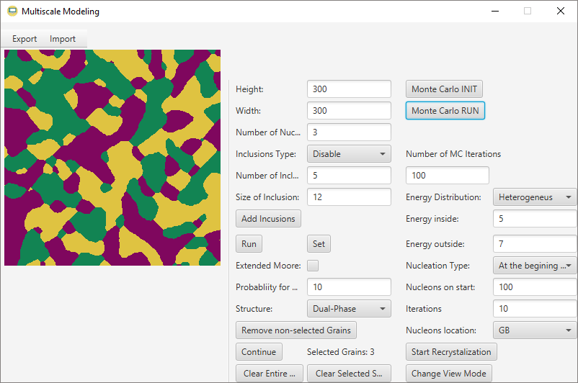

1 2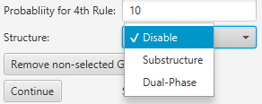

1 1

2

1

10

3 

7

4

6

5

8

9

Figure 1 GUI of application

1. Button to initialize Monte Carlo Method (it takes Number of Nucleons as parameter for creating same amount of different states) after that lattice is filled with random states
2. This button starts MC algorithm.
3. This menu specifies number of MC iterations.
4. Energy distribution type can be selected from Homogeneous (same initial energy for all cells) or Heterogeneous (different energy for cells on boundaries and different for inside ones).
5. How many energy levels is stored in cells inside grains.
6. Specifies amount of energy on grains boundaries (should be higher than inside).
7. Nucleation type, determines in which way new recrystalized nucleons are added, three choices: At the beginning of simulation, constant, increasing.
8. How many nucleons should be added at the start of SRX simulation.
9. How many iterations of SRX method should be invoked.
10. Two types of localization of new recrystalized nucleons, GB – on grain boundaries or random
11. Button for starting SRX algorithm with given parameters
12. Option to change view between structure and energy inside.
13. Results, application features
14. **Class 8 - Monte Carlo grain growth algorithm**

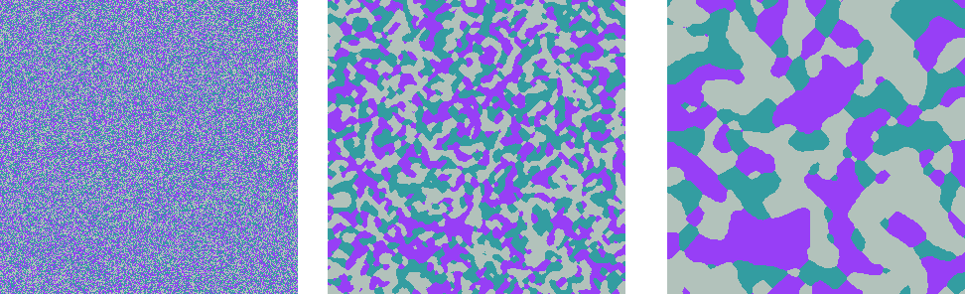

Figure 2 Result of the Monte Carlo Method

Implementation of Monte Carlo algorithm. In GUI size of structure could be specified like in Figure 1, height and width is set to 300 and 300 respectively, initial number of states is set to 3, after pressings Set and Monte Carlo INIT button, first part of above (Figure 2) structure is generated. Middle part of structure (Figure 2) is result of 10 MC iterations, right side is effect of 100 (total) iterations. Given high enough number of iterations only one state/colour would remain (grains are growing in each iteration).

1. **Class 9 – Modification of MC grain growth algorithm - substructures CA, MC**



Figure 3 MC->CA transition

Figure 3 shows MC->CA method transition. First structure (left side of Figure 4) with 2 initial states generated by MC method. After that (middle part of Figure 3) blue state was selected and changed to dual-phase. Remaining space was filled with 200 grains of CA method. Right image is final effect of the process.



Figure 5 CA->MC transition

Figure 4 shows CA->MC method transition. First structure (left side of Figure 4) with 20 initial nucleons by using CA method was created. After that Few grains from bottom-right corner was selected and changed to dual-phase (middle part of 4th Figure). Remaining space was filled with 3 states of MC initializer. Right image is final effect of 150 MC iterations.

1. **Class 10 - MC static recrystallization algorithm - energy distribution**

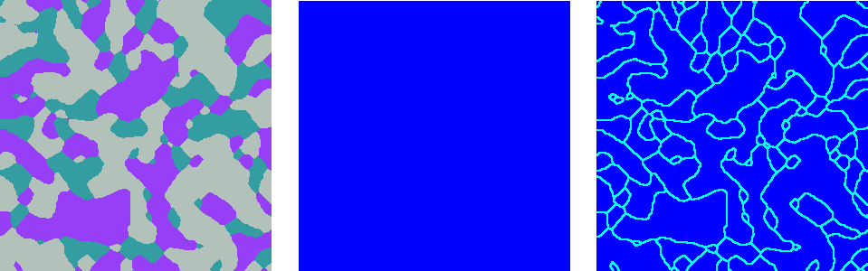

Figure 6 Change View between structure and energy

On the left side of figure 6 generated through MC algorithm could be saw. Middle part of figure shows Homogeneous type of energy (all cells have same amount of energy). Right side is showing Heterogeneous type of energy distribution, cells on the boundaries have more energy.

1. **Classes 11 and 12 - MC static recrystallization algorithm – nucleation and growth**

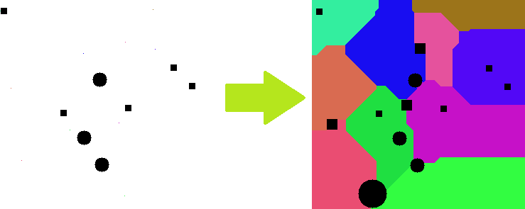

Figure 7 Different type of inclusions

In the figure 7 all possible type of inclusions were added, there are 3 small circles and 5 smaller squares added before simulation in random spots. Then simulation was completed and after that 1 big circular inclusion and 3 medium sized squares ones on boundaries were generated. Also example result could be seen in Figures 15,17,19,21.

1. Comparison with real microstructure

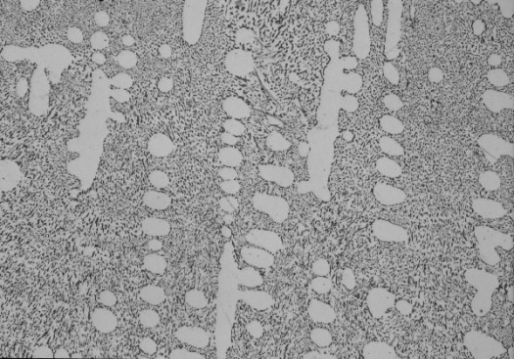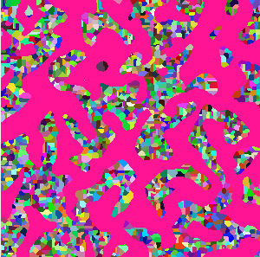

Figure 12 Aluminum-Silicon Alloy

<http://www.metallographic.com/Procedures/Al-Si.htm>

Alloy of Aluminium and Silicon, one phase is considerably bigger and have more rounded shapes witch is perfect for MC method, which was used for creating pink coloured phase, after that, rest of space was deleted to make second simulation, CA this time, of 2000 nucleons.

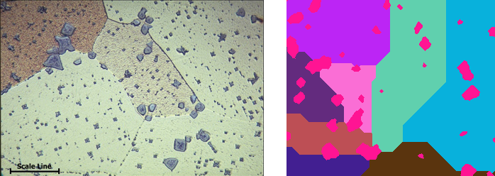

Figure 12 Manganese bronze Alloy

<https://www.copper.org/resources/properties/microstructure/brasses.html>

Alloy of Aluminium and Bronze, one phase irregular shapes witch is great for MC method, which was used for creating pink coloured phase, after that, rest of space was deleted to make second simulation, CA this time, of 8 nucleons.

1. Summary

* Still not all micro-structures could be generated, application could be enhanced to simulate different shapes, similar to needle for example
* Monte Carlo Method gives more tools, thanks to its probability factor for generating different, more accurate micro-structures than CA method. It could be helpful to model some types of materials.
* Generated micro-structures could be exported and then used in CAE type programs (like Abaqus) to create better, more realistic models.
* Coding took some time, but wasn’t particularly hard. Maybe introducing 3D models could change that.
* MC method is slower (performance wise) than CA method, due probability factor.
* Static recrystallization generating new nucleons, where energy is highest with more probability and process trying to minimalize energy in structure. Recrystallized grains haven’t energy so these can’t be seeds for new nucleation.
* Application allows to see how recrystallization is happening in micro-structure, because in real life this process could be fast it’s hard to see same effect in real example. This information could crucial to predict how created material will work.
* Both, CA and MC method could be combined to generate specific, more advanced micro-structures