Section 1: Functional testing

a) Kamil results:

References:

$JBOSS_HOME - jboss home directory

$GIT - [github repository](https://github.com/kamilsmuga/performance-assignment.git)

Logs for data mining:

$JBOSS_HOME/server/default/log/server.log

$JBOSS_HOME/server/default/log/boot.log

~/.visualvm/1.3.5/var/log/messages.log

/var/log/syslog

# 2. Test suite: Interactions execution. OOM identification and exception findings

1. Enabled jmx remote connection to jboss to monitor Threads and CPU with visualvm:

- edit $JBOSS_HOME/bin/run.conf and add:

### JAVA_OPTS=”$JAVA_OPTS -Dcom.sun.management.jmxremote.authenticate=false -Dcom.sun.management.jmxremote.ssl=false -Dcom.sun.management.jmxremote=true -Dcom.sun.management.jmxremote.port=12345“

2. Added GC logging:

- edit $JBOSS_HOME/bin/run.conf and add:

### TODAY=`date "+%Y%m%d-%H%M%S"`

### JAVA_OPTS=”$JAVA_OPTS -Xloggc:gc.log.$TODAY -XX:+PrintGCDetails -XX:+PrintGCDateStamps”

3. Head dump on OOM

- edit $JBOSS_HOME/bin/run.conf and add:

### -XX:+HeapDumpOnOutOfMemoryError

## 2.1. Test case: interaction config1

- start jboss Fri Jun 21 14:28:40 IST 2013

- attach jvisualvm Fri Jun 21 14:30:56 IST 2013

- create heap and thread dump: heapdump-1371822496474.hprof

- run config1 Fri Jun 21 14:59:41 IST 2013

- create heap and thread dump heapdump-1371823190015.hprof

- wait 2 mins

- run config1 Fri Jun 21 15:01:55 IST 2013

- create heap and thread dump heapdump-1371823324448.hprof

- wait 2 mins

- run config1 Fri Jun 21 15:04:27 IST 2013

- create heap and thread dump heapdump-1371823471768.hprof

- wait 2 mins

- run config1 Fri Jun 21 15:06:12 IST 2013

- create heap and thread dump heapdump-1371823576964.hprof

- wait 2 mins

- run config1 Fri Jun 21 15:08:31 IST 2013

- create heap and thread dump heapdump-1371823715444.hprof

- get graphs for:

jvm cpu

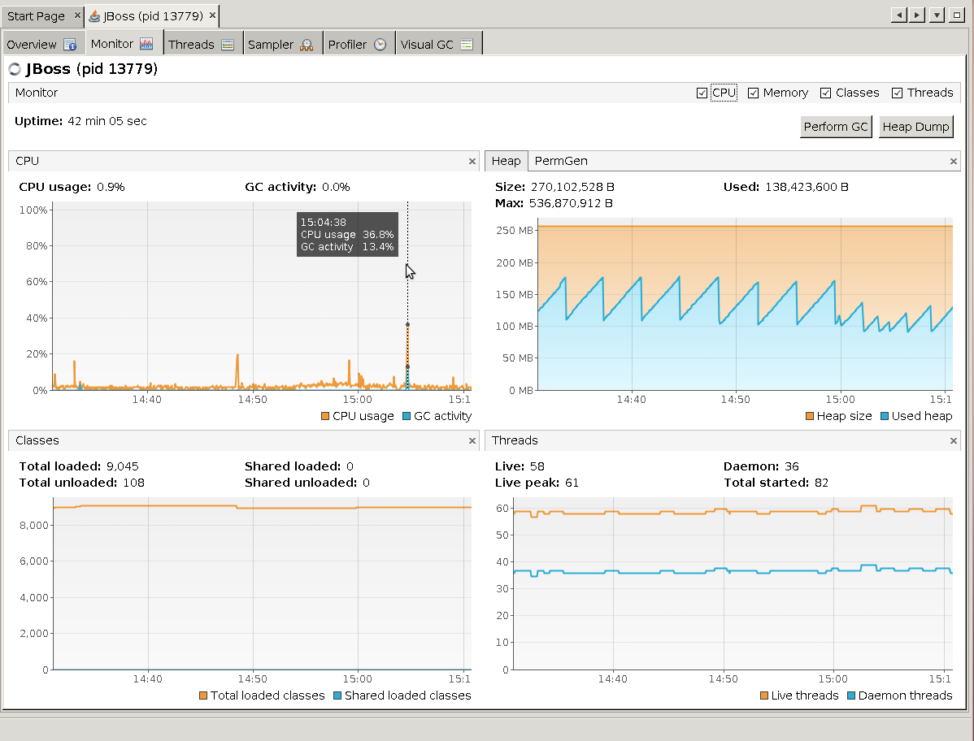

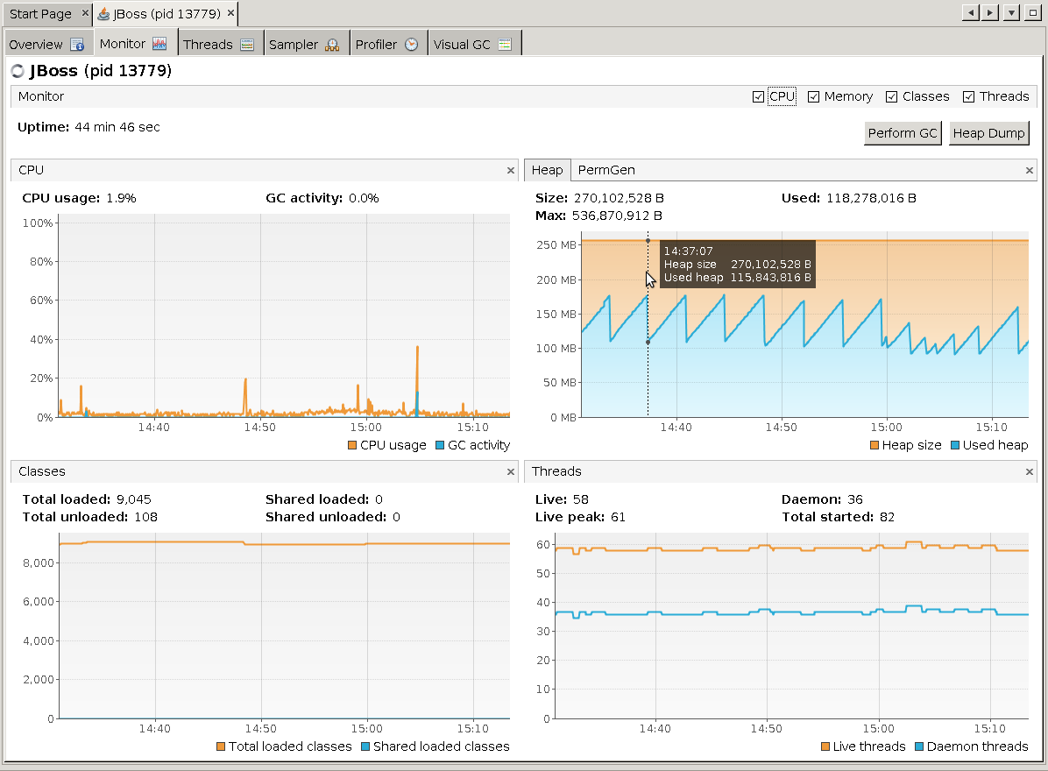

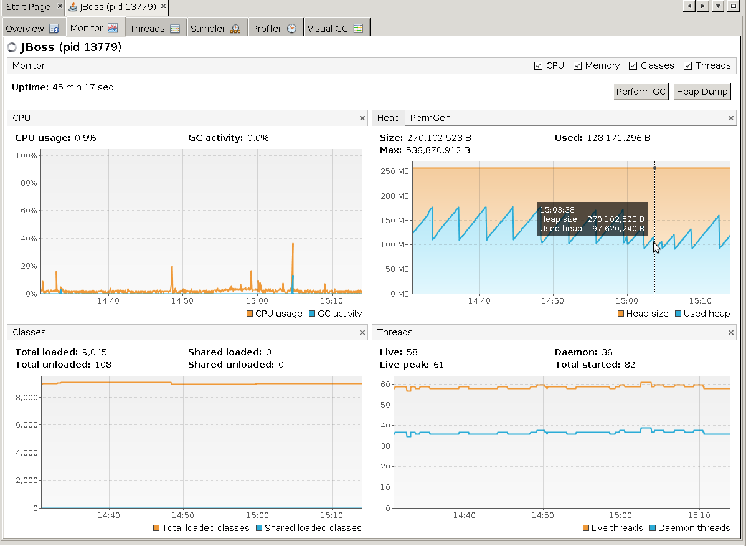

GC gc.log.20130621-142840

system graphs

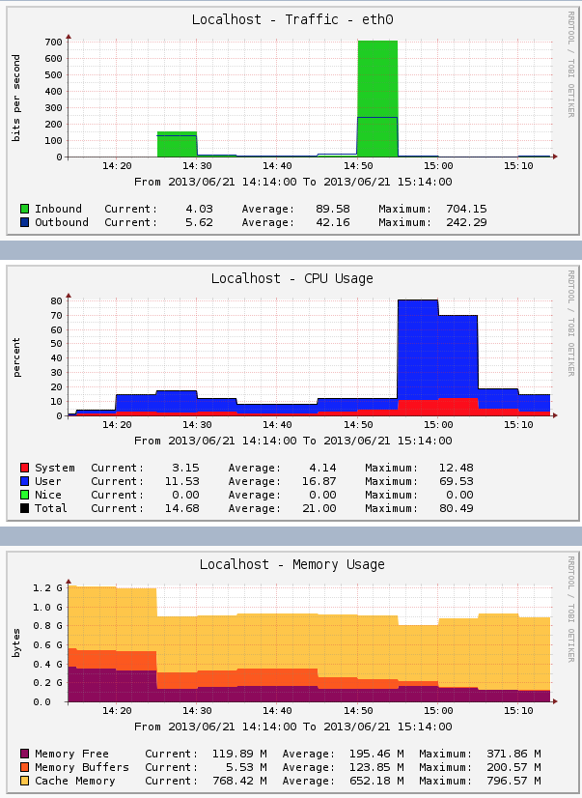

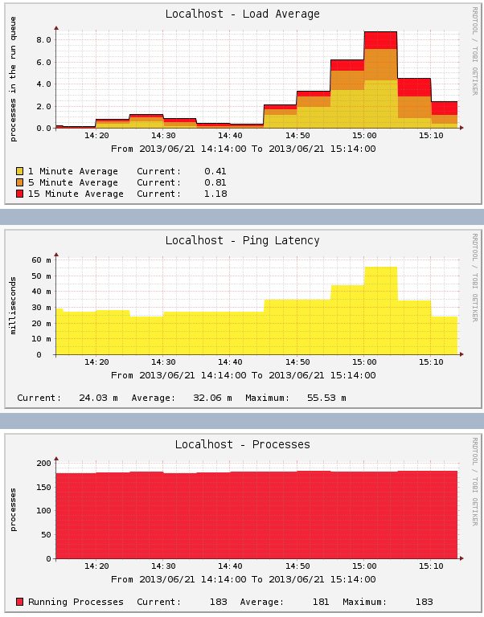

- detach jvisualvm Fri Jun 21 15:20:56 IST 2013

- stop jboss Fri Jun 21 15:21:28 IST 2013

- analyse exceptions:

## 2.2. Test case: interaction config2

- start jboss Fri Jun 21 16:24:13 IST 2013

- attach jvisualvm Fri Jun 21 16:25:30 IST 2013

- create heap and thread dump heapdump-1371828412616.hprof

- run config2 Fri Jun 21 16:28:23 IST 2013

- create heap and thread dump heapdump-1371828506739.hprof

- wait 2 mins

- run config2 Fri Jun 21 16:30:11 IST 2013

- create heap and thread dump heapdump-1371828614179.hprof

- wait 2 mins

- run config2 Fri Jun 21 16:32:14 IST 2013

- create heap and thread dump heapdump-1371828737324.hprof

- wait 2 mins

- run config2 Fri Jun 21 16:34:06 IST 2013

- create heap and thread dump heapdump-1371828852417.hprof

- wait 2 mins

- run config2 Fri Jun 21 16:36:13 IST 2013

- create heap and thread dump heapdump-1371828979074.hprof

- get graphs for:

jvm cpu

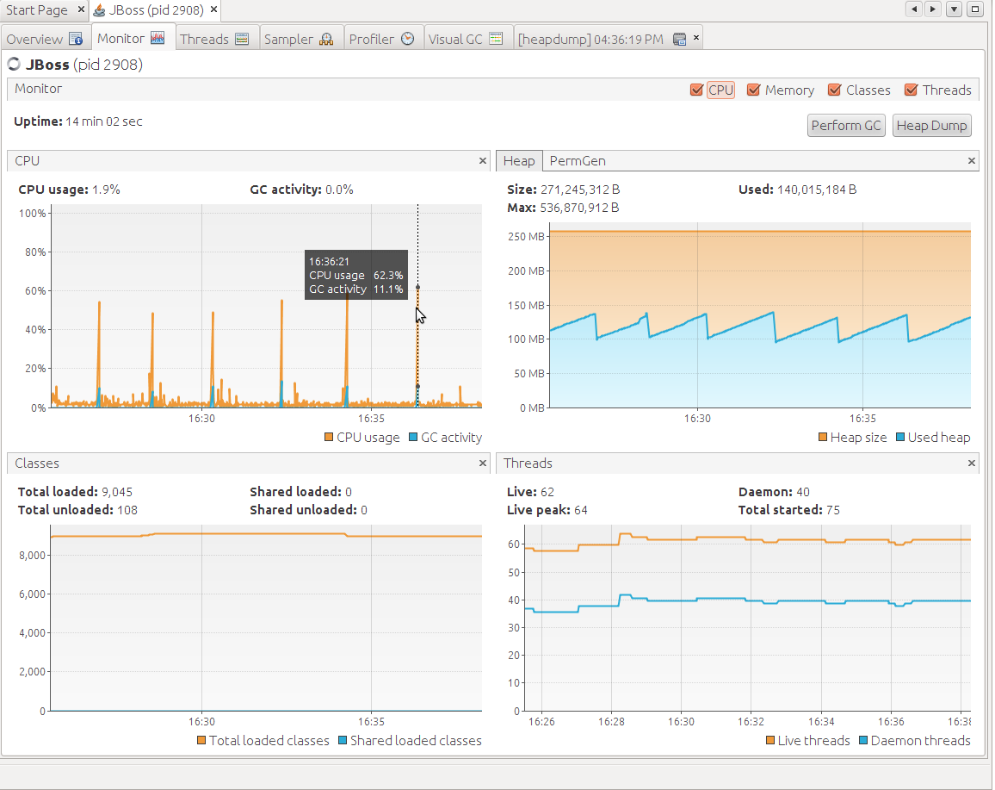

GC

system graphs

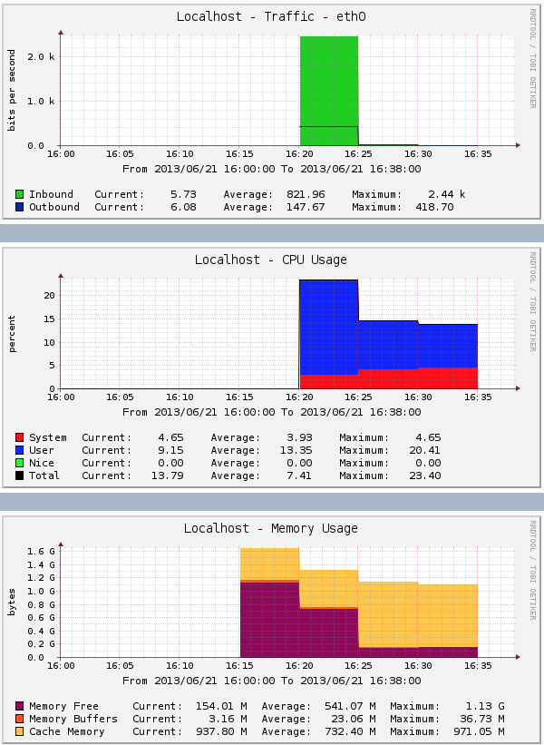

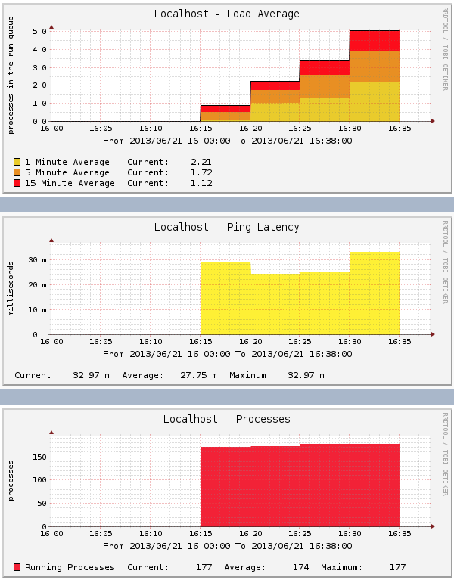

- detach jvisualvm Fri Jun 21 16:41:56 IST 2013

- stop jboss Fri Jun 21 16:42:25 IST 2013

- analyse exceptions:

## 2.3. Test case: interaction config3

- start jboss Fri Jun 21 17:14:50 IST 2013

- attach jvisualvm Fri Jun 21 17:16:01 IST 2013

- create heap and thread dump heapdump-1371831380016.hprof

- run config3 Fri Jun 21 17:17:46 IST 2013

- create heap and thread dump heapdump-1371831471936.hprof

- wait 2 mins

- run config3 Fri Jun 21 17:19:03 IST 2013

- create heap and thread dump heapdump-1371831548704.hprof

- wait 2 mins

- run config3 Fri Jun 21 17:20:19 IST 2013

- create heap and thread dump heapdump-1371831622361.hprof

- wait 2 mins

- run config3 Fri Jun 21 17:21:52 IST 2013

- create heap and thread dump heapdump-1371831716844.hprof

- wait 2 mins

- run config3 Fri Jun 21 17:23:11 IST 2013

- create heap and thread dump heapdump-1371831794583.hprof

- get graphs for:

jvm cpu

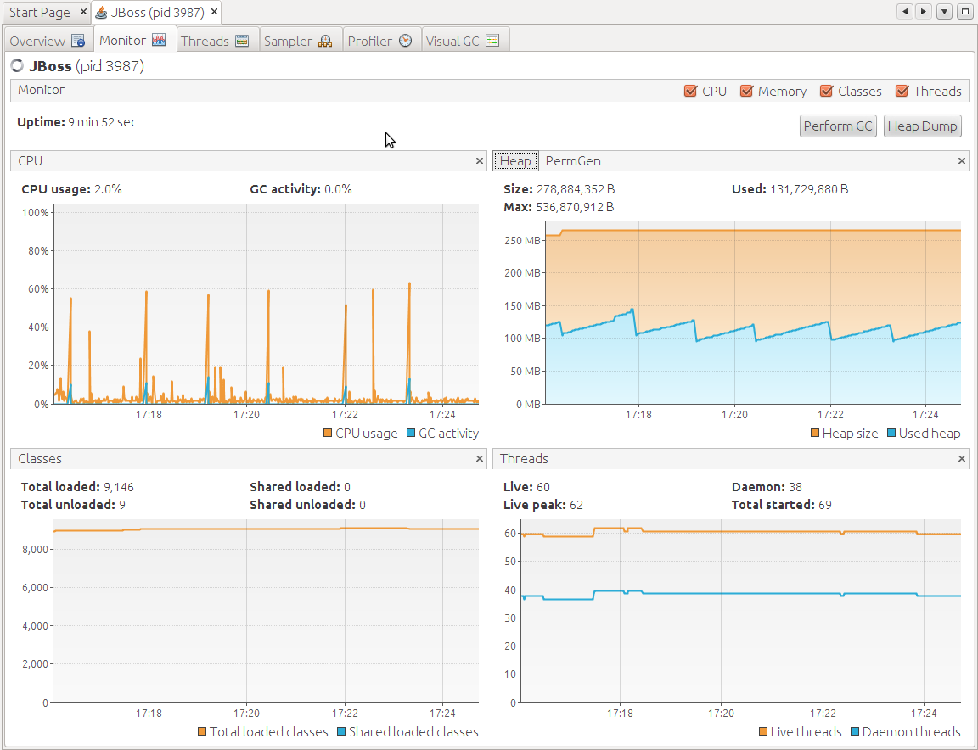

GC - deleted by mistake

system graphs

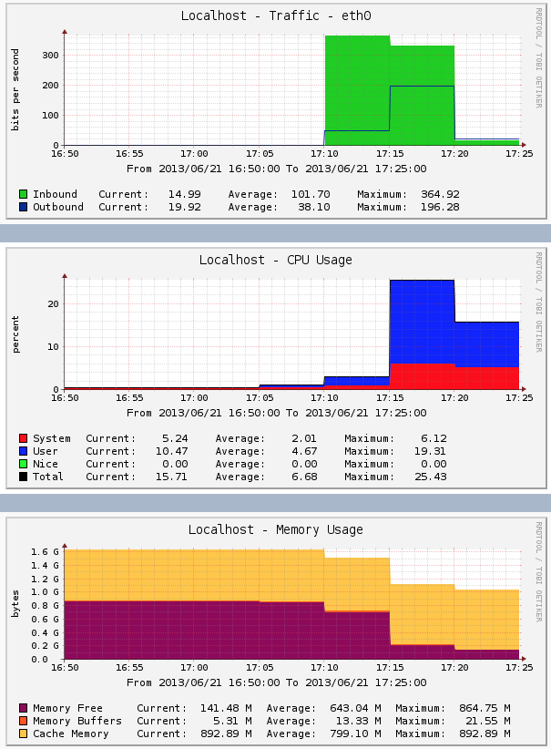

- detach jvisualvm Fri Jun 21 17:30:13 IST 2013

- stop jboss Fri Jun 21 17:28:45 IST 2013

- analyse exceptions:

## 2.4. Test case: interaction config4

- start jboss Sat Jun 22 21:35:55 IST 2013

- attach jvisualvm Sat Jun 22 21:37:05 IST 2013

- create heap and thread dump heapdump-1371933453065.hprof

- run config4 Sat Jun 22 21:39:03 IST 2013

Exception logged in browser:

The Adaptive Cells EJBs have raised the exception:

null; nested exception is:

java.lang.RuntimeException

You might have configured the cells to raise exceptions. This can be done adding an environment entry (namely configXexception) to the deployment descriptors of the cell EJBs.

- create heap and thread dump heapdump-1371933547442.hprof

- wait 2 mins

- run config4 Sat Jun 22 21:40:18 IST 2013

- create heap and thread dump heapdump-1371933621695.hprof

- wait 2 mins

- run config4 Sat Jun 22 21:41:28 IST 2013

- create heap and thread dump heapdump-1371933691850.hprof

- wait 2 mins

- run config4 Sat Jun 22 21:42:35 IST 2013

- create heap and thread dump heapdump-1371933758757.hprof

- wait 2 mins

- run config4 Sat Jun 22 21:44:08 IST 2013

- create heap and thread dump heapdump-1371933852225.hprof

- submitted config4 a lot of times in a row and generated heapdump heapdump-1371933970452.hprof

- get graphs for:

jvm cpu

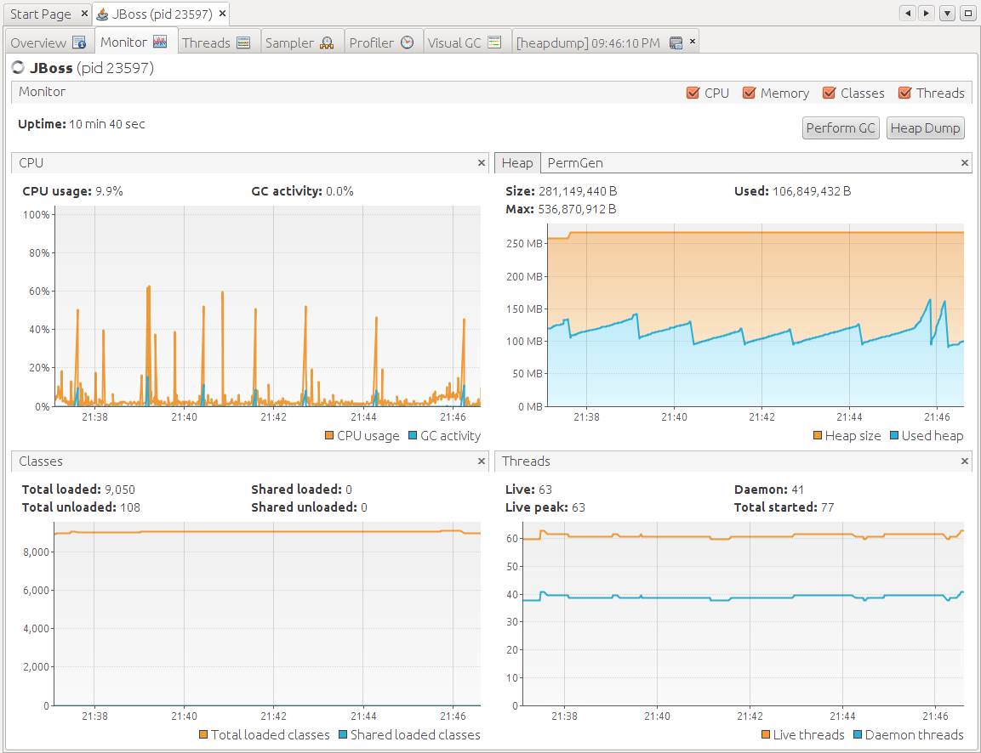

GC gc.log.20130622-213555

system graphs

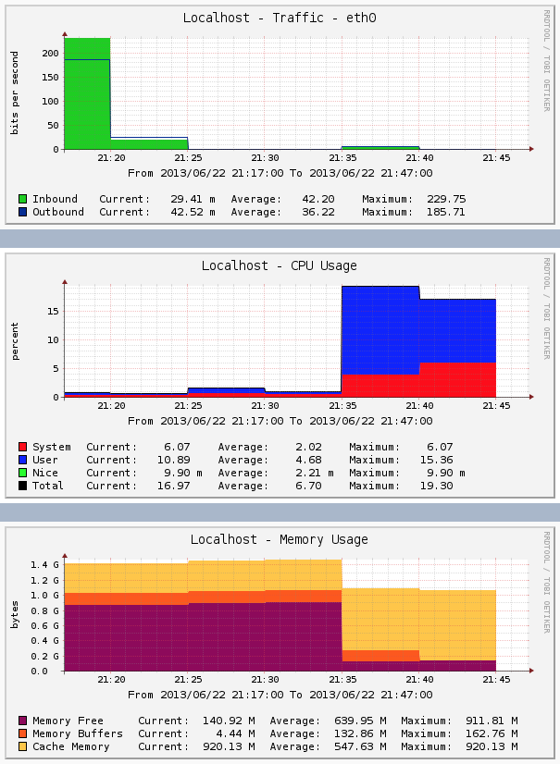

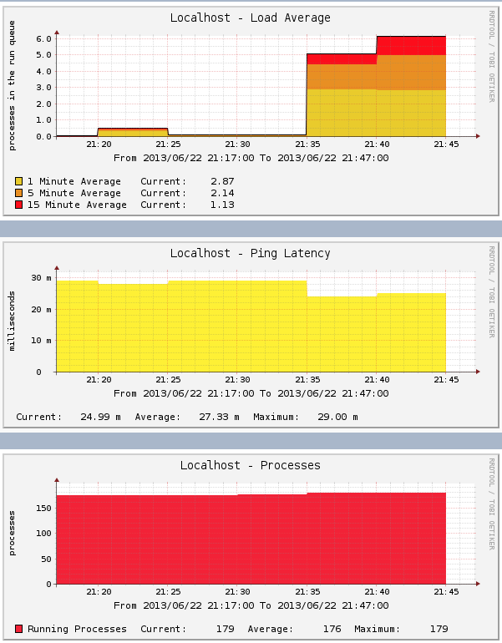

- detach jvisualvm Sat Jun 22 21:53:18 IST 2013

- stop jboss Sat Jun 22 21:53:18 IST 2013

- analyse exceptions:

## 2.5. Test case: interaction config

- start jboss Sat Jun 22 22:02:02 IST 2013

- attach jvisualvm Sat Jun 22 22:02:49 IST 2013

- create heap dump heapdump-1371934988628.hprof

- run config5 Sat Jun 22 22:04:21 IST 2013

- create heap dump heapdump-1371935066062.hprof

- wait 2 mins

- run config5 Sat Jun 22 22:05:32 IST 2013

- create heap dump heapdump-1371935137005.hprof

- wait 2 mins

- run config5 Sat Jun 22 22:06:38 IST 2013

- create heap dump heapdump-1371935202467.hprof

- wait 2 mins

- run config5 Sat Jun 22 22:07:53 IST 2013

- create heap dump heapdump-1371935276084.hprof

- wait 2 mins

- run config5 Sat Jun 22 22:08:56 IST 2013

- create heap dump heapdump-1371935340193.hprof

- submitted config5 a lot of times in a row and generated heapdump heapdump-1371935448066.hprof

- get graphs for:

jvm cpu

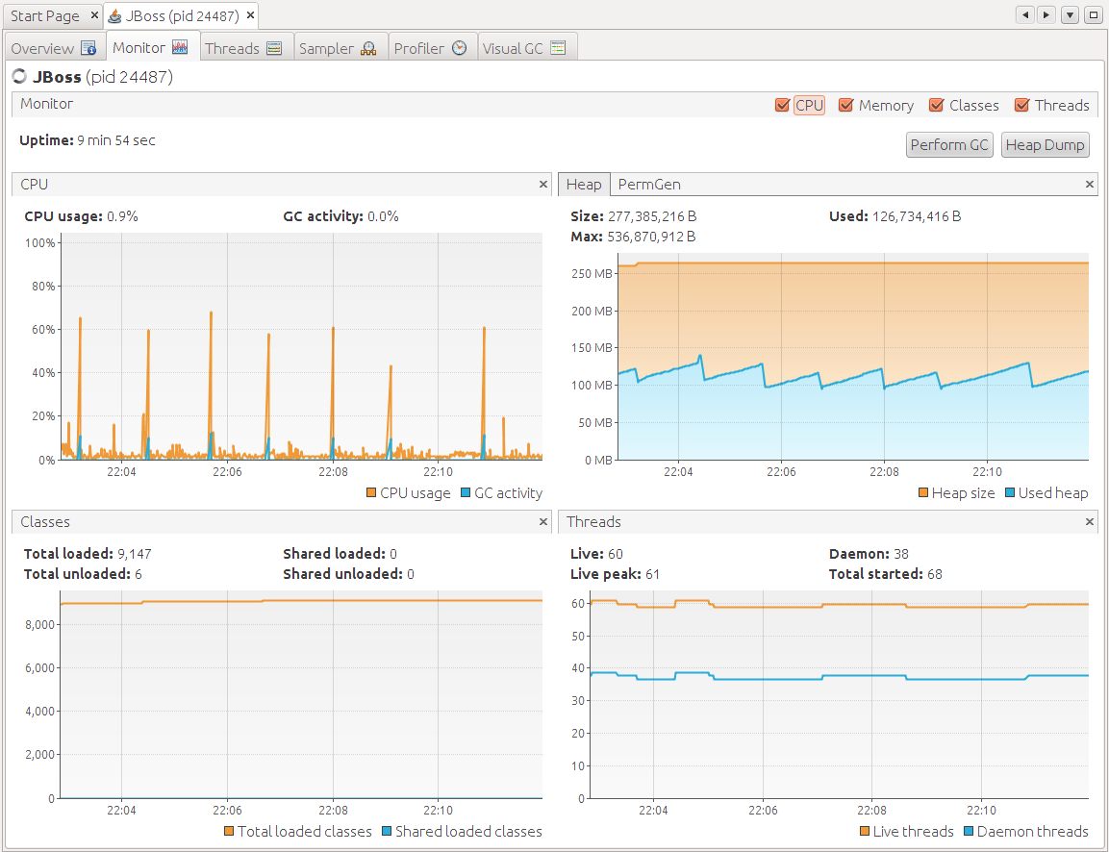

OS graphs

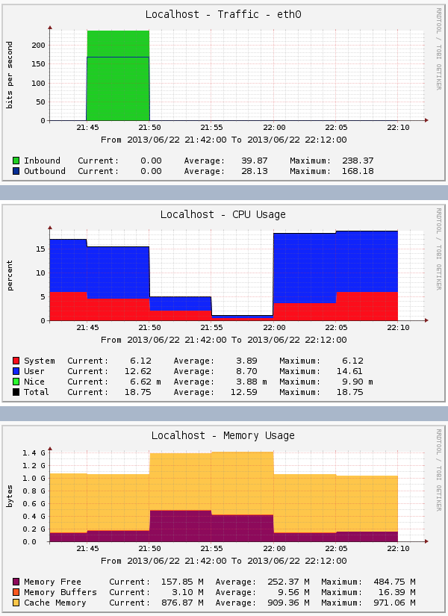

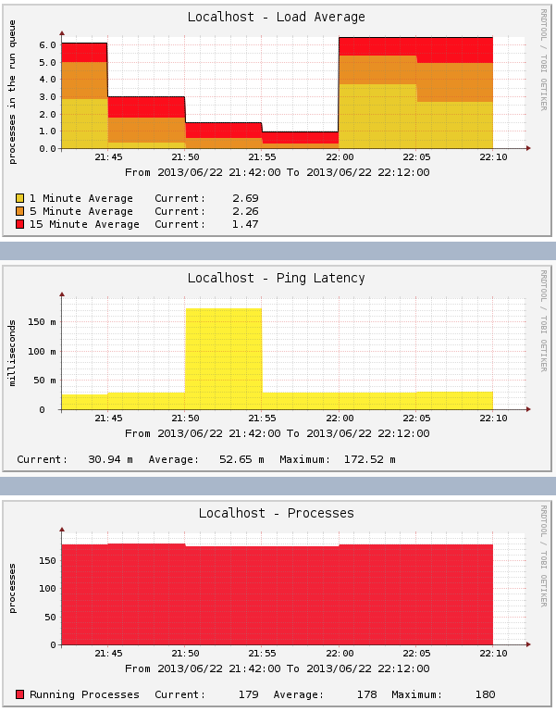

- stop jboss Sat Jun 22 22:15:13 IST 2013

- detach jvisualvm Sat Jun 22 22:15:13 IST 2013

GC gc.log.20130622-220202

- analyse exceptions:

## 2.6. Test case: interaction config

- start jboss Sat Jun 22 22:16:28 IST 2013

- attach jvisualvm Sat Jun 22 22:17:15 IST 2013

- create heap dump heapdump-1371935854144.hprof

- run config 6 Sat Jun 22 22:18:57 IST 2013

- create heap dump heapdump-1371935941481.hprof

- wait 2 mins

- run config6 Sat Jun 22 22:20:11 IST 2013

- create heap dump heapdump-1371936013710.hprof

- wait 2 mins

- run config6 Sat Jun 22 22:21:17 IST 2013

- create heap dump heapdump-1371936080239.hprof

- wait 2 mins

- run config6 Sat Jun 22 22:22:23 IST 2013

- create heap dump heapdump-1371936146761.hprof

- wait 2 mins

- run config6 Sat Jun 22 22:23:35 IST 2013

- create heap dump heapdump-1371936218381.hprof

- submitted config6 a lot of times in a row and generated heapdump heapdump-1371936323944.hprof

- get graphs for:

jvm cpu

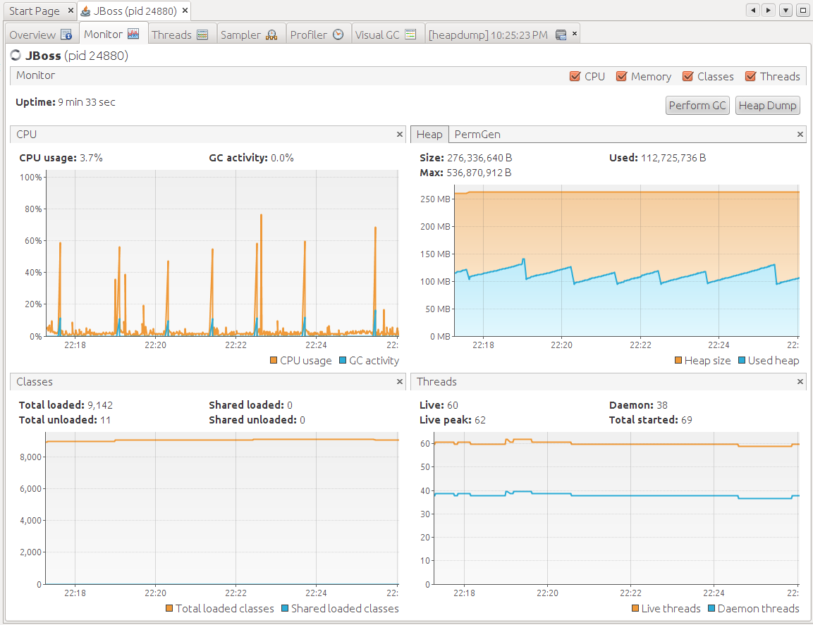

OS graphs

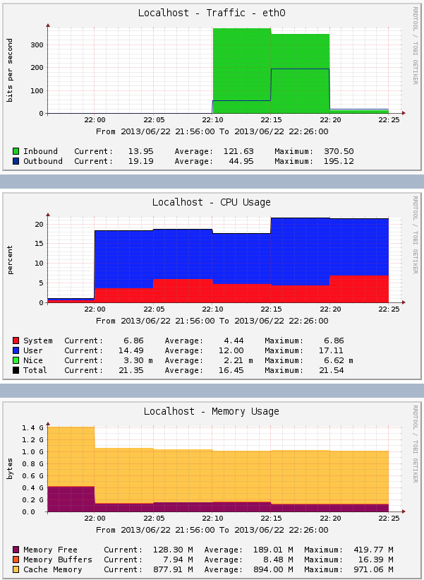

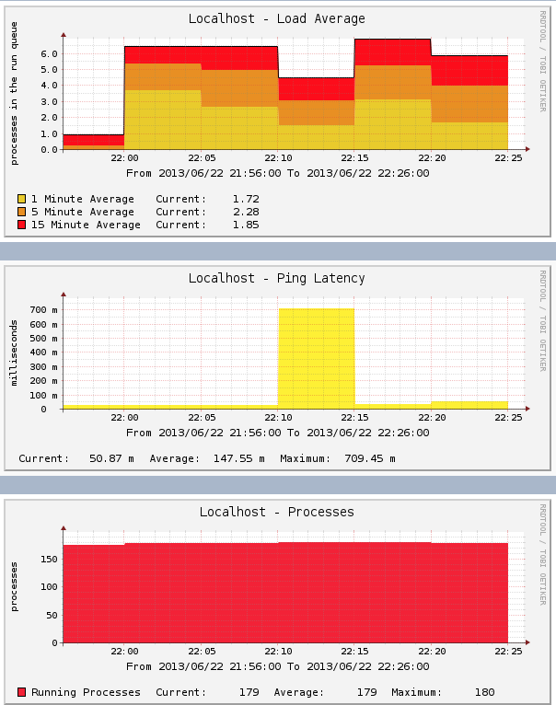

- stop jboss Sat Jun 22 22:28:30 IST 2013

- detach jvisualvm Sat Jun 22 22:28:30 IST 2013

GC gc.log.20130622-221628

- analyse exceptions:

## 2.7. Test case: interaction config

- start jboss Sat Jun 22 22:44:51 IST 2013

- attach jvisualvm Sat Jun 22 22:46:58 IST 2013

- create heap dump heapdump-1371937632751.hprof

- run config7 Sat Jun 22 22:48:55 IST 2013

- create heap dump heapdump-1371937738458.hprof

- wait 2 mins

- run config7 Sat Jun 22 22:50:10 IST 2013

- create heap dump heapdump-1371937812612.hprof

- wait 2 mins

- run config7 Sat Jun 22 22:51:26 IST 2013

- create heap dump heapdump-1371937888585.hprof

- wait 2 mins

- run config 7 Sat Jun 22 22:52:32 IST 2013

- create heap dump heapdump-1371937955282.hprof

- wait 2 mins

- run config7 Sat Jun 22 22:53:36 IST 2013

- create heap dump heapdump-1371938019159.hprof

- submitted config7 a lot of times in a row and generated heapdump heapdump-1371938119469.hprof

- get graphs for:

jvm cpu

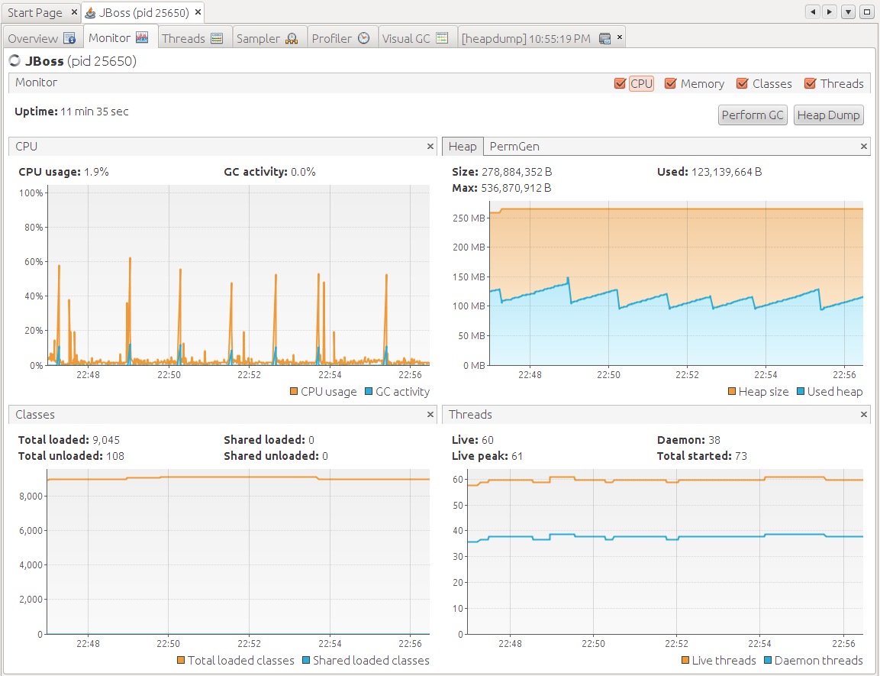

OS graphs

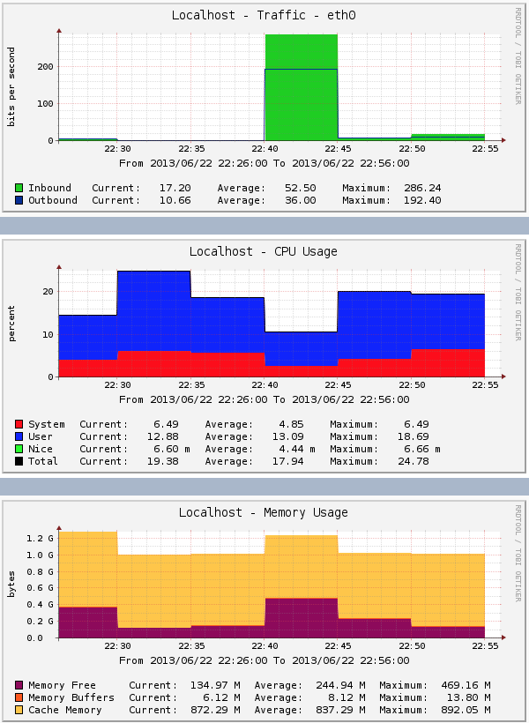

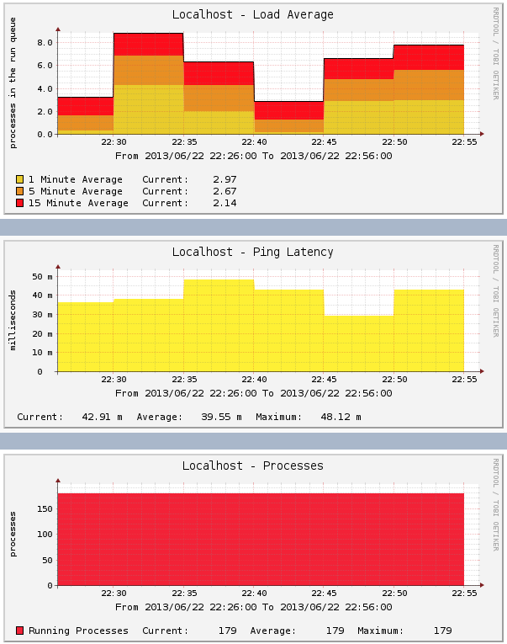

- stop jboss Sat Jun 22 22:59:10 IST 2013

- detach jvisualvm Sat Jun 22 22:59:10 IST 2013

GC gc.log.20130622-224451

- analyse exceptions:

## 2.8. Test case: interaction config8

- start jboss Sat Jun 22 23:01:09 IST 2013

- attach jvisualvm Sat Jun 22 23:02:13 IST 2013

- create heap dump heapdump-1371938546462.hprof

- run config8 Sat Jun 22 23:03:39 IST 2013

- create heap dump heapdump-1371938622700.hprof

- wait 2 mins

- run config8 Sat Jun 22 23:04:44 IST 2013

- create heap dump heapdump-1371938687974.hprof

- wait 2 mins

- run config8 Sat Jun 22 23:05:56 IST 2013

- create heap dump heapdump-1371938758639.hprof

- wait 2 mins

- run config8 Sat Jun 22 23:07:06 IST 2013

- create heap dump heapdump-1371938830174.hprof

- wait 2 mins

- run config8 Sat Jun 22 23:08:18 IST 2013

- create heap dump heapdump-1371938901111.hprof

- submitted config8 a lot of times in a row and generated heapdump heapdump-1371938994211.hprof

- get graphs for:

jvm cpu

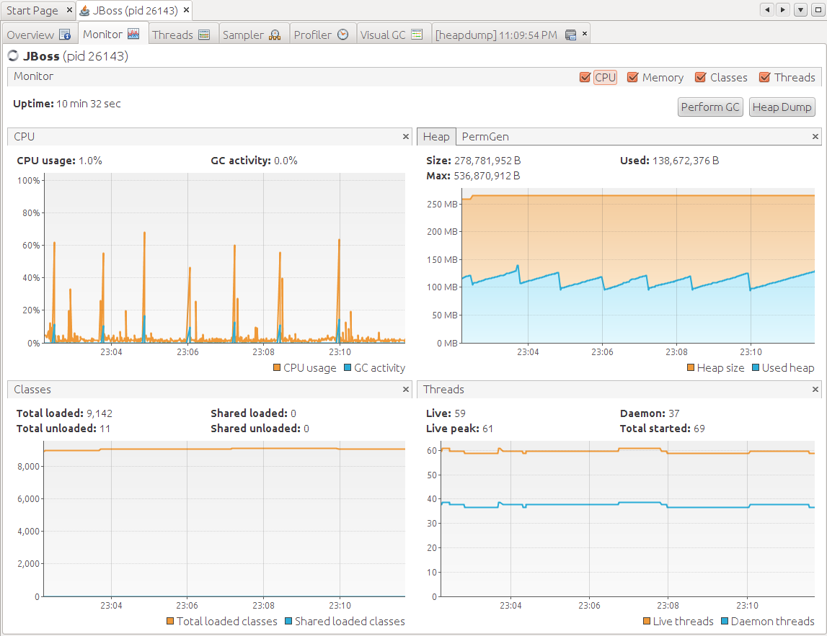

OS graphs

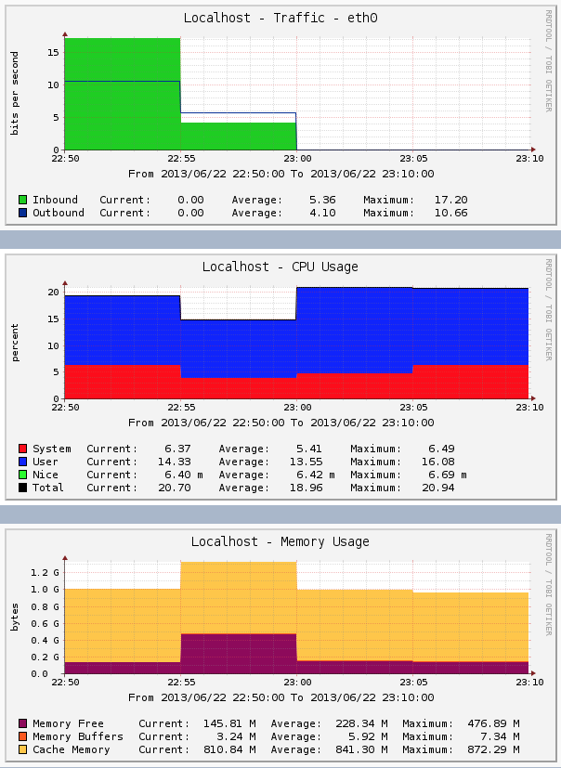

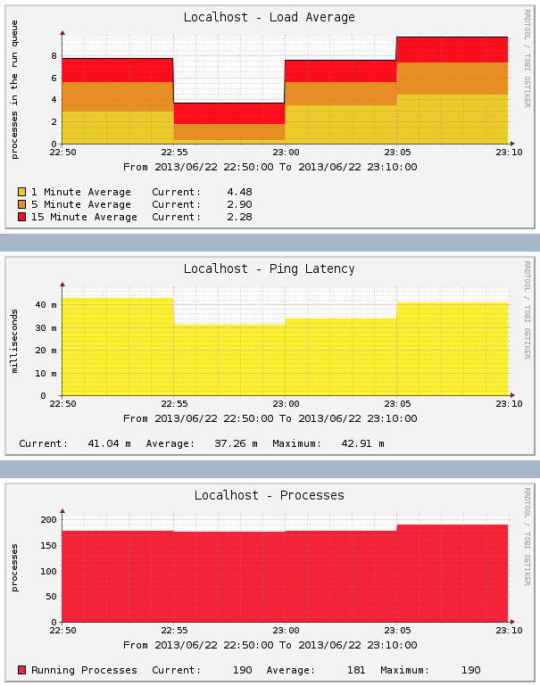

- stop jboss Sat Jun 22 23:13:35 IST 2013

- detach jvisualvm Sat Jun 22 23:13:35 IST 2013

GC gc.log.20130622-230109

- analyse exceptions:

## 2.9. Test case: interaction config 9

- start jboss Sat Jun 22 23:26:54 IST 2013

- attach jvisualvm Sat Jun 22 23:27:39 IST 2013

- create heap dump heapdump-1371940074770.hprof

- run config 9 Sat Jun 22 23:29:10 IST 2013

The Adaptive Cells EJBs have raised the exception:

null; nested exception is:

java.lang.RuntimeException

You might have configured the cells to raise exceptions. This can be done adding an environment entry (namely configXexception) to the deployment descriptors of the cell EJBs.

Testbed finished execution of configuration <config9>

Please check your application server's log for any errors and exceptions not explicitly generated by the EJB cells

- create heap dump heapdump-1371940154071.hprof

- wait 2 mins

- run config9 Sat Jun 22 23:30:20 IST 2013

- create heap dump heapdump-1371940223419.hprof

- wait 2 mins

- run config9 Sat Jun 22 23:31:27 IST 2013

- create heap dump heapdump-1371940290335.hprof

- wait 2 mins

- run config9 Sat Jun 22 23:32:32 IST 2013

- create heap dump heapdump-1371940357449.hprof

- wait 2 mins

- run config 9 Sat Jun 22 23:33:39 IST 2013

- create heap dump heapdump-1371940422002.hprof

- submitted config9 a lot of times in a row and generated heapdump heapdump-1371940542294.hprof

- get graphs for:

jvm cpu

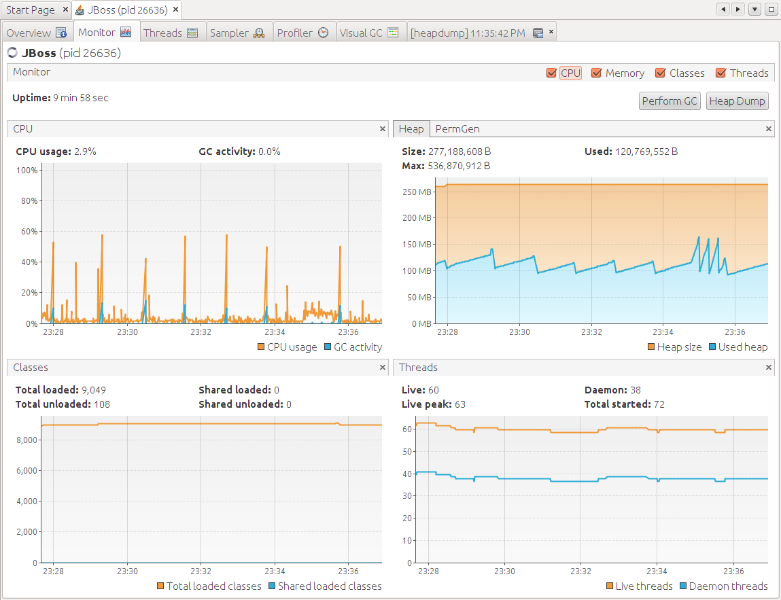

OS graphs

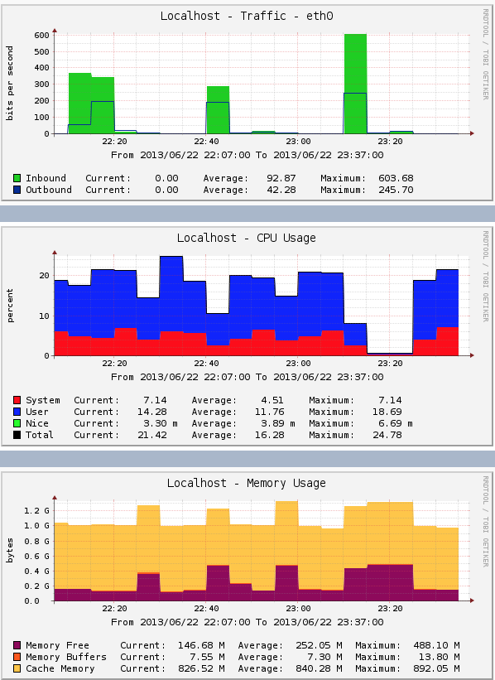

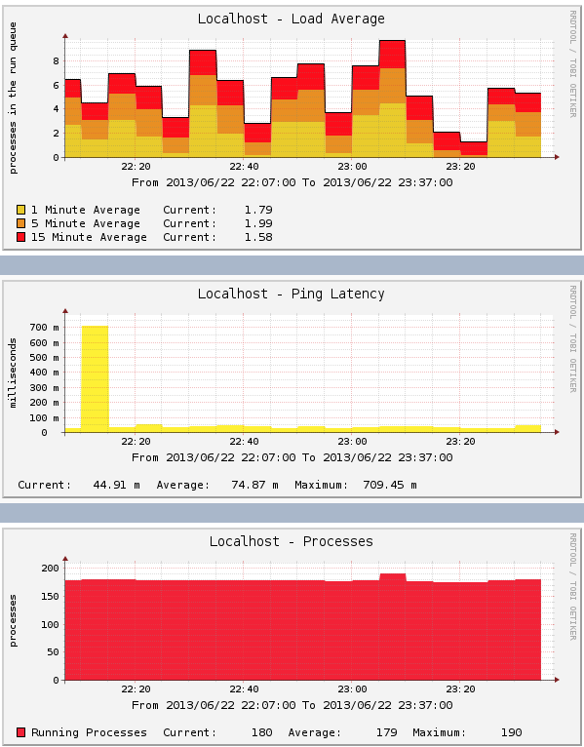

- stop jboss Sat Jun 22 23:39:03 IST 2013

- detach jvisualvm Sat Jun 22 23:39:03 IST 2013

GC gc.log.20130622-232654

- analyse exceptions:

## 2.10. Test case: interaction config10

- start jboss Sat Jun 22 23:40:37 IST 2013

- attach jvisualvm Sat Jun 22 23:41:20 IST 2013

- create heap dump heapdump-1371940894516.hprof

- run config10 Sat Jun 22 23:42:42 IST 2013

- create heap dump heapdump-1371940967608.hprof

- wait 2 mins

- run config10 Sat Jun 22 23:43:50 IST 2013

- create heap dump heapdump-1371941032725.hprof

- wait 2 mins

- run config10 Sat Jun 22 23:45:05 IST 2013

- create heap dump heapdump-1371941107689.hprof

- wait 2 mins

- run config10 Sat Jun 22 23:46:20 IST 2013

- create heap dump heapdump-1371941185426.hprof

- wait 2 mins

- run config10 Sat Jun 22 23:47:31 IST 2013

- create heap dump heapdump-1371941254997.hprof

- submitted config10 a lot of times in a row and generated heapdump heapdump-1371941353598.hprof

- get graphs for:

jvm cpu

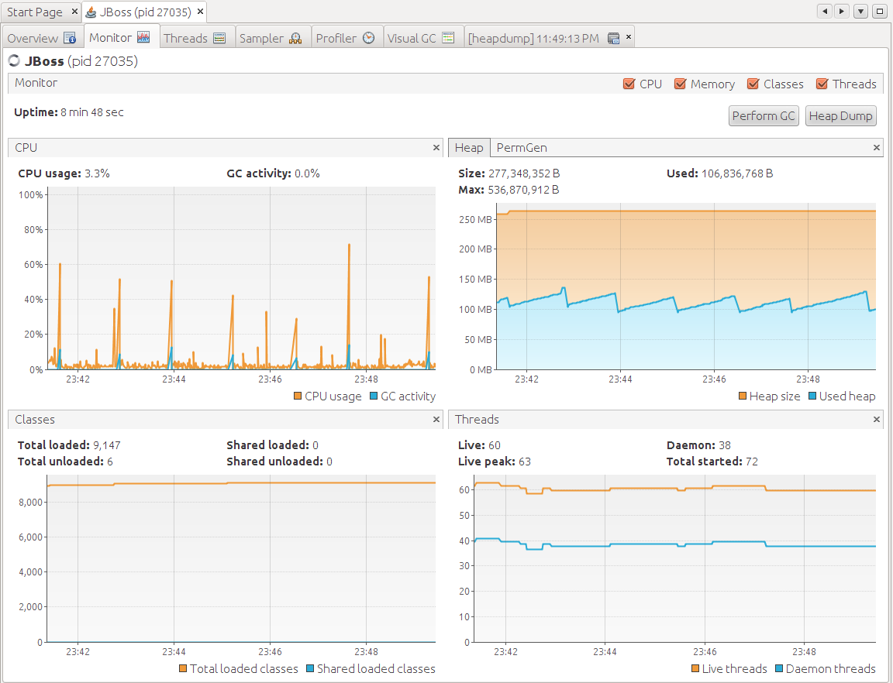

OS graphs

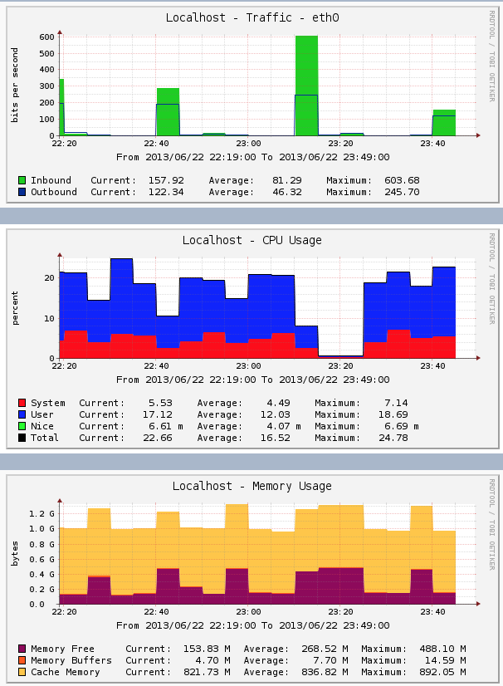

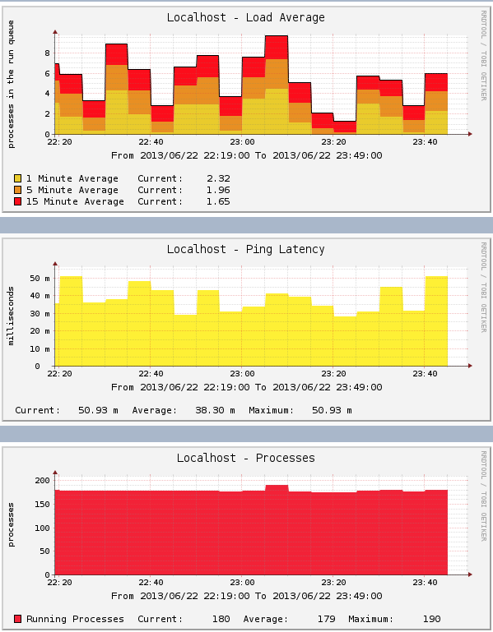

- stop jboss Sat Jun 22 23:52:07 IST 2013

- detach jvisualvm Sat Jun 22 23:52:07 IST 2013

GC gc.log.20130622-234037

- analyse exceptions:

## 2.. Test case: interaction config

- start jboss

- attach jvisualvm

- create heap dump

- run config

- create heap dump

- wait 2 mins

- run config

- create heap dump

- wait 2 mins

- run config

- create heap dump

- wait 2 mins

- run config

- create heap dump

- wait 2 mins

- run config

- create heap dump

- submitted config a lot of times in a row and generated heapdump

- get graphs for:

jvm cpu

OS graphs

- stop jboss

- detach jvisualvm

GC

- analyse exceptions: