Estimate
CUBE DESIGN

A-302, DEVAURM, PRAHLADNAGAR ROAD, AHMEDABAD, GUJARAT.
Phone no.: 9824754597
State : 24 - Gujarat
Estimate For |  |  |  | Estimate Details
PARMAR CHETNABEN  C 903 TIRUPATI TOWER NARLOL AHMEDABAD |  |  |  | Estimate No.:1118  Date: 01-10-2026
# | Item name | HSN/SAC | Quantity |  | Unit | Price/Unit | Amount
1 | Platform Marble Painting & Color Work |  | 1 |  |  | ₹1,25,000 | ₹1,25,000
2 | Furniture & Furnishing Work |  | 1 |  |  | ₹1,00,000 | ₹1,00,000
3 | Electrical, Lighting & Minor Repair Work |  | 1 |  |  | ₹45,000 | ₹45,000
4 | Final Finishing & Misc. Work |  | 1 |  |  | ₹30,000 | ₹30,000
 | Total |  |  |  |  |  | ₹3,00,000.00
 |  |  |  | Amounts
 |  |  |  | Subtotal |  |  | ₹3,00,000.00
 |  |  |  | Total ₹3,00,000.00
Estimate Amount in Words
Three Lakh Rupees Only
Terms and Conditions |  |  |  | For: CUBE DESIGN  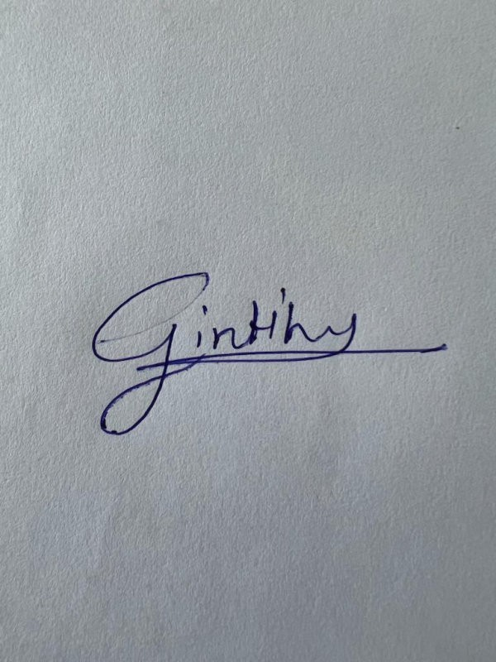  Authorized Signatory
Thanks for doing business with us!

