**JAVA SWING BASED – *SMART FARMING SYSTEMATIC APPROACH DATA MANAGEMENT SYSTEM’*- SQL**

**CONNECTIVITY USING JDBC**

*A*

*Report*

*Submitted in partial fulfillment of the*

*Requirements for the award of the Degree of*

**BACHELOR OF ENGINEERING IN**

**INFORMATION TECHNOLOGY**

**By**

**K.SaiArjun <1602-20-737-033>**

**Under the guidance of Ms B. Leelavathy**



**Department of Information Technology**

**Vasavi College of Engineering (Autonomous)**

**(Affiliated to Osmania University) Ibrahimbagh, Hyderabad-31**

**2020-2021**

# BONAFIDE CERTIFICATE

This is to certify that this project report titled

***‘ smart farming Systematic Approach data management system’***

is a project work of **K.SaiArjun** bearing

roll no. 1602-20-737-033 who carried out this

project under my supervision in the IV semester for the academic year 2020- 2021

|  |  |
| --- | --- |
| Signature | Signature |
| External Examiner | Internal Examiner |
|  |  |

**Smart farming**

**ABSTRACT**

Smart farming systematic approach data Management System is a console based project that connects farmers to the database with systematic approaches for farming so as to increase the yield by considering the type of land ,resources and external factors available for the land can provide the techniques or solutions for farmers.

**Requirement Analysis**

**List of Tables:**

-Farmer

-Land

-irrigation_methods

-Newcrop

**List of Attributes with their Domain Types:**

Farmer

fid varchar2(20) primary key

fname varchar2(20)

noof_acres_owned number(20)

Land

lid varchar2(10),

fid varchar2(20),

crop_grown varchar2(10),

irrigation_methods varchar2(20)

irrigation_methods

lid varchar2(20),

Technique varchar2(20),

amount_of_water varchar2(20),

water_supply_method varchar2(20));

New_crop

Ncrop_id varchar2(10),

reason varchar2(20),

suggestion varchar2(20));

**DDL COMMANDS**

**Table-1**

Create table farmer(

fid varchar2(20) primary key,

fname varchar2(20),

noof_acres_owned number(20));

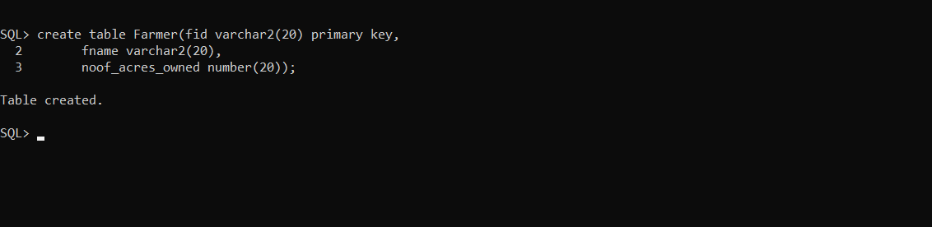

**Table-2**

Create table Land(

lid varchar2(10),

fid varchar2(20),

crop_grown varchar2(10),

irrigation_methods varchar2(20));

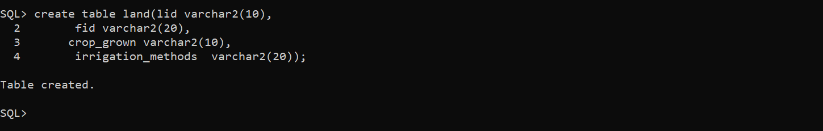

**Table-3**

create table irrigation_methods(

lid varchar2(10),

Technique varchar2(20),

water_supply_method varchar2(20));

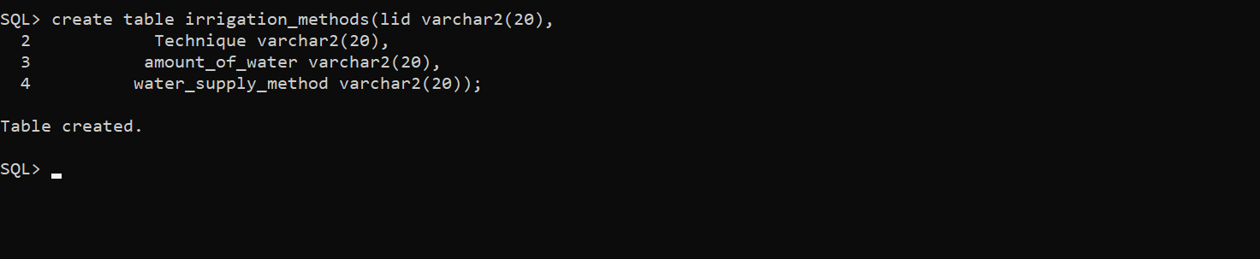

**Table-4**

Create table new_crop(

Ncrop_id varchar2(10),

reason varchar2(20),

suggestion varchar2(20));

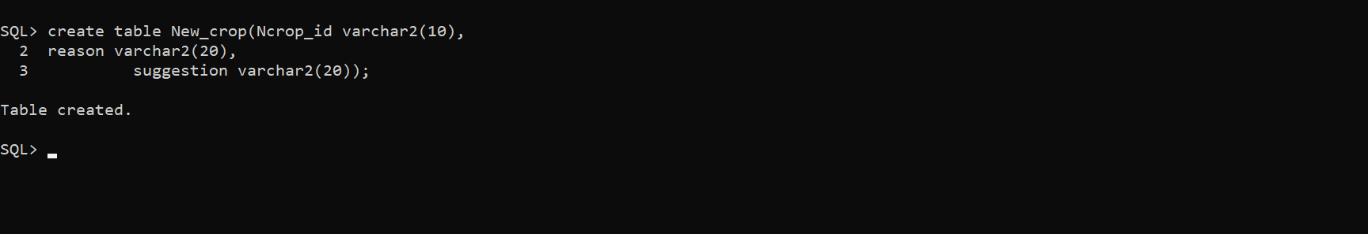

**DCL COMMANDS**

insert into farmer values('&fid','&fname',&noof_acres_owned);

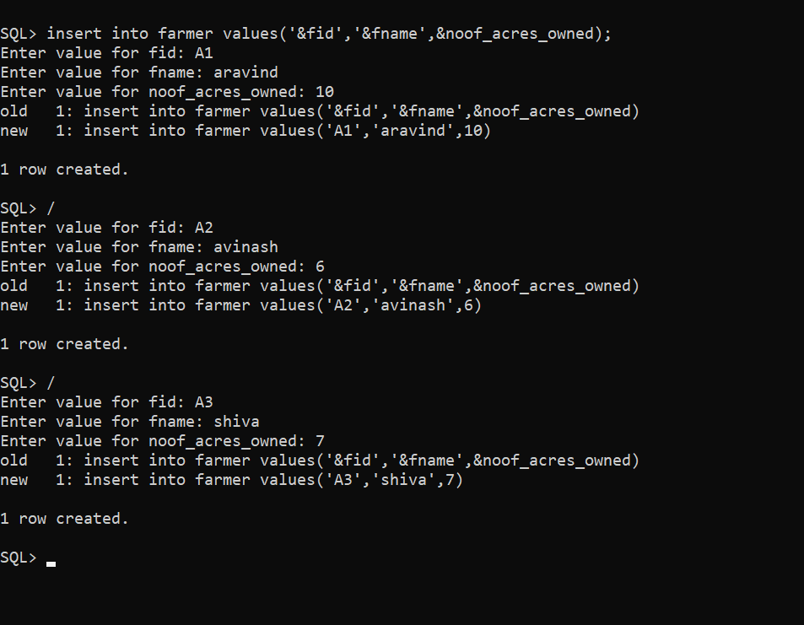

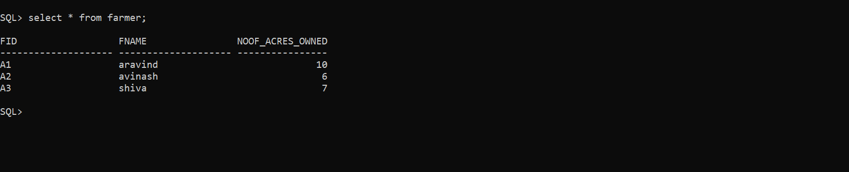

2.insert into Land values('&lid','&fid','&crop_grown','&irrigation_methods');

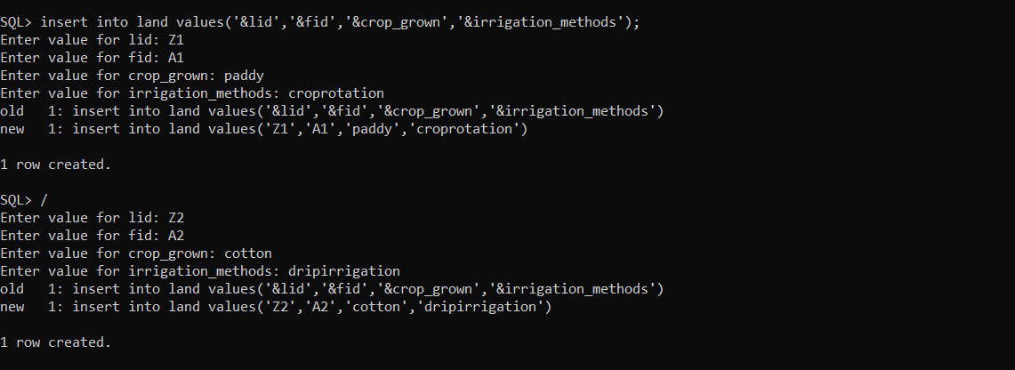

3.insert into Irrigation_methods values(‘&lid’,’&technique,’&amount_of_water’,’&water_supply_method);

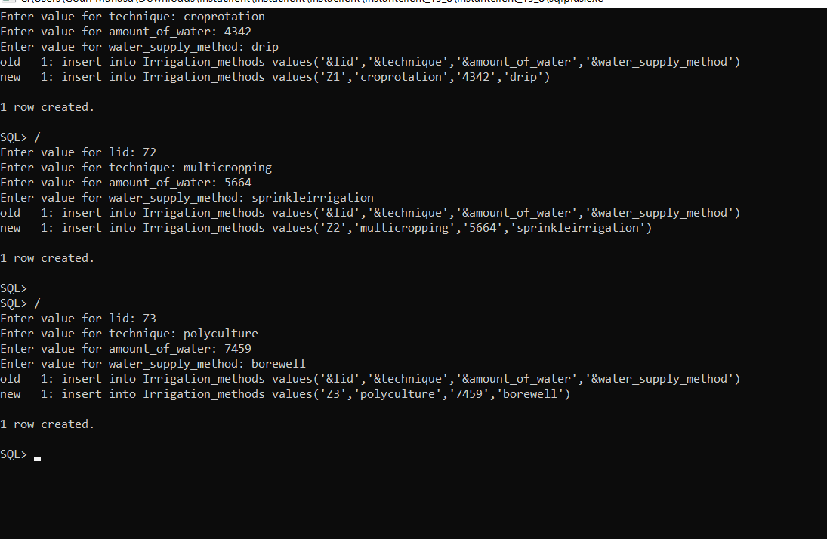

**IMPLEMENTATION**

**JAVA-SQL Connectivity using JDBC:**

**Java Database Connectivity (JDBC)** is an application programming interface (API) for the programming language Java, which defines how a client may access a database. It is a Java-based data access technology used for Java database connectivity. It is part of the Java Standard Edition platform, from Oracle Corporation. It provides methods to query and update data in a database and is oriented towards relational databases.

The connection to the database can be performed using Java programming (JDBC API) as:

import java.sql.Connection;

import java.sql.Driver;

import java.sql.DriverManager;

import java.sql.Statement;

private void jButton1ActionPerformed(java.awt.event.ActionEvent evt) {

Connection con =null;

try

{

Driver myDriver = new oracle.jdbc.driver.OracleDriver();

DriverManager.registerDriver( myDriver );

con = DriverManager.getConnection("jdbc:oracle:thin:@localhost:1521:XE", "manasa", "vasavi");

Statement stmt = con.createStatement();

String query= "INSERT INTO farmer VALUES(" + "'" +jTextField4.getText() + "',"+ "'" +jTextField2.getText() +"',"+"'"+ jTextField1.getText()+"')";

int i = stmt.executeUpdate(query);

System .out.println("Inserted ....");

stmt.close();

con.close();

}catch(Exception e){

System.out.println(e);

}

}

Main page

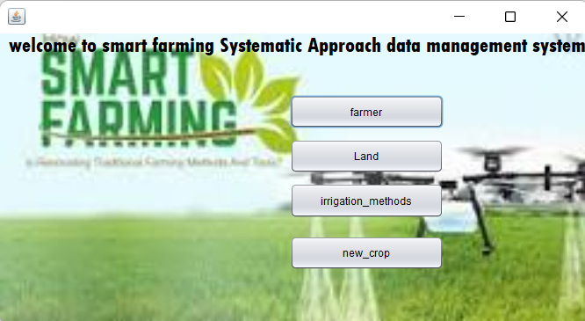

package smart.farming;

/**

*

* @author Gouri Manasa

*/

public class main extends javax.swing.JFrame {

/**

* Creates new form main

*/

public main() {

initComponents();

}

/**

* This method is called from within the constructor to initialize the form.

* WARNING: Do NOT modify this code. The content of this method is always

* regenerated by the Form Editor.

*/

@SuppressWarnings("unchecked")

// <editor-fold defaultstate="collapsed" desc="Generated Code">

private void initComponents() {

jButton4 = new javax.swing.JButton();

jLabel3 = new javax.swing.JLabel();

jButton1 = new javax.swing.JButton();

jButton2 = new javax.swing.JButton();

jButton3 = new javax.swing.JButton();

jButton5 = new javax.swing.JButton();

jLabel1 = new javax.swing.JLabel();

jLabel2 = new javax.swing.JLabel();

jButton4.setText("jButton4");

jLabel3.setText("jLabel3");

setDefaultCloseOperation(javax.swing.WindowConstants.EXIT_ON_CLOSE);

getContentPane().setLayout(new org.netbeans.lib.awtextra.AbsoluteLayout());

jButton1.setText("farmer");

jButton1.addActionListener(new java.awt.event.ActionListener() {

public void actionPerformed(java.awt.event.ActionEvent evt) {

jButton1ActionPerformed(evt);

}

});

getContentPane().add(jButton1, new org.netbeans.lib.awtextra.AbsoluteConstraints(330, 70, 175, 38));

jButton2.setText("new_crop");

jButton2.addActionListener(new java.awt.event.ActionListener() {

public void actionPerformed(java.awt.event.ActionEvent evt) {

jButton2ActionPerformed(evt);

}

});

getContentPane().add(jButton2, new org.netbeans.lib.awtextra.AbsoluteConstraints(330, 230, 175, 39));

jButton3.setText("irrigation_methods");

jButton3.addActionListener(new java.awt.event.ActionListener() {

public void actionPerformed(java.awt.event.ActionEvent evt) {

jButton3ActionPerformed(evt);

}

});

getContentPane().add(jButton3, new org.netbeans.lib.awtextra.AbsoluteConstraints(330, 170, 175, 40));

jButton5.setText("Land");

jButton5.addActionListener(new java.awt.event.ActionListener() {

public void actionPerformed(java.awt.event.ActionEvent evt) {

jButton5ActionPerformed(evt);

}

});

getContentPane().add(jButton5, new org.netbeans.lib.awtextra.AbsoluteConstraints(330, 120, 175, 39));

jLabel1.setFont(new java.awt.Font("Tw Cen MT Condensed Extra Bold", 0, 24)); // NOI18N

jLabel1.setText("welcome to smart farming Systematic Approach data management system");

getContentPane().add(jLabel1, new org.netbeans.lib.awtextra.AbsoluteConstraints(10, 0, -1, -1));

jLabel2.setIcon(new javax.swing.ImageIcon("C:\\Users\\Gouri Manasa\\Desktop\\DM pdfs\\g (1).jpg")); // NOI18N

getContentPane().add(jLabel2, new org.netbeans.lib.awtextra.AbsoluteConstraints(0, -30, 670, 360));

pack();

}// </editor-fold>

private void jButton1ActionPerformed(java.awt.event.ActionEvent evt) {

farmer f=new farmer();

f.show();

dispose();

// TODO add your handling code here:

}

private void jButton5ActionPerformed(java.awt.event.ActionEvent evt) {

Land l=new Land();

l.show();

dispose();

// TODO add your handling code here:

}

private void jButton3ActionPerformed(java.awt.event.ActionEvent evt) {

irrigation_methods i=new irrigation_methods();

i.show();

dispose();

// TODO add your handling code here:

}

private void jButton2ActionPerformed(java.awt.event.ActionEvent evt) {

new_crop n=new new_crop();

n.show();

dispose();

// TODO add your handling code here:

}

/**

* @param args the command line arguments

*/

public static void main(String args[]) {

/* Set the Nimbus look and feel */

//<editor-fold defaultstate="collapsed" desc=" Look and feel setting code (optional) ">

/* If Nimbus (introduced in Java SE 6) is not available, stay with the default look and feel.

* For details see http://download.oracle.com/javase/tutorial/uiswing/lookandfeel/plaf.html

*/

try {

for (javax.swing.UIManager.LookAndFeelInfo info : javax.swing.UIManager.getInstalledLookAndFeels()) {

if ("Nimbus".equals(info.getName())) {

javax.swing.UIManager.setLookAndFeel(info.getClassName());

break;

}

}

} catch (ClassNotFoundException ex) {

java.util.logging.Logger.getLogger(main.class.getName()).log(java.util.logging.Level.SEVERE, null, ex);

} catch (InstantiationException ex) {

java.util.logging.Logger.getLogger(main.class.getName()).log(java.util.logging.Level.SEVERE, null, ex);

} catch (IllegalAccessException ex) {

java.util.logging.Logger.getLogger(main.class.getName()).log(java.util.logging.Level.SEVERE, null, ex);

} catch (javax.swing.UnsupportedLookAndFeelException ex) {

java.util.logging.Logger.getLogger(main.class.getName()).log(java.util.logging.Level.SEVERE, null, ex);

}

//</editor-fold>

/* Create and display the form */

java.awt.EventQueue.invokeLater(new Runnable() {

public void run() {

new main().setVisible(true);

}

});

}

// Variables declaration - do not modify

private javax.swing.JButton jButton1;

private javax.swing.JButton jButton2;

private javax.swing.JButton jButton3;

private javax.swing.JButton jButton4;

private javax.swing.JButton jButton5;

private javax.swing.JLabel jLabel1;

private javax.swing.JLabel jLabel2;

private javax.swing.JLabel jLabel3;

// End of variables declaration

}

Farmer details

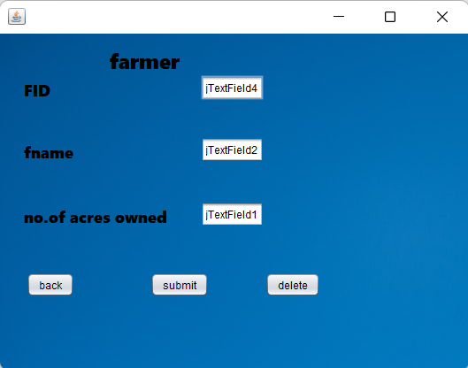

package smart.farming;

import java.sql.Connection;

import java.sql.Driver;

import java.sql.DriverManager;

import java.sql.ResultSet;

import java.sql.Statement;

public class farmer extends javax.swing.JFrame {

public farmer() {

initComponents();

}

private void initComponents() {

jTextField3 = new javax.swing.JTextField();

jButton3 = new javax.swing.JButton();

jLabel1 = new javax.swing.JLabel();

jLabel2 = new javax.swing.JLabel();

jLabel3 = new javax.swing.JLabel();

jButton1 = new javax.swing.JButton();

jTextField1 = new javax.swing.JTextField();

jTextField2 = new javax.swing.JTextField();

jTextField4 = new javax.swing.JTextField();

jLabel4 = new javax.swing.JLabel();

jButton2 = new javax.swing.JButton();

jButton4 = new javax.swing.JButton();

jLabel6 = new javax.swing.JLabel();

jTextField3.setText("jTextField3");

jButton3.setText("jButton3");

setDefaultCloseOperation(javax.swing.WindowConstants.EXIT_ON_CLOSE);

getContentPane().setLayout(new org.netbeans.lib.awtextra.AbsoluteLayout());

jLabel1.setFont(new java.awt.Font("Segoe UI Black", 0, 18)); // NOI18N

jLabel1.setText("FID");

getContentPane().add(jLabel1, new org.netbeans.lib.awtextra.AbsoluteConstraints(27, 51, -1, -1));

jLabel2.setFont(new java.awt.Font("Segoe UI Black", 0, 18)); // NOI18N

jLabel2.setText("fname");

getContentPane().add(jLabel2, new org.netbeans.lib.awtextra.AbsoluteConstraints(27, 121, -1, -1));

jLabel3.setFont(new java.awt.Font("Segoe UI Black", 0, 18)); // NOI18N

jLabel3.setText("no.of acres owned");

getContentPane().add(jLabel3, new org.netbeans.lib.awtextra.AbsoluteConstraints(27, 194, -1, -1));

jButton1.setText("submit");

jButton1.addActionListener(new java.awt.event.ActionListener() {

public void actionPerformed(java.awt.event.ActionEvent evt) {

jButton1ActionPerformed(evt);

}

});

getContentPane().add(jButton1, new org.netbeans.lib.awtextra.AbsoluteConstraints(170, 270, -1, -1));

jTextField1.setText("jTextField1");

getContentPane().add(jTextField1, new org.netbeans.lib.awtextra.AbsoluteConstraints(227, 190, -1, -1));

jTextField2.setText("jTextField2");

getContentPane().add(jTextField2, new org.netbeans.lib.awtextra.AbsoluteConstraints(227, 117, -1, -1));

jTextField4.setText("jTextField4");

jTextField4.addActionListener(new java.awt.event.ActionListener() {

public void actionPerformed(java.awt.event.ActionEvent evt) {

jTextField4ActionPerformed(evt);

}

});

getContentPane().add(jTextField4, new org.netbeans.lib.awtextra.AbsoluteConstraints(227, 47, -1, -1));

jLabel4.setFont(new java.awt.Font("Segoe UI Black", 0, 24)); // NOI18N

jLabel4.setText("farmer");

getContentPane().add(jLabel4, new org.netbeans.lib.awtextra.AbsoluteConstraints(124, 14, -1, -1));

jButton2.setText("back");

jButton2.addActionListener(new java.awt.event.ActionListener() {

public void actionPerformed(java.awt.event.ActionEvent evt) {

jButton2ActionPerformed(evt);

}

});

getContentPane().add(jButton2, new org.netbeans.lib.awtextra.AbsoluteConstraints(30, 270, -1, -1));

jButton4.setText("delete");

jButton4.addActionListener(new java.awt.event.ActionListener() {

public void actionPerformed(java.awt.event.ActionEvent evt) {

jButton4ActionPerformed(evt);

}

});

getContentPane().add(jButton4, new org.netbeans.lib.awtextra.AbsoluteConstraints(300, 270, -1, -1));

jLabel6.setIcon(new javax.swing.ImageIcon("C:\\Users\\Gouri Manasa\\Desktop\\DM pdfs\\rr.jpg")); // NOI18N

getContentPane().add(jLabel6, new org.netbeans.lib.awtextra.AbsoluteConstraints(0, 0, 530, 380));

pack();

}// </editor-fold>

private void jButton1ActionPerformed(java.awt.event.ActionEvent evt) {

Connection con =null;

try

{

Driver myDriver = new oracle.jdbc.driver.OracleDriver();

DriverManager.registerDriver( myDriver );

con = DriverManager.getConnection("jdbc:oracle:thin:@localhost:1521:XE", "manasa", "vasavi");

Statement stmt = con.createStatement();

String query= "INSERT INTO farmer VALUES(" + "'" +jTextField4.getText() + "',"+ "'" +jTextField2.getText() +"',"+"'"+ jTextField1.getText()+"')";

int i = stmt.executeUpdate(query);

System .out.println("Inserted ....");

stmt.close();

con.close();

}catch(Exception e){

System.out.println(e);

}

}

private void jButton2ActionPerformed(java.awt.event.ActionEvent evt) {

this.hide();

main m=new main();

m.show();

dispose();

}

private void jTextField4ActionPerformed(java.awt.event.ActionEvent evt) {

// TODO add your handling code here:

}

private void jButton4ActionPerformed(java.awt.event.ActionEvent evt) {

try

{

DriverManager.registerDriver(new oracle.jdbc.driver.OracleDriver());

// Connect to Oracle Database

Connection con = DriverManager.getConnection("jdbc:oracle:thin:@localhost:1521:XE", "manasa", "vasavi");

Statement statement = con.createStatement();

String query= "DELETE from farmer where fid='"+jTextField4.getText()+"'";

ResultSet rs = statement.executeQuery(query);

System .out.println("deleted");

rs.close();

statement.close();

con.close();

}

catch(Exception e){

System.out.println(e);

}

}

/**

* @param args the command line arguments

*/

public static void main(String args[]) {

/* Set the Nimbus look and feel */

//<editor-fold defaultstate="collapsed" desc=" Look and feel setting code (optional) ">

/* If Nimbus (introduced in Java SE 6) is not available, stay with the default look and feel.

* For details see http://download.oracle.com/javase/tutorial/uiswing/lookandfeel/plaf.html

*/

try {

for (javax.swing.UIManager.LookAndFeelInfo info : javax.swing.UIManager.getInstalledLookAndFeels()) {

if ("Nimbus".equals(info.getName())) {

javax.swing.UIManager.setLookAndFeel(info.getClassName());

break;

}

}

} catch (ClassNotFoundException ex) {

java.util.logging.Logger.getLogger(farmer.class.getName()).log(java.util.logging.Level.SEVERE, null, ex);

} catch (InstantiationException ex) {

java.util.logging.Logger.getLogger(farmer.class.getName()).log(java.util.logging.Level.SEVERE, null, ex);

} catch (IllegalAccessException ex) {

java.util.logging.Logger.getLogger(farmer.class.getName()).log(java.util.logging.Level.SEVERE, null, ex);

} catch (javax.swing.UnsupportedLookAndFeelException ex) {

java.util.logging.Logger.getLogger(farmer.class.getName()).log(java.util.logging.Level.SEVERE, null, ex);

}

//</editor-fold>

/* Create and display the form */

java.awt.EventQueue.invokeLater(new Runnable() {

public void run() {

new farmer().setVisible(true);

}

});

}

// Variables declaration - do not modify

private javax.swing.JButton jButton1;

private javax.swing.JButton jButton2;

private javax.swing.JButton jButton3;

private javax.swing.JButton jButton4;

private javax.swing.JLabel jLabel1;

private javax.swing.JLabel jLabel2;

private javax.swing.JLabel jLabel3;

private javax.swing.JLabel jLabel4;

private javax.swing.JLabel jLabel6;

private javax.swing.JTextField jTextField1;

private javax.swing.JTextField jTextField2;

private javax.swing.JTextField jTextField3;

private javax.swing.JTextField jTextField4;

// End of variables declaration

}

Land

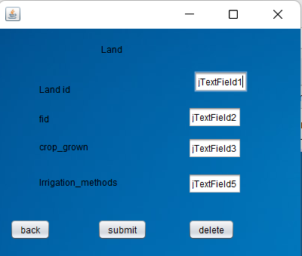

package smart.farming;

import java.sql.Connection;

import java.sql.Driver;

import java.sql.DriverManager;

import java.sql.ResultSet;

import java.sql.Statement;

public class Land extends javax.swing.JFrame {

public Land() {

initComponents();

}

private void initComponents() {

jLabel4 = new javax.swing.JLabel();

jButton2 = new javax.swing.JButton();

textField1 = new java.awt.TextField();

jTextField4 = new javax.swing.JTextField();

jLabel1 = new javax.swing.JLabel();

jLabel2 = new javax.swing.JLabel();

jLabel3 = new javax.swing.JLabel();

jButton1 = new javax.swing.JButton();

jLabel5 = new javax.swing.JLabel();

jLabel6 = new javax.swing.JLabel();

jLabel7 = new javax.swing.JLabel();

jButton3 = new javax.swing.JButton();

jTextField1 = new javax.swing.JTextField();

jTextField2 = new javax.swing.JTextField();

jTextField3 = new javax.swing.JTextField();

jTextField5 = new javax.swing.JTextField();

jButton4 = new javax.swing.JButton();

jLabel8 = new javax.swing.JLabel();

jLabel4.setText("jLabel4");

jButton2.setText("jButton2");

textField1.setText("textField1");

textField1.addActionListener(new java.awt.event.ActionListener() {

public void actionPerformed(java.awt.event.ActionEvent evt) {

textField1ActionPerformed(evt);

}

});

jTextField4.setText("jTextField4"); setDefaultCloseOperation(javax.swing.WindowConstants.EXIT_ON_CLOSE);

getContentPane().setLayout(new org.netbeans.lib.awtextra.AbsoluteLayout());

jLabel1.setText("Land");

getContentPane().add(jLabel1, new org.netbeans.lib.awtextra.AbsoluteConstraints(136, 19, -1, -1));

jLabel2.setText("Land id");

getContentPane().add(jLabel2, new org.netbeans.lib.awtextra.AbsoluteConstraints(54, 72, 150, -1));

getContentPane().add(jLabel3, new org.netbeans.lib.awtextra.AbsoluteConstraints(171, 138, 33, -1));

jButton1.setText("submit");

jButton1.addActionListener(new java.awt.event.ActionListener() {

public void actionPerformed(java.awt.event.ActionEvent evt) {

jButton1ActionPerformed(evt);

}

});

getContentPane().add(jButton1, new org.netbeans.lib.awtextra.AbsoluteConstraints(131, 252, -1, -1));

jLabel5.setText("Irrigation_methods");

getContentPane().add(jLabel5, new org.netbeans.lib.awtextra.AbsoluteConstraints(54, 195, 150, -1));

jLabel6.setText("crop_grown");

getContentPane().add(jLabel6, new org.netbeans.lib.awtextra.AbsoluteConstraints(54, 148, -1, -1));

jLabel7.setText("fid");

getContentPane().add(jLabel7, new org.netbeans.lib.awtextra.AbsoluteConstraints(54, 111, -1, -1));

jButton3.setText("back");

jButton3.addActionListener(new java.awt.event.ActionListener() {

public void actionPerformed(java.awt.event.ActionEvent evt) {

jButton3ActionPerformed(evt);

}

});

getContentPane().add(jButton3, new org.netbeans.lib.awtextra.AbsoluteConstraints(15, 252, -1, -1));

jTextField1.setText("jTextField1");

getContentPane().add(jTextField1, new org.netbeans.lib.awtextra.AbsoluteConstraints(250, 60, -1, -1));

jTextField2.setText("jTextField2");

getContentPane().add(jTextField2, new org.netbeans.lib.awtextra.AbsoluteConstraints(251, 103, -1, -1));

jTextField3.setText("jTextField3");

getContentPane().add(jTextField3, new org.netbeans.lib.awtextra.AbsoluteConstraints(251, 144, -1, -1));

jTextField5.setText("jTextField5");

getContentPane().add(jTextField5, new org.netbeans.lib.awtextra.AbsoluteConstraints(251, 191, -1, -1));

jButton4.setText("delete");

jButton4.addActionListener(new java.awt.event.ActionListener() {

public void actionPerformed(java.awt.event.ActionEvent evt) {

jButton4ActionPerformed(evt);

}

});

getContentPane().add(jButton4, new org.netbeans.lib.awtextra.AbsoluteConstraints(251, 252, -1, -1));

jLabel8.setIcon(new javax.swing.ImageIcon("C:\\Users\\Gouri Manasa\\Desktop\\DM pdfs\\rr.jpg"));

getContentPane().add(jLabel8, new org.netbeans.lib.awtextra.AbsoluteConstraints(0, 0, 400, 310));

pack();

}

private void textField1ActionPerformed(java.awt.event.ActionEvent evt) {

}

private void jButton3ActionPerformed(java.awt.event.ActionEvent evt) {

this.hide();

main m=new main();

m.show();

dispose();

}

private void jButton1ActionPerformed(java.awt.event.ActionEvent evt) {

Connection con =null;

try

{

Driver myDriver = new oracle.jdbc.driver.OracleDriver();

DriverManager.registerDriver( myDriver );

con = DriverManager.getConnection("jdbc:oracle:thin:@localhost:1521:XE", "manasa", "vasavi");

Statement stmt = con.createStatement();

String query= "INSERT INTO Land VALUES( "+jTextField1.getText() + ","+ "'" +jTextField2.getText() +"',"+ "'"+jTextField3.getText() +"',+"+"'"+ jTextField5.getText()+"'" +")";

int i = stmt.executeUpdate(query);

System .out.println("Inserted ....");

stmt.close();

con.close();

}catch(Exception e){

System.out.println(e);

}

}

private void jButton4ActionPerformed(java.awt.event.ActionEvent evt) {

try

{

DriverManager.registerDriver(new oracle.jdbc.driver.OracleDriver());

Connection con = DriverManager.getConnection("jdbc:oracle:thin:@localhost:1521:XE", "manasa", "vasavi");

Statement statement = con.createStatement();

String query= "DELETE from Land where fid='"+jTextField2.getText()+"'";

ResultSet rs = statement.executeQuery(query);

System .out.println("deleted");

rs.close();

statement.close();

con.close();

}

catch(Exception e){

System.out.println(e);

}

}

try {

for (javax.swing.UIManager.LookAndFeelInfo info : javax.swing.UIManager.getInstalledLookAndFeels()) {

if ("Nimbus".equals(info.getName())) {

javax.swing.UIManager.setLookAndFeel(info.getClassName());

break;

}

}

} catch (ClassNotFoundException ex) {

java.util.logging.Logger.getLogger(Land.class.getName()).log(java.util.logging.Level.SEVERE, null, ex);

}

catch (InstantiationException ex) { java.util.logging.Logger.getLogger(Land.class.getName()).log(java.util.logging.Level.SEVERE, null, ex);

} catch (IllegalAccessException ex) {

java.util.logging.Logger.getLogger(Land.class.getName()).log(java.util.logging.Level.SEVERE, null, ex);

} catch (javax.swing.UnsupportedLookAndFeelException ex) {

java.util.logging.Logger.getLogger(Land.class.getName()).log(java.util.logging.Level.SEVERE, null, ex);

}

java.awt.EventQueue.invokeLater(new Runnable() {

public void run() {

new Land().setVisible(true);

}

});

}

private javax.swing.JButton jButton1;

private javax.swing.JButton jButton2;

private javax.swing.JButton jButton3;

private javax.swing.JButton jButton4;

private javax.swing.JLabel jLabel1;

private javax.swing.JLabel jLabel2;

private javax.swing.JLabel jLabel3;

private javax.swing.JLabel jLabel4;

private javax.swing.JLabel jLabel5;

private javax.swing.JLabel jLabel6;

private javax.swing.JLabel jLabel7;

private javax.swing.JLabel jLabel8;

private javax.swing.JTextField jTextField1;

private javax.swing.JTextField jTextField2;

private javax.swing.JTextField jTextField3;

private javax.swing.JTextField jTextField4;

private javax.swing.JTextField jTextField5;

private java.awt.TextField textField1;

}

Irrigation_methods

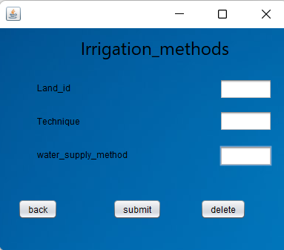

package smart.farming;

import java.sql.Connection;

import java.sql.Driver;

import java.sql.DriverManager;

import java.sql.ResultSet;

import java.sql.Statement;

public class irrigation_methods extends javax.swing.JFrame {

public irrigation_methods() {

initComponents();

}

private void initComponents() {

jLabel1 = new javax.swing.JLabel();

jLabel2 = new javax.swing.JLabel();

jLabel3 = new javax.swing.JLabel();

jLabel4 = new javax.swing.JLabel();

jTextField1 = new javax.swing.JTextField();

jTextField2 = new javax.swing.JTextField();

jTextField3 = new javax.swing.JTextField();

jButton1 = new javax.swing.JButton();

jButton2 = new javax.swing.JButton();

jButton3 = new javax.swing.JButton();

jLabel5 = new javax.swing.JLabel();

setDefaultCloseOperation(javax.swing.WindowConstants.EXIT_ON_CLOSE);

getContentPane().setLayout(new org.netbeans.lib.awtextra.AbsoluteLayout());

jLabel1.setFont(new java.awt.Font("Segoe UI", 0, 24)); // NOI18N

jLabel1.setText("Irrigation_methods");

getContentPane().add(jLabel1, new org.netbeans.lib.awtextra.AbsoluteConstraints(110, 10, -1, -1));

jLabel2.setText("Land_id");

getContentPane().add(jLabel2, new org.netbeans.lib.awtextra.AbsoluteConstraints(51, 72, -1, -1));

jLabel3.setText("Technique");

getContentPane().add(jLabel3, new org.netbeans.lib.awtextra.AbsoluteConstraints(51, 119, -1, 13));

jLabel4.setText("water_supply_method");

getContentPane().add(jLabel4, new org.netbeans.lib.awtextra.AbsoluteConstraints(51, 162, -1, -1));

jTextField1.setText("jTextField1");

getContentPane().add(jTextField1, new org.netbeans.lib.awtextra.AbsoluteConstraints(297, 68, -1, -1));

jTextField2.setText("jTextField2");

getContentPane().add(jTextField2, new org.netbeans.lib.awtextra.AbsoluteConstraints(297, 111, -1, -1));

jTextField3.setText("jTextField3");

getContentPane().add(jTextField3, new org.netbeans.lib.awtextra.AbsoluteConstraints(297, 158, -1, -1));

jButton1.setText("submit");

jButton1.addActionListener(new java.awt.event.ActionListener() {

public void actionPerformed(java.awt.event.ActionEvent evt) {

jButton1ActionPerformed(evt);

}

});

getContentPane().add(jButton1, new org.netbeans.lib.awtextra.AbsoluteConstraints(153, 230, -1, -1));

jButton2.setText("back");

jButton2.addActionListener(new java.awt.event.ActionListener() {

public void actionPerformed(java.awt.event.ActionEvent evt) {

jButton2ActionPerformed(evt);

}

});

getContentPane().add(jButton2, new org.netbeans.lib.awtextra.AbsoluteConstraints(25, 230, -1, -1));

jButton3.setText("delete");

jButton3.addActionListener(new java.awt.event.ActionListener() {

public void actionPerformed(java.awt.event.ActionEvent evt) {

jButton3ActionPerformed(evt);

}

});

getContentPane().add(jButton3, new org.netbeans.lib.awtextra.AbsoluteConstraints(271, 230, -1, -1));

jLabel5.setIcon(new javax.swing.ImageIcon("C:\\Users\\Gouri Manasa\\Desktop\\DM pdfs\\rr.jpg")); // NOI18N

getContentPane().add(jLabel5, new org.netbeans.lib.awtextra.AbsoluteConstraints(0, 0, 390, 300));

pack();

}

private void jButton2ActionPerformed(java.awt.event.ActionEvent evt) {

this.hide();

main m=new main();

m.show();

dispose();

}

private void jButton1ActionPerformed(java.awt.event.ActionEvent evt) {

Connection con =null;

try

{

Driver myDriver = new oracle.jdbc.driver.OracleDriver();

DriverManager.registerDriver( myDriver );

con = DriverManager.getConnection("jdbc:oracle:thin:@localhost:1521:XE", "manasa", "vasavi");

Statement stmt = con.createStatement();

String query= "INSERT INTO Irrigation_methods VALUES(" + "'" +jTextField1.getText() + "',"+ "'" +jTextField2.getText() +"',"+"'"+ jTextField3.getText()+"')";

int i = stmt.executeUpdate(query);

System .out.println("Inserted ....");

stmt.close();

con.close();

}catch(Exception e){

System.out.println(e);

}

// TODO add your handling code here:

// TODO add your handling code here:

}

private void jButton3ActionPerformed(java.awt.event.ActionEvent evt) {

try

{

DriverManager.registerDriver(new oracle.jdbc.driver.OracleDriver());

// Connect to Oracle Database

Connection con = DriverManager.getConnection("jdbc:oracle:thin:@localhost:1521:XE", "manasa", "vasavi");

Statement statement = con.createStatement();

String query= "DELETE from irrigation_methods where lid='"+jTextField1.getText()+"'";

ResultSet rs = statement.executeQuery(query);

System .out.println("deleted");

rs.close();

statement.close();

con.close();

}

catch(Exception e){

System.out.println(e);

}

// TODO add your handling code here:

}

/**

* @param args the command line arguments

*/

public static void main(String args[]) {

/* Set the Nimbus look and feel */

//<editor-fold defaultstate="collapsed" desc=" Look and feel setting code (optional) ">

/* If Nimbus (introduced in Java SE 6) is not available, stay with the default look and feel.

* For details see http://download.oracle.com/javase/tutorial/uiswing/lookandfeel/plaf.html

*/

try {

for (javax.swing.UIManager.LookAndFeelInfo info : javax.swing.UIManager.getInstalledLookAndFeels()) {

if ("Nimbus".equals(info.getName())) {

javax.swing.UIManager.setLookAndFeel(info.getClassName());

break;

}

}

} catch (ClassNotFoundException ex) {

java.util.logging.Logger.getLogger(irrigation_methods.class.getName()).log(java.util.logging.Level.SEVERE, null, ex);

} catch (InstantiationException ex) {

java.util.logging.Logger.getLogger(irrigation_methods.class.getName()).log(java.util.logging.Level.SEVERE, null, ex);

} catch (IllegalAccessException ex) {

java.util.logging.Logger.getLogger(irrigation_methods.class.getName()).log(java.util.logging.Level.SEVERE, null, ex);

} catch (javax.swing.UnsupportedLookAndFeelException ex) {

java.util.logging.Logger.getLogger(irrigation_methods.class.getName()).log(java.util.logging.Level.SEVERE, null, ex);

}

//</editor-fold>

/* Create and display the form */

java.awt.EventQueue.invokeLater(new Runnable() {

public void run() {

new irrigation_methods().setVisible(true);

}

});

}

// Variables declaration - do not modify

private javax.swing.JButton jButton1;

private javax.swing.JButton jButton2;

private javax.swing.JButton jButton3;

private javax.swing.JLabel jLabel1;

private javax.swing.JLabel jLabel2;

private javax.swing.JLabel jLabel3;

private javax.swing.JLabel jLabel4;

private javax.swing.JLabel jLabel5;

private javax.swing.JTextField jTextField1;

private javax.swing.JTextField jTextField2;

private javax.swing.JTextField jTextField3;

// End of variables declaration

}

New_crop

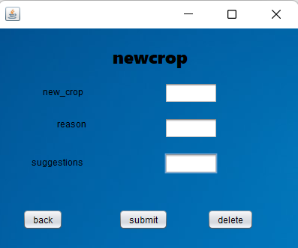

package smart.farming;

import java.sql.Connection;

import java.sql.Driver;

import java.sql.DriverManager;

import java.sql.ResultSet;

import java.sql.Statement;

public class new_crop extends javax.swing.JFrame {

public new_crop() {

initComponents();

}

private void initComponents() {

jLabel1 = new javax.swing.JLabel();

jLabel2 = new javax.swing.JLabel();

jLabel3 = new javax.swing.JLabel();

jTextField1 = new javax.swing.JTextField();

jTextField2 = new javax.swing.JTextField();

jTextField3 = new javax.swing.JTextField();

jLabel4 = new javax.swing.JLabel();

jButton1 = new javax.swing.JButton();

jButton2 = new javax.swing.JButton();

jButton3 = new javax.swing.JButton();

jLabel5 = new javax.swing.JLabel();

setDefaultCloseOperation(javax.swing.WindowConstants.EXIT_ON_CLOSE);

getContentPane().setLayout(new org.netbeans.lib.awtextra.AbsoluteLayout());

jLabel1.setText("new_crop");

getContentPane().add(jLabel1, new org.netbeans.lib.awtextra.AbsoluteConstraints(59, 76, -1, -1));

jLabel2.setText("reason");

getContentPane().add(jLabel2, new org.netbeans.lib.awtextra.AbsoluteConstraints(78, 119, -1, -1));

jLabel3.setText("suggestions");

getContentPane().add(jLabel3, new org.netbeans.lib.awtextra.AbsoluteConstraints(44, 170, -1, -1));

jTextField1.setText("jTextField1");

getContentPane().add(jTextField1, new org.netbeans.lib.awtextra.AbsoluteConstraints(221, 72, -1, -1));

jTextField2.setText("jTextField2");

getContentPane().add(jTextField2, new org.netbeans.lib.awtextra.AbsoluteConstraints(221, 119, -1, -1));

jTextField3.setText("jTextField3");

getContentPane().add(jTextField3, new org.netbeans.lib.awtextra.AbsoluteConstraints(221, 166, -1, -1));

jLabel4.setFont(new java.awt.Font("Segoe UI Black", 0, 24)); // NOI18N

jLabel4.setText("newcrop");

getContentPane().add(jLabel4, new org.netbeans.lib.awtextra.AbsoluteConstraints(152, 21, -1, -1));

jButton1.setText("submit");

jButton1.addActionListener(new java.awt.event.ActionListener() {

public void actionPerformed(java.awt.event.ActionEvent evt) {

jButton1ActionPerformed(evt);

}

});

getContentPane().add(jButton1, new org.netbeans.lib.awtextra.AbsoluteConstraints(160, 241, -1, -1));

jButton2.setText("back");

jButton2.addActionListener(new java.awt.event.ActionListener() {

public void actionPerformed(java.awt.event.ActionEvent evt) {

jButton2ActionPerformed(evt);

}

});

getContentPane().add(jButton2, new org.netbeans.lib.awtextra.AbsoluteConstraints(32, 241, -1, -1));

jButton3.setText("delete");

jButton3.addActionListener(new java.awt.event.ActionListener() {

public void actionPerformed(java.awt.event.ActionEvent evt) {

jButton3ActionPerformed(evt);

}

});

getContentPane().add(jButton3, new org.netbeans.lib.awtextra.AbsoluteConstraints(278, 241, -1, -1));

jLabel5.setIcon(new javax.swing.ImageIcon("C:\\Users\\Gouri Manasa\\Desktop\\DM pdfs\\rr.jpg")); // NOI18N

getContentPane().add(jLabel5, new org.netbeans.lib.awtextra.AbsoluteConstraints(0, 0, 400, 300));

pack();

}// </editor-fold>

private void jButton1ActionPerformed(java.awt.event.ActionEvent evt) {

Connection con =null;

try

{

Driver myDriver = new oracle.jdbc.driver.OracleDriver();

DriverManager.registerDriver( myDriver );

con = DriverManager.getConnection("jdbc:oracle:thin:@localhost:1521:XE", "manasa", "vasavi");

Statement stmt = con.createStatement();

String query= "INSERT INTO new_crop VALUES(" + "'" +jTextField1.getText() + "',"+ "'" +jTextField2.getText() +"',"+"'"+ jTextField3.getText()+"')";

int i = stmt.executeUpdate(query);

System .out.println("Inserted ....");

stmt.close();

con.close();

}catch(Exception e){

System.out.println(e);

}

}

private void jButton2ActionPerformed(java.awt.event.ActionEvent evt) {

this.hide();

main m=new main();

m.show();

dispose();

}

private void jButton3ActionPerformed(java.awt.event.ActionEvent evt) {

try

{

DriverManager.registerDriver(new oracle.jdbc.driver.OracleDriver());

Connection con = DriverManager.getConnection("jdbc:oracle:thin:@localhost:1521:XE", "manasa", "vasavi");

Statement statement = con.createStatement();

String query= "DELETE from new_crop where ncrop_id='"+jTextField1.getText()+"'";

ResultSet rs = statement.executeQuery(query);

System .out.println("deleted");

rs.close();

statement.close();

con.close();

}

catch(Exception e){

System.out.println(e);

}

}

try {

for (javax.swing.UIManager.LookAndFeelInfo info : javax.swing.UIManager.getInstalledLookAndFeels()) {

if ("Nimbus".equals(info.getName())) { javax.swing.UIManager.setLookAndFeel(info.getClassName());

break;

}

}

} catch (ClassNotFoundException ex) { java.util.logging.Logger.getLogger(new_crop.class.getName()).log(java.util.logging.Level.SEVERE, null, ex);

} catch (InstantiationException ex) { java.util.logging.Logger.getLogger(new_crop.class.getName()).log(java.util.logging.Level.SEVERE, null, ex);

} catch (IllegalAccessException ex) { java.util.logging.Logger.getLogger(new_crop.class.getName()).log(java.util.logging.Level.SEVERE, null, ex);

} catch (javax.swing.UnsupportedLookAndFeelException ex) {

java.util.logging.Logger.getLogger(new_crop.class.getName()).log(java.util.logging.Level.SEVERE, null, ex);

}

java.awt.EventQueue.invokeLater(new Runnable() {

public void run() {

new new_crop().setVisible(true);

}

});

}

private javax.swing.JButton jButton1;

private javax.swing.JButton jButton2;

private javax.swing.JButton jButton3;

private javax.swing.JLabel jLabel1;

private javax.swing.JLabel jLabel2;

private javax.swing.JLabel jLabel3;

private javax.swing.JLabel jLabel4;

private javax.swing.JLabel jLabel5;

private javax.swing.JTextField jTextField1;

private javax.swing.JTextField jTextField2;

private javax.swing.JTextField jTextField3;

}

package smart.farming;

import java.sql.Connection;

import java.sql.Driver;

import java.sql.DriverManager;

import java.sql.ResultSet;

import java.sql.Statement;

public class new_crop extends javax.swing.JFrame {

public new_crop() {

initComponents();

}

private void initComponents() {

jLabel1 = new javax.swing.JLabel();

jLabel2 = new javax.swing.JLabel();

jLabel3 = new javax.swing.JLabel();

jTextField1 = new javax.swing.JTextField();

jTextField2 = new javax.swing.JTextField();

jTextField3 = new javax.swing.JTextField();

jLabel4 = new javax.swing.JLabel();

jButton1 = new javax.swing.JButton();

jButton2 = new javax.swing.JButton();

jButton3 = new javax.swing.JButton();

jLabel5 = new javax.swing.JLabel();

setDefaultCloseOperation(javax.swing.WindowConstants.EXIT_ON_CLOSE);

getContentPane().setLayout(new org.netbeans.lib.awtextra.AbsoluteLayout());

jLabel1.setText("new_crop");

getContentPane().add(jLabel1, new org.netbeans.lib.awtextra.AbsoluteConstraints(59, 76, -1, -1));

jLabel2.setText("reason");

getContentPane().add(jLabel2, new org.netbeans.lib.awtextra.AbsoluteConstraints(78, 119, -1, -1));

jLabel3.setText("suggestions");

getContentPane().add(jLabel3, new org.netbeans.lib.awtextra.AbsoluteConstraints(44, 170, -1, -1));

jTextField1.setText("jTextField1");

getContentPane().add(jTextField1, new org.netbeans.lib.awtextra.AbsoluteConstraints(221, 72, -1, -1));

jTextField2.setText("jTextField2");

getContentPane().add(jTextField2, new org.netbeans.lib.awtextra.AbsoluteConstraints(221, 119, -1, -1));

jTextField3.setText("jTextField3");

getContentPane().add(jTextField3, new org.netbeans.lib.awtextra.AbsoluteConstraints(221, 166, -1, -1));

jLabel4.setFont(new java.awt.Font("Segoe UI Black", 0, 24)); // NOI18N

jLabel4.setText("newcrop");

getContentPane().add(jLabel4, new org.netbeans.lib.awtextra.AbsoluteConstraints(152, 21, -1, -1));

jButton1.setText("submit");

jButton1.addActionListener(new java.awt.event.ActionListener() {

public void actionPerformed(java.awt.event.ActionEvent evt) {

jButton1ActionPerformed(evt);

}

});

getContentPane().add(jButton1, new org.netbeans.lib.awtextra.AbsoluteConstraints(160, 241, -1, -1));

jButton2.setText("back");

jButton2.addActionListener(new java.awt.event.ActionListener() {

public void actionPerformed(java.awt.event.ActionEvent evt) {

jButton2ActionPerformed(evt);

}

});

getContentPane().add(jButton2, new org.netbeans.lib.awtextra.AbsoluteConstraints(32, 241, -1, -1));

jButton3.setText("delete");

jButton3.addActionListener(new java.awt.event.ActionListener() {

public void actionPerformed(java.awt.event.ActionEvent evt) {

jButton3ActionPerformed(evt);

}

});

getContentPane().add(jButton3, new org.netbeans.lib.awtextra.AbsoluteConstraints(278, 241, -1, -1));

jLabel5.setIcon(new javax.swing.ImageIcon("C:\\Users\\Gouri Manasa\\Desktop\\DM pdfs\\rr.jpg"));

getContentPane().add(jLabel5, new org.netbeans.lib.awtextra.AbsoluteConstraints(0, 0, 400, 300));

pack();

}

private void jButton1ActionPerformed(java.awt.event.ActionEvent evt) {

Connection con =null;

try

{

Driver myDriver = new oracle.jdbc.driver.OracleDriver();

DriverManager.registerDriver( myDriver );

con = DriverManager.getConnection("jdbc:oracle:thin:@localhost:1521:XE", "manasa", "vasavi");

Statement stmt = con.createStatement();

String query= "INSERT INTO new_crop VALUES(" + "'" +jTextField1.getText() + "',"+ "'" +jTextField2.getText() +"',"+"'"+ jTextField3.getText()+"')";

int i = stmt.executeUpdate(query);

System .out.println("Inserted ....");

stmt.close();

con.close();

}catch(Exception e){

System.out.println(e);

}

}

private void jButton2ActionPerformed(java.awt.event.ActionEvent evt) {

this.hide();

main m=new main();

m.show();

dispose();

}

private void jButton3ActionPerformed(java.awt.event.ActionEvent evt) {

try

{

DriverManager.registerDriver(new oracle.jdbc.driver.OracleDriver());

Connection con = DriverManager.getConnection("jdbc:oracle:thin:@localhost:1521:XE", "manasa", "vasavi");

Statement statement = con.createStatement();

String query= "DELETE from new_crop where ncrop_id='"+jTextField1.getText()+"'";

ResultSet rs = statement.executeQuery(query);

System .out.println("deleted");

rs.close();

statement.close();

con.close();

}

catch(Exception e){

System.out.println(e);

}

}

public static void main(String args[]) {

try {

for (javax.swing.UIManager.LookAndFeelInfo info : javax.swing.UIManager.getInstalledLookAndFeels()) {

if ("Nimbus".equals(info.getName())) {

javax.swing.UIManager.setLookAndFeel(info.getClassName());

break;

}

}

} catch (ClassNotFoundException ex) { java.util.logging.Logger.getLogger(new_crop.class.getName()).log(java.util.logging.Level.SEVERE, null, ex);

} catch (InstantiationException ex) {

java.util.logging.Logger.getLogger(new_crop.class.getName()).log(java.util.logging.Level.SEVERE, null, ex);

} catch (IllegalAccessException ex) {

java.util.logging.Logger.getLogger(new_crop.class.getName()).log(java.util.logging.Level.SEVERE, null, ex);

} catch (javax.swing.UnsupportedLookAndFeelException ex) {

java.util.logging.Logger.getLogger(new_crop.class.getName()).log(java.util.logging.Level.SEVERE, null, ex);

}

java.awt.EventQueue.invokeLater(new Runnable() {

public void run() {

new new_crop().setVisible(true);

}

});

}

private javax.swing.JButton jButton1;

private javax.swing.JButton jButton2;

private javax.swing.JButton jButton3;

private javax.swing.JLabel jLabel1;

private javax.swing.JLabel jLabel2;

private javax.swing.JLabel jLabel3;

private javax.swing.JLabel jLabel4;

private javax.swing.JLabel jLabel5;

private javax.swing.JTextField jTextField1;

private javax.swing.JTextField jTextField2;

private javax.swing.JTextField jTextField3;

}

**Github links and folders**

**GithubLink**

<https://github.com/kaminenisaiarjun/-smart-farming-Systematic-Approach-data-management-system.git>

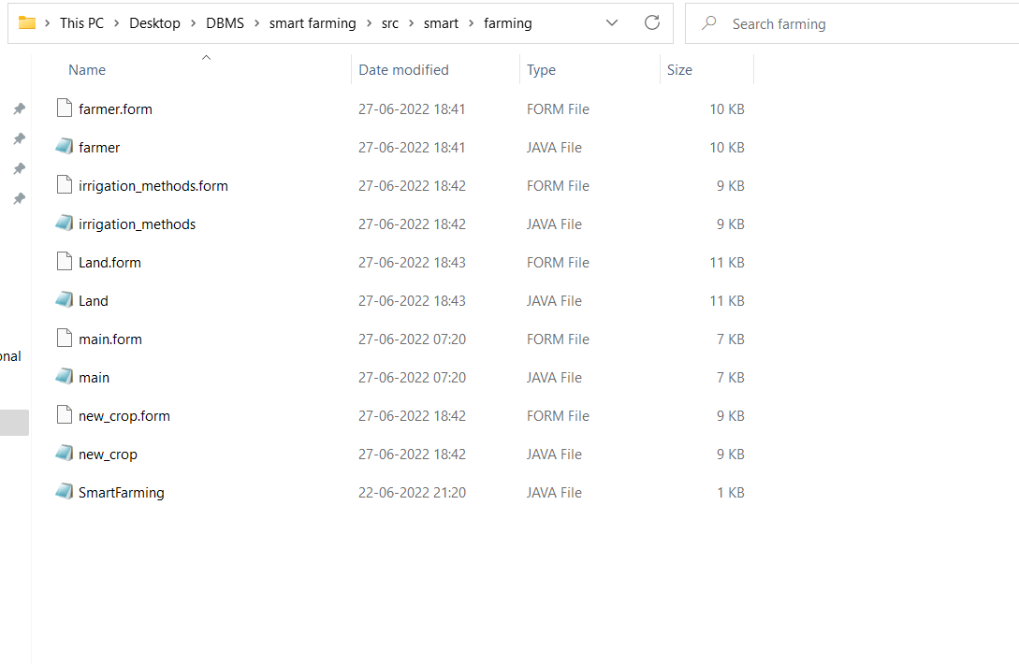

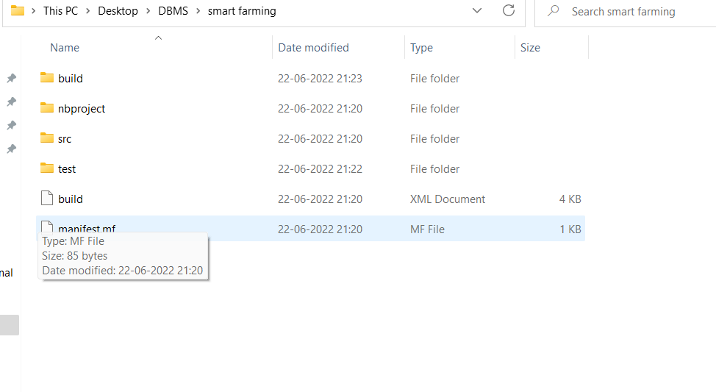

**Testing**

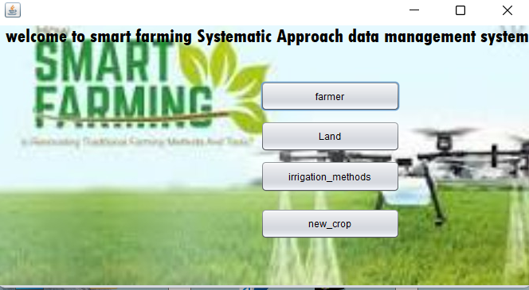

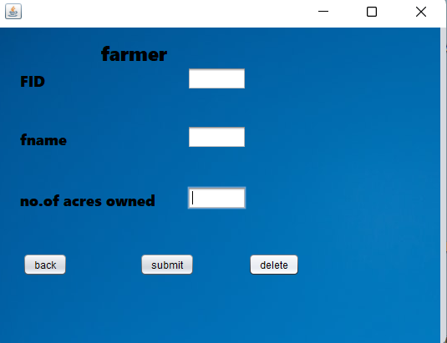

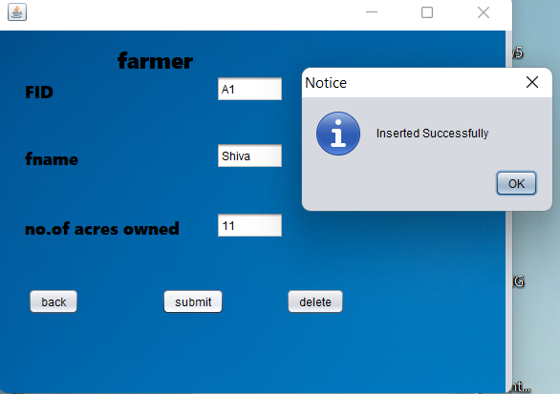

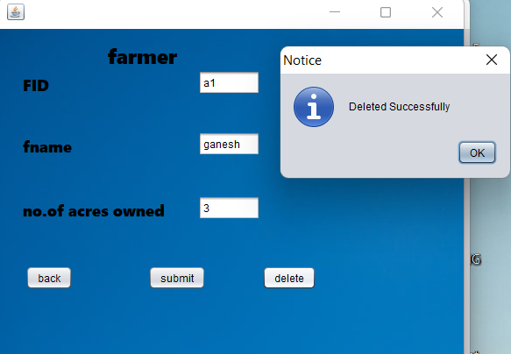

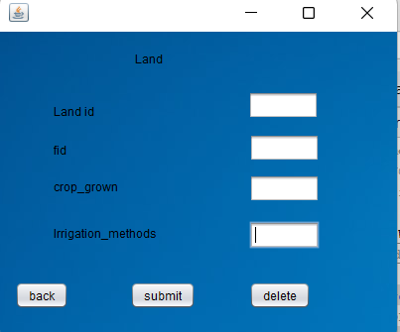

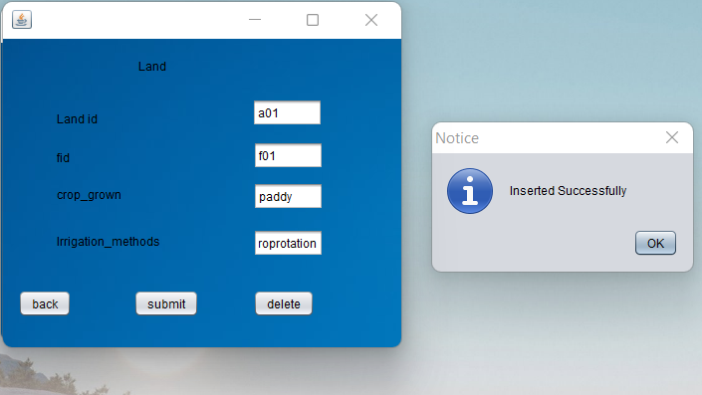

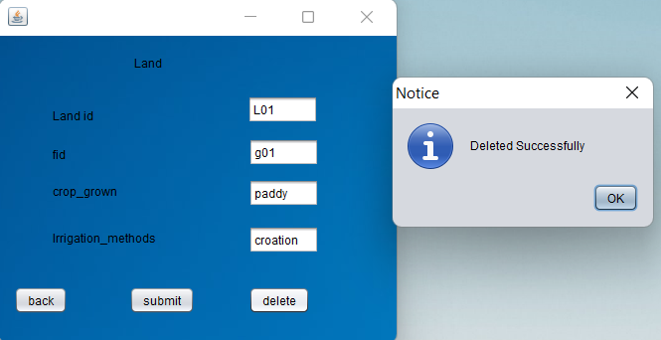

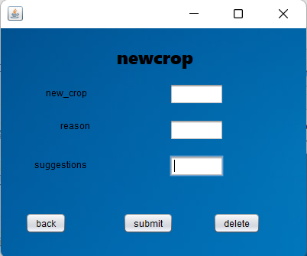

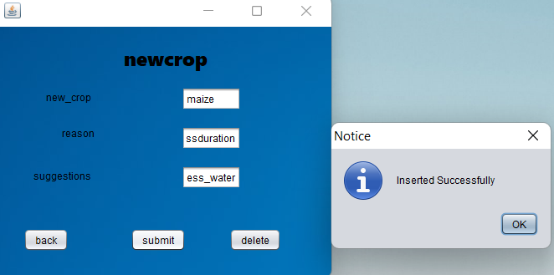

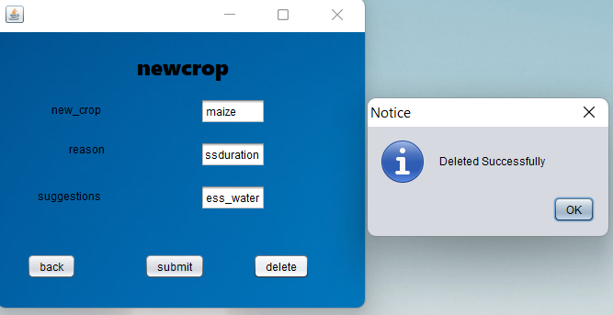

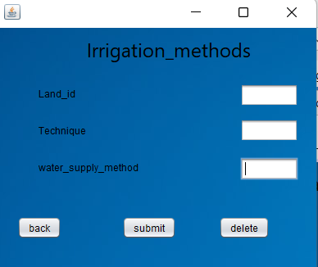

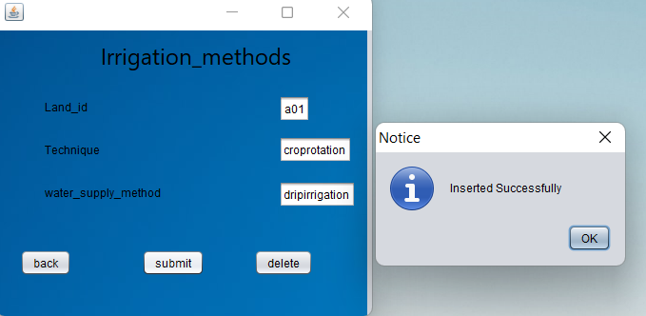

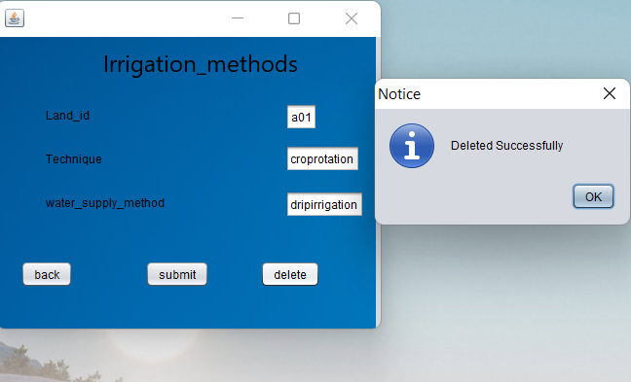

**RESULTS**

I have successfully completed the project ***“smart farming Systematic Approach data management system’’***

## DISCUSSION AND FUTURE WORK

This project contains the system that manages the farming in a smart way.

Main aim of the project is to identify the details of land and farmer provides the effective ways for smart farming. Future scope would be to make the UI more appealing by using graphics. We can also think of including a feedback system to allow the users to leave their valuable feedback after using this app. Making this feedback to be publicly viewable, would attract many more users to use this app.

## REFERENCES

* <https://docs.oracle.com/javase/7/docs/api/>
* <https://www.javatpoint.com/java-swing>
* <https://stackoverflow.com/>