Appointment module

**After login->**

**Module Name**: Appointment

3 menus are present as seen below.

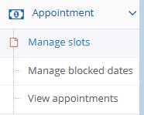

For **adding consulate** below module is used (country embassy locations) ->

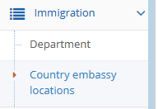

**New tables created->**

appointment_bookings

embassy_locations

Table **modifications**->

ALTER TABLE `user_accounts` ADD COLUMN `is_embassy_user` TINYINT DEFAULT 0 NOT NULL AFTER `publish`;

ALTER TABLE `user_accounts` CHANGE `is_embassy_user` `countryembassyid` INT(4) DEFAULT 0 NOT NULL

ALTER TABLE `s_visa_applications` ADD COLUMN `unique_identifier` VARCHAR(100) NULL AFTER `countryembassyid`;

**Involved files->**

model\ApplicationForm.class.php

model\AppointmentBlockedDates.class.php

model\CountryEmbassyLocation.class.php

model\EmbassyAppointments.class.php

model\AppointmentSlots.class.php

model\UserAccount.class.php

views\country_embassy_mapping\add_edit.php

views\country_embassy_mapping\index.php

views\embassy_appointments\index.php

views\manage_appointment_slots\index.php

views\menus\side_menu_appointment.php

views\manage_appointment_slots\add_edit.php

views\manage_appointment_blocked_dates\add_edit.php

views\manage_appointment_blocked_dates\index.php

views\embassy_appointments\mark_attendance.php

views\user_accounts\add_edit.php

controller\BookAppointmentController.php

controller\CountryEmbassyMappingController.php

controller\EmbassyAppointmentsController.php

controller\AppointmentSlotsController.php

controller\AppointmentBlockedDatesController.php

lang\EN\enGb.mod.admin.country.embassy.locations.ini

**Application form filling->**

[visa/OnlineApplicationFormv1](http://locallive.visagov.so/OnlineApplicationFormv1)

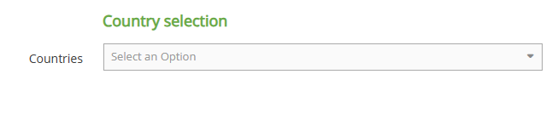

**After application form filling and payment completed🡪**

[visa/OnlineApplicationStatusv1](http://locallive.visagov.so/OnlineApplicationStatusv1)

In the status page reached by above link the link for appointment booking will be there. Clicking on that will take to below page.

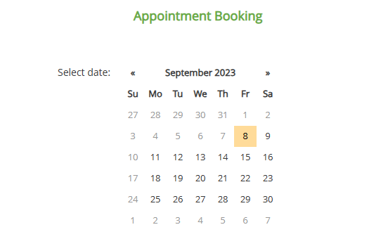

**User will select a slot and then submit.**

**Involved files**->

|  |
| --- |
| model\BookAppointment.class.php |
| model\ApplicationFormProcessingFee.class.php |
| model\Transactions.class.php |
| model\ApplicationForm.class.php |

|  |
| --- |
| views\online_application_form_v1\applicationEdit.php |
| views\online_application_form_v1\countryselection.php |
| views\book_appointment\basic.php |
| views\book_appointment\response.php |
| views\online_application_form_v1\status.php |
| views\online_application_form_v1\basic.php |
| views\application_form_processing_fee\index.php |
| views\online_application_form_v1\basic.php |
| views\reports\printedvisa.php |
| views\reports\processingfee.php |
| views\online_application_form_v1\applicationCorrection.php |
| views\application_form\detail.php |
| views\application_form\perm.php |
| views\reports\applicationforms.php |

|  |
| --- |
| controller\OnlineApplicationStatusv1Controller.php |
| controller\OnlineApplicationFormv1Controller.php |
| controller\LoginController.php |
| controller\UserAccountController.php |
| controller\ApiController.php |
| controller\ApplicationFormProcessingFeeController.php |
| controller\ApplicationFormController.php |
| controller\OnlineServicesController.php |
|  |

|  |
| --- |
| lang\EN\enGb.application.form.appointment.ini |
| lang\EN\enGB.users.ini |
|  |
| config\modules\appointment.php |
|  |
| visa_application_template\images\COPY_TRAIL.jpg |
| visa_application_template\images\entry-permit-header_2.png |
|  |
|  |
|  |

**Add User account🡪**

**Module Name**: User Accounts

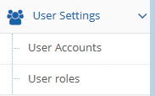

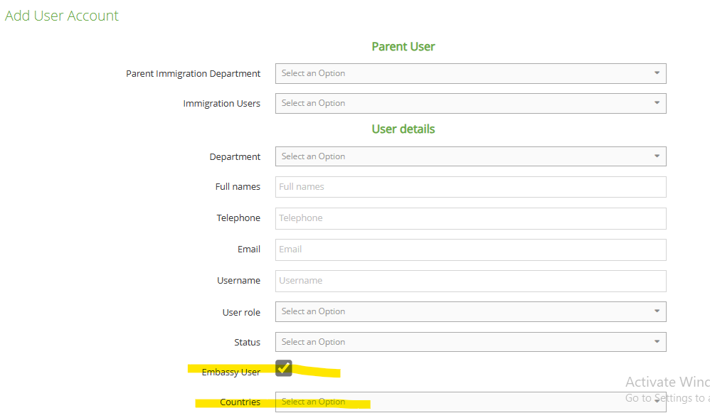

**Embassy user check box** and **countries dropdown** added as shown above.

**Files involved->**

controller\UserAccountController.php

lang\EN\enGB.users.ini

model\UserAccount.class.php

views\user_accounts\add_edit.php

**Approve Application forms🡪**

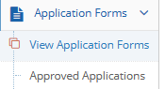

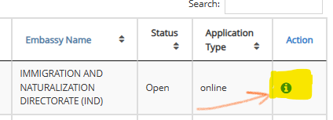

**Appointment booking section added as shown below.**

**If appointment is booked by the applicant then it will be displayed as shown below and then only the “Process” button will be activated for enabling the application for further process.**

