Page Object Model Design Pattern

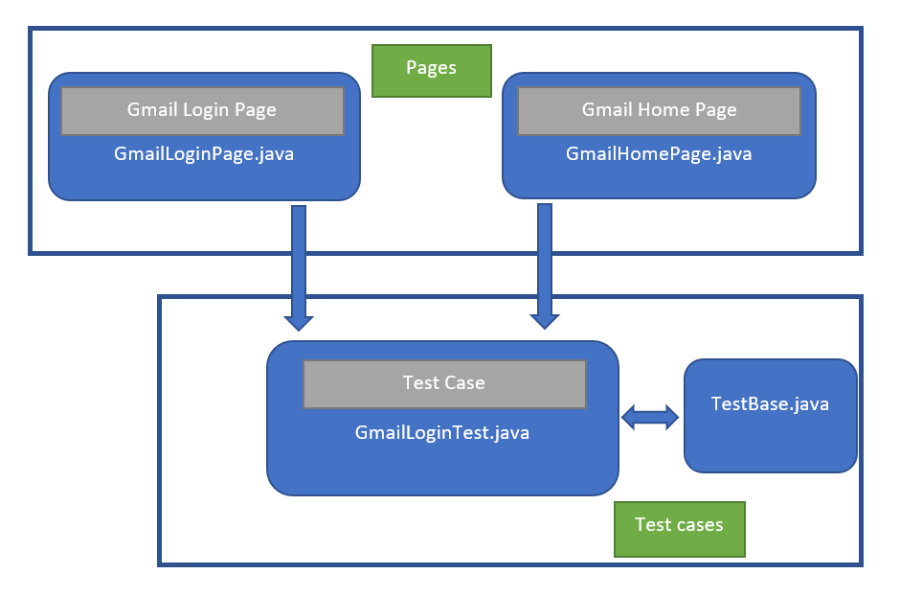

base(Base Classes)

pages(page Classes)

tests(Test Classes)

Configuration file

Screenshots

Page Object Model:

1) Base classs : - Base Page Class is the one from which classes of all other pages inherit. We will therefore create it first, populate it with methods for the most common actions that are expected to be performed on any page in the application. The base page class should look something like this:
We can define locators as well

class BasePage():
def _init_(self, driver):
self.driver = driver

2) Page Classes – One page class for each web page in the application. Find the WebElements of web page. Contains page methods which perform actions on those WebElement. We can create new page for each module.

3) Test Classes - The test case file should contain only the test logic only. We have to keep “test” as prefix or suffix of testcase file name.

4) Configureation – we can create config file and put all configuration in it. Like drivers (chromedriver, geckodriver) , Base URL , Username, Password

Advantages:

1) Makes our code cleaner and easy to understand.
2) Tests are more readable, flexible and maintainable
3) Re-usablw code that reduces redundancy of code
4) Shorten the learning curve for testers and help QA teams meet timelines.

