23.09.2022 MODEL PRACTICAL EXAMINATIONS CSA07

COMPUTER NETWORKS

1.BUS TOPOLOGY

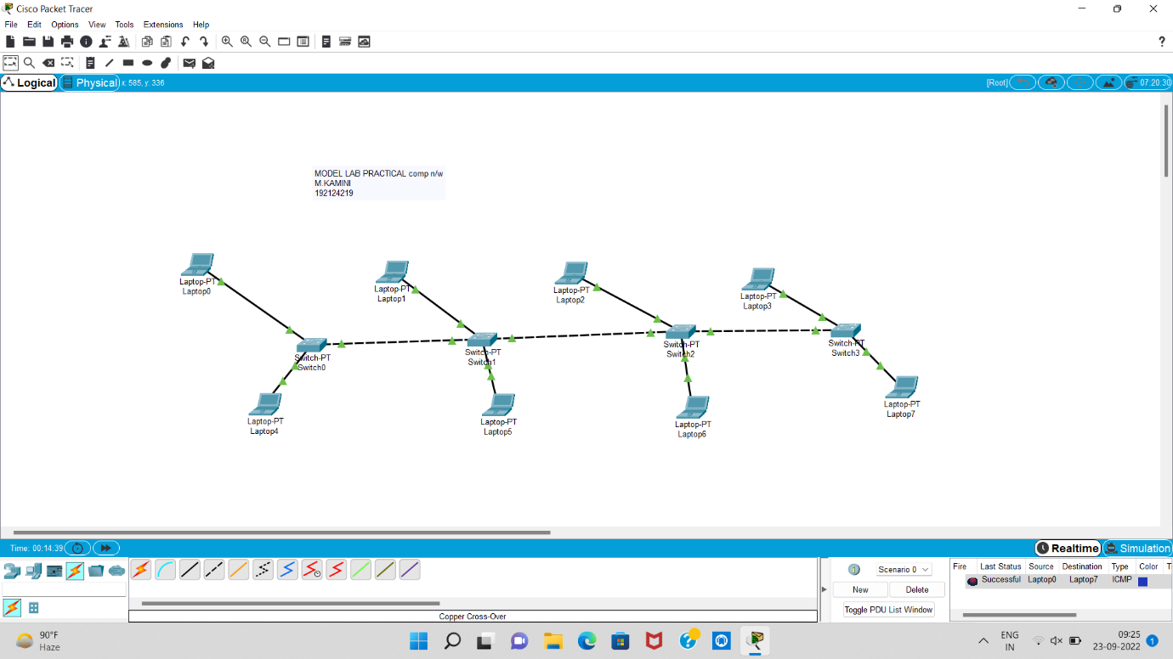

2.OSPF LINK STATE ROUTING

