1. Create a Dataset
   1. Get Openlabelimg from <https://github.com/Cartucho/OpenLabeling>
   2. Another reqirements
      1. Python
      2. OpenCV version >= 3.0
   3. How to run project
      1. Open the main/ directory
      2. Insert input images and videos in the folder input/
      3. Insert the classes in the file class_list.txt (one classe name per line). Example:

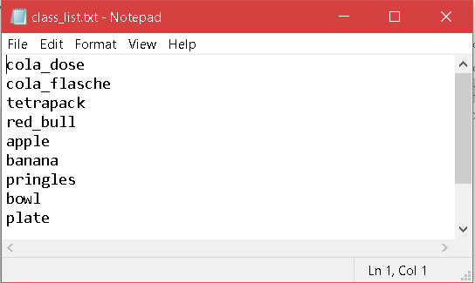

* + 1. Run the code in the terminal, e.g.: python main.py -i video
    2. Optional arguments:

|  |  |
| --- | --- |
| -h, --help | show this help , message and exit |
| -i, --input | Path to images and videos input folder | Default: /input |
| -o, --output | Path to output folder (if using the PASCAL VOC it’s important to set this path correctly) | Default: output/ |
| -t, --thickness | Bounding box and cross line thickness (int) | Default: -t 1 |

* + 1. Shorcut key

|  |  |
| --- | --- |
| **Key** | **Description** |
| a/d | Previous/next image |
| s/w | Previous/ next class |
| E | Edges |
| H | Help |
| Q | Quit |
| P | Predict next frames’ label |

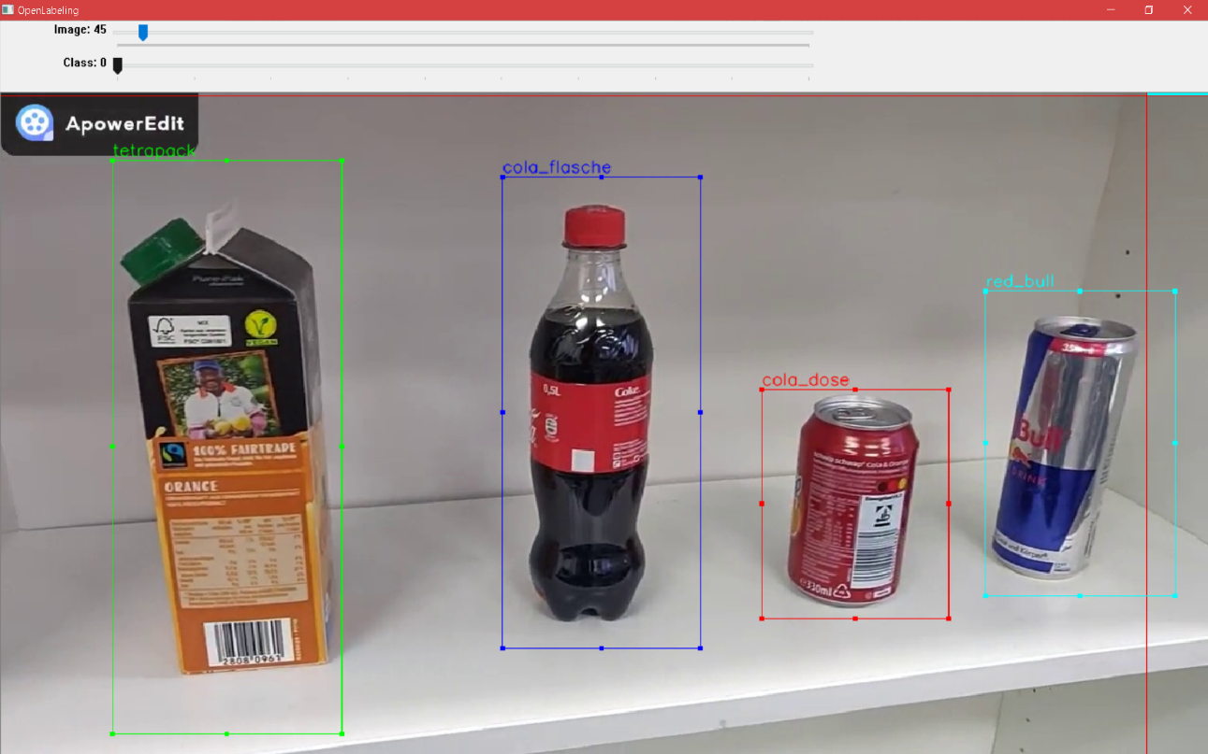

Figure 1 Example of using OpenLabeling

* 1. The labelled images will have its paired txt files which contain information about the position of the box

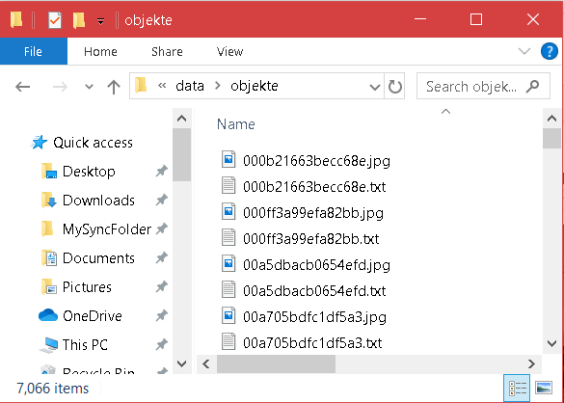

Figure 2 txt file's name should be the same as image file's name

* 1. Place the images and the txt file into /data directory in darknet
  2. Create train.txt file that contain the path of all images file

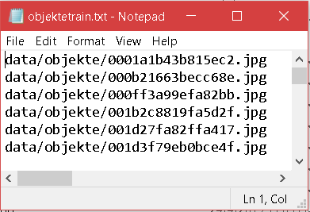

* 1. Create object.name file that contain all class names (the format for the list is as same as class_list.txt in OpenLabeling)

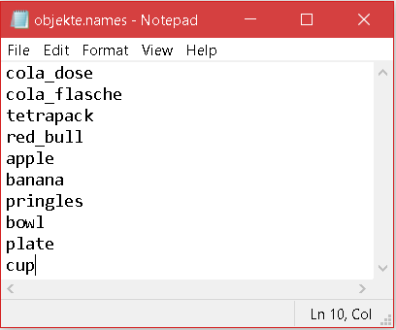

* 1. Create an object.data file that contains information about the number of classes and the path to the train.txt, object.name and the weight file to be stored.

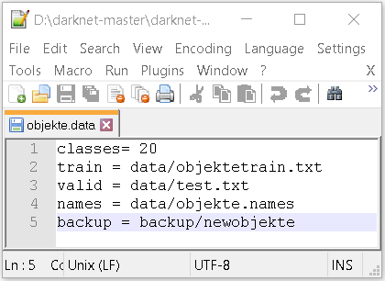

1. Getting images using google images search engine
   1. Get google-image-download-center from <https://github.com/hardikvasa/google-images-download>
   2. How to run project
      1. Open the google_images_download/ directory
      2. Run the code in terminal in the terminal, e.g.: python google_images_download.py --k cat
      3. The downloaded images will be saved in /downloads directory