1. **Install on Windows:**
2. Get Darknet: git clone <https://github.com/AlexeyAB/darknet.git>
3. Download CUDA 10.0: <https://developer.nvidia.com/cuda-10.0-download-archive?target_os=Windows&target_arch=x86_64&target_version=10&target_type=exelocal>

And install: <https://docs.nvidia.com/cuda/cuda-quick-start-guide/index.html#windows-local>

1. Download cudNN for CUDA 10: <https://developer.nvidia.com/rdp/cudnn-archive>

Unzip and copy

\cuda\bin\cudnn64_7.dll to C:\Program Files\NVIDIA GPU Computing Toolkit\CUDA\v10.0\bin

\cuda\include\cudnn.h to C:\Program Files\NVIDIA GPU Computing Toolkit\CUDA\v10.0\include

\cuda\lib\x64\cudnn.lib to C:\Program Files\NVIDIA GPU Computing Toolkit\CUDA\v10.0\lib\x64

1. Add to system variables CUDA_PATH and CUDNN with value C:\Program Files\NVIDIA GPU Computing Toolkit\CUDA\v10.0 like in the image:

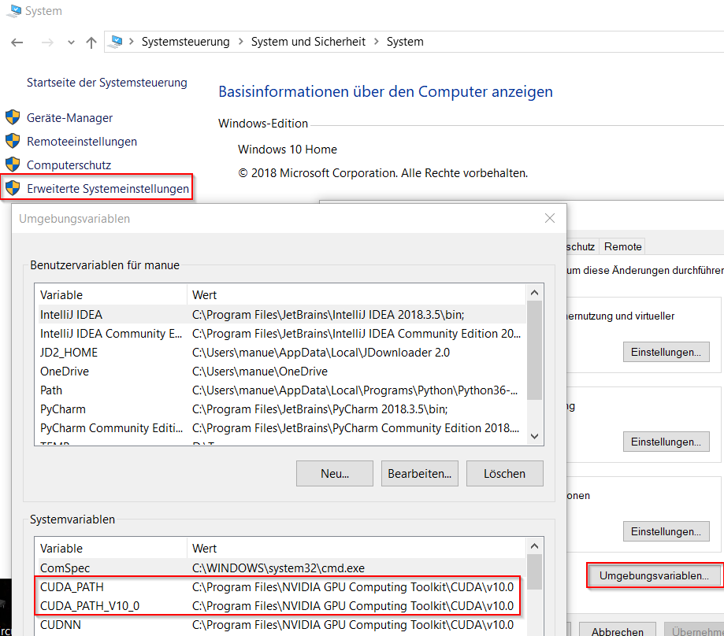

1. Download and extract OpenCV for Windows: <https://opencv.org/releases/> into C – directory

Add system variable OPENCV_DIR with value C:\opencv\build

1. Open C:\darknet\build\darknet\darknet.sln and build the project with x64 Release
2. Copy files opencv_world346.dll and opencv_ffmpeg346_64.dll from C:\opencv\build\x64\vc14\bin and cudnn64_7.dll from C:\Program Files\NVIDIA GPU Computing Toolkit\CUDA\v10.0\bin into the directory of darknet.exe
3. **Install on Linux:**

git clone https://github.com/pjreddie/darknet

cd darknet

make