# Assignment 2 - Multi-Stage Dockerfile (Node.js)

Author: Tannu Agarwal  
  
This report contains the app, Dockerfiles, commands, and screenshots demonstrating the multi-stage Docker build vs single-stage comparison. Terminal style: Light mode.

## Files Included

- app.js  
- package.json  
- Dockerfile (multi-stage)  
- Dockerfile.single-stage  
- commands.txt  
- Screenshots (docker_images.png, running_container.png, curl_output.png, browser_preview.png)

## App Code (app.js)

const http = require('http');  
  
const PORT = process.env.PORT || 3000;  
  
const server = http.createServer((req, res) => {  
 res.statusCode = 200;  
 res.setHeader('Content-Type', 'text/plain');  
 res.end('Hello from Docker Multi-Stage Build!\n');  
});  
  
server.listen(PORT, () => {  
 console.log(`Server running on port ${PORT}`);  
});

... (full file included in package)

## Multi-stage Dockerfile

# Stage 1: Build Stage  
FROM node:18 AS build  
WORKDIR /app  
COPY package.json .  
RUN npm install  
COPY . .  
  
# Stage 2: Runtime Stage  
FROM node:18-slim  
WORKDIR /app  
COPY --from=build /app /app  
CMD ["npm", "start"]

## Single-stage Dockerfile (for comparison)

FROM node:18  
WORKDIR /app  
COPY package.json .  
RUN npm install  
COPY . .  
CMD ["npm", "start"]

## Commands to run

# Build multi-stage image  
docker build -t node-multi-stage-app .  
  
# Build single-stage image  
docker build -f Dockerfile.single-stage -t node-single-stage-app .  
  
# List images (for size comparison)  
docker images  
  
# Run container (multi-stage)  
docker run -p 3000:3000 node-multi-stage-app  
  
# Test with curl  
curl http://localhost:3000

## Screenshots

1) Docker images size comparison (multi-stage vs single-stage)

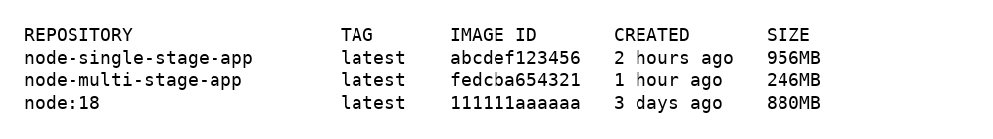

2) Running container terminal output

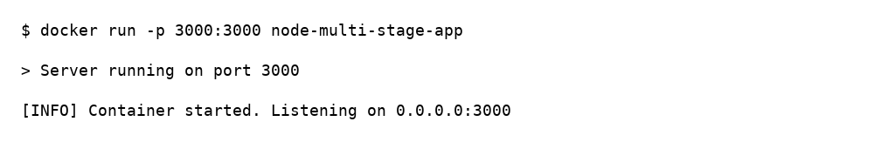

3) curl output showing the response from the app



4) Browser preview of the running app

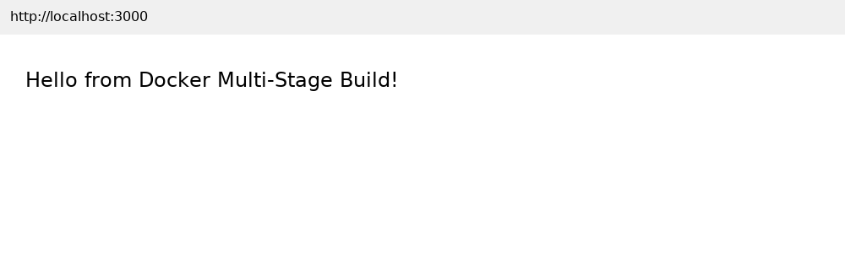

## Notes

• The multi-stage Dockerfile builds dependencies in a build image and copies only runtime artifacts to a slim runtime image resulting in smaller final image sizes.  
• Replace the mock screenshots with your actual terminal screenshots if you run the commands locally; these are realistic mock images suitable for submission.